**Docker**

Docker is a software platform that allows you to build, test, and deploy applications quickly. Docker packages software into standardized units called containers that have everything the software needs to run including libraries, system tools, code, and runtime.

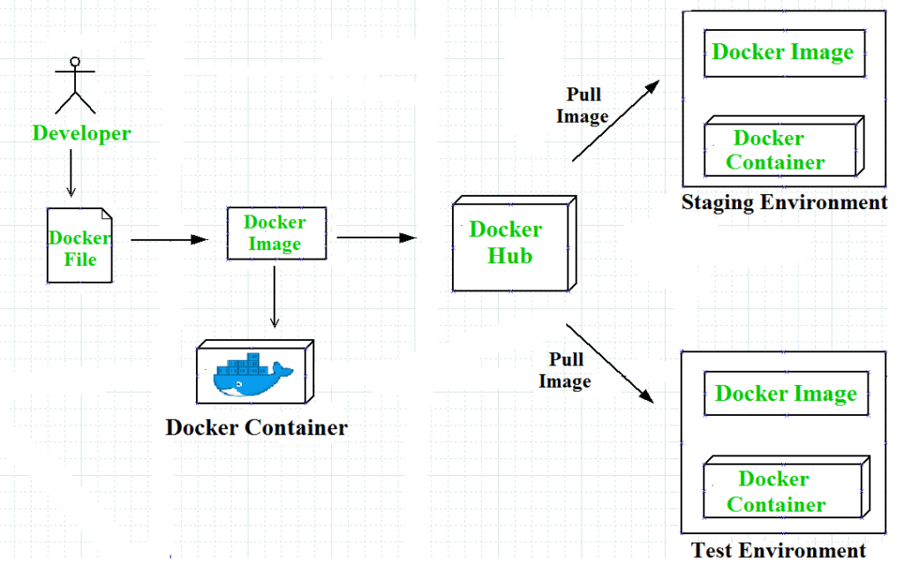

Step1: First step is to build one crud operations in spring boot .

Here I created one spring boot Crud operations using All Restful operations in spring boot application.

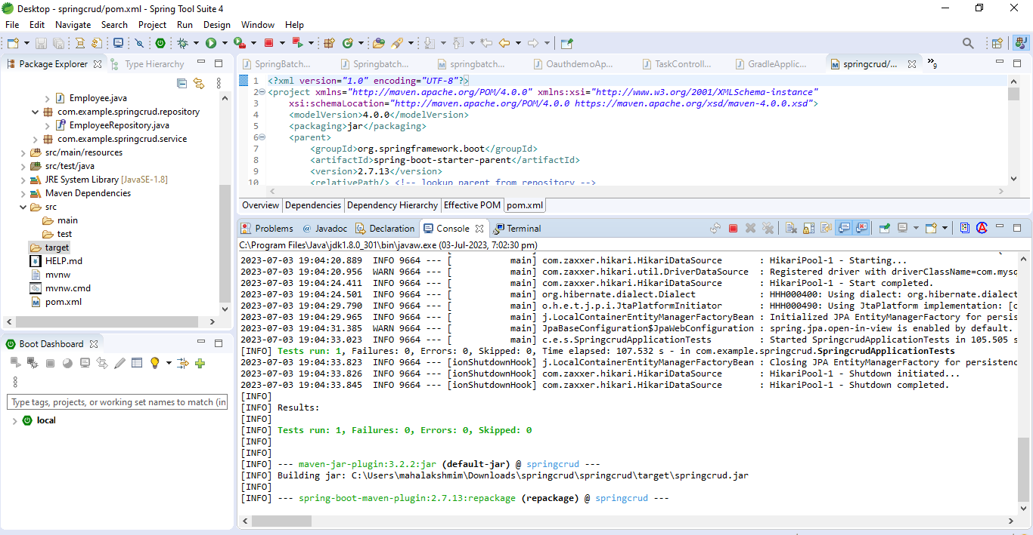

Once the application was build successful

Here the jar file for the application is generated successfully.here it is shown below

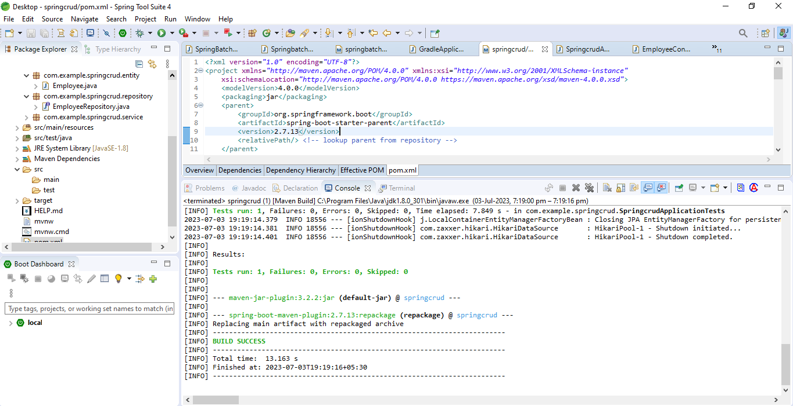

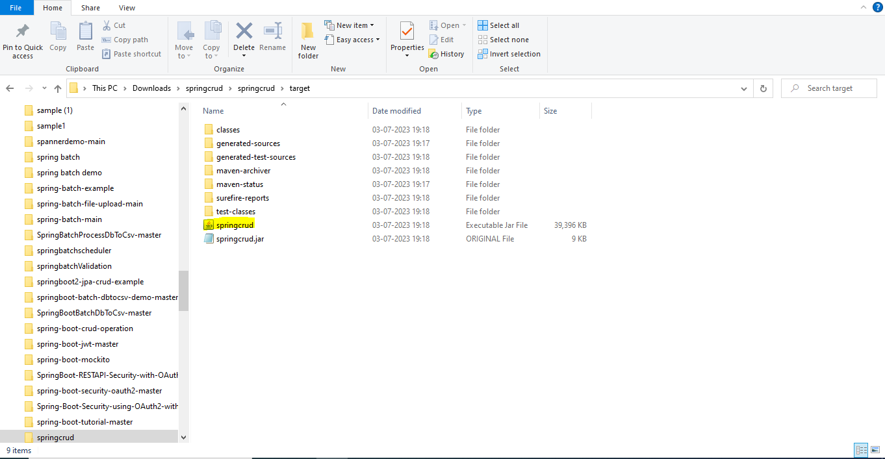

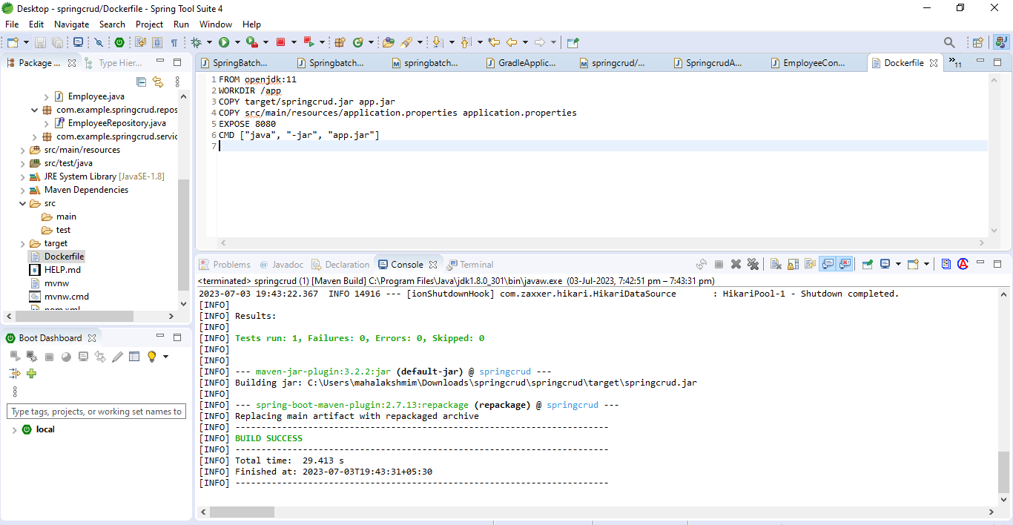

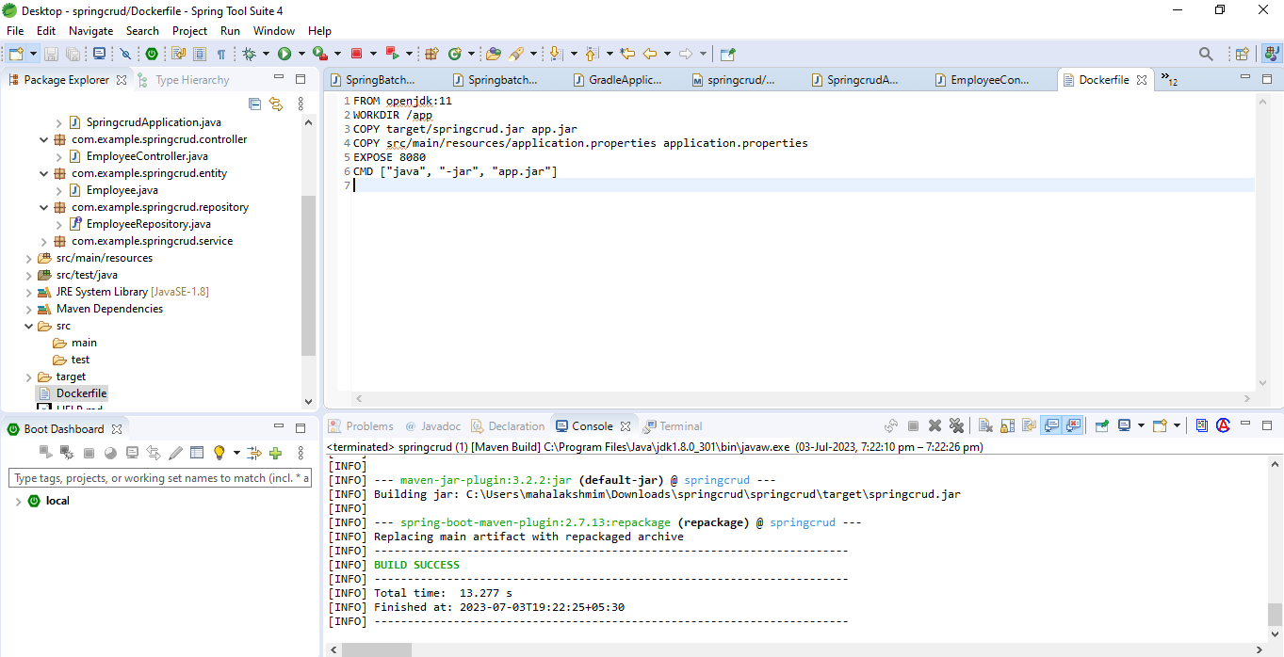

**Step 1: Pull the MySQL Docker Image**

1. Start by pulling the appropriate Docker image for MySQL. You can download a specific version or opt for the latest release as seen in the following command:

**docker pull mysql/mysql-server:latest**

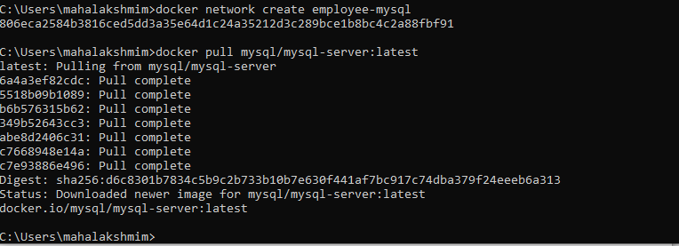

After using this command then I will use docker images command ,I can able to see the recent image that I was pushed in my docker desktop

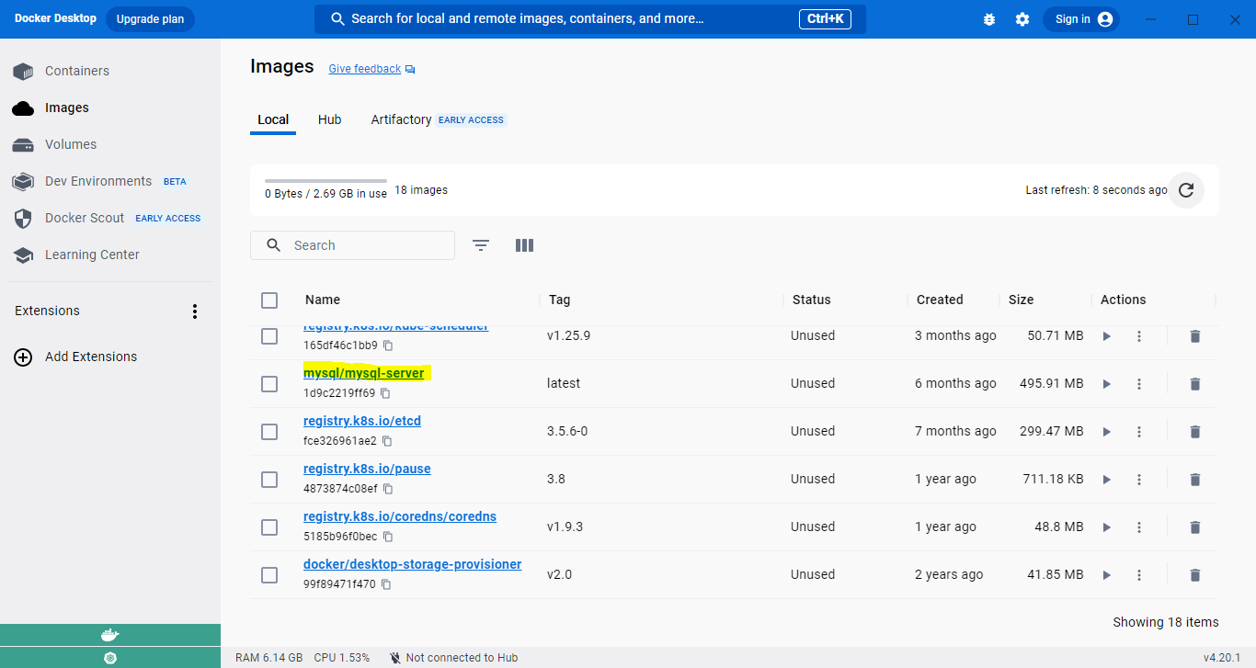

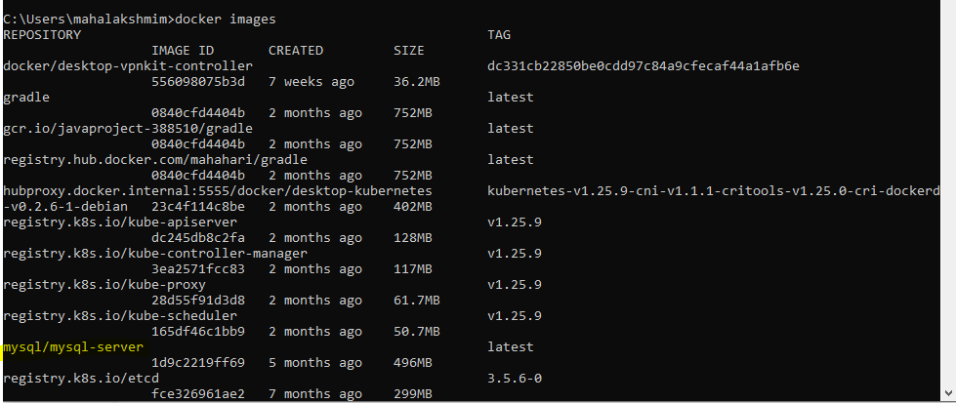

**docker run --name=[container_name] -d mysql/mysql-server:latest**



