**Github**

GitHub is a Git repository hosting service. GitHub also facilitates with many of its features, such as access control and collaboration. It provides a Web-based graphical interface.

It offers both **distributed version control and source code management (SCM)** functionality of Git. It also facilitates with some collaboration features such as bug tracking, feature requests, task management for every project.

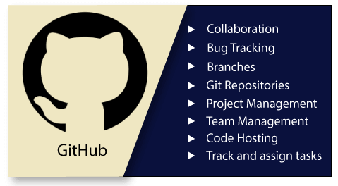

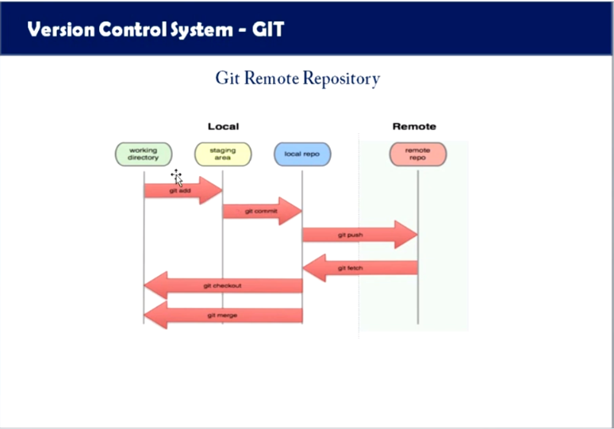

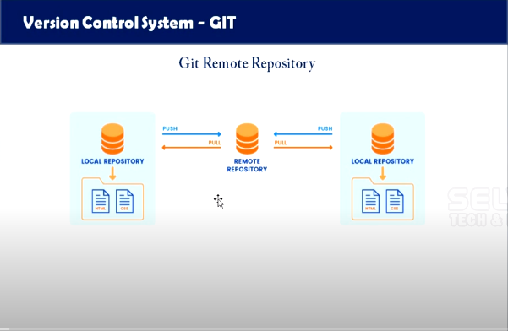

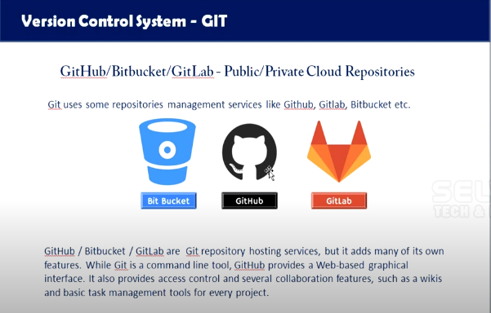

**Bitbucket.org**

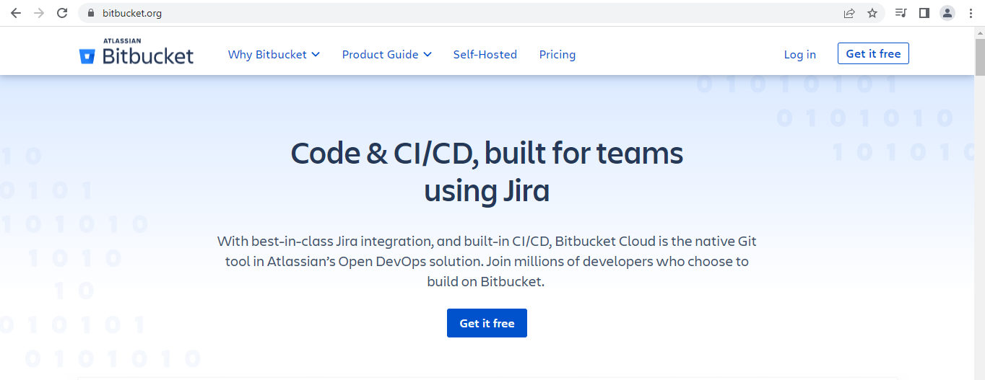

**Gitlab.org**



**Github.com**



After login in into github the dashboard of github will be look like this

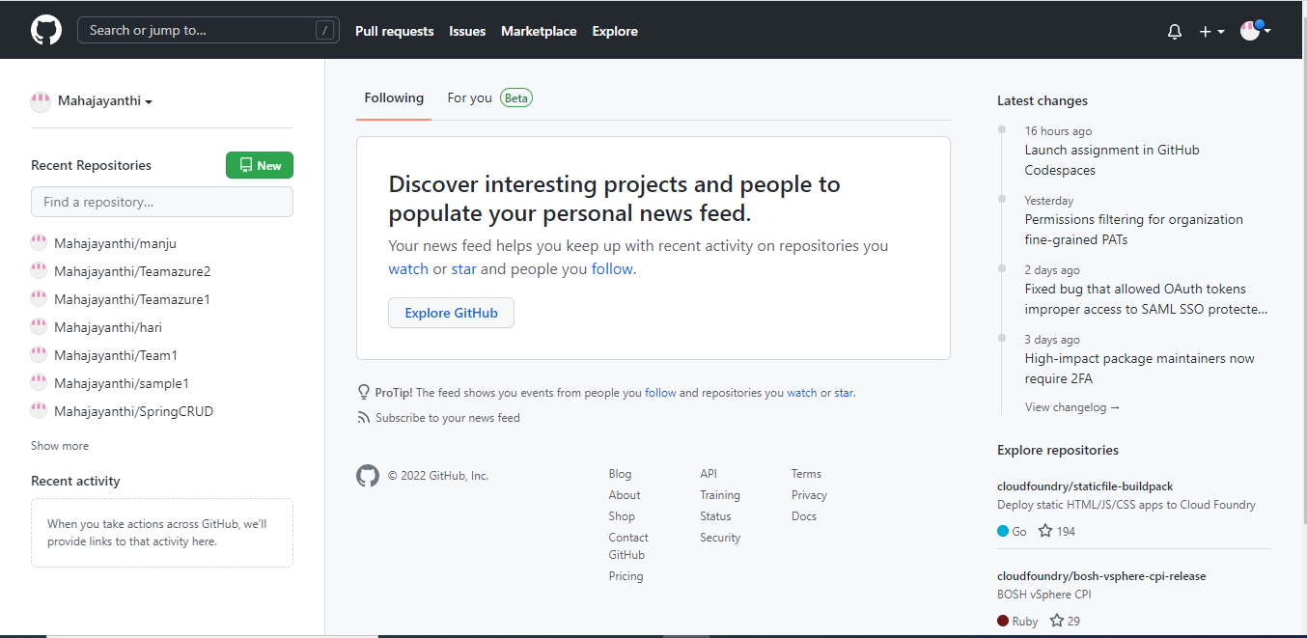

If want to create a new repository click on New

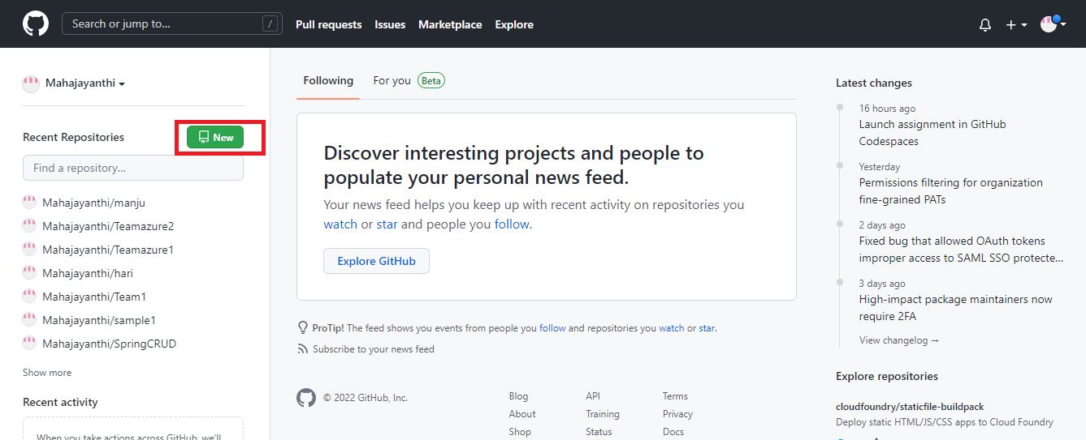

Create a new Repository

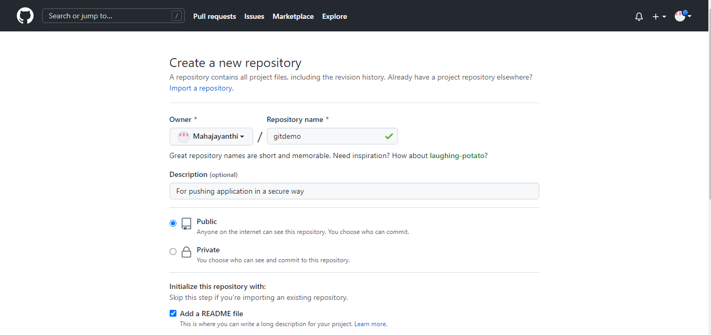

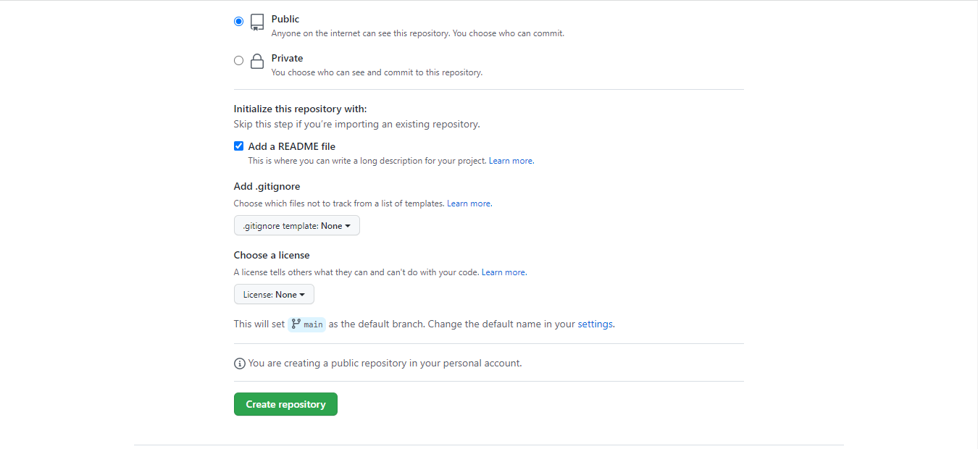

After creating a new repository it will be look like this

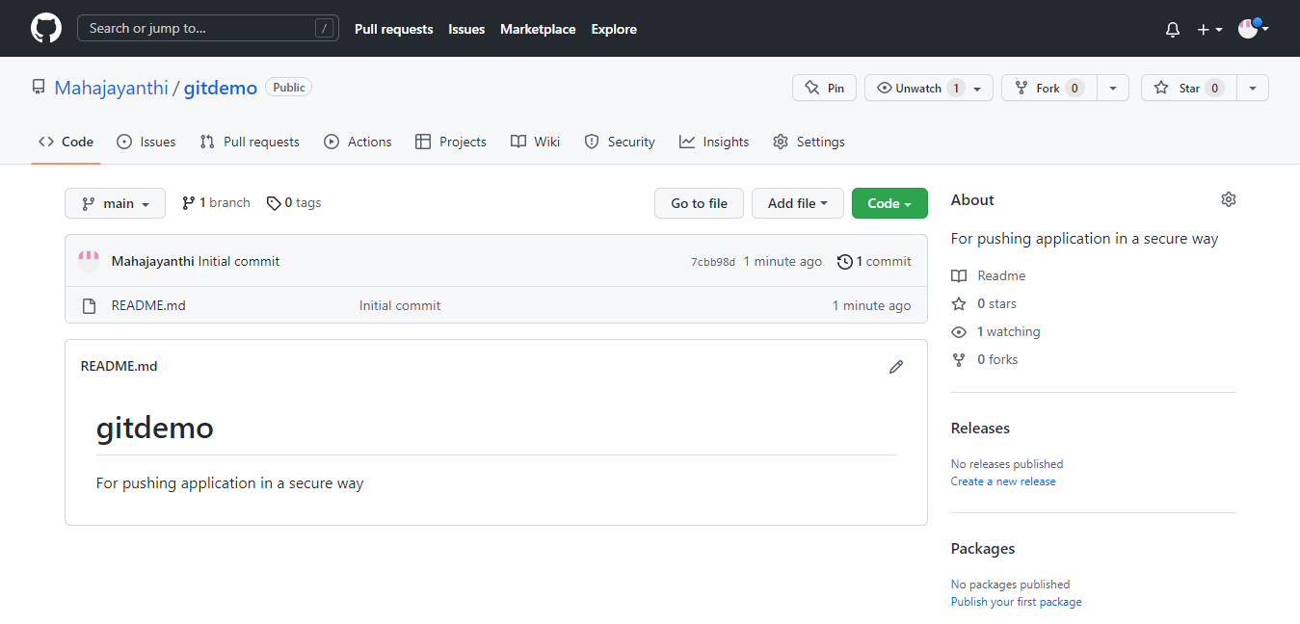

If want to add any collaborators in your project then choose settings

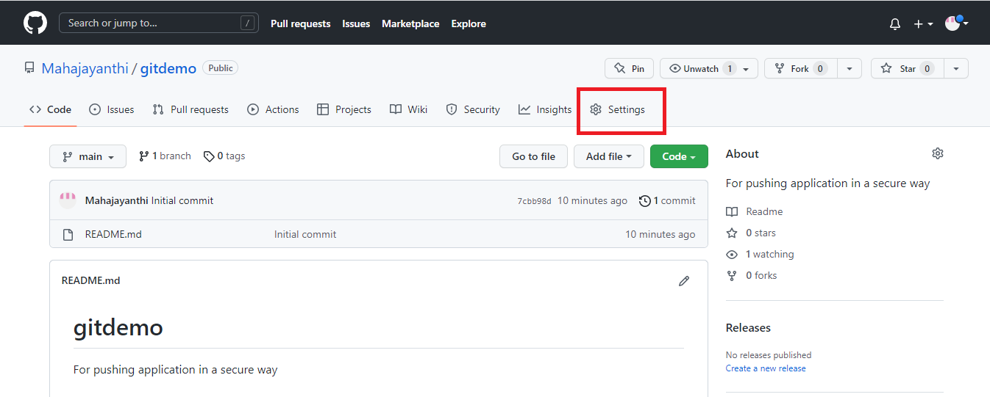

Choose collaborators under Access

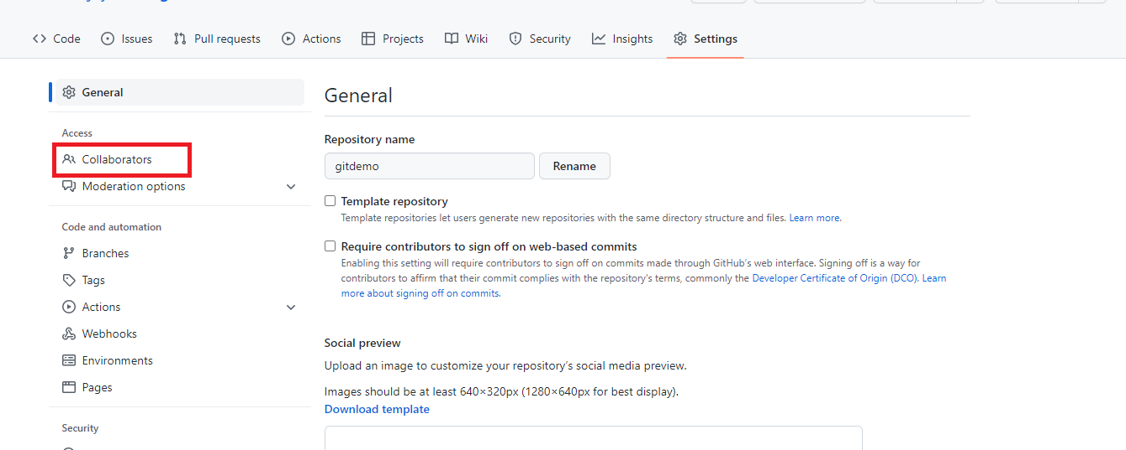

Click on Add people

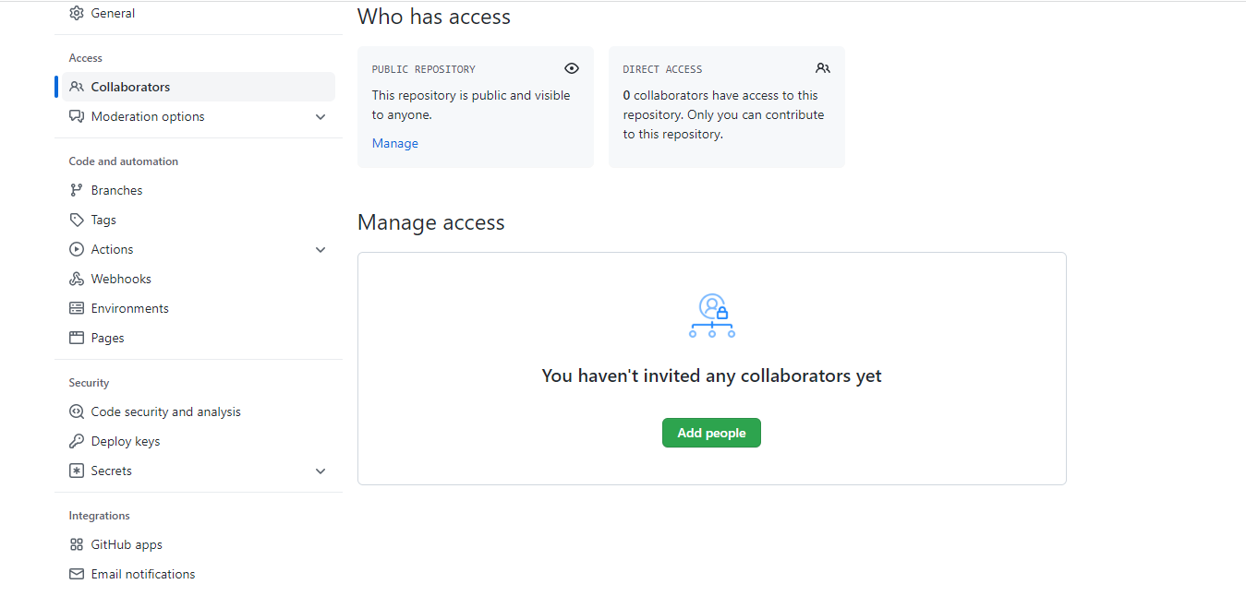

Enter the person github id and add

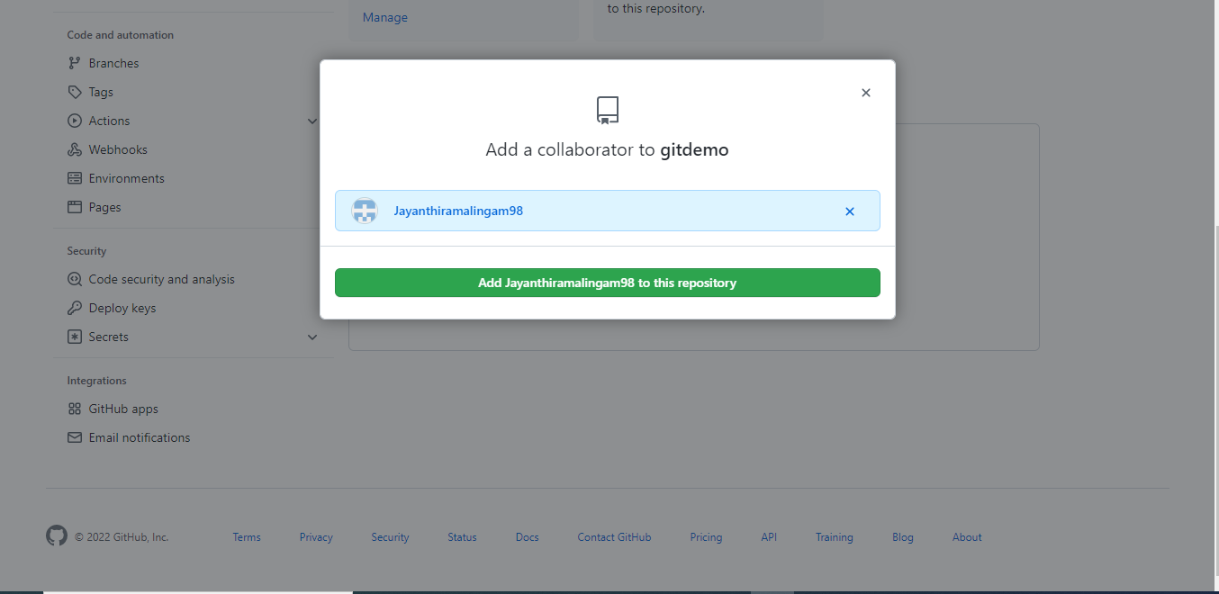

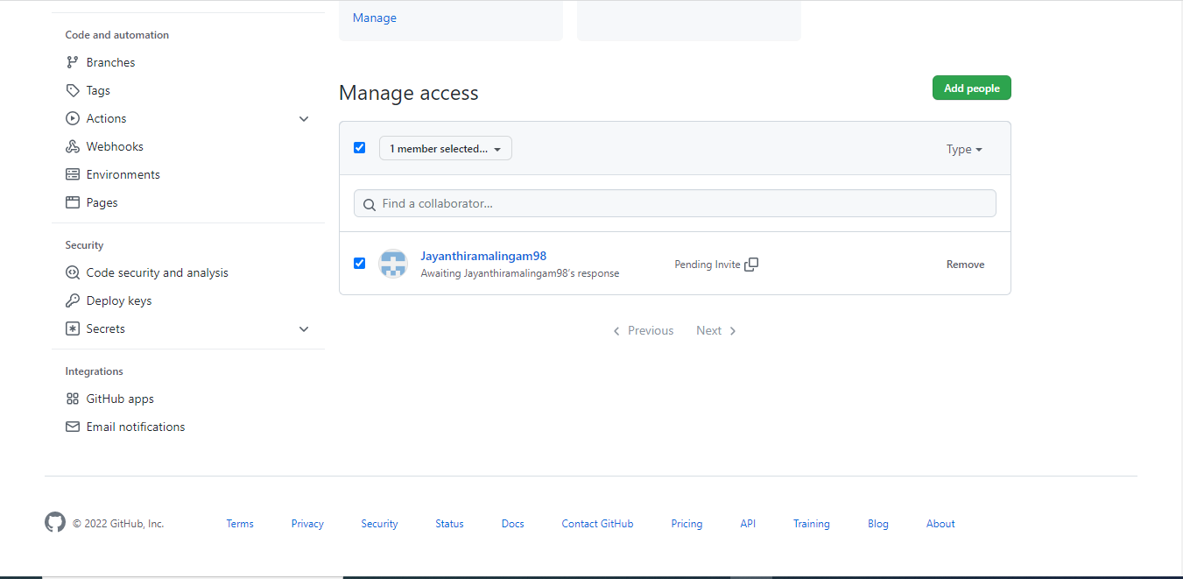

Commands:

1.**Git push** :used for pushing the code from local repository to Remote Repsoitory

* **Git init**- For initializing git in your Local
* **Git remote add origin <repository url>-** Adding the code in the remote origin
* **Git add .** – adding two or many files in the local workspace/git add <filename>-adding particular file name.
* **Git commit –m “commit message”-** for save the code in github
* **Git push <repository url>-** push the code into github
* **Git remote –v** –which remote we have (default origin)
* **Git remote rename existingone newone**-for rename the remote one
* **Git branch <branchname>**-for creating a new branch
* **Git checkout <branch name>**-for move to another branch

Sample coding in local repository

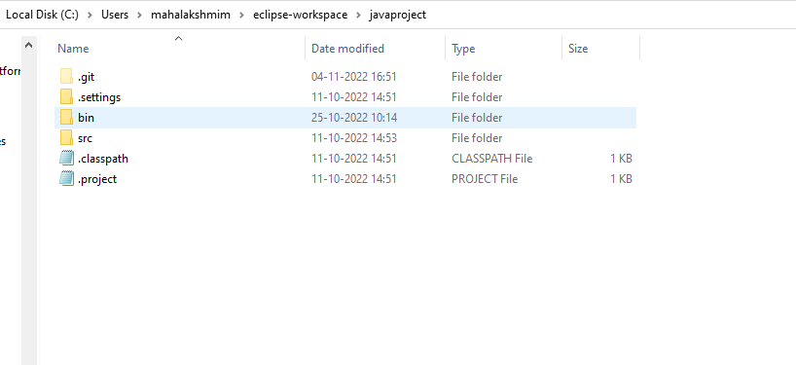

Github url of the Repository

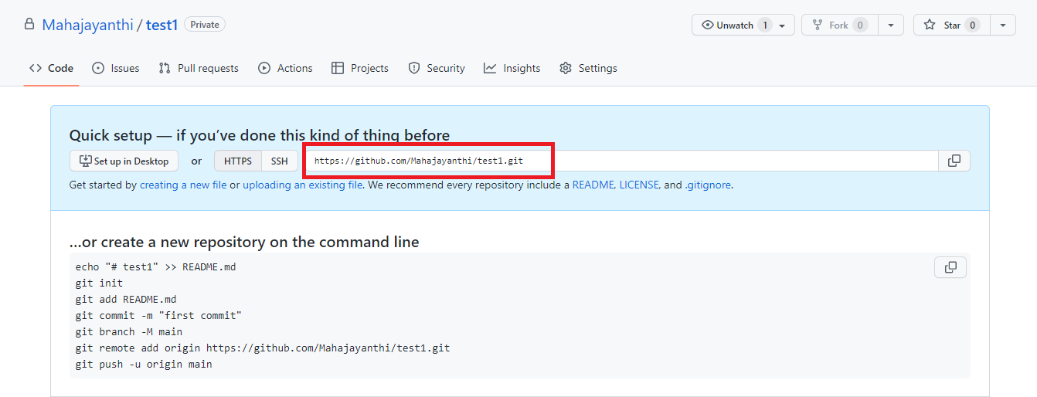

Commands for pushing

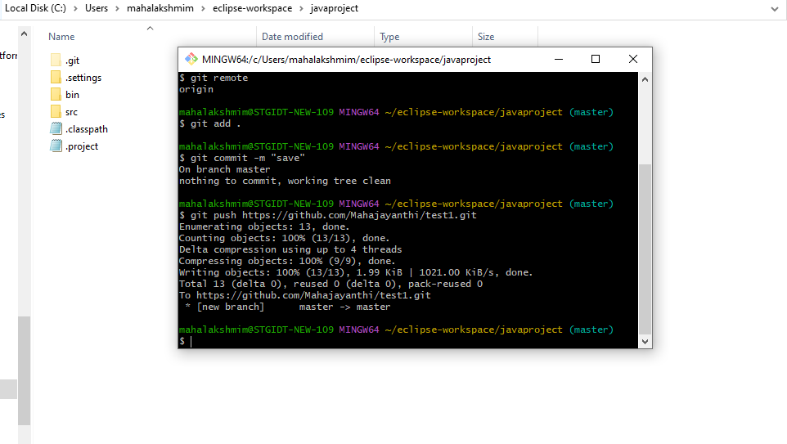

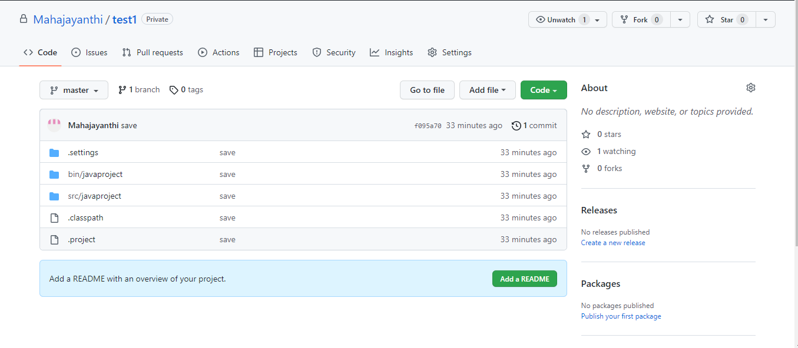

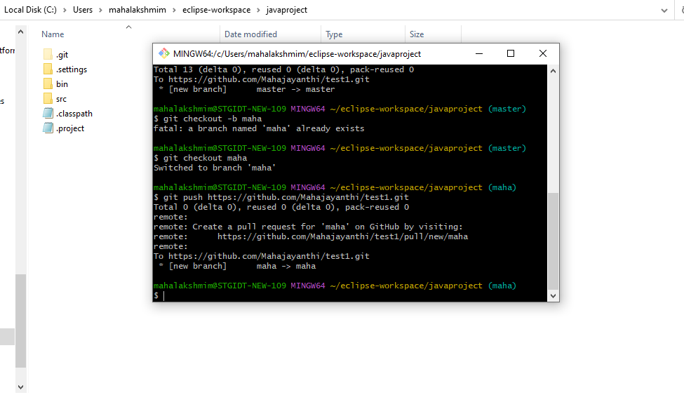

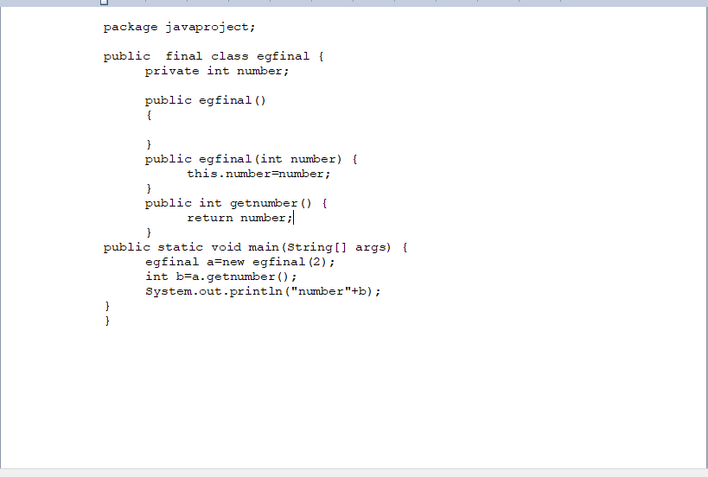

2.**Git clone:** clone the code into the local repository

**git clone <repository url>**

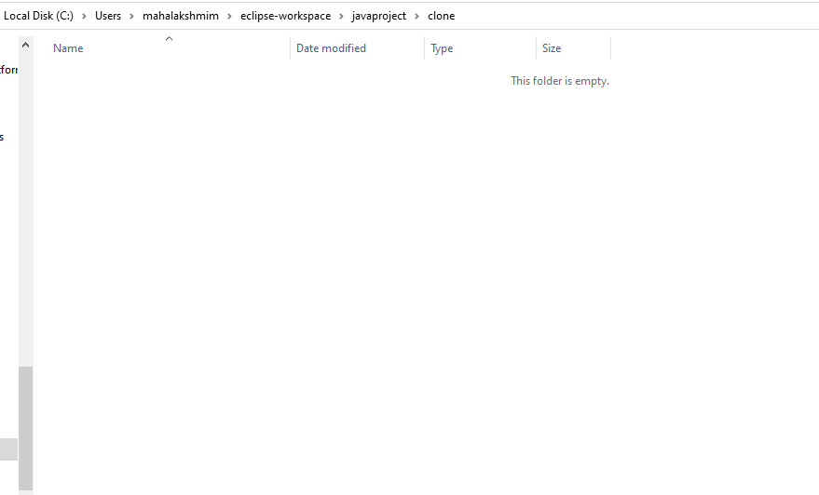

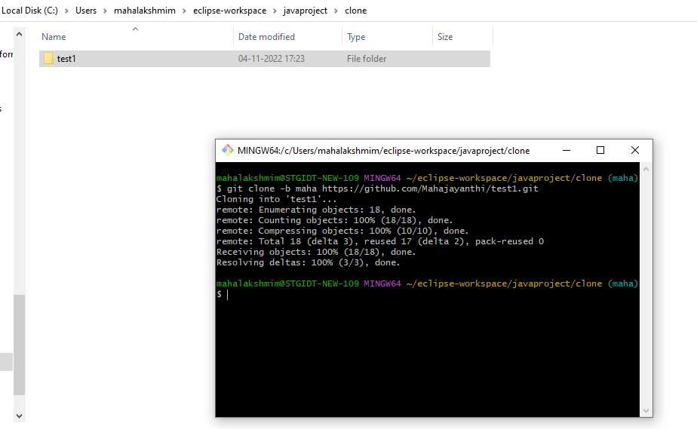

**Git pull:**

