**Kubernetes**

[Kubernetes](https://kubernetes.io/docs/concepts/overview/), also known as K8s, is an open-source system for automating deployment, scaling, and management of containerized applications.

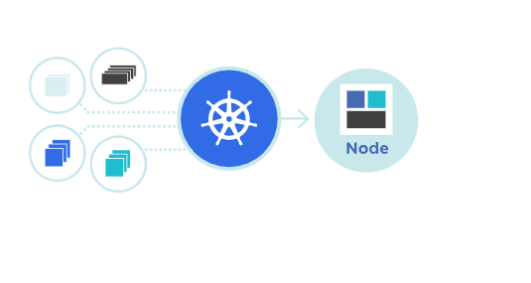

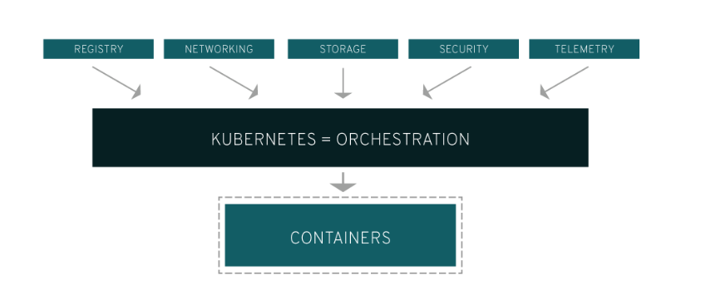

**What is container orchestration?**

Containers support VM-like separation of concerns but with far less overhead and far greater flexibility. As a result, containers have reshaped the way people think about developing, deploying, and maintaining software. In a containerized architecture, the different services that constitute an application are packaged into separate containers and deployed across a cluster of physical or virtual machines. But this gives rise to the need for *container orchestration*—a tool that automates the deployment, management, scaling, networking, and availability of container-based applications.

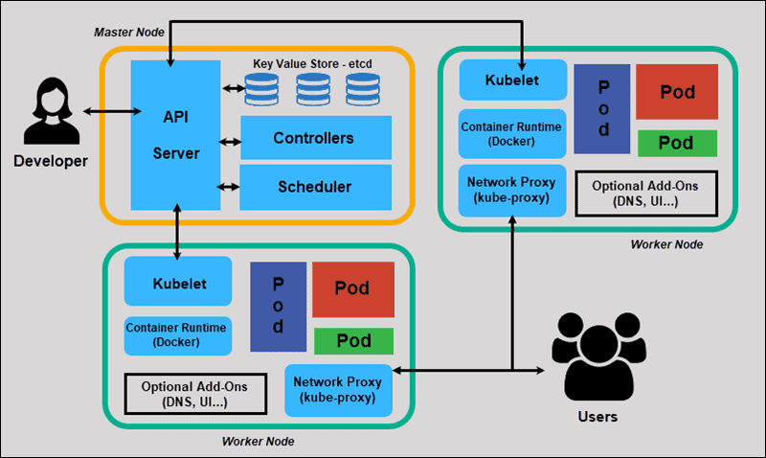

[Kubernetes](https://kubernetes.io/) is an open source project that has become one of the most popular container orchestration tools around; it allows you to deploy and manage multi-container applications at scale. While in practice Kubernetes is most often used with [Docker](https://www.infoworld.com/article/3204171/what-is-docker-the-spark-for-the-container-revolution.html), the most popular containerization platform, it can also work with any container system that conforms to the Open Container Initiative (OCI) standards for container image formats and runtimes. And because Kubernetes is open source, with relatively few restrictions on how it can be used, it can be used freely by anyone who wants to run containers, most anywhere they want to run them—on-premises, in the public cloud, or both.

Kubernetes is also called as K8S from i18n internationalization

**Traditional Deployment:**

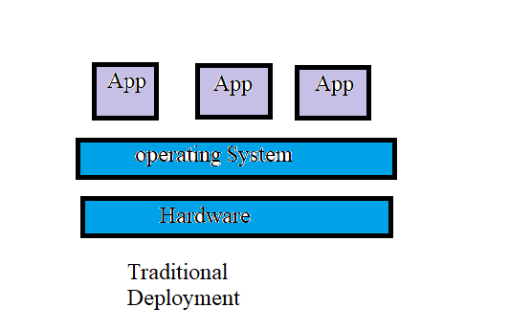

**Virtualized Deployment:**

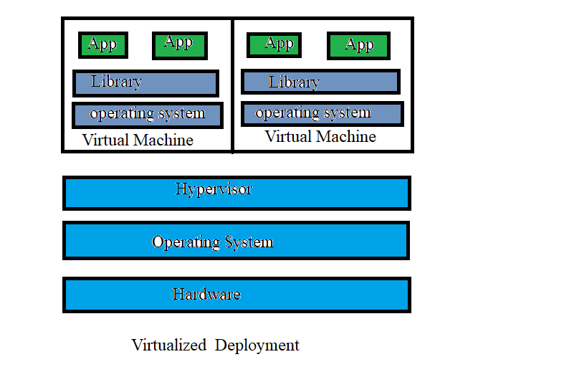

**Kubernetes Installation:**

There are numerous ways to install kubernetes,following are some of the popular ways:

1.**kubeadm** –Bare Metal Installation

2.**Minikube-** Virtualized Environment for kubernetes

3.**Kops-**kubernetes on AWS

4.**Kubernetes on GCP-** Kubernetes running on Google cloud Platform

**Steps for importing kubernetes in windows:**

Go to this link and see the download link https://medium.com/@javatechie/kubernetes-tutorial-setup-kubernetes-in-windows-run-spring-boot-application-on-k8s-cluster-c6cab8f7de5a

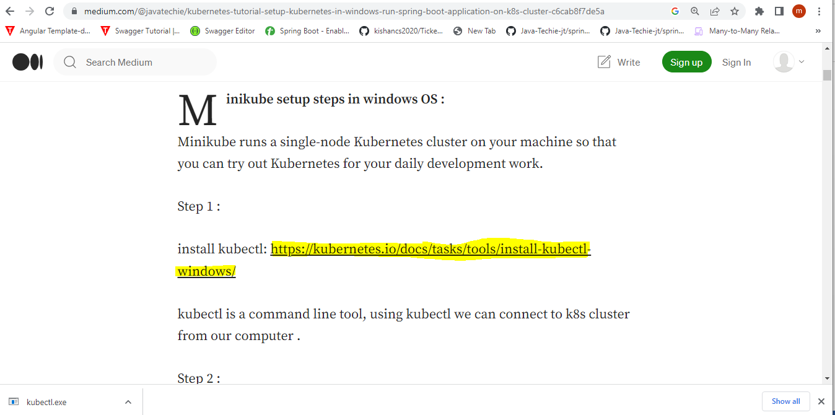

Then go to this Link <https://kubernetes.io/docs/tasks/tools/install-kubectl-windows/> then click on Kubectl 1.27.4

