CV TEMPLATE

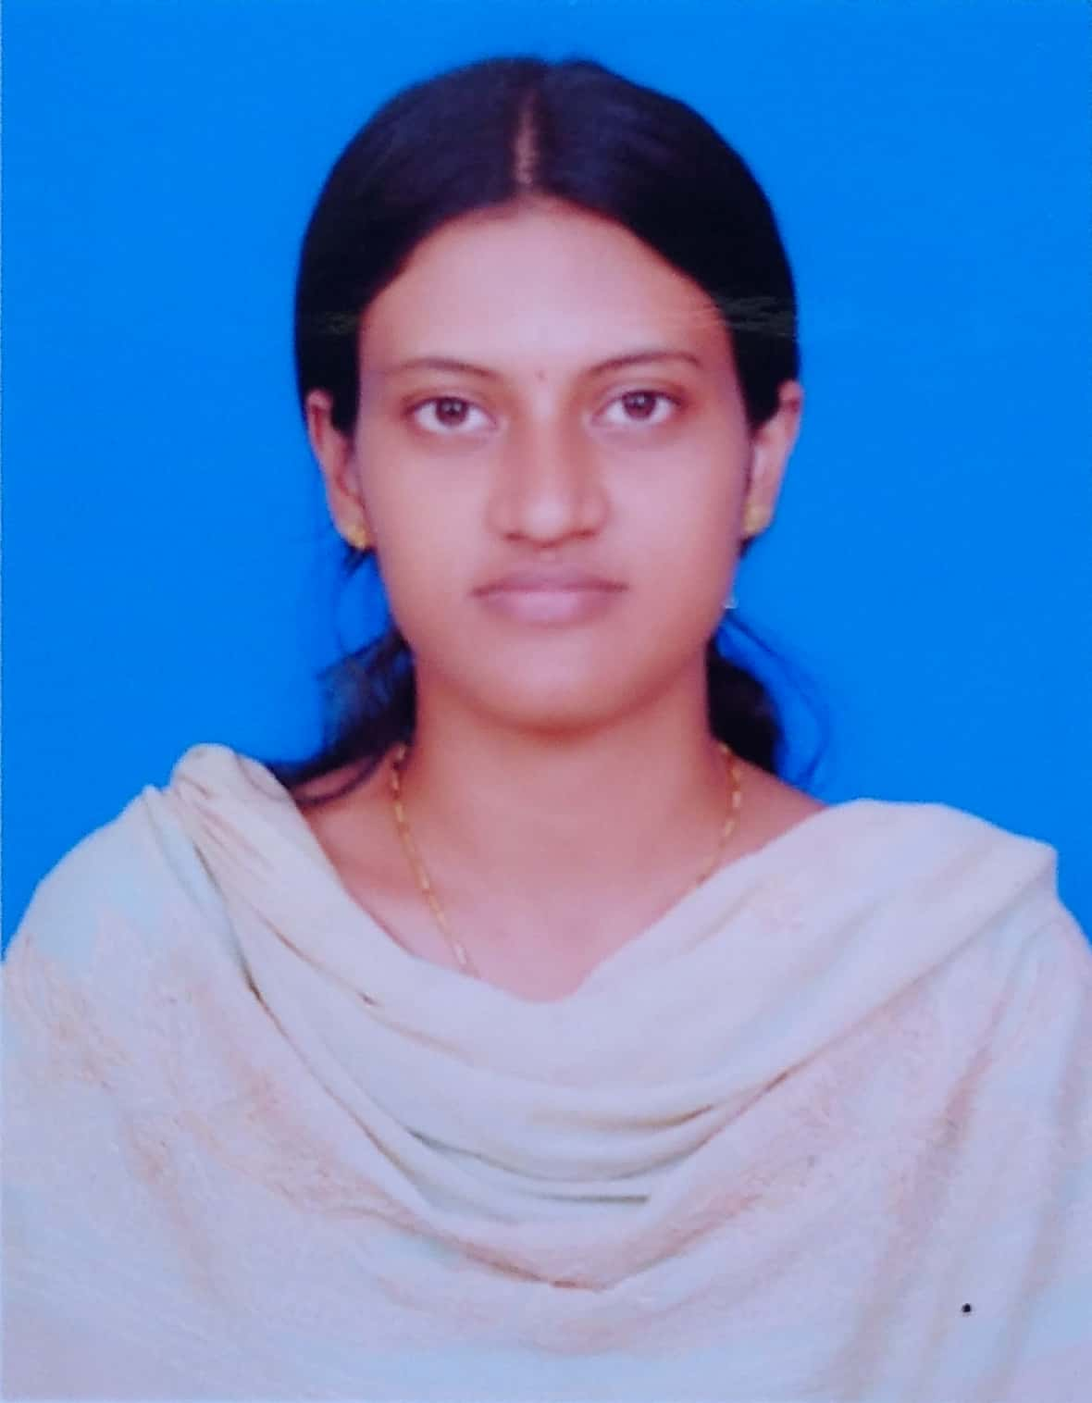

**Candidate First Name:** Mahalakshmi **(As per Passport/Aadhar)**

**Candidate Last Name:** Mothilal **(As per Passport/Aadhar)**

**Notice Period of the Candidate:**

**Internal or External Candidate:** Internal candidate

**Interview Availability Date: DD/MM/YYYY**

**Start Availability Date: DD/MM/YYYY**

**Has the candidate worked directly for Ford before? (Yes/No)**

**Has the candidate worked for Ford as an Agency worker before? (Yes/No)**

**If yes to either of the above, please specify the below details:**

1. **CDSID:** MMOTILAL
2. **Supervisor:** Sri Ramoju Ramu
3. **Duration of the Project:** 3 months
4. **Exit reason:** Assignment Completed

**Overall IT Experience:** 2 years

**Experience in Core Skill:**  Core Java, Java 8, SpringBoot, Angular, Microsoft Azure, GCP, Jenkins.

**Other relevant Qualification/Certifications, if any:** No

**Hacker rank Score: /**

**Candidate’s Top 3 relevant Skills:**

**i.** Communication skills, Teamwork skills.

**ii.** Learning/adaptability skills

**iii.** Problem-Solving skills

EDUCATION HISTORY

**Educational History:** B.E(CSE)

**University Degree Bachelor**

Please enter Duration of study (MM.YYYY – MM.YYYY)**:** (08/2016 – 10/2020)

Please enter final degree, course of study and university name**:** B.E(CSE), Regular, Anna University

**University Degree Master**

Please enter Duration of study (MM.YYYY – MM.YYYY)

Please enter final degree, course of study and university name

EMPLOYMENT HISTORY (Please start with most recent employment)

* You can leave this blank; we would paste your profile here.