**Microservice**

**Microservices** is a service-oriented architecture pattern wherein applications are built as a collection of various smallest independent service units. It is a [software engineering](https://www.guru99.com/what-is-software-engineering.html) approach that focuses on decomposing an application into single-function modules with well-defined interfaces. These modules can be independently deployed and operated by small teams that own the entire lifecycle of the service.

Microservices - also known as the [microservice architecture](https://microservices.io/patterns/microservices.html) - is an architectural style that structures an application as a collection of services that are:

* [Independently deployable](https://microservices.io/post/architecture/2022/05/04/microservice-architecture-essentials-deployability.html)
* [Loosely coupled](https://microservices.io/post/architecture/2023/03/28/microservice-architecture-essentials-loose-coupling.html)
* Organized around business capabilities
* Owned by a small team

The microservice architecture enables an organization to deliver large, complex applications rapidly, frequently, reliably and sustainably - a necessity for competing and winning in today’s world.

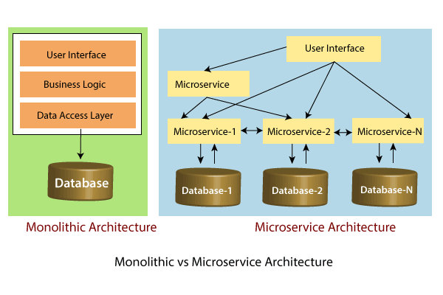

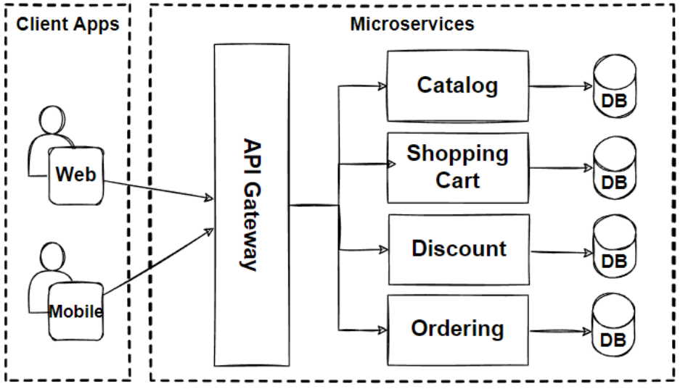

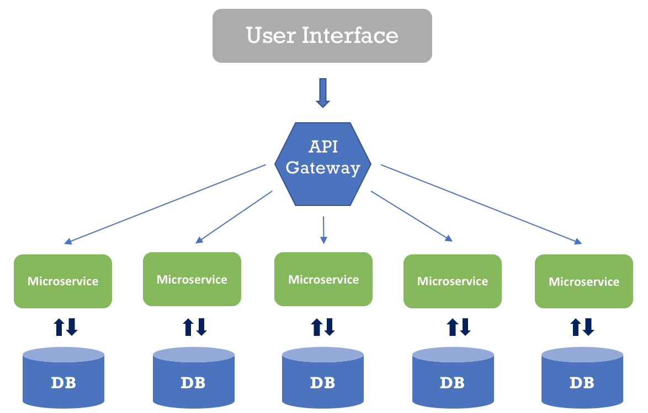

**Example for Monolithic :** 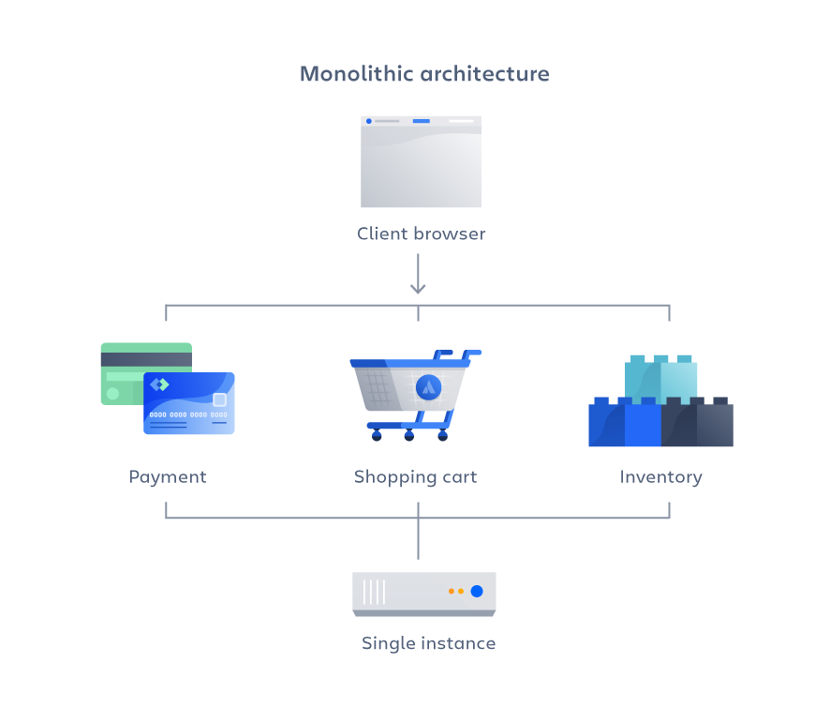

**Example for Microservice:**

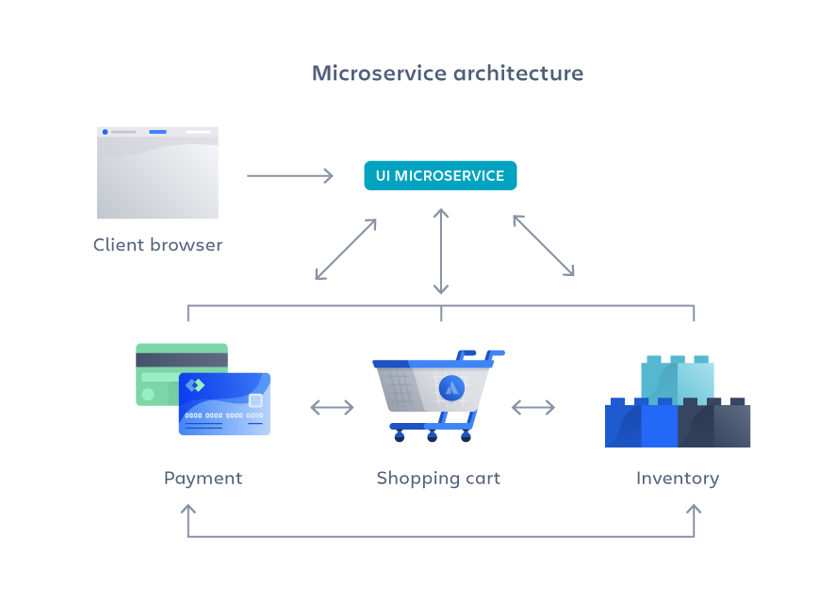

**Coding example flow diagram:**

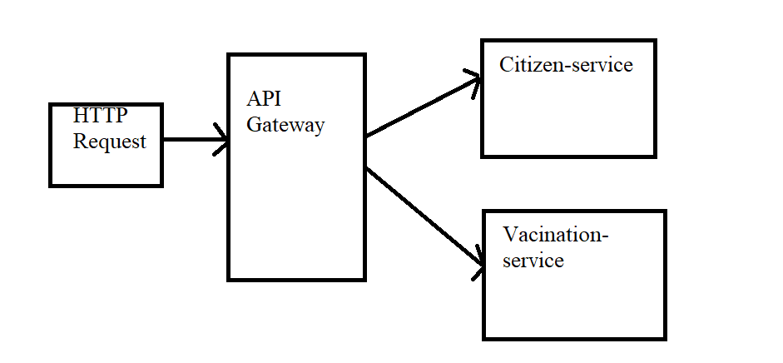

**Advantages of Microservice:**

* Scalability improvements.
* Improved fault isolation
* Program language and technology agnostic
* Simpler to deploy
* Reusability across different areas of business
* Faster time-to-market
* Ability to experiment.
* Improved data security

