**Store Procedure**

A stored procedure is a prepared SQL code that you can save, so the code can be reused over and over again.

So if you have an SQL query that you write over and over again, save it as a stored procedure, and then just call it to execute it.

You can also pass parameters to a stored procedure, so that the stored procedure can act based on the parameter value(s) that is passed.

Stored Procedure Syntax

CREATE PROCEDURE procedure_name  
AS  
sql_statement  
GO;

### Execute a Stored Procedure

EXEC procedure_name;

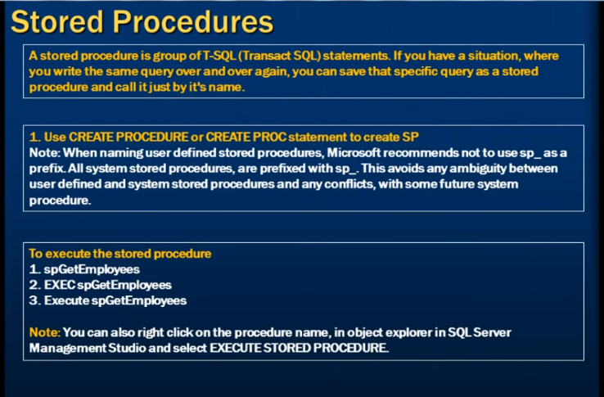

A stored Procedure is a group of T-SQL(Transact SQL)statements.if you have a situation where you write the same query over and over again,you can save that specific query as a stored Procedure and call it just by its name.

**Why we are Going for store Procedure?**

1. Using stored procedures can **help simplify and speed up the execution of SQL queries**.
2. Stored procedures can reduce network traffic between servers and clients, for example. This is a result of the commands being executed as a single batch of code rather than multiple.