**5GMM (5G Mobility Management)**: This is part of the 5G core network responsible for managing mobility functions, including tracking the user's location and handling handovers between cells.

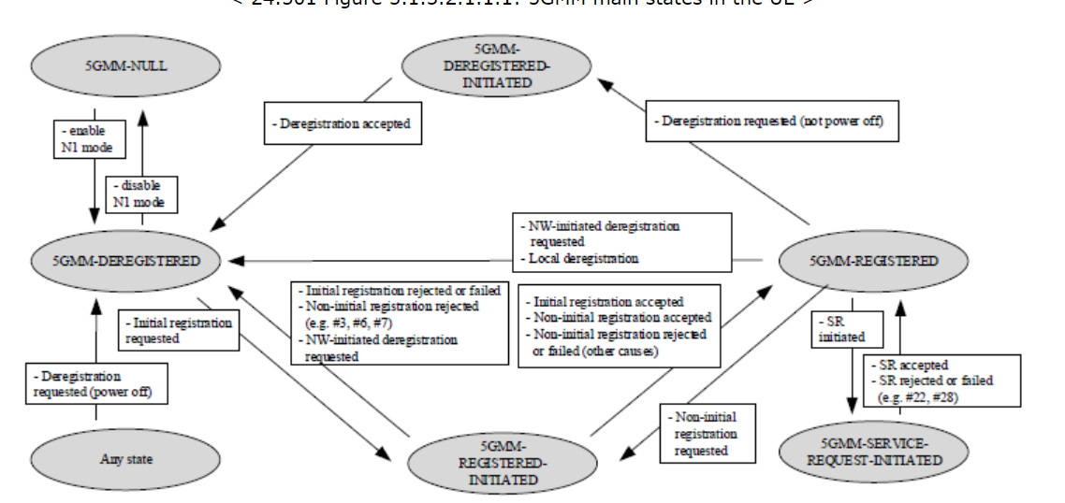

Followings are brief description on each of the states. Understanding the details of each of the status and transition trigger would be helpful for you to troubleshoot various NAS issues from UE log.

* **5GMM-NULL**: This state represents the initial condition when the UE is powered on or reset. In this state, 5GS services are disabled in the UE. No 5GS mobility management function shall be performed in this state. The UE is not registered to any 5G network, and no context is stored in the network for the UE. The UE is not reachable for mobile-terminated services.
* **5GMM-DEREGISTERED**: In this state, the UE is not registered to any 5G network. No 5GMM context has been established and the UE location is unknown to the network and hence it is unreachable by a network. In order to establish a 5GMM context, the UE shall start the initial registration procedure. It is either switched off, out of coverage, or has been deregistered from the network for some reason. The UE is not reachable for mobile-terminated services, and no context is stored in the network for the UE.
* **5GMM-DEREGISTERED-INITIATED**: This state indicates that the UE has initiated the deregistration process but has not yet completed it. The UE is in the process of exchanging messages with the network to complete the deregistration.
* **5GMM-REGISTERED-INITIATED**: In this state, the UE has initiated the registration process but has not yet completed it. The UE is in the process of exchanging messages with the network to complete the registration.
* **5GMM-REGISTERED**: This state indicates that the UE has successfully registered with a 5G network. In this state, the UE can receive mobile-terminated services, and the network maintains context information for the UE. This state implies that the UE has successfully completed the registration process and can now utilize network services.
* **5GMM-SERVICE-REQUEST-INITIATED**: In this state, the UE has initiated a service request to the network to establish a connection. This typically occurs when the UE needs to access specific network services or resources (e.g., to initiate a data session or a voice call). The UE remains in this state until the service request is either granted or rejected by the network.

**5GSM (5G Session Management)**: This handles session management in the 5G core network, dealing with establishing, modifying, and releasing bearers and sessions for data transfer.

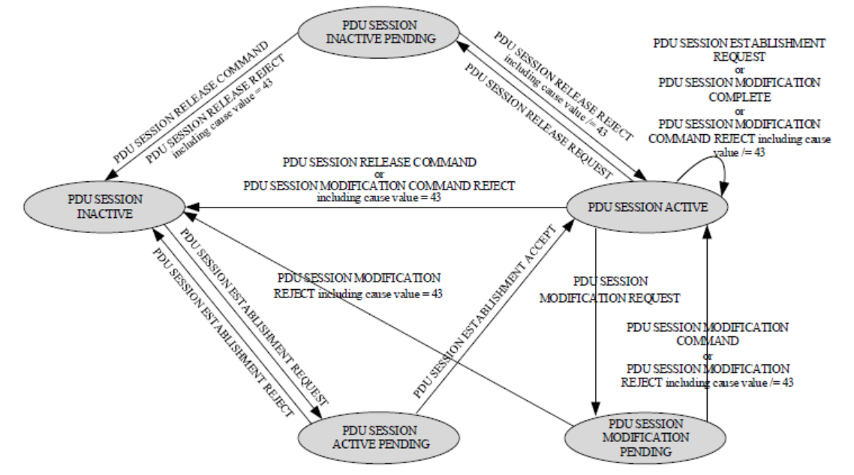

PDU SESSION INACTIVE : This is the state where the PDU session is not active, meaning there's no ongoing data transmission for this session.

Followings are transition to other states:

* To PDU SESSION ACTIVE PENDING: Triggered by "PDU SESSION ESTABLISHMENT REQUEST".

PDU SESSION ACTIVE PENDING : This state indicates that the PDU session is in the process of becoming active.

Followings are transition to other states:

* To PDU SESSION ACTIVE: Triggered by "PDU SESSION ESTABLISHMENT ACCEPT"
* To PDU SESSION INACTIVE: Triggered by "PDU SESSION ESTABLISHMENT REJECT"

PDU SESSION ACTIVE : The PDU session is active and data transmission is possible in this state.

Followings are transition to other states:

* To PDU SESSION INACTIVE: Triggered by "PDU SESSION RELEASE COMMAND".
* To PDU SESSION INACTIVE PENDING: Triggered by "PDU SESSION RELEASE REQUEST".
* To PDU SESSION MODIFICATION PENDING: Triggered by "PDU SESSION MODIFICATION REQUEST"
* Self-looping transition: Triggered by PDU SESSION ESTABLISHMENT REQUEST or PDU SESSION MODIFICATION COMPLETE or "PDU SESSION MODIFICATION REJECT including cause value = 43".

PDU SESSION INACTIVE PENDING : This state indicates that the PDU session is in the process of transitioning to an inactive status.

Followings are transition to other states:

* To PDU SESSION INACTIVE: Triggered by PDU SESSION RELEASE COMMAND or "PDU SESSION RELEASE REJECT including cause value = 43".

**State Transition**: In 5G networks, this refers to changes in the state of a network entity, like the transition of a user's session or mobility state as they move or as network conditions change.

**PDU Session**: The Protocol Data Unit (PDU) session is a logical connection between the user equipment (UE) and the data network, used for transmitting data. It supports different types of services, such as IP and non-IP data services.

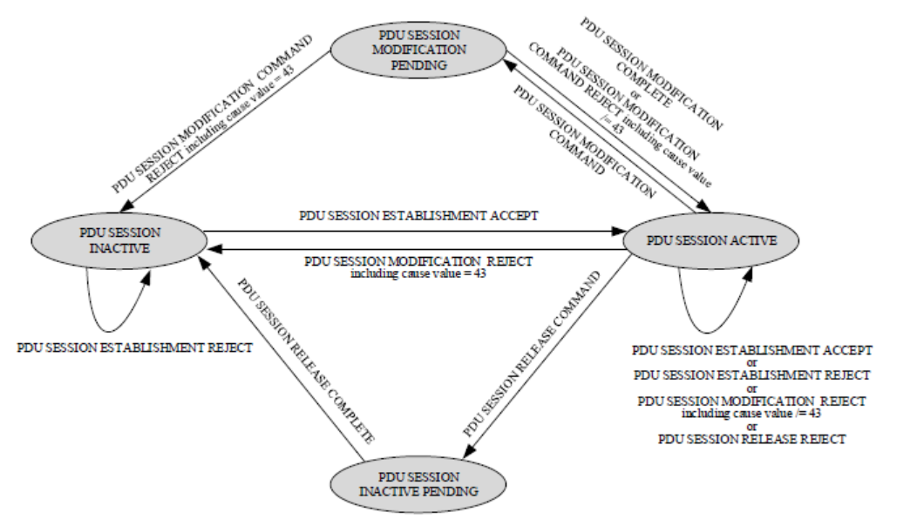

PDU SESSION INACTIVE: This is a state where the PDU session is not currently active, indicating there's no ongoing data transmission for this session.

Followings are transition to other states:

* To PDU SESSION ACTIVE: Triggered by "PDU SESSION ESTABLISHMENT ACCEPT", indicating that the session setup request was successful.
* Self-looping transition: Triggered by "PDU SESSION ESTABLISHMENT REJECT"

PDU SESSION ACTIVE: In this state, the PDU session is active, and data transmission is feasible.

Followings are transition to other states:

* To PDU SESSION INACTIVE: Triggered by "PDU SESSION MODIFICATION REJECT including cause value = 43"
* To PDU SESSION INACTIVE PENDING : Triggered by PDU SESSION RELEASE COMMAND
* To PDU SESSION MODIFICATION PENDING: Triggered by "PDU SESSION MODIFICATION COMMAND", indicating an intent to modify certain session parameters.

PDU SESSION MODIFICATION PENDING: This state signifies that there's an ongoing process to alter the PDU session's parameters or characteristics.

Followings are transition to other states:

* To PDU SESSION INACTIVE: Triggered by "PDU SESSION MODIFICATION COMMAND REJECT including cause value = 43", indicating that the session modification was rejected.
* To PDU SESSION ACTIVE: Triggered by "PDU SESSION MODIFICATION COMPLETE" or "PDU SESSION MODIFICATION COMMAND REJECT including cause value = 43"

PDU SESSION INACTIVE PENDING: This state represents that the PDU session is in transition towards an inactive status.

Followings are transition to other states:

* To PDU SESSION INACTIVE: Triggered by PDU SESSION ESTABLISHMENT REJECT. This can be inferred as a natural progression once all processes leading to inactivity are complete.

**QoS Flow**: Quality of Service (QoS) flows are used to differentiate and prioritize different types of data traffic within a PDU session. Each QoS flow is associated with specific QoS parameters to ensure the required level of service for various applications.

**5QI (5G QoS Identifier)**: This is an identifier used in 5G to define the QoS characteristics for different types of traffic. It helps ensure that services meet their performance requirements.

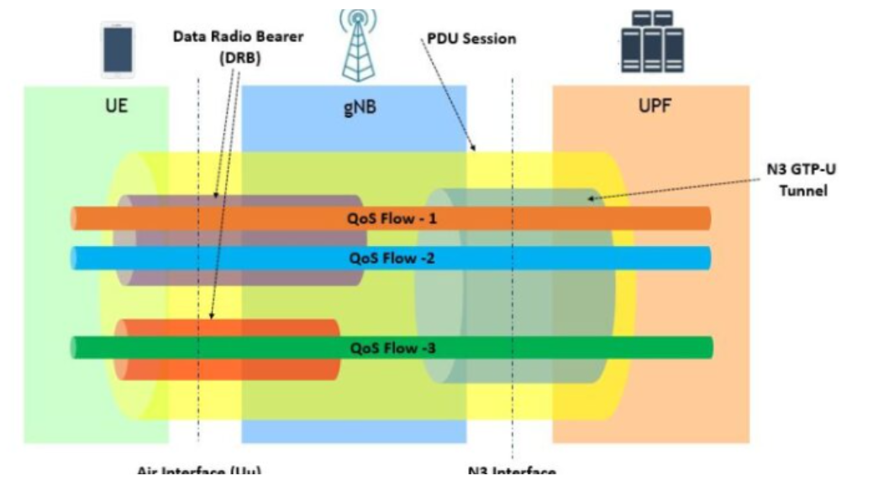

5QI stands for 5G QoS Identifier and it is equivalent to [QCI in LTE](https://www.sharetechnote.com/html/Handbook_LTE_QCI.html). It just has more options and granularities. In addition, there is a new type called Delay Critical GBR which is not in QCI in LTE.

**S-NSSAI (Single Network Slice Selection Assistance Information)**: This information helps the network to select the appropriate network slice for a user's service. Network slicing allows different network slices to be tailored for specific types of services or customers.

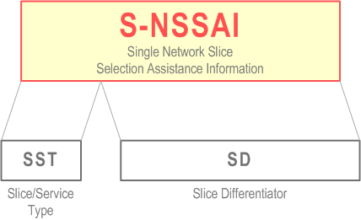

**NRF (Network Repository Function)**: In the 5G core network, the NRF is responsible for maintaining a repository of network functions and their capabilities. It helps with service discovery and management of network functions.

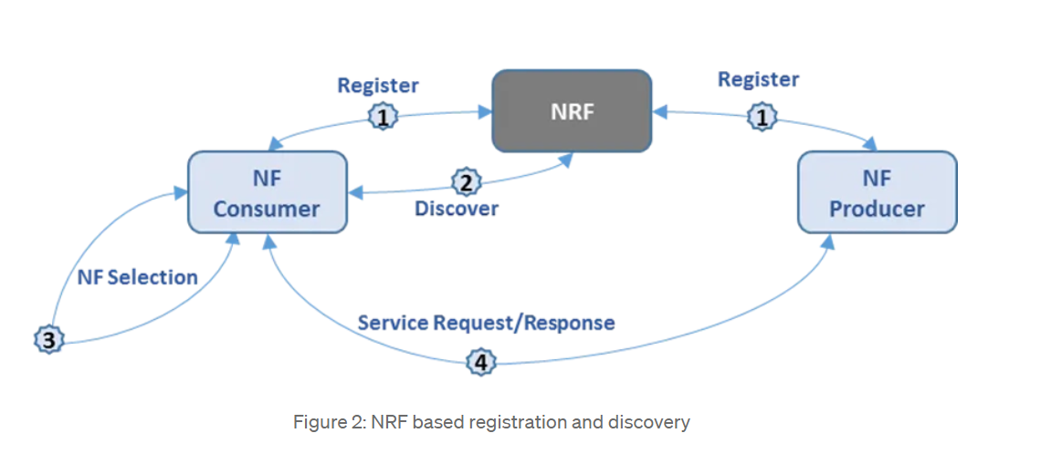

**N1, N2, N8, N22, N26**: These refer to various interfaces in the 5G network:

* **N1**: Interface between the User Equipment (UE) and the Access and Mobility Management Function (AMF).
* **N2**: Interface between the AMF and the User Plane Function (UPF), and also between AMF and the Radio Access Network (RAN).
* **N8**: Interface between the AMF and the Unified Data Management (UDM) function.
* **N22**: Interface between the AMF and the Session Management Function (SMF).
* **N26**: Interface between the AMF and the 4G Mobility Management Entity (MME).

**Tracking Area**: This is a logical area in the network where the user equipment (UE) is currently located. It helps in efficient paging and location updates.

**TAC (Tracking Area Code)**: The TAC is a unique identifier assigned to each tracking area. It helps in identifying the tracking area in which the UE is located.

