Abstract
Introduction
Building a GenAI-powered COTS (commercial off-the-shelf) parts sizing & selection system: architecture, data model, ingestion pipeline, simulation & surrogate modelling, recommendation engine (with trade-offs and alternatives) assuming the parts are mechanical/electrical components (bearings, fasteners, gears, motors, capacitors, etc.) Here's what it does:
- Analyse large datasets
The system looks at data from thousands of components, including their specifications, performance metrics, availability, cost, and supplier information.
- Simulate part performance
It can virtually test how a component will behave in a specific design—for example, whether a motor can handle the required torque, or if a gear can withstand the load.
- Recommend optimal components
It selects the parts that best meet the design requirements while considering constraints like space, weight, material, cost, and sustainability.
- Offer alternatives and highlight trade-offs
If the optimal part is expensive or hard to source, the system can suggest alternatives, showing trade-offs (e.g., cheaper but lower lifespan, heavier but stronger, etc.) so engineers can make informed decisions.
Real-life example
Scenario: Designing a robotic arm for industrial automation.
- Design requirements:
  - Must lift 10 kg with a reach of 1 meter
  - Operate for 8 hours continuously
  - Fit in a compact workspace
  - Maintain a cost below $2,000
- COTS components: Motors, gears, fasteners, bearings, sensors, capacitors for electronics.
GenAI-powered system
- Motor selection: It checks motors that can handle the load and torque requirements, evaluates their size, efficiency, cost, and availability.
- Gear selection: Suggests gears that can transmit the torque, fit in the available space, and last for the required cycles.
- Fasteners & bearings: Ensures the components can physically hold the structure together without overloading any part.
- Alternatives: If the best motor is backordered, it shows a slightly smaller motor but with faster delivery and slightly higher speed, highlighting the trade-offs.
- Sustainability: Flags components made from recycled materials or with lower energy consumption.

Problem statement
Modern engineering design across industries—such as robotics, aerospace, automotive, and electronics—relies heavily on Commercial Off-The-Shelf (COTS) components for faster development and reduced cost. However, the manual process of selecting and sizing these components is tedious, time-consuming, and prone to human error.
Engineers often need to compare hundreds or thousands of parts from multiple suppliers, analyse their specifications, evaluate compatibility, and check availability—all while balancing performance, cost, and sustainability. This becomes even more difficult as product complexity increases and market timelines shrink.
Furthermore, the growing emphasis on sustainable design, cost optimization, and supply chain resilience demands smarter and data-driven decision-making tools. Traditional CAD tools or static databases cannot adapt to rapidly changing data such as new components, pricing, or performance metrics.
This challenge motivates the development of a Generative AI-powered system that can learn from vast engineering datasets, predict optimal part performance, and automatically recommend the most suitable COTS components based on design requirements. The system aims to act as an intelligent design assistant, helping engineers focus more on innovation and less on repetitive manual selection work.
Objectives
Automatically recommend optimal COTS components given design parameters + application constraints, simulate expected performance (or use surrogate models), and surface alternatives and trade-offs (cost, availability, sustainability, size, material, reliability).
Methodology
- Frontend: Web app/dashboard for engineers — part search, upload spec, see recommendations, compare alternatives, export BOM.
- Backend API: Node.js+Express serving search, retrieval, recommendations, simulations.
- Data Layer:
- Part catalog DB (canonical part records from suppliers + normalized fields).
- PostgreSQL
- Supplier/availability & price feed.
- Historical usage & field-failure data.
- Simulation & test-result DB.
- Ingestion & ETL: Connectors for supplier APIs, CSV upload, web scrapers, CAD/PDF parsers, normalizer.
- Vector DB / Semantic Search: For unstructured spec sheets, datasheets, product pages.
- GenAI Layer:
- LLM-based natural language interface (ask questions, explain trade-offs).
- Embeddings + retrieval for specs.
- Recommendation engine (multi-criteria scoring + ML ranking).
- Simulation Layer:
- Integration with FEA / thermal / electrical simulation tools OR surrogate ML models trained on simulation outputs.
- Explainability & Trade-off Generator: SHAP/feature importance, sensitivity analysis, Pareto front visualization.
- Orchestration & Monitoring: Airflow/Kubeflow for workflows, Prometheus/ELK for monitoring.

Block Diagram

Frontend (React + TypeScript + Tailwind)
File | Purpose
App.tsx | Main React component; handles search and CSV upload; stores recommendations in state.
components/SearchBar.tsx | Search input component.
components/UploadSpecs.tsx | CSV upload component.
components/RecommendationsTable.tsx | Displays the table with recommendation results, including score, predicted stress, verification status.
index.css | Tailwind CSS styles.
vite.config.ts | Vite configuration.
package. json | Frontend dependencies.

Backend (Node.js + Express)
File | Purpose
server.js (or server.ts) | Main backend file; defines endpoints such as /api/recommend. Integrates simulation service, calculates scores, returns JSON to frontend.
package. json | Node.js dependencies (express, cors, etc.).
dummy_catalog. json (optional) | Sample parts catalog for testing.

Simulation Service (Python + FastAPI)
File | Purpose
sim_service.py | FastAPI app with /simulate endpoint. Receives part IDs, load/temperature, returns predicted stress, uncertainty, verification status.
train_surrogate.py | Contains the logic for surrogate modelling (dummy or ML). Generates predicted stresses per part.
requirements.txt | Python dependencies (fast Api, uvicorn, NumPy, optionally lightgbm).

Backend/vector_db
File | Purpose
embeddings.py | Converts text (datasheet text, specs, descriptions) → numerical embeddings using a model (e.g., OpenAI, HuggingFace).
vector_store.py | Connects to Milvus, Weaviate, or Pinecone — stores and queries those embeddings.

Integration flow
Folder structure
frontend/
|--components/
| |--RecommendationsTable.tsx
| |--SearchBar.tsx
| |--UploadSpecs.tsx
| |--App.tsx
| |--App.css
| |--Index.css
| |--main.tsx
| |--index.html
| |--Readme.md
backend/
├─ db/
│ ├─ schema.sql # PostgreSQL schema for parts, suppliers, simulation results
│ └─ queries.py # DB helper functions
├─ etl/
│ ├─ supplier_api.py # Fetch parts from supplier APIs
│ ├─ datasheet_parser.py # Extract text/tables from PDFs
│ ├─ cad_parser.py # Extract envelope from STEP/IGES
│ └─ etl_runner.py # Run ETL pipeline
├─ vector_db/
│ ├─ embeddings.py # Generate embeddings from text
│ └─ vector_store.py # Insert/query vector DB (Milvus/Weaviate/Pinecone)
├─ genai/
│ ├─ llm_service.py # Parse natural language requirements
│ └─ tradeoff_service.py # Generate trade-off explanations using LLM
├─ simulation_service/
│ ├─ sim_service.py # Expose simulation API
│ └─ train_surrogate.py # Train surrogate ML model
└─ server.js # Main backend API
How it works
- How Frontend works
- Search: Type a keyword (e.g., "bearing") → handleSearch calls backend → backend filters catalog → calls simulation service → returns full part recommendations → table updates automatically.
- Upload CSV: User uploads a BOM → UploadSpecs parses CSV → sends rows to backend → backend computes score + simulation → table updates automatically.
- Table: RecommendationsTable now shows:
  - Part Name
  - Score
  - Predicted Max Stress
  - Uncertainty
  - Verification Status
  - Job ID
2. What the Vector DB Does
Step Description
- A datasheet or spec text is parsed (via etl/datasheet_parser.py).
- Text is embedded into a numeric vector using embeddings.py.
- Embedding is stored in Milvus (via vector_store.py).
- When a user types “bearing 500N aluminium”, the query is embedded the same way.
- Milvus finds the most similar stored vectors → returns best matching parts.

Vector DB like Milvus will store datasheet embeddings for semantic search.
When engineers upload datasheets, specs, or CAD files, you want your system to “understand” them — not just match exact keywords.
This is where semantic search and vector databases come in.
Example:
A user search for
“lightweight aluminium bearing for 500N load”
Traditional keyword search only finds exact words like “bearing” or “aluminium”.
But semantic search can also find:
- “Al alloy bearing”
- “low-weight bearing rated 500 Newtons”
- “industrial lightweight roller bearing”
Because all text is represented as dense vector embeddings that capture meaning, not just words.
3. How PostgreSQL work
Connect this queries.py to your FastAPI backend (server.js or server.py) so your /api/recommend endpoint can fetch real data from PostgreSQL
queries.py
Function | Purpose
get_connection () | Connects to PostgreSQL using environment variables
fetch_all_parts () | Get all parts with joined simulation + supplier info
fetch_parts_by_category(category) | Filter by category like "bearing"
insert_part () | Add new part into DB
insert_simulation_result () | Add simulation data (stress, uncertainty)
update_part_rating () | Update part rating
schema.sql
Table | Purpose
suppliers | Contains metadata about suppliers.
parts | Stores part catalog (core database).
simulation_results | Links each part to simulation outputs (stress, uncertainty).
part_summary view | Combines everything for easy querying.

4.How GenAI layer work
Semantic GenAI recommendation
  - Create a file parts.csv in backend folder
  - Create GenAI recommender (Python file) in backend folder
  - Modify your backend server.py (add the import and endpoint for GenAI search)
  - Now your FastAPI app is connected to the GenAI logic.
  - Run the backend in VS code terminal
  - Test the API http://127.0.0.1:5000/docs
  - Enter {“searchTerm": "bearing stainless steel 500N"}
You should get a JSON response like:
{
"recommendations": [
{"partName": "Bearing A1", "score": 0.95, "material": "Stainless Steel", ...},
{"partName": "Bearing B2", "score": 0.82, ...},
{"partName": "Bearing C3", "score": 0.78, ...}
]
}
This is your semantic GenAI recommendation working

Result
Frontend
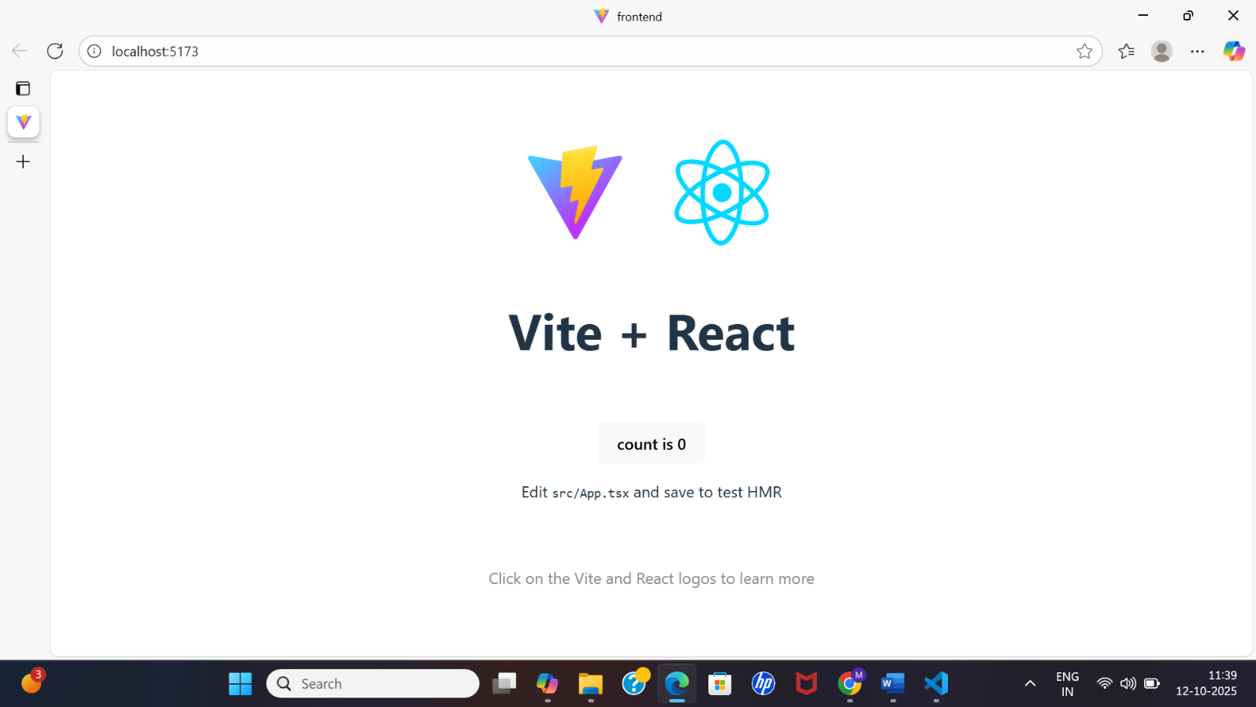
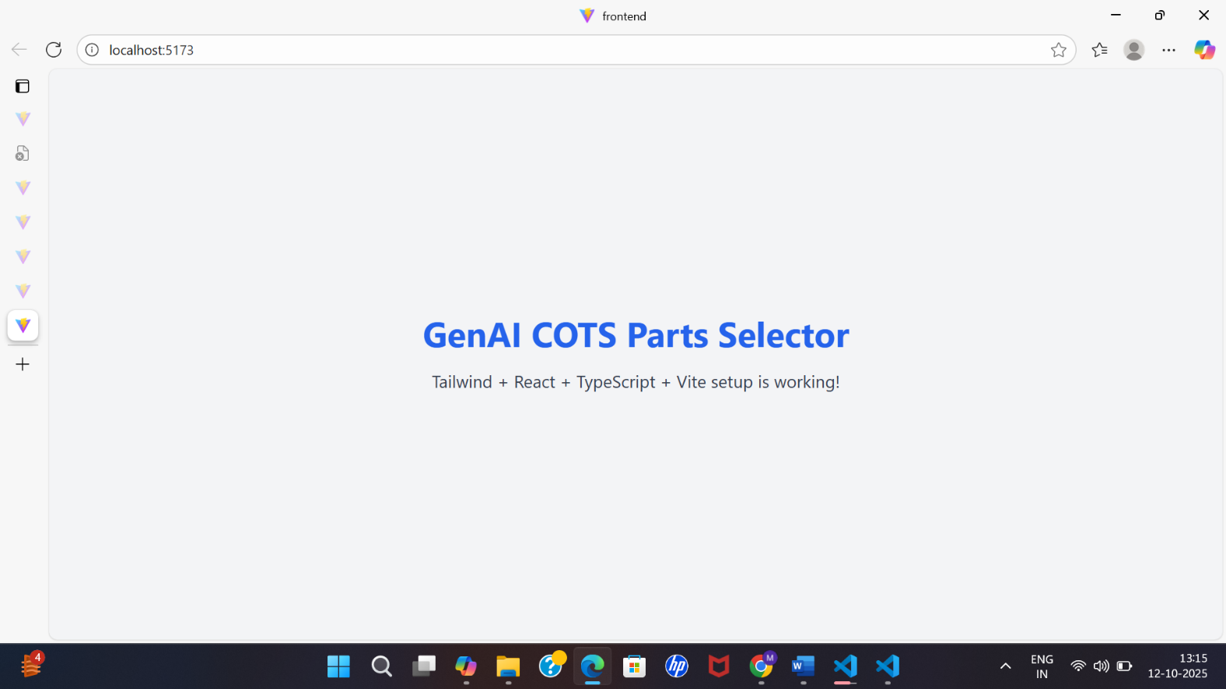
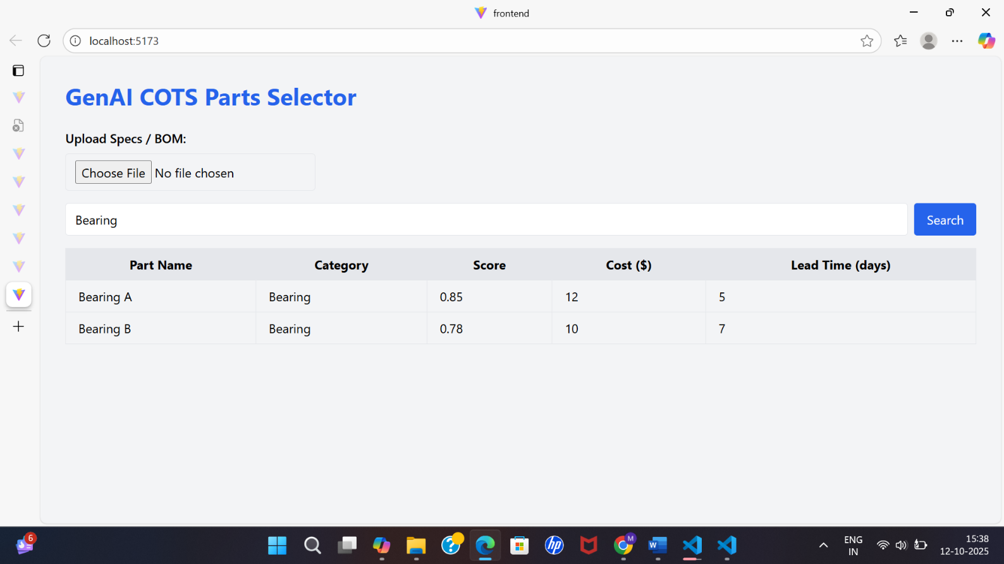
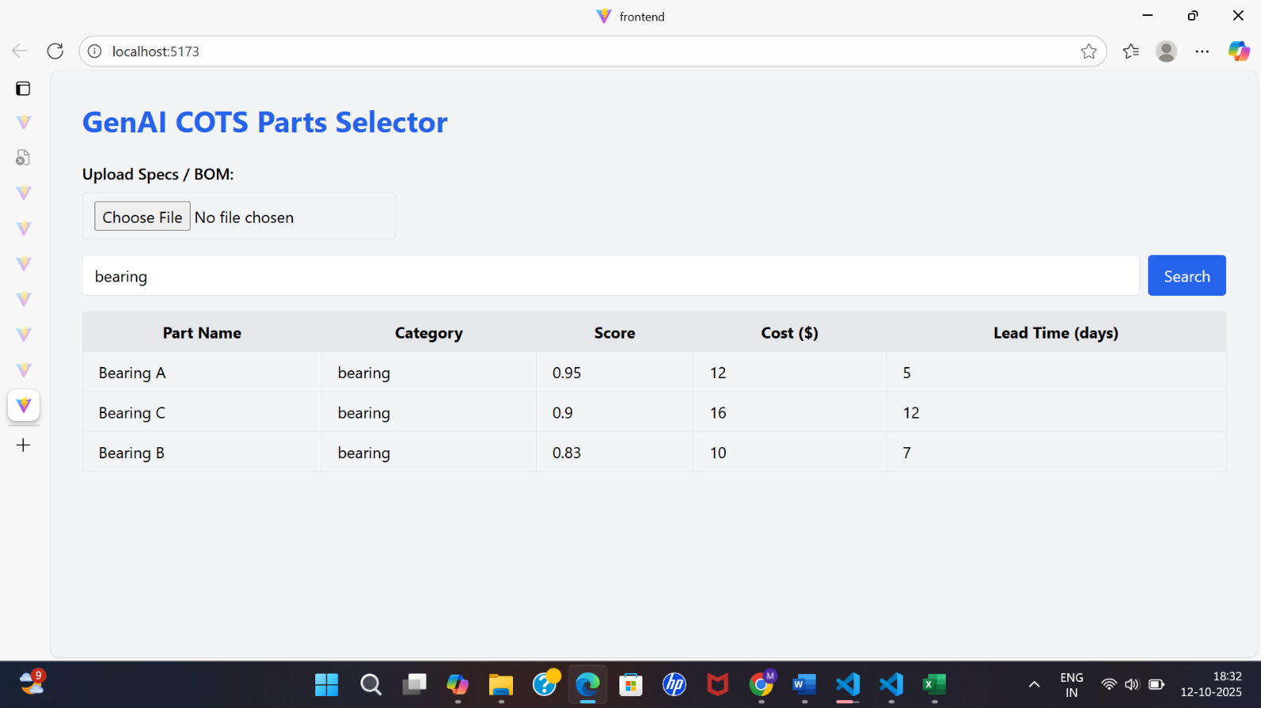
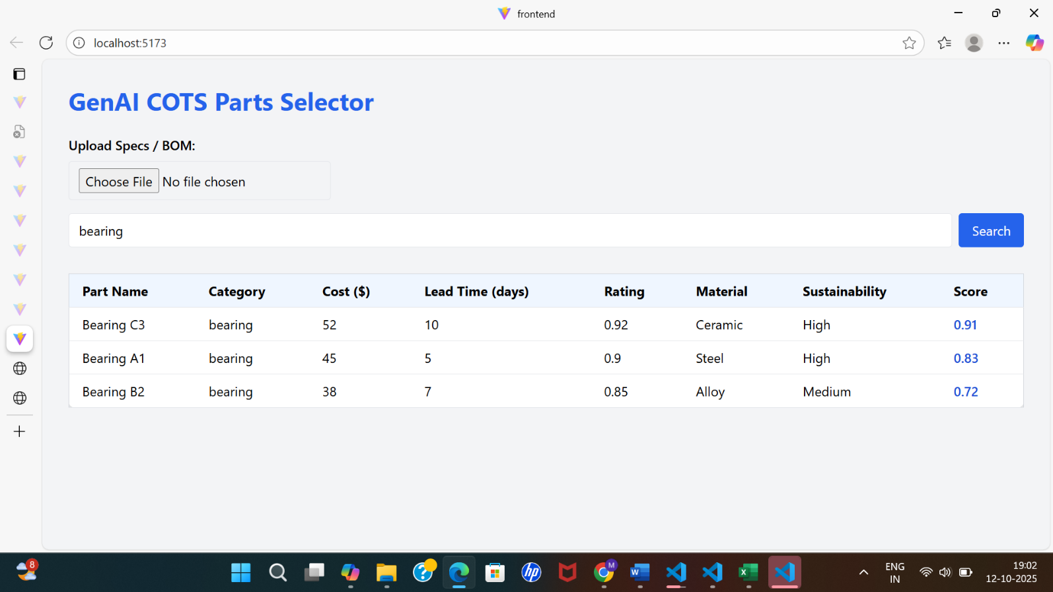
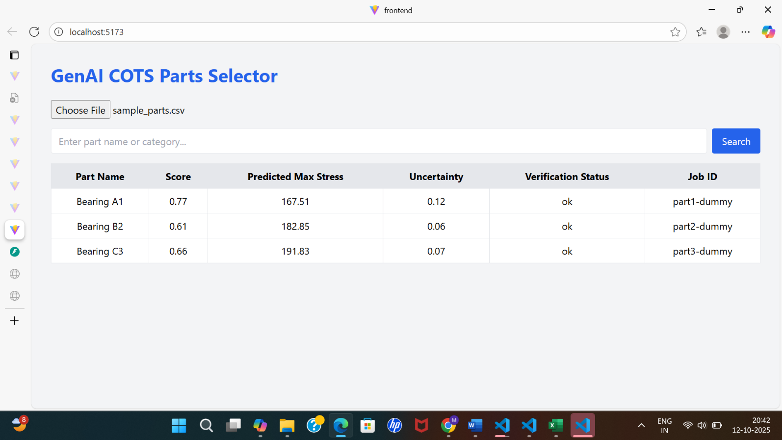

Backend
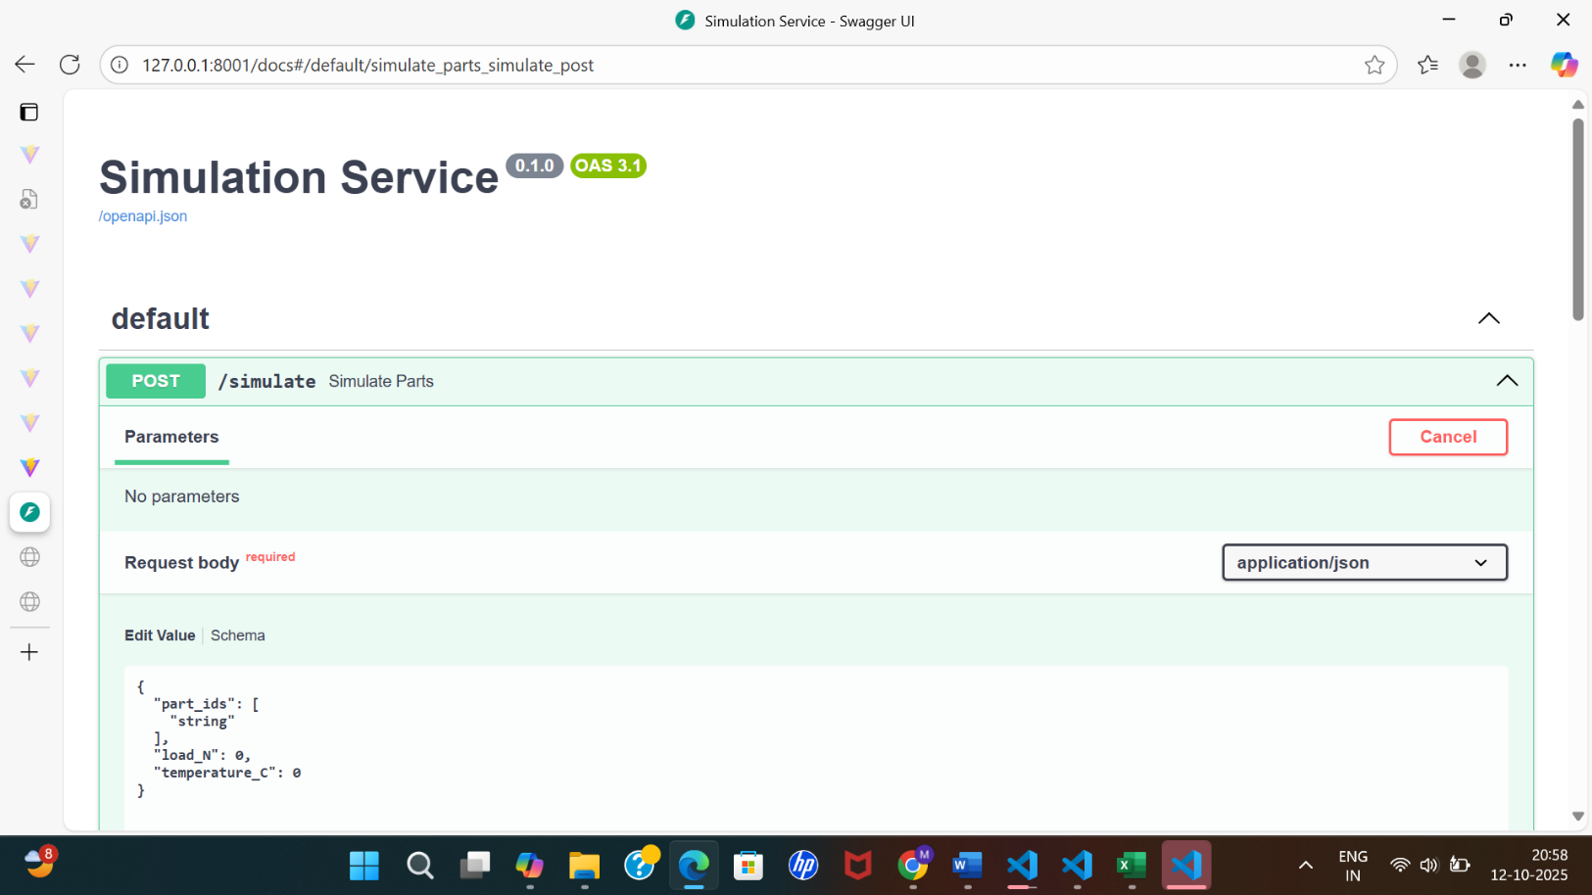
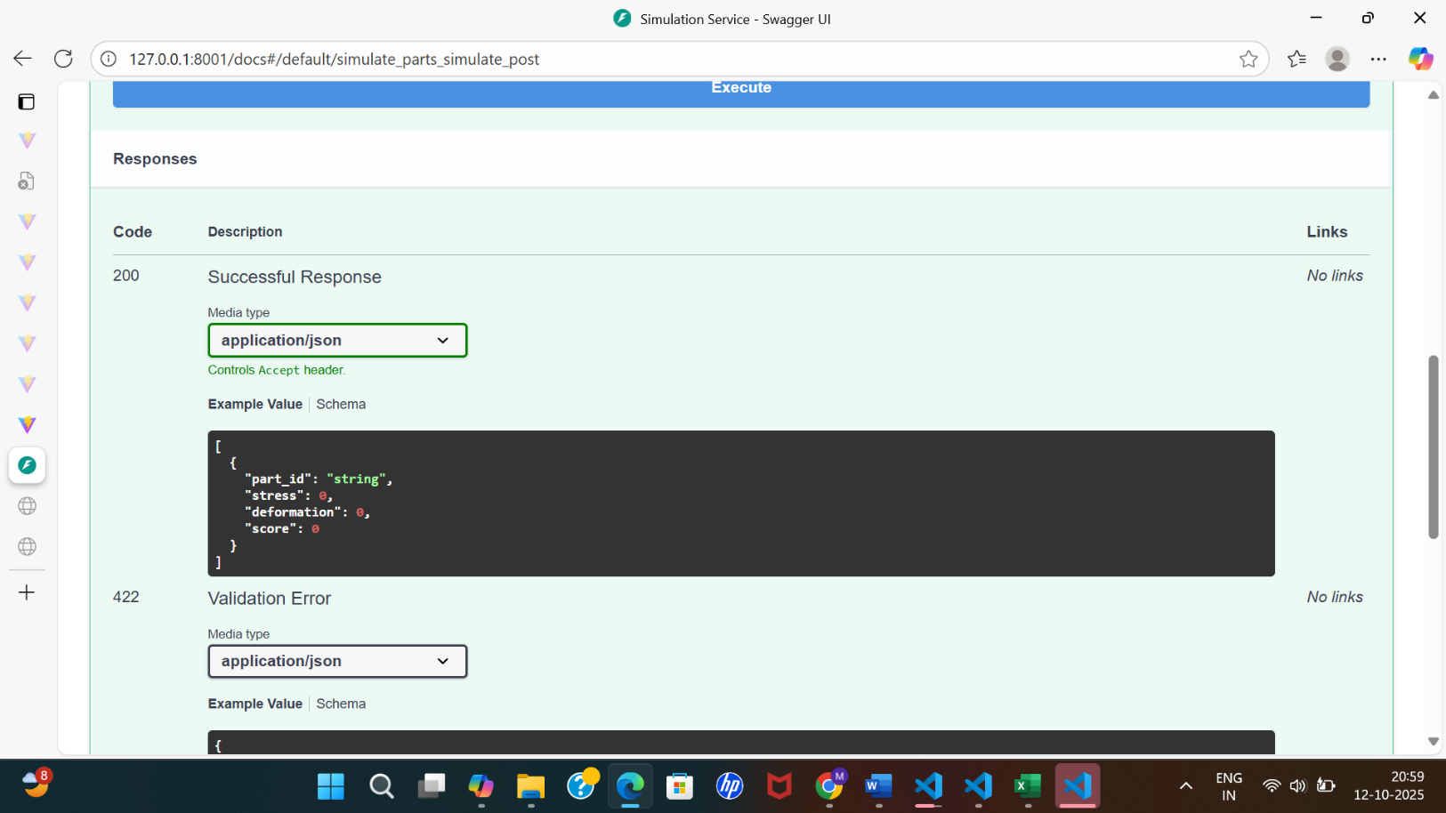
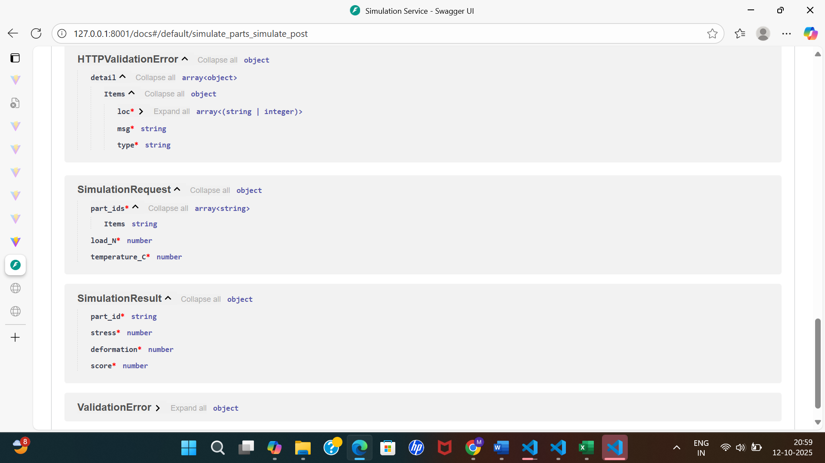
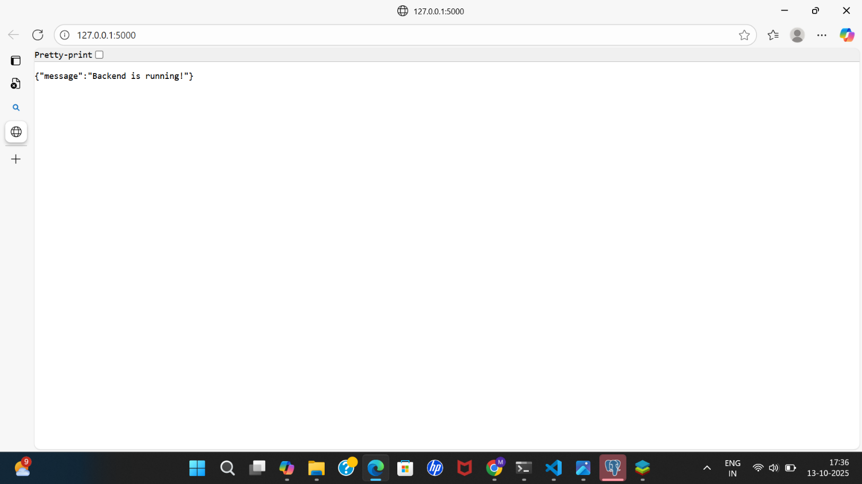
Data Layer
PostgreSQL
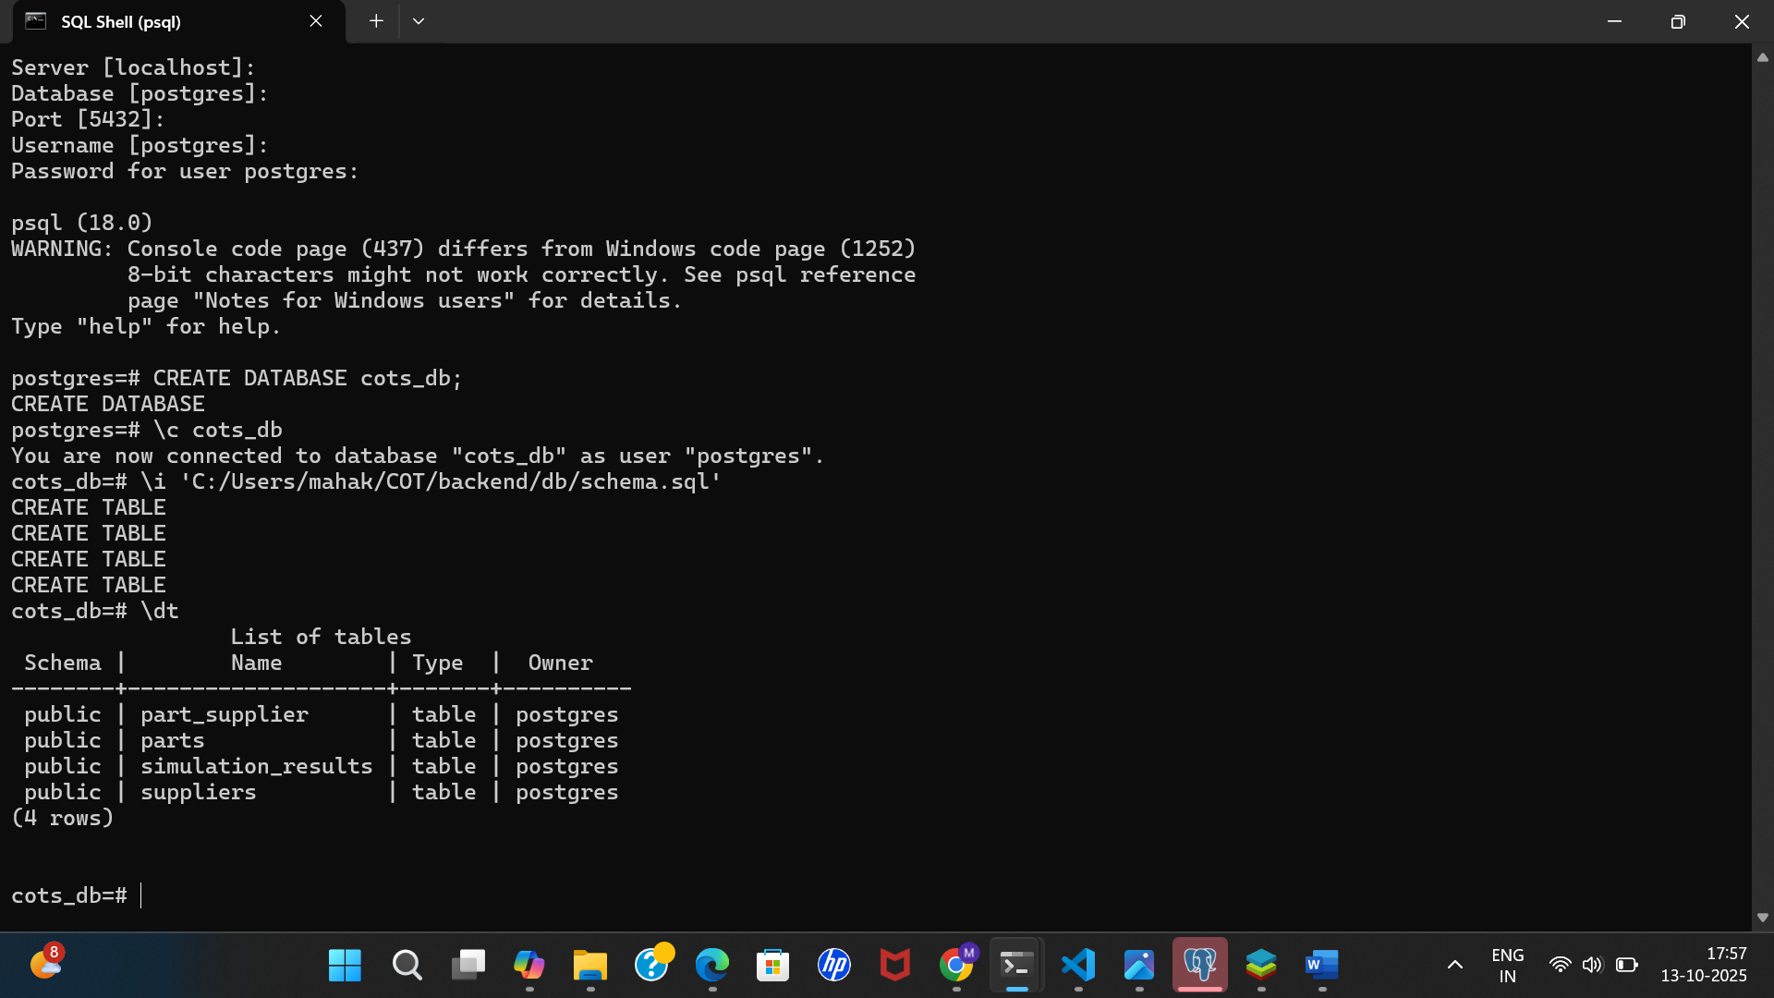

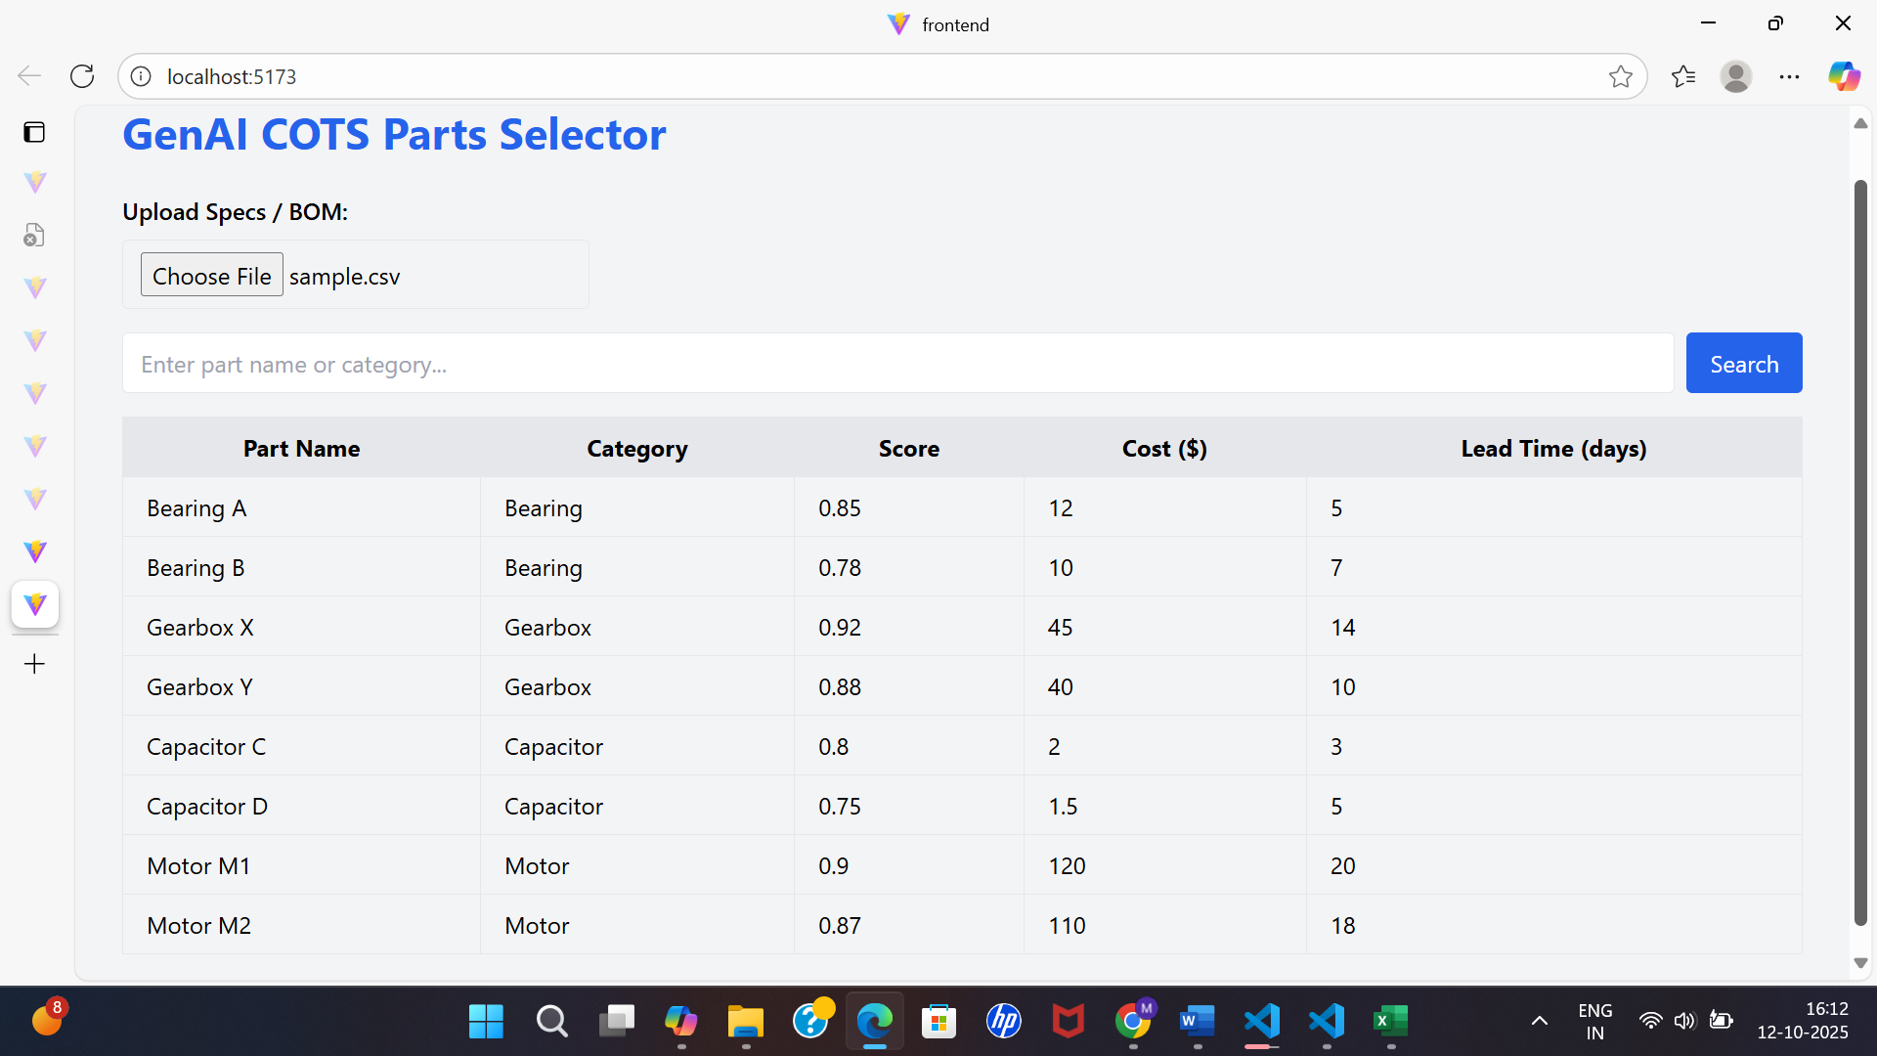

VS code
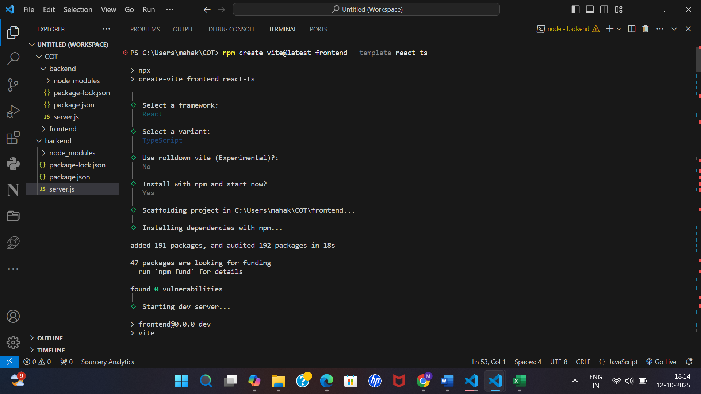
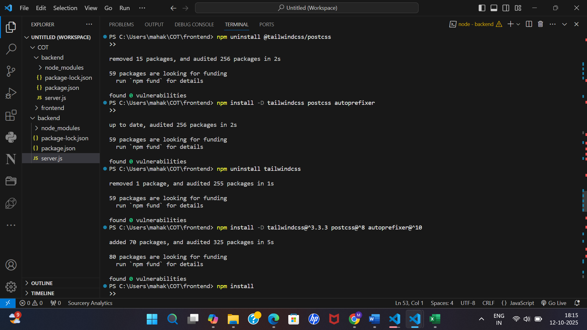
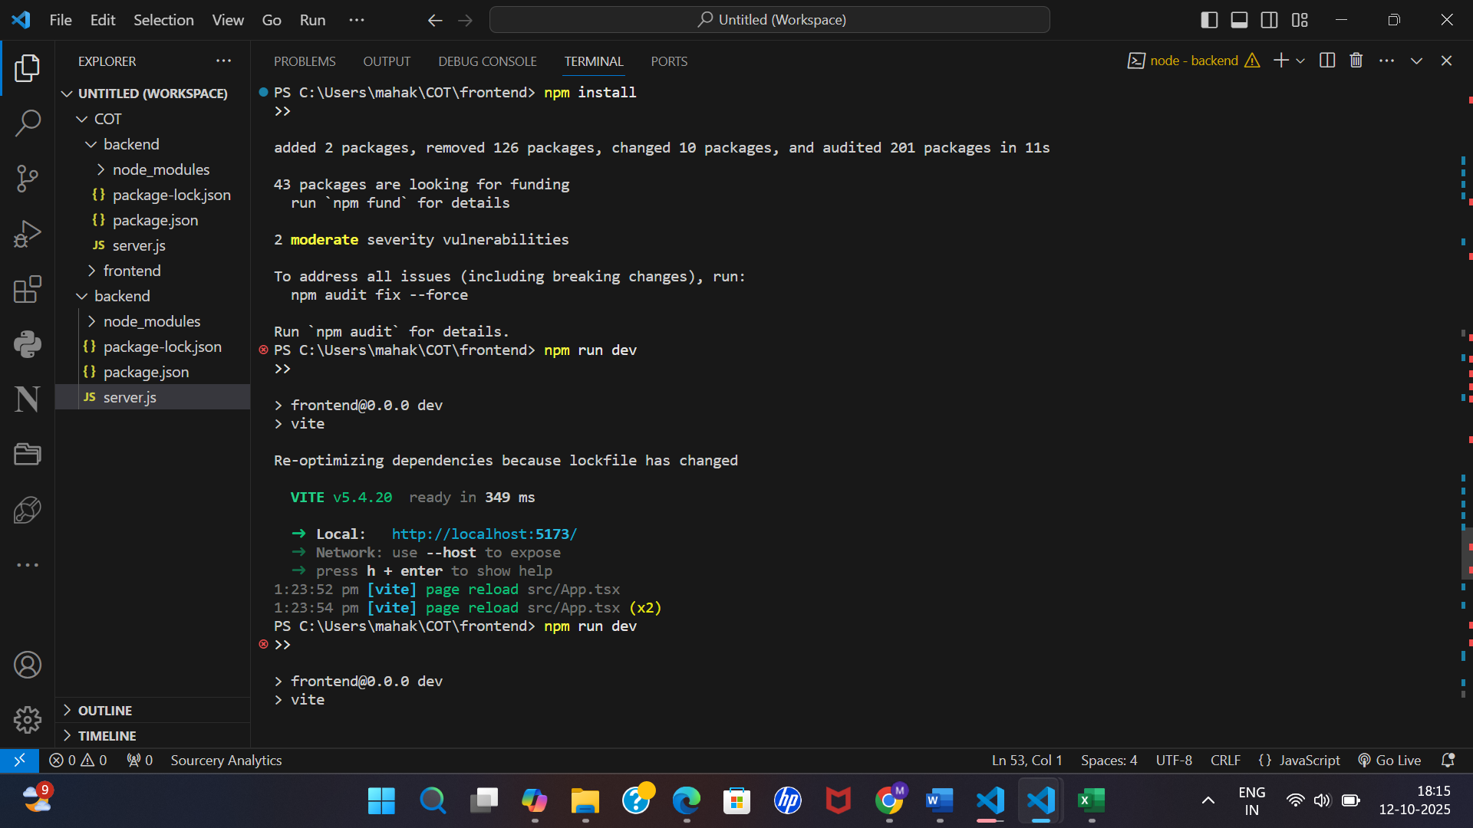
GenAI layer
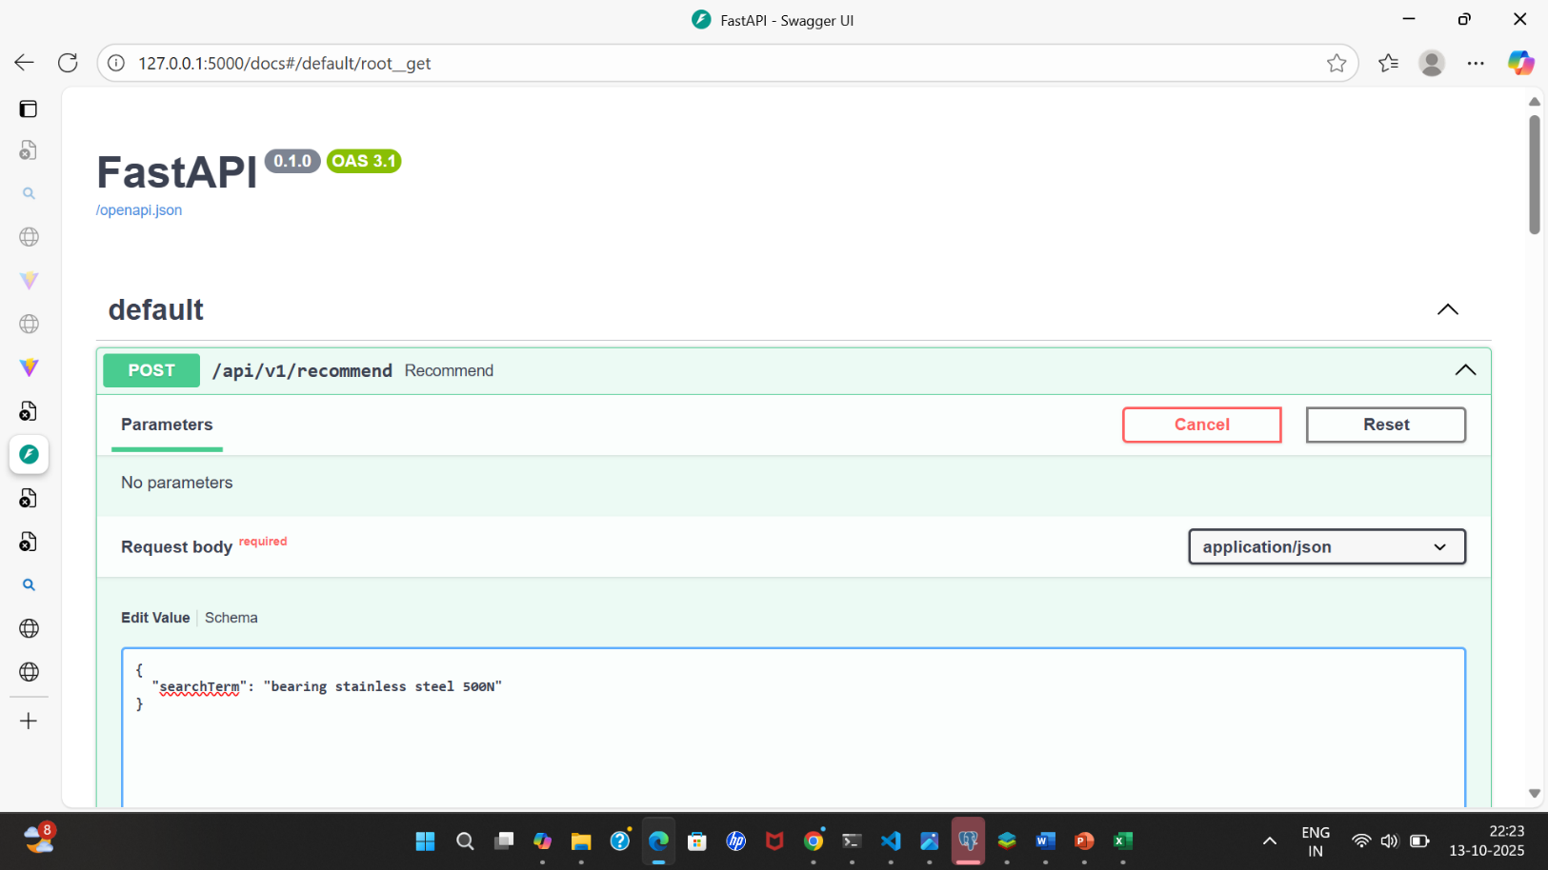
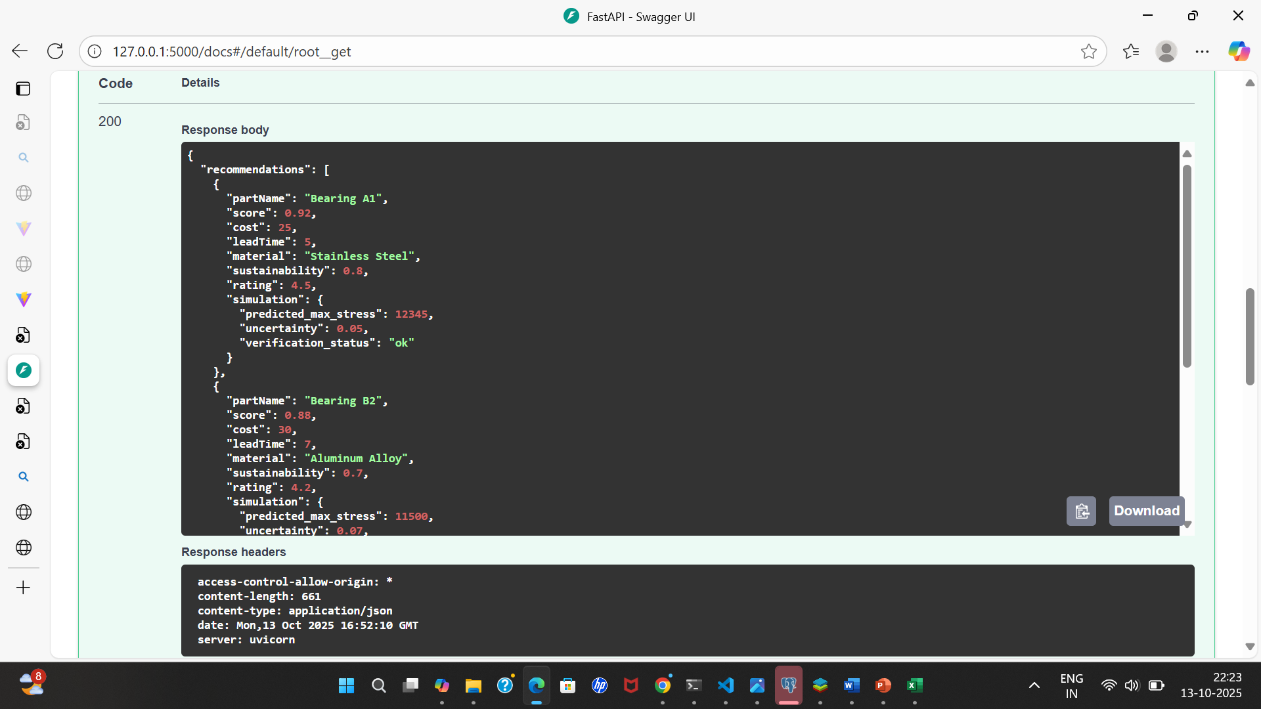
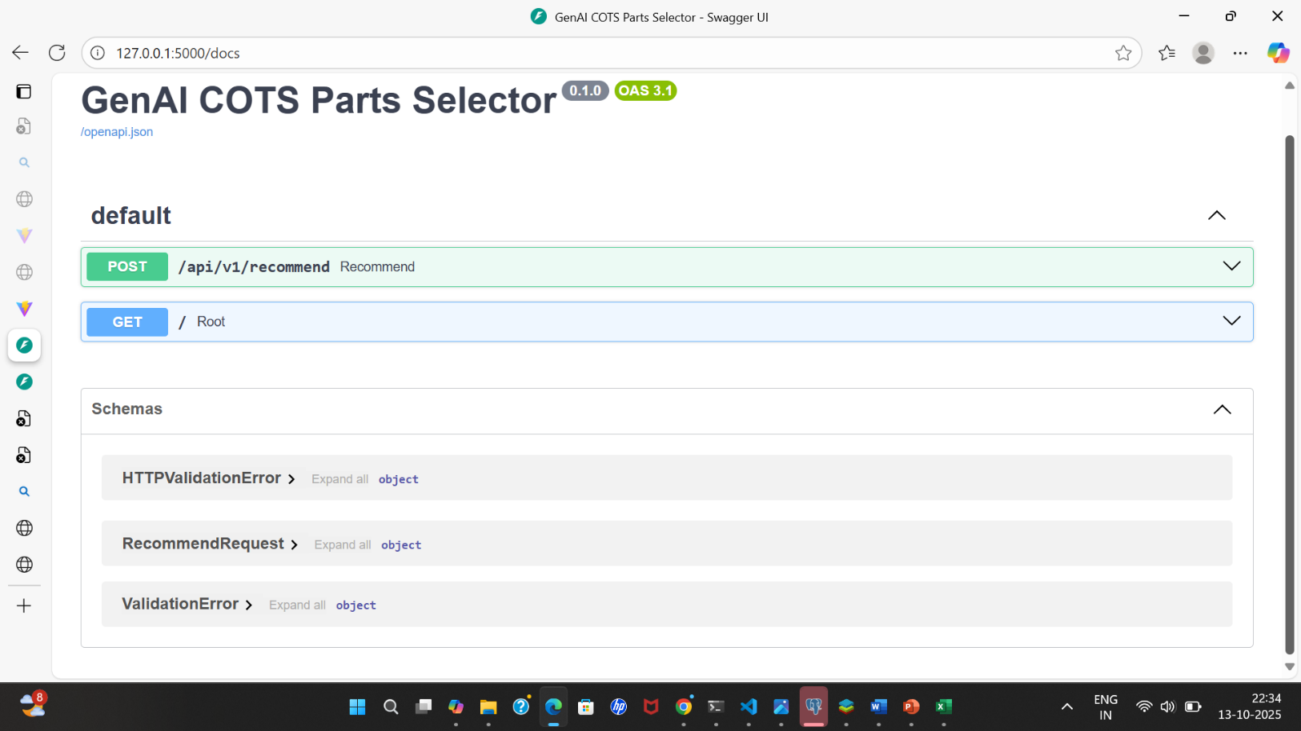
Conclusion
This research is driven by the need to make engineering smarter, faster, and more sustainable using the power of Generative AI to make better design decisions and accelerate innovation in real-world hardware development.
- Engineers save weeks of manual searching and testing.
- The final design is optimized for performance, cost, and practicality.
- Decisions are supported with data and trade-off analysis.
GitHub link
https://github.com/MahakLal/GenAI_COTS_parts_selection

