PROJECT FILE

**Subject: Database Management Systems LAB Course Code: 20CP208P**



### Submitted By: Submitted To:

**Richee Chabhadiya [22BCP236] Dr. Nandni Modi**

**Mahak Lodha [22BCP218] Department of CSE**

## DEPARTMENT OF COMPUTER SCIENCE & ENGINEERING SCHOOL OF TECHNOLOGY

**PANDIT DEENDAYAL ENERGY UNIVERSITY, GANDHINAGAR**

# INDEX

|  |  |  |
| --- | --- | --- |
| Sr. No. | Topic | Page No. |
| **1** | Cover Page | 1 |
| **2** | Introduction | 3 |
| **3** | Problem Statement | 4 |
| **4** | ER Diagram | 5 |
| **5** | Relational Schema | 5 |
| **6** | Code | 6 |
| **7** | Output | 19 |
| **8** | Normalization | 27 |
| **9** | Queries & Functionalities | 30 |
| **10** | Application Features | 31 |
| **11** | Conclusion | 32 |

**INTRODUCTION**

## What is DBMS?

A Database Management System (DBMS) is software that enables users to create, maintain, and manipulate databases. A database is a collection of interrelated data stored in a systematic way, and a DBMS is used to store, organize, retrieve, and manage this data.

## Some advantages of using a DBMS include:

* Improved data sharing: A DBMS allows multiple users to access and share data, which eliminates the need to create and maintain multiple copies of the same data.
* Data security and privacy: A DBMS provides security measures to protect sensitive data from unauthorized access or modification. Access to data can also be controlledbased on user roles and privileges.
* Efficient data access and retrieval: A DBMS allows users to retrieve data quickly andefficiently using SQL queries, and indexes can be created to speed up data access.
* Data integrity and consistency: A DBMS ensures that data is accurate and consistentby enforcing data integrity constraints and providing features such as transaction management.
* Scalability: A DBMS can handle large amounts of data and can be scaled up or downto meet changing business needs.
* Ease of Use: MySQL is known for its user-friendly interface and ease of installation and configuration.
* Scalability: MySQL can handle large datasets and can be scaled up to support high-volume websites and applications.
* Performance: MySQL is optimized for speed and efficiency, making it suitable for demanding applications.
* Security: MySQL offers robust security features, including encryption, access control, and authentication mechanisms

Overall, using a DBMS helps to ensure that data is organized, accessible, and secure, which is essential for many businesses and organizations.

# HOSPITAL MANAGEMENT DATABASE

### Problem Statement:

A hospital requires a comprehensive database management system to efficiently handle its operations, including patient information, medical records, appointments, treatments, prescriptions, and staff details. The database should be capable of managing various aspects of hospital management, such as patient admissions, diagnoses, surgeries, medications, and billing.

### Overview:

The hospital management database is a robust solution designed to streamline the operations of a healthcare facility. It encompasses a relational database model to organize and manage data related to patients, medical staff, appointments, treatments, prescriptions, medical procedures, and administrative tasks. The database includes multiple tables interconnected through foreign keys to establish relationships and ensure data integrity.

The hospital management database offers flexibility and scalability to accommodate the diverse needs of different medical specialties and departments within the hospital. It provides a centralized platform for managing patient care, resource allocation, and administrative tasks, thereby enhancing operational efficiency and patient satisfaction.

### Objectives:

1. To store and manage comprehensive patient information, including personal details, medical history, insurance information, and contact details.
2. To facilitate the scheduling and management of patient appointments, including appointment dates, times, and assigned healthcare providers.
3. To maintain accurate records of medical treatments, diagnoses, procedures, and medications prescribed to patients.
4. To manage hospital admissions, discharges, and transfers, along with corresponding medical records and billing information.
5. To track medical staff details, including their qualifications, roles, schedules, and contact information.
6. To handle inventory management for medical supplies, equipment, and pharmaceuticals, ensuring timely replenishment and usage tracking.
7. To generate reports and analytics for monitoring hospital performance, patient outcomes, resource utilization, and financial metrics.
8. To support seamless integration with external systems, such as electronic health records (EHR), laboratory information systems (LIS), and billing systems, for data exchange and interoperability.

The hospital management database serves as a comprehensive solution to optimize healthcare delivery, streamline administrative processes, improve patient care quality, and enhance overall operational efficiency within the hospital environment.

# ER theory

# ER MODEL

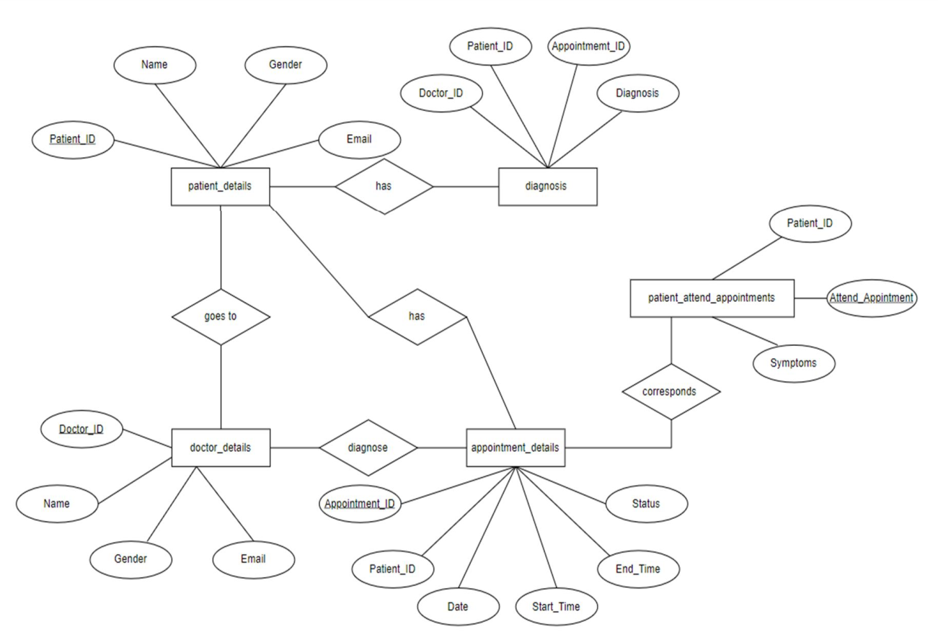

**theory**

**RELATIONAL SCHEMAS**

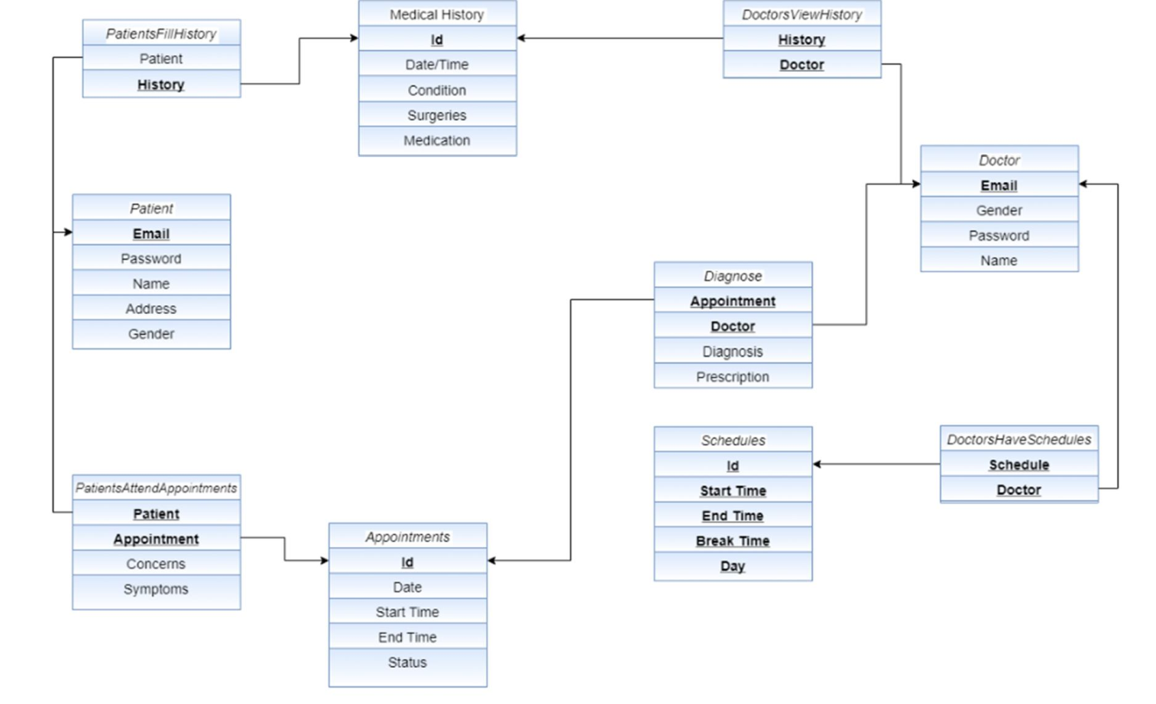

**Keys:**

# CODE

## HTML:

# SQL TABLES

# WEBSITE OVERVIEW

**NORMALISATION**

A large database defined as a single relation may result in data duplication. This repetition of data may result in:

* Making relations very large.
* It isn't easy to maintain and update data as it would involve searching many records in relation.
* Wastage and poor utilization of disk space and resources.
* The likelihood of errors and inconsistencies increases.

So, to handle these problems, we should analyze and decompose the relations with redundant data into smaller, simpler, and well-structured relations that are satisfy desirable properties. Normalization is a process of decomposing the relations into relations with fewer attributes.

### What is Normalization?

Normalization is the process of organizing the data in the database.

Normalization is used to minimize the redundancy from a relation or set of relations. It is also used to eliminate undesirable characteristics like Insertion, Update, and Deletion Anomalies.

Normalization divides the larger table into smaller and links them using relationships. The normal form is used to reduce redundancy from the database table.

### Why do we need Normalization?

The main reason for normalizing the relations is removing these anomalies. Failure to eliminate anomalies leads to data redundancy and can cause data integrity and other problems as the database grows. Normalization consists of a series of guidelines that helps to guide you in creating a good database structure.

### Advantages of Normalization

* Normalization helps to minimize data redundancy.
* Greater overall database organization.
* Data consistency within the database.
* Much more flexible database design.
* Enforces the concept of relational integrity.

### Disadvantages of Normalization

* You cannot start building the database before knowing what the user needs.
* The performance degrades when normalizing the relations to higher normal forms, i.e., 4NF, 5NF.
* It is very time-consuming and difficult to normalize relations of a higher degree.
* Careless decomposition may lead to a bad database design, leading to serious problems.

# First Normal Form (1NF)

If a table has data redundancy and is not properly normalized, then it will be difficult to handle and update the database, without facing data loss. It will also eat up extra memory space and Insertion, Update, and Deletion Anomalies are very frequent if the database is not normalized.

Normalization is the process of minimizing redundancy from a relation or set of relations. Redundancy in relation may cause insertion, deletion, and update anomalies. So, it helps to minimize the redundancy in relations. Normal forms are used to eliminate or reduce redundancy in database tables.

* A relation will be 1NF if it contains an atomic value.
* It states that an attribute of a table cannot hold multiple values. It must hold only single- valued attribute.
* First normal form disallows the multi-valued attribute, composite attribute, and their combinations.

# Second Normal Form (2NF)

* In the 2NF, relational must be in 1NF.
* In the second normal form, all non-key attributes are fully functional dependent on the primary key

# QUERIES & FUNCTIONALITIES

1. Query to retrieve all the details of a hospital, including contact information and address.
2. Query to fetch the details of all bookings made by a specific patient.
3. Query to retrieve the details of all bookings made for a particular medical procedure along with patient information.
4. Query to list all medical procedures along with their corresponding destinations and transportation details.
5. Query to retrieve the list of all bookings made for a specific medical procedure along with payment details.
6. Query to obtain details of all medical procedures, including the total number of bookings for each procedure where the number of bookings exceeds the average number of bookings for all procedures.
7. Query to fetch details of all medical procedures along with patient information for patients who have booked appointments for more than one procedure.
8. Feature to facilitate the addition of a new booking for a patient.
9. Feature to enable the addition of a new patient to the hospital database.
10. Query to list all patients who have made a payment for a specific medical procedure booking.

# APPLICATION FEATURES

The Hospital Management application serves as a comprehensive solution to streamline clinical and administrative processes, enhance patient care delivery, optimize resource utilization, and ensure regulatory compliance within the healthcare organization.

* 1. Patient Management: This feature enables the hospital to efficiently manage patient information, including demographics, medical history, insurance details, and contact information. It allows for easy retrieval and updating of patient records, ensuring accurate and comprehensive documentation.
  2. Appointment Scheduling: The system facilitates the scheduling and management of patient appointments with healthcare providers. It allows staff to schedule appointments based on availability, assign healthcare professionals, and send appointment reminders to patients, thereby optimizing re source utilization and minimizing appointment conflicts.
  3. Medical Records Management: This feature enables the hospital to maintain detailed records of patient diagnoses, treatments, procedures, and medications. It ensures the secure storage and retrieval of medical data, supporting continuity of care and clinical decision-making.
  4. Admissions and Discharges: The system manages the admission, discharge, and transfer processes for patients, along with associated administrative tasks such as bed allocation, room assignment, and discharge planning. It streamlines the admission workflow, enhances patient flow management, and facilitates seamless transitions of care.
  5. Staff Management: This feature allows the hospital to manage staff information, including qualifications, roles, schedules, and contact details. It supports workforce planning, scheduling, and resource allocation, ensuring adequate staffing levels and efficient staff deployment across various departments and shifts.
  6. Inventory Control: The system enables the hospital to monitor and control inventory levels of medical supplies, equipment, and pharmaceuticals. It tracks inventory usage, facilitates procurement processes, and alerts staff when stock levels are low, ensuring timely replenishment and minimizing stockouts.
  7. Billing and Financial Management: This feature manages patient billing, invoicing, and payment processing, including insurance claims and reimbursement. It generates accurate billing statements, tracks payment transactions, and provides financial reports to support revenue cycle management and financial analysis.
  8. Reporting and Analytics: The system generates various reports and analytics to monitor hospital performance, patient outcomes, resource utilization, and financial metrics. It provides insights into key performance indicators (KPIs) and trends.

# CONCLUSION

In conclusion, the implementation of a Database Management System (DBMS) is indispensable for effective data management in today's data-centric environment. Just as demonstrated in the case of the travel agency database, a DBMS serves as a cornerstone for managing diverse data types within a specific industry or application.

The hospital management database, similarly, embodies the critical role of a DBMS in healthcare settings. It provides a robust platform for handling a myriad of data related to patient care, administrative tasks, and financial operations. By leveraging a DBMS, hospitals can ensure seamless storage, retrieval, and management of patient records, appointments, treatments, staff information, and financial transactions.

Moreover, the benefits offered by a DBMS extend beyond efficient data handling. Features such as data integrity, concurrency control, backup and recovery mechanisms, and robust security protocols safeguard the integrity and confidentiality of sensitive healthcare information.

In essence, the hospital management database epitomizes the transformative power of a DBMS in optimizing healthcare delivery, enhancing patient outcomes, and fostering operational excellence within healthcare organizations. It underscores the significance of leveraging technological solutions to navigate the complexities of modern healthcare management, ultimately driving improvements in patient care quality, operational efficiency, and organizational performance.