
Software Requirements Specification
for
PALESTINE IN YOUR HAND
Prepared by
Rama Hawash
Maha Khilfeh
Yasmeen Ghazi
An-Najah National University
11-23-2023
Table of Contents
Table of Contents ii
Revision History ii
1. Introduction 1
1.1 Purpose 1
1.2 Product Scope
1.3 Definitions, acronyms, and abbreviations 2
1.4 References 3
1.5 Overview
2. Overall Description 3
2.1 Product Perspective 3
2.2 Product Functions 4
2.2.1 Admin use case………………………………………………………………………………...4
Use case: Accept to be in the website.............................................................................................. 5
Use case: Total accses..........................................................................................................5
2.2.2 Accountant Use Case............................................................................................................... 5
Use case: Track payments ................................................................................................. 6
Use case: Calculate............................................................................................................. 6
2.2.3 User Use Case ......................................................................................................................... 7
Use case: Partial access........................................................................................................7
Use case:Booking …….......................................................................................................... 8
Use case: Pay ....................................................................................................................... 9
Use case: Search................................................................................................................... 10
2.2.4 Visitor Use Cases.................................................................................................................. 11
Use case: View................................................................................................................... 11
2.2.5 Maintenance use case…………………………………………………………………………11
Use case: Maintenance problems……………………………………………………………..12
Use case:Develop and modify………………………………………………………………….12
2.3 User Classes and Characteristics 13
2.4 Operating Environment 14
2.5 Design and Implementation Constraints 15
2.6 Assumptions and Dependencies 15
3. Specific requirements
3.1 External Interface Requirements 16
3.1.1 User Interfaces 16
3.1.2Hardware Interfaces 16
3.1.3Software Interfaces 17
3.1.4Communications Interfaces 18
3.2 Functional requirements 19
3.2.1 Accept to be in the website …………………………………………………………….19
3.2.2 Total accses ……………………………………………………………………………20
3.2.3 Track payments …………………………………………………………………...….21
3.2.4 Calculate……………………………………………………………………………….21
3.2.5 Partial access……………………………………………………………………………22
3.2.6 Booking…………………………………………………………………………………22
3.2.7 Pay ..................................................................................................................................23
3.2.8 Search...............................................................................................................................24
3.2.9 View................................................................................................................................24
3.2.10 Maintenance problems…………………………………………………………………..25
3.2.11 Develop and modify……………………………………………………………..…….26
3.3 Other Nonfunctional Requirements 27
3.3.1Performance Requirements 27
3.3.2Safety Requirements 27
3.3.3Security Requirements 27
3.3.4Software Quality Attributes 28
3.4 Logical data base requirements 29

Revision History
Name | Date | Reason For Changes | Version

List of figures

Figure 1-Admin Use case………………………………………………………………………….….4

Figure 2-Accountant Use case……………………………………………………………………...…. 5

Figure 3- User Use case ……………………………………………………………………………… 7

Figure 4-Maintenance Use case ………………………………………………………………………11

Figure 5- Logical Structure of System…………………………….………………………………….29

Figure 6- Block diagram ……………………………………………………………………………….35

Figure 7- Block diagram (context model) ………………………………………………………………………….36

Figure 8- Use Case diagram………………………………………………………………………………………36

Figure 9-19 -Sequence diagram………………………………………………………………………………….37-45

Figure 20-30-Activity diagram.………………………………………………………………………………...46-52

Figure 31- Class diagram …………………………………………………………………………………………53

Figure 32 -ER diagram………………………………………………………………………………………………54

Figure 33- State diagram…………………………………………………………………………………………...55

Introduction

Purpose
The document is a file containing detailed information or a precise description of something specific, such as a system, process, or concept. The purpose of a document is to clarify the purpose, features, interfaces, constraints, and how the system will respond to external inputs.

The document is aimed at providing a better understanding of the project or system and serves as a tool for communication among stakeholders, whether they are developers or interested parties.

Product Scope
This software system will be a local tourism website within Palestine. The design of this website aims to assist users in touring Palestine to find satisfying tours by saving time and streamlining the search for the best tours.

Specifically, our website provides information on destinations (restaurants, hotels, tours, public places) with customer ratings, aiming to facilitate communication between users and our clients.

The system also includes a database containing a list of users, clients, places, and regular maintenance features.

Definitions, acronyms, and abbreviations
Term | Definition
Admin | The person responsible for managing the platform and its members
Accountant | Who monitors financial matters in the system.
Maintenance | Fix site problems and errors in the event of an error and perform routine maintenance
User | Who wants to take a tour around Palestine for several purposes (entertainment, knowledge, tourism)
Software Requirements Specification | A document that completely describes all of the functions of a proposed system and the constraints under which it must operate. For example, this document.
Data base | Collection of all the information monitored by this system
Stakeholder | Any person with an interest in the project who is not a developer
Visitor | who can visit the site and view the places in general No login required.

1.4 References
IEEE. IEEE Std 830-1998 IEEE Recommended Practice for Software Requirements Specifications. IEEE Computer Society, 1998.

Overview
The following section, termed "Overall Description," within this document, provides a broad outline of the product's functionalities. It delineates the non-formal prerequisites and serves as a foundational framework for the subsequent chapter, which delves into the technical requirements specification.

The third section, known as "Requirements Specification," within this document, is crafted predominantly for developers. It employs technical jargon to elucidate the intricate functionalities of the product.

While both segments encompass a comprehensive depiction of the software product, they cater to distinct audiences, thereby employing disparate linguistic approaches.

Overall Description

Product Perspective

The Product Perspective for the website focusing on internal tourism within Palestine involves presenting various locations such as hotels, restaurants, public spots, and guided tours within Palestine. It provides comprehensive information about each place, including user reviews to aid in selecting the best tour. The website aims to create a user-friendly platform that facilitates exploration and decision-making for tourists seeking to experience and navigate Palestinian destinations.

Product Functions

This section outlines the use cases for each of the Accountant, Maintenance, user, visitor, while the admin is main actor in this system

Admin use case:
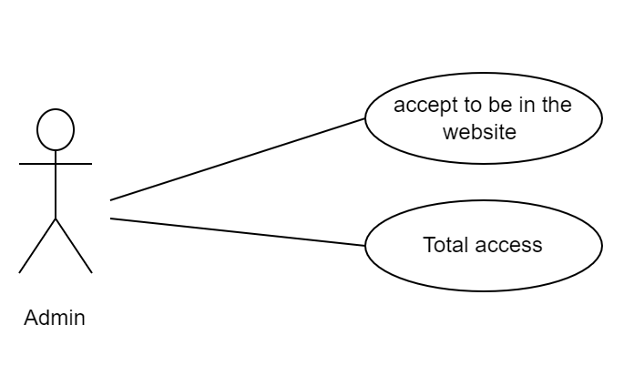
The admin has the following sets of use cases:

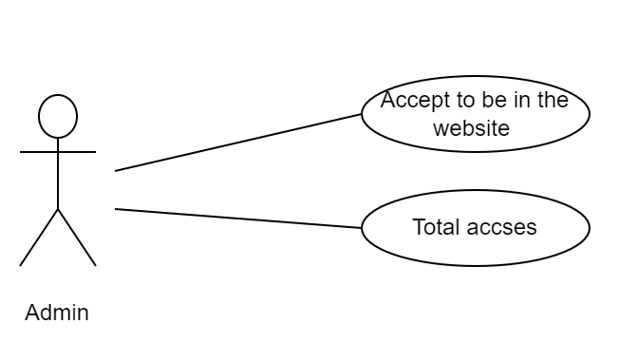

Figure 1- Admin Use case

Use case: accept to be in the website

Diagram:
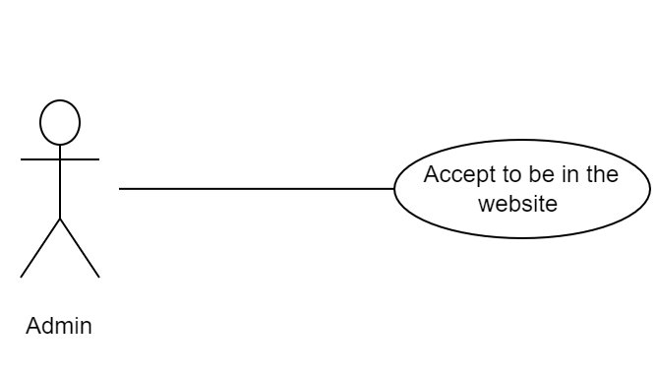

Brief Description:

The admin accepts the restaurant or hotels or trips to be in the website
Initial Step-By-Step Description:
1-The admin enters to the site
2-The admin can see who want to be in the website.
3-The admin can accept them or not.

Xref: Section 3.2.1, accept to be in the website

Use Case: Total access
Diagram:
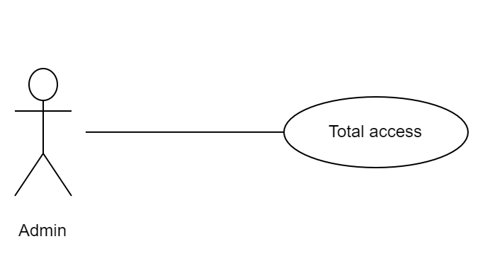
Brief Description:
The admin access to whole website
Initial Step-By-Step Description:
1-The admin enters to the site.
2-The admin can see all the hotels, restaurants and trips.
3-The admin can see all the users and their information.

Xref: Section 3.2.2, Total access

accountant Use Case:
The accountant has the following sets of use cases:
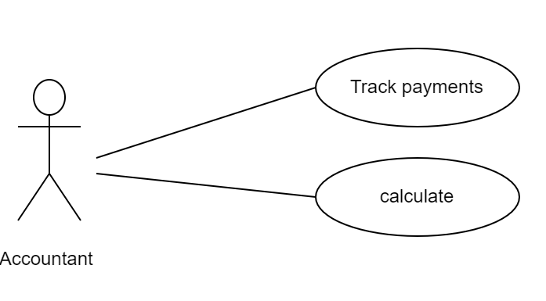

Figure 2- Accountant Use case

Use Case: Track payments

diagram:
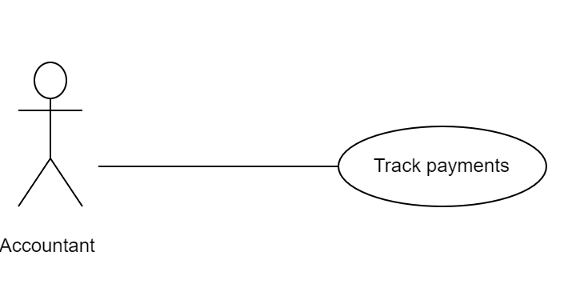

Brief Description:
the accountant can track all payment information that user pay
Initial Step-By-Step Description:
1-The accountant enters to the site.
2-Check all payment reports.
3- the accountant can track and know every user payment information.
Xref: Section 3.2.3, Track payments

Use case: Calculate
Diagram:
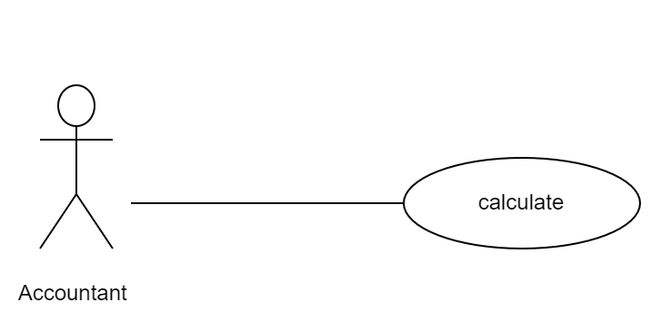
Brief Description:
the accountant can calculate the money and calculate the percentage
Initial Step-By-Step Description:
1-The accountant knows every user how much the pay
2-The accountant calculates the amount of money
3-The accountant calculates the percentage
Xref: Section 3.2.4, Calculate

User use case:
The User has the following sets of use cases:
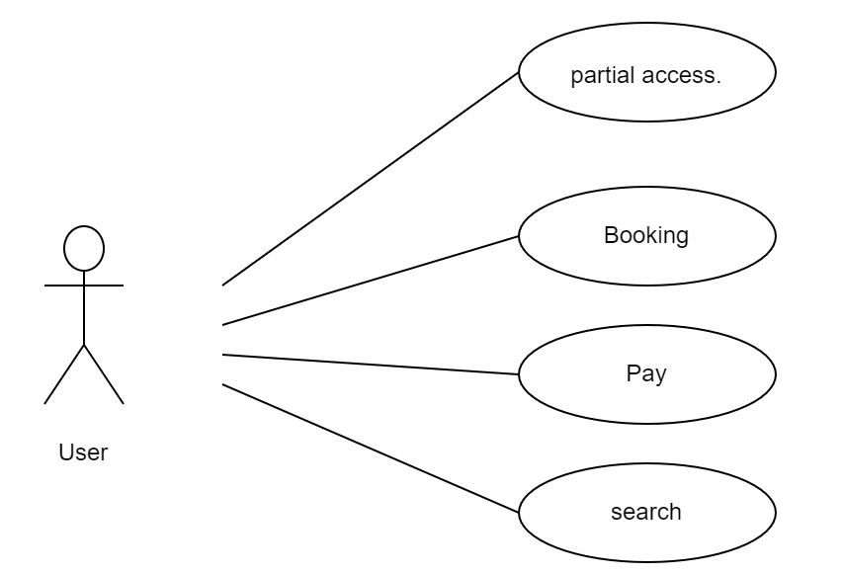

Figure 3-User Use case

Use case: Partial access
Diagram:
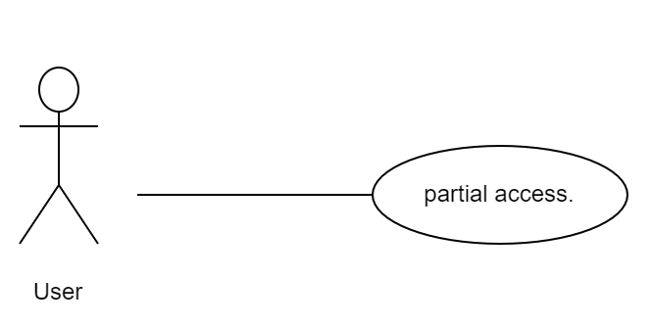

Brief description:
A partial access use case involves enabling users to interact with specific features on a website without full access. For example, users may perform actions like making reservations for restaurants, hotels, or they may log in or create an account.
Initial Step-By-Step Description:
1-The user can browse the website.
2-The user can access information about restaurants, hotels, and more.
3-The user has the ability to perform reservation operations.
4-The user can make payments for trip expenses and other services.
Xref: Section 3.2.5, partial access.
Use case: Booking
Diagram:
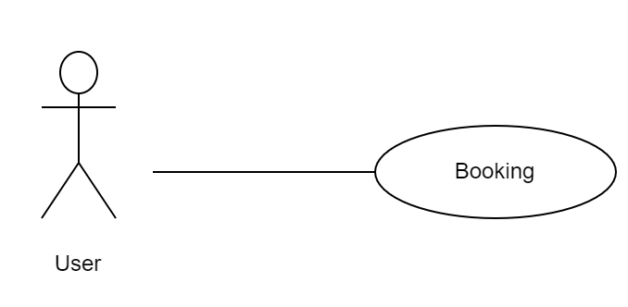

Brief Description:
The user has the ability to make reservations for hotels, trips, or restaurants, choosing and booking the specific lodging, local trip, or dining experience of their preference in Palestine.
Initial Step-By-Step Description:
1-The user initiates a reservation process for a hotel, local trip, or restaurant within Palestine.
2-They have the authority to select and book a particular hotel room, local trip, or restaurant reservation.
3-The user can input reservation details such as dates, times, and preferences during the booking process.
4-Upon completion, the user confirms and finalizes the reservation.
Xref: Section 3.2.6, Booking.

Use case: Pay
Diagram:
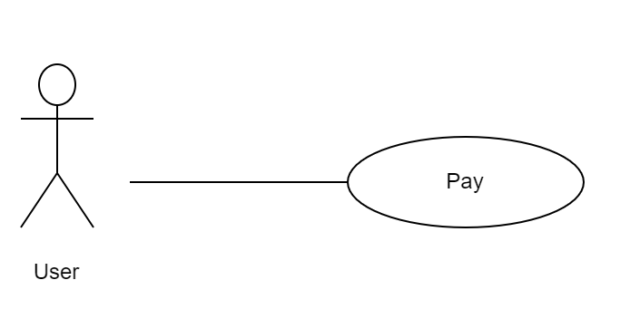
Brief Description:
After selecting a specific hotel, trip, or restaurant for reservation, the user has the capability to proceed with the payment process. For instance, when booking a particular hotel or trip, the user can make the payment through the website. In the case of restaurant reservations, payment may be made directly, such as to the restaurant owner, as the website may not support the feature of online payment for restaurant bookings.

Initial Step-By-Step Description:
1-The user selects a hotel, trip, or restaurant for reservation.
2-Upon choosing a specific accommodation, local trip, or restaurant, the user is given the option to proceed with the payment process.
3-For hotel or trip reservations, the user makes the payment through the website after confirming the booking.
4-In the case of restaurant reservations, the user may make the payment directly, for example, to the restaurant owner, as online payment for restaurant bookings may not be available on the website.
Xref: Section 3.2.7, pay.
Use case: Search
Diagram:
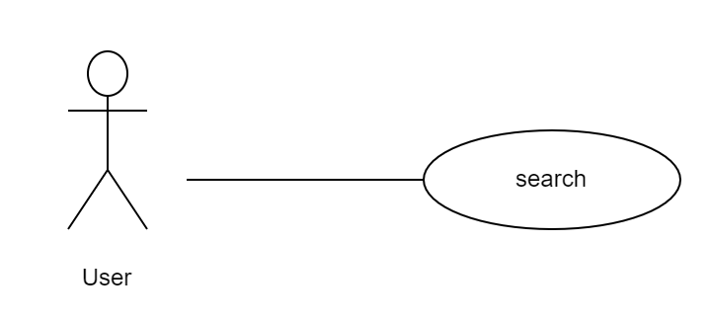
Brief Description:
The Search use case allows the user to search for anything they desire and view detailed information about it. For example, if the user searches for a specific restaurant in a particular city, all relevant information about that restaurant is displayed. Similarly, searching for a specific hotel in a certain city shows all its details, including reservation availability and payment information. Additionally, the user can search for a specific trip and obtain details such as itinerary and schedule.
Initial Step-By-Step Description:
1-The user initiates a search for a specific item, service, or location.
2-After entering search criteria, the system retrieves relevant information matching the user's query.
3-For a restaurant search, detailed information about the selected restaurant, such as its location and offerings, is displayed.
3-When searching for a specific hotel, the user is presented with information about the hotel, including reservation availability and payment details.
4-A search for a specific trip provides the user with detailed trip information, including the itinerary and schedule.
Xref: Section 3.2.8,Search.

VISITOR Use case:
Use case: View a general of the web (without registration)
Diagram:
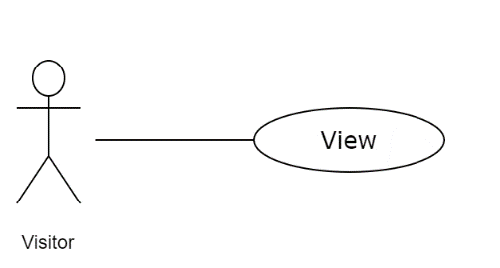

Brief Description:
The visitor can enter our web page to get an overview of it without having to log in.
Initial Step-By-Step Description:
1-The visitor enters the system.
2-He determines the destination he wants to go to.
3-Choose a destination (whether a public place, restaurant, hotel).
4-It just continues browsing without any actual event taking place in its name.
Xref: Section 3.2.9, View.

Maintenance use case:

The Maintenance has the following sets of use cases:
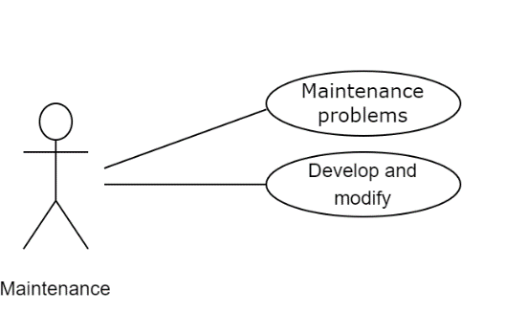

Figure 4-Maintenance Use case

Use case: Maintenance problems
Diagram:

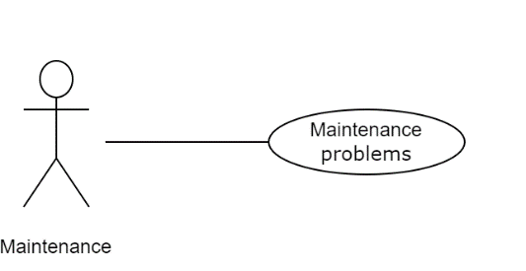
Brief Description:
The maintenance officer works to maintain our website as needed
Initial Step-By-Step Description:

1-The administrator arrives at the site
2-The maintenance officer conducts a preliminary inspection of the site as a whole
3 -Works to fix the problem, if any
Xref: Section 3.2.10, Maintenance problems
Use case: Develop and modify
Diagram:
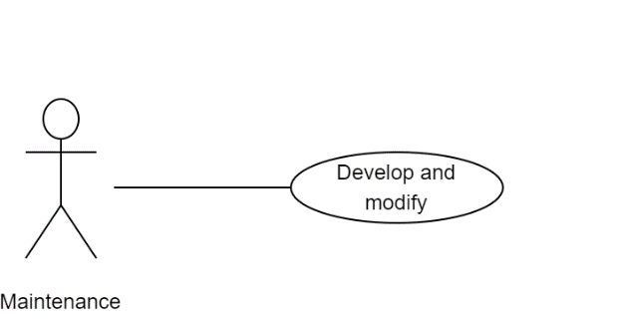
Brief Description:
The maintenance officer can develop the site and increase and modify the required services.
Initial Step-By-Step Description:
1-The administrator arrives at the site.
2-The maintenance officer conducts a general inspection.
3-He works to modify the property of what you requested from him.

Xref: Section 3.2.11, Develop and modify

User Classes and Characteristics
The admin is expected to be knowledgeable about the locations in Palestine and have the ability to identify the best clients for our website. Additionally, the admin should be capable of using the website easily.
Maintenance personnel are expected to be skilled programmers capable of easily identifying and swiftly rectifying errors.
The users are individuals who wish to tour Palestine.
The accountant should be proficient in accounting and capable of collecting monthly profits.

Operating Environment
This section outlines the conditions and tools in which the Palestinian tourism website will work smoothly. It includes details about the hardware, operating system, and other software it needs to get along with.

Operating Environment Description:

Hardware Platform: The website is designed to operate on standard hardware commonly used for accessing websites, ensuring compatibility with various devices like computers, tablets, and smartphones.

Operating System and Versions: The website is compatible with popular operating systems such as Windows, macOS, and Linux. It supports the latest versions of these operating systems to provide users with an optimal experience.

Software Components: The website is crafted to work seamlessly with essential software components, including web browsers like Google Chrome, Mozilla Firefox, Safari, and Microsoft Edge. Compatibility with these browsers ensures users can access the website regardless of their preferred browser.

Coexistence Requirements: The website is built to peacefully coexist with external applications and services, such as mapping services and payment gateways. It ensures smooth interactions and data exchanges to enhance user experience.

Design and Implementation Constraints
Creating the Palestinian tourism website has some rules we need to follow. These are important because they help us work within limits and make the website safe and effective. We have to stick to legal and privacy rules, use specific technologies, and consider how the website will work for many users at the same time. We also need to make sure the website is secure, supports different languages, and follows good coding practices. These rules are crucial to build a website that is safe, works well, and follows the standards everyone expects.

Assumptions and Dependencies
As we work on the Palestinian tourism website, we're making some guesses and relying on certain things to go as planned. These are our assumptions:

- We assume that tools we get from other companies, like maps or payment systems, will work well for our website.

- We're counting on the environment where our website will run to be reliable and steady, and we're assuming users will have regular internet access.

- We're also assuming that the legal and industry rules for our website will stay the same.

Here are the things we depend on:
- Our website uses some tools and software from outside, and we really need them to work properly for our website to be successful.

- We depend on getting the right information from external sources like databases, so our website has the latest details about hotels, trips, and restaurants.

- We have to follow certain rules and laws, and this is crucial for the success of our project.

Specific requirements

External Interface Requirements

User Interfaces
The user interfaces of the Palestinian tourism website are designed for an intuitive and user-friendly experience. Users will interact with the following interfaces:

- Homepage:
The main landing page provides a welcoming interface, featuring navigation options for cities, hotels, trips, and restaurants.
- Place Selection:
Users can easily select their hotel, restaurant and trip ,triggering a dynamic interface that displays relevant information about the chosen location.
- Reservation Forms:
When making a reservation for a hotel, trip, or restaurant, users encounter clear and concise reservation forms. These forms guide users through the booking process, capturing necessary details.
- Search Bar:
The website includes a versatile search bar allowing users to find specific items or services. Search results are presented in an easy-to-read format.

Hardware Interfaces
The Palestinian tourism website interfaces with various hardware components to ensure smooth functionality and accessibility. The hardware interfaces include:

- Device Compatibility:
The website is designed to be compatible with standard hardware devices such as desktop computers, laptops, tablets, and smartphones. It supports various screen sizes and resolutions to accommodate different devices.
- Data Interaction:
The interaction between the software and hardware involves data exchange, including the retrieval and display of information related to cities, hotels, trips, and restaurants. This interaction is optimized for efficient data processing and presentation.
- Control Mechanisms:
The software interacts with hardware components to control user inputs and actions. This includes mechanisms for navigating through the website, entering data in forms, and initiating reservation processes.
- Communication Protocols:
Communication between the software and hardware follows standard internet protocols, ensuring compatibility with common web browsers. This includes HTTP and HTTPS protocols for secure data transmission.
- Device-Specific Optimization:
The website is optimized for specific device types, adapting its interface and functionality to provide an optimal user experience on each device. This includes responsive design elements for mobile devices.

Software Interfaces
The Palestinian tourism website interacts with various software components to provide a seamless and integrated user experience. The software interfaces include:

- Database Interaction:
The website interacts with a relational database management system (RDBMS) to store and retrieve information about cities, hotels, trips, and restaurants. The database version is MySQL 8.0, and the interaction involves SQL queries for data manipulation and retrieval.
- Operating System Compatibility:
The software is designed to be compatible with popular operating systems such as Windows 10, macOS Big Sur, and Ubuntu 20.04. This compatibility ensures a consistent user experience across different operating environments.
- Web Browsers:
The website interfaces with various web browsers, including Google Chrome (v98), Mozilla Firefox (v97), Safari (v15), and Microsoft Edge (v98). Compatibility with these browsers is crucial for a broad user reach.
- Payment Gateway Integration:
To facilitate online payments, the website integrates with a secure payment gateway. The integration follows industry-standard protocols to ensure the confidentiality and integrity of financial transactions.
- Mapping Services:
The website incorporates mapping services for displaying geographical information. The mapping service API version used is Google Maps API v3, allowing users to visualize the locations of hotels, trips, and restaurants.
- Communication Protocols:
Communication between the website and external components follows HTTPS protocols to ensure secure data transmission. APIs are utilized for structured communication with external services.
- Data Sharing:
Data shared across software components includes user preferences, reservation details, and location information. The website utilizes JSON as the data interchange format for smooth communication between components.
- User Authentication Services:
The website integrates with user authentication services using OAuth 2.0 protocols. This allows users to log in securely and access personalized features.

Communications Interfaces

1. User Interface: The web interface through which users interact with the website to explore places, restaurants, trips, and hotels, view information, and make bookings.

2. Database Interface: The interface that connects the web application to the database where information about places, restaurants, trips, hotels, and bookings is stored.

3. External APIs (Maps, Reviews, etc.): Integration with external APIs to fetch additional data such as maps, reviews, or weather information.

Functional requirements
The Logical Structure of the Data is contained in Section 3.3.1.

3.2.1 Accept to be in the website
Use Case Name | accept to be in the website
Xref | Section 2.2.1, access to be in the website
Trigger | The admin starts to see who wants to be in the website and accept it or not
Precondition | The administrator must be logged into the system and have the necessary permissions to review and accept new users.
Basic Path | The admin can:  1. Administrator Login.  2. Access User Requests  3. Review User Requests  4. Accept or Reject User  5. Confirmation  6. Logout
Alternative Paths | 1- Admin Rejects User Request:  The admin selects the option to reject the user.  The system updates the user's status to "rejected."  2- Technical Issue:  The system displays an error message.  The admin may attempt to log in again.  If the issue persists, the admin may contact maintenance
Postcondition | Upon successfully accepting a new user on the website, the following postconditions are established:  1-User Status Update  2-System Notification
Exception Paths | User Already Accepted

Total access

Use Case Name | Total access
Xref | Section 2.2.2, Total access
Trigger | When the administrator logs into the website with total access privileges
Precondition | The administrator must have valid login credentials and be authorized with total access privileges to the website
Basic Path | The admin can:  1 Administrator Login.  2. Perform Administrative Tasks  3. Logout.
Alternative Paths | 1.Technical Issue during Login:  The system displays an error message.  The administrator may attempt to log in again.  If the issue persists, the administrator may contact technical support.  2.Unauthorized Access Attempt  The system detects the unauthorized access.  Security measures are activated, such as account lockout or notification  to system administrators
Postcondition | Upon the admin with total access completing their tasks within the admin  panel, the following postconditions are establish then he can logout
Exception Paths | Logout Failure

3.2.3 Track payment

Use Case Name | Track payment
XRef | Section 3.2.3, access to be in the website
Trigger | Upon receiving payment reports from users, the accountant initiates the process of reconciling and tracking the payments.
Precondition | The accountant must be logged into the financial system and have the necessary permissions to access and track payment reports from users.
Basic Path | The user can:  1. Accountant Login  2. Access Payment Reports.  3. Review Payment Reports.  4. Perform Tracking and Analysis.  5. Logout
Alternative Paths | Payment Error Detected:  The accountant flags the transaction for further investigation.  The system generates an alert or notification for the accounting team.
Postcondition | Upon the accountant successfully completing the tracking of payment transactions, the following postconditions are established then he can Logout
Exception Paths | Payment Record Not Found

3.2.4 Calculate

Use Case Name | Calculate
XRef | Section 2.2.4, access to be in the website
Trigger | At the end of the business day or financial reporting period, the accountant initiates the money counting process.
Precondition | The accountant must be logged into the financial system and have the necessary permissions to access financial data and perform calculations.
Basic Path | The user can:  1. Accountant Login.  2. Access Financial Data.  3. Perform Calculations.  4. Record Results.  5. Logout
Postcondition | Upon the accountant successfully completing the calculation of financial figures, the following postconditions are established then he can Logout
Alternative Paths | Data Discrepancy Detected  Flag the Discrepancy  Alert Notification
Exception Paths | Calculation Error

3.2.5 Access partial

Use Case Name | Partial Access
XRef | Section 2.2.5, Partial Access
Trigger | The User initiates partial access features.
Precondition | The User is on the Partial Access page linked from the website main page.
Basic Path | The user can:  1. Browse the website.  2. Access information about restaurants, hotels, and more.  3. Perform limited reservation operations.  4. Make payments for trip expenses and other services.
Alternative Paths | In step 2, if the user decides not to access specific features and abandons the process:  The system remains on the main page, and the access partial process is aborted.
Postcondition | The User interacts with specific features on the website based on partial access.
Exception Paths | The User may exit the partial access features at any time.
Other | Partial access features are dynamically generated based on user privileges and preferences.

3.2.6 Booking

Use Case Name | Booking
Xref | Section 2.2.6, Booking
Trigger | The User initiates a reservation process for a hotel, local trip, or restaurant within Palestine.
Precondition | The User is on the Booking page linked from the website main page.
Basic Path | The user can:  1. Initiate a reservation process for a hotel, local trip, or restaurant.  2. Select and book a particular hotel room, local trip, or restaurant reservation.  3. Input reservation details such as dates, times, and preferences during the booking process.  4. Confirm and finalize the reservation.
Alternative Paths | - In step 2, if the user decides not to proceed with the reservation after initiation:  The system returns the user to the main page, and the reservation process is aborted.  - In step 3, if the user encounters issues or errors while inputting reservation details:  The user is given the option to either go back and edit the details or abandon the reservation process.
Postcondition | The User successfully completes the reservation for a hotel, local trip, or restaurant in Palestine.
Exception Paths | The User may abandon the reservation process at any time.
Other | Reservation details are stored securely, and the booking process is designed to be user-friendly and intuitive.

3.2.7 Pay

Use Case Name | Pay
XRef | Section 2.2.7, Pay
Trigger | The User proceeds to make a payment after confirming the reservation for a selected hotel, trip, or restaurant.
Precondition | The User is on the Pay page linked from the reservation confirmation page.
Basic Path | The user can:  1. Select a hotel, trip, or restaurant for reservation.  2. Choose a specific accommodation, local trip, or restaurant.  3. Be given the option to proceed with the payment process.  4. For hotel or trip reservations, make the payment through the website after confirming the booking.  5. In the case of restaurant reservations, make the payment directly, for example, to the restaurant owner, as online payment for restaurant bookings may not be available on the website.
Alternative Paths | - In step 2, if the user decides not to proceed with the selected accommodation, local trip, or restaurant after initiation:  The system returns the user to the main page, and the payment process is aborted.  - In step 3, if the user decides not to proceed with the payment process:  The system returns the user to the main page, and the reservation remains confirmed but not paid for.
Postcondition | The User successfully completes the payment process for a hotel or trip reservation.
Exception Paths | The User may abandon the payment process at any time.
Other | Payment details are securely processed, and the payment process is designed to be user-friendly.

3.2.8 Search

Use Case Name | Search
XRef | Section 2.2.8, Search
Trigger | The User initiates a search for a specific item, service, or location.
Precondition | The User is on the main page of the website.
Basic Path | The user can:  1. Initiate a search for a specific item, service, or location.  2. Enter search criteria.  3. The system retrieves relevant information matching the user's query.  4. For a restaurant search, detailed information about the selected restaurant, such as its location and offerings, is displayed. 5. When searching for a specific hotel, the user is presented with information about the hotel, including reservation availability and payment details.  6. A search for a specific trip provides the user with detailed trip information, including the itinerary and schedule.
Postcondition | The User obtains detailed information matching their search criteria.
Exception Paths | The User may abandon the search process at any time.
Other | Search results are dynamically generated based on user input, providing a comprehensive view of the desired item, service, or location.

3.2.9 View a general of the web (without registration)

Use Case Name | View a general of the web (without registration)
Xref | Section 2.2.4, View a general of the web (without registration)
Trigger | The visitor can enter our web page to get an overview of it without having to log in.
Precondition
Basic Path | 1-Arriving at the Homepage.  2-Browsing Publicly Available Content  3-Limited Interactivity
Alternative Paths | non
Postcondition | Limited functionality: The visitor might not have access to certain features that are exclusive to registered users, such as leaving comments, making purchases, accessing personalized content, or interacting with specific elements requiring user authentication.
Exception Paths | The visitor does not access the site due to Error in Accessing Content

3.2.10 Maintenance problems
Use Case Name | Maintenance problems
Xref | Section 2.2.5, Maintenance problems
Trigger | The maintenance officer works to maintain our website as needed
Precondition | 1- Identification of Issues  2- Maintenance Tools
Basic Path | 1- Login to the site  3- View previous problem files  4- Identification of Issues  5- Access to Maintenance Tools  4- Solve the problem
Alternative Paths | In step 1, the maintenance official could make a mistake in his login  In step 4, it may take time to solve the problem, so the maintenance person must find a temporary solution
Postcondition | The maintenance person must report that the problem has been resolved  Continue to monitor and follow up on the site after the problem is resolved
Exception Paths | Unexpected Impact on Other Systems: Maintenance actions could inadvertently impact other interconnected systems or functionalities, causing unexpected disruptions or errors in different areas of the website.

3.2.11 Develop and modify:
Use Case Name | Develop and modify
Xref | Section 2.2.5, Develop and modify
Trigger | The maintenance officer can develop the site and increase and modify the required services
Precondition | 1- Clear Requirements: Clear and documented requirements or specifications should be available, outlining the changes or modifications needed for the website.  2- Backup and Version Control.
Basic Path | 1-After the administrator accesses the site  2- Required development and modification needs are identified  3-The administrator plans and designs to begin modification or development  4-The action is performed  5- Testing is done  6-The administrator must monitor and follow up the site after modification or development
Alternative Paths | In step 2, Unexpected Change Requests: If there are sudden change requests or additional requirements not initially identified, an alternative path could involve revisiting the planning phase to accommodate these changes.  In step 5, Identification of Critical Bugs: If critical bugs or issues are discovered during testing that cannot be easily resolved, an alternative path might involve prioritizing bug fixing over other tasks or reverting to a previous stable version while investigating the issues.
Postcondition | Stable Website Performance, Successful Incorporation of Change Requests
Exception Paths | Stakeholder Deadlock or Persistent Disagreements: Exception path might involve prolonged deadlock among stakeholders or persistent disagreements despite attempts at resolution, leading to delays or rework.

Other Nonfunctional Requirements

Performance Requirements
1. Response Time: The response time for main pages and key functions should be less than 2 seconds to enhance user experience.
2. Load Capacity The website should be designed to support periods of high traffic, maintaining stable performance. The site's capability to handle a large number of simultaneous users should be tested.
3. Image and Media Optimization: Effectively compress images and media to reduce page sizes and improve loading speed.
4. Search Response: The response time for search operations should be quick, providing accurate and relevant results to meet user needs.
5. Achieving Stability: The website should remain stable under varying loads, avoiding any negative impact on performance during peak times.

Meeting these requirements helps provide an efficient and satisfactory user experience, ensuring that the website operates effectively and meets user needs under various conditions

Safety Requirements
Safety requirements are crucial to ensure the security and well-being of users, their data, and the overall functionality of the website. Here are some safety requirements for your website that includes information about places, restaurants, trips, and hotels:
Safety Requirements:

1. Data Encryption: All sensitive user data, including personal information and payment details, must be encrypted during transmission using secure protocols such as HTTPS.
2. Payment Security: Integrate a secure and compliant payment gateway for handling financial transactions. Adhere to industry standards for payment security to protect user payment information.
3. Security Audits and Monitoring: Conduct regular security audits and monitoring to identify and address potential vulnerabilities. Implement intrusion detection systems to alert administrators of suspicious activities.

Security Requirements
Security is paramount in ensuring the integrity, confidentiality, and privacy of user data within the system. The following security requirements are established to create a secure environment for users and protect sensitive information:

1.User Authentication:
Requirement: Users must authenticate their identity to access sensitive features such as making reservations or accessing payment details. Authentication ensures that only authorized individuals can perform specific actions, enhancing overall system security.
2. Data Encryption:
Requirement: All sensitive user data, including personal information and payment details, must be encrypted during transmission and storage. This encryption measure safeguards user information, preventing unauthorized access and protecting user privacy.
3. Access Control:
Requirement: Role-based access control (RBAC) will be implemented to restrict access to certain functionalities based on user roles. Access control ensures that users have appropriate permissions, minimizing the risk of unauthorized actions.
4.Secure Payment Processing:
Requirement: Payment processing must adhere to industry-standard security protocols, such as PCI DSS, to ensure secure financial transactions. This measure is essential for protecting user financial information and building trust in the platform.

Software Quality Attributes
In addition to functional and security aspects, the product is designed to exhibit specific software quality attributes that are crucial for customer satisfaction and effective development. These attributes address various dimensions to ensure a high-quality user experience and facilitate efficient software development:
- Usability:
Attribute: The system will prioritize usability, ensuring an intuitive and user-friendly interface. Usability metrics, such as task success rates and user satisfaction scores, will be employed to measure and enhance the overall user experience.
- Maintainability:
Attribute: Code maintainability is essential for streamlined development and future enhancements. The software architecture and coding practices will adhere to industry standards to facilitate ease of maintenance. Code maintainability will be periodically assessed using static code analysis tools.
- Reliability:
Attribute: The system's reliability is critical for user trust. It will be designed to minimize downtime and ensure consistent performance. Mean Time Between Failures (MTBF) will be used as a metric to quantify the system's reliability.
- Scalability:
Attribute: The system's scalability is vital to accommodate potential growth in user base and system load. Scalability will be measured by assessing the system's performance under increasing user loads and concurrent transactions.
- Interoperability:
Attribute: The product will be designed to seamlessly interact with other systems and services. Interoperability will be verified through testing with various external systems and services to ensure smooth data exchange.
- Testability:
Attribute: The software will be designed with testability in mind. Unit testing, integration testing, and system testing will be conducted regularly to identify and address any issues early in the development process.
- Flexibility:
Attribute: The system will exhibit flexibility in adapting to changing requirements and user needs. Agile development methodologies will be employed to enable iterative changes and continuous improvement.

Logical database requirements
The logical structure of the data to be stored in database is given below.

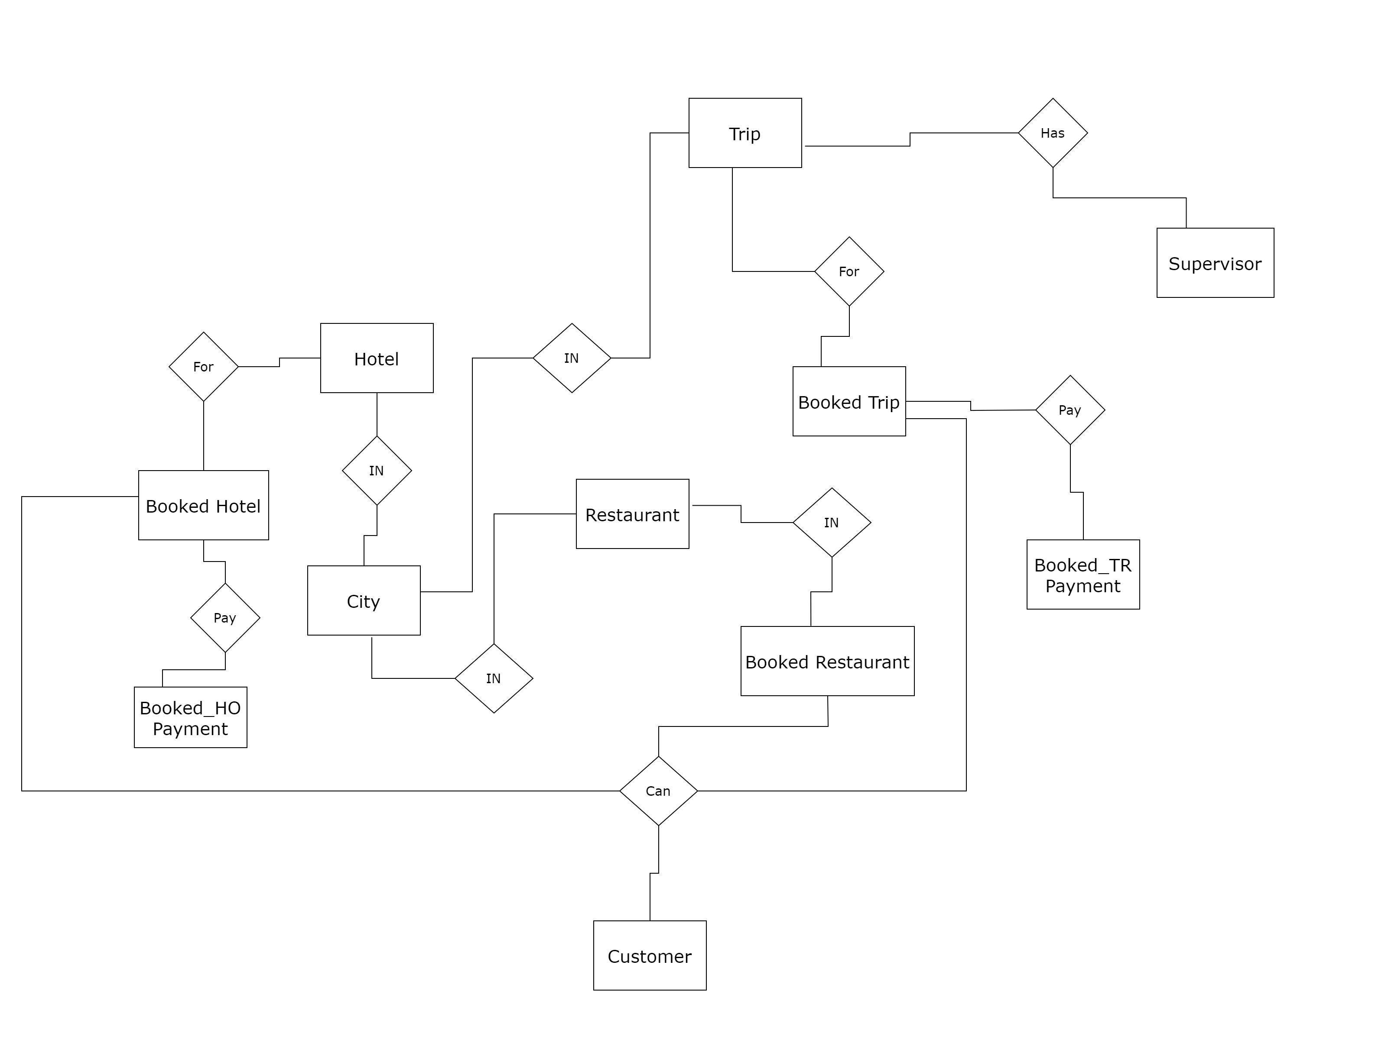

Figure 5 - Logical Structure of system
The data descriptions of each of these data entities is as follows:
City data entity
Data item | Type | Description | Comment
Name | Text | Name of the city
Id | Integer | Id of the city | Used as key of city entity
Trip | Pointer | Trip entity
Hotel | Pointer | Hotel entity
Restaurant | Pointer | Restaurant entity

Trip Data Entity:

Data Item | Type | Description | Comment
NU-Trip | Integer | Trip number according to the system | Used as key of Trip entity
Departure Time | Time | Trip departure time
Duration | Integer | Duration of the trip from start to finish
Start Date | Date | Trip start date
End Date | Date | Trip end date
Price | Integer | Price of Trip
Itinerary | Text | Areas included in the trip
NU-Seats | Integer | Number seats of Trip
Type | Text | Trip of Trip | Entertainment, educational, tourism, exploration, etc.
City | Pointer | City entity
Supervisor | Pointer | Supervisor entity | May be several
Booked Trip | Pointer | Booked Trip entity

Booked Trip Data Entity:

Data Item | Type | Description | Comment
Id | Integer | Reservation number | Used as key of Booked Trip entity
NU_ of Seats | Integer | Number of Seats
Reservation Date | Date | Date of Reservation
Deadline cancellation | Date | Date of withdrawal and cancellation of registration
Booked Payment | Pointer | Booked Payment entity
Trip | Pointer | Trip entity

Payment -TR Data Entity:
Data Item | Type | Description | Comment
NU-Payment | Integer | Payment transaction number | Used as key of Payment -TR entity
Amount | Integer | Quantity of amount paid
Type | Text | payment method
Payment Date | Date | Date of payment
Booked Trip | Pointer | Booked Trip entity

Customer Data Entity:
Data item | Type | Description | Comment
Id | Integer | Id of customer | Used as key of customer entity
Email | Email | Email of customer
Password | Password | Password of the email
Booked Restaurant1 | Pointer | Booked Restaurant entity
Booked Trip | Pointer | Booked Trip entity
Booked Hotel | Pointer | Booked Hotel entity
Restaurant Data Entity:
Data item | Type | Description | Comment
Id | Integer | Id of restaurant | Used as key of restaurant entity
Name | Text | Name of restaurant
Street name | Text | Name of street
Phone number | integer | Phone number of the restaurant
Rate | Integer | Rate of restaurant
City | Pointer | City entity
Booked Restaurant | Pointer | Restaurant entity

Booked Restaurant Data Entity:
data item | Type | Description | comment
Id | Integer | Id of restaurant | use as key of booked restaurant
Name | Text | Name of the costumer
Phone | Integer | phone number of the costumer
Email | Email | Email of the costumer

Hotel Data Entity:
Data item | Type | Description | Comment
Id | Integer | Id of hotel | Used as key of hotel entity
Name | Text | Name of Hotel
Street name | Text | Name of street
Phone number | integer | Phone number of the Hotel
Rate | Integer | Rate of restaurant
City | Pointer | City entity
Booked Hotel | Pointer | Restaurant entity

Booked Hotel Data Entity:

Data Item | Type | Description | Comment
Id | Integer | Reservation number | Used as key of Booked Hotel entity
NU_ of Room | Integer | Number of Room
Reservation Date | Date | Date of Reservation
Deadline cancellation | Date | Date of withdrawal and cancellation of registration
Booked Payment -HO | Pointer | Booked Payment entity
Hotel | Pointer | Hotel entity

Payment-HO Data Entity:
Data Item | Type | Description | Comment
NU-Payment | Integer | Payment transaction number | Used as key of Payment -HO entity
Amount | Integer | Quantity of amount paid
Type | Text | payment method
Payment Date | Date | Date of payment
Booked Hotel | Pointer | Booked Hotel entity

Supervisor Of Trip Data Entity:

Data Item | Type | Description | Comment
Name | Text | Name of Supervisor
Phone | Integer | Phone number of Supervisor
SNN | Integer | Guide identification card | Used as key of Supervisor entity
Trip | Pointer | Trip entity

Architectural design:

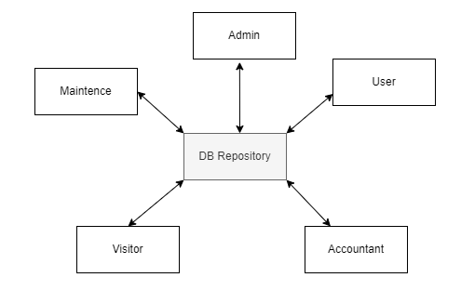

Figure 6- Block diagram

The block diagram illustrates the components and their interactions in a system. Here's a description:

1. DB Repository (Database Repository):
- This is like a central storage area for all the data in the system.
- It stores information related to visitors, administrators (admin), maintenance, users, and accountants.
2. Components (Visitor, Admin, Maintenance, User, Accountant):
- These are different parts or sections of the system, each responsible for specific tasks.
- Each component interacts with the DB Repository to access or store data.
3. Arrows:
- The arrows represent connections or interactions between the components and the DB Repository.
- They show the flow of information or actions, indicating that the components can access or update data in the database.

System Models:
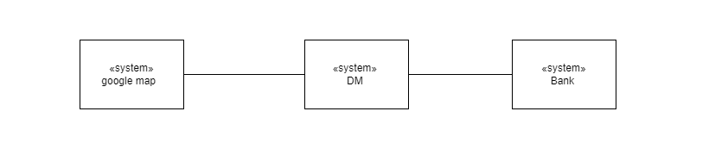
Block diagram (context model):
Figure 7- Block diagram (context model)
Use cases:
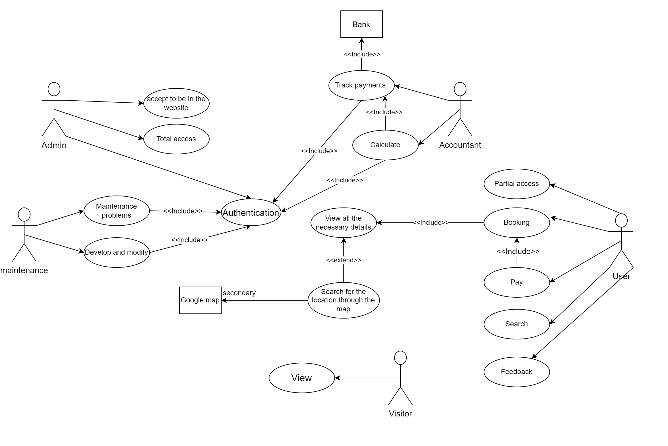
Figure 8 -Use case Diagram

Sequence diagram:

Admin:
- Accept to be in the website:
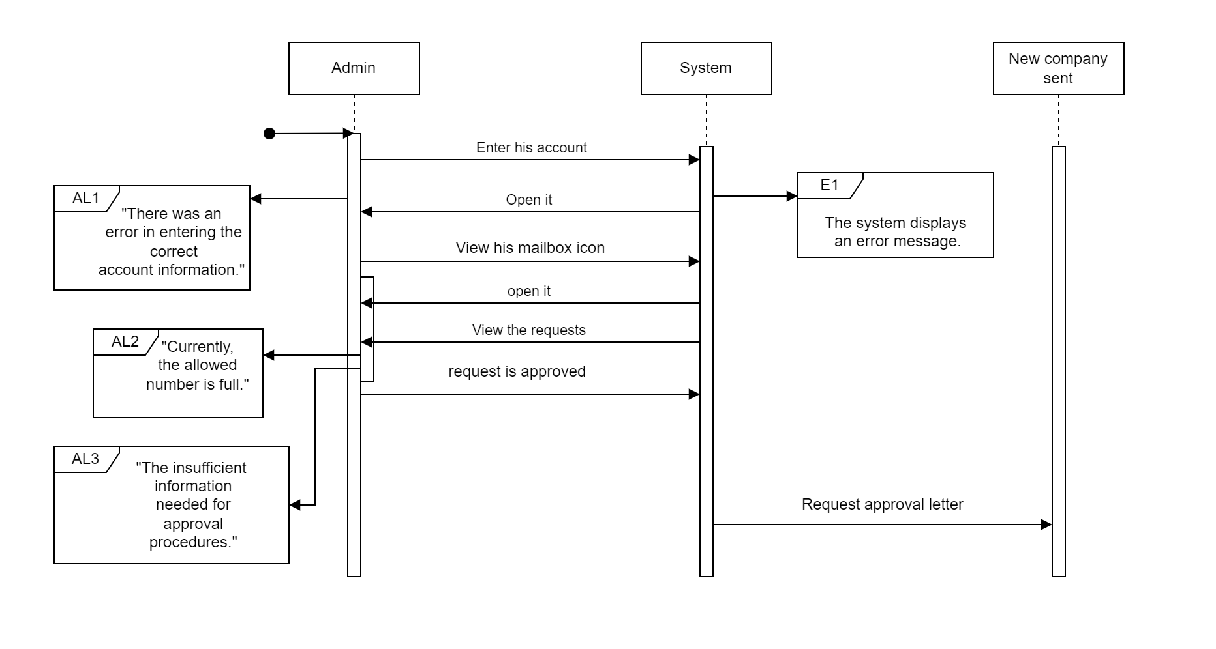
Figure 9- Accept to be in the website Sequence diagram
- Total access:
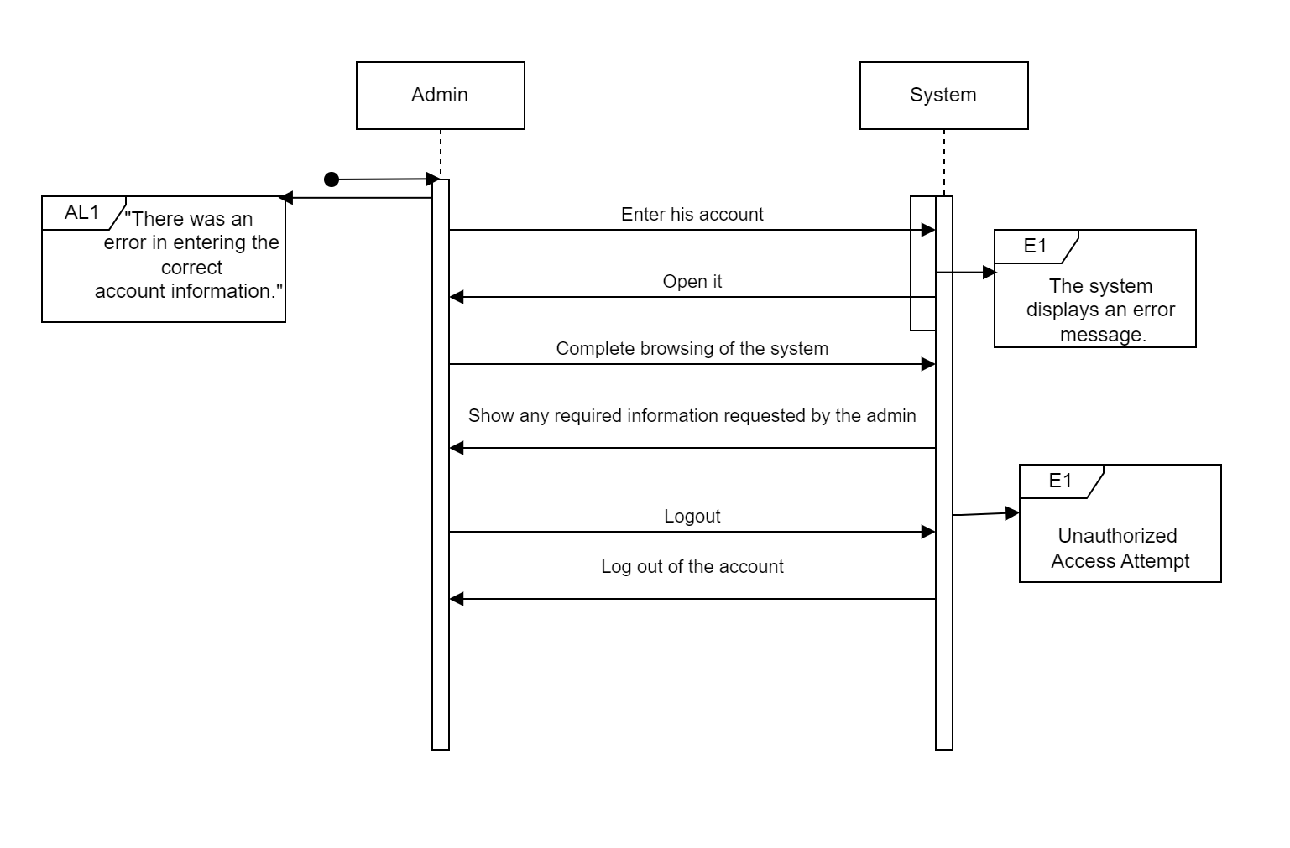
Figure 10- Total access Sequence diagram
Accountant:

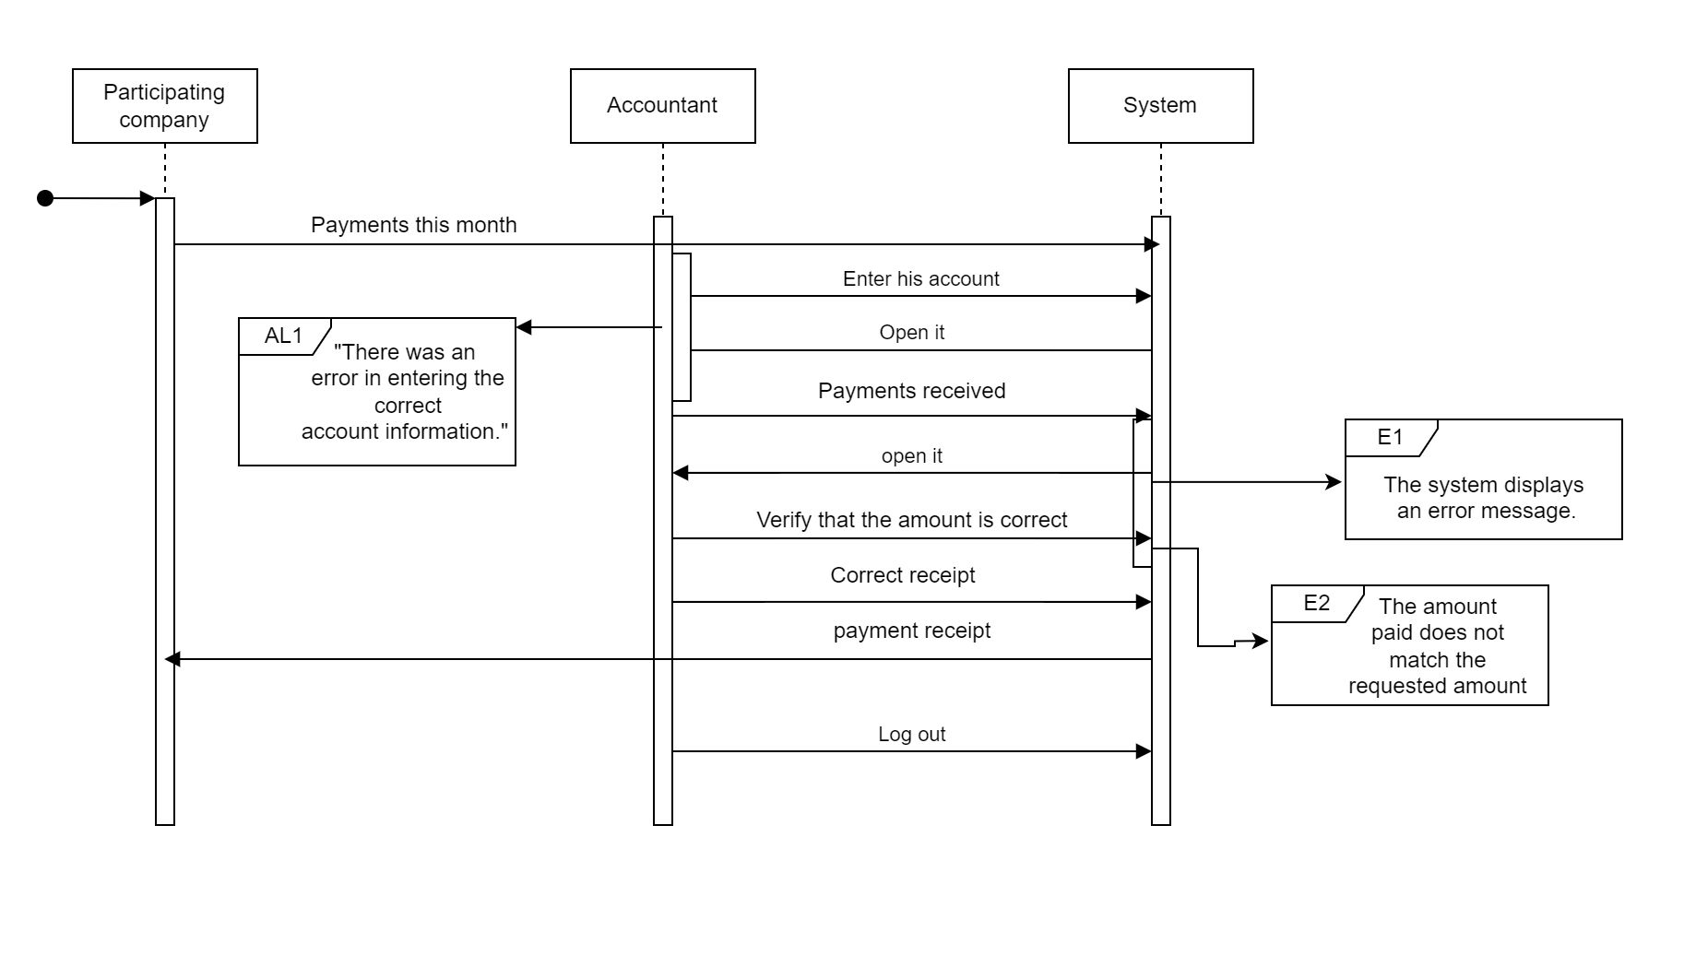
- Track payment:
Figure 11- Track payment Sequence diagram

- Calculate:

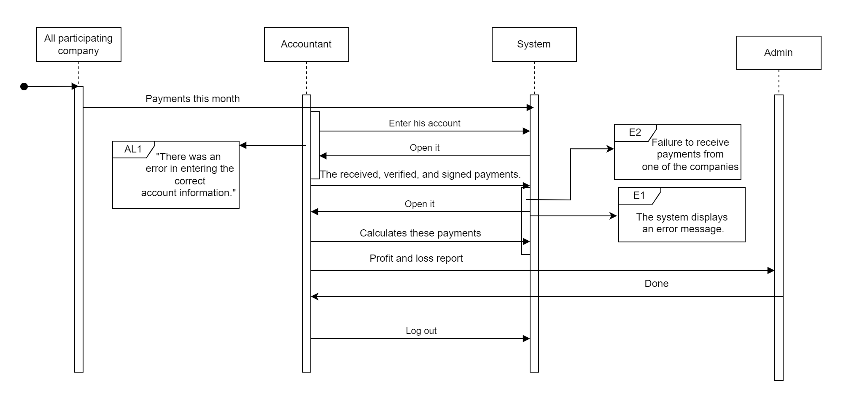
Figure 12- Calculate Sequence diagram

User:

- Partial access:
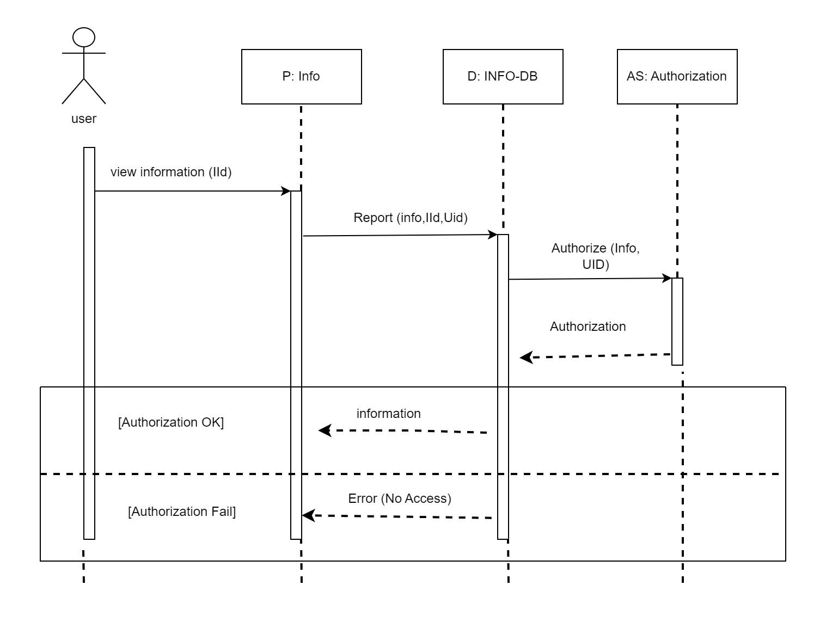

Figure 13- Partial access Sequence diagram

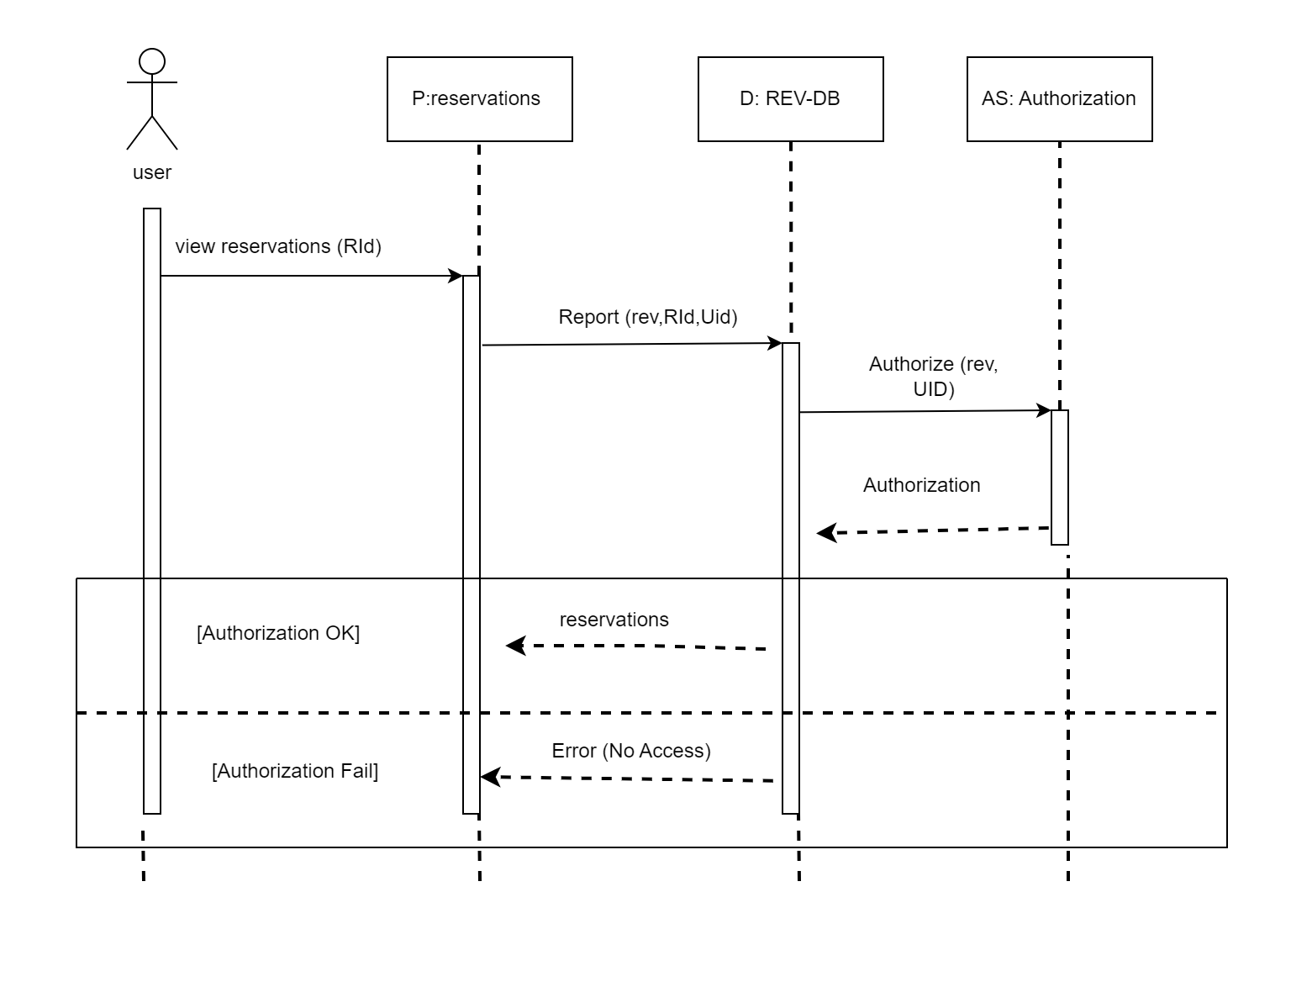
- Booking:
Figure 14- Booking Sequence diagram

- Pay:

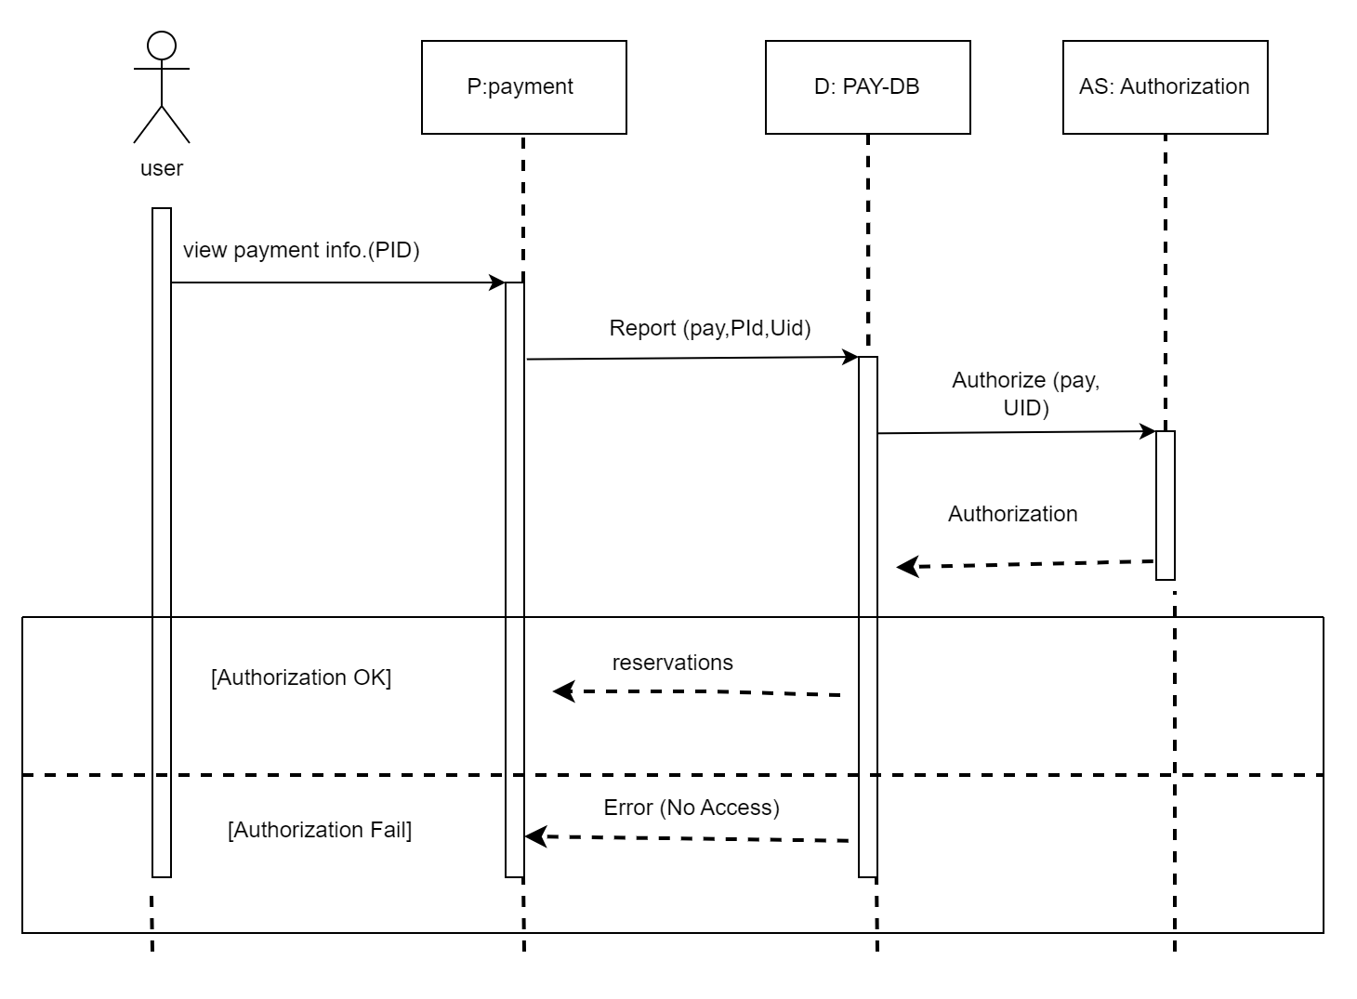

Figure 15- Pay Sequence diagram

- Search:
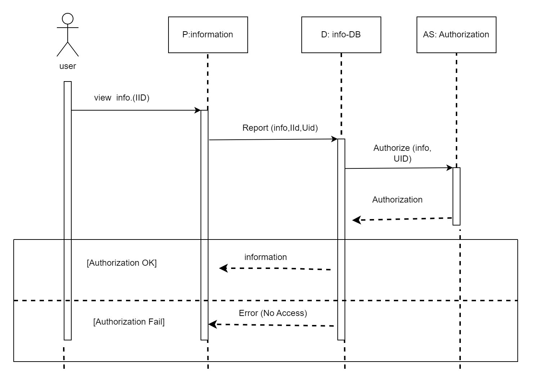

Figure 16- Search Sequence diagram

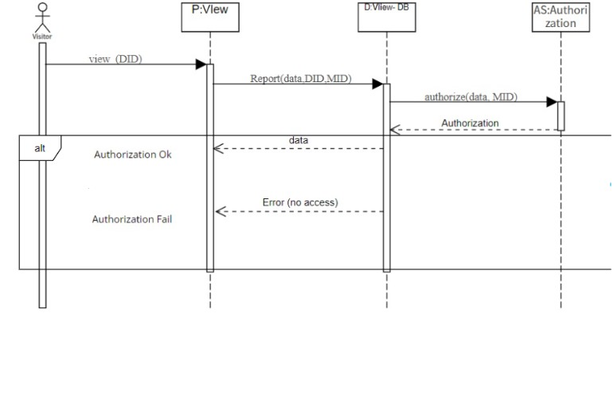
Visitor:

- View:

Figure 17- View Sequence diagram

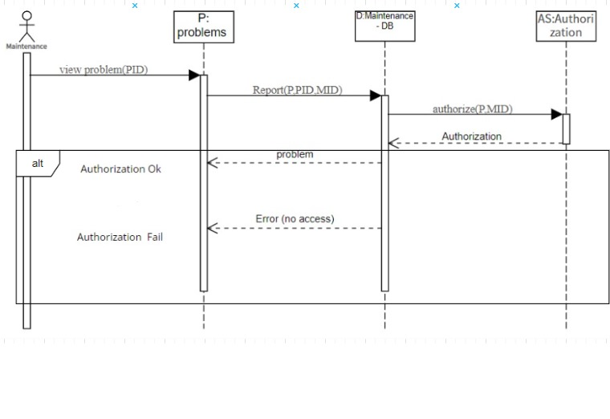
Maintenance:

- Maintenance problems:

Figure 18- Maintenance problems Sequence diagram

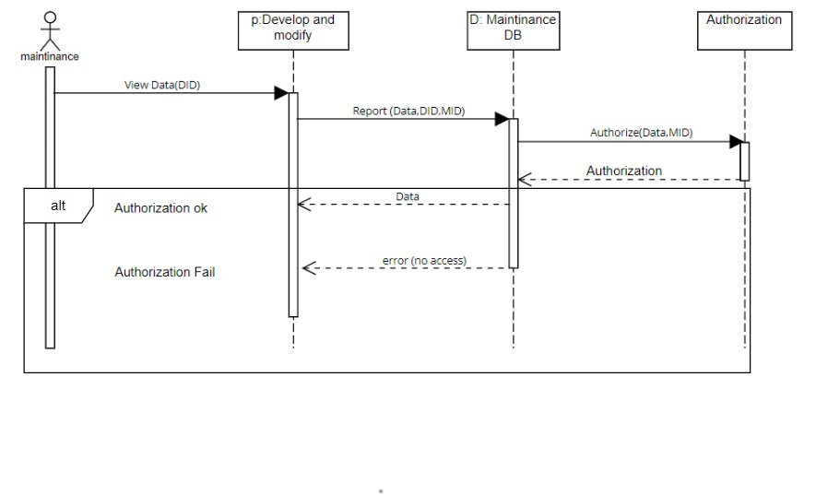
- Develop and modify:

Figure 19- Maintenance problems Sequence diagram

Activity diagrams:

Admin:

- Accept to be in the website:

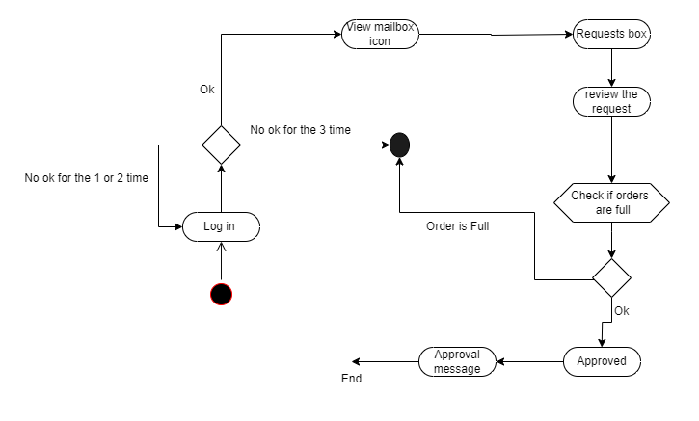

Figure 20- Accept to be in website Activity diagram

- Total access:

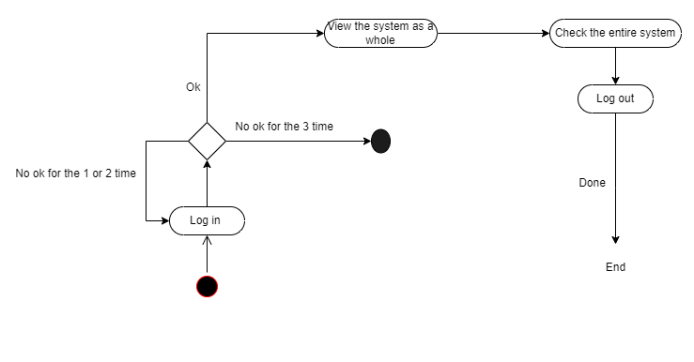

Figure 21-Total access Activity diagram

Accountant:

- Track payment:

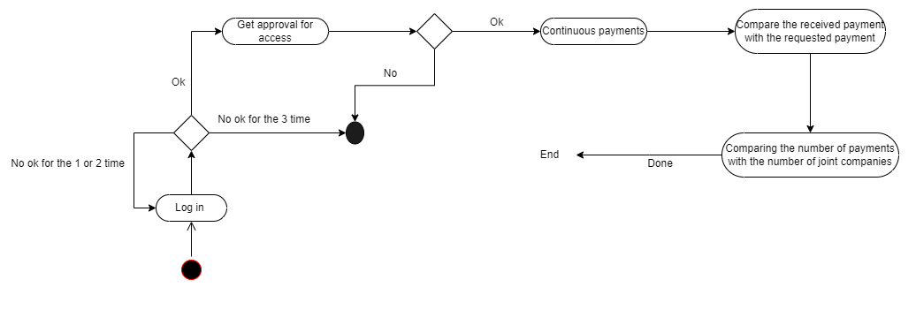
Figure 22- Track payment Activity diagram

- Calculate:

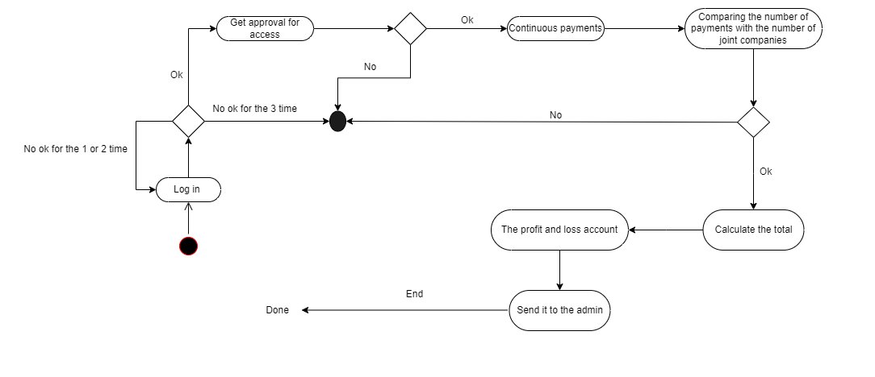

Figure 23- Calculate Activity diagram

User:

- Partial access:

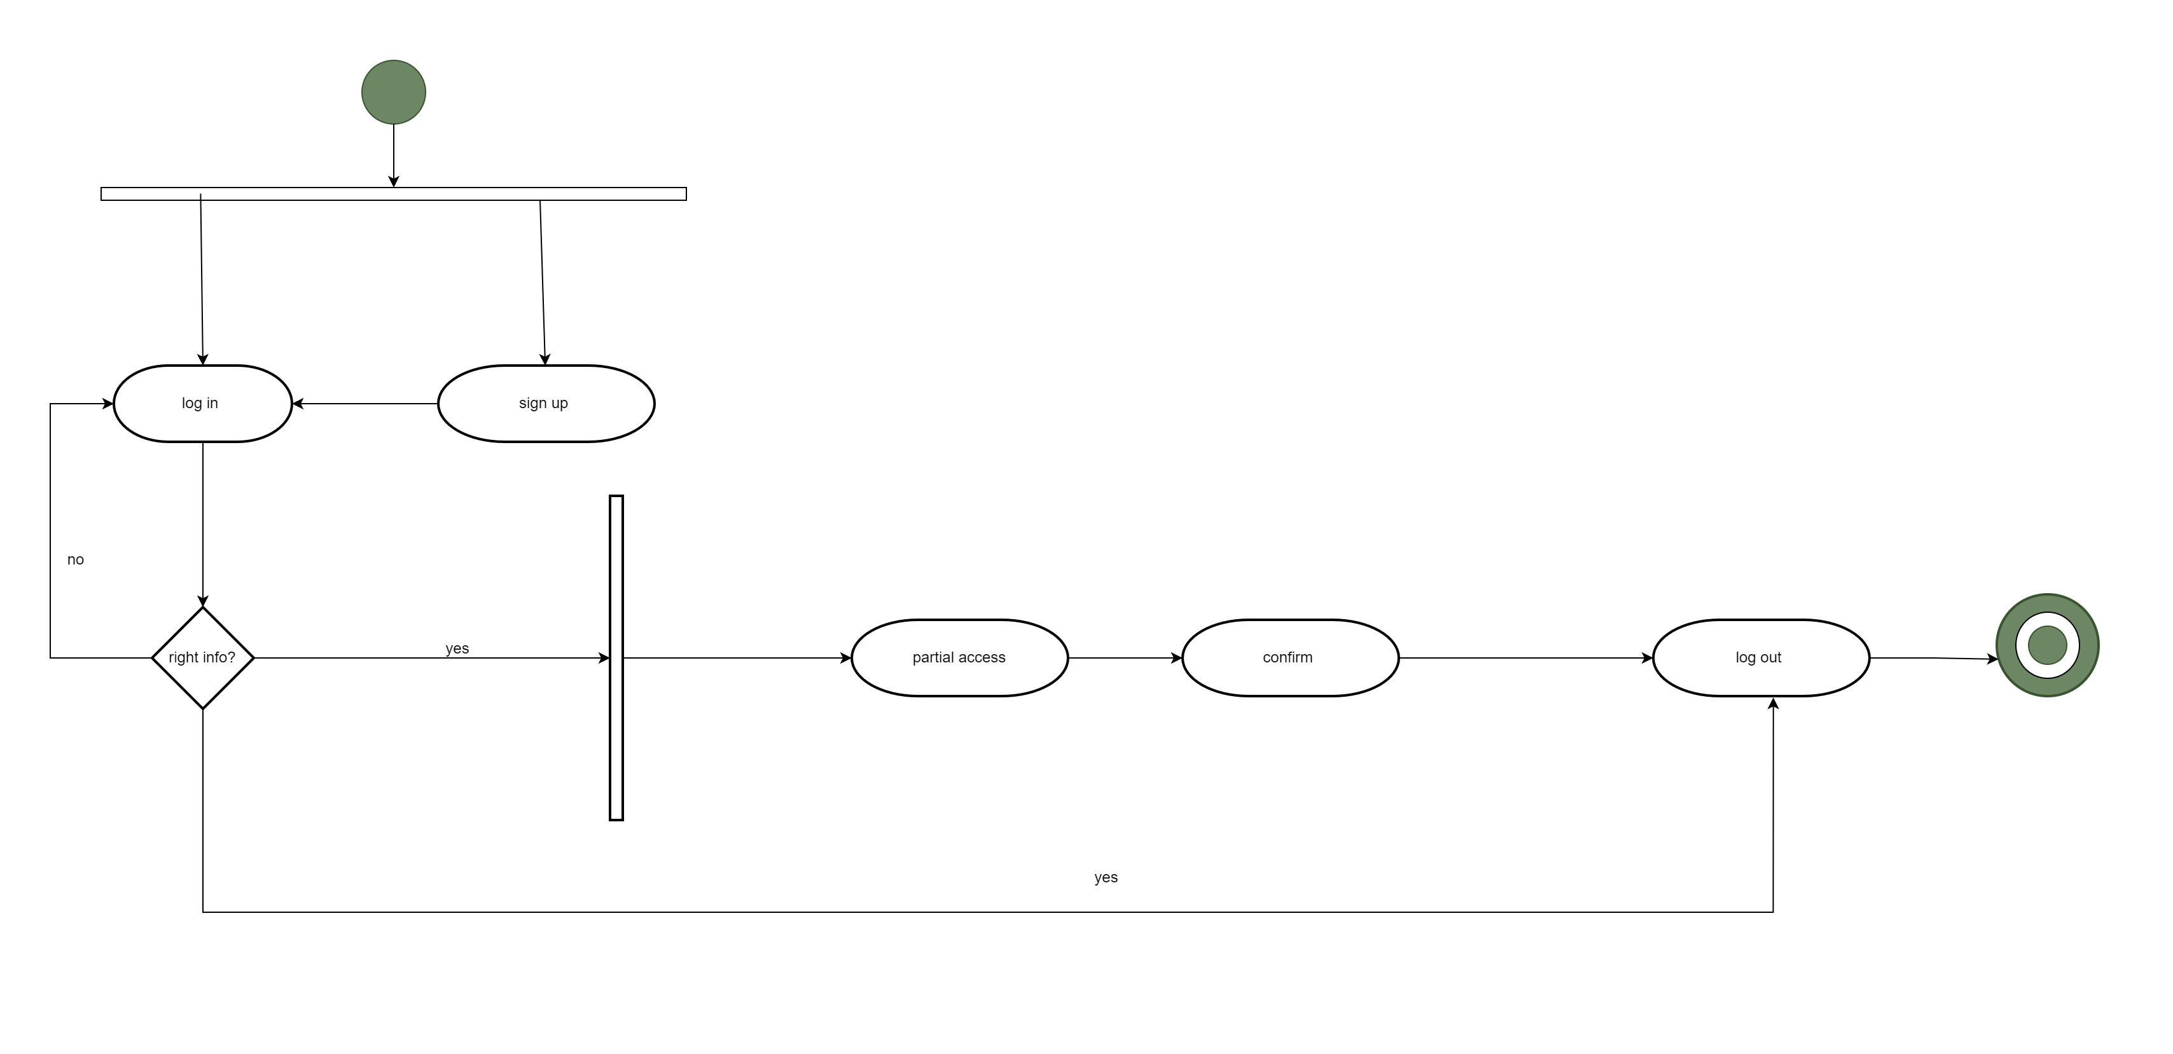
Figure 24- Partial access Activity diagram

- Booking:

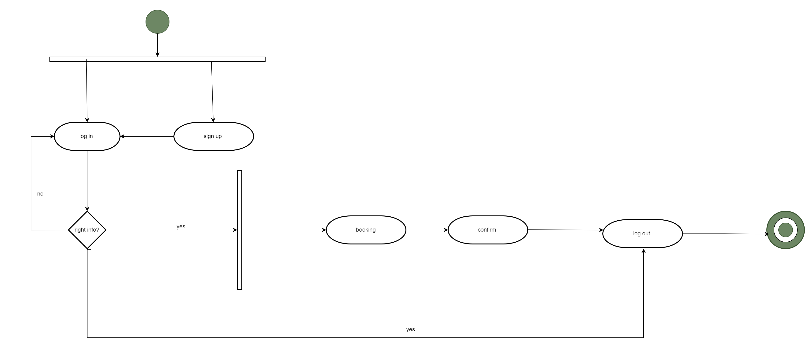

Figure 25-Booking Activity diagram

- Pay
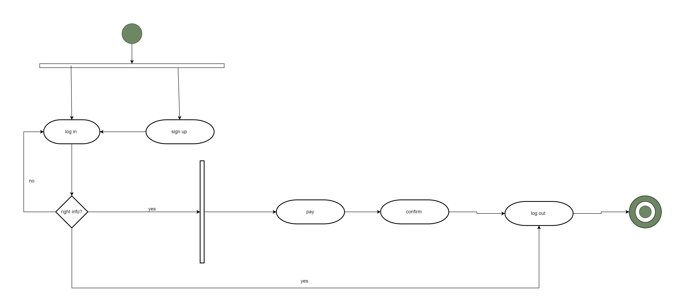
Figure 26-Pay Activity diagram

- Search:
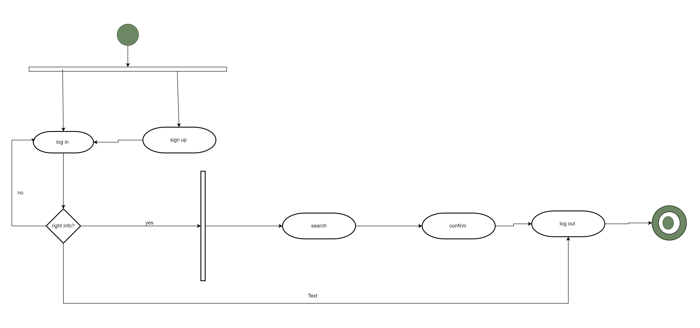
Figure 27-Search Activity diagram

Maintenance:

- Maintenance problems:
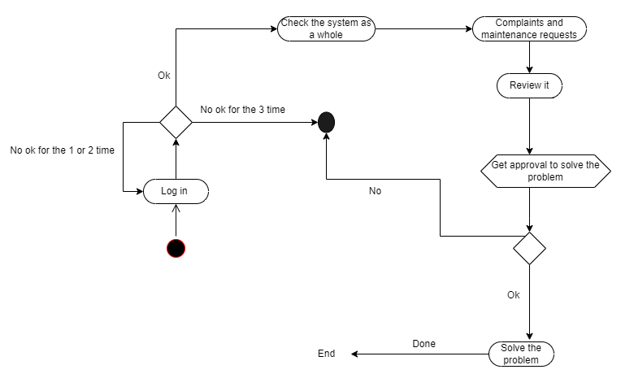
Figure 28- Maintenance problems Activity diagram

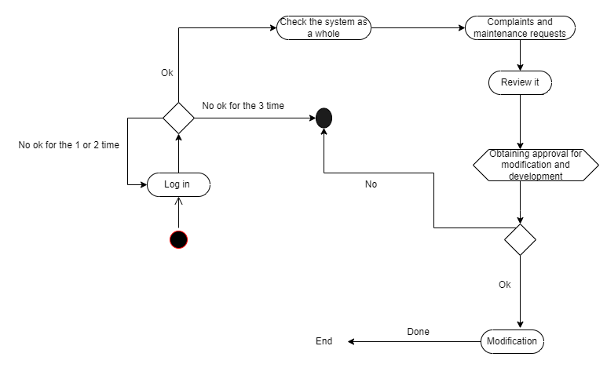
- Develop and modify:
Figure 29- Develop and modify Activity diagram
Visitor:

- View:
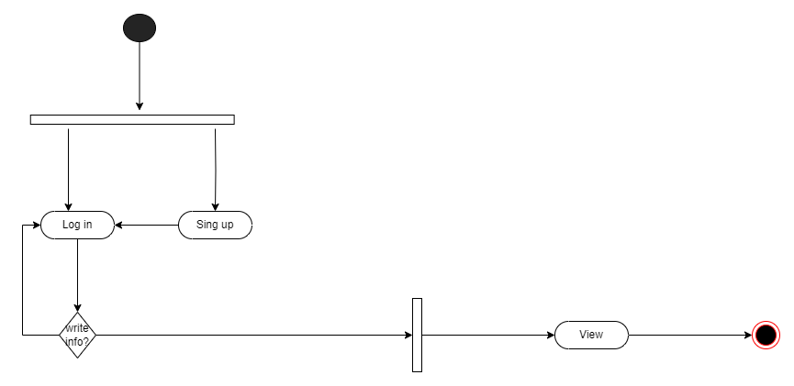

Figure 30- View Activity diagram
Class diagrams:

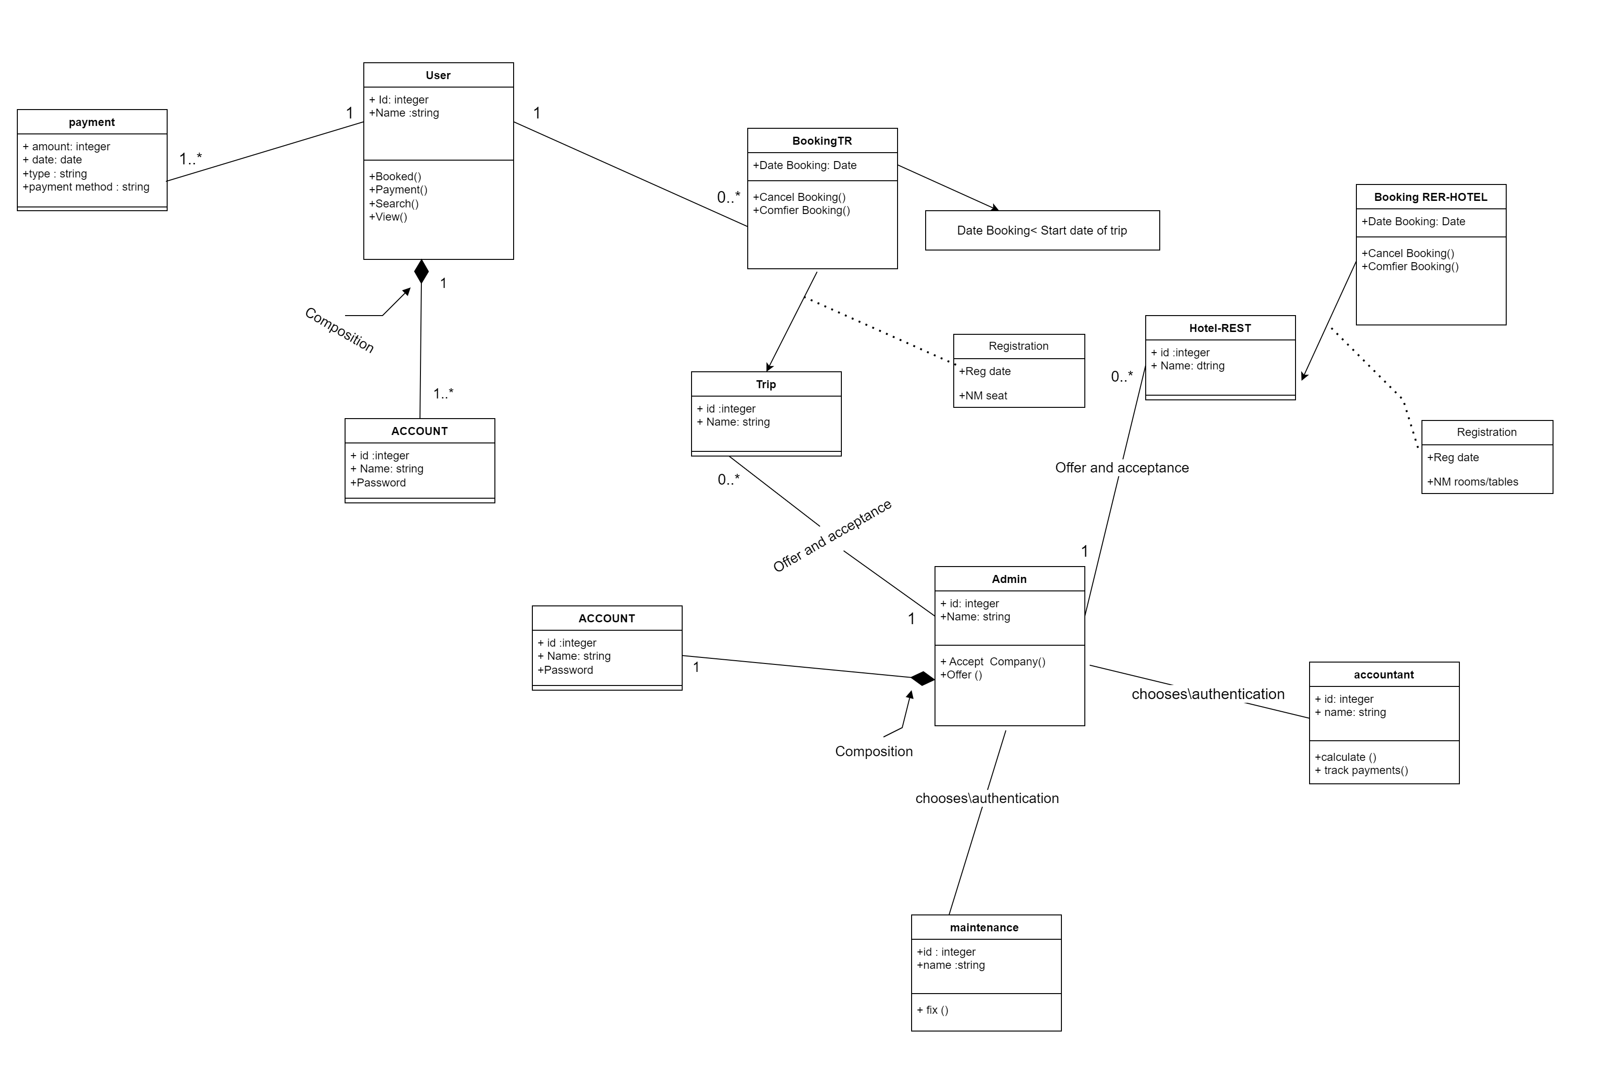

Figure 31- Class Diagram

ER diagram:
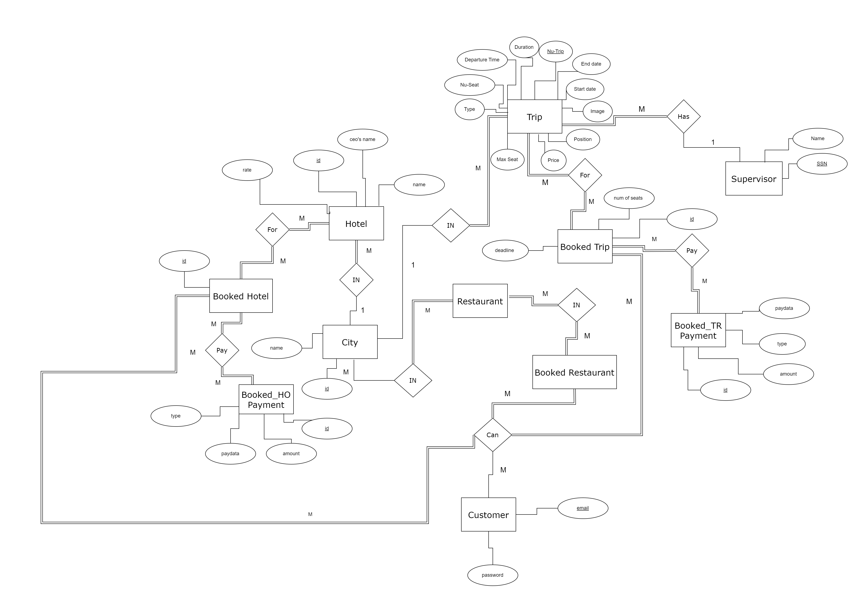

Figure 32- ER Diagram

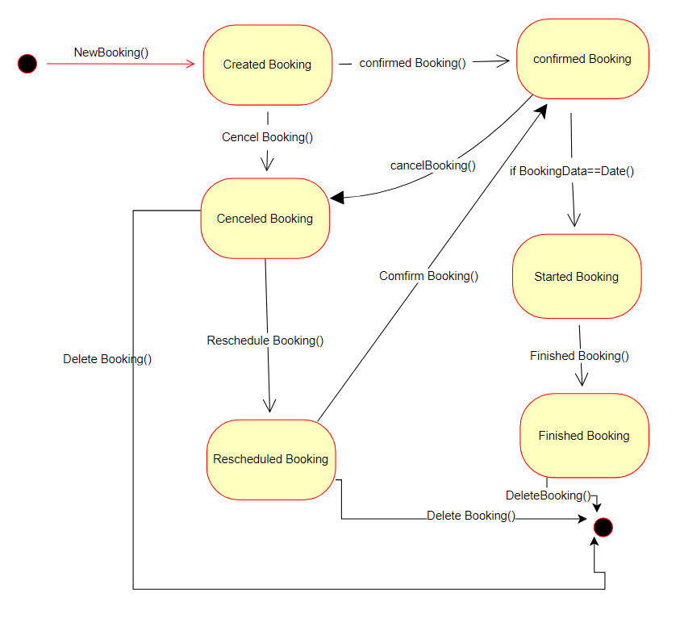
State Diagram:
For Booking Use Case:

Figure 33- Booking State diagram

Software Evolution:

- Change Requests:

Users, administrators, or maintenance personnel submit change requests. For instance, a user might request adding new tourist spots or a maintenance person could suggest system improvements.

- Impact Analysis:

Evaluate the impact of proposed changes. Determine how adding new features (like displaying public places, organizing internal trips, or incorporating new hotels/restaurants) could affect system functionality, user experience, and data integrity.

- Release Planning:

Based on change requests, plan releases for different types of changes:

a) Fault Repair: Addressing bugs or system errors reported by users or maintenance personnel.
b) Platform Adaptation: Updating the system to be compatible with new technologies or operating system versions.
c) System Enhancement: Adding new functionalities approved by the administrator, like new places to visit or improving trip organizing features.

- Change Implementation:

Develop and implement approved changes:

System Development and Testing:
-Develop functionalities for displaying public places, organizing trips, managing hotels/restaurants, and ensure they're thoroughly tested.
-Administrator Approval: The administrator approves the additions/modifications before they are live on the system.

- System Release:

After successful implementation and testing, release the updated version of the system:

- User Access: Users can now view new public places, book internal trips, explore hotels/restaurants.
-Administrator Validation: The administrator validates that the approved changes are correctly displayed and functional.

Throughout these processes, interactions between the administrator, maintenance person, user, and accountant are crucial:

- Administrator: Approves new places, internal trips, hotels, and restaurants for display within the system.
- Maintenance Person: Reports system faults and suggests improvements.
- User: Initiates change requests and interacts with the system for bookings and information.
- Accountant: Might be involved in financial aspects related to internal trips, accommodation, or payments within the system.
.

