DiagramForge
An AI-Assisted Text-to-Diagram Platform Built on a Production-Grade
Kubernetes DevSecOps Pipeline
A Comprehensive Project Report
Cloud Computing & DevOps Engineering Project
August 2026

Table of Contents
Abstract
1. Introduction
2. Literature Review
3. System Architecture
4. Technology Stack
5. Implementation
6. Security Architecture
7. CI/CD Pipeline
8. GitOps and Continuous Delivery
9. Observability and Monitoring
10. Testing Strategy
11. Cost Analysis and Resource Management
12. Engineering Retrospective
13. Conclusion and Future Work
References

Abstract
DiagramForge is a text-to-diagram generation platform — a user submits plain-language notes and receives an automatically-typed, rendered diagram (flowchart, sequence, mind map, class, state, entity-relationship, or timeline) via a Large Language Model reasoning over the input and Mermaid.js handling deterministic layout. Generation is served by a multi-provider architecture — Groq (Llama 3.3 70B), free and default, with automatic, cost-guarded fallback to Claude — rather than a single hard-coded provider, discussed in Section 4.5. While the application itself is deliberately narrow in scope, the surrounding engineering is not: this report documents a complete, production-oriented DevSecOps delivery pipeline built to carry it — Infrastructure as Code via Terraform, security-gated continuous integration via Jenkins (SonarQube, OWASP Dependency-Check, Trivy), GitOps-based continuous delivery via ArgoCD, container orchestration on Amazon EKS, full observability via Prometheus and Grafana, and a defense-in-depth security posture spanning network policies, Pod Security Standards, and automated secret rotation.
This report documents the system end-to-end: the architectural rationale behind each major decision, the literature and industry practice that informed those decisions, the concrete implementation across fourteen build phases, and — deliberately included rather than edited out — the real engineering gaps discovered and corrected along the way. The intent is to demonstrate not only a working system, but the reasoning discipline behind it: why a particular tool was chosen over an alternative, what trade-off was accepted and why, and what would be done differently at greater scale.

1. Introduction

1.1 Problem Statement
Two distinct but related problems motivate this project. First, converting unstructured notes into a visual diagram is a common, low-value-added task performed manually by engineers, students, and technical writers — sketching a flowchart from a paragraph of process description, or a sequence diagram from a description of a system interaction, is mechanical work well-suited to automation, provided the automation is reliable enough that its output does not itself require heavy correction. Second, and separately, a large fraction of student and early-career cloud engineering projects stop at "the application runs in a container," without exercising the operational disciplines — security-gated CI, GitOps delivery, observability, secret rotation, network segmentation, and cost-aware infrastructure lifecycle management — that differentiate a production system from a deployed demo.
This project addresses both problems in a single system: a genuinely useful, narrowly-scoped AI application, delivered through an intentionally complete production pipeline, so that the operational disciplines are exercised against real (if modest) production traffic rather than demonstrated in isolation.

1.2 Objectives
- Design and implement a three-tier web application (React, Node.js/Express, MongoDB) that uses an LLM to convert free text into syntactically valid Mermaid diagram definitions, with an explicit validation-and-retry mechanism for handling malformed model output.
- Provision all infrastructure as code using Terraform, with remote state management, modular reuse across environments, and least-privilege IAM throughout.
- Implement a continuous integration pipeline (Jenkins) that enforces, rather than merely reports, code quality (SonarQube), dependency vulnerability (OWASP Dependency-Check), and container image vulnerability (Trivy) gates.
- Adopt GitOps as the deployment model (ArgoCD), such that the Git repository — not an operator's terminal — is the authoritative description of what is running in the cluster.
- Instrument the application with production-relevant metrics and build alerting rules specific to observed failure modes, not generic infrastructure metrics alone.
- Apply a defense-in-depth security model: network segmentation, restrictive Pod Security Standards, automated secret rotation, and narrowly-scoped IAM roles built incrementally rather than granted broadly at the outset.
- Document, honestly, the engineering gaps discovered during implementation and their resolutions, as a demonstration of engineering judgment rather than a sanitized account of a process that never encountered friction.

1.3 Report Structure
Section 2 surveys the literature and industry practice informing the major design decisions. Section 3 presents the overall system architecture. Section 4 details the technology stack and the rationale for each major tool selection. Section 5 documents the implementation across its build phases. Sections 6 through 9 treat security, CI/CD, GitOps, and observability as dedicated deep-dives given their centrality to the project's DevSecOps objective. Section 10 covers testing strategy, Section 11 cost management, Section 12 a candid retrospective of engineering corrections made during the build, and Section 13 concludes with future work.

2. Literature Review
The system draws on four distinct bodies of work: LLM-based diagram and structured-output generation, container and Kubernetes security, empirical software engineering on CI/CD practice, and foundational distributed-systems literature underpinning the orchestration and GitOps model adopted.

2.1 LLM-Based Diagram and Structured Output Generation
The core generative task in DiagramForge — converting free text into syntactically valid, semantically faithful diagram markup — sits within an active and recent research area. Yang et al. (2025), in "Automating Software Diagram Generation with Large Language Models" (DiagramAI), evaluate seven LLMs across five diagram types and compare direct Mermaid-syntax generation against an intermediate structured (YAML-like) representation, finding that intermediate structuring improves both syntactic validity and semantic accuracy — a finding directly relevant to DiagramForge's design, which asks the model to first select a diagram type and then generate syntax conditioned on that choice, rather than generating free-form output in a single step.
A closely related system, described in the 2026 preprint "GenAI-DrawIO-Creator," uses Claude to generate diagrams and explicitly discusses the need for "specialized prompt engineering and error-checking to ensure well-formed XML outputs" — the same class of problem DiagramForge addresses with its basic-syntax-check-and-retry mechanism, implemented independently but converging on a structurally similar solution: LLM output cannot be trusted as syntactically valid without a verification step, and a single, targeted retry with the specific parse error attached is more effective than either blind trust or an unguided second attempt.
Kim et al.'s "Graphologue" (ACM UIST 2023) addresses a related but distinct problem — generating interactive node-link diagrams from LLM chat responses in real time to aid sense-making — and is relevant to this project primarily as evidence that real-time, LLM-driven diagram generation is an established and actively studied interaction pattern, not a novel or unprecedented one. Cai et al.'s "DiagrammerGPT" (2023) similarly tackles LLM-driven diagram generation but from a planning perspective, decomposing generation into a layout-planning stage followed by rendering, a design pattern DiagramForge deliberately does not adopt (Mermaid.js's own layout engine performs this role instead), a decision revisited in Section 4.

2.2 Kubernetes and Container Security
Shamim, Bhuiyan, and Rahman's "XI Commandments of Kubernetes Security" (IEEE Secure Development Conference, 2020) systematizes 104 sources into eleven concrete security practice categories, including RBAC configuration, network segmentation, and secrets management — the same three areas addressed in this project's Phase 12 hardening pass (Network Policies, Pod Security Standards, and the migration to External Secrets Operator). Rahman, Shamim, Bose, and Pandita's empirical study, "Security Misconfigurations in Open Source Kubernetes Manifests" (ACM Transactions on Software Engineering and Methodology, 2023), analyzes real-world Kubernetes manifests and documents the prevalence of exactly the class of misconfiguration this project deliberately avoided by design — default-permissive network policies, containers without explicit non-root security contexts, and secrets embedded directly in manifest values rather than referenced from an external store.
Jarkas, Ko, Dong, and Mahmud's "A Container Security Survey: Exploits, Attacks, and Defenses" (ACM Computing Surveys, 2025) provides a comprehensive taxonomy of container-specific attack surfaces, informing the choice of minimal, non-root base images and multi-stage Docker builds adopted throughout this project's Dockerfiles. A further IEEE study on the security implications of Kubernetes networking substantiates a specific design choice made in Section 6 of this report: the acknowledged limitation that Network Policies cannot meaningfully restrict ingress from an AWS Application Load Balancer using IP-based target routing, since the ALB's source addresses are not a fixed, allow-listable range.

2.3 Empirical Studies of CI/CD Practice
Ghaleb, Da Costa, and Zou's "An Empirical Study of the Long Duration of Continuous Integration Builds" (Empirical Software Engineering, 2019) provides large-scale, real-world evidence on the factors that make CI pipelines slow, directly informing this project's pipeline design choices — specifically, the relevant-change-detection guard added to each Jenkins pipeline (Section 7) to avoid running a full security-gated pipeline for changes that do not touch the corresponding tier's source. Rausch, Hummer, Leitner, and Schulte's "An Empirical Analysis of Build Failures in the Continuous Integration Workflows of Java-Based Open-Source Software" (IEEE/ACM MSR, 2017) documents the real-world distribution of CI failure causes, providing grounding for prioritizing the specific gates implemented (dependency vulnerabilities and static analysis findings) over more exotic failure categories.

2.4 Foundational Distributed Systems and Orchestration Literature
While not directly implemented as a component of this system, two papers inform the operational model this project depends upon: Verma et al.'s "Large-Scale Cluster Management at Google with Borg" (ACM EuroSys, 2015) describes the declarative, reconciliation-loop scheduling model — desired state compared continuously against observed state — that both Kubernetes' own controller pattern and, at a higher layer, ArgoCD's GitOps reconciliation loop directly descend from. Understanding this lineage clarifies why ArgoCD's "self-heal" behavior (Section 8) is not an incidental feature but an expression of the same reconciliation principle Kubernetes itself is built on, applied one layer higher, to the Git repository rather than only to the live cluster state.

2.5 Synthesis
Taken together, this literature supports three specific design commitments made in this project: (1) LLM-generated structured output requires an explicit, targeted validation and correction step rather than single-shot trust, consistent with contemporaneous work on LLM diagram generation; (2) the majority of real-world Kubernetes security incidents stem from a small, well-characterized set of misconfiguration categories, all of which this project addresses directly rather than partially; and (3) CI/CD pipeline design should be informed by empirical data on real failure and slowdown causes rather than intuition alone.

3. System Architecture
The complete system spans four cooperating subsystems: the application itself (a three-tier React/Node.js/MongoDB stack); the CI subsystem (Jenkins, with three enforced security gates); the CD subsystem (ArgoCD, operating on a GitOps model); and the operational subsystem (Prometheus/Grafana for observability, External Secrets Operator for secret lifecycle, and Terraform for all underlying infrastructure). Figure 1 presents the complete architecture.
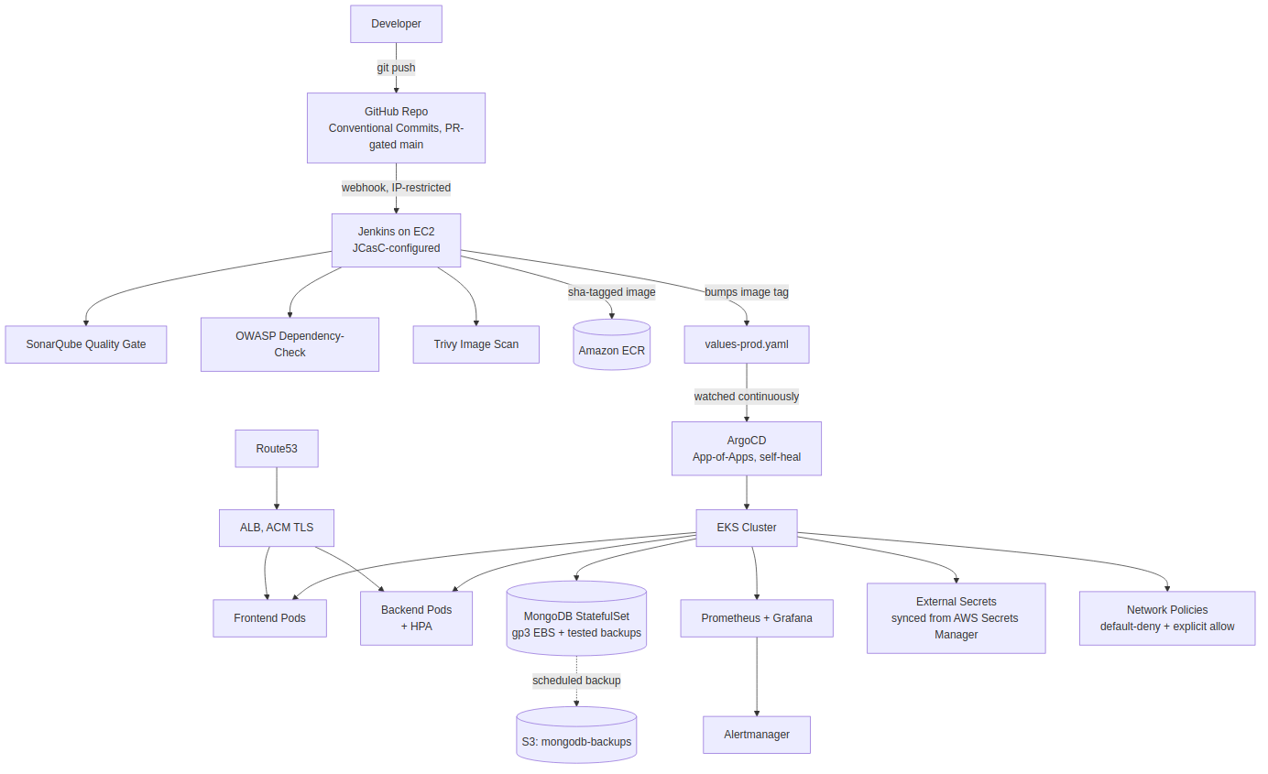
Figure 1. Complete system architecture: commit-to-production flow, GitOps reconciliation, and supporting infrastructure.

3.1 Application Architecture
The application layer follows a conventional three-tier pattern with one distinguishing internal behavior: the backend does not treat the LLM call as a single, trusted operation, but wraps it in a structural validation check and a bounded retry loop, illustrated in Figure 2.
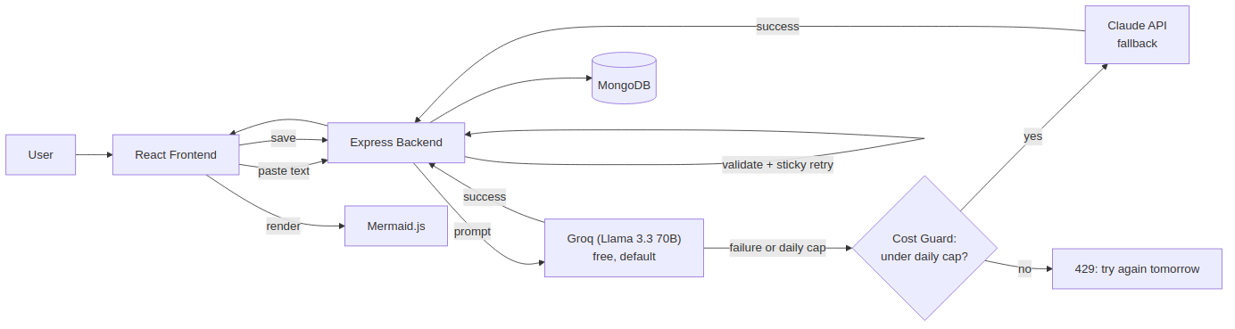
Figure 2. Application-level request flow: Groq as default provider, cost-guarded fallback to Claude, and the validation/sticky-retry loop.

3.2 Deployment Topology
The application is deployed to a single Amazon EKS cluster spanning two availability zones, with worker nodes in public subnets — a deliberate cost/complexity trade-off discussed in Section 4.4, made in place of the more conventional private-subnet-plus-NAT-Gateway topology. Ingress is terminated at an AWS Application Load Balancer provisioned by the AWS Load Balancer Controller, with TLS handled by AWS Certificate Manager rather than a cluster-internal certificate authority.

3.3 Data Layer
MongoDB is deployed as a Kubernetes StatefulSet — not a Deployment — specifically because a StatefulSet provides the stable network identity and consistent volume-claim reattachment a database workload requires across pod rescheduling events; this distinction, and its concrete verification, is detailed in Section 5.7. Persistent storage uses an explicitly-provisioned, encrypted gp3 EBS-backed StorageClass, and a scheduled backup process ships nightly snapshots to Amazon S3, with the restore procedure validated by deliberate execution rather than left untested.

4. Technology Stack
Each major technology selection below reflects a deliberate choice among viable alternatives, not a default. Where an alternative was consciously rejected, the rationale is recorded — this is treated as a first-class part of the documentation, since the reasoning behind a decision is of greater engineering value than the decision alone.

4.1 Application Layer
Component | Choice | Rationale
Frontend | React (Vite), Tailwind CSS, Framer Motion | Fast dev server; utility-first styling; physics-based animation for the diagram-reveal interaction
Diagram rendering | Mermaid.js | Delegates deterministic graph layout to a mature, purpose-built engine rather than reimplementing it
Backend | Node.js, Express | Consistent language across the stack; mature ecosystem for the required middleware (rate limiting, validation, metrics)
LLM | Groq (Llama 3.3 70B, default) with cost-guarded Claude fallback | Multi-provider abstraction — see Section 4.5 for the full rationale
Database | MongoDB | Document model maps naturally onto a heterogeneous "saved diagram" record

4.2 Infrastructure and Provisioning
Component | Choice | Rationale
IaC | Terraform, modular, S3 + DynamoDB remote state | Team-safe state management; module reuse between the Jenkins and EKS provisioning stacks
Compute (CI) | EC2 (Jenkins), IAM instance role | No static credentials required for AWS API access from the CI host
Orchestration | Amazon EKS | Managed control plane; native integration with IAM (IRSA) for pod-level AWS permissions
TLS | AWS Certificate Manager | Native ALB integration; deliberately chosen over cert-manager + Let's Encrypt for this specific ALB-based topology (Section 9)

4.3 CI/CD and GitOps
Component | Choice | Rationale
CI orchestrator | Jenkins (Configuration as Code) | System configuration versioned as YAML rather than accumulated through undocumented UI changes
Static analysis | SonarQube | Enforced quality gate, not advisory-only reporting
Dependency scanning | OWASP Dependency-Check | CVSS-threshold build-failing gate on known-vulnerable dependencies
Image scanning | Trivy | Exit-code-based gate on HIGH/CRITICAL container vulnerabilities
CD model | ArgoCD, App-of-Apps pattern | Git as the single source of truth; automatic drift correction (self-heal)
Packaging | Helm, environment-specific values files | Templated, versioned releases rather than hand-edited manifests per environment

4.4 A Note on Deliberate Simplifications
Two infrastructure decisions were made primarily for cost reasons and are documented as such rather than presented as unconsidered defaults. First, worker nodes are placed in public rather than private subnets, avoiding a NAT Gateway's recurring cost (approximately USD 32 per month plus data processing) at the expense of the additional network isolation a private-subnet topology would provide. Second, MongoDB is deployed as a single-replica StatefulSet rather than a true high-availability replica set; this is explicitly noted as the first change warranted at any meaningful production scale.

4.5 Multi-Provider LLM Architecture
Generation was initially implemented against a single provider (Claude) before being revised into a provider-abstracted design: Groq, serving Llama 3.3 70B, as the default provider, with automatic fallback to Claude only if Groq errors or is rate-limited. This is not primarily a cost-cutting measure applied to an otherwise-finished design — it reflects a genuine architectural question every LLM-backed product must answer: whether to depend on a single provider, or to treat "which model answers this request" as a routable, swappable decision. The system takes the latter position.
Two further design details make this a defensible production pattern rather than an ad hoc workaround. First, the syntax-validation retry (Section 5, Phase 1) is "sticky" — a retry stays on whichever provider already succeeded once, rather than re-triggering the fallback cascade, avoiding redundant cross-provider calls for what is fundamentally a formatting correction, not an availability failure. Second, because Groq's free tier enforces a hard daily request ceiling, the fallback path is itself rate-guarded: a MongoDB-backed daily counter refuses further Claude fallback once a configured cap is reached, returning a clear error rather than allowing an exhausted free tier to silently convert into unbounded paid usage. This closes a real failure mode that a naive "just fall back on error" implementation would not have caught, since a quota exhaustion and a transient outage present identically to the calling code without an explicit guard.
Figure 2 (Section 3.1) reflects this design directly, including the cost-guard decision point ahead of any fallback call.

5. Implementation
The system was implemented across fourteen sequential build phases plus one polish phase, each independently documented, version-controlled, and verified before the next began. This section summarizes each phase's objective, key decisions, and verification approach; full configuration listings are maintained in the project's own phase documentation and version control history.

Phase 0 — Foundations
Established repository structure, git branching strategy (GitHub-flow, chosen over GitFlow as the better fit for a continuously-deployed system), Conventional Commits, PR templates, branch protection, and AWS account setup including a least-privilege IAM user and an AWS Budget alert established before any infrastructure was provisioned.

Phase 1 — Application
Implemented the three-tier application locally via Docker Compose, including the core AI generation service with its structural validation and single-retry correction loop, before any cloud infrastructure was introduced — deliberately, so that any later cloud-environment failure could be attributed to infrastructure rather than application logic.

Phase 2 — Jenkins Infrastructure
Provisioned the Jenkins host via modular Terraform (VPC, security group restricted to the operator's IP address, least-privilege IAM instance role), with remote state bootstrapped in a dedicated, one-time local-state configuration.

Phase 3 — Jenkins Configuration
Configured Jenkins via Configuration as Code (JCasC) rather than manual UI interaction, installed the required tool chain (Trivy, SonarQube, kubectl, eksctl, Terraform, Helm), and resolved the inherent tension between a locked-down security group and GitHub's webhook delivery requirement by allow-listing GitHub's published webhook IP ranges.

Phase 4 — EKS Cluster
Provisioned the EKS control plane, a Spot-backed managed node group, an OIDC provider enabling IAM Roles for Service Accounts (IRSA), and the AWS Load Balancer Controller; Jenkins was granted cluster access via the modern EKS Access Entry API rather than the deprecated aws-auth ConfigMap mechanism.

Phase 5 — Container Registry
Established private, scan-on-push ECR repositories with an explicit repository policy restricting push access to Jenkins' IAM role, and adopted a git-SHA-based image tagging convention in place of a "latest"-only strategy, to guarantee that any running image is traceable to an exact commit.

Phase 6 — CI Pipelines
Implemented Jenkins declarative pipelines for both application tiers, factored through a shared Jenkins library to avoid duplicating scan/build/push logic, with SonarQube's quality gate, OWASP Dependency-Check, and Trivy each configured as build-failing gates and verified by deliberately triggering each gate's failure condition, not merely assumed to function.

Phase 7 — Helm Chart
Templated the Kubernetes manifests into a Helm chart with environment-specific values files, used a StatefulSet (rather than a Deployment) for MongoDB with an explicit rationale, and wired liveness/readiness probes to the health-check endpoints implemented in Phase 1.

Phase 8 — GitOps (ArgoCD)
Installed ArgoCD using an App-of-Apps pattern, converting deployment from operator-invoked Helm commands to continuous, automated reconciliation with self-heal enabled; this phase also required correcting a Phase 7 design (a Helm-templated secret) that was incompatible with unattended GitOps reconciliation.

Phase 9 — Observability
Instrumented the backend with Prometheus-format, application-specific metrics (not only infrastructure metrics), including direct instrumentation of the diagram-generation success/failure/retry behavior, and defined alerting rules whose annotations point toward likely root cause rather than only signaling that a threshold was crossed.

Phase 10 — DNS and TLS
Provisioned a Route53 hosted zone and an AWS Certificate Manager certificate with DNS validation, attached to the ALB Ingress with forced HTTPS redirection; the choice of ACM over the more commonly-tutorialized cert-manager and Let's Encrypt combination is documented as a deliberate, topology-specific decision.

Phase 11 — Persistence and Backup
Identified and corrected a latent defect from Phase 4 — modern EKS does not provision EBS-backed volumes without the EBS CSI driver explicitly installed as a cluster addon — and implemented a scheduled backup CronJob shipping MongoDB dumps to S3, with the restore procedure executed once, deliberately, against a scratch database to verify it functions rather than assuming it does.

Phase 12 — Security Hardening
Replaced the manually-created Kubernetes Secret from Phase 8 with an External Secrets Operator integration synchronized from AWS Secrets Manager (restoring both GitOps compatibility and automatic rotation), implemented default-deny Network Policies with explicit tier-to-tier allow rules, enforced the Kubernetes "restricted" Pod Security Standard, and narrowed Jenkins' cluster access from full cluster-admin (granted provisionally in Phase 4) to a namespace-scoped Edit policy.

Phase 13 — Cost and Teardown Discipline
Documented the full, dependency-ordered teardown and resume procedure, including an explicit safeguard against a real and costly failure mode: destroying the EKS cluster while its Ingress (and therefore its externally-provisioned ALB) still exists can orphan a billing AWS resource untracked by Terraform state.

Phase 14 — Documentation and Packaging
Consolidated the project into portfolio-facing artifacts: a complete architecture diagram, a structured README, and a written retrospective (Section 12 of this report) treating the corrections made across Phases 4, 7, 8, 11, and 12 as the project's primary demonstrated engineering competency, not as incidents to omit.

6. Security Architecture
Security is treated as a layered, defense-in-depth model rather than a single control. Figure 3 illustrates the four cooperating mechanisms implemented: automated, rotatable secret delivery; network-level lateral-movement restriction; namespace-enforced pod security constraints; and least-privilege, incrementally-scoped IAM.
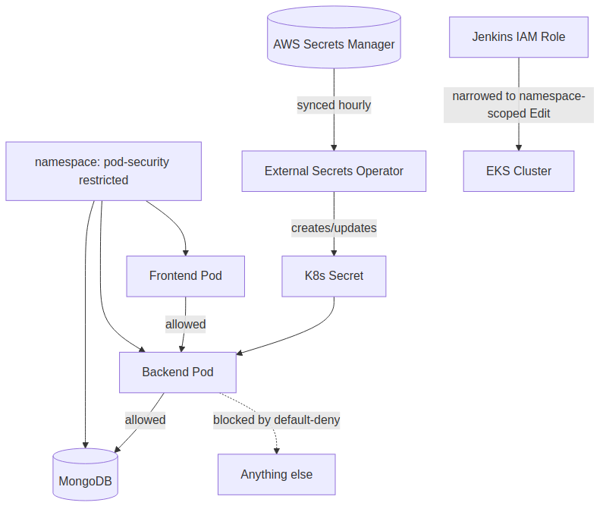
Figure 3. Security architecture: secret lifecycle, network segmentation, and scoped cluster access.

6.1 Secret Lifecycle Management
Secret handling in this project deliberately evolved across three phases rather than being solved correctly on the first attempt, and that evolution is preserved in the documentation as evidence of the reasoning process. A Helm-templated secret (Phase 7) is straightforward for an operator-invoked install but fundamentally incompatible with unattended GitOps reconciliation, since ArgoCD cannot supply an install-time secret value with no human present. The interim fix — a manually-created, GitOps-unmanaged Kubernetes Secret (Phase 8) — restored functionality but sacrificed automation and rotation. The final architecture (Phase 12) resolves both concerns: the External Secrets Operator synchronizes a Kubernetes Secret from AWS Secrets Manager on a fixed interval, meaning the Kubernetes manifest committed to Git contains only a reference to a secret's location, never its value, and rotating the underlying value in Secrets Manager propagates to the cluster automatically.

6.2 Network Segmentation
A default-deny Network Policy is applied at the namespace level, with explicit allow rules permitting only frontend-to-backend and backend-to-database traffic. Two limitations of this approach are documented rather than concealed: first, default-deny policies also block DNS resolution unless an explicit allow rule for UDP/TCP port 53 is added, a frequently-encountered and easily-misdiagnosed failure mode; second, because the AWS Load Balancer Controller routes directly to pod IP addresses from AWS-managed, non-fixed source addresses, ingress from the load balancer cannot be meaningfully restricted by IP at the Network Policy layer, and this boundary is instead enforced by TLS termination and AWS's own network controls. The concrete security property Network Policies do provide in this architecture is lateral-movement restriction: a compromised frontend pod cannot reach the database directly, only through the backend.

6.3 Pod Security Standards
The Kubernetes-native "restricted" Pod Security Standard is enforced at the namespace level, prohibiting privileged containers and mandating non-root execution. Because the application containers were built with explicit non-root users from Phase 1 onward, they satisfy this constraint without modification — a concrete, retrospective validation that the earlier container-hardening decisions were not merely stylistic.

6.4 Identity and Access Management
IAM permissions throughout the system follow an incremental least-privilege model: Jenkins' IAM role, for example, was granted broad EKS cluster-admin access in Phase 4 specifically to avoid blocking progress on cluster provisioning, with an explicit commitment to narrow that access once the actual operational requirement was clear — fulfilled in Phase 12 by replacing the cluster-admin grant with a namespace-scoped Edit policy via the EKS Access Entry API. This pattern — deliberately permissive to unblock early progress, followed by a scheduled and executed narrowing — is presented as a legitimate engineering practice, distinct from simply leaving broad permissions in place indefinitely.

7. CI/CD Pipeline
Figure 4 depicts the complete continuous integration flow. The defining property of this pipeline is that its three security gates are enforced, not advisory: a failing SonarQube quality gate, an OWASP Dependency-Check finding above the configured CVSS threshold, or a Trivy-detected HIGH/CRITICAL container vulnerability each independently halts the pipeline before an image reaches the container registry.
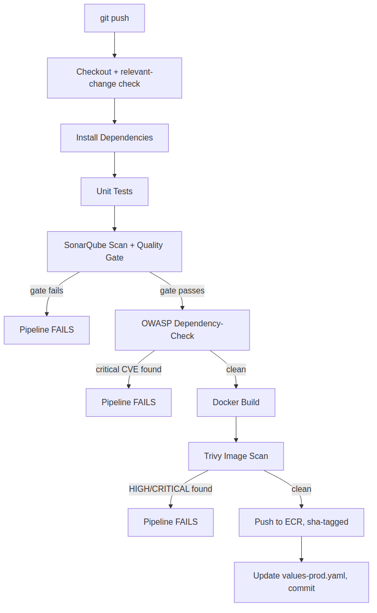
Figure 4. CI pipeline stages, showing each security gate as a genuine failure point.

7.1 Pipeline Design Decisions
- A shared Jenkins library factors the scan, build, and push logic common to both the frontend and backend pipelines, avoiding duplicated pipeline code across the two Jenkinsfiles.
- A relevant-change-detection stage inspects the diff of each triggering commit and aborts early if the change does not touch the corresponding tier, avoiding wasted, security-gate-running builds for unrelated changes in a monorepo — directly informed by the empirical CI-duration literature reviewed in Section 2.3.
- Every image is tagged with its triggering commit's short SHA, never solely "latest," so that any running container can be traced to an exact source revision.
- Each gate was verified by deliberately triggering its failure condition once (an intentionally introduced code smell, a deliberately vulnerable pinned dependency) and confirming the pipeline halted, rather than trusting the gate's presence in the pipeline definition alone.

8. GitOps and Continuous Delivery
Deployment in this system is not performed by the CI pipeline directly. Jenkins updates a Helm values file with a new image tag and commits that change to the repository; ArgoCD, continuously watching the repository, detects the change and reconciles the cluster to match. This separation — illustrated in Figure 5 — is the defining property of the GitOps model: the Git repository, not any individual pipeline run, is the authoritative description of desired cluster state.
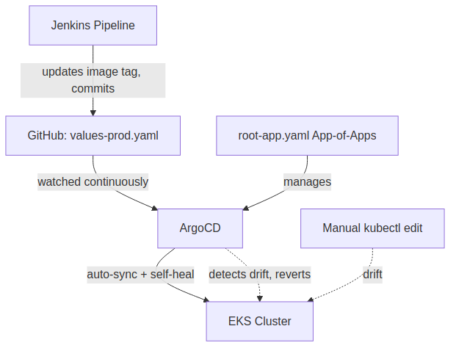
Figure 5. GitOps reconciliation flow, including the self-heal behavior that reverts manual cluster drift.

8.1 App-of-Apps Pattern
A single "root" ArgoCD Application manages a folder of child Application definitions, such that adding a new managed component — the monitoring stack in Phase 9, the External Secrets Operator in Phase 12 — requires only committing a new file to that folder, never an additional manual kubectl invocation. This is verified concretely, not merely asserted: a manual kubectl scale command issued directly against a managed Deployment was observed to be reverted automatically by ArgoCD's self-heal behavior within its polling interval.

8.2 A Documented Trade-off
The pipeline stage that commits an updated image tag pushes directly to the main branch, which — by design — bypasses the pull-request review process established for source-code changes in Phase 0. A more rigorous alternative, in which automated tag-bump commits are routed through a dedicated branch that ArgoCD watches instead of main, is documented as the more production-correct pattern and treated as a scoped extension rather than implemented, in the interest of containing this phase's complexity.

9. Observability and Monitoring
Figure 6 shows the observability data flow. A deliberate design principle underlies this subsystem: metrics instrument the application's actual business logic (diagram generation success, failure, and retry rates) in addition to generic infrastructure signals (request latency, pod restarts), since infrastructure-only monitoring cannot distinguish "the LLM API is degraded" from "the application has a defect," two failure modes that warrant materially different responses.
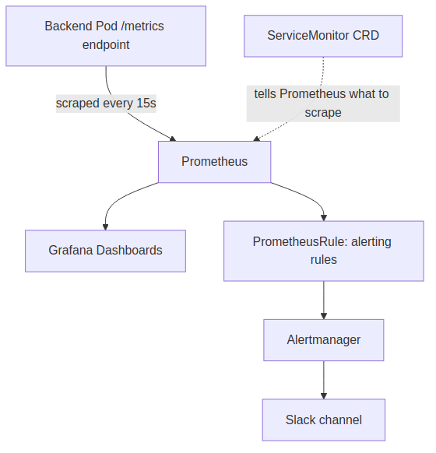
Figure 6. Observability pipeline: application-level metrics, alerting, and Slack routing.

9.1 Instrumentation
The backend exposes a Prometheus-format /metrics endpoint instrumented at two levels: HTTP request duration and status code (via middleware, applied uniformly), and diagram-generation-specific counters distinguishing first-attempt success, success-after-retry, and failure outcomes, directly instrumenting the validation-and-retry mechanism discussed in Sections 2.1 and 5.

9.2 Alerting Design
Alert rules are written to be diagnostically specific rather than purely threshold-based; for example, the diagram-generation-failure-rate alert's annotation explicitly suggests the likely cause is an upstream LLM API issue rather than an application defect, narrowing the responder's first investigative step. Alert delivery is routed to a dedicated Slack channel via Alertmanager, with the webhook credential itself supplied through a mounted Kubernetes Secret rather than embedded in committed configuration, consistent with the secret-handling discipline established in Section 6.1.

10. Testing Strategy

10.1 Backend Testing
Backend tests (Jest and Supertest) cover three layers: input validation middleware (empty input, missing field, length-limit enforcement), the health-check endpoint depended upon by Kubernetes liveness and readiness probes, and — most significantly — the diagram-type-to-syntax structural validation function underlying the retry mechanism, with an explicit test case constructing the exact mismatch condition (a diagram type paired with syntax for a different type) that the retry loop exists to catch.

10.2 Frontend Testing
Frontend component tests (Vitest and React Testing Library) verify the input component's interaction logic: that the generation action is disabled for empty input, enabled once text is present, and correctly invoked with the entered text.

10.3 Infrastructure Verification
Given the project's emphasis on infrastructure correctness, verification extends beyond application unit tests to deliberate infrastructure-level checks performed once and documented as evidence rather than assumed: killing the MongoDB pod to confirm persistent-volume reattachment, scaling a Deployment manually to confirm ArgoCD's self-heal reversion, deliberately introducing a vulnerable dependency to confirm the OWASP gate halts the pipeline, and executing a full backup-restore cycle against a scratch database rather than trusting an untested backup mechanism.

11. Cost Analysis and Resource Management
A continuously-running instantiation of this system was estimated, prior to any optimization, at approximately USD 140–150 per month, dominated by the EKS control plane (a fixed cost of approximately USD 0.10 per hour, independent of usage, and not pausable short of cluster deletion) and the associated managed node group and Application Load Balancer.
Resource | Approx. Monthly Cost | Pausable?
EKS control plane | ~$73 | No — destroy/recreate only
EKS node group (2× t3.medium, Spot) | ~$15–20 | No — destroy/recreate only
Application Load Balancer | ~$16–20 + data | Deleted with its Ingress
Jenkins EC2 (t3.medium) | ~$30 running / ~$2–3 stopped | Yes — stop/start
ECR, S3, Route53 | ~$3–5 combined | N/A — negligible cost to retain
Cost discipline is enforced through two mechanisms: an AWS Budget alert established before any infrastructure was provisioned (Phase 0), and a documented, dependency-ordered teardown procedure (Phase 13) that explicitly guards against the most significant identified cost risk — an orphaned Application Load Balancer resulting from destroying the EKS cluster before its Ingress (and the ALB it provisions) has been deleted, since the ALB is not itself a Terraform-tracked resource.

12. Engineering Retrospective
This section documents, without editing for narrative convenience, the substantive engineering corrections made during implementation. These are presented as the project's primary demonstrated competency: the capacity to identify a design or configuration defect, reason about its cause, and correct it — a capacity a final, corrected-only account of the system cannot itself demonstrate.

EBS CSI Driver Omission (discovered in Phase 11, originating in Phase 4)
Recent versions of Amazon EKS do not provision EBS-backed persistent volumes without the EBS CSI driver explicitly installed as a cluster add-on, a change from earlier EKS versions' in-tree provisioning behavior. This was discovered when MongoDB's PersistentVolumeClaim remained indefinitely in a Pending state. The correction — adding the add-on and its associated IAM role to the Phase 4 Terraform configuration, retroactively — illustrates that infrastructure omissions can remain latent for several build phases before manifesting.

Secret Management Evolution (Phases 7, 8, 12)
Detailed in Section 6.1. The progression from a Helm-templated secret, to a manually-created interim workaround, to a fully automated External Secrets Operator integration is preserved as documentation of an iterative correction process rather than compressed into only the final state.

Over-Broad Initial IAM Grant (Phases 4, 12)
Jenkins was granted full EKS cluster-admin access in Phase 4 to avoid blocking cluster-provisioning progress, with an explicit, subsequently-honored commitment to narrow that grant once actual operational requirements were understood — completed in Phase 12 via a namespace-scoped Edit policy.

Webhook Connectivity Versus Network Restriction (Phase 3)
A security group restricting Jenkins' inbound access to the operator's own IP address is, by construction, incompatible with GitHub's webhook delivery mechanism, which originates from GitHub-controlled infrastructure. This was resolved by allow-listing GitHub's published webhook source IP ranges rather than opening the port unrestricted, preserving the security posture while restoring functionality.

ALB Orphaning Risk (identified proactively in Phase 13)
Because the Application Load Balancer is provisioned by the AWS Load Balancer Controller in response to a Kubernetes Ingress object, rather than directly by Terraform, destroying the EKS cluster while the Ingress still exists can leave an orphaned, continuously-billing load balancer with no corresponding Terraform state reference. This risk was identified during the design of the teardown procedure, prior to being encountered as an incident, and an explicit ordering safeguard was built into the teardown runbook as a result.

Single-Provider Dependency and Unbounded Fallback Cost (post-launch revision)
The generation service was initially implemented against a single hard-coded provider (Claude). This was revised to a provider-abstracted design (Section 4.5) once the single-provider dependency was recognized as both a resilience risk (one vendor's outage fully disables the product) and, separately, a cost risk once a free-tier default provider was introduced: a naive fallback-on-error implementation would silently convert a free provider's quota exhaustion into unbounded paid usage, since a quota error and a transient failure are indistinguishable to calling code without an explicit check. The correction — a MongoDB-backed daily usage counter gating the fallback path itself — was added specifically to close this, rather than trusting alerting alone to catch it after the fact.

13. Conclusion and Future Work
This project set out to demonstrate that a narrowly-scoped, genuinely useful AI application and a complete, production-oriented DevSecOps delivery pipeline could be built as a single, coherent system, with each reinforcing the other: the application provides real, if modest, traffic that exercises the pipeline's operational disciplines meaningfully, and the pipeline's security and observability tooling gives the application a genuine production posture rather than a deployed-once demonstration.
Several directions are identified for future extension, each explicitly scoped rather than left vague: migrating worker nodes to private subnets behind a NAT Gateway for stronger network isolation; converting the single-replica MongoDB StatefulSet into a true high-availability replica set; separating the GitOps configuration into a dedicated repository from the application source, the more conventional production pattern; routing automated CI tag-bump commits through a dedicated branch rather than directly to main, preserving pull-request review for all changes to the deployed state; and extending the provider abstraction introduced in Section 4.5 with a third, self-hosted option (via vLLM or Ollama, using constrained decoding to improve structured-output reliability on smaller open models), letting generation run with zero external API dependency entirely, at the cost of the GPU infrastructure such a deployment would require.
More broadly, this report has attempted to treat engineering judgment — the reasoning behind a decision, the trade-off accepted, the defect discovered and corrected — as content equally as important as the final working system, on the premise that the former, not the latter alone, is what a technical reviewer or interviewer is actually evaluating.

References
Yang, S. et al. (2025). Automating Software Diagram Generation with Large Language Models. ScienceDirect / Journal of Systems and Software.
GenAI-DrawIO-Creator: LLM-Assisted Diagram Generation with Claude (2026). arXiv:2601.05162.
Kim, D. et al. (2023). Graphologue: Exploring Large Language Model Responses with Interactive Diagrams. ACM Symposium on User Interface Software and Technology (UIST).
Cai, J. et al. (2023). DiagrammerGPT: Generating Open-Domain, Open-Platform Diagrams via LLM Planning. arXiv:2310.12128.
Shamim, M. S. I., Bhuiyan, F. A., & Rahman, A. (2020). XI Commandments of Kubernetes Security: A Systematization of Knowledge Related to Kubernetes Security Practices. IEEE Secure Development Conference (SecDev).
Rahman, A., Shamim, S. I., Bose, D. B., & Pandita, R. (2023). Security Misconfigurations in Open Source Kubernetes Manifests: An Empirical Study. ACM Transactions on Software Engineering and Methodology (TOSEM).
Jarkas, O., Ko, R., Dong, N., & Mahmud, N. (2025). A Container Security Survey: Exploits, Attacks, and Defenses. ACM Computing Surveys.
Ghaleb, T. A., Da Costa, D. A., & Zou, Y. (2019). An Empirical Study of the Long Duration of Continuous Integration Builds. Empirical Software Engineering, 24.
Rausch, T., Hummer, W., Leitner, P., & Schulte, S. (2017). An Empirical Analysis of Build Failures in the Continuous Integration Workflows of Java-Based Open-Source Software. IEEE/ACM International Conference on Mining Software Repositories (MSR).
Verma, A., Pedrosa, L., Korupolu, M., Oppenheimer, D., Tune, E., & Wilkes, J. (2015). Large-Scale Cluster Management at Google with Borg. ACM European Conference on Computer Systems (EuroSys).
Ongaro, D., & Ousterhout, J. (2014). In Search of an Understandable Consensus Algorithm. USENIX Annual Technical Conference (ATC).
Yao, S. et al. (2023). ReAct: Synergizing Reasoning and Acting in Language Models. International Conference on Learning Representations (ICLR).
Shinn, N., Cassano, F., Berman, E., Gopinath, A., Narasimhan, K., & Yao, S. (2023). Reflexion: Language Agents with Verbal Reinforcement Learning. Advances in Neural Information Processing Systems (NeurIPS).

