22AIE452 — Data Driven Material Modelling and Simulation
Term Project — Zeroth Review
Domain-Specific LLM Assistant
for Materials Science Literature (RAG + NER)
What's in this document
• Objective — what the project sets out to do, and why
• Our approach explained in plain terms, and the base paper it is built on
• The base paper's documented drawbacks, and exactly how our design improves on each one
• Supporting literature behind every individual improvement
• Datasets, models, and the complete tech stack — with verified, working links
• The full end-to-end pipeline, with diagrams, and planned deliverables

1. Objective
This project builds a chatbot/tool that lets a user query materials science literature in natural language — for example, "What alloys have been reported with hardness above 9 GPa?" — and receive an answer that is grounded in real published papers, with the exact source passages shown alongside the answer. Alongside answering questions, the system automatically extracts structured material → property → value facts from unstructured abstracts.
More concretely, the project aims to:
- Curate a focused corpus of a few hundred materials science abstracts from arXiv (e.g., high-entropy alloys and/or solid-state hydrogen storage).
- Fine-tune / apply MatSciBERT to extract MATERIAL, PROPERTY, and VALUE entities from this corpus, and benchmark it against a generic BERT model fine-tuned on the same labeled data — to demonstrate the value of domain-specific pretraining.
- Build a Retrieval-Augmented Generation (RAG) pipeline (chunking → embedding → FAISS similarity search → LLM-generated answer) so that every generated answer is grounded in, and traceable to, real retrieved abstracts rather than the LLM's possibly hallucinated internal knowledge.
- Present the system through a Streamlit chat interface, with citations displayed next to every answer, and a lightweight CI workflow (GitHub Actions) to smoke-test the pipeline.
The central motivation is hallucination: general-purpose LLMs answer fluently but are not reliably correct on niche, specific technical questions (a precise property value, an alloy composition, a citation). Retrieval-Augmented Generation addresses this by forcing the model to answer only from real retrieved text, and Named Entity Recognition addresses the complementary problem of pulling structured, usable facts out of unstructured scientific prose.

2. Our Approach — The Idea in Plain Terms
The idea is to combine two complementary AI techniques that are normally built separately, so that each covers the other's weak spot:
- RAG (Retrieval-Augmented Generation): handles free-form questions. Instead of trusting an LLM's memorized (and sometimes wrong) knowledge, the system first retrieves the real passages most relevant to the question, then asks the LLM to answer using only those passages. This is what makes every answer traceable and checkable.
- NER (Named Entity Recognition): handles structured fact mining. A domain-tuned model (MatSciBERT) reads every abstract and tags spans of text as MATERIAL, PROPERTY, or VALUE — turning "the CrMoNbTiW alloy showed a hardness of 9.2 GPa" into a clean row in a table: (material = CrMoNbTiW, property = hardness, value = 9.2 GPa). This is what makes the corpus queryable as structured data, not just as text.
The novelty of this project (developed in detail in Sections 4–6) is combining the two: the structured facts table produced by NER is used to enrich the prompt given to the RAG generator, so answers can draw on both the free-text passage and the pre-extracted, disambiguated fact — directly addressing the multi-entity confusion problem documented in our chosen base paper.
In short: retrieval keeps the system honest (grounded in real text); extraction keeps it precise (grounded in a specific, disambiguated fact); and showing both to the user keeps it verifiable.

3. Base Paper
Following the mentor's guidance, this project anchors on a single, latest base paper closest to its own scope and topic — rather than treating several related papers as equally foundational. Its documented drawbacks are then used directly as the improvement targets that define this project's novelty (Section 5).
Retrieval-Augmented Generation for Building Datasets from Scientific Literature
Maharana, P. R., Verma, A., & Joshi, K. (2025). Journal of Physics: Materials, 8, 035006.
https://doi.org/10.1088/2515-7639/ade1fa
Why this is the base paper: it is the most recent (2025) and closest match to this project on both axes — topic (solid-state hydrogen storage materials, one of the two corpus areas suggested for this project) and architecture (chunk → embed → retrieve → generate over scientific abstracts, using an open LLM). It is, in effect, the published version of close to the exact system this project sets out to build.

3.1 What the base paper did
The authors built a Retrieval-Augmented Generation pipeline using an open-source LLM (Gemma2-9B) to extract structured property data for solid-state hydrogen storage materials directly from scientific abstracts. They compared answer accuracy with RAG (retrieve-then-generate) versus direct prompting of the same base model with no retrieval at all.

3.2 Key result
RAG substantially reduced hallucination and increased the number of correct responses compared to direct prompting on the same model — a clean, reproducible demonstration that grounding an LLM's answers in retrieved real text meaningfully helps, using fully open tooling that a student project can realistically replicate.

4. Drawbacks of the Base Paper
These limitations are documented by the authors themselves (in their own error analysis and system description), not speculative gaps we are inferring:
- Multi-entity confusion: When a single abstract mentions multiple alloys or materials, the model sometimes conflates values across materials in the same passage — producing an incomplete or hallucinated answer.
- No dedicated extraction layer: The system asks the generation LLM to both find and extract the structured fact in one step; there is no domain-specific Named Entity Recognition model doing the extraction, so the LLM is doing extraction "blind," with no explicit MATERIAL / PROPERTY / VALUE tagging to lean on.
- "Naive" retrieval: The authors themselves describe the system as simple: a single fixed retrieve-then-generate pass, with no re-ranking, no hybrid (keyword + semantic) search, and no query reformulation.
- Small, unverified final dataset: The final curated dataset contained only 59 data points, illustrating how much manual verification RAG-extracted scientific data still needs before it can be trusted at scale — there is no automatic self-verification step after generation.

5. Our Novelty — How We Improve on It
Each drawback above is addressed by a specific, deliberate design choice in this project. This mapping is the core novelty argument for the mentor discussion — the project is not "a RAG chatbot" in the abstract, it is a direct, targeted improvement on a named, recent, published system.
Drawback in the base paper | Our improvement
Multi-entity confusion across materials in the same passage | A dedicated MatSciBERT NER layer explicitly tags MATERIAL / PROPERTY / VALUE spans before generation, instead of leaving disambiguation to the generation LLM alone
No dedicated extraction layer — LLM does extraction "blind" | NER output is stored as a structured facts table (material, property, value, source) that can enrich the prompt alongside retrieved passages — combining NER and RAG into one system, which the field's own 2025 survey literature flags as rare
Naive, single-pass retrieval with no re-ranking or query reformulation | Documented as a concrete, prioritized future-work upgrade: an agentic retrieval loop with dynamic query refinement (see Section 6.4)
Small, unverified final dataset; no self-verification step | A self-verification step after generation, plus source abstracts shown alongside every answer, so every claim is human-checkable end to end

Two additional, concrete benchmarking outputs strengthen this novelty claim beyond the base paper's scope:
- A direct NER benchmark (MatSciBERT vs. generic BERT on the same labeled data) — quantifying, on our own corpus, why a domain-specific extraction layer is worth adding at all, something the base paper does not test.
- Evaluating RAG and NER quality together rather than in isolation — extending prior domain-pretraining studies (which only measure NER accuracy on its own) into whether better entity extraction actually produces better downstream, grounded answers.

6. Supporting Literature Behind Each Improvement
These papers are not the base paper — they are the literature basis for each specific improvement above, i.e. the evidence that each proposed fix is a real, published, working technique rather than an untested idea.

6.1 For the NER extraction layer
MatSciBERT: A Materials Domain Language Model for Text Mining and Information Extraction
Gupta, T., Zaki, M., Krishnan, N. M. A., & Mausam. (2022). npj Computational Materials, 8, 102.
https://www.nature.com/articles/s41524-022-00784-w
Source of the pretrained MatSciBERT model this project reuses for the NER layer that the base paper lacks. Reports MatSciBERT outperforming generic BERT and SciBERT on materials-science NER.

Quantifying the Advantage of Domain-Specific Pre-training on Named Entity Recognition Tasks in Materials Science
Trewartha, A., Walker, N., Huo, H., Lee, S., Cruse, K., Dagdelen, J., Dunn, A., Persson, K. A., Ceder, G., & Jain, A. (2022). Patterns, 3(4), 100488.
https://doi.org/10.1016/j.patter.2022.100488
Justifies the exact NER benchmarking method this project runs (MatSciBERT vs. generic BERT, identical labeled data, held-out test set). Notes the advantage is largest precisely in low-data regimes — the realistic setting for a semester project — and that it does not itself test downstream RAG performance, a gap this project's combined evaluation extends into.

6.2 For structured, linked entity extraction (fixing multi-entity confusion)
Structured Information Extraction from Scientific Text with Large Language Models
Dagdelen, J., Dunn, A., Lee, S., Walker, N., Rosen, A. S., Ceder, G., Persson, K. A., & Jain, A. (2024). Nature Communications, 15, 1418.
https://www.nature.com/articles/s41467-024-45563-x
Fine-tunes a model to output linked {material, property, value} records directly rather than tagging spans independently — the technique basis for resolving the "which value belongs to which material" ambiguity documented in the base paper.

6.3 For the self-verification step
Extracting Accurate Materials Data from Research Papers with Conversational Language Models and Prompt Engineering (ChatExtract)
Polak, M. P., & Morgan, D. (2023, revised 2024). Nature Communications.
https://arxiv.org/abs/2303.05352
Uses follow-up, conversational prompts that force a model to double-check and correct its own extractions, reaching ~90% precision/recall with zero fine-tuning. Basis for the self-verification step this project adds after generation, directly addressing the base paper's lack of automatic answer checking.

6.4 For the future-work retrieval upgrade (query refinement)
Nanostructured Material Design via a Retrieval-Augmented Generation (RAG) Approach
Krotkov, N. A., Sbytov, D. A., Chakhoyan, A. A., Kornienko, P. I., et al. (2025). Journal of Chemical Information and Modeling, 65(20), 11064-11078.
https://pubs.acs.org/doi/10.1021/acs.jcim.5c01897
A 2025 agent-based RAG system that dynamically refines its own search query instead of a single fixed retrieval pass, reporting improved grounding (semantic accuracy 0.82, precision 0.81) over naive single-pass retrieval. Evidence that upgrading the base paper's naive retrieval step is a real, working direction — noted here as prioritized future work rather than core scope, given added system complexity.

6.5 Positioning the combined NER + RAG novelty
Information Extraction for Materials Science Using Large Language Models: A Survey of Recent Advances and New Frontiers
(2025). ScienceDirect.
https://www.sciencedirect.com/science/article/pii/S2352492826009402
A broad, recent survey of the field that explicitly identifies combined extraction (NER/relation extraction) and generation/retrieval (RAG) systems as under-explored, since the two threads have largely developed separately. Directly supports this project's central novelty claim: a system that does both together, evaluated jointly, is genuinely uncommon in the current literature.

7. Datasets
The project uses two distinct datasets — one for building the retrieval corpus (raw literature) and one for training/evaluating the NER model (labeled entity spans) — and both are free, public, and require no institutional access.

7.1 Raw literature corpus (for RAG)
Source: arXiv API, filtered to the cond-mat.mtrl-sci category, with topic keywords such as "high entropy alloy hardness" or "solid state hydrogen storage." Roughly a few hundred abstracts (~300-500) are pulled to keep the corpus focused and manageable for a semester project.
arXiv API documentation: https://info.arxiv.org/help/api/index.html
arXiv API query endpoint: http://export.arxiv.org/api/query
arxiv Python package (used to query the API in code): https://pypi.org/project/arxiv/
Each record retrieved contains the paper's arXiv ID, title, abstract text, and publication date — the abstract text is what gets chunked, embedded, and indexed in FAISS; the arXiv ID is preserved throughout the pipeline so every answer can be traced back to its exact source paper.

7.2 Labeled NER benchmark dataset (for training / evaluating MatSciBERT vs. BERT)
Dataset: Matscholar NER dataset (UC Berkeley / Lawrence Berkeley National Laboratory) — the same benchmark dataset the original MatSciBERT paper itself was evaluated on, so results from this project are directly comparable to published, peer-reviewed numbers.
Matscholar dataset repository: https://github.com/materialsintelligence/matscholar
What it contains: materials-science sentences labeled with 7 entity types:
- MAT — inorganic material
- SPL — symmetry / phase label
- DSC — sample descriptor
- PRO — material property
- APL — material application
- SMT — synthesis method
- CMT — characterization method
Size: a well-known, citable split of 440 training sentences, 511 validation sentences, and 546 test sentences. This project will focus primarily on the MAT, PRO (property), and associated value spans relevant to our MATERIAL / PROPERTY / VALUE extraction goal.
Optionally, a small custom-labeled subset of our own arXiv corpus (Section 7.1) will also be manually annotated using Doccano (Section 8) and combined with, or compared against, the Matscholar benchmark — to demonstrate the full annotation-to-training pipeline end to end.

7.3 Dataset summary table
What / Source | Link / Notes
Raw literature (abstracts) — arXiv API | export.arxiv.org/api/query — Free, no signup; ~300-500 abstracts, topic-filtered
Labeled NER benchmark — Matscholar (UC Berkeley / LBNL) | github.com/materialsintelligence/matscholar — 440/511/546 train/val/test split; same split used in the MatSciBERT paper
Optional custom-labeled data — Our own annotation via Doccano | github.com/doccano/doccano — Small hand-labeled subset of our arXiv corpus

8. Models and Tools

8.1 Domain-specific language model (NER)
MatSciBERT — publicly available on the Hugging Face Model Hub, free, no API key required.
https://huggingface.co/m3rg-iitd/matscibert
from transformers import AutoTokenizer, AutoModel
tokenizer = AutoTokenizer.from_pretrained("m3rg-iitd/matscibert")
model = AutoModel.from_pretrained("m3rg-iitd/matscibert")

8.2 Generic baseline model (for the NER comparison)
bert-base-uncased — the standard generic BERT checkpoint, fine-tuned on the exact same labeled data (Section 7.2) as MatSciBERT, so the only variable being tested is the value of domain-specific pretraining.
https://huggingface.co/bert-base-uncased

8.3 Pretrained NER shortcut (optional, if skipping fine-tuning from scratch)
A ready-to-run model already trained on the Matscholar dataset:
LBNLP toolkit: https://lbnlp.github.io/lbnlp/pretrained/02ner/
MatBERT_NER training framework (Ceder Group, UC Berkeley): https://github.com/CederGroupHub/MatBERT_NER

8.4 Embedding model (for RAG retrieval)
sentence-transformers/all-MiniLM-L6-v2 — a small, fast, well-established sentence-embedding model; a good default for a semester-scale corpus. Converts each passage and each incoming query into a dense vector living in the same vector space, which is what makes similarity search meaningful.
https://huggingface.co/sentence-transformers/all-MiniLM-L6-v2

8.5 Vector store (for similarity search)
FAISS (faiss-cpu) — Facebook AI Similarity Search, an open-source library for fast nearest-neighbor search over dense vectors. faiss-cpu is sufficient at this project's scale (a few hundred to a few thousand passages); faiss-gpu would only be needed if the corpus grew into the hundreds of thousands.
https://github.com/facebookresearch/faiss

8.6 Generation model (for answering questions)
google/flan-t5-base — a moderately sized, instruction-tuned, open T5-family model. Takes the retrieved passages plus the user's question as a prompt and generates a grounded answer, with an explicit "if the answer is not in the context, say you don't know" instruction to reduce hallucination.
https://huggingface.co/google/flan-t5-base

8.7 Manual annotation tool (optional)
Doccano — a free, open-source, browser-based tool for manually labeling MATERIAL / PROPERTY / VALUE spans in our own abstracts, to build a small custom-labeled evaluation or training set alongside the Matscholar dataset.
https://github.com/doccano/doccano

8.8 Interface, training, and automation libraries
- transformers, datasets, seqeval, accelerate — model loading, fine-tuning, and entity-level F1 scoring
- Streamlit — the chat-style web interface for the demo
- GitHub Actions — CI workflow that smoke-tests the pipeline on every push

8.9 Complete tech stack summary
Layer / Tool | Link / Role
Corpus collection — arxiv (Python package) | pypi.org/project/arxiv — Pull abstracts from the arXiv API
NER model (domain) — MatSciBERT | huggingface.co/m3rg-iitd/matscibert — Extract MATERIAL/PROPERTY/VALUE entities
NER model (baseline) — bert-base-uncased | huggingface.co/bert-base-uncased — Generic-pretraining comparison point
NER training / eval — transformers, datasets, seqeval | huggingface.co/docs/transformers — Fine-tuning and entity-level F1 scoring
Embeddings — sentence-transformers (all-MiniLM-L6-v2) | huggingface.co/sentence-transformers/all-MiniLM-L6-v2 — Convert text to dense vectors
Vector search — FAISS (faiss-cpu) | github.com/facebookresearch/faiss — Nearest-neighbor passage retrieval
Answer generation — Flan-T5-base | huggingface.co/google/flan-t5-base — Generate grounded answers from retrieved context
Annotation (optional) — Doccano | github.com/doccano/doccano — Manually label custom training sentences
User interface — Streamlit | streamlit.io — Chat-style web app for the live demo
Automation / CI — GitHub Actions | github.com/features/actions — Run pipeline smoke-tests on every push

Every resource in this stack is free, publicly available, and requires no paid subscription or special institutional access — the entire project is reproducible by anyone with a laptop (a free Google Colab account is recommended, though not required, for faster fine-tuning).

9. End-to-End Pipeline
The system has two distinct phases: Phase A builds the knowledge base once (and is re-run only when the corpus is updated); Phase B answers a user's question every time it is asked, using the knowledge base built in Phase A. Unlike the base paper's single-pass "retrieve → generate" design, this pipeline adds a parallel NER extraction path that feeds a structured facts table into the prompt — this is the pipeline-level view of the novelty argument in Section 5.
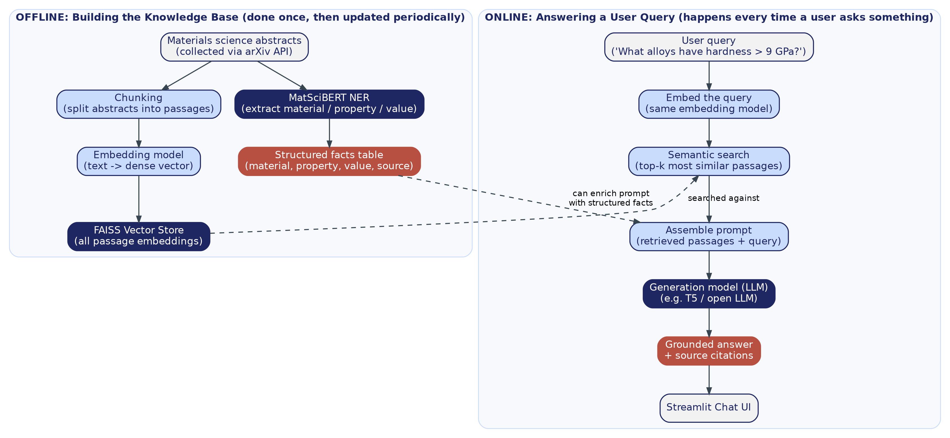
Figure 1 — Left (Phase A / offline): the knowledge base is built once. Right (Phase B / online): every user query is answered using that knowledge base.

9.1 Phase A — Building the Knowledge Base (offline, done once)
- 1. Collect a focused set of real materials science abstracts from the arXiv API (topic-filtered to 'high entropy alloy' and/or 'solid state hydrogen storage', scoped to the cond-mat.mtrl-sci category) and save them as corpus.jsonl (id, title, abstract, publication date).
- 2. Chunk each abstract into passages — for a semester-scale corpus, each abstract can be treated as one passage; longer full-text documents would be split into ~200-word overlapping chunks instead.
- 3. Embed every passage with the sentence-transformers MiniLM model, normalize the vectors, and add them to a FAISS index (inner product on normalized vectors = cosine similarity) — saved to disk as faiss.index alongside the original passage text/metadata.
- 4. Separately, run every abstract through the MatSciBERT NER pipeline to extract (material, property, value) facts and store them in a structured facts table, linked back to their source arXiv ID.

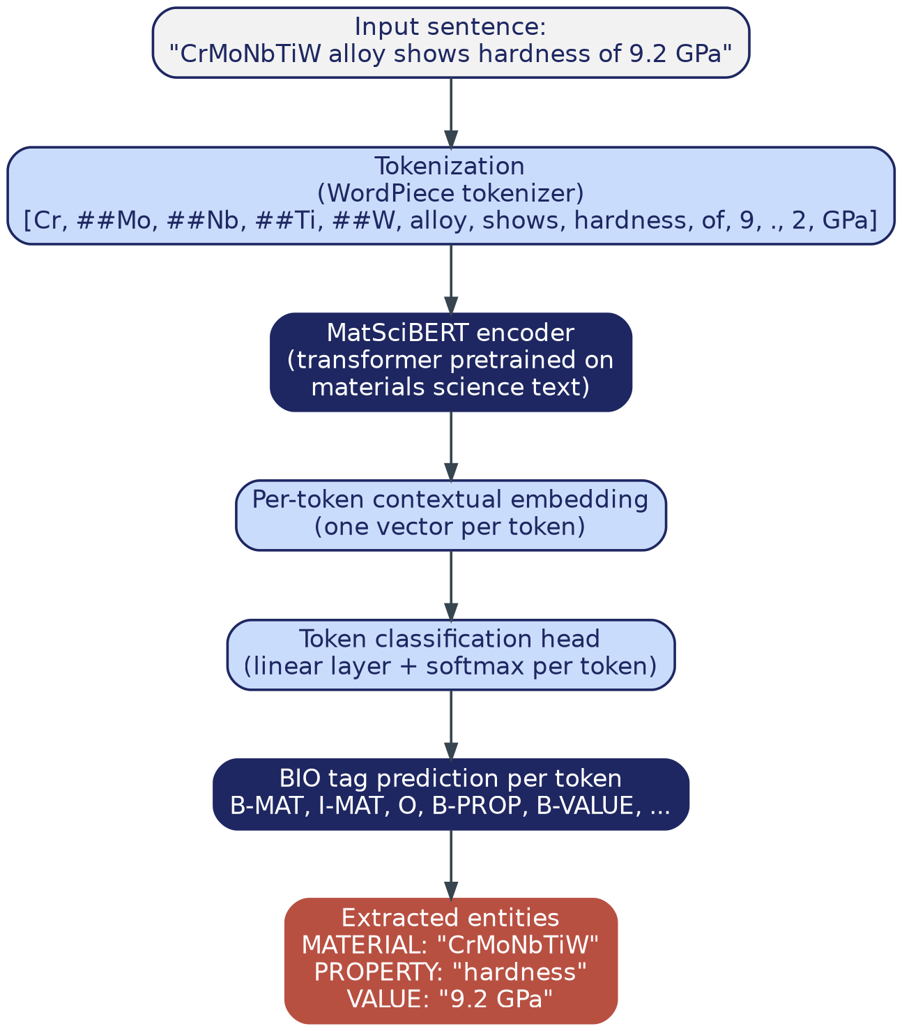
Figure 2 — Zooming into step 4 of Phase A: a sentence is tokenized, passed through MatSciBERT, and every token is classified using BIO tagging (Beginning/Inside/Outside of an entity), then reassembled into clean MATERIAL/PROPERTY/VALUE entities.

9.2 Phase B — Answering a Question (online, every query)
- 1. A user types a natural-language question into the Streamlit chat interface.
- 2. The question is embedded using the same MiniLM model used in Phase A (query and passage embeddings must live in the same vector space to be comparable).
- 3. FAISS finds the top-k (e.g., k=5) most similar passages to the question by cosine similarity.
- 4. Those passages — and, where relevant, matching rows from the structured facts table — are assembled into a prompt: "Answer the question using ONLY the context below. If the answer is not contained in the context, say you don't know," followed by the numbered passages and the question.
- 5. Flan-T5-base generates an answer from that prompt.
- 6. The answer and its source passage(s) are shown together in the Streamlit chat UI, with each source expandable/clickable so the user can verify the claim against the original abstract.
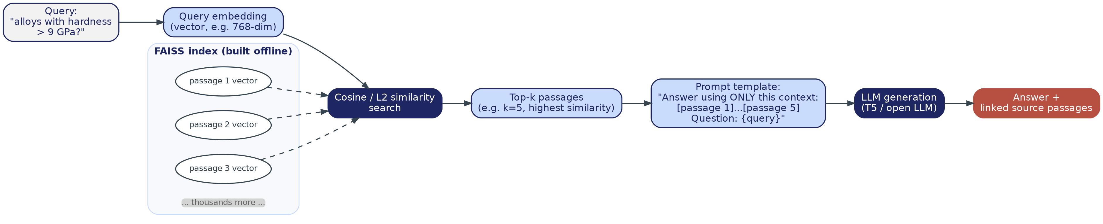
Figure 3 — Phase B zoomed in: query embedding, FAISS similarity search, top-k passage selection, and prompt assembly before generation.

9.3 How the NER model itself is trained and evaluated
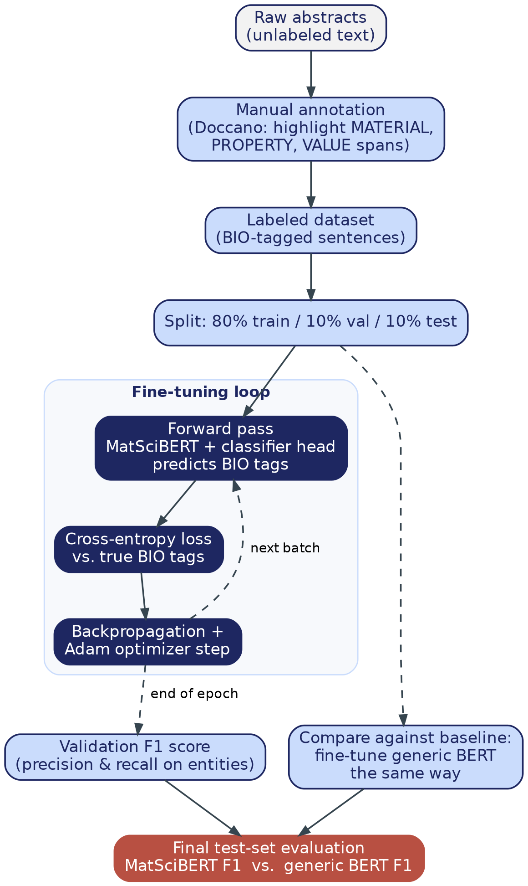
Figure 4 — MatSciBERT and generic BERT are fine-tuned on identical labeled data and compared on a held-out test set — the direct, controlled experiment behind our novelty claim in Section 5.
MatSciBERT and generic bert-base-uncased are both fine-tuned on the same labeled data — the Matscholar benchmark dataset (Section 7.2), optionally combined with a small custom-labeled subset of our own corpus. Both models are then compared on the same held-out test set using entity-level F1 score (computed with the seqeval library), which combines precision and recall over exact entity spans rather than individual tokens. This is the concrete experiment that replicates, at smaller scale, the comparison in the original MatSciBERT paper (Section 6.1) — the expected, citable result is that MatSciBERT outperforms generic BERT, especially in this project's realistic, low-data regime.

9.4 How the RAG pipeline itself is evaluated
Since there is no single 'correct sentence' to automatically grade a generated answer against, the practical evaluation is: write ~15-20 test questions by hand (each with a known, expected source abstract), run them through the pipeline, and check whether the expected source is actually among the top-k retrieved passages — a simple, defensible metric called retrieval hit rate. This is supplemented with a manual read-through of a sample of generated answers, to confirm they are actually grounded in the retrieved passages rather than ignoring them.

10. Planned Deliverables
Deliverable | Description
NER benchmark | MatSciBERT vs. generic BERT, compared via entity-level F1 on the Matscholar test split
RAG pipeline | Working chunk → embed → FAISS → generate pipeline with source citations shown per answer
Structured facts table | Automatically extracted (material, property, value, source) records mined from the whole corpus
Streamlit demo | Chat interface for querying the corpus, with citations next to each answer
GitHub repository | Includes a CI (GitHub Actions) workflow that smoke-tests the pipeline

10.1 What we will be able to demo live
- Typing a materials-science question into the chat interface and watching it retrieve real passages from actual papers.
- A generated answer with the source abstract(s) shown directly underneath, expandable for verification.
- A table of automatically extracted (material, property, value) facts mined from the whole corpus — something that would take a human many hours to compile by hand.
- A side-by-side chart comparing MatSciBERT vs. generic BERT on our NER benchmark.

11. References
Base paper
Maharana, P. R., Verma, A., & Joshi, K. (2025). Retrieval-Augmented Generation for Building Datasets from Scientific Literature. J. Phys. Materials, 8, 035006. https://doi.org/10.1088/2515-7639/ade1fa
Supporting literature
Gupta, T. et al. (2022). MatSciBERT: A Materials Domain Language Model for Text Mining and Information Extraction. npj Computational Materials, 8, 102. https://www.nature.com/articles/s41524-022-00784-w
Trewartha, A. et al. (2022). Quantifying the Advantage of Domain-Specific Pre-training on NER Tasks in Materials Science. Patterns, 3(4), 100488. https://doi.org/10.1016/j.patter.2022.100488
Dagdelen, J. et al. (2024). Structured Information Extraction from Scientific Text with Large Language Models. Nature Communications, 15, 1418. https://www.nature.com/articles/s41467-024-45563-x
Polak, M. P., & Morgan, D. (2023, revised 2024). Extracting Accurate Materials Data from Research Papers with Conversational Language Models and Prompt Engineering (ChatExtract). Nature Communications. https://arxiv.org/abs/2303.05352
Krotkov, N. A. et al. (2025). Nanostructured Material Design via a Retrieval-Augmented Generation (RAG) Approach. J. Chem. Inf. Model., 65(20), 11064-11078. https://pubs.acs.org/doi/10.1021/acs.jcim.5c01897
(2025). Information Extraction for Materials Science Using Large Language Models: A Survey of Recent Advances and New Frontiers. https://www.sciencedirect.com/science/article/pii/S2352492826009402
Datasets and tools
arXiv API — https://info.arxiv.org/help/api/index.html
Matscholar NER dataset — https://github.com/materialsintelligence/matscholar
MatSciBERT model — https://huggingface.co/m3rg-iitd/matscibert
sentence-transformers/all-MiniLM-L6-v2 — https://huggingface.co/sentence-transformers/all-MiniLM-L6-v2
Flan-T5-base — https://huggingface.co/google/flan-t5-base
FAISS — https://github.com/facebookresearch/faiss
Doccano — https://github.com/doccano/doccano

