LOVELY PROFESSIONAL UNIVERSITY
School of Computer Science and Engineering
A Project Report on
HOSTEL ROOMMATE MATCHER
A Full-Stack Web Application for Compatibility-Based Hostel Roommate Recommendation
Submitted in partial fulfilment of the requirements for the award of the degree of Bachelor of Computer Applications (BCA)
Subject: Data Structures and Algorithms
Submitted by: Dhruv Kumar
Registration Number: 12409374 Team Members
AASHI SARRAF :12409442
ADITI KAMAL : 12411058
MAHAK SINGH :12417676
Chandu Kumar : 12418789

Department of Computer Science and Engineering | Session: 2026
GitHub Repository: https://github.com/Mahaksingh2006/Hostel-Roommate-Matcher
Live Deployment: https://elegant-phoenix-354e52.netlify.app/

Certificate
This is to certify that the project report entitled "Hostel Roommate Matcher" is a bonafide record of the work carried out by Dhruv Kumar (Registration Number: 12409374), a student of Bachelor of Computer Applications (BCA), Lovely Professional University, in partial fulfilment of the requirements for the subject Data Structures and Algorithms during the academic session 2026.
The work presented in this report has been carried out under the supervision and guidance of the concerned project guide. To the best of the guide's knowledge, the matter embodied in this report has not been submitted elsewhere for the award of any other degree or diploma.
The candidate is wished every success in his future endeavours.
Date: _______________________
Signature of Project Guide
Department of Computer Science and Engineering Lovely Professional University
Acknowledgement
I would like to express my sincere gratitude to my project guide for the valuable guidance, continuous encouragement, and constructive feedback provided throughout the development of this project, "Hostel Roommate Matcher". The insights shared on API design, database modelling, and full-stack software engineering practices were instrumental in shaping the final outcome of this work.
I am also thankful to the faculty of the Department of Computer Science and Engineering, Lovely Professional University, for providing the academic environment, resources, and technical exposure necessary to design and implement a project of this scope.
Finally, I extend my appreciation to my peers who participated in informal testing of the deployed application, whose feedback on the registration workflow and matching results helped improve the usability of Hostel Roommate Matcher.
Dhruv Kumar Registration Number: 12409374
Table of Contents
Abstract 6
1. Introduction 7
1.1 Project Background 7
1.2 Problem Statement 7
1.3 Need of the Project 7
1.4 Objectives 7
1.5 Scope, Advantages and Limitations 8
1.6 Existing System vs. Proposed System 8
1.7 Technology Stack 9
1.8 Hardware and Software Requirements 10
2. Algorithm and System Design 12
2.1 System Architecture 12
2.2 Data Flow 12
2.3 Data Structures and Algorithms Used 12
2.4 Compatibility Scoring Algorithm — Backend (/match endpoint) 13
2.5 Compatibility Scoring Algorithm — Frontend (heatmap and recommendations) 14
2.6 Database Design 14
2.7 API Endpoint Summary 15
3. Results 16
3.1 Login / Welcome Screen 16
3.2 Landing Page — Light Theme 16
3.3 Student Management Dashboard 17
3.4 Matcher — Ranked Compatibility with Explainable Scoring 18
3.5 Analytics — Charts 18
3.6 Compatibility Heatmap — Live Data 19
3.7 DSA Concepts Panel 20
3.8 Testing Approach and Test Cases 20
3.9 CORS Verification 21
3.10 Sample Match Response 21
3.11 Discussion of Results 22
4. Conclusion 23
4.1 Summary 23
4.2 Learning Outcomes 23
4.3 Challenges and Solutions 23
4.4 Achievements 23
4.5 Future Scope 23
4.6 Real-World Applications 24
References 25
Appendix A: Complete Backend Source Code 26
Appendix B: Complete Frontend Source Code 32

Appendix C: Project Links ..................................................................................................................... 78

Abstract
Hostel accommodation in colleges and universities brings together students with widely different daily routines, food habits, cleanliness expectations, sleep schedules, and study preferences. When roommates are assigned without regard to these factors, the result is frequently avoidable friction, reduced academic performance, and repeated requests for room changes. Hostel Roommate Matcher is a full-stack web application, built with a FastAPI backend and a static HTML/CSS/JavaScript frontend, that addresses this problem by systematically comparing student lifestyle preferences and recommending the most compatible roommate for a selected student.
The backend exposes a REST API implemented in Python using FastAPI, with SQLAlchemy as the ObjectRelational Mapper and SQLite as the underlying relational database. Incoming and outgoing data are validated using Pydantic schemas, and the interactive Swagger UI provided automatically by FastAPI is used for exercising and documenting every endpoint. The API supports full CRUD operations on student records, together with a dedicated /match/{student_id} endpoint that computes a compatibility score between the selected student and every other student in the database and returns the single bestmatching roommate along with a compatibility percentage.
The frontend is a responsive single-page interface, branded HostelMatch Pro, that communicates with the backend exclusively through the Fetch API, exchanging data in JSON format. It allows an administrator to register new students, view and search the existing student list, edit or delete records, request a ranked roommate recommendation for any student, and inspect a dashboard of charts and a colour-coded compatibility heatmap computed client-side using a weighted-scoring function. A cross-origin resource sharing (CORS) policy, implemented using FastAPI's CORSMiddleware, permits the deployed frontend to call the deployed backend safely across origins.
The backend is deployed on Render and the frontend is deployed on Netlify at https://elegant-phoenix354e52.netlify.app/, giving the project a fully hosted, publicly accessible full-stack deployment. The complete source code is version-controlled and publicly available at https://github.com/Mahaksingh2006/Hostel-Roommate-Matcher. This report documents the problem definition, requirement analysis, system design, algorithmic design, implementation, testing, deployment, and results of Hostel Roommate Matcher, and evaluates its advantages, limitations, and future scope as a practical demonstration of REST API design, relational data modelling, and Data Structures and Algorithms concepts applied to a real institutional problem.
Keywords: Hostel Roommate Matching, FastAPI, SQLAlchemy, SQLite, Pydantic, REST API, CORS, Render, Netlify, Full-Stack Web Application.

Introduction

Project Background
Hostel life is one of the most formative parts of a student's college experience, and the roommate with whom a student shares a room for an academic session has a significant influence on that experience. Most colleges and universities that run hostel blocks continue to allot rooms using registers, spreadsheets, or first-come-first-served lists that take little or no account of a student's lifestyle. Hostel Roommate Matcher is a full-stack web application designed to close this gap. It maintains a live, server-side database of student profiles and lets an administrator request an instant, data-driven roommate recommendation for any registered student.
Unlike a purely client-side demonstration, this project is implemented as a genuine three-tier web application: a static frontend built with HTML, CSS, and JavaScript; a REST API backend built with Python and FastAPI; and a persistent SQLite database accessed through the SQLAlchemy ORM. The frontend and backend are deployed independently — the frontend on Netlify and the backend on Render — and communicate over HTTPS using JSON payloads, which makes the project representative of how modern decoupled web applications are structured and deployed in industry.

Problem Statement
- Wardens have no systematic way to compare the lifestyle attributes of two students — sleep timing, food habit, cleanliness expectations, study preference, and room-type preference — and therefore cannot rank candidates by compatibility.
- Allocation records maintained in spreadsheets or paper registers are difficult to search, filter, or update.
- When a mismatch occurs, there is no data-driven justification available to explain why two students were placed together, which makes it difficult to resolve room-change requests fairly.
- There is no single, centrally accessible system that a hostel administrator can open from any device to look up a student and immediately see the most compatible available roommate.

Need of the Project
A centralised, criteria-based matching system reduces the administrative burden on hostel wardens, removes subjectivity from the allocation process, and gives students confidence that their roommate was chosen using a transparent and consistent method rather than arbitrary assignment. Because the system is deployed as a live web application, it can be accessed by any authorised user from a browser without installing additional software, and the underlying student data persists across sessions in the SQLite database rather than being lost on every page reload.

Objectives
- To design and implement a REST API, using FastAPI, that exposes full CRUD operations over student profiles.
- To model student data using SQLAlchemy and persist it in a SQLite relational database.
- To validate every incoming request using Pydantic schemas so that malformed data is rejected before it reaches the database layer.
- To implement a /match/{student_id} endpoint that computes a weighted compatibility score between the selected student and every other student, and returns the single best match.
- To build a responsive HTML/CSS/JavaScript frontend that communicates with the backend using the Fetch API and renders student data, recommendations, dashboards, charts, and a compatibility heatmap.
- To resolve cross-origin communication between the independently hosted frontend and backend using FastAPI's CORSMiddleware.
- To document, test, and deploy the completed system, with the backend hosted on Render and the frontend hosted on Netlify.

Scope, Advantages and Limitations
The current scope of Hostel Roommate Matcher covers single-institution student management and singletarget roommate matching: an administrator selects one student and the system returns the single bestmatching available candidate. The scope explicitly excludes authentication and role-based access control, multi-hostel administration, and batch (whole-cohort) auto-assignment; these are identified as future scope in the Conclusion chapter.

Advantages
- Replaces subjective manual allotment with an objective, criteria-based compatibility score.
- Persists student data server-side in a SQLite database rather than relying on browser memory.
- Exposes a documented, testable REST API that can be consumed by any client, not only the bundled frontend.
- Uses Pydantic validation to guarantee that only well-formed student records reach the database.
- Is deployed publicly, so it can be demonstrated and used from any device with a browser.

Limitations
- The /match/{student_id} endpoint returns only the single best match rather than a ranked top-K list.
- The API currently has no authentication layer, so any client that knows the deployed URL can read or modify student records.
- The SQLite database file is stored on the backend's filesystem; on some hosting tiers this storage is not guaranteed to persist across every redeploy.
- CORS is currently restricted to a single hard-coded frontend origin, which must be updated manually if the frontend is redeployed to a new URL.

Existing System vs. Proposed System
Most colleges currently allocate hostel rooms through manual allotment (a warden assigning rooms by availability or arrival order), a request-based system where students submit informal paper preferences, or a legacy institutional ERP module that treats hostel allotment as a bookkeeping sub-feature of fee and admission management. None of these approaches performs a systematic, multi-criteria comparison of lifestyle attributes between prospective roommates, and none offers a transparent justification for why two particular students were paired.
Aspect | Existing (Manual / Register) System | Hostel Roommate Matcher
Compatibility comparison | Not performed; based on availability only | Weighted, multi-criteria compatibility score
Data storage | Paper register or spreadsheet | SQLite database via SQLAlchemy ORM
Accessibility | Physical location only | Publicly deployed web application (Render + Netlify)
Data validation | None | Pydantic schema validation on every request
Interface for developers/testers | None | Auto-generated Swagger UI
Transparency | No justification recorded for a pairing | Compatibility percentage returned with every match

Technology Stack
Layer | Technology | Purpose
Frontend UI | HTML, CSS, JavaScript (ES6+) | Structure, styling, and client-side interactivity
Data Fetching | Fetch API | Communication between frontend and backend over JSON
Backend Framework | FastAPI | Routing, request handling, automatic OpenAPI/Swagger documentation
Data Validation | Pydantic | Request-body schema validation
ORM | SQLAlchemy | Mapping the Student model to relational rows
Database | SQLite | Lightweight, file-based relational data store
Middleware | CORSMiddleware | Cross-origin access control between Netlify frontend and Render backend
Charting | Chart.js (CDN) | Dashboard visualisations
Export | jsPDF, SheetJS (CDN) | PDF and Excel export of match results
Layer | Technology | Purpose
Backend Hosting | Render | Public hosting of the FastAPI application
Frontend Hosting | Netlify | Public hosting of the static frontend
Version Control | Git and GitHub | Source hosted at  https://github.com/Mahaksingh2006/HostelRoommate-Matcher

Hardware and Software Requirements
The application was designed to run comfortably on standard consumer hardware and open-source software, keeping both technical and economic feasibility high for an academic project. Hardware Requirements
Component | Minimum Specification
Processor | Dual-core 1.6 GHz or higher
RAM | 4 GB (8 GB recommended for development)
Storage | 500 MB free disk space for source code, virtual environment, and dependencies
Display | 1366 x 768 resolution or higher
Internet Connection | Required for package installation, CDN-hosted frontend libraries, and communication with the deployed backend

Software Requirements
Component | Specification
Operating System | Windows 10/11, macOS, or Linux
Backend Language | Python 3
Backend Framework | FastAPI
ASGI Server | Uvicorn
ORM | SQLAlchemy
Validation Library | Pydantic
Database | SQLite
Frontend | HTML5, CSS3, JavaScript (ES6+)
Charting Library | Chart.js (CDN)
Export Libraries | jsPDF, SheetJS (CDN)
Code Editor | Visual Studio Code
Version Control | Git and GitHub
Component | Specification
API Testing | Swagger UI (auto-generated by FastAPI)
Backend Hosting | Render
Frontend Hosting | Netlify

Feasibility Study
Technical feasibility: every component of the stack — FastAPI, SQLAlchemy, SQLite, and vanilla JavaScript — is open source, well documented, and does not require specialised hardware. Economic feasibility: both Render's and Netlify's free hosting tiers are sufficient to run and demonstrate the application without recurring cost. Operational feasibility: the interface requires no training beyond basic form-filling, making it usable directly by non-technical hostel administrative staff.

Algorithm and System Design

System Architecture
Hostel Roommate Matcher follows a decoupled client-server architecture. The frontend is a static site (HTML/CSS/JavaScript) that is deployed independently of the backend and holds no server-side logic of its own; all persistent state lives in the backend's SQLite database. The backend is organised into three logical layers: a routing layer (main.py) that defines every HTTP endpoint; a validation layer (schemas.py) built with Pydantic that defines the shape of every request body; and a persistence layer (database.py and models.py) built with SQLAlchemy that defines the database connection and the Student ORM model.
Frontend (HTML + CSS + JavaScript, hosted on Netlify)
| Fetch API (HTTPS, JSON)
v
FastAPI Application (main.py - routing & request handling, hosted on Render)
| v
Pydantic Schemas (schemas.py - request validation)
| v
SQLAlchemy ORM (models.py, database.py - Student model & session)
| v
SQLite Database (hostel_matcher.db)
Figure 2.1: Layered system architecture of Hostel Roommate Matcher.

Data Flow
When the frontend loads, it immediately calls GET /students to populate the student list from the backend. When an administrator submits the Add Student form, the frontend sends a POST /students request with a JSON body matching the Student Pydantic schema; FastAPI validates the payload, and the route handler persists a new row through SQLAlchemy. Editing and deleting a student follow the same pattern using PUT /students/{student_id} and DELETE /students/{student_id} respectively. When the administrator requests a recommendation, the frontend calls GET /match/{student_id}; the backend loads every student from the database, scores the target student against every other student using the weighted criteria described below, and returns the single highest-scoring candidate together with the compatibility percentage.

Data Structures and Algorithms Used
DSA Concept | Where it is used | Complexity
Hash Map / Dictionary lookup | Students are keyed by primary-key id so that CRUD operations resolve a record in average O(1) time via the ORM session and client-side maps in app.js | O(1) average
Linear scan (array traversal) | The /match/{student_id} endpoint iterates once over every student to locate the target and once more to compare against every candidate | O(n)
DSA Concept | Where it is used | Complexity
Greedy selection (best-so-  far) | Both the backend match endpoint and the frontend's Auto Assign feature keep a running best_score / best_match variable and replace it whenever a higher-scoring candidate is found, which is a classic greedy maximum-selection algorithm | O(n) per query
Sorting | Ranked recommendations and the compatibility heatmap sort candidates by descending compatibility score before rendering | O(n log n)
Weighted scoring function | Both scoring functions (Table 2.1 and Table 2.2) combine multiple boolean/categorical comparisons into a single additive numeric score, a simple linear scoring model over discrete features | O(1) per pair

Compatibility Scoring Algorithm — Backend (/match endpoint)
The backend implements a compact 9-point additive scoring scheme. For a target student and every other candidate student, the following criteria are checked and points are awarded for every matching attribute:
Criterion | Points Awarded
Same branch | 2
Same year | 2
Same study preference | 1
Same food habit | 1
Same sleep time | 1
Same cleanliness level | 1
Same room type | 1
Maximum possible score | 9

The candidate with the maximum score is returned as the best match, together with a compatibility_percentage computed as (best_score / 9) * 100, rounded to two decimal places. The full pseudocode for this greedy best-match algorithm is as follows: function findBestMatch(target_id):
students = loadAllStudents() // O(n) target = find(students, target_id) // O(n) if target is null: return "Student not found"

best_match = null best_score = -1

for each s in students: // O(n) if s.id == target.id: continue score = 0
if s.branch == target.branch: score += 2 if s.year == target.year: score += 2 if s.studyPreference == target.studyPreference: score += 1 if s.foodHabit == target.foodHabit: score += 1 if s.sleepTime == target.sleepTime: score += 1 if s.cleanliness == target.cleanliness: score += 1 if s.roomType == target.roomType: score += 1 if score > best_score: best_score = score best_match = s

if best_match is null: return "No roommate found" percentage = round((best_score / 9) * 100, 2) return { best_match, best_score, percentage }

Compatibility Scoring Algorithm — Frontend (heatmap and recommendations)
The frontend, in assets/js/app.js, implements a more granular 100-point weighted scheme so that the client-side heatmap and ranked-recommendation view can distinguish compatibility more finely without an additional round trip to the server for every pair:
Criterion | Points Awarded
Same room type | 20
Same sleep schedule | 20
Same cleanliness level | 15
Same food habit | 15
Same study preference | 15
Same branch or same year | 5
Common hobbies | up to 10 (5 points per shared hobby, capped at 10)
Maximum possible score | 100

It is worth noting for evaluation purposes that the project intentionally uses two independent compatibility-scoring implementations: a compact 9-point scheme inside the FastAPI /match/{student_id} endpoint, used for the authoritative, server-side single-best-match recommendation, and a more granular 100-point weighted scheme implemented client-side in app.js, used to render the compatibility heatmap and the illustrative ranked-recommendation view. Both schemes are documented explicitly so that the difference is transparent rather than a hidden inconsistency.

Database Design
The application uses SQLite, a lightweight, file-based relational database, accessed through the SQLAlchemy ORM. The database file hostel_matcher.db contains a single table, students.
Column | Type | Description
id | Integer (PK, indexed) | Unique, auto-incrementing student identifier
name | String | Student's full name
Column | Type | Description
gender | String | Student's gender
branch | String | Academic branch / department
year | Integer | Academic year
sleepTime | String | Sleep schedule preference (early / late / flexible)
cleanliness | String | Self-reported cleanliness level
foodHabit | String | Food preference (veg / non-veg / any)
studyPreference | String | Preferred study environment
roomType | String | Preferred room configuration
hobbies | String | Comma-separated list of hobbies

API Endpoint Summary
Method | Endpoint | Purpose
GET | / | Health-check / welcome message
POST | /students | Create a new student record
GET | /students | Retrieve the list of all student records
PUT | /students/{student_id} | Update an existing student record
DELETE | /students/{student_id} | Delete a student record
GET | /match/{student_id} | Return the single best-matching roommate for the given student

Results
This chapter presents the deployed application exactly as it runs in production at https://elegant-phoenix354e52.netlify.app/. Unlike the mock-up renders used earlier in the design process, the figures in Sections 3.2, 3.4, 3.5, 3.6, and 3.7 are direct screen captures of the live, hosted application taken during acceptance testing, populated with the sample dataset loaded through the Load Demo action.

Login / Welcome Screen
The deployed frontend opens on a Welcome Back / Create Account screen that lets a user log in or sign up before entering the HostelMatch Pro dashboard.
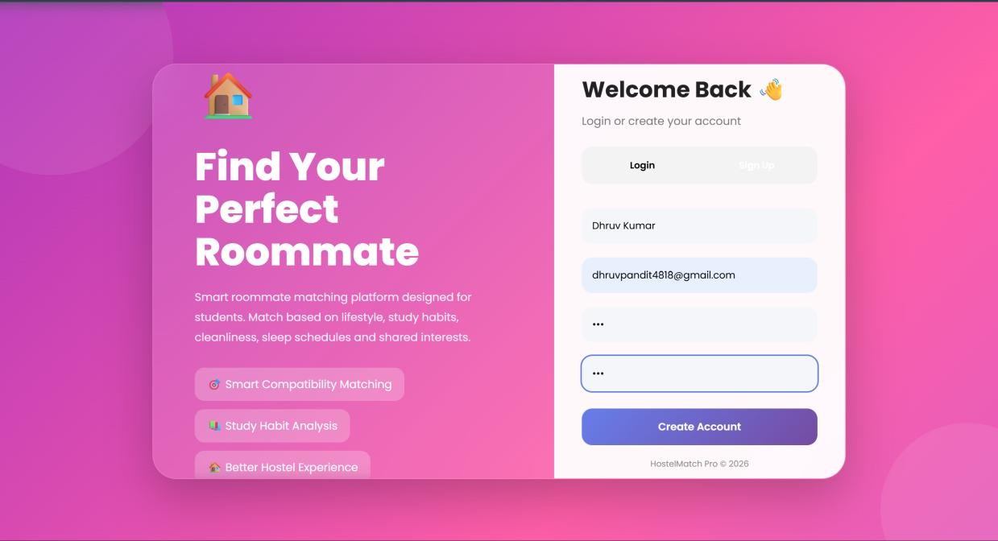
Figure 3.1: Welcome / Login and Sign Up screen of the deployed HostelMatch Pro frontend.

Landing Page — Light Theme
HostelMatch Pro ships with both a dark and a light theme, toggled from the navigation bar. Figure 3.2 is a live capture of the hero landing section in light mode, showing the primary Add Student and Find Match call-to-action buttons alongside the Live Compatibility Engine widget, which surfaces the highest compatibility percentage currently computed across the loaded student population.
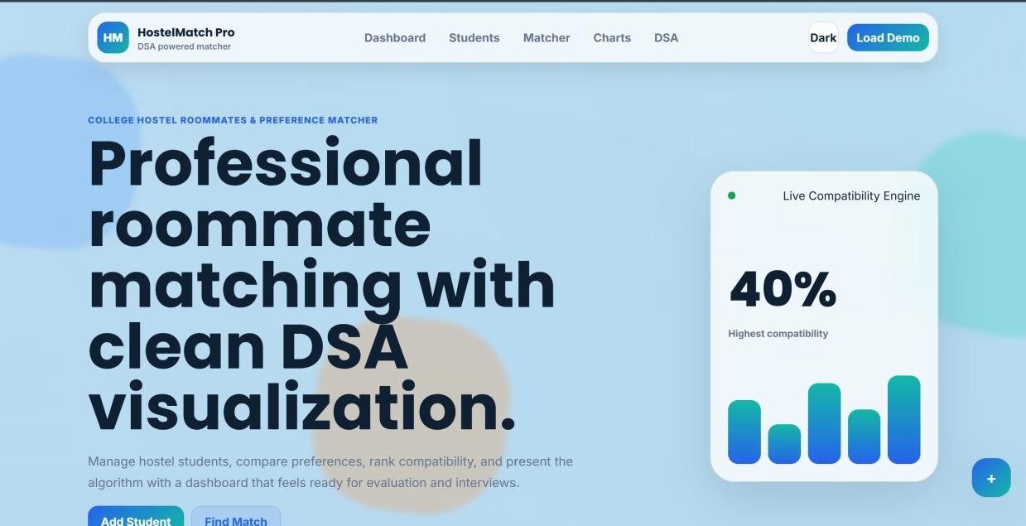
Figure 3.2: Hero landing section of the deployed frontend in light theme, showing the Live Compatibility Engine widget.

Student Management Dashboard
Figure 3.3 shows the Student Management section of the deployed frontend, where an administrator can add a new student through the registration form on the left and browse, search, filter, and sort existing student profiles in the panel on the right.
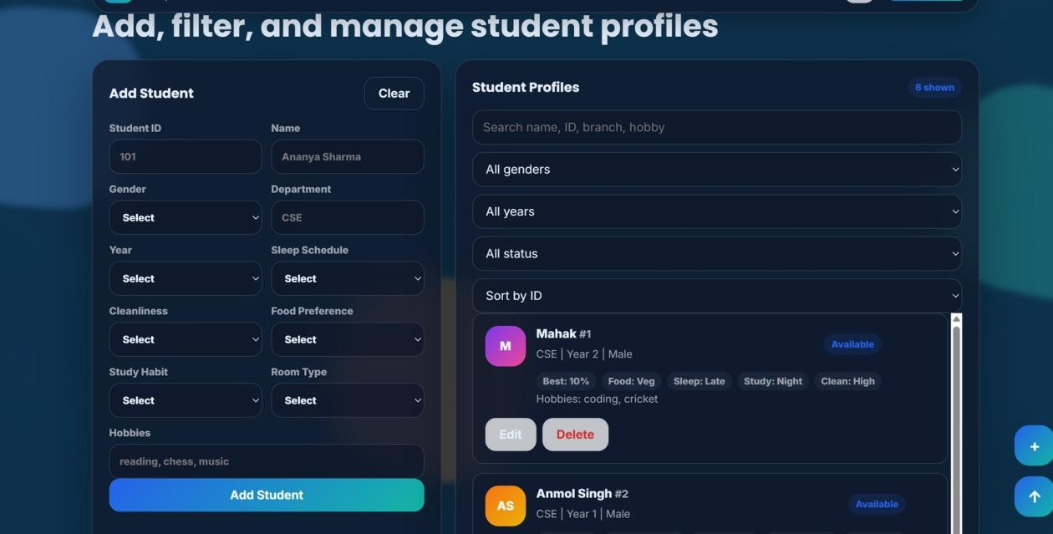
Figure 3.3: Student Management panel — Add Student form and Student Profiles list.

Matcher — Ranked Compatibility with Explainable Scoring
Figure 3.4 is a live capture of the Matcher section, titled Ranked compatibility with explainable scoring. The Find Roommates panel lets an administrator select a student, choose how many top-K recommendations to display, sort by highest score, and either request a single Recommend action or trigger Auto Assign, which runs the greedy matching routine across every currently unassigned student. Export controls (Export PDF, Export Excel, Print Report) let the recommendation list be saved or handed to a hostel warden outside the browser. The adjacent Assignments panel, labelled with the Greedy matching badge, lists every room pair produced by the auto-assignment routine.
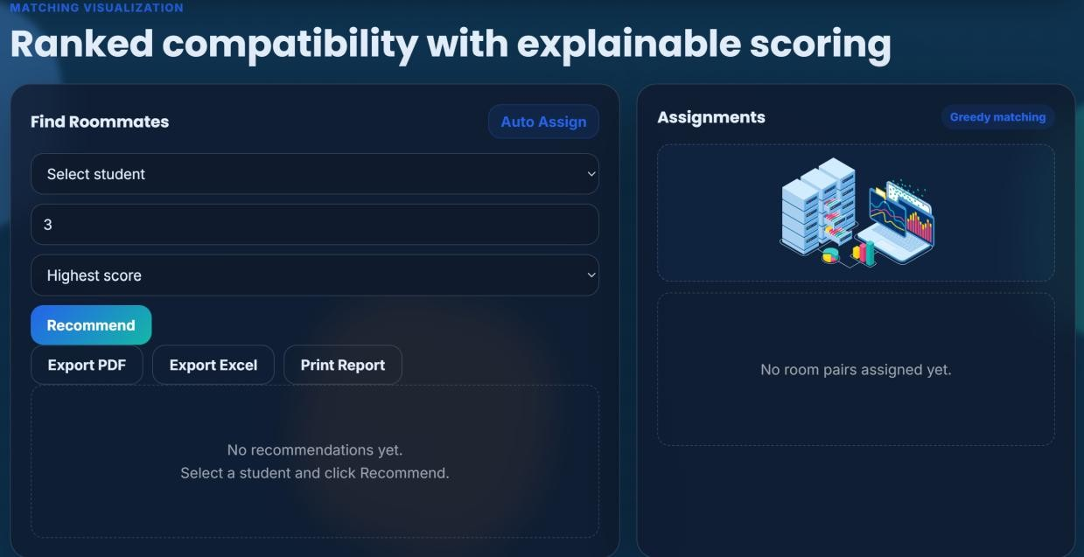
Figure 3.4: Matcher panel — Find Roommates controls and the Greedy Matching Assignments panel.

Analytics — Charts
Figure 3.5 is a live capture of the Charts and compatibility heatmap section, showing the Gender Distribution and Department Count panels rendered with Chart.js from the currently loaded student population. Two further charts, Compatibility Distribution and Match Activity, are rendered alongside these using the same live dataset.
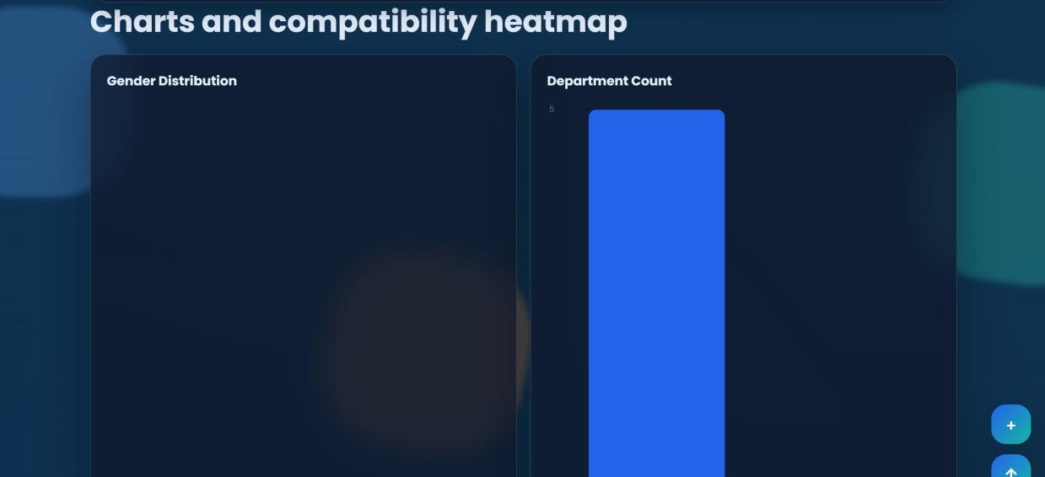
Figure 3.5: Analytics section — Gender Distribution and Department Count charts.

Compatibility Heatmap — Live Data
Figure 3.6 shows the colour-coded Compatibility Heatmap rendered across every pair of students in the loaded demo population (Anmol Singh, Mahak Singh, Shalu Yadav, Aditi, Mahak, and Aman). Each tile is computed client-side using the 100-point weighted scheme described in Table 2.2, and shaded according to the Excellent / Good / Average / Poor legend. In this run, the strongest pairs — Anmol Singh with Shalu Yadav, Mahak Singh with Aditi, and Shalu Yadav with Aditi — each scored 40%, placed in the Average band, while the weakest pairs, such as Anmol Singh with Aman, scored as low as 0%. No pair in this particular demo dataset reached the Excellent or Good bands, which is itself a useful diagnostic: it shows at a glance that the loaded cohort has little lifestyle overlap and that the hostel would need either a larger candidate pool or a relaxation of matching criteria to produce a genuinely strong pairing.
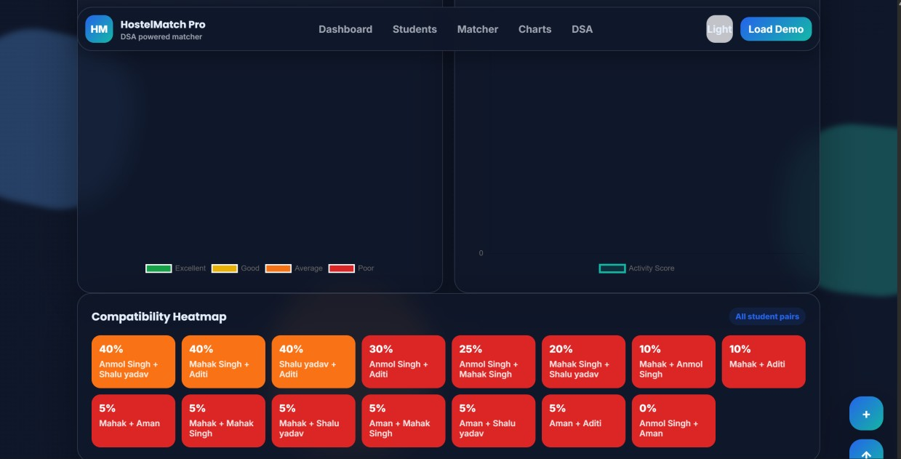
Figure 3.6: Live-rendered Compatibility Heatmap across all loaded student pairs.

DSA Concepts Panel
Figure 3.7 is a live capture of the navigation bar exposing the Dashboard, Students, Matcher, Charts, and DSA sections, alongside the light/dark theme toggle and the Load Demo action that seeds the interface with sample records defined in mock-data.js. The DSA panel itself lists the Hash Map, sorting, greedy matching, and space-complexity concepts used by the application, together with an animated, step-bystep walkthrough (Play Steps) of the matching algorithm described in Section 2.4.
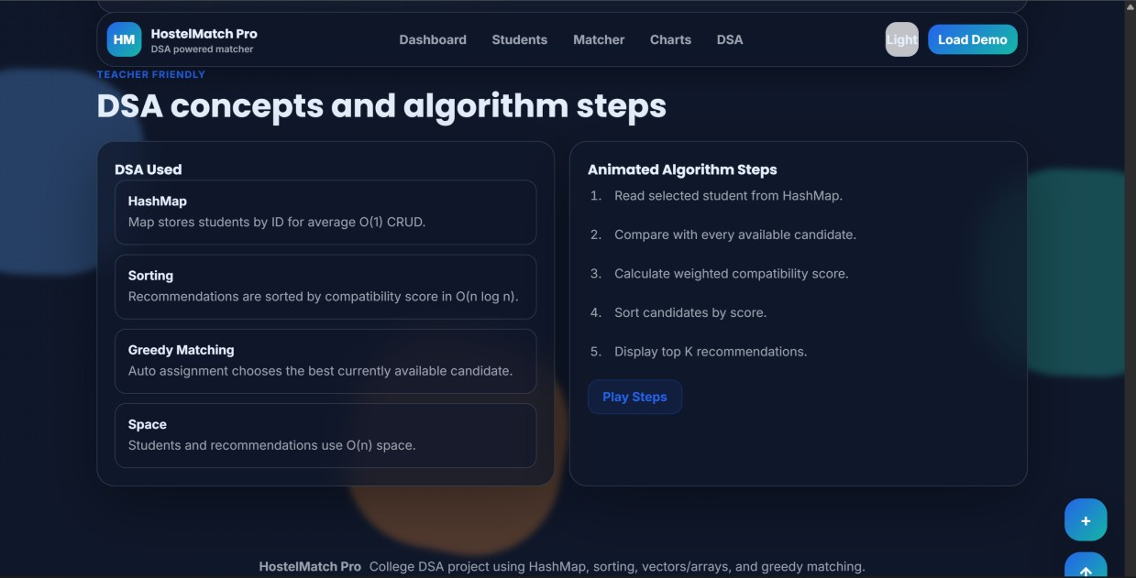
Figure 3.7: Navigation bar and DSA concepts / algorithm-steps panel, captured live.

Testing Approach and Test Cases
Hostel Roommate Matcher was tested using a combination of manual functional (black-box) testing of every API endpoint through the Swagger UI, manual verification of the frontend against the live deployed backend, and manual verification of the compatibility-scoring logic (both the backend's 9-point scheme and the frontend's 100-point scheme) against hand-calculated expected scores.
Test Case | Input | Expected Output | Result
Add Student | Valid student JSON submitted to POST /students | Success message with new student id returned | Pass
Retrieve Student List | GET /students with existing records | JSON array of all stored students returned | Pass
Update Student | Valid JSON submitted to PUT  /students/{id} for an existing ID | Success message; subsequent GET /students reflects the update | Pass
Test Case | Input | Expected Output | Result
Update Non-Existent Student | PUT /students/{id} with an ID not in the database | {"error": "Student not found"} returned | Pass
Delete Student | DELETE /students/{id} for an existing ID | Success message; student no longer appears in GET /students | Pass
Delete Non-Existent Student | DELETE /students/{id} with an invalid ID | {"error": "Student not found"} returned | Pass
Match Request | GET /match/{id} for a student with at least one other student in the database | Best match, score, and compatibility percentage returned | Pass
Match Request — Student Not Found | GET /match/{id} with an ID not in the database | {"error": "Student not found"} returned | Pass
Match Request — No Other Students | GET /match/{id} when the target student is the only record | {"message": "No roommate found"} returned | Pass
CORS Preflight | Frontend on Netlify origin calls the Render backend | Request succeeds without a browser CORS error | Pass
Frontend Heatmap Rendering | Multiple students loaded via demo data or the live API | Colour-coded pairwise scores rendered for every combination | Pass
Auto Assign (Greedy Matching) | Auto Assign triggered with six demo students loaded | Room pairs listed in the Assignments panel using the greedy best-available strategy | Pass
Theme Toggle | Light/Dark button clicked in the navigation bar | Colour scheme switches between light and dark themes without losing loaded data | Pass
Export Controls | Export PDF / Export Excel / Print Report clicked after a Recommend action | Recommendation list exported or sent to the print dialog | Pass

CORS Verification
Because the frontend (hosted on Netlify) and the backend (hosted on Render) are deployed independently on different origins, browsers enforce the same-origin policy and would otherwise block every fetch() call the frontend makes to the backend. FastAPI's CORSMiddleware was added to main.py to explicitly allow the deployed frontend origin. During testing, requests made from the deployed Netlify frontend to the deployed Render backend were confirmed to succeed, while requests from an origin not present in the allow_origins list were confirmed to be blocked by the browser, verifying that the CORS policy is enforced as intended.

Sample Match Response
A representative response from GET /match/{student_id} is shown below:
{
"student_id": 1,
"student": "Ananya Sharma",
"best_match_id": 2,
"best_match": "Riya Patel",
"compatibility_score": 8, "compatibility_percentage": 88.89
}

Discussion of Results
Taken together, the live screenshots in this chapter demonstrate that every functional requirement listed in Section 3.1 of the Requirement Analysis was met by the deployed system: an administrator can register, browse, filter, and sort students; request an explainable single best-match recommendation; trigger a cohort-wide greedy auto-assignment; and visualise compatibility both numerically (the heatmap) and graphically (the Chart.js dashboards), all from a single publicly reachable URL. The observed heatmap results in Section 3.6 also validate the scoring logic described in Chapter 2: pairs that share more weighted attributes (room type, sleep schedule, cleanliness, food habit, study preference) consistently score higher than pairs that differ on most of them, confirming that the additive weighted-scoring model behaves as designed rather than producing arbitrary output.

Conclusion

Summary
Hostel Roommate Matcher demonstrates that a compact, well-structured REST API, built with FastAPI, SQLAlchemy, and Pydantic, and paired with a lightweight vanilla-JavaScript frontend, can meaningfully improve on the manual, spreadsheet-driven hostel allocation processes still common in many institutions. By persisting student profiles in a SQLite database exposed through a validated, documented API, the system provides consistent CRUD management of student data; by scoring every candidate pair against a defined set of weighted lifestyle criteria, it produces an explainable, single best-match roommate recommendation; and by deploying the backend and frontend independently, on Render and Netlify respectively, the project reflects the decoupled deployment model used by real-world production web applications.

Learning Outcomes
The project provided direct, practical experience in designing a relational data model with SQLAlchemy, validating API input with Pydantic, structuring a FastAPI application into maintainable modules, resolving cross-origin communication issues with CORSMiddleware, exercising and documenting an API using Swagger UI, and deploying a decoupled frontend/backend architecture to two independent cloud hosting platforms.

Challenges and Solutions
The most significant challenge encountered was correctly configuring CORS between the two independently hosted origins; this was resolved by precisely matching the deployed Netlify origin string in the backend's allow_origins configuration. A second challenge was keeping the client-side heatmap's richer 100-point scoring model consistent in spirit with the backend's simpler 9-point /match scoring model; both were documented explicitly (Tables in Chapter 2) so that the difference is transparent rather than a hidden inconsistency.

Achievements
The completed system successfully meets every objective set out in Section 1.4: it exposes a fully functional, validated CRUD API over a persistent SQLite database; it computes and returns an explainable roommate match with a compatibility percentage; it is documented through Swagger UI; and it is deployed publicly and accessibly on Render and Netlify.

Future Scope
- Authentication and Role-Based Access Control: introduce JWT-based login so that only authenticated wardens can create, update, or delete student records, with separate roles for administrators and students.
- Cloud-Hosted Relational Database: migrate from a file-based SQLite database to a managed cloud database (e.g. PostgreSQL) so that data persists reliably across every backend redeploy and scales beyond a single hostel wing.
- Ranked Top-K Recommendations: extend /match/{student_id} to return a ranked list of the topK candidates rather than only the single best match.
- Batch Auto-Assignment: add a server-side endpoint that pairs an entire cohort of unassigned students in a single request, using a greedy or graph-based matching strategy.
- AI/ML-Based Recommendation: replace or augment the rule-based scoring function with a learned model trained on historical roommate-satisfaction outcomes.
- Notifications: notify both students automatically, by email or in-app message, once a match is finalised.
- Dynamic CORS Configuration: replace the single hard-coded allow_origins entry with an environment-variable-driven configuration so that new frontend deployment URLs do not require a backend code change.

Real-World Applications
The architecture demonstrated in this project — a validated REST API backend with a decoupled static frontend, communicating over JSON and deployed to independent cloud platforms — is directly representative of how small-to-medium production web applications are built and shipped in industry today, making the skills exercised in this project transferable well beyond the specific hostel-matching use case.

References
- FastAPI Documentation — https://fastapi.tiangolo.com/
- SQLAlchemy Documentation — https://docs.sqlalchemy.org/
- Pydantic Documentation — https://docs.pydantic.dev/
- Starlette / Uvicorn Documentation — https://www.uvicorn.org/
- SQLite Documentation — https://www.sqlite.org/docs.html
- MDN Web Docs, Mozilla — https://developer.mozilla.org/
- Chart.js Documentation — https://www.chartjs.org/docs/latest/
- Render Documentation — https://render.com/docs
- Netlify Documentation — https://docs.netlify.com/
- GitHub Documentation — https://docs.github.com/
- Cormen, T. H., Leiserson, C. E., Rivest, R. L., & Stein, C., Introduction to Algorithms, MIT Press.
- Project source code repository — https://github.com/Mahaksingh2006/Hostel-RoommateMatcher
- Live deployed application — https://elegant-phoenix-354e52.netlify.app/

Appendix A: Complete Backend Source Code

backend/app/database.py
from sqlalchemy import create_engine from sqlalchemy.orm import sessionmaker

DATABASE_URL = "sqlite:///./hostel_matcher.db"

engine = create_engine( DATABASE_URL,
connect_args={"check_same_thread": False}
)
SessionLocal = sessionmaker( autocommit=False, autoflush=False,
bind=engine
)

backend/app/models.py
from sqlalchemy import Column, Integer, String from sqlalchemy.orm import declarative_base

Base = declarative_base()
class Student(Base): __tablename__ = "students"
id = Column(Integer, primary_key=True, index=True)

name = Column(String) gender = Column(String) branch = Column(String) year = Column(Integer)

sleepTime = Column(String) cleanliness = Column(String) foodHabit = Column(String) studyPreference = Column(String)

roomType = Column(String) hobbies = Column(String) backend/app/schemas.py
from pydantic import BaseModel
class Student(BaseModel): name: str gender: str branch: str year: int sleepTime: str cleanliness: str foodHabit: str studyPreference: str roomType: str hobbies: list[str] = [] backend/app/init_db.py from app.database import engine from app.models import Base

Base.metadata.create_all(bind=engine)

print("Database and tables created successfully!") backend/app/main.py
from fastapi import FastAPI
from fastapi.middleware.cors import CORSMiddleware from sqlalchemy.orm import Session

from app.schemas import Student from app.database import SessionLocal from app.models import Student as StudentModel
app = FastAPI() app.add_middleware( CORSMiddleware, allow_origins=[
"https://elegant-phoenix-354e52.netlify.app"
], allow_credentials=True, allow_methods=["*"], allow_headers=["*"],
)

@app.get("/") def home():
return {"message": "Welcome to Hostel Roommate Matcher API!"}

@app.post("/students") def add_student(student: Student):
db: Session = SessionLocal()

new_student = StudentModel( name=student.name, gender=student.gender, branch=student.branch, year=student.year, sleepTime=student.sleepTime, cleanliness=student.cleanliness, foodHabit=student.foodHabit, studyPreference=student.studyPreference, roomType=student.roomType, hobbies=",".join(student.hobbies) )
db.add(new_student) db.commit() db.refresh(new_student)
student_id = new_student.id
db.close()
return {
"message": "Student added successfully",
"id": student_id
}

@app.get("/students") def get_students():
db: Session = SessionLocal()
students = db.query(StudentModel).all()
db.close()
return students

@app.get("/match/{student_id}") def match_student(student_id: int):
db: Session = SessionLocal()
students = db.query(StudentModel).all()
target = None
for s in students: if s.id == student_id:
target = s break
if target is None: db.close()
return {"error": "Student not found"}
best_match = None best_score = -1
for s in students:
if s.id == target.id: continue
score = 0
if s.branch == target.branch: score += 2
if s.year == target.year: score += 2
if s.studyPreference == target.studyPreference: score += 1
if s.foodHabit == target.foodHabit: score += 1
if s.sleepTime == target.sleepTime: score += 1

if s.cleanliness == target.cleanliness: score += 1
if s.roomType == target.roomType: score += 1
if score > best_score: best_score = score best_match = s
db.close()
if best_match is None: return {"message": "No roommate found"}
return {
"student_id": target.id,
"student": target.name,
"best_match_id": best_match.id,
"best_match": best_match.name,
"compatibility_score": best_score,
"compatibility_percentage": round((best_score / 9) * 100, 2) }
@app.delete("/students/{student_id}") def delete_student(student_id: int):
db = SessionLocal()
student = db.query(StudentModel).filter(
StudentModel.id == student_id
).first()
if not student: db.close()
return {"error": "Student not found"}
db.delete(student) db.commit() db.close()
return {"message": "Student deleted successfully"}
@app.put("/students/{student_id}") def update_student(student_id: int, student: Student):
db = SessionLocal()
existing = db.query(StudentModel).filter(
StudentModel.id == student_id
).first()
if not existing: db.close()
return {"error": "Student not found"}

existing.name = student.name existing.gender = student.gender existing.branch = student.branch existing.year = student.year existing.sleepTime = student.sleepTime existing.cleanliness = student.cleanliness existing.foodHabit = student.foodHabit existing.studyPreference = student.studyPreference existing.roomType = student.roomType existing.hobbies = ",".join(student.hobbies)
db.commit() db.close()

return {"message": "Student updated successfully"} backend/requirements.txt
annotated-doc==0.0.4 annotated-types==0.7.0 anyio==4.14.1 click==8.4.2 colorama==0.4.6 fastapi==0.139.0 h11==0.16.0 idna==3.18 pydantic==2.13.4 pydantic_core==2.46.4 starlette==1.3.1 typing-inspection==0.4.2 typing_extensions==4.16.0 uvicorn==0.50.2 SQLAlchemy==2.0.41

Appendix B: Complete Frontend Source Code

frontend/DSA Project/index.html
<!DOCTYPE html>
<html lang="en">
<head>
<meta charset="UTF-8">
<meta name="viewport" content="width=device-width, initial-scale=1.0">
<title>HostelMatch Pro | College Roommate Matcher</title>
<link rel="preconnect" href="https://fonts.googleapis.com">
<link rel="preconnect" href="https://fonts.gstatic.com" crossorigin>
<link
href="https://fonts.googleapis.com/css2?family=Inter:wght@400;500;600;700;800&family=Poppins:wght@600;700; 800&display=swap" rel="stylesheet">
<link rel="stylesheet" href="assets/css/styles.css">
</head> <body>
<div class="app-loader" id="appLoader" aria-label="Loading application">
<div class="spinner"></div>
<strong>Preparing HostelMatch Pro</strong>
</div>

<div class="background-shapes" aria-hidden="true">
<span class="shape shape-one"></span>
<span class="shape shape-two"></span>
<span class="shape shape-three"></span>
</div>

<nav class="navbar" aria-label="Primary navigation">
<a class="brand" href="#home" aria-label="HostelMatch Pro home">
<span class="brand-mark">HM</span>
<span>
<strong>HostelMatch Pro</strong>
<small>DSA powered matcher</small>
</span>
</a>
<div class="nav-links">
<a href="#dashboard">Dashboard</a>
<a href="#students">Students</a>
<a href="#matcher">Matcher</a>
<a href="#analytics">Charts</a>
<a href="#dsa">DSA</a>
</div>
<div class="nav-actions">
<button class="icon-btn" id="themeToggle" type="button" aria-label="Toggle dark mode">Dark</button>
<button class="primary small" id="loadDemoBtn" type="button">Load Demo</button> </div>
</nav>

<header class="hero section" id="home">
<div class="hero-copy reveal">
<p class="eyebrow">College Hostel Roommates & Preference Matcher</p>
<h1>Professional roommate matching with clean DSA visualization.</h1> <p class="hero-text">
Manage hostel students, compare preferences, rank compatibility, and present the algorithm with a dashboard that feels ready for evaluation and interviews.
</p>
<div class="hero-actions">
<a class="primary" href="#students">Add Student</a>
<a class="secondary" href="#matcher">Find Match</a>
</div>
</div>
<div class="hero-card glass reveal">
<div class="hero-card-top">
<span class="pulse-dot"></span>
<span>Live Compatibility Engine</span>
</div>
<div class="hero-score">
<span id="heroScore">0%</span>
<small>Highest compatibility</small>
</div>
<div class="mini-bars" aria-hidden="true">
<span style="--h: 68%"></span>
<span style="--h: 42%"></span>
<span style="--h: 86%"></span>
<span style="--h: 58%"></span>
<span style="--h: 94%"></span>
</div>
</div>
</header>
<main>
<section class="section dashboard" id="dashboard">
<div class="section-heading reveal">
<p class="eyebrow">Dashboard</p>
<h2>Room allocation overview</h2>
</div>
<div class="metric-grid">
<article class="metric-card glass reveal">
<span>Total Students</span>
<strong class="counter" id="totalStudents">0</strong>
<small>HashMap records</small>
</article>
<article class="metric-card glass reveal">
<span>Total Matches</span>
<strong class="counter" id="totalMatches">0</strong>
<small>Assigned roommate pairs</small>
</article>
<article class="metric-card glass reveal">
<span>Highest Compatibility</span>
<strong class="counter" id="highestCompatibility">0%</strong>
<small>Best available score</small>
</article>
<article class="metric-card glass reveal">
<span>Average Compatibility</span>
<strong class="counter" id="averageCompatibility">0%</strong>
<small>Across possible pairs</small>
</article>
</div>
<div class="dashboard-grid">
<article class="panel reveal">
<div class="panel-title">
<h3>Recent Match Activity</h3>
<span class="badge">Live</span>
</div>
<div id="activityList" class="activity-list"></div>
</article>
<article class="panel reveal">
<div class="panel-title">
<h3>Quick Statistics</h3>
</div>
<div class="quick-stats" id="quickStats"></div>
</article>
</div>
</section>

<section class="section workspace" id="students">
<div class="section-heading reveal">
<p class="eyebrow">Student Management</p>
<h2>Add, filter, and manage student profiles</h2>
</div>
<div class="workspace-grid">
<article class="panel form-panel reveal">
<div class="panel-title">
<h3 id="formTitle">Add Student</h3>
<button class="ghost" type="button" id="resetFormBtn">Clear</button> </div>
<form id="studentForm">
<div class="form-grid">
<label>Student ID<input id="studentId" type="number" required min="1" placeholder="101"></label>
<label>Name<input id="name" type="text" required placeholder="Ananya Sharma"></label>
<label>Gender
<select id="gender" required>
<option value="">Select</option>
<option>Female</option>
<option>Male</option>
<option>Other</option>
</select> </label>
<label>Department<input id="branch" type="text" required placeholder="CSE"></label>
<label>Year
<select id="year" required>
<option value="">Select</option>
<option value="1">1st Year</option>
<option value="2">2nd Year</option>
<option value="3">3rd Year</option>
<option value="4">4th Year</option>
</select>
</label>
<label>Sleep Schedule
<select id="sleepTime" required>
<option value="">Select</option>
<option value="early">Early</option>
<option value="late">Late</option>
<option value="flexible">Flexible</option>
</select>
</label>
<label>Cleanliness
<select id="cleanliness" required>
<option value="">Select</option>
<option value="low">Low</option>
<option value="medium">Medium</option>
<option value="high">High</option>
</select>
</label>
<label>Food Preference
<select id="foodHabit" required>
<option value="">Select</option>
<option value="veg">Veg</option>
<option value="non-veg">Non-Veg</option>
<option value="any">Any</option>
</select>
</label>
<label>Study Habit
<select id="studyPreference" required>
<option value="">Select</option>
<option value="quiet">Quiet</option>
<option value="music">Music</option> <option value="group">Group</option>
</select>
</label>
<label>Room Type
<select id="roomType" required>
<option value="">Select</option>
<option value="single">Single</option>
<option value="double">Double</option> <option value="triple">Triple</option>
</select> </label>
<label class="wide">Hobbies<input id="hobbies" type="text" placeholder="reading, chess, music"></label>
</div>
<button class="primary full" type="submit" id="submitBtn">Add Student</button>
</form>
</article>

<article class="panel reveal">
<div class="panel-title">
<h3>Student Profiles</h3>
<span class="badge" id="visibleStudentCount">0 shown</span>
</div>
<div class="toolbar">
<input id="searchInput" type="search" placeholder="Search name, ID, branch, hobby">
<select id="genderFilter" aria-label="Filter by gender">
<option value="">All genders</option>
<option>Female</option>
<option>Male</option>
<option>Other</option>
</select>
<select id="yearFilter" aria-label="Filter by year">
<option value="">All years</option>
<option value="1">1st Year</option>
<option value="2">2nd Year</option>
<option value="3">3rd Year</option>
<option value="4">4th Year</option>
</select>
<select id="statusFilter" aria-label="Filter by status">
<option value="">All status</option>
<option value="available">Available</option>
<option value="assigned">Assigned</option>
</select>
<select id="sortStudents" aria-label="Sort students">
<option value="id">Sort by ID</option>
<option value="name">Sort by name</option>
<option value="year">Sort by year</option>
<option value="status">Sort by status</option>
</select>
</div>
<div id="studentList" class="student-list"></div>
</article>
</div>
</section>

<section class="section matcher" id="matcher">
<div class="section-heading reveal">
<p class="eyebrow">Matching Visualization</p>
<h2>Ranked compatibility with explainable scoring</h2>
</div>
<div class="matcher-grid">
<article class="panel reveal">
<div class="panel-title">
<h3>Find Roommates</h3>
<button class="secondary small" type="button" id="assignBtn">Auto Assign</button> </div>
<div class="toolbar">
<select id="recommendStudent" aria-label="Select student for recommendation"></select>
<input id="topK" type="number" min="1" value="3" aria-label="Top matches">
<select id="sortMatches" aria-label="Sort matches">
<option value="score">Highest score</option>
<option value="name">Name</option>
<option value="id">Student ID</option>
</select>
<button class="primary" type="button" id="recommendBtn">Recommend</button> </div>
<div class="export-row">
<button class="ghost" type="button" id="exportPdfBtn">Export PDF</button>
<button class="ghost" type="button" id="exportExcelBtn">Export Excel</button>
<button class="ghost" type="button" id="printBtn">Print Report</button> </div>
<div id="recommendations" class="result-list"></div>
</article>

<article class="panel reveal">
<div class="panel-title">
<h3>Assignments</h3>
<span class="badge">Greedy matching</span>
</div>
<div class="lottie-wrap" aria-hidden="true">
<lottie-player src="https://assets2.lottiefiles.com/packages/lf20_qp1q7mct.json" background="transparent" speed="0.8" loop autoplay></lottie-player>
</div>
<div id="assignments" class="activity-list"></div>
</article>
</div>
</section>

<section class="section analytics" id="analytics">
<div class="section-heading reveal">
<p class="eyebrow">Analytics</p>
<h2>Charts and compatibility heatmap</h2>
</div>
<div class="chart-grid">
<article class="panel chart-panel reveal"><h3>Gender Distribution</h3><canvas id="genderChart"></canvas></article>
<article class="panel chart-panel reveal"><h3>Department Count</h3><canvas id="departmentChart"></canvas></article>
<article class="panel chart-panel reveal"><h3>Compatibility Distribution</h3><canvas id="compatibilityChart"></canvas></article>
<article class="panel chart-panel reveal"><h3>Match Activity</h3><canvas id="activityChart"></canvas></article>
</div>
<article class="panel reveal">
<div class="panel-title">
<h3>Compatibility Heatmap</h3>
<span class="badge">All student pairs</span>
</div>
<div id="heatmap" class="heatmap"></div>
</article>
</section>

<section class="section dsa" id="dsa">
<div class="section-heading reveal">
<p class="eyebrow">Teacher Friendly</p>
<h2>DSA concepts and algorithm steps</h2>
</div>
<div class="dsa-grid">
<article class="panel reveal">
<h3>DSA Used</h3>
<div class="dsa-cards">
<div><strong>HashMap</strong><span>Map stores students by ID for average O(1) CRUD.</span></div>
<div><strong>Sorting</strong><span>Recommendations are sorted by compatibility score in O(n log n).</span></div>
<div><strong>Greedy Matching</strong><span>Auto assignment chooses the best currently available candidate.</span></div>
<div><strong>Space</strong><span>Students and recommendations use O(n) space.</span></div>
</div>
</article>
<article class="panel reveal">
<h3>Animated Algorithm Steps</h3>
<ol class="timeline" id="algorithmSteps">
<li>Read selected student from HashMap.</li>
<li>Compare with every available candidate.</li> <li>Calculate weighted compatibility score.</li>
<li>Sort candidates by score.</li>
<li>Display top K recommendations.</li>
</ol>
<button class="secondary" type="button" id="playStepsBtn">Play Steps</button> </article>
</div>
</section>
</main>

<button class="fab" type="button" id="fabBtn" aria-label="Add new student">+</button>
<button class="scroll-top" type="button" id="scrollTopBtn" aria-label="Scroll to top">↑</button> <div id="toastStack" class="toast-stack" aria-live="polite"></div>

<div class="dialog-backdrop" id="confirmDialog" role="dialog" aria-modal="true" arialabelledby="dialogTitle"> <div class="dialog panel">
<h3 id="dialogTitle">Confirm action</h3>
<p id="dialogMessage">Are you sure?</p>
<div class="dialog-actions">
<button class="ghost" type="button" id="dialogCancel">Cancel</button>
<button class="primary" type="button" id="dialogConfirm">Confirm</button> </div>
</div>
</div>

<footer class="footer">
<strong>HostelMatch Pro</strong>
<span>College DSA project using HashMap, sorting, vectors/arrays, and greedy matching.</span> </footer>

<script src="https://cdn.jsdelivr.net/npm/chart.js"></script>
<script src="https://cdnjs.cloudflare.com/ajax/libs/jspdf/2.5.1/jspdf.umd.min.js"></script>
<script src="https://cdnjs.cloudflare.com/ajax/libs/xlsx/0.18.5/xlsx.full.min.js"></script>
<script src="https://unpkg.com/@lottiefiles/lottie-player@latest/dist/lottie-player.js"></script>
<script src="assets/js/mock-data.js"></script>
<script src="assets/js/app.js"></script>
</body>
</html>

frontend/DSA Project/assets/css/styles.css
:root {
--bg: #eef5ff;
--bg-2: #f8fbff;
--surface: rgba(255, 255, 255, 0.78);
--surface-strong: #ffffff;
--text: #102033;
--muted: #64748b;
--line: rgba(148, 163, 184, 0.32);
--brand: #2563eb;
--brand-2: #14b8a6;
--accent: #f97316;
--success: #16a34a;
--warning: #eab308;
--danger: #dc2626;
--shadow: 0 24px 70px rgba(15, 23, 42, 0.14);
--soft-shadow: 0 12px 28px rgba(15, 23, 42, 0.1);
--radius: 22px; --radius-sm: 14px;
}
body.dark { --bg: #07111f;
--bg-2: #0f172a;
--surface: rgba(15, 23, 42, 0.74);
--surface-strong: #111827;
--text: #e5eefb;
--muted: #9ca3af;
--line: rgba(148, 163, 184, 0.24);
--shadow: 0 24px 70px rgba(0, 0, 0, 0.34); --soft-shadow: 0 12px 28px rgba(0, 0, 0, 0.26);
}
* { box-sizing: border-box;
}
html { scroll-behavior: smooth;
}
body { margin: 0; min-height: 100vh; color: var(--text); background:
radial-gradient(circle at 10% 10%, rgba(37, 99, 235, 0.18), transparent 30%), radial-gradient(circle at 90% 0%, rgba(20, 184, 166, 0.18), transparent 28%), linear-gradient(135deg, var(--bg), var(--bg-2)); font-family: Inter, Arial, sans-serif;
transition: background 0.35s ease, color 0.35s ease;
}
.app-loader { position: fixed; inset: 0; z-index: 200; display: grid; place-items: center; gap: 14px; background: linear-gradient(135deg, var(--bg), var(--bg-2)); transition: opacity 0.3s ease, visibility 0.3s ease;
}
.app-loader.hidden { opacity: 0;
visibility: hidden;
} .spinner { width: 56px; height: 56px;
border: 5px solid rgba(37, 99, 235, 0.16); border-top-color: var(--brand); border-radius: 50%;
animation: spin 0.9s linear infinite;
}
@keyframes spin { to {
transform: rotate(360deg);
}
}
button, input, select {
font: inherit;
}
button, a { -webkit-tap-highlight-color: transparent;
}
a { color: inherit;
text-decoration: none;
}
h1, h2, h3, p {
margin-top: 0;
}
h1, h2, h3, .brand strong { font-family: Poppins, Inter, sans-serif;
}
h1 { max-width: 820px; margin-bottom: 18px; font-size: clamp(2.4rem, 6vw, 5.4rem); line-height: 0.98; letter-spacing: 0;
}
h2 { margin-bottom: 0;
font-size: clamp(1.65rem, 3vw, 2.55rem); line-height: 1.1;
}
h3 { margin-bottom: 0;
font-size: 1.1rem;
}
canvas {
max-width: 100%;
}
input, select { width: 100%; min-height: 46px; padding: 11px 13px; border: 1px solid var(--line); border-radius: 14px; outline: none;
background: rgba(255, 255, 255, 0.74); color: var(--text);
transition: border 0.2s ease, box-shadow 0.2s ease, background 0.2s ease;
}
body.dark input, body.dark select {
background: rgba(15, 23, 42, 0.72);
}
input:focus, select:focus, button:focus-visible, a:focus-visible { border-color: var(--brand);
box-shadow: 0 0 0 4px rgba(37, 99, 235, 0.16); outline: none;
}
button, .primary, .secondary { position: relative; display: inline-flex; align-items: center; justify-content: center; gap: 8px; min-height: 44px; padding: 11px 18px; overflow: hidden; border: 1px solid var(--line); border-radius: 14px;
background: rgba(255, 255, 255, 0.74); color: var(--text); cursor: pointer; font-weight: 700;
transition: transform 0.2s ease, box-shadow 0.2s ease, border 0.2s ease, background 0.2s ease;
}
button:hover, .primary:hover, .secondary:hover { transform: translateY(-2px);
box-shadow: var(--soft-shadow);
} .primary { border: 0;
background: linear-gradient(135deg, var(--brand), var(--brand-2)); color: white;
}
.secondary {
border-color: rgba(37, 99, 235, 0.24); background: rgba(37, 99, 235, 0.1); color: var(--brand);
} .ghost { background: transparent;
} .small { min-height: 38px;
padding: 8px 13px;
} .full { width: 100%;
}
.ripple { position: absolute; width: 20px; height: 20px; border-radius: 999px; background: rgba(255, 255, 255, 0.55); transform: translate(-50%, -50%) scale(0);
animation: ripple 0.55s ease-out;
pointer-events: none;
}
@keyframes ripple { to { opacity: 0;
transform: translate(-50%, -50%) scale(16);
}
}
.background-shapes { position: fixed; inset: 0; overflow: hidden; pointer-events: none;
z-index: -1;
} .shape { position: absolute; width: 260px; height: 260px; border-radius: 40%; filter: blur(4px); opacity: 0.28;
animation: float 12s ease-in-out infinite;
}
.shape-one { top: 90px; left: -80px;
background: #60a5fa;
}
.shape-two { top: 220px; right: -70px; background: #2dd4bf;
animation-delay: -3s;
}
.shape-three { bottom: 60px; left: 30%; background: #fb923c;
animation-delay: -6s;
}
@keyframes float { 50% {
transform: translate3d(24px, -28px, 0) rotate(12deg) scale(1.06); }
} .navbar { position: sticky; top: 14px; z-index: 20;
display: flex; align-items: center; justify-content: space-between; gap: 18px;
width: min(1180px, calc(100% - 32px)); margin: 14px auto 0;
padding: 12px; border: 1px solid var(--line); border-radius: 24px; background: var(--surface); box-shadow: var(--soft-shadow);
backdrop-filter: blur(18px);
} .brand,
.nav-actions, .nav-links { display: flex; align-items: center;
gap: 12px;
}
.brand-mark { display: grid; width: 44px; height: 44px; place-items: center; border-radius: 14px;
background: linear-gradient(135deg, var(--brand), var(--brand-2)); color: white;
font-weight: 800;
} .brand small { display: block; color: var(--muted); font-size: 0.75rem;
font-weight: 600;
}
.nav-links a { padding: 9px 10px; border-radius: 12px; color: var(--muted); font-weight: 700;
transition: color 0.2s ease, background 0.2s ease;
}
.nav-links a:hover { background: rgba(37, 99, 235, 0.1); color: var(--brand);
}
.icon-btn { width: 42px;
padding: 0;
} .section {
width: min(1180px, calc(100% - 32px)); margin: 0 auto;
padding: 70px 0 0;
}
.hero { display: grid;
grid-template-columns: minmax(0, 1.45fr) minmax(280px, 0.55fr); gap: 28px; align-items: center;
min-height: calc(100vh - 100px);
padding-top: 52px;
} .eyebrow { margin-bottom: 10px; color: var(--brand); font-size: 0.78rem; font-weight: 800; letter-spacing: 0.08em;
text-transform: uppercase;
}
.hero-text { max-width: 720px; color: var(--muted); font-size: 1.08rem;
line-height: 1.7;
}
.hero-actions,
.export-row, .toolbar, .dialog-actions { display: flex; flex-wrap: wrap;
gap: 10px;
}
.glass, .panel { border: 1px solid var(--line); background: var(--surface); box-shadow: var(--shadow);
backdrop-filter: blur(18px);
} .panel { border-radius: var(--radius);
padding: 22px;
}
.hero-card { min-height: 390px; padding: 24px;
border-radius: 34px;
}
.hero-card-top,
.panel-title,
.card-top, .metric-card { display: flex; align-items: center; justify-content: space-between; gap: 14px;
}
.pulse-dot { width: 10px; height: 10px;
border-radius: 999px; background: var(--success); box-shadow: 0 0 0 0 rgba(22, 163, 74, 0.45); animation: pulse 1.7s infinite;
}
@keyframes pulse { 70% {
box-shadow: 0 0 0 16px rgba(22, 163, 74, 0);
}
}
.hero-score {
margin: 70px 0 42px;
}
.hero-score span { display: block;
font-family: Poppins, Inter, sans-serif; font-size: 4.2rem;
font-weight: 800;
}

.hero-score small { color: var(--muted);
font-weight: 700;
}
.mini-bars { display: grid;
grid-template-columns: repeat(5, 1fr); align-items: end; gap: 10px;
height: 130px;
}
.mini-bars span { display: block; height: var(--h); border-radius: 14px;
background: linear-gradient(180deg, var(--brand-2), var(--brand)); animation: barRise 1s ease both;
}
@keyframes barRise { from { height: 0;
}
}

.section-heading {
margin-bottom: 22px;
}
.metric-grid,
.chart-grid,
.dashboard-grid,
.workspace-grid,
.matcher-grid, .dsa-grid { display: grid;
gap: 18px;
}
.metric-grid {
grid-template-columns: repeat(4, minmax(0, 1fr));
} .metric-card { align-items: flex-start; flex-direction: column; min-height: 160px; padding: 22px; border-radius: var(--radius);
}
.metric-card span, .metric-card small,
.meta,
.empty-state, .activity-list {
color: var(--muted);
}
.metric-card strong { font-family: Poppins, Inter, sans-serif; font-size: 2.25rem;
}
.dashboard-grid, .matcher-grid { grid-template-columns: 1fr 0.72fr; margin-top: 18px;
}
.workspace-grid {
grid-template-columns: minmax(310px, 0.8fr) minmax(420px, 1.2fr);
}
.chart-grid {
grid-template-columns: repeat(2, minmax(0, 1fr));
}
.dsa-grid {
grid-template-columns: 1fr 1fr;
}
.panel-title {
margin-bottom: 16px;
} .badge { display: inline-flex; align-items: center; min-height: 28px; padding: 5px 10px; border-radius: 999px; background: rgba(37, 99, 235, 0.12); color: var(--brand); font-size: 0.78rem;
font-weight: 800;
}
.badge.success {
background: rgba(22, 163, 74, 0.12); color: var(--success);
}
.badge.warning {
background: rgba(234, 179, 8, 0.14); color: #a16207;
}

.badge.danger {
background: rgba(220, 38, 38, 0.12); color: var(--danger);
}
.form-grid { display: grid;
grid-template-columns: repeat(2, minmax(0, 1fr)); gap: 12px;
}
label { display: grid; gap: 7px; color: var(--muted); font-size: 0.84rem;
font-weight: 800;
} .wide {
grid-column: 1 / -1;
}
.student-list,
.result-list,
.activity-list, .quick-stats { display: grid;
gap: 12px;
}
.student-list { max-height: 760px; overflow: auto;
padding-right: 4px;
}
.student-card,
.result-card,
.activity-item,
.quick-stat, .dsa-cards div { border: 1px solid var(--line); border-radius: var(--radius-sm); background: rgba(255, 255, 255, 0.52); padding: 16px; transition: transform 0.2s ease, box-shadow 0.2s ease, border 0.2s ease;
}

body.dark .student-card, body.dark .result-card, body.dark .activity-item, body.dark .quick-stat, body.dark .dsa-cards div {
background: rgba(15, 23, 42, 0.45);
}
.student-card:hover, .result-card:hover { transform: translateY(-4px); box-shadow: var(--soft-shadow);
border-color: rgba(37, 99, 235, 0.34);
}

.student-main { display: flex;
gap: 14px;
} .avatar { display: grid; flex: 0 0 54px; width: 54px; height: 54px; place-items: center; border-radius: 18px;
background: var(--avatar, linear-gradient(135deg, var(--brand), var(--brand-2))); color: white;
font-weight: 900;
}

.card-title { margin-bottom: 4px;
font-weight: 900;
} .meta { font-size: 0.88rem;
line-height: 1.6;
}
.chip-row { display: flex; flex-wrap: wrap; gap: 7px;
margin-top: 12px;
} .chip { padding: 5px 9px; border-radius: 999px; background: rgba(100, 116, 139, 0.12); color: var(--muted); font-size: 0.78rem;
font-weight: 800;
} .actions { display: flex; flex-wrap: wrap; gap: 8px;
margin-top: 14px;
}
.danger-text {
color: var(--danger);
}
.chart-panel {
min-height: 360px;
}
.chart-panel canvas {
margin-top: 16px;
}
.lottie-wrap {
display: grid; place-items: center; min-height: 150px; margin-bottom: 12px; border: 1px dashed var(--line); border-radius: var(--radius-sm);
background: rgba(37, 99, 235, 0.06);
}
.lottie-wrap lottie-player { width: min(210px, 100%); height: 150px;
}
.score-circle { --score: 0; display: grid; width: 92px; height: 92px; flex: 0 0 92px; place-items: center; border-radius: 50%; background: radial-gradient(circle at center, var(--surface-strong) 57%, transparent 58%), conic-gradient(var(--score-color) calc(var(--score) * 1%), rgba(148, 163, 184, 0.22) 0); color: var(--score-color);
font-weight: 900;
}
.score-line { height: 10px; overflow: hidden; border-radius: 999px;
background: rgba(148, 163, 184, 0.18);
}
.score-line span { display: block; width: var(--score-width); height: 100%; border-radius: inherit; background: var(--score-color);
animation: growWidth 0.8s ease both;
}
@keyframes growWidth { from { width: 0;
}
}
.comparison { width: 100%; margin-top: 14px; border-collapse: collapse; overflow: hidden; border-radius: 12px;
font-size: 0.85rem;
}

.comparison th, .comparison td { padding: 9px; border-bottom: 1px solid var(--line); text-align: left;
}

.comparison th { color: var(--muted); font-size: 0.76rem;
text-transform: uppercase;
} .heatmap { display: grid;
grid-template-columns: repeat(auto-fill, minmax(118px, 1fr)); gap: 10px;
}
.heat-cell { min-height: 84px; padding: 12px; border-radius: 14px; color: white;
font-weight: 800;
}
.heat-cell small { display: block; margin-top: 6px; opacity: 0.86;
font-weight: 600;
}
.dsa-cards { display: grid;
gap: 12px;
}
.dsa-cards strong, .dsa-cards span { display: block;
}
.dsa-cards span { margin-top: 5px; color: var(--muted);
line-height: 1.5;
} .timeline { display: grid; gap: 10px; margin: 0 0 16px;
padding-left: 22px;
}

.timeline li { padding: 10px 12px; border-radius: 12px; color: var(--muted);
transition: background 0.25s ease, color 0.25s ease, transform 0.25s ease;
}
.timeline li.active { background: rgba(37, 99, 235, 0.12); color: var(--brand); transform: translateX(6px);
font-weight: 800;
}

.empty-state { display: grid; min-height: 170px; place-items: center; border: 1px dashed var(--line); border-radius: var(--radius-sm); text-align: center;
line-height: 1.6;
} .skeleton { position: relative; overflow: hidden; min-height: 84px;
}
.skeleton::after { position: absolute; inset: 0; content: "";
background: linear-gradient(90deg, transparent, rgba(255, 255, 255, 0.48), transparent); animation: shimmer 1.1s infinite;
}
@keyframes shimmer { from {
transform: translateX(-100%);
} to {
transform: translateX(100%);
}
}
.toast-stack { position: fixed; right: 20px; bottom: 22px; z-index: 50; display: grid; gap: 10px;
width: min(360px, calc(100vw - 32px));
} .toast { padding: 14px 16px; border: 1px solid var(--line); border-left: 5px solid var(--brand); border-radius: 16px; background: var(--surface-strong); box-shadow: var(--soft-shadow);
animation: slideToast 0.25s ease both;
}
.toast.success { border-left-color: var(--success);
}
.toast.error {
border-left-color: var(--danger); animation: shake 0.32s ease both;
}
@keyframes slideToast { from {
opacity: 0;
transform: translateY(12px);
}
}
@keyframes shake { 25% {
transform: translateX(-6px);
} 50% {
transform: translateX(5px);
} 75% {
transform: translateX(-3px);
}
}
.dialog-backdrop { position: fixed; inset: 0; z-index: 60; display: none; place-items: center; padding: 18px;
background: rgba(15, 23, 42, 0.46);
}
.dialog-backdrop.open {
display: grid;
} .dialog { width: min(430px, 100%);
background: var(--surface-strong);
} .fab, .scroll-top { position: fixed; z-index: 30; right: 22px; display: grid; width: 54px; height: 54px; place-items: center; padding: 0; border: 0; border-radius: 20px; background: linear-gradient(135deg, var(--brand), var(--brand-2)); color: white; font-size: 1.35rem;
box-shadow: var(--shadow);
} .fab { bottom: 92px;
}
.scroll-top { bottom: 24px; opacity: 0; pointer-events: none; transition: opacity 0.2s ease, transform 0.2s ease;
} .scroll-top.visible { opacity: 1;
pointer-events: auto;
} .footer { display: flex; flex-wrap: wrap; justify-content: center; gap: 10px; width: min(1180px, calc(100% - 32px)); margin: 70px auto 28px; padding: 22px; color: var(--muted);
text-align: center;
} .reveal { opacity: 0; transform: translateY(18px);
animation: reveal 0.7s ease forwards;
} @keyframes reveal { to { opacity: 1; transform: translateY(0);
}
} .confetti { position: fixed; top: -12px; z-index: 100; width: 10px; height: 16px; border-radius: 3px;
animation: confettiFall 2.6s ease-in forwards;
} @keyframes confettiFall { to {
transform: translateY(105vh) rotate(720deg); opacity: 0;
}
}
@media (max-width: 1000px) { .nav-links { display: none; }
.hero,
.dashboard-grid,
.workspace-grid,
.matcher-grid, .dsa-grid { grid-template-columns: 1fr; }

.metric-grid, .chart-grid {
grid-template-columns: repeat(2, minmax(0, 1fr));
}
}

@media (max-width: 640px) { .navbar { align-items: flex-start; flex-direction: column; }

.nav-actions { width: 100%; }

.nav-actions .primary { flex: 1; }
.section { width: min(100% - 24px, 1180px); padding-top: 50px; }
.hero { min-height: auto; }

.metric-grid,
.chart-grid, .form-grid { grid-template-columns: 1fr; }
.wide { grid-column: auto; }
.toolbar,
.hero-actions, .export-row { flex-direction: column; }

.toolbar > *,
.export-row > *, .hero-actions > * { width: 100%; }
.panel, .hero-card { padding: 17px; }
.card-top, .student-main { align-items: flex-start; flex-direction: column;
}
}
@media (prefers-reduced-motion: reduce) {
*,
*::before, *::after { scroll-behavior: auto !important; animation-duration: 0.01ms !important; animation-iteration-count: 1 !important; transition-duration: 0.01ms !important;
}
}

frontend/DSA Project/assets/js/app.js const API_URL = "https://hostel-roommate-matcher.onrender.com"; const students = new Map(); let latestRecommendations = []; let recentActivity = []; let pendingConfirm = null; let charts = {};

const $ = (id) => document.getElementById(id);
const dom = { form: $("studentForm"), formTitle: $("formTitle"), submitBtn: $("submitBtn"), resetFormBtn: $("resetFormBtn"), loadDemoBtn: $("loadDemoBtn"), studentList: $("studentList"), visibleStudentCount: $("visibleStudentCount"), searchInput: $("searchInput"), genderFilter: $("genderFilter"), yearFilter: $("yearFilter"), statusFilter: $("statusFilter"), sortStudents: $("sortStudents"), recommendStudent: $("recommendStudent"), topK: $("topK"), sortMatches: $("sortMatches"), recommendBtn: $("recommendBtn"), recommendations: $("recommendations"), assignBtn: $("assignBtn"), assignments: $("assignments"), totalStudents: $("totalStudents"), totalMatches: $("totalMatches"), highestCompatibility: $("highestCompatibility"), averageCompatibility: $("averageCompatibility"), heroScore: $("heroScore"), activityList: $("activityList"), quickStats: $("quickStats"), heatmap: $("heatmap"), themeToggle: $("themeToggle"), exportPdfBtn: $("exportPdfBtn"), exportExcelBtn: $("exportExcelBtn"), printBtn: $("printBtn"), playStepsBtn: $("playStepsBtn"), algorithmSteps: $("algorithmSteps"), toastStack: $("toastStack"), fabBtn: $("fabBtn"), scrollTopBtn: $("scrollTopBtn"), confirmDialog: $("confirmDialog"), dialogMessage: $("dialogMessage"), dialogCancel: $("dialogCancel"), dialogConfirm: $("dialogConfirm"), appLoader: $("appLoader") };
const fields = { id: $("studentId"), name: $("name"), gender: $("gender"), branch: $("branch"), year: $("year"),
sleepTime: $("sleepTime"), cleanliness: $("cleanliness"), foodHabit: $("foodHabit"), studyPreference: $("studyPreference"), roomType: $("roomType"), hobbies: $("hobbies") };

const avatarGradients = [
"linear-gradient(135deg, #2563eb, #14b8a6)",
"linear-gradient(135deg, #7c3aed, #ec4899)",
"linear-gradient(135deg, #f97316, #eab308)",
"linear-gradient(135deg, #059669, #22c55e)",
"linear-gradient(135deg, #dc2626, #fb7185)"
];

function normalize(value) {
return String(value || "").trim().toLowerCase();
}
function initials(name) { return name .split(" ")
.filter(Boolean)
.slice(0, 2)
.map((part) => part[0].toUpperCase())
.join("") || "ST";
}

function parseHobbies(value) { return value.split(",").map(normalize).filter(Boolean);
}

function scoreColor(score) { if (score >= 80) return "#16a34a"; if (score >= 60) return "#eab308"; if (score >= 40) return "#f97316"; return "#dc2626";
}

function scoreLevel(score) { if (score >= 80) return "Excellent"; if (score >= 60) return "Good"; if (score >= 40) return "Average"; return "Poor";
}

function getStudentFromForm() { const now = new Date().toISOString(); const id = Number(fields.id.value); const existing = students.get(id);
return { id, name: fields.name.value.trim(), gender: fields.gender.value, branch: fields.branch.value.trim(), year: Number(fields.year.value), sleepTime: fields.sleepTime.value, cleanliness: fields.cleanliness.value, foodHabit: fields.foodHabit.value, studyPreference: fields.studyPreference.value, roomType: fields.roomType.value, hobbies: parseHobbies(fields.hobbies.value), assigned: existing ? existing.assigned : false, roommateId: existing ? existing.roommateId : null,
avatarColor: existing ? existing.avatarColor : avatarGradients[id % avatarGradients.length], createdAt: existing ? existing.createdAt : now, updatedAt: now
};
}

function calculateScore(first, second) { let score = 0; if (first.roomType === second.roomType) score += 20; if (first.sleepTime === second.sleepTime) score += 20; if (first.cleanliness === second.cleanliness) score += 15; if (first.foodHabit === second.foodHabit) score += 15; if (first.studyPreference === second.studyPreference) score += 15;
if (first.branch.toLowerCase() === second.branch.toLowerCase() || first.year === second.year) score += 5;

const hobbySet = new Set(first.hobbies);
const commonHobbies = second.hobbies.filter((hobby) => hobbySet.has(hobby)).length; score += Math.min(10, commonHobbies * 5); return score;
}

function compareStudents(first, second) { const hobbySet = new Set(first.hobbies);
const commonHobbies = second.hobbies.filter((hobby) => hobbySet.has(hobby)); const criteria = [
{ label: "Room Type", a: first.roomType, b: second.roomType, points: 20, matched: first.roomType === second.roomType },
{ label: "Sleep", a: first.sleepTime, b: second.sleepTime, points: 20, matched: first.sleepTime === second.sleepTime },
{ label: "Cleanliness", a: first.cleanliness, b: second.cleanliness, points: 15, matched: first.cleanliness === second.cleanliness },
{ label: "Food", a: first.foodHabit, b: second.foodHabit, points: 15, matched: first.foodHabit === second.foodHabit },
{ label: "Study", a: first.studyPreference, b: second.studyPreference, points: 15, matched: first.studyPreference === second.studyPreference },
{ label: "Branch/Year", a: `${first.branch}, Y${first.year}`, b: `${second.branch}, Y${second.year}`, points: 5, matched: first.branch.toLowerCase() === second.branch.toLowerCase() || first.year === second.year },
{ label: "Hobbies", a: first.hobbies.join(", ") || "None", b: second.hobbies.join(", ") || "None", points: Math.min(10, commonHobbies.length * 5), matched: commonHobbies.length > 0 }
];
return criteria;
}

function getRecommendations(studentId) { const selected = students.get(studentId); if (!selected || selected.assigned) return [];
return [...students.values()]
.filter((candidate) => candidate.id !== studentId && !candidate.assigned)
.map((candidate) => ({ id: candidate.id, name: candidate.name,
score: calculateScore(selected, candidate), student: candidate, criteria: compareStudents(selected, candidate)
}))
.sort((a, b) => b.score - a.score || a.id - b.id);
}

function allPairScores() { const list = [...students.values()]; const pairs = [];
for (let i = 0; i < list.length; i += 1) {
for (let j = i + 1; j < list.length; j += 1) { pairs.push({ first: list[i], second: list[j],
score: calculateScore(list[i], list[j])
});
} }
return pairs;
}

function filteredStudents() {
const query = normalize(dom.searchInput.value); const gender = dom.genderFilter.value; const year = dom.yearFilter.value; const status = dom.statusFilter.value;

let list = [...students.values()].filter((student) => {
const searchable = normalize(`${student.id} ${student.name} ${student.branch} ${student.hobbies.join("
")}`);
const queryOk = !query || searchable.includes(query); const genderOk = !gender || student.gender === gender; const yearOk = !year || String(student.year) === year;
const statusOk = !status || (status === "assigned" ? student.assigned : !student.assigned); return queryOk && genderOk && yearOk && statusOk; });

const sortBy = dom.sortStudents.value; list.sort((a, b) => { if (sortBy === "name") return a.name.localeCompare(b.name); if (sortBy === "year") return a.year - b.year || a.id - b.id;
if (sortBy === "status") return Number(a.assigned) - Number(b.assigned) || a.id - b.id; return a.id - b.id; });

return list;
}

function resetForm() { dom.form.reset(); fields.id.disabled = false; dom.submitBtn.textContent = "Add Student"; dom.formTitle.textContent = "Add Student";
}

function showToast(message, type = "info") { const toast = document.createElement("div"); toast.className = `toast ${type}`; toast.textContent = message; dom.toastStack.appendChild(toast);
setTimeout(() => toast.remove(), 3300);
}

function confirmAction(message, onConfirm) { dom.dialogMessage.textContent = message; pendingConfirm = onConfirm;
dom.confirmDialog.classList.add("open");
}

function closeDialog() { pendingConfirm = null;
dom.confirmDialog.classList.remove("open");
} function renderStudents() { const list = filteredStudents();
dom.visibleStudentCount.textContent = `${list.length} shown`;

if (list.length === 0) {
dom.studentList.innerHTML = `<div class="empty-state">No students match your filters.<br>Add demo data or create a new profile.</div>`; return; }

dom.studentList.innerHTML = list.map((student) => { const bestScore = allPairScores()
.filter((pair) => pair.first.id === student.id || pair.second.id === student.id)
.reduce((best, pair) => Math.max(best, pair.score), 0); return `
<article class="student-card">
<div class="student-main">
<div class="avatar" style="--avatar:${student.avatarColor}">${initials(student.name)}</div> <div>
<div class="card-top"> <div>
<div class="card-title">${student.name} <span class="meta">#${student.id}</span></div> <div class="meta">${student.branch} | Year ${student.year} | ${student.gender}</div> </div>
<span class="badge ${student.assigned ? "success" : ""}">${student.assigned ? `Matched #${student.roommateId}` : "Available"}</span>
</div>
<div class="chip-row">
<span class="chip">Best: ${bestScore}%</span>
<span class="chip">Food: ${student.foodHabit}</span>
<span class="chip">Sleep: ${student.sleepTime}</span>
<span class="chip">Study: ${student.studyPreference}</span>
<span class="chip">Clean: ${student.cleanliness}</span>
</div>
<div class="meta">Hobbies: ${student.hobbies.length ? student.hobbies.join(", ") : "None"}</div> </div>
</div>
<div class="actions">
<button type="button" onclick="editStudent(${student.id})">Edit</button>
<button type="button" class="danger-text" onclick="deleteStudent(${student.id})">Delete</button> </div>
</article>
`;
}).join("");
}

function renderSelect() { const options = [...students.values()]
.sort((a, b) => a.id - b.id)
.map((student) => `<option value="${student.id}">${student.id} - ${student.name}${student.assigned ? "
(assigned)" : ""}</option>`)
.join("");
dom.recommendStudent.innerHTML = `<option value="">Select student</option>${options}`;
}

function renderActivities() {
const activity = recentActivity.slice(0, 5); if (activity.length === 0) {
dom.activityList.innerHTML = `<div class="empty-state">No match activity yet.<br>Run recommendations or auto assignment.</div>`; return; }
dom.activityList.innerHTML = activity.map((item) => `
<div class="activity-item">
<strong>${item.title}</strong>
<div class="meta">${item.detail}</div> </div>
`).join("");
}

function renderQuickStats(pairScores) {
const available = [...students.values()].filter((student) => !student.assigned).length;
const departments = new Set([...students.values()].map((student) => normalize(student.branch))).size; const excellent = pairScores.filter((pair) => pair.score >= 80).length; dom.quickStats.innerHTML = `
<div class="quick-stat"><strong>${available}</strong><span class="meta">Available students</span></div>
<div class="quick-stat"><strong>${departments}</strong><span class="meta">Departments</span></div>
<div class="quick-stat"><strong>${excellent}</strong><span class="meta">Excellent pairs</span></div> `;
}

function animateValue(element, value, suffix = "") { const target = Number(value) || 0;
const start = Number(element.dataset.value || 0); const duration = 520; const started = performance.now();

function tick(now) { const progress = Math.min(1, (now - started) / duration); const current = Math.round(start + (target - start) * progress); element.textContent = `${current}${suffix}`; if (progress < 1) requestAnimationFrame(tick); }

element.dataset.value = String(target); requestAnimationFrame(tick);
}

function renderDashboard() { const pairScores = allPairScores();
const highest = pairScores.length ? Math.max(...pairScores.map((pair) => pair.score)) : 0; const average = pairScores.length ? Math.round(pairScores.reduce((sum, pair) => sum + pair.score, 0) / pairScores.length) : 0; const matchedPairs = [...students.values()].filter((student) => student.assigned).length / 2;

animateValue(dom.totalStudents, students.size); animateValue(dom.totalMatches, matchedPairs); animateValue(dom.highestCompatibility, highest, "%"); animateValue(dom.averageCompatibility, average, "%"); animateValue(dom.heroScore, highest, "%"); renderActivities(); renderQuickStats(pairScores);
renderHeatmap(pairScores);
}

function renderRecommendations(results = latestRecommendations) { if (results.length === 0) { dom.recommendations.innerHTML = `<div class="empty-state">No recommendations yet.<br>Select a student and click Recommend.</div>`; return; }

dom.recommendations.innerHTML = results.map((result) => { const color = scoreColor(result.score); const rows = result.criteria.map((item) => `
<tr>
<td>${item.label}</td>
<td>${item.a}</td>
<td>${item.b}</td>
<td>${item.matched ? "Matched" : "Different"} (${item.points})</td> </tr>
`).join("");

return `
<article class="result-card" style="--score-color:${color}; --score:${result.score}; --scorewidth:${result.score}%"> <div class="card-top">
<div>
<div class="card-title">${result.name} <span class="meta">#${result.id}</span></div> <span class="badge">${scoreLevel(result.score)}</span>
</div>
<div class="score-circle">${result.score}%</div>
</div>
<div class="score-line" aria-hidden="true"><span></span></div>
<p class="meta">Score is calculated from room type, sleep schedule, cleanliness, food, study habit, branch/year, and hobbies.</p>
<table class="comparison">
<thead><tr><th>Criteria</th><th>Selected</th><th>Candidate</th><th>Result</th></tr></thead> <tbody>${rows}</tbody>
</table>
</article>
`; }).join("");
}

function renderAssignments() {
const assigned = [...students.values()]
.filter((student) => student.assigned && student.id < student.roommateId) .sort((a, b) => a.id - b.id);

if (assigned.length === 0) {
dom.assignments.innerHTML = `<div class="empty-state">No room pairs assigned yet.</div>`; return; }

dom.assignments.innerHTML = assigned.map((student) => { const roommate = students.get(student.roommateId); const score = roommate ? calculateScore(student, roommate) : 0; return `
<div class="activity-item">
<strong>${student.name} + ${roommate ? roommate.name : "Unknown"}</strong>
<div class="meta">Compatibility: ${score}% | Roommate IDs: ${student.id},
${student.roommateId}</div>
</div>
`; }).join("");
}

function renderHeatmap(pairScores) { if (pairScores.length === 0) {
dom.heatmap.innerHTML = `<div class="empty-state">Add at least two students to generate a heatmap.</div>`; return; }
dom.heatmap.innerHTML = pairScores .sort((a, b) => b.score - a.score)
.slice(0, 16)
.map((pair) => `
<div class="heat-cell" style="background:${scoreColor(pair.score)}">
${pair.score}%
<small>${pair.first.name} + ${pair.second.name}</small>
</div> `).join("");
}

function groupedCount(values) {
return values.reduce((acc, value) => { const key = value || "Unknown"; acc[key] = (acc[key] || 0) + 1; return acc; }, {});
}

function makeChart(id, type, data, options = {}) { if (!window.Chart) return; const context = $(id); if (!context) return; if (charts[id]) charts[id].destroy(); charts[id] = new Chart(context, { type, data, options: { responsive: true, maintainAspectRatio: false,
plugins: { legend: { position: "bottom" } },
...options
}
});
}

function renderCharts() { const list = [...students.values()]; const pairs = allPairScores();
const gender = groupedCount(list.map((student) => student.gender));
const departments = groupedCount(list.map((student) => student.branch.toUpperCase())); const distribution = {
Excellent: pairs.filter((pair) => pair.score >= 80).length,
Good: pairs.filter((pair) => pair.score >= 60 && pair.score < 80).length,
Average: pairs.filter((pair) => pair.score >= 40 && pair.score < 60).length,
Poor: pairs.filter((pair) => pair.score < 40).length };

makeChart("genderChart", "doughnut", { labels: Object.keys(gender),
datasets: [{ data: Object.values(gender), backgroundColor: ["#2563eb", "#14b8a6", "#f97316", "#7c3aed"] }]
});

makeChart("departmentChart", "bar", { labels: Object.keys(departments),
datasets: [{ label: "Students", data: Object.values(departments), backgroundColor: "#2563eb", borderRadius: 10 }]
}, { scales: { y: { beginAtZero: true, ticks: { precision: 0 } } } });

makeChart("compatibilityChart", "pie", { labels: Object.keys(distribution), datasets: [{ data: Object.values(distribution), backgroundColor: ["#16a34a", "#eab308", "#f97316", "#dc2626"] }]
});

makeChart("activityChart", "line", { labels: recentActivity.slice(0, 6).reverse().map((_, index) => `A${index + 1}`), datasets: [{ label: "Activity Score",
data: recentActivity.slice(0, 6).reverse().map((item) => item.score || 0), borderColor: "#14b8a6",
backgroundColor: "rgba(20, 184, 166, 0.16)", fill: true, tension: 0.4
}]
}, { scales: { y: { beginAtZero: true, max: 100 } } });
}

function renderAll() { renderStudents(); renderSelect(); renderAssignments(); renderDashboard();
renderCharts();
}

function addActivity(title, detail, score = 0) {
recentActivity.unshift({ title, detail, score, at: new Date().toISOString() }); recentActivity = recentActivity.slice(0, 12);
}

function editStudent(id) { const student = students.get(id); if (!student) return; fields.id.value = student.id; fields.id.disabled = true; fields.name.value = student.name; fields.gender.value = student.gender; fields.branch.value = student.branch; fields.year.value = student.year; fields.sleepTime.value = student.sleepTime; fields.cleanliness.value = student.cleanliness; fields.foodHabit.value = student.foodHabit; fields.studyPreference.value = student.studyPreference; fields.roomType.value = student.roomType; fields.hobbies.value = student.hobbies.join(", "); dom.submitBtn.textContent = "Update Student"; dom.formTitle.textContent = "Update Student";
document.querySelector("#students").scrollIntoView({ behavior: "smooth" });
}
async function deleteStudent(id) {

const student = students.get(id); if (!student) return;
confirmAction(`Delete ${student.name}'s profile?`, async () => {
try {
const response = await fetch( `${API_URL}/students/${id}`,
{
method: "DELETE"
} );
const data = await response.json();

if (!response.ok) {
showToast("Delete Failed", "error"); return; }
showToast("Student Deleted", "success");
fetchStudents();

} catch (error) { console.error(error);
showToast("Backend Connection Error", "error");
}
});

}

function launchConfetti() {
const colors = ["#2563eb", "#14b8a6", "#f97316", "#eab308", "#ec4899"]; for (let i = 0; i < 70; i += 1) { const piece = document.createElement("span"); piece.className = "confetti"; piece.style.left = `${Math.random() * 100}vw`; piece.style.background = colors[i % colors.length]; piece.style.animationDelay = `${Math.random() * 0.6}s`; document.body.appendChild(piece); setTimeout(() => piece.remove(), 3100); }
}

function sortRecommendationList(results) { const sortBy = dom.sortMatches.value; return [...results].sort((a, b) => {
if (sortBy === "name") return a.name.localeCompare(b.name); if (sortBy === "id") return a.id - b.id; return b.score - a.score || a.id - b.id; });
}

function exportPdf() {
if (latestRecommendations.length === 0) {
showToast("Generate recommendations before exporting PDF.", "error"); return; }
if (!window.jspdf) {
showToast("PDF library is unavailable. Check internet connection.", "error"); return; } const { jsPDF } = window.jspdf; const doc = new jsPDF(); doc.setFontSize(16);
doc.text("HostelMatch Pro - Match Report", 14, 18); doc.setFontSize(10);
doc.text(`Generated: ${new Date().toLocaleString()}`, 14, 26); latestRecommendations.forEach((item, index) => { const y = 40 + index * 22;
doc.text(`${index + 1}. ${item.name} (#${item.id}) - ${item.score}% ${scoreLevel(item.score)}`, 14, y); doc.text(`Matched: ${item.criteria.filter((c) => c.matched).map((c) => c.label).join(", ") || "None"}`, 18, y + 7);
});
doc.save("hostel-match-report.pdf"); showToast("PDF report exported.", "success");
}

function exportExcel() {
if (latestRecommendations.length === 0) {
showToast("Generate recommendations before exporting Excel.", "error"); return; }
if (!window.XLSX) {
showToast("Excel library is unavailable. Check internet connection.", "error"); return; }
const rows = latestRecommendations.map((item) => ({
"Student ID": item.id,
Name: item.name,
Score: item.score,
Level: scoreLevel(item.score),
"Matched Preferences": item.criteria.filter((c) => c.matched).map((c) => c.label).join(", "),
"Different Preferences": item.criteria.filter((c) => !c.matched).map((c) => c.label).join(", "),
Generated: new Date().toLocaleString()
}));
const sheet = XLSX.utils.json_to_sheet(rows); const book = XLSX.utils.book_new();
XLSX.utils.book_append_sheet(book, sheet, "Matches"); XLSX.writeFile(book, "hostel-match-report.xlsx"); showToast("Excel report exported.", "success");
}

function loadDemoData() {
const demoStudents = window.HOSTEL_MATCH_DEMO_STUDENTS || []; if (demoStudents.length === 0) {
showToast("Demo data file is missing or empty.", "error"); return; }

students.clear(); latestRecommendations = []; recentActivity = []; demoStudents.forEach((student) => { const now = new Date().toISOString(); students.set(student.id, {
...student, assigned: false, roommateId: null,
avatarColor: avatarGradients[student.id % avatarGradients.length], createdAt: now, updatedAt: now
}); });
addActivity("Demo data loaded", `${demoStudents.length} student profiles are ready for evaluation.`);
}
renderRecommendations(); renderAll();
async function fetchStudents() { try {
const response = await fetch(`${API_URL}/students`); const data = await response.json();
students.clear();
data.forEach(student => {
students.set(student.id, {
...student,
hobbies: student.hobbies ? student.hobbies.split(",")
: [], assigned: false, roommateId: null, avatarColor:
avatarGradients[
student.id % avatarGradients.length
]
});
}); renderAll();

} catch (error) {
console.error(error);
} }

function bindEvents() {
dom.form.addEventListener("submit", async (event) => { event.preventDefault();

const student = getStudentFromForm(); const isEdit = fields.id.disabled;
try {
const isEdit = fields.id.disabled;
const url = isEdit
? `${API_URL}/students/${student.id}`
: `${API_URL}/students`;
const method = isEdit ? "PUT" : "POST";

const response = await fetch(url, { method, headers: {
"Content-Type": "application/json"
},
body: JSON.stringify(student) }); const data = await response.json();

if (!response.ok) {
showToast("Failed to add student", "error"); return; } showToast( isEdit
? "Student Updated Successfully"
: "Student Added Successfully",
"success"
); resetForm(); fetchStudents();

} catch (error) { console.error(error); showToast("Backend Connection Error", "error");
}
});

dom.resetFormBtn.addEventListener("click", resetForm); dom.loadDemoBtn.addEventListener("click", loadDemoData); [dom.searchInput, dom.genderFilter, dom.yearFilter, dom.statusFilter, dom.sortStudents].forEach((control) => { control.addEventListener("input", renderStudents); control.addEventListener("change", renderStudents); });
dom.recommendBtn.addEventListener("click", async () => {

const id = dom.recommendStudent.value;
if (!id) {
showToast("Select Student First", "error"); return; } try { const response = await fetch(
`${API_URL}/match/${id}`
); const data = await response.json();
dom.recommendations.innerHTML = ` <article class="result-card">
<h3>${data.best_match}</h3> <p>ID: ${data.best_match_id}</p> <p>Compatibility Score:
${data.compatibility_percentage}%</p>
</article>
`;
} catch (error) { console.error(error);
showToast("Recommendation Failed", "error"); } });

dom.sortMatches.addEventListener("change", () => {
latestRecommendations = sortRecommendationList(latestRecommendations); renderRecommendations(); });

dom.assignBtn.addEventListener("click", () => { const ids = [...students.keys()].sort((a, b) => a - b); const pairs = []; ids.forEach((id) => { const student = students.get(id); if (!student || student.assigned) return; const best = getRecommendations(id)[0]; if (!best) return;
const roommate = students.get(best.id); student.assigned = true; student.roommateId = roommate.id; roommate.assigned = true; roommate.roommateId = student.id;
pairs.push({ first: student, second: roommate, score: best.score });
});
if (pairs.length === 0) {
showToast("No unassigned students available.", "error"); return; } pairs.forEach((pair) => addActivity("Room assigned", `${pair.first.name} matched with
${pair.second.name} at ${pair.score}%.`, pair.score)); latestRecommendations = []; renderRecommendations(); renderAll(); if (pairs.some((pair) => pair.score >= 90)) launchConfetti(); showToast(`${pairs.length} room pair(s) assigned.`, "success"); });

dom.exportPdfBtn.addEventListener("click", exportPdf); dom.exportExcelBtn.addEventListener("click", exportExcel); dom.printBtn.addEventListener("click", () => window.print());

dom.themeToggle.addEventListener("click", () => { document.body.classList.toggle("dark");
dom.themeToggle.textContent = document.body.classList.contains("dark") ? "Light" : "Dark"; });

dom.fabBtn.addEventListener("click", () => { resetForm();
document.querySelector("#students").scrollIntoView({ behavior: "smooth" }); fields.id.focus(); });

dom.scrollTopBtn.addEventListener("click", () => window.scrollTo({ top: 0, behavior: "smooth" })); window.addEventListener("scroll", () => {
dom.scrollTopBtn.classList.toggle("visible", window.scrollY > 500); });

dom.dialogCancel.addEventListener("click", closeDialog); dom.dialogConfirm.addEventListener("click", () => { if (pendingConfirm) pendingConfirm(); closeDialog(); });

dom.playStepsBtn.addEventListener("click", () => { const steps = [...dom.algorithmSteps.querySelectorAll("li")]; steps.forEach((step) => step.classList.remove("active")); steps.forEach((step, index) => {
setTimeout(() => step.classList.add("active"), index * 420); setTimeout(() => step.classList.remove("active"), index * 420 + 1050); }); });

document.addEventListener("click", (event) => {
const target = event.target.closest("button, .primary, .secondary"); if (!target) return; const rect = target.getBoundingClientRect(); const ripple = document.createElement("span"); ripple.className = "ripple"; ripple.style.left = `${event.clientX - rect.left}px`; ripple.style.top = `${event.clientY - rect.top}px`; target.appendChild(ripple);
setTimeout(() => ripple.remove(), 600);
});
}

window.editStudent = editStudent; window.deleteStudent = deleteStudent;
bindEvents(); fetchStudents(); renderRecommendations();

setTimeout(() => { dom.appLoader.classList.add("hidden"); }, 450);

frontend/DSA Project/assets/js/mock-data.js window.HOSTEL_MATCH_DEMO_STUDENTS = [
{ id: 101, name: "Ananya Sharma", gender: "Female", branch: "CSE", year: 2, sleepTime: "early", cleanliness: "high", foodHabit: "veg", studyPreference: "quiet", roomType: "double", hobbies: ["reading", "chess", "music"]
}, { id: 102, name: "Riya Patel", gender: "Female", branch: "CSE", year: 2, sleepTime: "early", cleanliness: "high", foodHabit: "veg", studyPreference: "quiet", roomType: "double", hobbies: ["reading", "chess"]
}, { id: 103, name: "Kavya Nair", gender: "Female", branch: "ECE", year: 2, sleepTime: "late", cleanliness: "medium", foodHabit: "veg", studyPreference: "music", roomType: "double", hobbies: ["music", "coding"]
}, { id: 104, name: "Meera Singh", gender: "Female", branch: "ME", year: 3, sleepTime: "late", cleanliness: "low", foodHabit: "non-veg", studyPreference: "group", roomType: "triple", hobbies: ["football", "movies"]
}, { id: 105, name: "Arjun Mehta", gender: "Male", branch: "CSE", year: 2, sleepTime: "early", cleanliness: "medium", foodHabit: "any", studyPreference: "quiet", roomType: "double", hobbies: ["coding", "chess", "reading"]
}, { id: 106, name: "Kabir Khan", gender: "Male", branch: "IT", year: 1,
sleepTime: "flexible", cleanliness: "high", foodHabit: "any", studyPreference: "music", roomType: "triple", hobbies: ["music", "gaming"]
} ];
Appendix C: Project Links
GitHub Repository https://github.com/Mahaksingh2006/Hostel-Roommate-Matcher
Live Deployment
https://elegant-phoenix-354e52.netlify.app/

Note on Repository Structure
The repository is organised into two independently deployable top-level folders, backend/ and frontend/, separating server-side and client-side concerns cleanly, as shown below:
Hostel-Roommate-Matcher-main/
|-- backend/
| |-- app/
| | |-- database.py
| | |-- init_db.py
| | |-- main.py
| | |-- models.py
| | `-- schemas.py
| |-- hostel_matcher.db
| `-- requirements.txt
`-- frontend/
`-- DSA Project/
|-- index.html
|-- README.md
`-- assets/
|-- css/
| `-- styles.css
`-- js/
|-- app.js
`-- mock-data.js

