INDIA GENERAL ELECTION RESULTS – 2024
PROBLEM STATEMENT
Total Seats
SELECT
DISTINCT COUNT (Parliament_Constituency) AS Total_Seats
FROM constituencywise_results
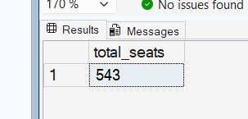

What is the total number of seats available for elections in each state
select s.state as state_name,count(conr.Parliament_Constituency) as total_seats
from constituencywise_results conr inner join statewise_results st on
conr.Parliament_Constituency=st.Parliament_Constituency
inner join states s on s.State_ID=st.State_ID
group by s.State
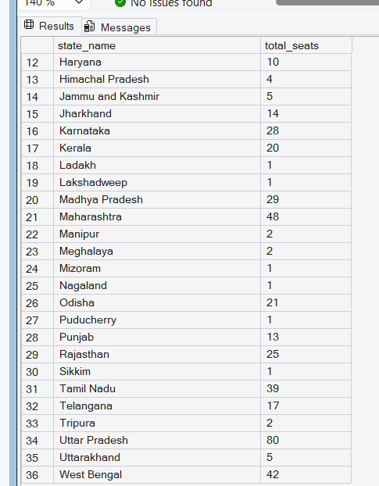

Seats Won by NDA Allianz Parties
SELECT party as party_name,won as seats_won
FROM partywise_results
WHERE Party IN (
'Bharatiya Janata Party - BJP',
'Telugu Desam - TDP',
'Janata Dal (United) - JD(U)',
'Shiv Sena - SHS',
'AJSU Party - AJSUP',
'Apna Dal (Soneylal) - ADAL',
'Asom Gana Parishad - AGP',
'Hindustani Awam Morcha (Secular) - HAMS',
'Janasena Party - JnP',
'Janata Dal (Secular) - JD(S)',
'Lok Janshakti Party(Ram Vilas) - LJPRV',
'Nationalist Congress Party - NCP',
'Rashtriya Lok Dal - RLD',
'Sikkim Krantikari Morcha - SKM'
) order by seats_won desc;
or
select party as party_name,won as seats_won
FROM partywise_results_1 where allinece='india' order by seats_won desc
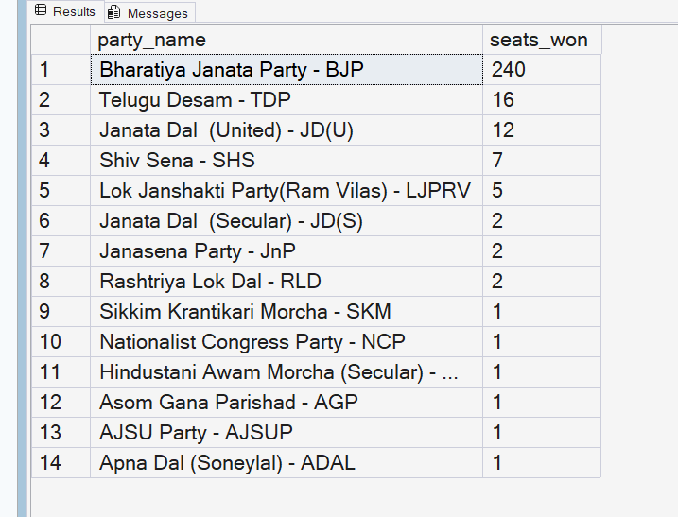

Total Seats Won by NDA Allianz
SELECT SUM(Won) AS NDA_Total_Seats
FROM partywise_results
WHERE Party IN (
'Bharatiya Janata Party - BJP',
'Telugu Desam - TDP',
'Janata Dal (United) - JD(U)',
'Shiv Sena - SHS',
'AJSU Party - AJSUP',
'Apna Dal (Soneylal) - ADAL',
'Asom Gana Parishad - AGP',
'Hindustani Awam Morcha (Secular) - HAMS',
'Janasena Party - JnP',
'Janata Dal (Secular) - JD(S)',
'Lok Janshakti Party(Ram Vilas) - LJPRV',
'Nationalist Congress Party - NCP',
'Rashtriya Lok Dal - RLD',
'Sikkim Krantikari Morcha - SKM'
);
or
select SUM(Won) AS NDA_Total_Seats_Won
FROM partywise_results_1 where allinece='NDA';

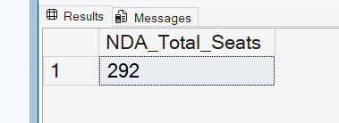

Total Seats Won by I.N.D.I.A. Allianz
SELECT SUM(Won) AS INDIA_Total_Seats_Won
FROM partywise_results
WHERE Party IN (
'Indian National Congress - INC',
'Aam Aadmi Party - AAAP',
'All India Trinamool Congress - AITC',
'Bharat Adivasi Party - BHRTADVSIP',
'Communist Party of India (Marxist) - CPI(M)',
'Communist Party of India (Marxist-Leninist) (Liberation) - CPI(ML)(L)',
'Communist Party of India - CPI',
'Dravida Munnetra Kazhagam - DMK',
'Indian Union Muslim League - IUML',
'Nat`Jammu & Kashmir National Conference - JKN',
'Jharkhand Mukti Morcha - JMM',
'Jammu & Kashmir National Conference - JKN',
'Kerala Congress - KEC',
'Marumalarchi Dravida Munnetra Kazhagam - MDMK',
'Nationalist Congress Party Sharadchandra Pawar - NCPSP',
'Rashtriya Janata Dal - RJD',
'Rashtriya Loktantrik Party - RLTP',
'Revolutionary Socialist Party - RSP',
'Samajwadi Party - SP',
'Shiv Sena (Uddhav Balasaheb Thackrey) - SHSUBT',
'Viduthalai Chiruthaigal Katchi - VCK'

);
or
select SUM(Won) AS INDIA_Total_Seats_Won
FROM partywise_results_1 where allinece='INDIA';
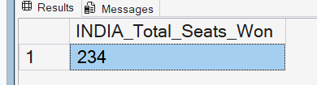

Seats Won by I.N.D.I.A. Allianz Parties
select party as party_name,won as seats_won
FROM partywise_results_1 where allinece='india' order by seats_won desc
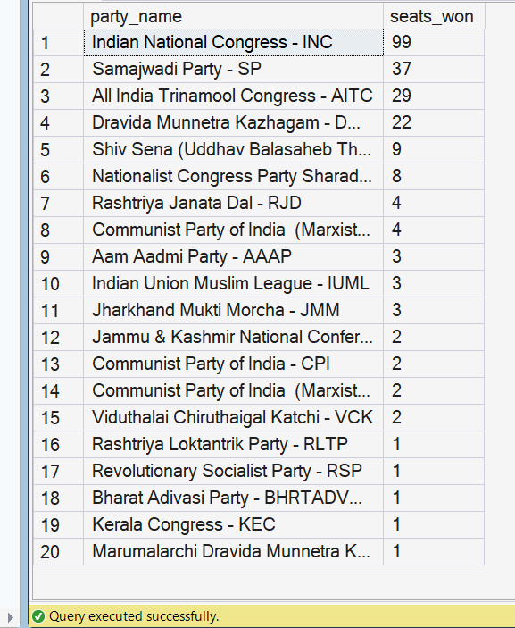

Which party alliance (NDA, I.N.D.I.A, or OTHER) won the most seats across all states?
select allinece,sum(won) as total_won from partywise_results_1
group by allinece;
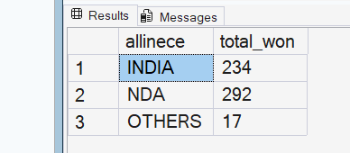
charts
winning candicate name,partname,total votes,
& margin and victory specific state & constituency
select
cor.Winning_Candidate as winning_candiacate,pt.party as party_name,
cor.Total_Votes as total_votes,st.margin,st.State as state_name,st.Constituency as
constituency_name from constituencywise_results cor inner join statewise_results st
on cor.Parliament_Constituency=st.Parliament_Constituency inner join
partywise_results_1 pt on cor.Party_ID=pt.Party_ID;
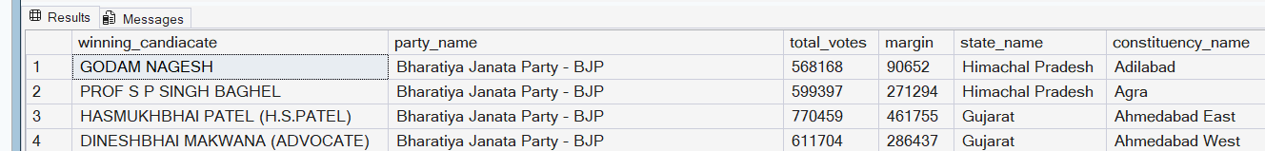
What is the distribution of EVM votes versus postal votes for candidates in a specific constituency?

select cond.EVM_Votes as Evm_votes,cond.Postal_Votes as postal_votes,cond.total_Votes
as total_votes,cond.Candidate as candicate_name,conr.Constituency_Name as constituney_name
from constituencywise_details cond inner join constituencywise_results conr
on cond.Constituency_ID=conr.Constituency_ID;
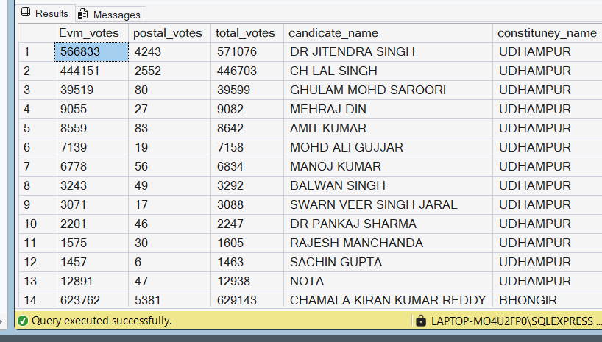
Which parties won the most seats in s State, and how many seats did each party win?
select pt.party as party_name,count(conr.Constituency_ID)
as total_win_seats,st.state as stat_name from constituencywise_results conr
inner join partywise_results_1 pt on conr.Party_ID=pt.Party_ID
inner join statewise_results strw on conr.Parliament_Constituency=strw.Parliament_Constituency
inner join states st on st.State_ID=strw.state_id where st.state='Andhra Pradesh'
GROUP BY pt.party,st.state;
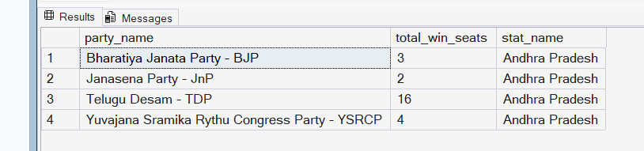

What is the total number of seats won by each party alliance (NDA, I.N.D.I.A, and OTHER) in each state for the India Elections 2024

SELECT
st.state AS state_name,

SUM(CASE WHEN pt.allinece = 'NDA' THEN 1 ELSE 0 END) AS NDA,

SUM(CASE WHEN pt.allinece = 'INDIA' THEN 1 ELSE 0 END) AS INDIA,

SUM(CASE WHEN pt.allinece = 'OTHERS' THEN 1 ELSE 0 END) AS OTHERS

FROM constituencywise_results conr

INNER JOIN partywise_results_1 pt
ON conr.Party_ID = pt.Party_ID

INNER JOIN statewise_results strw
ON conr.Parliament_Constituency = strw.Parliament_Constituency

INNER JOIN states st
ON st.State_ID = strw.State_ID

GROUP BY
st.state

ORDER BY
st.state;

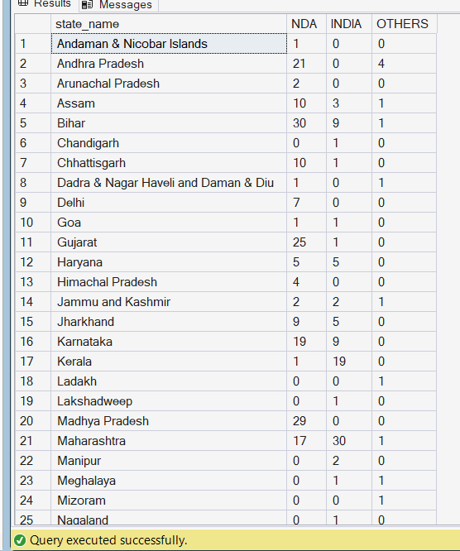

Which candidate received the highest number of EVM votes in each constituency (Top 10)?
select top 10 cond.Candidate as candicate_name,cond.EVM_Votes as evm_votes,
max(cond.EVM_Votes) as max_Evm_votes,conr.Constituency_Name as
constituney_name from constituencywise_details cond inner join
constituencywise_results conr on cond.Constituency_ID=conr.Constituency_ID
group by Constituency_Name,cond.EVM_Votes,cond.Candidate
order by cond.EVM_Votes desc;

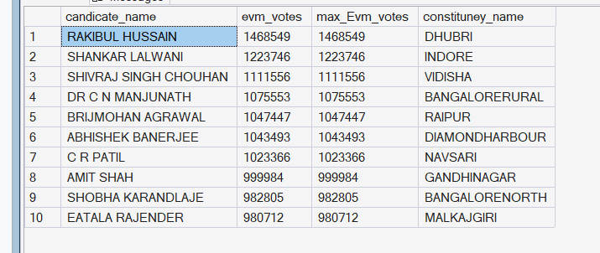

Which candidate won and which candidate was the runner-up in each constituency of State for the 2024 elections?
WITH test AS (
SELECT
cd.Constituency_ID,
cr.Constituency_Name,
cd.Candidate,
ROW_NUMBER() OVER (
PARTITION BY cd.Constituency_ID
ORDER BY (cd.Total_Votes) DESC
) AS rn
FROM constituencywise_details cd
JOIN constituencywise_results cr
ON cd.Constituency_ID = cr.Constituency_ID
JOIN statewise_results sr
ON cr.Parliament_Constituency = sr.Parliament_Constituency
JOIN states s
ON sr.State_ID = s.State_ID
WHERE s.State = 'Maharashtra'
)

SELECT
Constituency_Name,
MAX(CASE WHEN rn = 1 THEN Candidate END) AS Winner,
MAX(CASE WHEN rn = 2 THEN Candidate END) AS Runner_Up
FROM test
GROUP BY Constituency_Name
ORDER BY Constituency_Name;

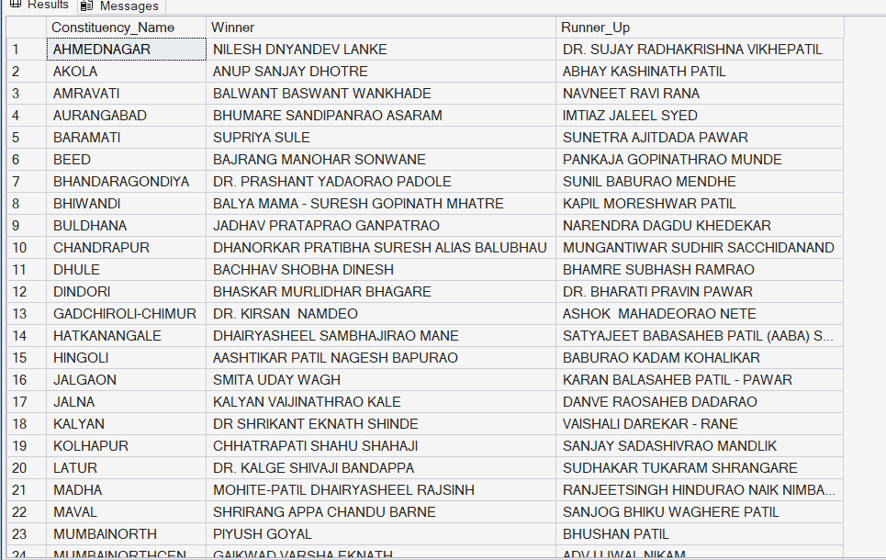
For the state of Maharashtra, what are the total number of seats, total number of candidates, total number of parties, total votes (including EVM and postal), and the breakdown of EVM and postal votes?

select count(distinct conr.Constituency_ID) as total_seats,
count(distinct cond.Candidate) as total_candicate,count(distinct cond.Party) as total_parties,
sum(cond.Total_Votes) as total_votes from constituencywise_details cond inner join
constituencywise_results conr on cond.Constituency_ID=conr.Constituency_ID
inner join statewise_results strw on conr.Parliament_Constituency=strw.Parliament_Constituency
inner join states st on st.State_ID=strw.state_id
where st.state='Maharashtra'
