PIZZA SALES SQL QUERIES
KPI’s
- Total Revenue:
SELECT SUM(total_price) AS Total_Revenue FROM pizza_sales;
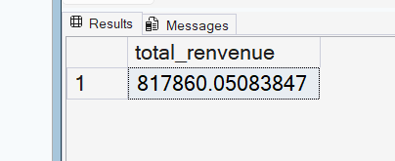
- Average Order Value
select (sum(total_price)/COUNT(DISTINCT order_id)) as avg_sales from pizza_sales;

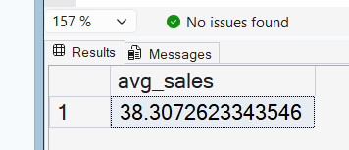
3. Total Pizzas Sold
select sum(quantity) as pizza_sold from pizza_sales;

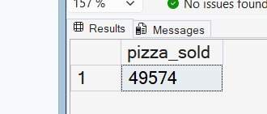
4. Total Orders
select count(distinct(order_id)) as Total_order from pizza_sales;

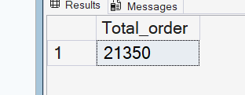

5. Average Pizzas Per Order
select sum(quantity)/COUNT(DISTINCT order_id) as avg_pizza_sold from pizza_sales;

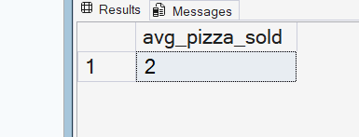

Charts
Daily trend
Select datename(dw,order_date) as order_day, count(distinct(order_id) as Total_order_day from sales group by(datename(dw,order_date)
Hourly Trend for Total Pizzas Sold

select DATEPART(hour,order_time) as hourly_order,sum(quantity) as total_qty
from pizza_sales group by DATEPART(hour,order_time)
order by DATEPART(hour,order_time);

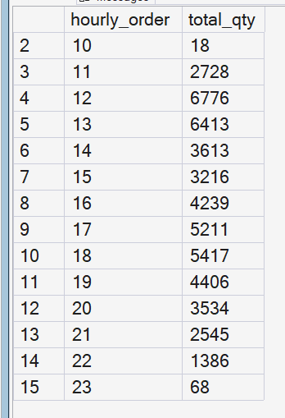

Weekly Trend for Total Orders
SELECT
DATEPART(ISO_WEEK,order_date) AS week_order,year(order_date) as order_year,
COUNT(DISTINCT order_id) AS total_order
FROM pizza_sales
GROUP BY DATEPART(ISO_WEEK, order_date),year(order_date)
ORDER BY DATEPART(ISO_WEEK, order_date),year(order_date);

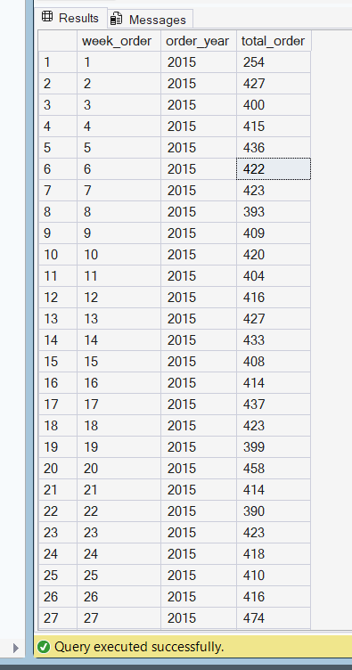

Percentage of Sales by Pizza Category

select pizza_category,sum(total_price) * 100/ (select sum(total_price) from pizza_sales)as pct from pizza_sales
group by pizza_category
order by pizza_category;
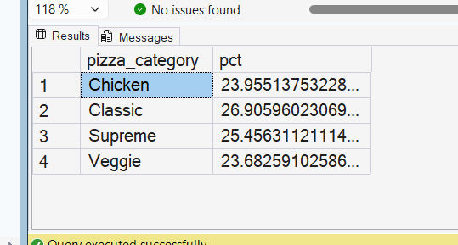
Percentage of Sales by Pizza Size:
select pizza_size,sum(total_price) * 100 / (select sum(total_price) from pizza_sales) as size_of_pizzza
from pizza_sales
group by pizza_size
order by pizza_size;
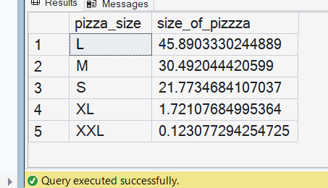
Bottom 5 Pizzas by Revenue,total order,total quantity:
select top 5 pizza_name,sum(total_price) as total_sales from pizza_sales
group by pizza_name order by total_sales asc;
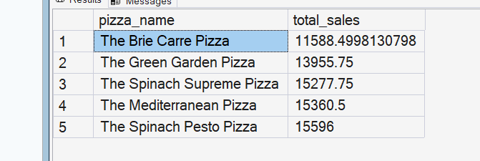

Bottom 5 Pizzas by Quantity:
select top 5 pizza_name,sum(quantity) as total_sales from pizza_sales
group by pizza_name order by total_sales asc;
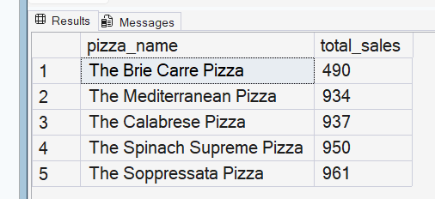
Bottom 5 Pizzas by Total Orders:
select top 5 pizza_name,count(distinct(order_id)) as total_order from pizza_sales
group by pizza_name order by total_order asc;
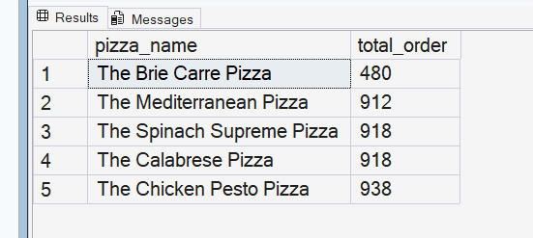
top5 Pizzas by Total Orders
select top 5 pizza_name,sum(total_price) as total_sales from pizza_sales
group by pizza_name order by total_sales desc;
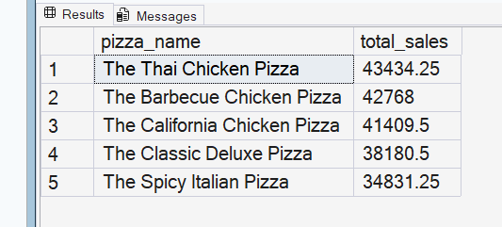
select top 5 pizza_name,sum(quantity) as total_qty from pizza_sales
group by pizza_name order by total_qty desc;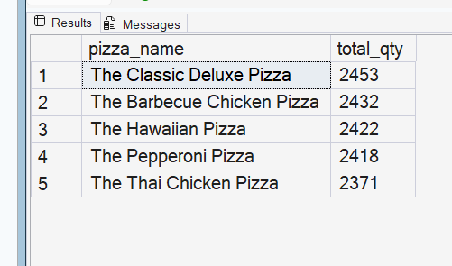
select top 5 pizza_name,count(distinct(order_id))as total_order from pizza_sales
group by pizza_name order by total_order desc;

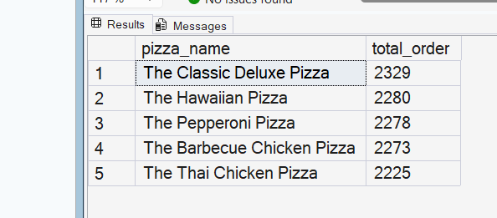
Total Pizzas Sold by Pizza Category
SELECT pizza_category, SUM(quantity) as Total_Quantity_Sold
FROM pizza_sales
WHERE MONTH(order_date) = 2
GROUP BY pizza_category
ORDER BY Total_Quantity_Sold DESC

