**GIT ASSIGNMENT**

# Question 1

**Step 1: Create a new Git repository.**

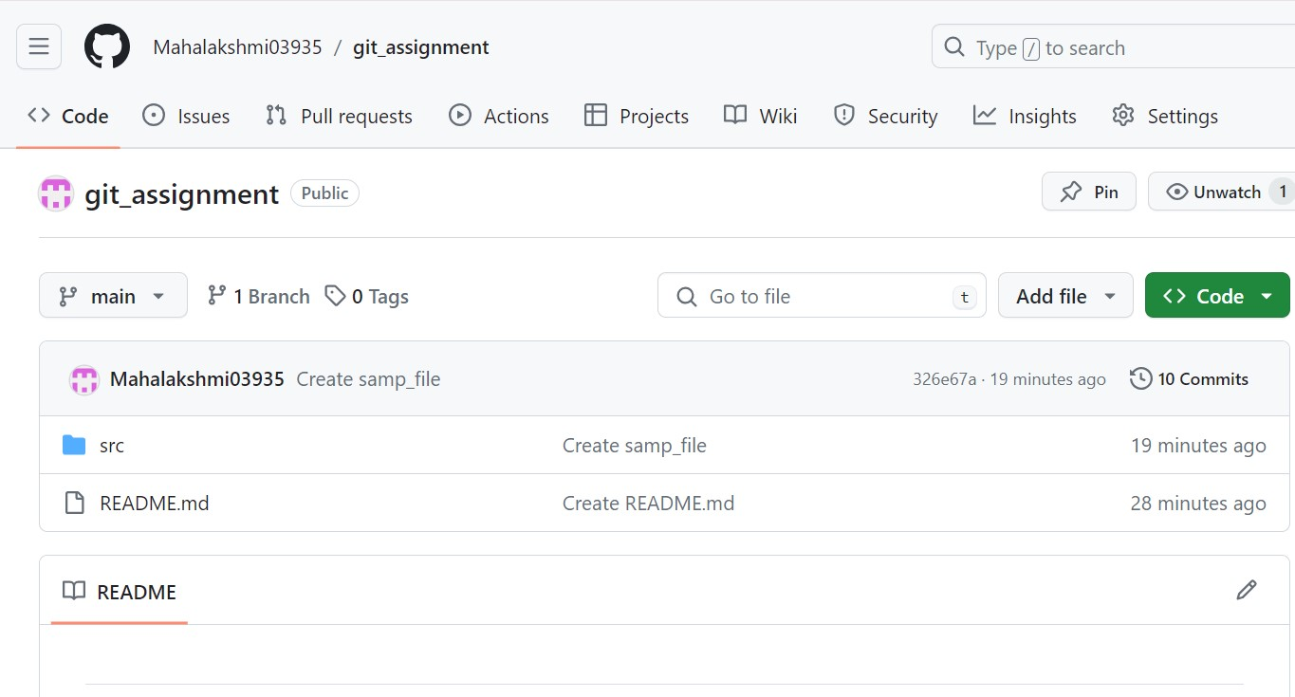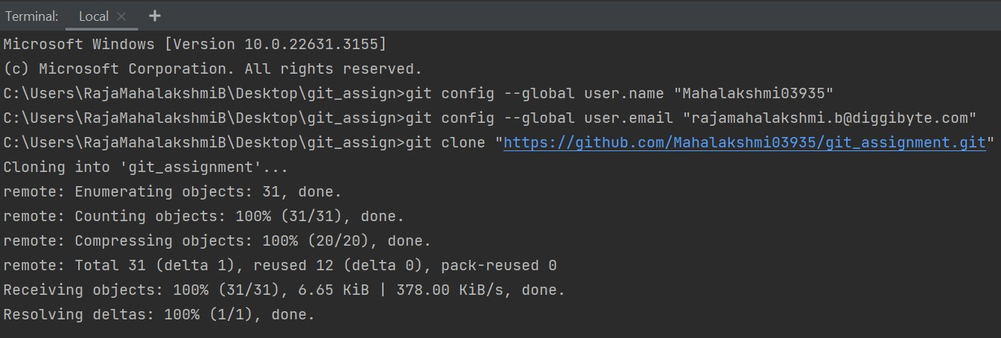

Created a new Git Repository and copied the repository from GitHub to your local machine using git clone command

**Step 2: Create a file and commit changes.**

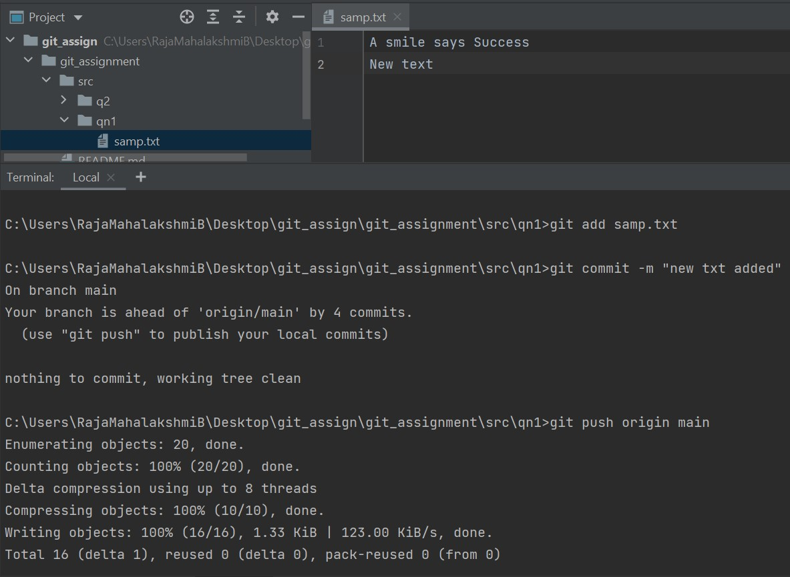

Created a file ,modified the the text and pushed it in to the Remote Repository

(Git commands like git add,commit and push are used here)

**Step 3: View the commit history of your repository.**

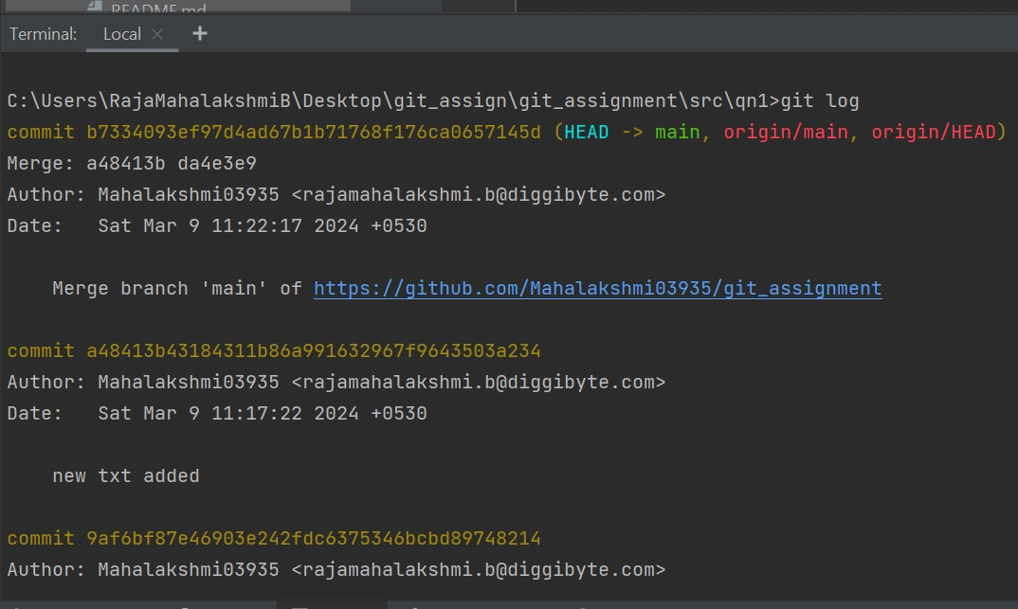

The list of changes made is displayed using git log command

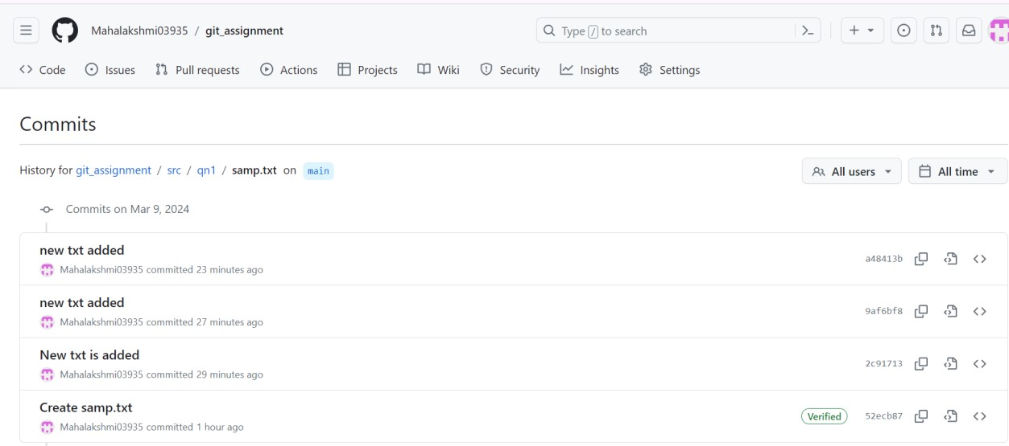

**Step 4: Open the file you created earlier and make some changes to it**

**Step 5: Check the file you modified is now marked as "modified" and unstaged.**

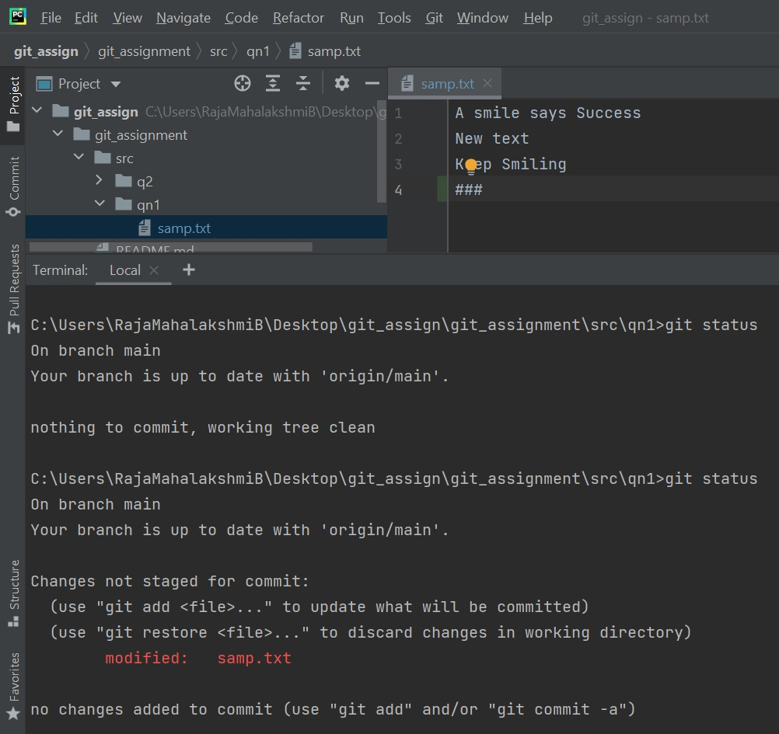

Accessed the file and made some changes to it and git status command is used to check the file status

**Step 6: Stage the changes you made to the file and commit the changes to the repository.**

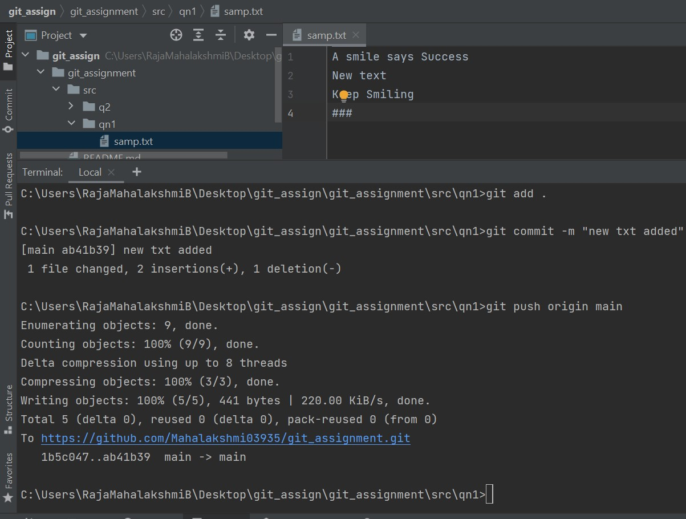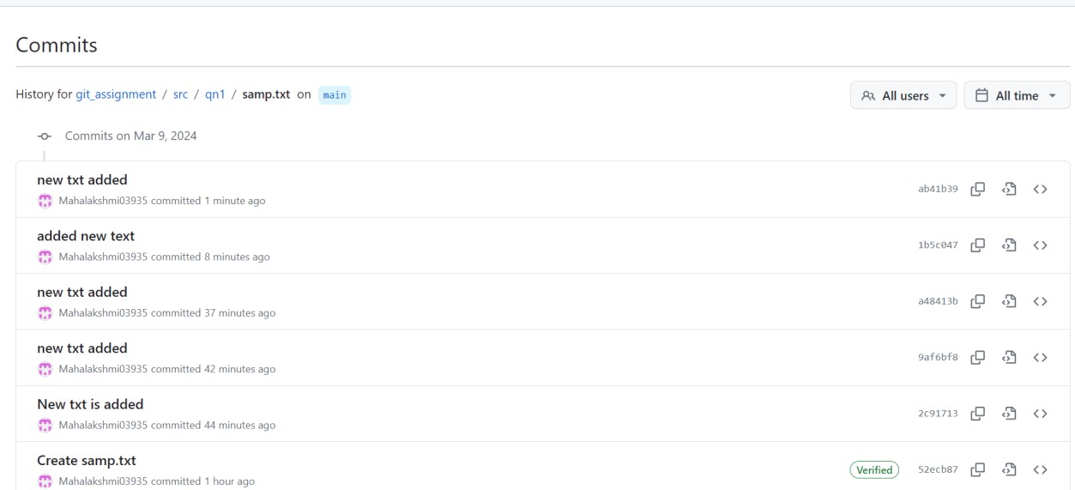

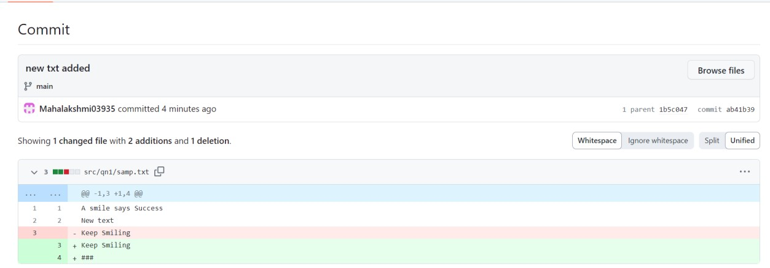

Added and saved the changes to the Repository

**Step 7: Clone the repository you have created in GitHub.**

**Step 8: Fetch the changes, navigate into the cloned repository using the command line, and use the command git fetch to fetch any changes that have been made to the original repository since you cloned it.**

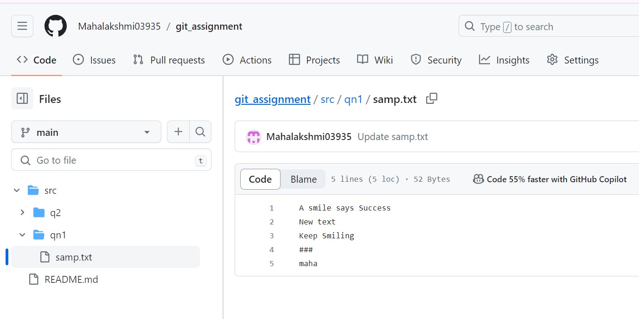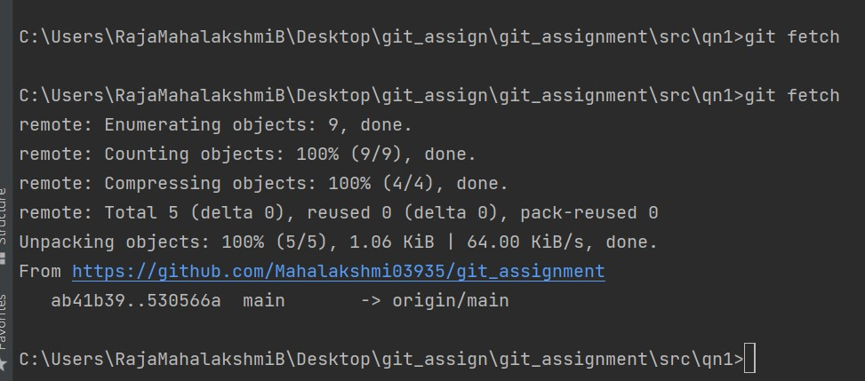

Fetched the changes, navigated into the cloned repository using the command line and

git fetch command is used to fetch any changes that have been made to the original repository

**Step 9: Pull changes, merge the changes you just fetched into your local copy of the repository, and use the command git pull.**

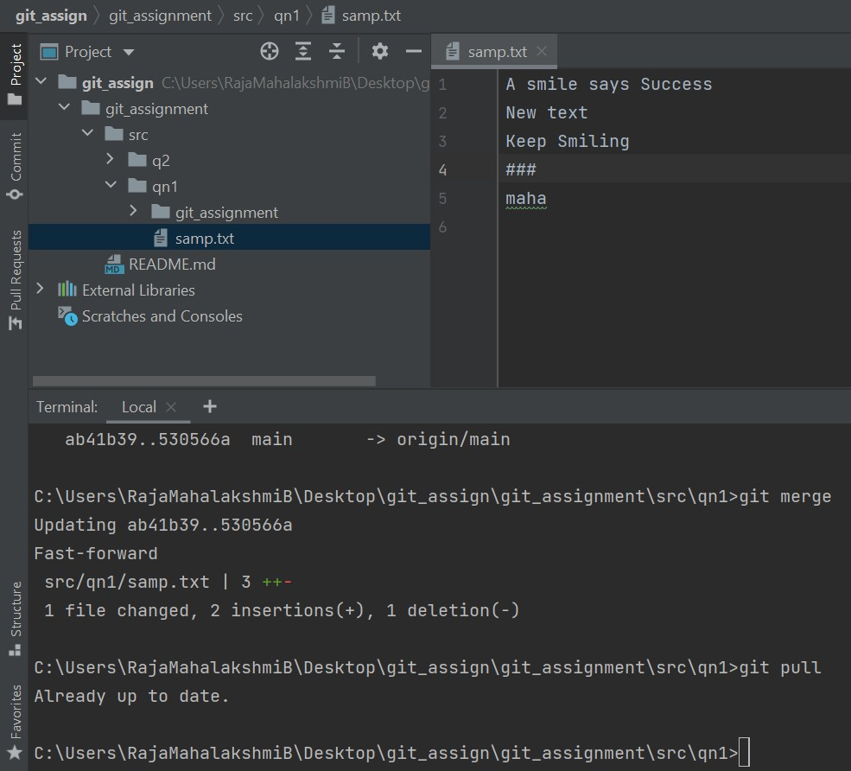

Merged the fetched changes into your local repository and git pull command is used