# **Question 2**

**Step 1: Clone the repository you have created in GitHub.**

**Step 2: Create a new branch using the command.**

**Step 3: Switch to the new branch.**

Created a new branch using git branch command and switched to the new branch using git checkout branch command

**Step 4: Make some changes to the code in your local copy of the repository.**

**Step 5: Commit changes to the new branch.**

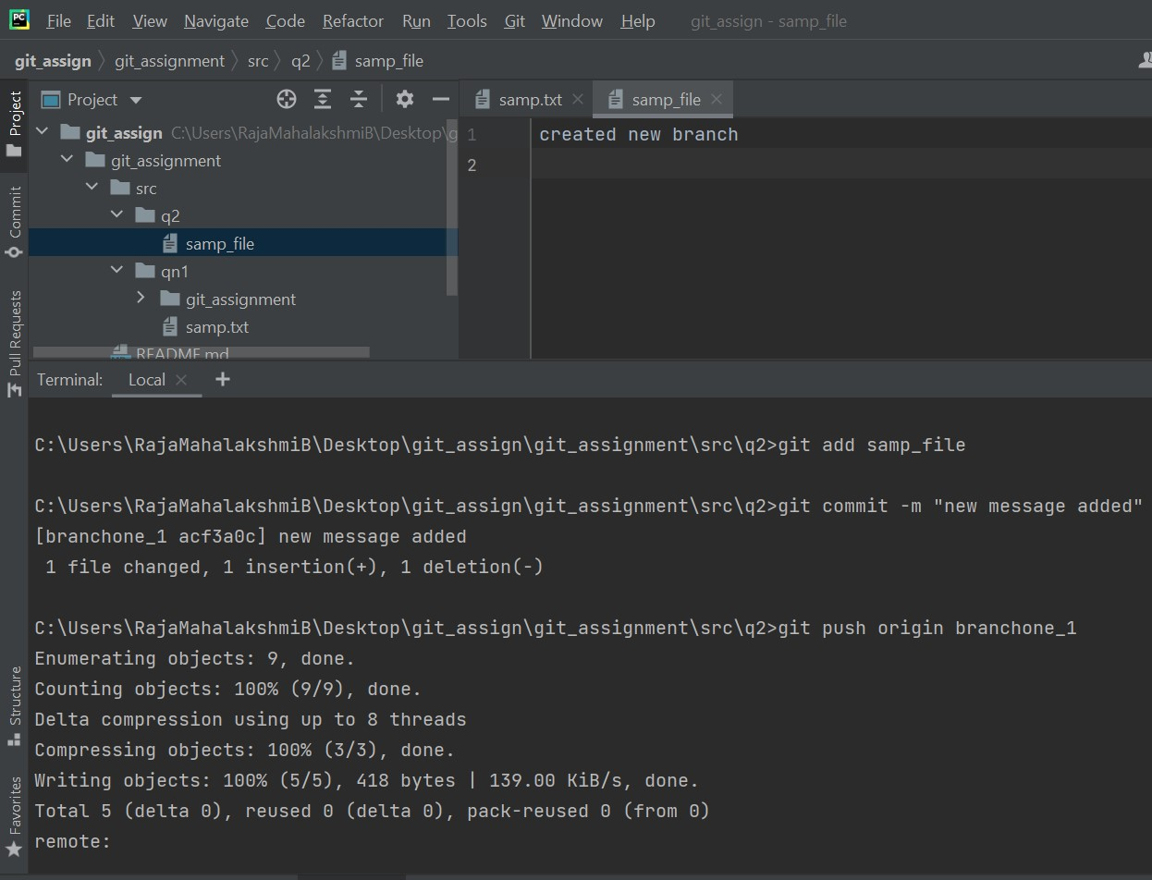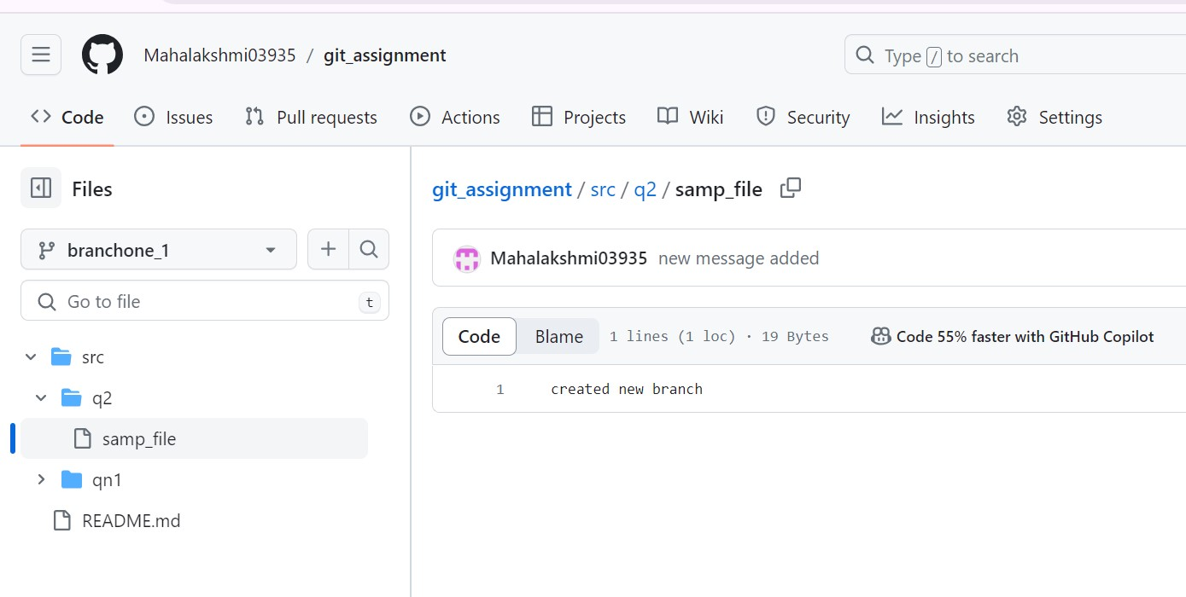

Made some changes to the code in the local copy of the repository and committed the changes to the new branch.

**Step 6: Switch back to the original branch**

Switched back to the original branch

**Step 7: Merge the new branch.**

**Step 8: Push changes to the original branch**

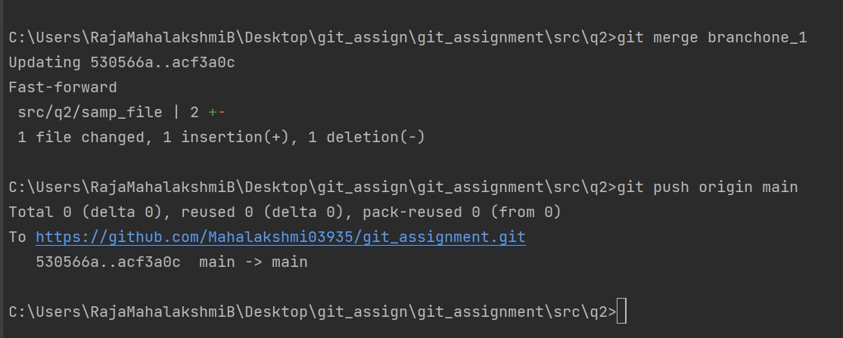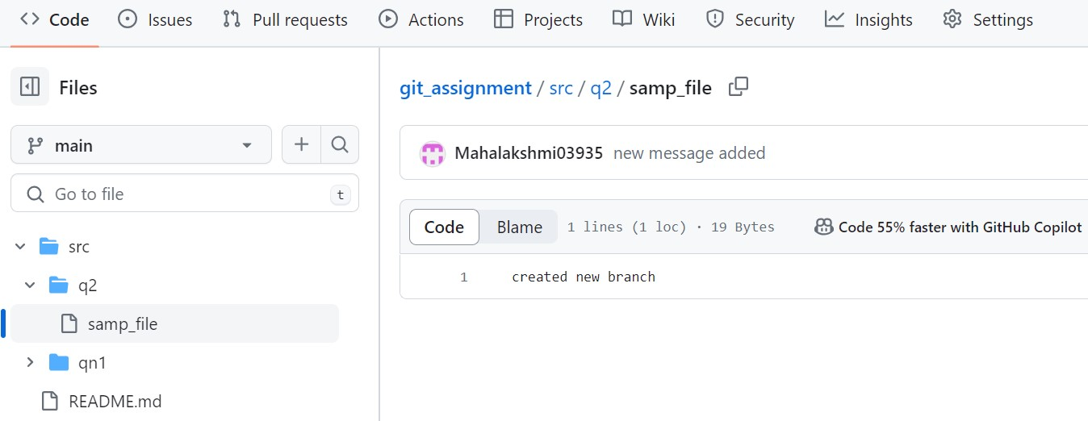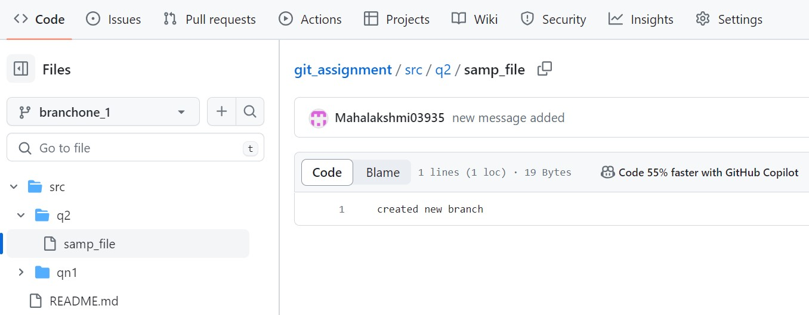

Merged the new branch and Pushed the changes to the original branch