# **Question 4 :**

**Step 1: Create a feature branch.**

**Step 2: Switch to the new branch.**

**open the file and make some changes to it.**

**Add and commit the changes to the new branch.**

**open the same file and make some changes to it.**

**Add and commit the changes to the new branch.**

**open the same file and make some changes to it.**

**Add and commit the changes to the new branch.**

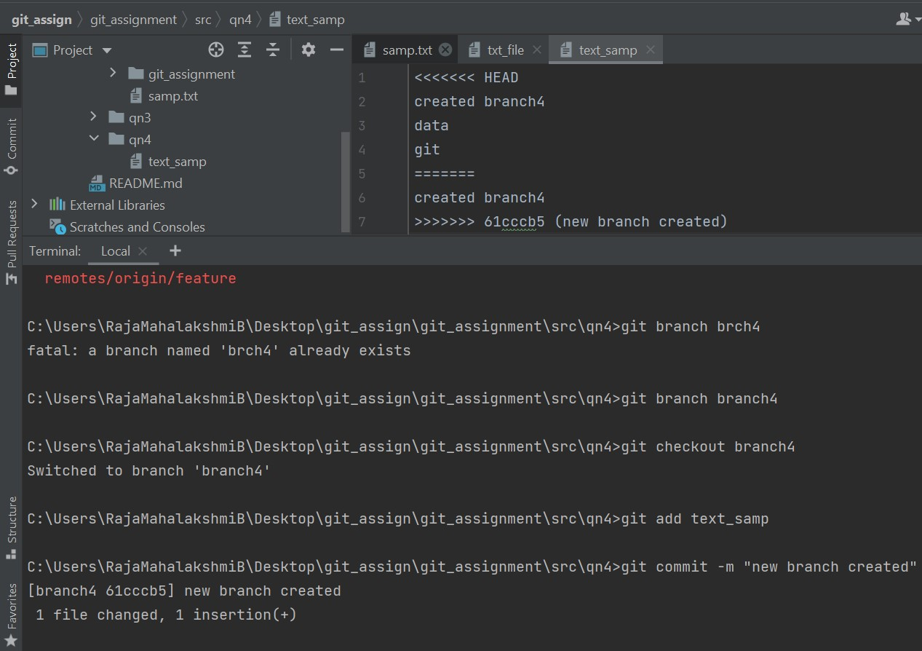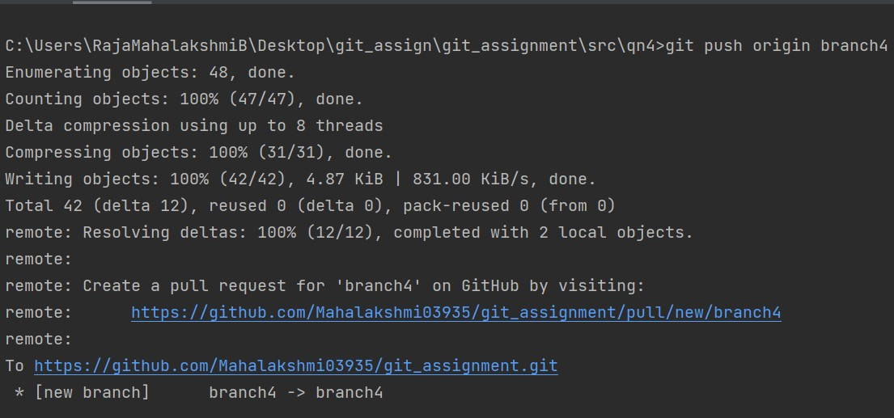

Created a new feature branch and switched to the new branch ,added and committed the changes to the new branch thrice

**Step 3: Identify the commit or commits that you want to "cherry-pick"(Note the hash of the commit or commits that you want to "cherry-pick")**

**Step 4: Use the "git checkout" command to switch to the branch where you want to apply the changes.**

**Step 5: Use the "git cherry-pick" command followed by the commit hash(es) that you want to apply.**

Identified the commit that I need to do cherry-pick and the git cherry-pick command is used