**HARSHITHA H MOOLYA**

**118A1048 TE/CE/C3**

**EXPERIMENT NO-4**

create table employee1(emp_id CHAR(5) PRIMARY KEY,emp_name varchar(15),job_name varchar(10),manager_id CHAR(5),hire_date date ,salary int,comm int,deptid char(4));

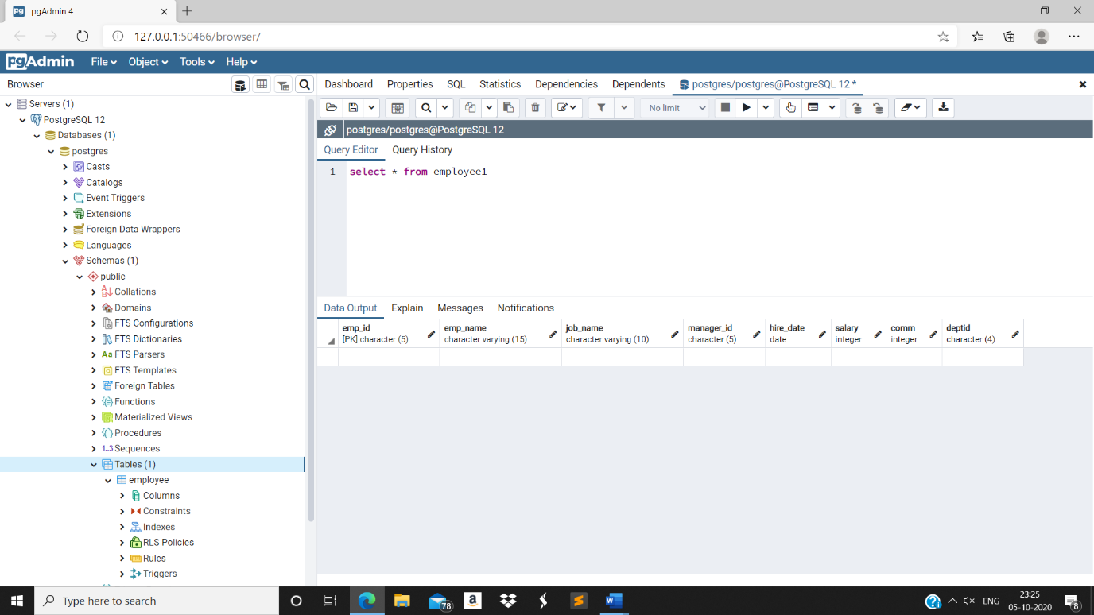

insert into employee1 (emp_id,emp_name,job_name,manager_id,hire_date,salary,comm,deptid) values ('66928','BLAZE','MANAGER','68319','1991-05-01',2750,0,'3001'),

('67832','CLARE','MANAGER','68319','1991-06-09',2550,0,'1001'),

('65646','JONAS','MANAGER','68319','1991-04-02',2957,0,'2001'),

('64989','ADELYN','SALESMAN','66928','1991-02-20',1700,400,'3001'),

('65271','WADE','SALESMAN','66928','1991-09-28',1350,600,'3001'),

('66564','MADDAN','SALESMAN','66928','1991-09-08',1600,0,'3001'),

('68454','TUCKER','SALESMAN','66928','1991-02-22',1600,0,'3001');

select * from employee1

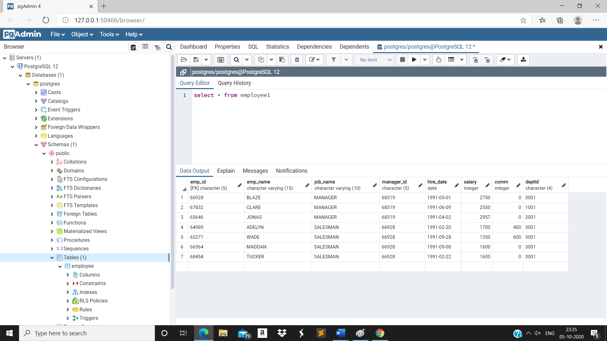

insert into employee1(emp_id,emp_name,job_name,manager_id,hire_date,salary,comm,deptid) values ('68736','ADNRES','CLERK','67858','1997-05-23',1200,0,'2001'),

('69000','JULIUS','CLERK','67858','1997-05-23',1200,0,'2001'),

('69324','MARKER','CLERK','67832','1992-01-23',1400,0,'1001'),

('67858','SCARLET','ANALYST','65646','1997-04-19',3100,0,'2001'),

('69062','FRANK','ANALYST','65646','1991-12-03',3100,0,'2001'),

('63679','SANDRINE','CLERK','69062','1990-12-18',900,0,'2001');

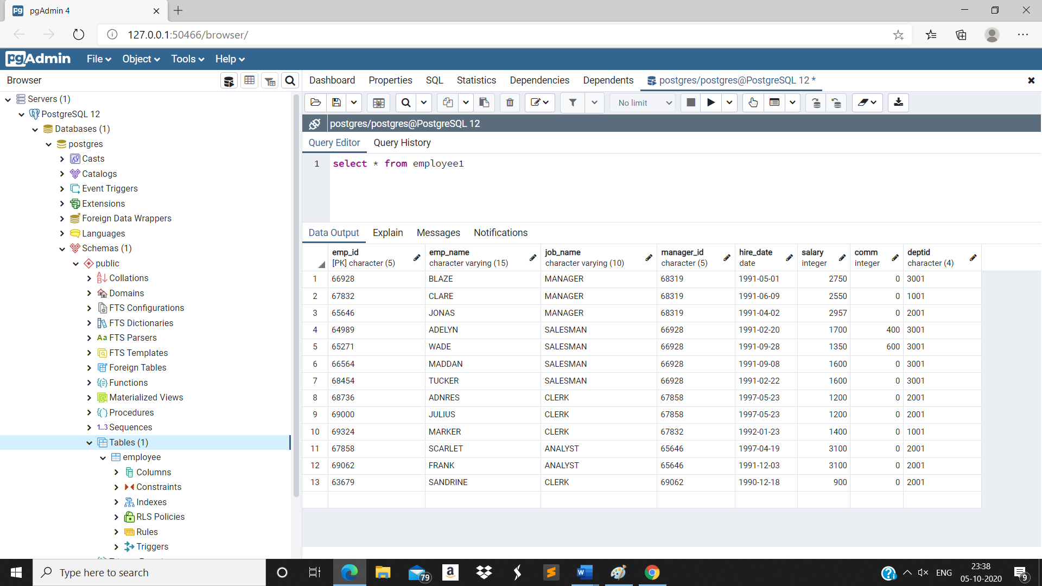

1. Select the name and salary of all employees whose salary is between 2000 and 3000.

select emp_name,salary from employee1 where (salary>=2000 and salary<=3000);

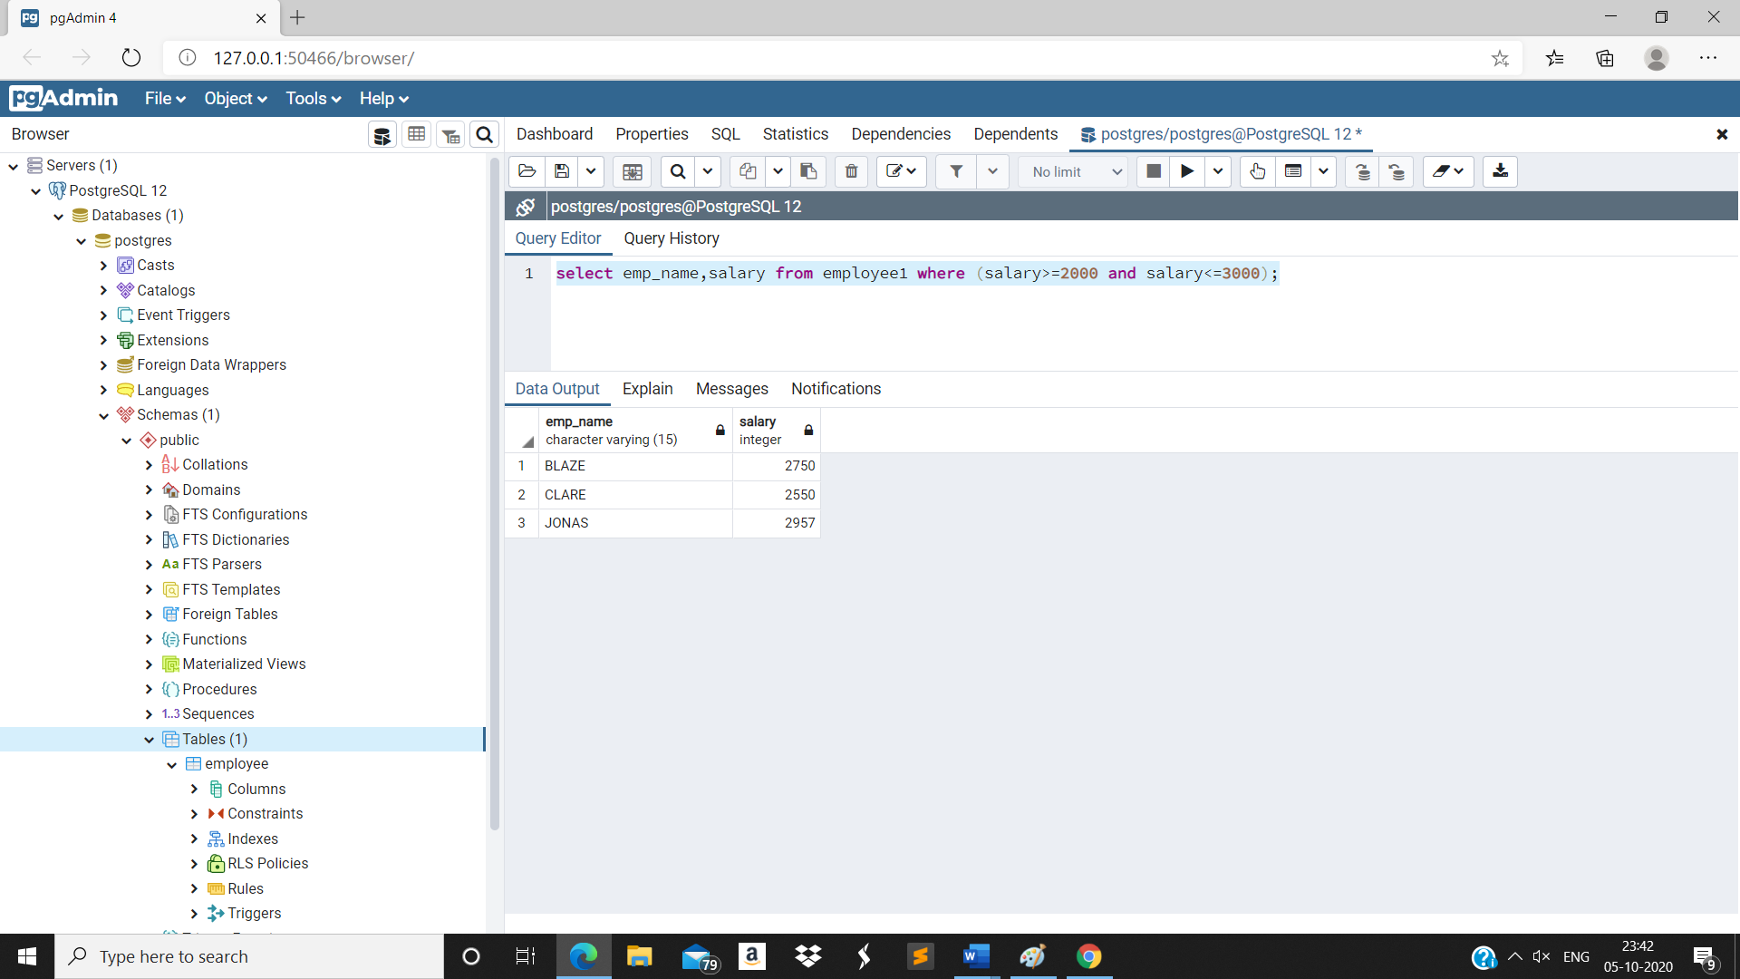

1. Select the name and salary of all employees whose Hire date is between 1st Jan 92 and 31st Dec 97

select emp_name,salary from employee1 where (hire_date>='1992-01-01' and hire_date<='1997-12-31');

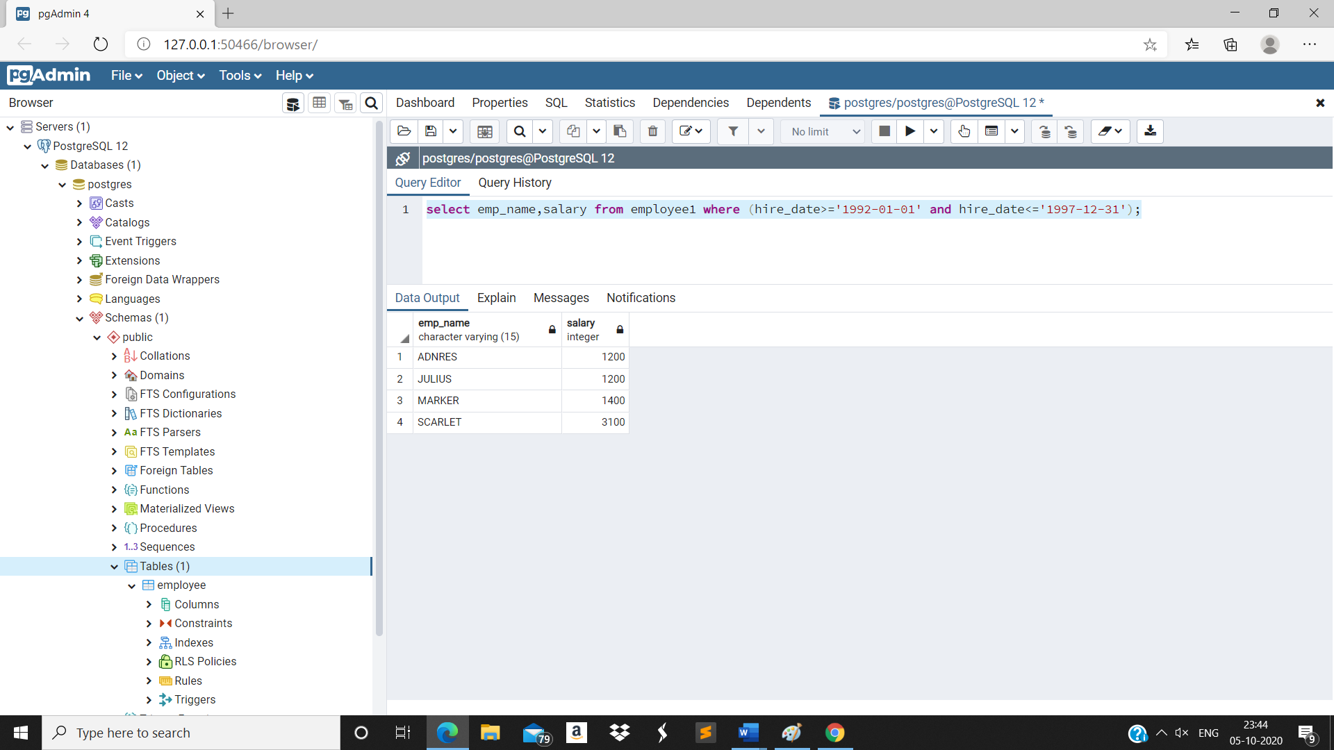

1. Select the name of all employees who work in dept 1001or 2001

select emp_name from employee1 where (deptid='1001' or deptid='2001');

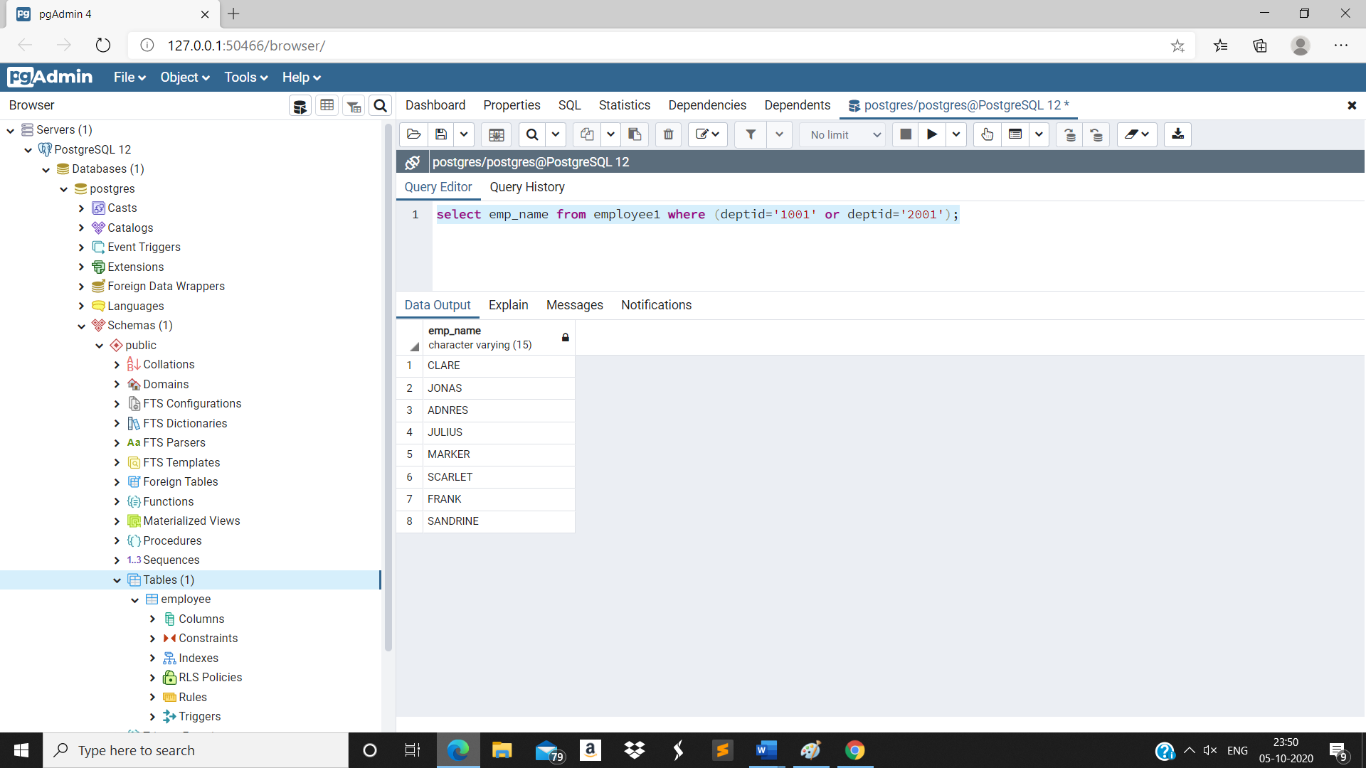

1. Select the name of all employees whose commission is 0.

select emp_name from employee1 where (comm=0)

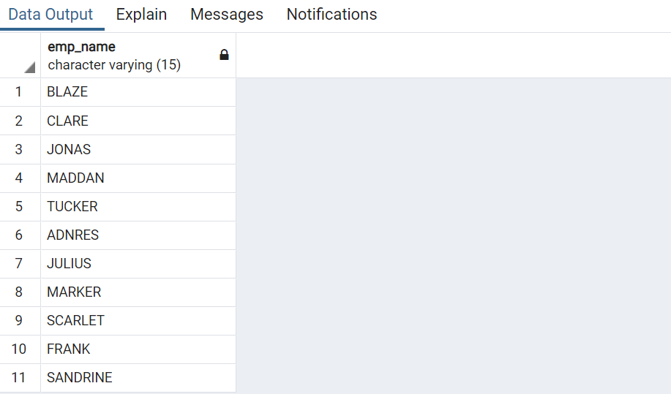

1. Select the name of all employees who are hired after 1st sep 1992 from dept 1001

select emp_name from employee1 where (hire_date>='1992-09-01' and deptid='1001')

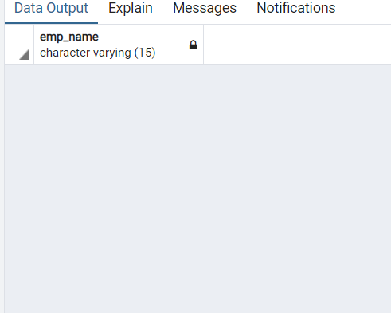

1. Select the name of all employees who do not belong to dept 1001

select emp_name from employee1 where (deptid!='1001')

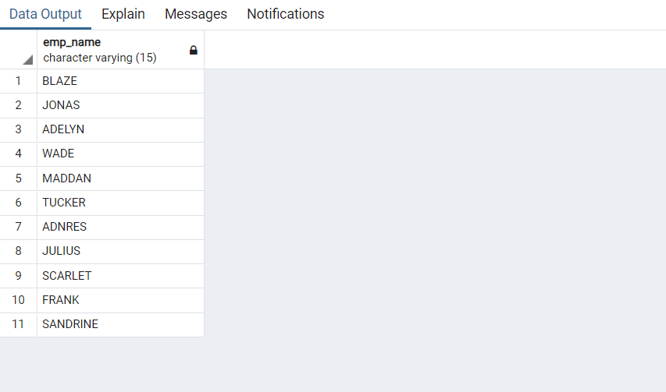

1. count the no of employees

select count(*) from employee1

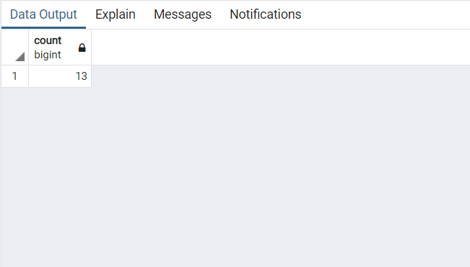

1. count the no of employees hired after 13th Jan 1997

select count(*) from employee1 where (hire_date>='1997-01-13')

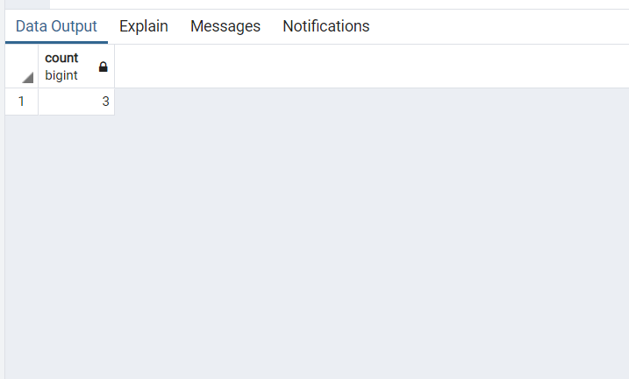

1. calculate the sum of salaries of all employees

select sum(salary) from employee1

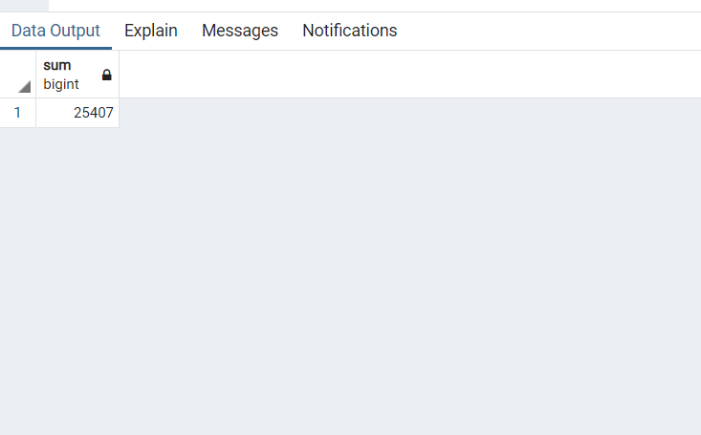

1. calculate the average of salaries of all employees

select avg(salary) from employee1

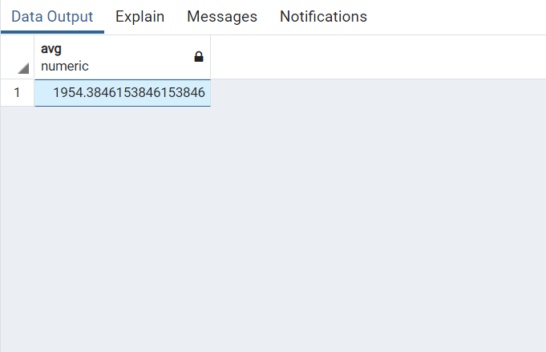

1. Get the average,minimum,maximum salary of employees for each dept

select deptid,avg(salary),min(salary),max(salary) from employee1 group by(deptid)

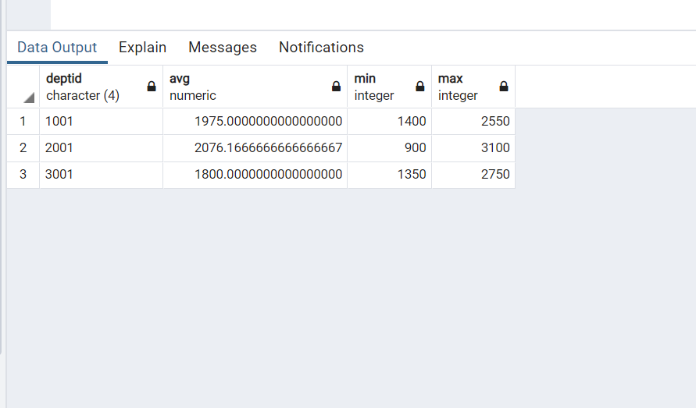

1. Get the average, minimum, maximum salary of employees for each dept having

average salary >2000

select deptid,avg(salary),min(salary),max(salary) from employee1 group by(deptid) having (avg(salary)>2000)

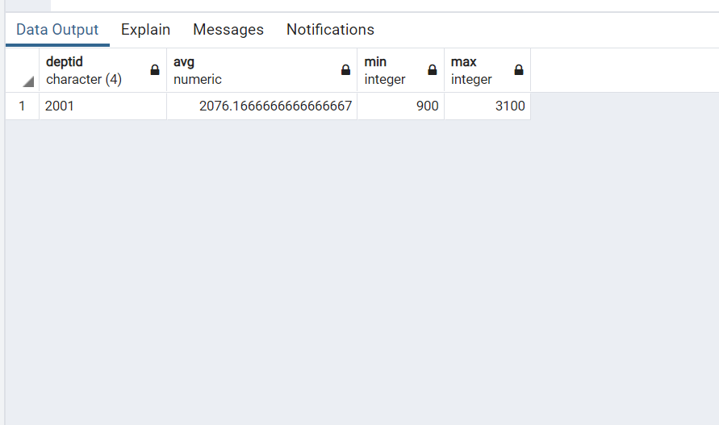

1. Get the minimum salary of employees for each job

select job_name,min(salary) from employee1 group by job_name

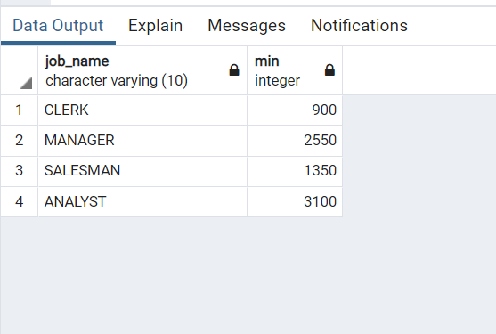

1. For each dept Get the minimum salary of employees who are clerk.

select deptid,min(salary) from employee1 where (job_name='clerk') group by(deptid)

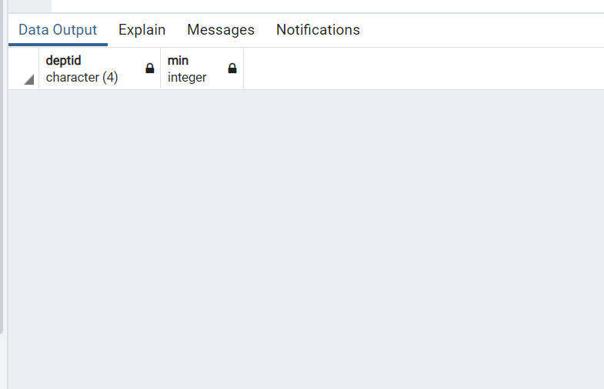

1. Get the minimum and maximum salary of employees for jobs in each dept.

select deptid,job_name,max(salary),min(salary) from employee1 group by(deptid,job_name)

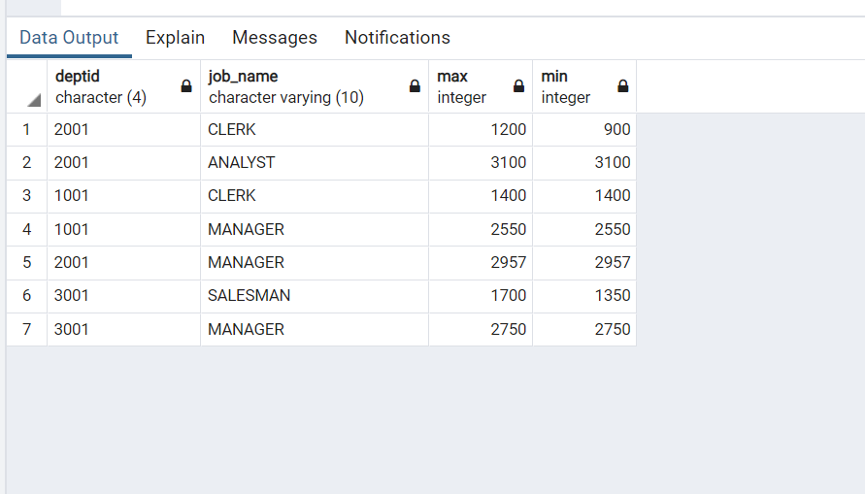

1. Get the number of available job opportunities

select count(distinct job_name) from employee1

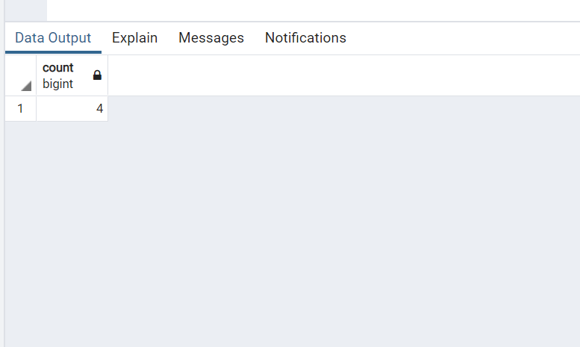

1. calculate 12 times the average salary

select 12*avg(salary) as PRODUCT from employee1

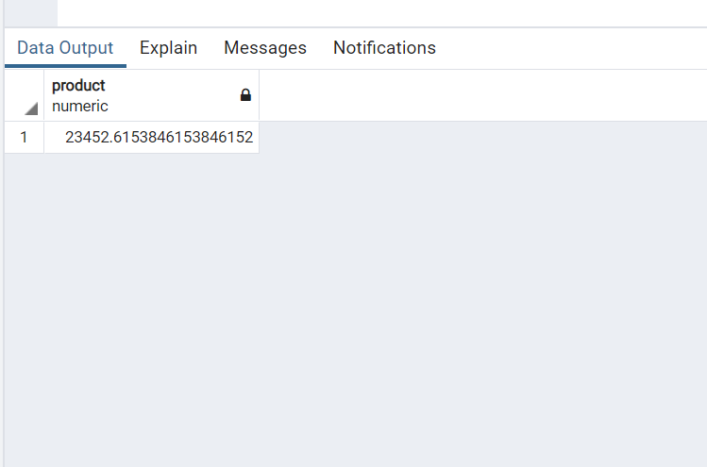

1. Get the number of employees in each department

select job_name,count(deptid) from employee1 group by(job_name)

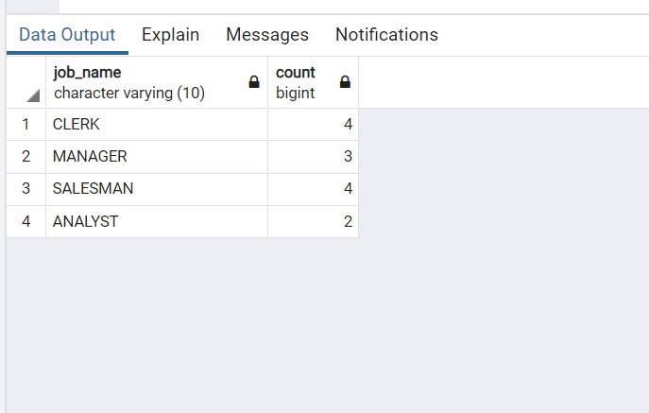

1. Get the total salary for each department.

select deptid,sum(salary) from employee1 group by(deptid)

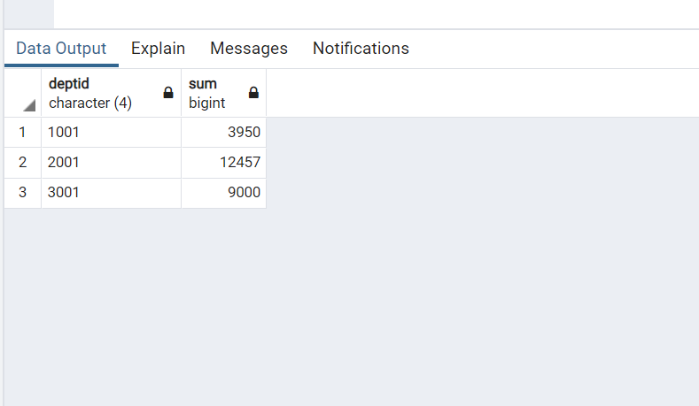

1. Get the total salary for each job.

select job_name,sum(salary) from employee1 group by(job_name)

