118A1084

**EXPERIMENT NO-3**

Create the table   
Table: Employee

|  |  |
| --- | --- |
| ATTRIBUTE (FIELD) NAME | DATA DECLARATION |
| EMP_NUM | CHAR(3) |
| EMP_LNAME | VARCHAR(15) |
| EMP_FNAME | VARCHAR(15) |
| EMP_INITIAL | CHAR(1) |
| EMP_HIREDATE | DATE |
| JOB_CODE | CHAR(3) |

**create table employee(emp_num char(3) primary key,emp_fname varchar(15),emp_lname varchar(15),emp_initial char(1),emp_hiredate date,job_code char(3))**

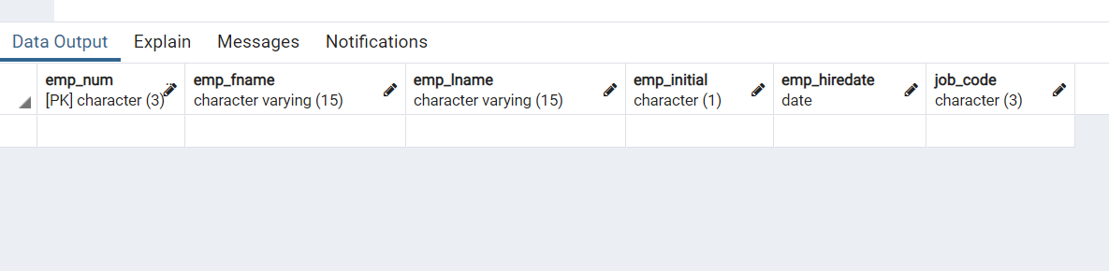

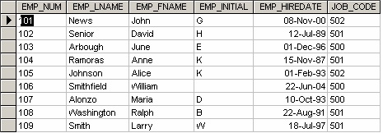

**insert into employee (emp_num,emp_fname,emp_lname,emp_initial,emp_hiredate,job_code) values**

**('101','John','News','G','2000-11-08','502'),**

**('102','David','Junior','H','1989-07-12','501'),**

**('103','June','Arbough','E','1996-12-01','500'),**

**('104','Anne','Ramoras','K','1987-11-15','501'),**

**('105','Alice','Johnson','K','1993-02-01','502'),**

**('106','William','Smithfield','','2004-06-22','500'),**

**('107','Maria','Alonzo','D','1993-10-10','500'),**

**('108','Ralph','Washington','B','1991-08-22','501'),**

**('109','Larry','Smith','W','1997-07-18','501');**

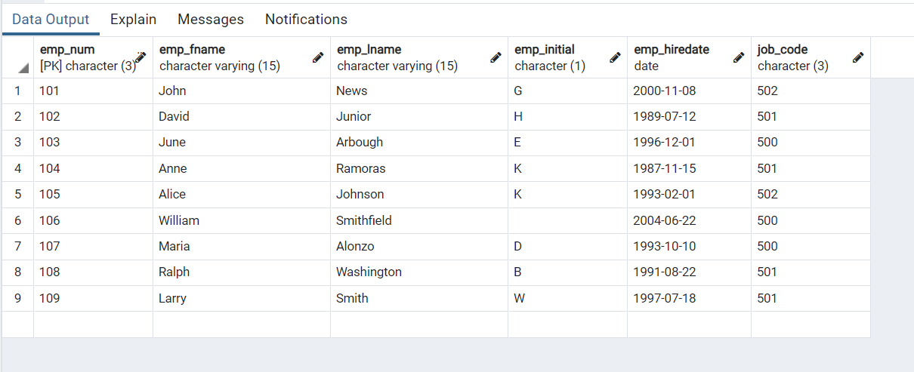

1. Write the SQL code to change the job code to 501 for the person whose personnel number is 107. After you have completed the task, examine the results, and then reset the job code to its original value.

**update employee set job_code='501' where emp_num='107'**

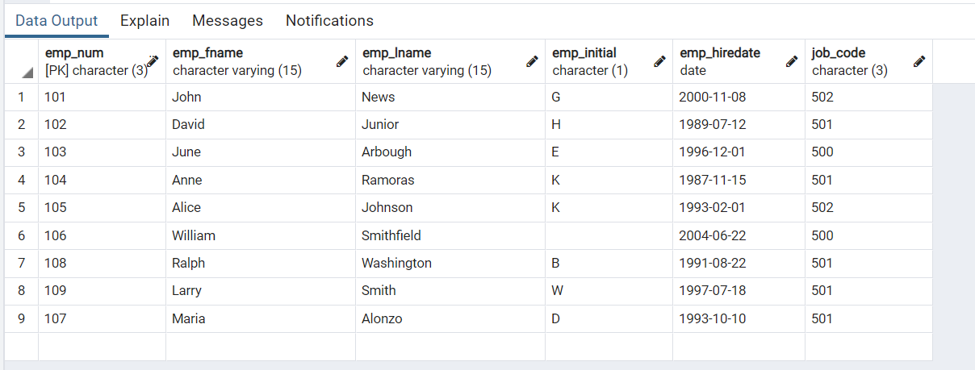

1. Insert the data in Employee table, write the SQL code that lists all attributes for a job code of 502.

**select * from employee where job_code='502'**

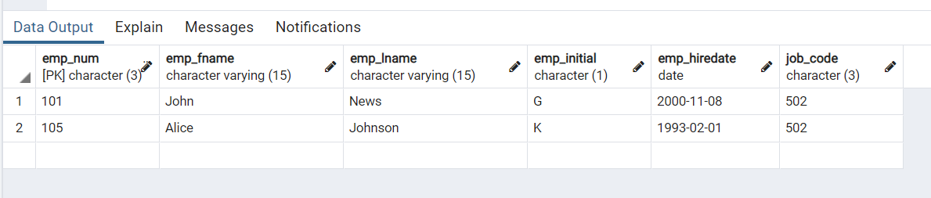

1. Write the SQL code to delete the row for the person named William Smithfield, who was hired on June 22, 2004, and whose job code classification is 500. (*Hint*: Use logical operators to include all the information given in this problem.

**delete from employee where (emp_fname='William' and emp_lname='Smithfield' and emp_hiredate='2004-06-22')**

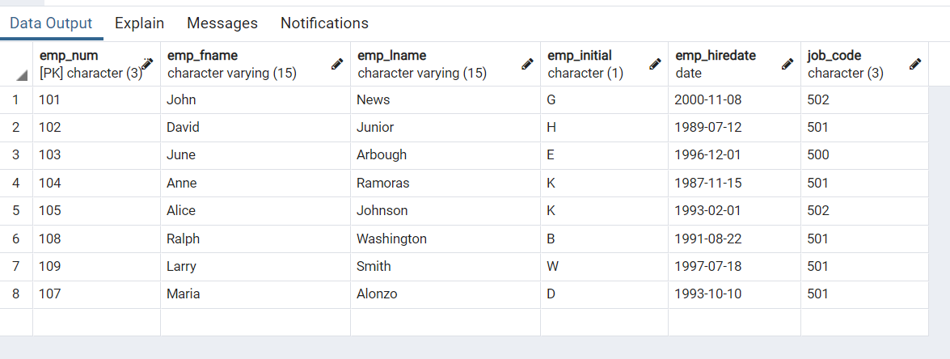

1. Add the attributes EMP_PCT and PROJ_NUM to the Employee table. The EMP_PCT is the bonus percentage to be paid to each employee.

**alter table employee add emp_pct char(3);**

**alter table employee add pro_num char(3);**

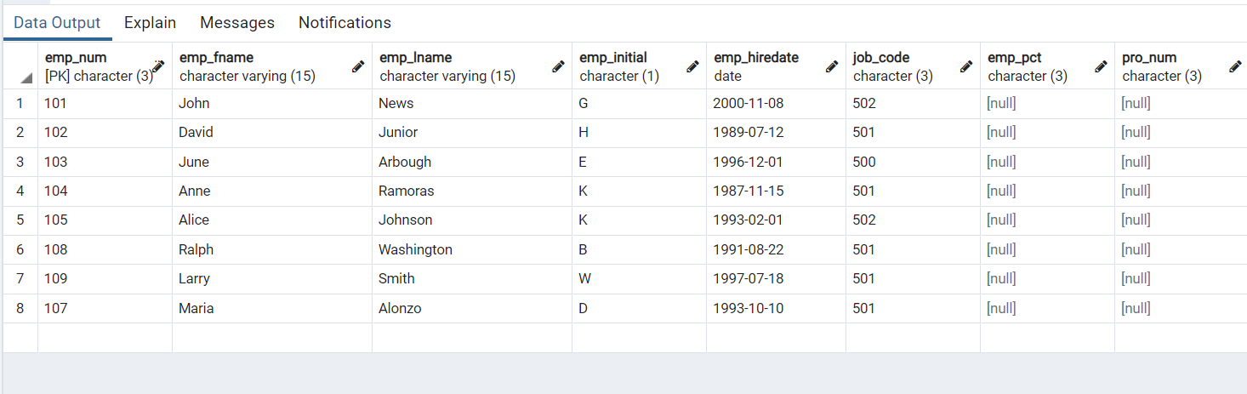

1. Using a single command, write the SQL code that will enter the project number (PROJ_NUM) = 18 for all employees whose job classification (JOB_CODE) is 500.

**update employee set pro_num='18' where job_code='500'**

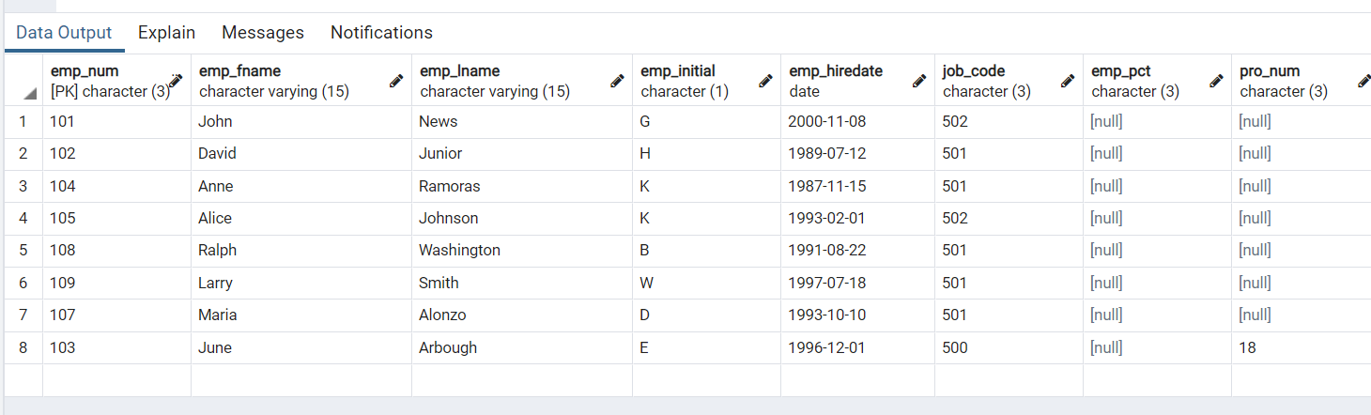

1. Write the SQL code that will change the PROJ_NUM to 14 for those employees who were hired before January 1, 1994, and whose job code is at least 501. (You may assume that the table will be restored to its original condition preceding this question.)

**update employee set pro_num='14' where (emp_hiredate<='1994-01-01' and job_code>='501')**

