**Objective:**

**Flipkart Smartphone Product Analysis**

To analyse the smartphone listings on Flipkart to extract meaningful insights about product features, pricing trends, customer preferences, and brand performance using Power BI.

**Tools & Technologies Used:**

* **Python**: For web scraping, data cleaning, and exploratory data analysis (EDA).
* **MySQL**: For storing and querying structured product data.
* **Power BI**: For creating an interactive dashboard and visual analytics.
* **Jupyter Notebook**: For scripting and documenting Python code.

**Methodology:**

1. **Data Collection**: Web scraping Flipkart smartphone listings using Python and BeautifulSoup.
2. **Data Cleaning**: Removing missing values, standardizing formats (e.g., price, RAM, ROM), and extracting product attributes.
3. **Data Storage**: Cleaned data was stored in a MySQL database.
4. **EDA**: Performed statistical summaries, distributions, and feature relationships.
5. **Dashboard**: Visualized key metrics using Power BI (e.g., most-reviewed brands, price vs. rating, specs distribution).

**Data Cleaning & Preparation:**

* Converted string features like "16 GB RAM" and "512 GB ROM" into numerical values.
* Extracted display size, battery capacity, and brand name from the product description.
* Removed duplicates and null entries.
* Final dataset columns included:  
  Product_Name, Product_Description, Product_Reviews, Product_Price, RAM, ROM, Display_Size, Battery, Brand.

**Exploratory Data Analysis (EDA):**

* Conducted in Jupyter using Python.
* Analyzed price distributions, review scores, and average specs across brands.
* Found outliers in pricing and identified top-performing brands based on average ratings.

**Insights from Power BI Dashboard:**

* **Top Brands by Product Count**: OnePlus, Samsung, and Apple dominate listings.
* **Most Reviewed Brands**: OnePlus and Apple have the highest number of reviews.
* **Price Distribution**: Most smartphones fall in the ₹30,000–₹50,000 range.
* **RAM & ROM Trends**: Increasing preference for phones with ≥8 GB RAM and ≥256 GB ROM.
* **Battery vs Display**: Larger battery phones (>5000 mAh) often come with 6.6+ inch displays.
* **Interactive Filters**: Slicers for brand, price, rating, etc. for granular analysis

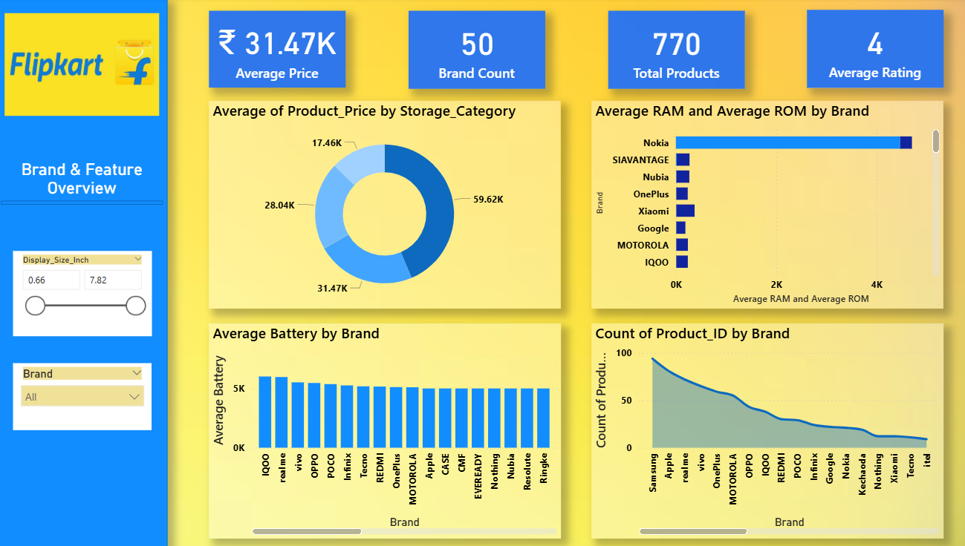

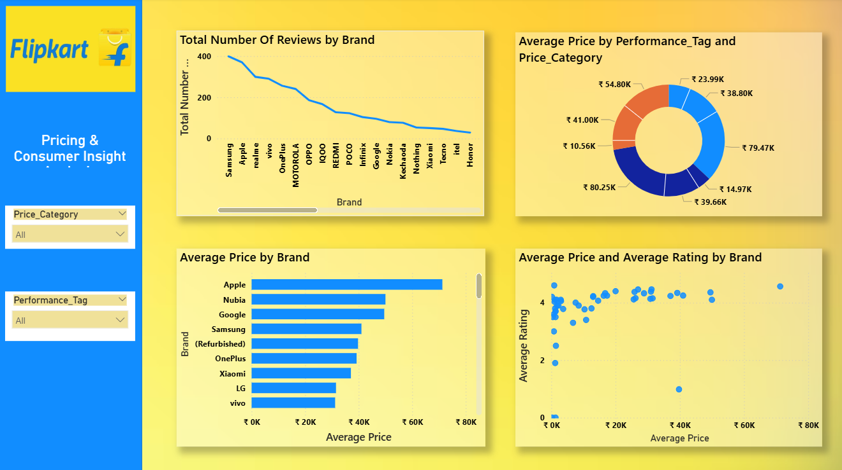

**DAX Measures and Calculated Columns:**

**Basic Statistical Measures**

* Average Battery = AVERAGE('flipkart_products'[Battery_mAh])
* Average Price = AVERAGE('flipkart_products'[Product_Price])
* Average RAM = AVERAGE('flipkart_products'[RAM_GB])
* Average ROM = AVERAGE('flipkart_products'[ROM_GB])
* Average Rating = AVERAGE('flipkart_products'[Product_Reviews])

**Aggregated Insights**

* Total Products = COUNTROWS (flipkart_products)
* Total Number of Reviews = SUM('flipkart_products'[Product_Reviews])
* Brand Count = DISTINCTCOUNT (flipkart_products[Brand])
* Battery_to_Price_Ratio = DIVIDE(SUM('flipkart_products'[Battery_mAh]), SUM('flipkart_products'[Product_Price]), 0)
* Price_per_GB_ROM = DIVIDE('flipkart_products'[Product_Price], 'flipkart_products'[ROM_GB], 0)
* Weighted Reviews = SUMX ('flipkart_products', 'flipkart_products'[Product_Reviews] * flipkart_products[Product_Price])

**Business Logic and Tagging (DAX):**

Storage_Category

SWITCH(TRUE(),

'flipkart_products'[ROM_GB] >= 512, "Ultra",

'flipkart_products'[ROM_GB] >= 256, "High",

'flipkart_products'[ROM_GB] >= 128, "Medium", "Low")

Price_Category

SWITCH(TRUE(),

'flipkart_products'[Product_Price] >= 50000, "Premium",

'flipkart_products'[Product_Price] >= 30000, "Mid-range",

"Budget")

Performance_Tag

SWITCH(TRUE(),

'flipkart_products'[RAM_GB] >= 12 && 'flipkart_products'[Battery_mAh] >= 5000, "High Performer",

'flipkart_products'[RAM_GB] >= 8, "Moderate","Basic")

**SQL Queries and Database Operations:**

CREATE TABLE flipkart_products (

Product_ID INT AUTO_INCREMENT PRIMARY KEY,

Product_Name VARCHAR(255),

Product_Description TEXT,

Product_Reviews FLOAT,

Product_Price INT,

RAM_GB INT,

ROM_GB INT,

Display_Size_Inch FLOAT,

Battery_mAh INT,

Brand VARCHAR(100)

);

**Conclusion & Business Recommendations:**

* **Customer Preference**: High storage, large displays, strong batteries.
* **Brand Strategy**: OnePlus should continue targeting mid-high range with strong specs.
* **Inventory Planning**: Focus on stocking 8GB/256GB variants, which are in high demand.
* **Improvement Opportunity**: Analyze lower-rated products for potential enhancements.

**Project Deliverables:**

* Python scripts – Web scraping, cleaning, Microsoft SQL Server integration
* SQL scripts – Flipkart database schema
* Power BI Dashboard – Full interactive visuals
* DAX measures and calculated columns for logic and KPIs
* Final Report – This insights and analysis document
* PPT – To summarize findings visually