# Title: Real-time dashboards from a source database to a cloud data warehouse

By T.Gomahalakshmi - 2200080020



# Screenshots

# C:\Users\DELL\OneDrive\Desktop\CLOUD\SDC\Project\Screenshot 2025-04-05 211939.png

# *Figure 1. Amazon RDS Create database screen with options for database creation method (Easy create selected) and configuration- of MySQL selected.*

# C:\Users\DELL\OneDrive\Desktop\CLOUD\SDC\Project\Screenshot 2025-04-05 215250.png

# Figure 2. Amazon RDS Created database.

# C:\Users\DELL\OneDrive\Desktop\CLOUD\SDC\Project\Screenshot 2025-04-06 084434.png

# *Figure 3. Amazon EC2 screen for launching an instance, with Windows AMI selected.*

# 

# Figure 3. Amazon EC2 created instance.

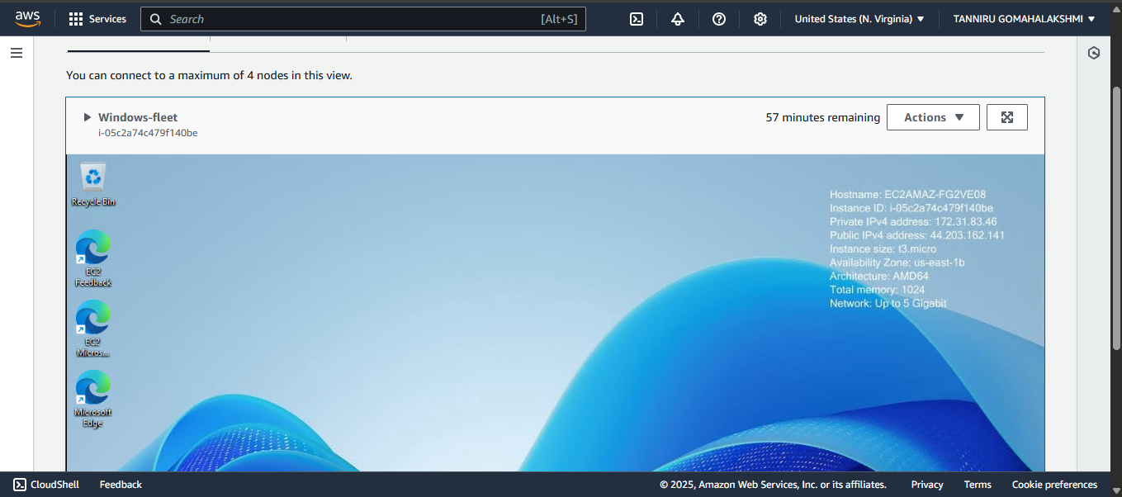

**Figure 4. Connected instance using fleet manager.**

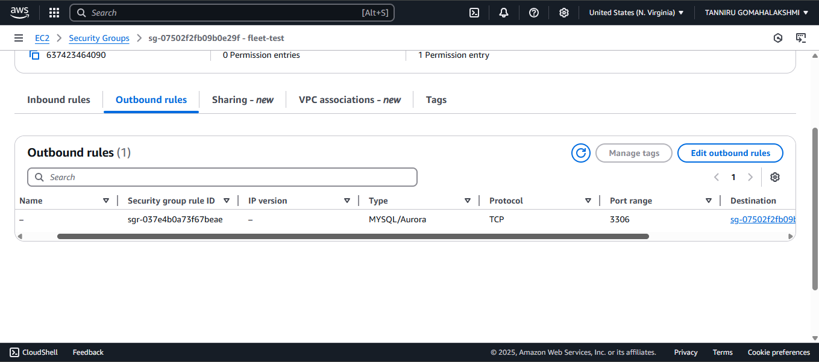

**Figure 5. The Amazon EC2 security group should allow outbound traffic type MYSQL/Aurora TCP with port = 3306  to the destination = security group of the RDS (no inbound rules)**

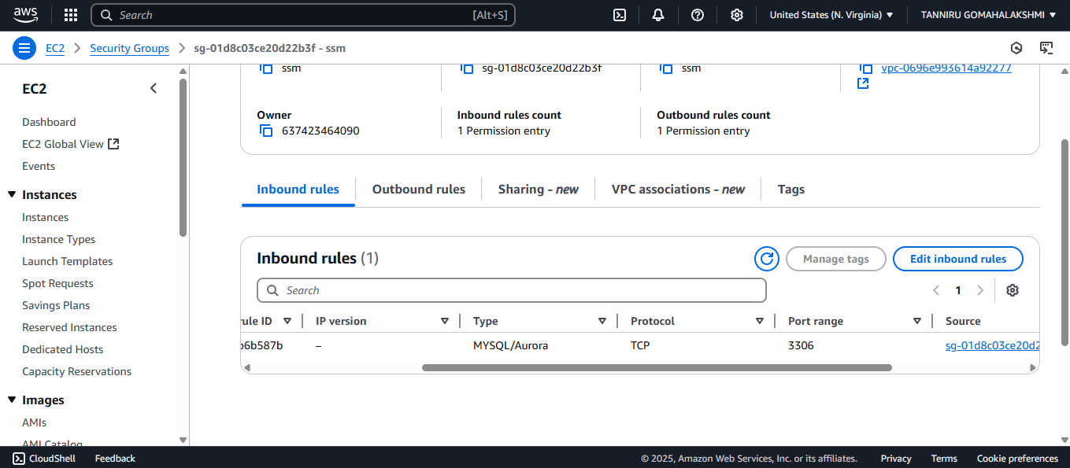

**Figure 6**. **The security group of the Amazon RDS instance should allow inbound of the type** **MYSQL/Aurora TCP with port = 3306** **from** **the security group of the EC2 instance.**

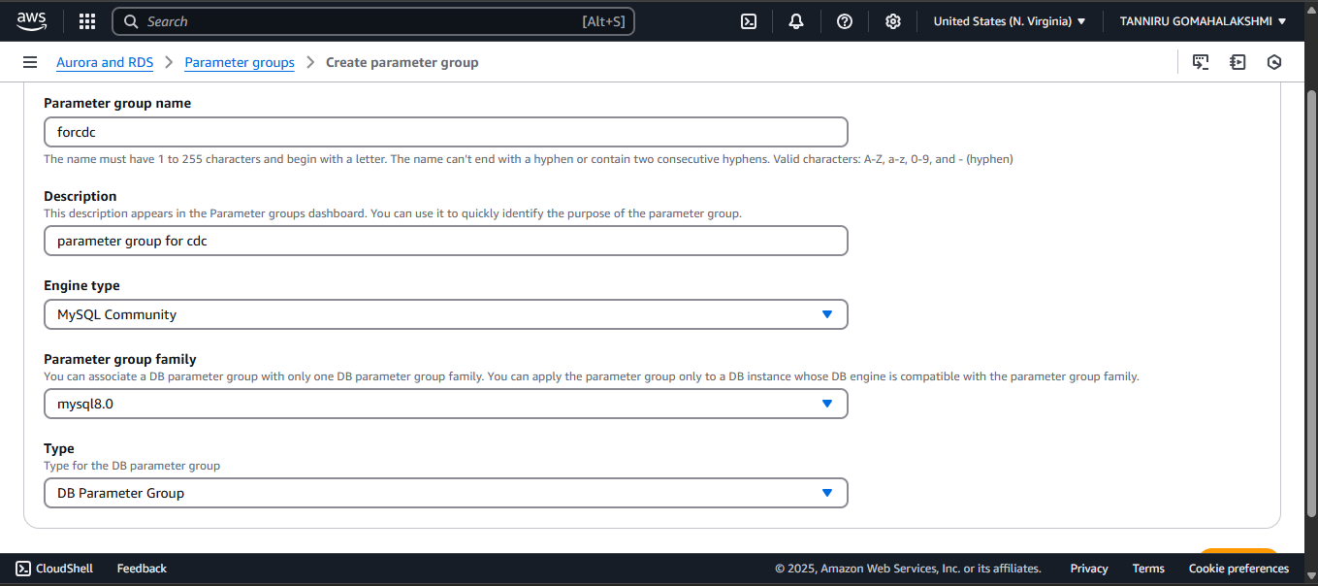

**Figure 7. *Parameter group details screen includes group name, description, engine type, parameter group family, and type fields and dropdown menus.***

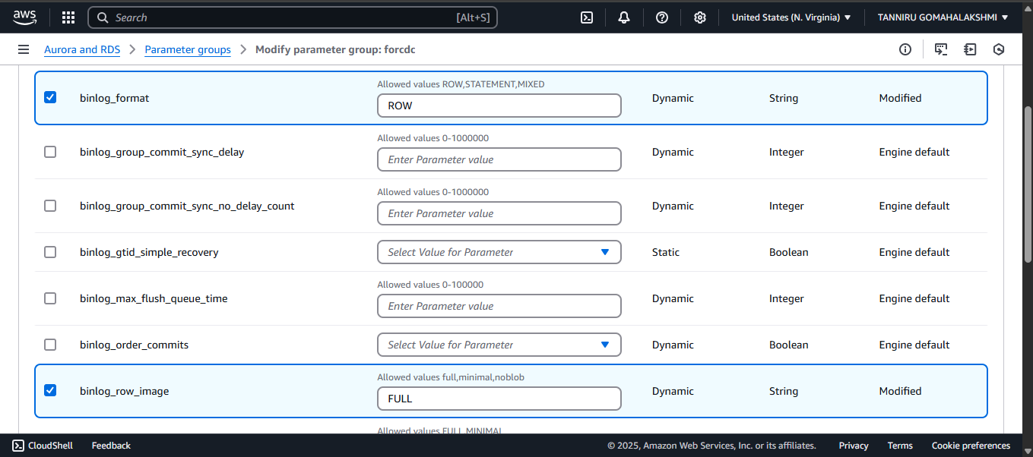

***Figure 8. Editing parameters for binlog_format and binlog_row_image.***

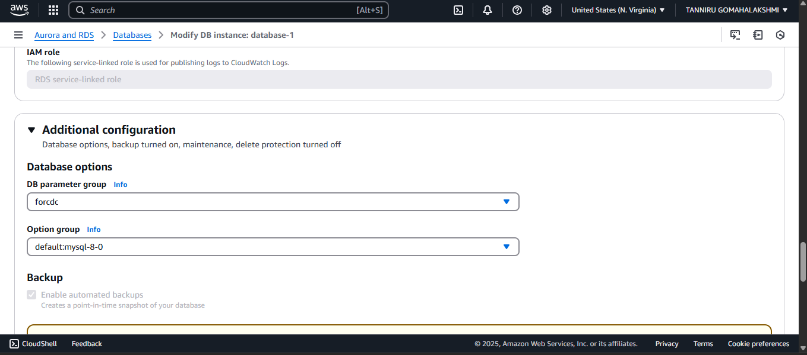

***Figure 9. Changing the DB parameter group.***

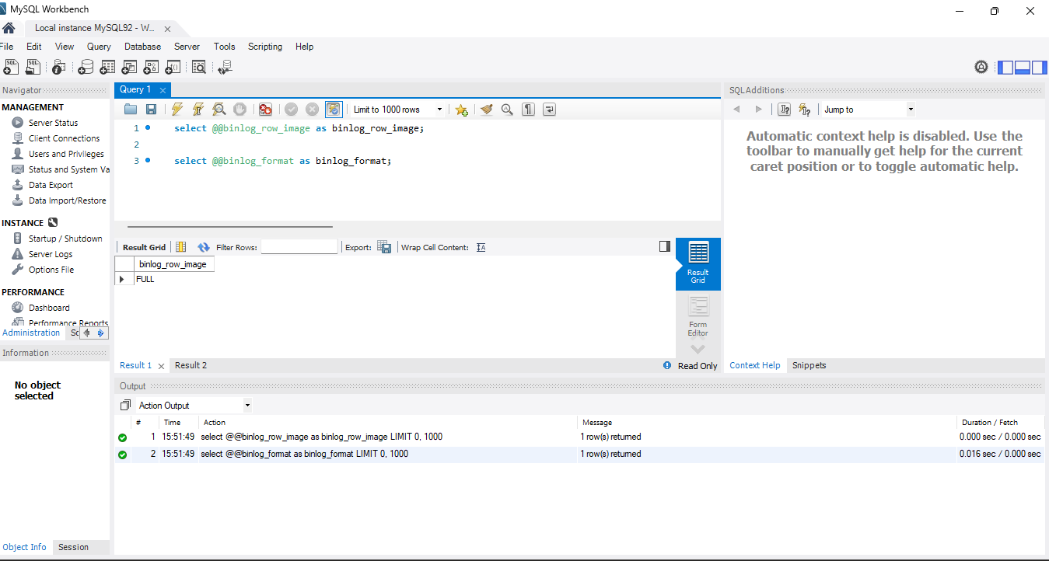

***Figure 10. MySQL Workbench with the queries run.***

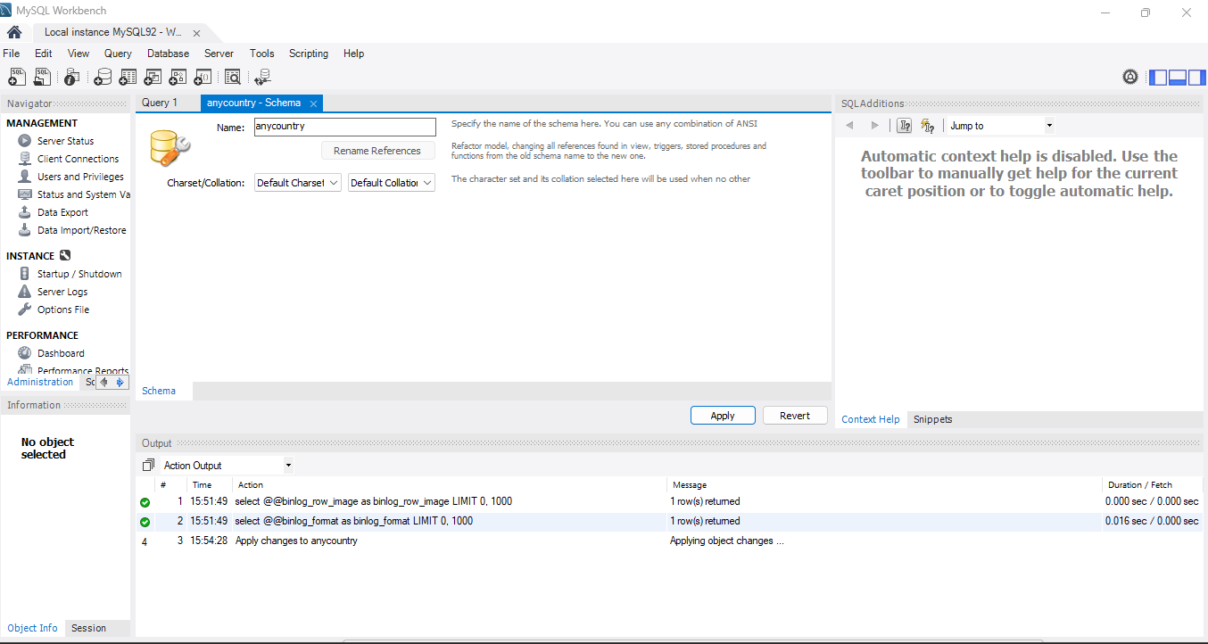

***Figure 11. Naming new schema in MySQL Workbench.***

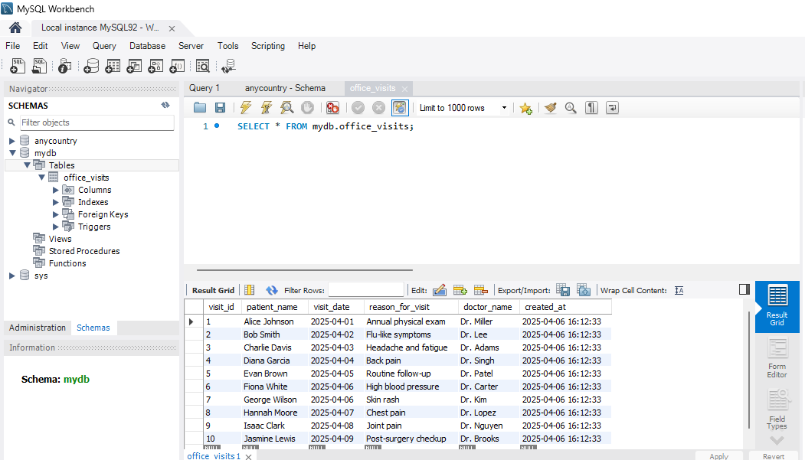

***Figure 12. Adding data to the table in MySQL Workbench.***

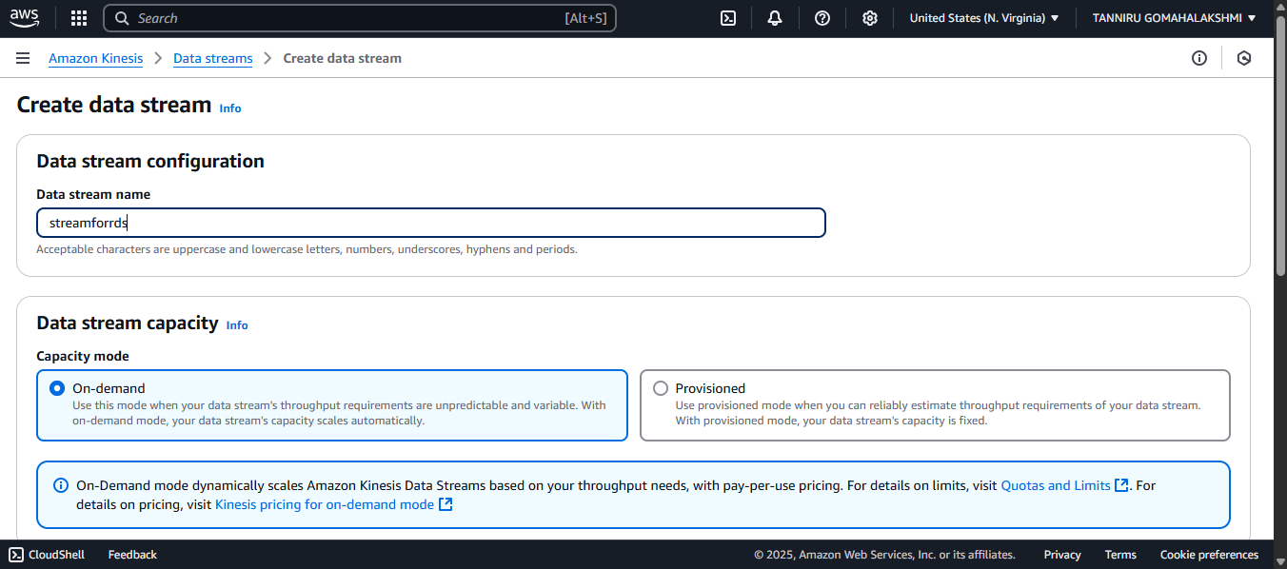

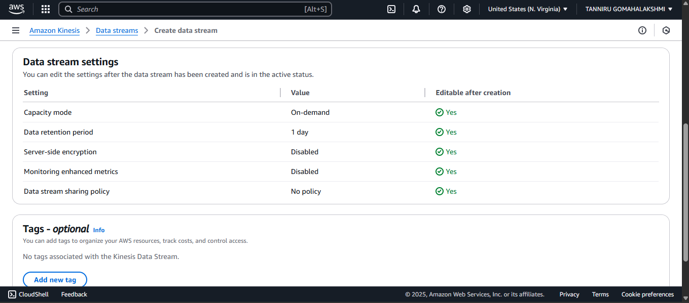

***Figure 13. Creating a data stream in Kinesis Data Streams.***

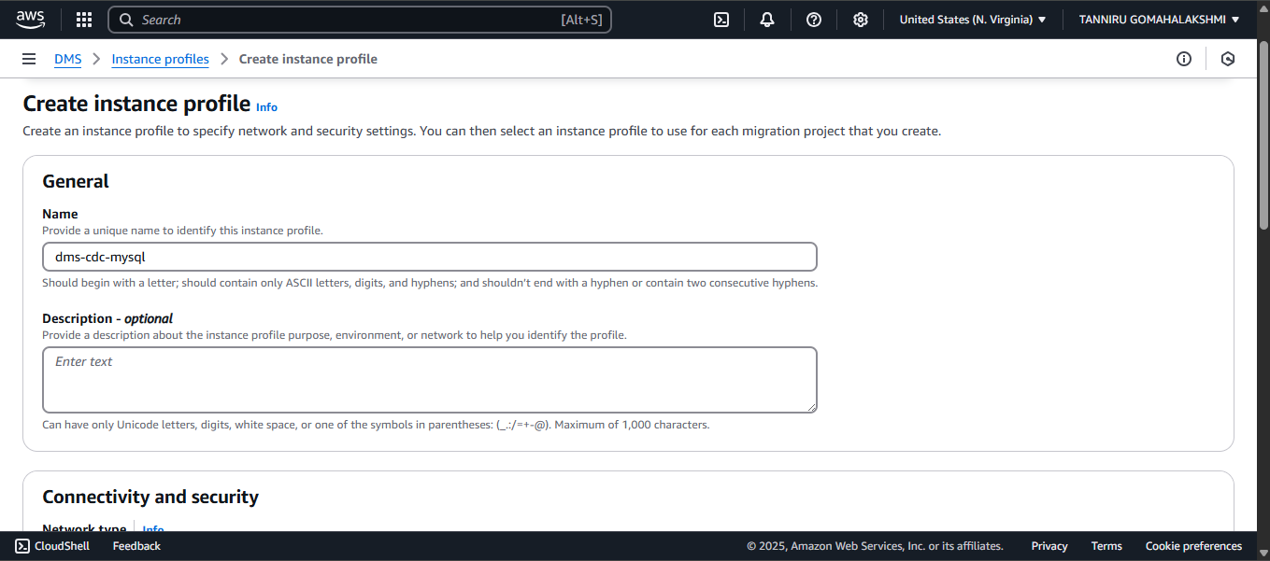

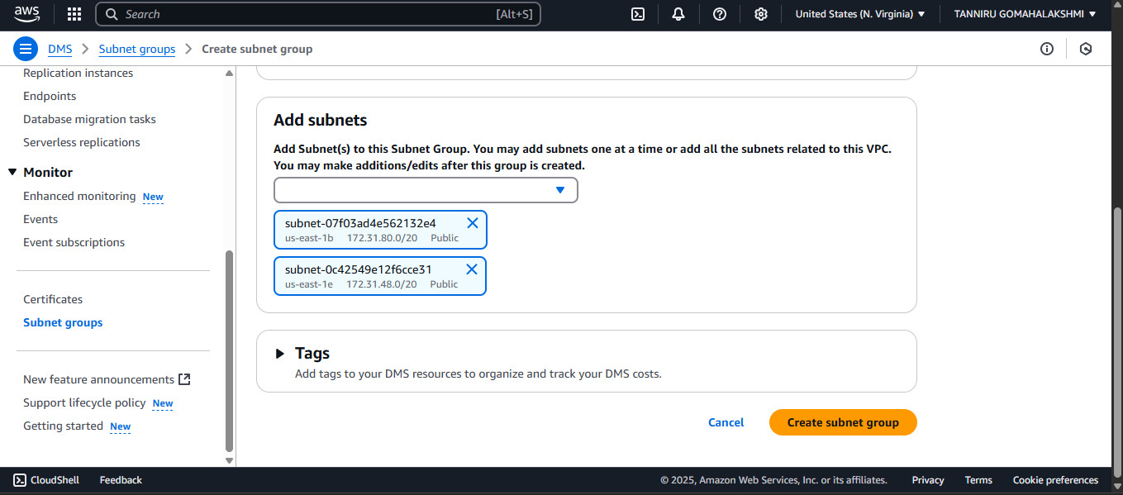

***Figure 14. Creating an instance for CDC.***

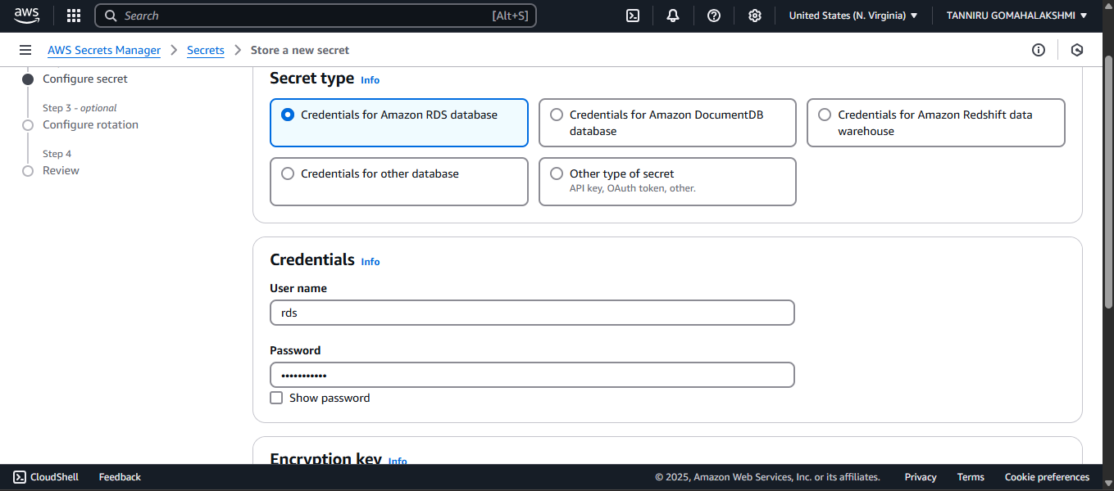

***Figure 15. Creating a secret for Amazon RDS.***

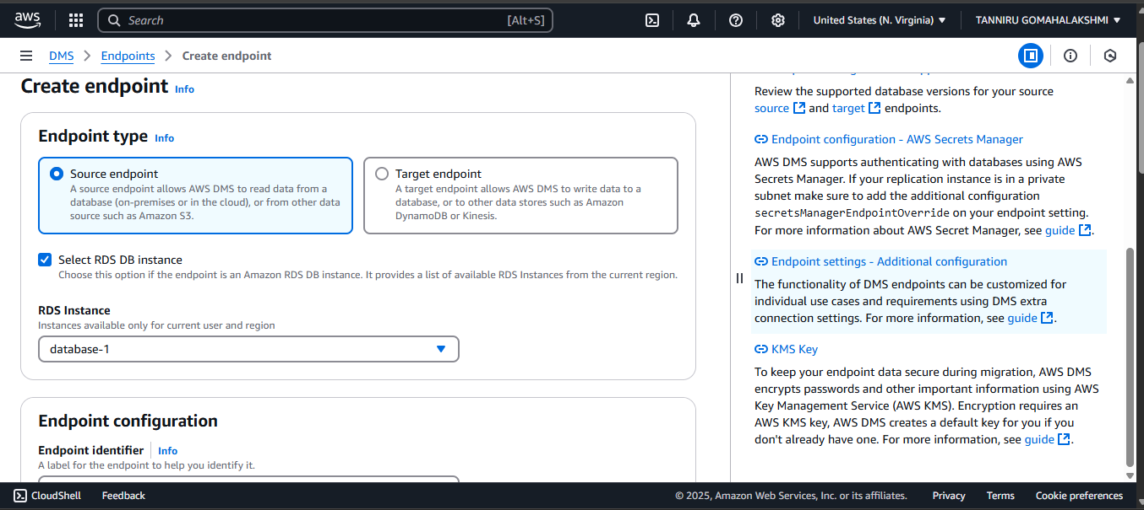

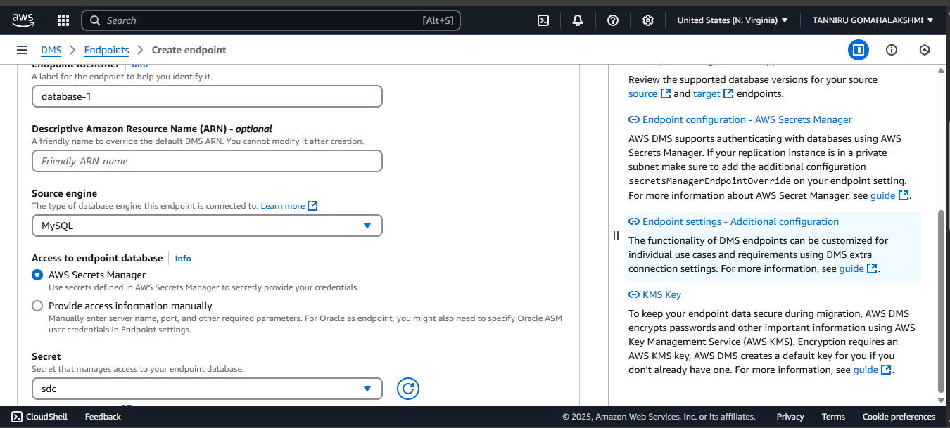

***Figure 16. Creating DMS endpoint to the RDS MySQL database.***

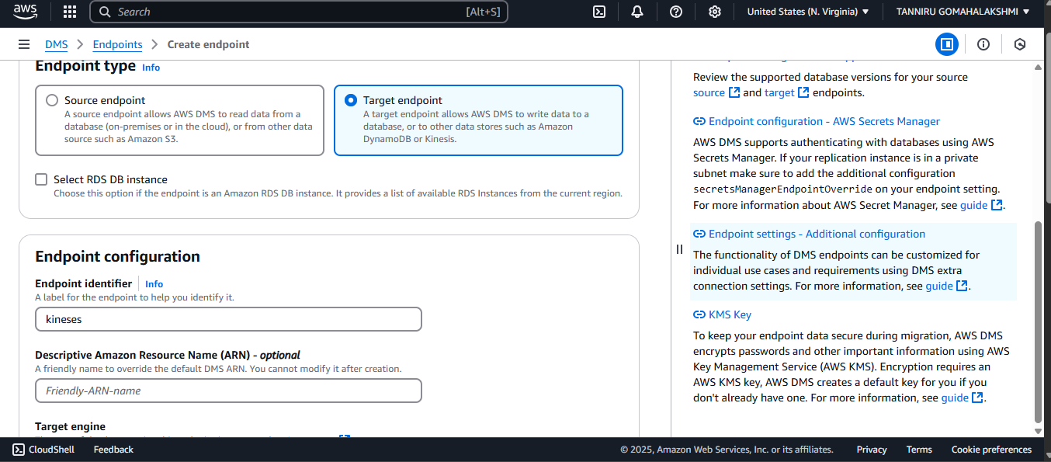

***Figure 18. Creating target endpoint.***

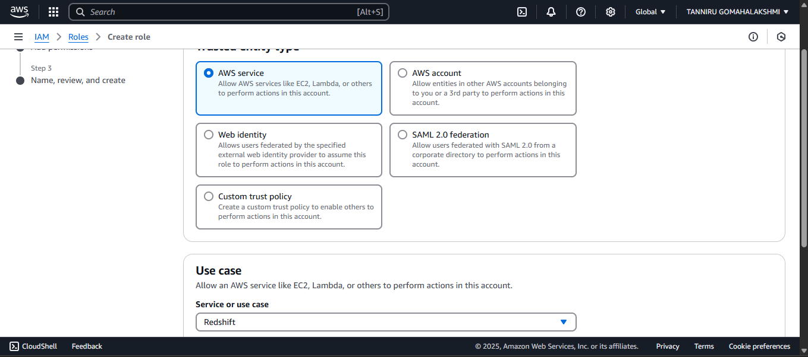

***Figure 20 . Creating an IAM Role for Amazon******Redshift Serverless.***

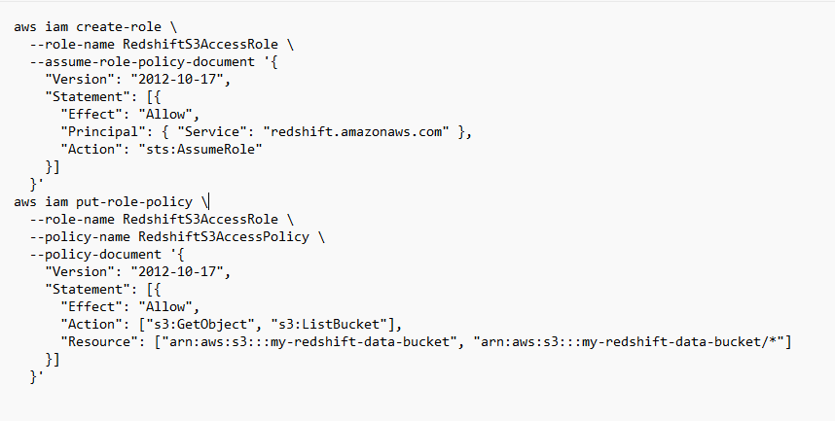

***Code for RedShift IAM Role***

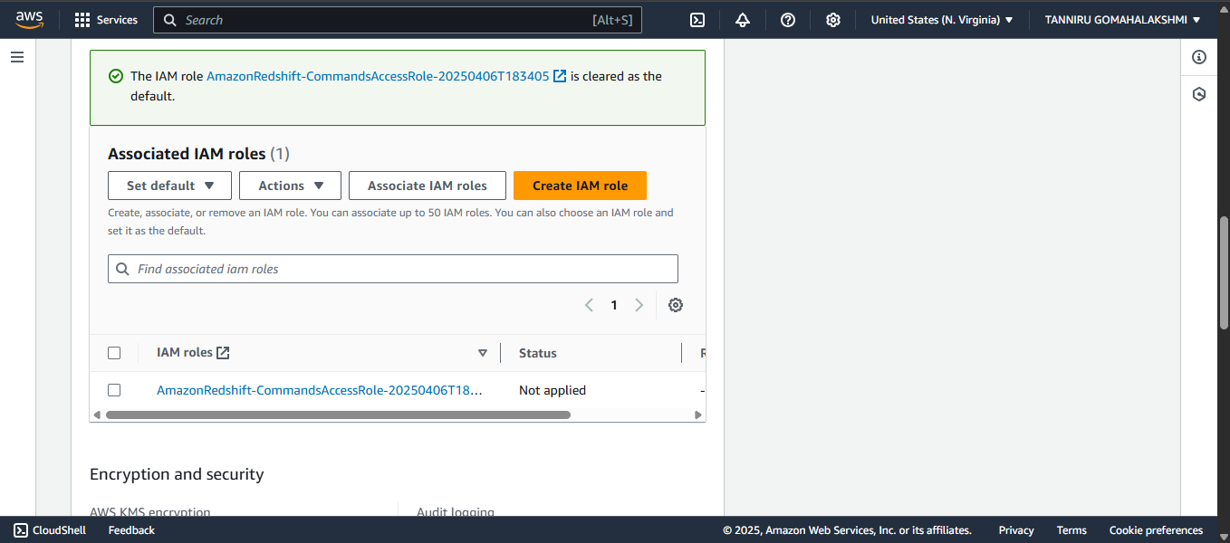

**Figure 22. Creating and Associating *default Amazon Redshift IAM role.***

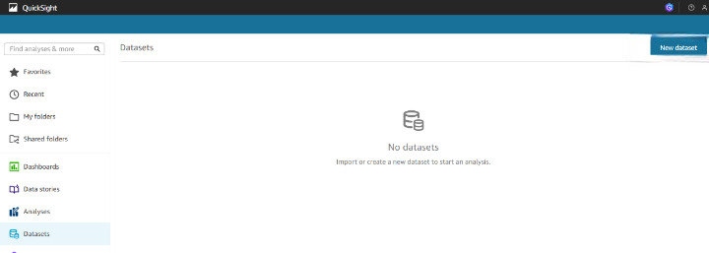

***Figure 23. Selecting “New dataset” button on top right of Amazon QuickSight Datasets page.***

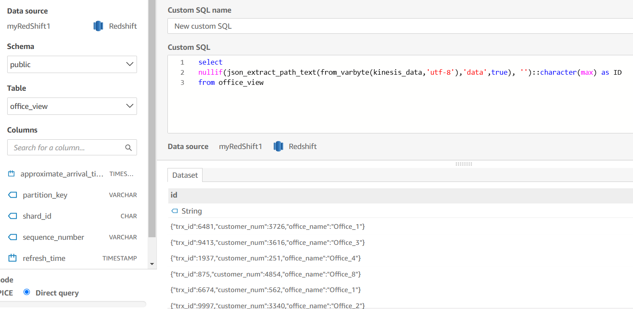

***Figure 24. Entering query to define new dataset.***

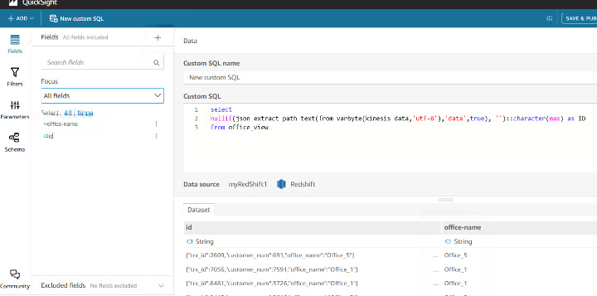

***Figure 25. Adding field for office names in Amazon QuickSight.***

### Testing for Output

### https://d2908q01vomqb2.cloudfront.net/9e6a55b6b4563e652a23be9d623ca5055c356940/2025/02/26/aws_dms_figure34.png

### *Figure 26. Vertical bar chart for office wait times.*