Exercise 1 - Singleton Pattern

# Code: SingletonExamplePattern.java

public class Singleton {  
  
 static class Logger {  
 private static Logger instance;  
  
 private Logger() {  
 System.out.println("Logger Created");  
 }  
  
 public static Logger getInstance() {  
 if (instance == null) {  
 instance = new Logger();  
 }  
 return instance;  
 }  
  
 public void log(String message) {  
 System.out.println("Log: " + message);  
 }  
 }  
  
 public static void main(String[] args) {  
 Logger logger1 = Logger.getInstance();  
 Logger logger2 = Logger.getInstance();  
  
 logger1.log("This is the first log.");  
 logger2.log("This is the second log.");  
  
 System.out.println("Are both loggers the same? " + (logger1 == logger2));  
 }  
}

# Output:

"C:\Program Files\Java\jdk-17.0.5\bin\java.exe" "-javaagent:C:\Program Files\JetBrains\IntelliJ IDEA Community Edition 2025.1.2\lib\idea_rt.jar=52360" -Dfile.encoding=UTF-8 -classpath "D:\DeepSkill Cognizant\Single\out\production\Single" SingletonPatternExample

Logger Created

Log: This is the first log.

Log: This is the second log.

Are both loggers the same? true

Process finished with exit code 0

# Output Screenshot:

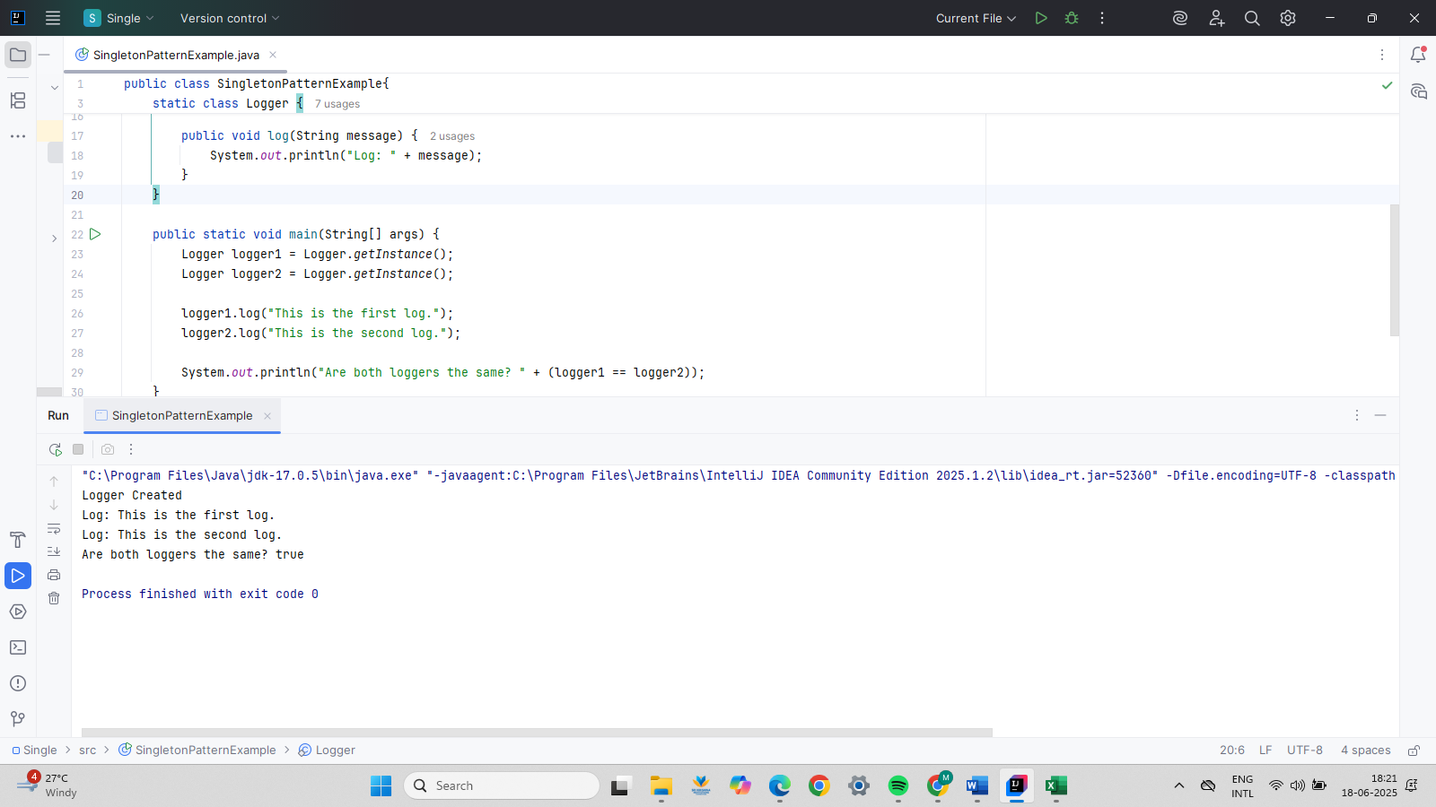

Exercise 2 - Implementing the Factory Method Pattern

public class FactoryMethodPatternExample {  
 interface Document {  
 void open();  
 }  
 static class WordDocument implements Document {  
 public void open() {  
 System.*out*.println("Opening Word Document...");  
 }  
 }  
  
 static class PdfDocument implements Document {  
 public void open() {  
 System.*out*.println("Opening PDF Document...");  
 }  
 }  
  
 static class ExcelDocument implements Document {  
 public void open() {  
 System.*out*.println("Opening Excel Document...");  
 }  
 }  
 abstract static class DocumentFactory {  
 public abstract Document createDocument();  
 }

static class WordDocumentFactory extends DocumentFactory {  
 public Document createDocument() {  
 return new WordDocument();  
 }  
 }

static class PdfDocumentFactory extends DocumentFactory {  
 public Document createDocument() {  
 return new PdfDocument();  
 }  
 }  
  
 static class ExcelDocumentFactory extends DocumentFactory {  
 public Document createDocument() {  
 return new ExcelDocument();  
 }  
 }

public static void main(String[] args) {  
 DocumentFactory wordFactory = new WordDocumentFactory();  
 Document word = wordFactory.createDocument();  
 word.open();  
  
 DocumentFactory pdfFactory = new PdfDocumentFactory();  
 Document pdf = pdfFactory.createDocument();  
 pdf.open();  
  
 DocumentFactory excelFactory = new ExcelDocumentFactory();  
 Document excel = excelFactory.createDocument();  
 excel.open();  
 }  
}

# Output:

"C:\Program Files\Java\jdk-17.0.5\bin\java.exe" "-javaagent:C:\Program Files\JetBrains\IntelliJ IDEA Community Edition 2025.1.2\lib\idea_rt.jar=52537" -Dfile.encoding=UTF-8 -classpath "D:\DeepSkill Cognizant\FactoryMethodPatternExample\out\production\FactoryMethodPatternExample" FactoryPatternTest

Opening Word Document

Opening PDF Document

Opening Excel Document

Process finished with exit code 0

# Output Screenshot:

