**STORE-SUPPLEMENTS REQUIREMENTS**

**1.Project Overview:**

Build a web and mobile application for a supplements store that enables users to browse products, make online payments, and track their orders. Admins can manage products, orders, and inventory.

**2.Target Platforms:**

Web (ReactJS)

**3. User Roles**

**Customer:-**

* Register/Login
* Browse products
* Cart and checkout
* Track orders
* View past orders

**Admin:**

* Product and order management
* View customer detail

**4. Technology Stack:-**

1. Frontend: ReactJS
2. Backend: SpringBoot
3. DataBase: MySQL

s

**USE CASE DIAGRAM FOR SUPPLEMENT STORE:**

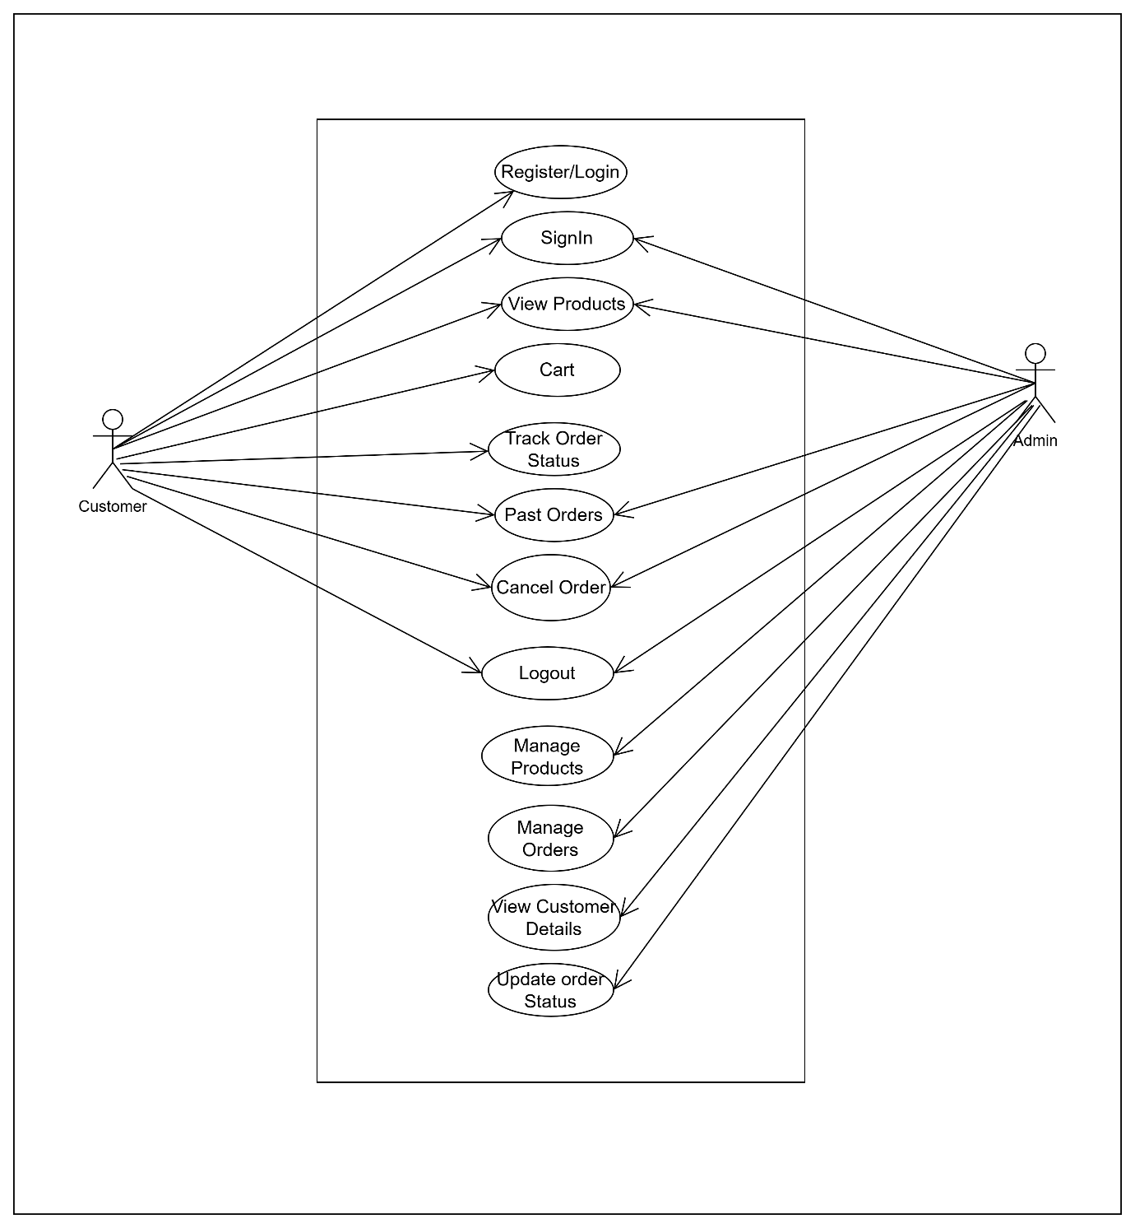

**Class Diagram:**

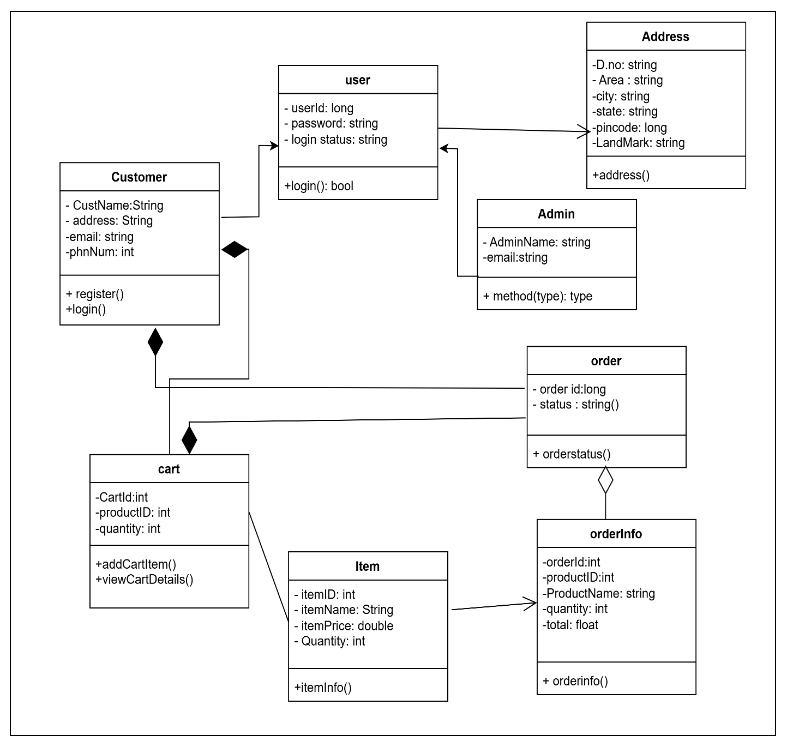

**ER Diagram:**

