College Admission Assistant — GenAI

1. Problem Statement
Students face difficulty in know Indian engineering colleges like IITs, NITs, BITS, and VIT due to scattered, unstructured, and inconsistent information across multiple sources. The goal of this project is to build an AI-powered assistant that provides structured, accurate, and comparative answers using a Retrieval-Augmented Generation (RAG) system.

2. High-Level Overview
This project is a RAG-based College Admission Assistant that allows users to ask queries about colleges, fees, placements, and cutoffs. The system retrieves relevant data from a vector database and generates structured responses using a Large Language Model.

3. Tech Stack and Justification
Frontend:
React 18 + TypeScript + Vite (fast UI rendering, type safety, and modular design)
React 18 is used to build an interactive chat UI for students.
TypeScript adds type safety and reduces runtime errors.
Vite provides fast development and build performance.
Backend:
FastAPI (high-performance async APIs)
FastAPI supports asynchronous request handling
It allows the system to process multiple concurrent queries efficiently within the limits of local deployment.
Vector DB:
ChromaDB (lightweight and local vector storage)
Stores embedded college data as vectors.
Enables fast semantic search instead of keyword matching.
Lightweight and easy to integrate with LangChain.

Embeddings:
SentenceTransformers (all-MiniLM-L6-v2 for efficient semantic similarity)
Converts text into numerical vectors.
Captures semantic meaning of queries and documents.
LLM:
Groq (llama-3.3-70b-versatile for fast inference)
Generates final AI responses.
Very fast inference with low latency.
RAG Framework:
LangChain (orchestration)
Connects embedding model, vector DB, and LLM.
Manages retrieval and response generation pipeline.
Simplifies overall architecture.
Why these choices:
React is chosen because it provides a scalable and modular UI structure for building interactive chat interfaces, whereas Angular and Vue were avoided due to higher complexity and heavier learning curve.
TypeScript is used to ensure type safety and reduce runtime errors during API handling, while plain JavaScript was not chosen because it is more prone to undefined and type-related errors.
Vite is selected as the frontend build tool because it offers a very fast development server and instant hot module replacement, whereas Webpack was avoided due to slower build and reload times.
FastAPI is used for backend development because it supports asynchronous processing and high-performance APIs, while Flask and Django were not preferred due to Flask being synchronous and Django being comparatively heavier for this use case.
ChromaDB is used as the vector database because it is lightweight, simple to integrate, and works well locally, whereas FAISS requires more manual setup and Pinecone introduces cloud cost and dependency.
SentenceTransformers (all-MiniLM-L6-v2) is used for embeddings because it is fast, efficient, and suitable for semantic search in real-time systems, while OpenAI embeddings were avoided due to cost and API latency.
Groq LLM (LLaMA 3.3-70B) is selected for inference because it provides extremely fast response times and strong reasoning capability, whereas OpenAI models were avoided due to higher cost and comparatively higher latency.
LangChain is used for RAG orchestration because it simplifies connecting retrieval, embeddings, and LLMs into a single pipeline, whereas building a manual pipeline would increase complexity and maintenance overhead.

4. Architecture Overview

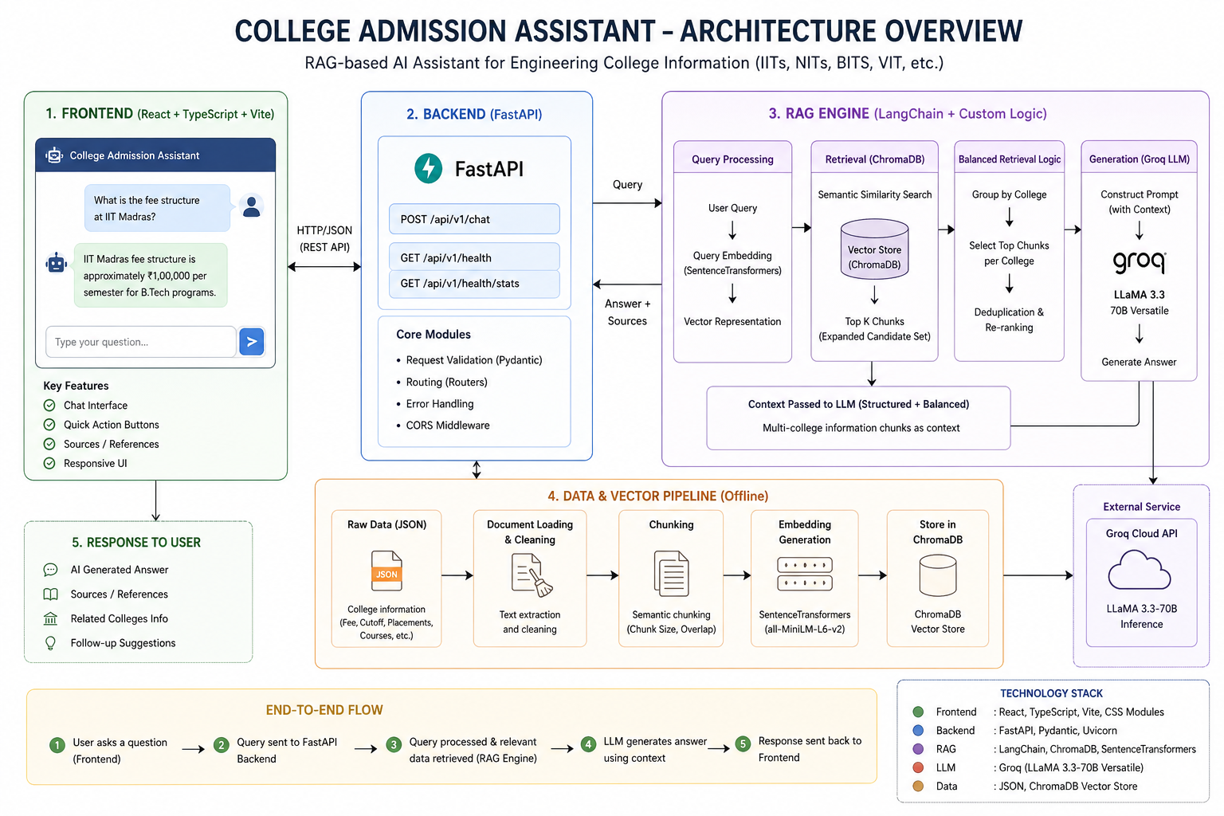

Flow:
User Query → Embedding → Vector Search → Retrieval → Context Building → LLM Generation → Response

5. End-to-End Flow
1. User enters query
2. Query is converted into embeddings
3. ChromaDB retrieves top-k relevant chunks
4. Retrieval is improved using balanced multi-college grouping
5. Context is passed to LLM
6. LLM generates structured response
7. Response + sources returned to frontend

6. Core Logic Implemented
- Expanded retrieval (k * 6) to improve coverage
- Balanced retrieval across multiple colleges
- Deduplication of chunks
- Grouping by college metadata
- Score normalization for ranking
- Structured LLM prompting for comparisons

7. Key Methods and Techniques
Chunking:
- Semantic text splitting with overlap (split_text function)
- Ensures context continuity across chunks
Embeddings:
- SentenceTransformers converts text into dense vectors
Retrieval:
- Cosine similarity via ChromaDB
- Multi-college grouping to avoid bias
LLM Generation:
- Groq LLM used for fast response generation

8. Error Handling and Edge Cases
- Handles empty queries gracefully
- Skips corrupted JSON records during ingestion
- Fallback for missing metadata fields
- Vector search failure handled with exceptions
- Ensures 'Data not available' instead of hallucination

9. Issues Faced and Solutions
Issue 1: Single-college bias in retrieval
Solution: Introduced multi-college grouping and balanced sampling
Issue 2: Missing context for some colleges
Solution: Increased retrieval size (k * 6)
Issue 3: Duplicate chunks in context
Solution: Implemented deduplication using content + metadata key
Issue 4: Poor comparison output
Solution: Strict prompt structure enforcing table-based comparison
Issue 5: Hallucination of missing data
Solution: Explicit rule to state 'Data not available'

10. Setup Instructions
Backend:
1. pip install -r requirements.txt
2. Set GROQ_API_KEY in .env
3. python ingest.py
4. uvicorn main:app --reload
Frontend:
1. npm install
2. npm run dev
3. Open http://localhost:5173

