WEEK–1 ASSIGNMENT
Module 1: Setup & Basics (Project + Cypress Setup)
- Introduction:
I implemented the initial setup of Cypress automation framework.
In this topics I covered: project setup, cypress setup, base configuration, CLI scripts, Test retries, cypress JSON
- Project Setup:
2.1 Creating Project Folder and Initializing Node Project:
I created a project folder named Cypress_Assignment1 inside my Assignments directory and opened it using Visual Studio Code.
I initialized the Node project using the following command:
npm init -y
This command created a package.json file which manages project dependencies and scripts. 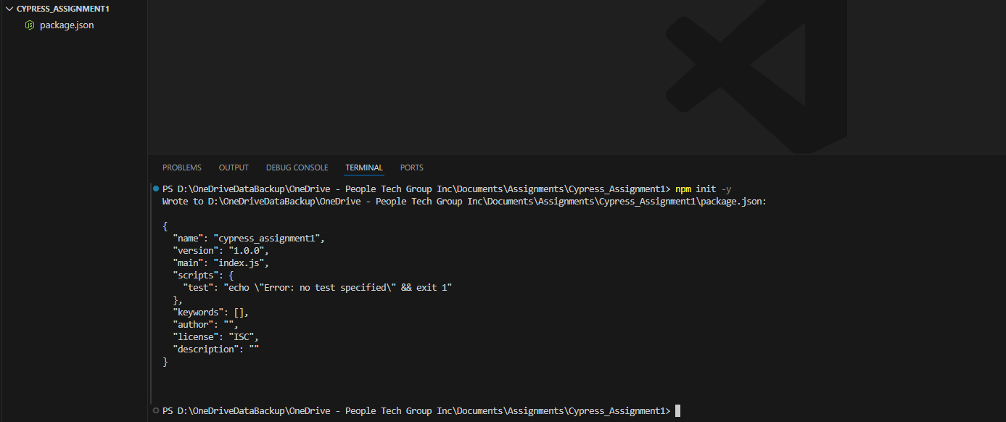
2.2 Installing Cypress:
Cypress was installed as a development dependency using the following command:
npm install cypress --save-dev
The --save-dev flag ensures that Cypress is added under devDependencies in the package.json file since it is used only for development and testing purposes.
After installation, node_modules and package-lock.json were automatically created. 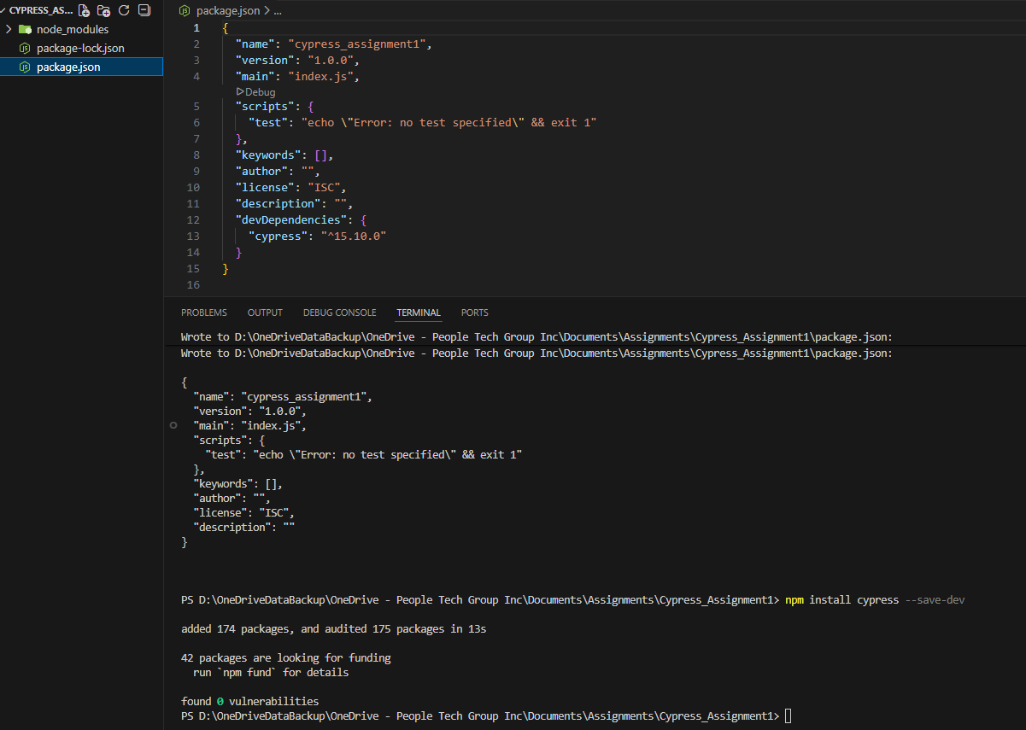
2.3 Launching Cypress:
Cypress was launched using the command:
npx cypress open
This opened the Cypress Test Runner and automatically generated the default project folder structure including:
- e2e folder (for test files)
- fixtures folder (for test data)
- support folder (for reusable commands)
- cypress.config.js (configuration file) 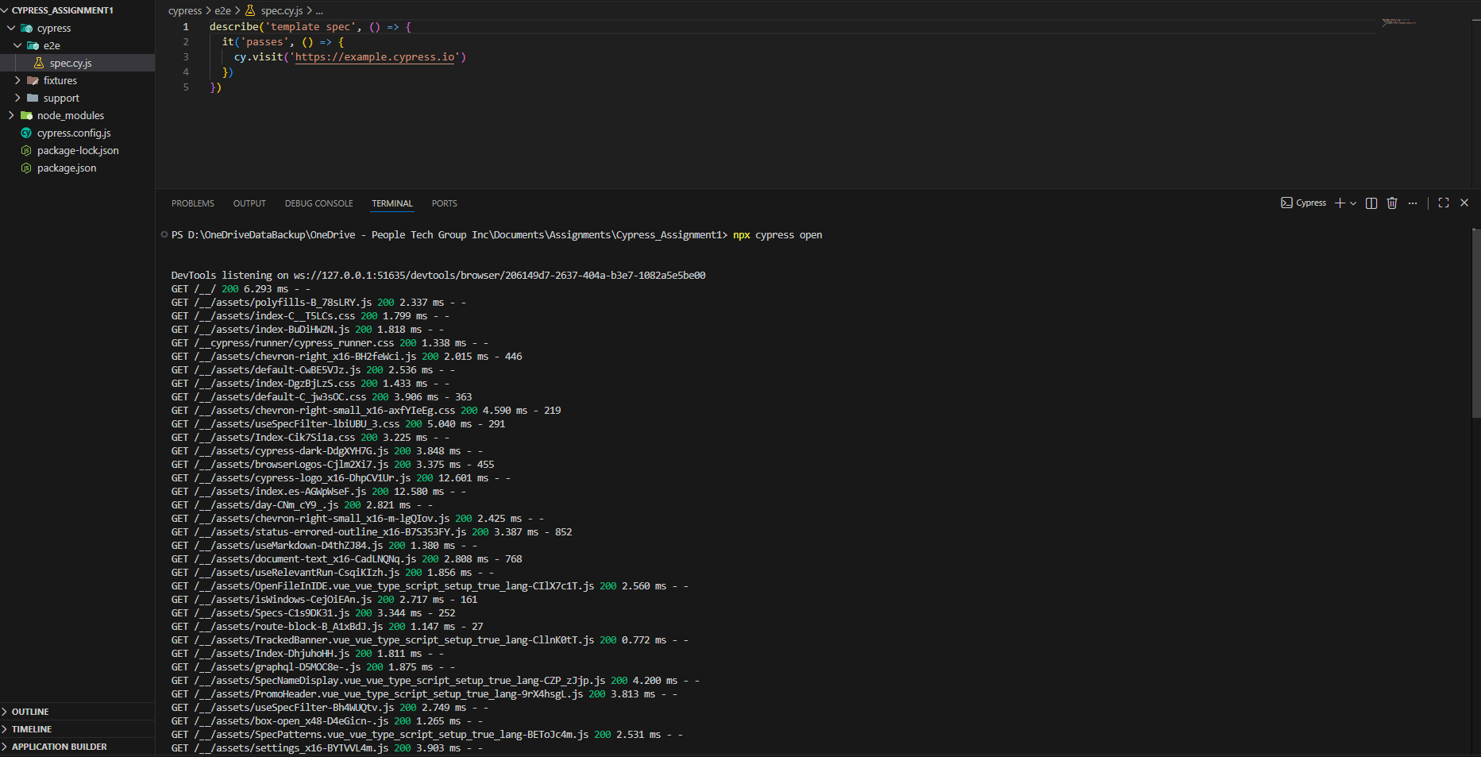
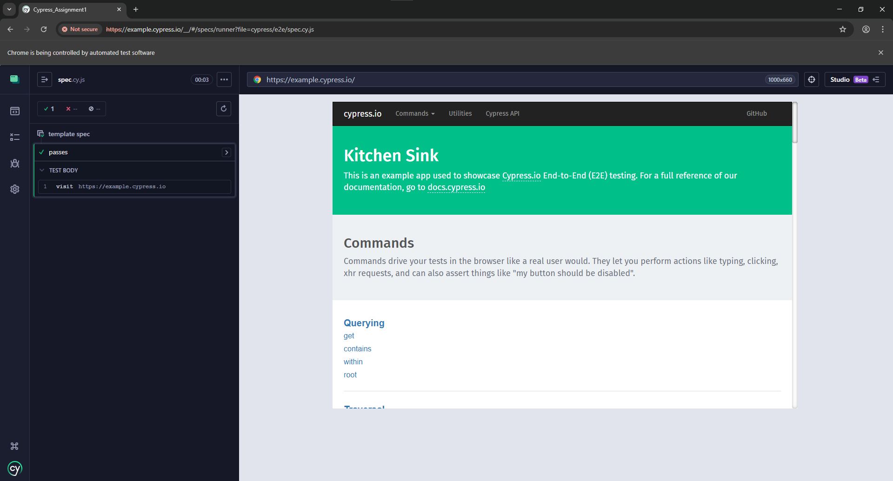
2.4 Configuring Cypress Framework:
The Cypress configuration file (cypress.config.js) was updated to define framework-level settings.
The following configurations were added:
- baseUrl:
Set to https://example.cypress.io to allow using cy.visit('/') instead of writing the full URL in every test.
- viewportWidth and viewportHeight:
Defined as 1280x720 to ensure consistent browser resolution during test execution.
- defaultCommandTimeout:
Increased to 8000 milliseconds to allow more time for elements to load before failing.
- retries:
Set to 2 so that failed tests automatically retry two additional times, reducing flaky test failures. 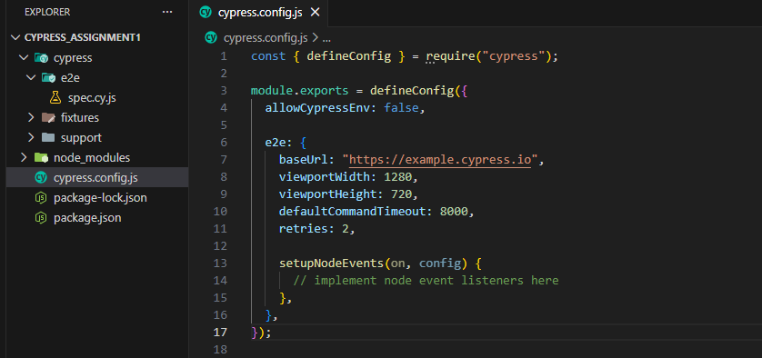
2.5 Creating First Test Case:
A test file named setup.cy.js was created inside the e2e folder.
Two test cases were implemented:
- Verify Base URL is working
- Verify Page Title
The test uses cy.visit('/'), which works because baseUrl was configured in the Cypress configuration file.
Both tests executed successfully and passed. 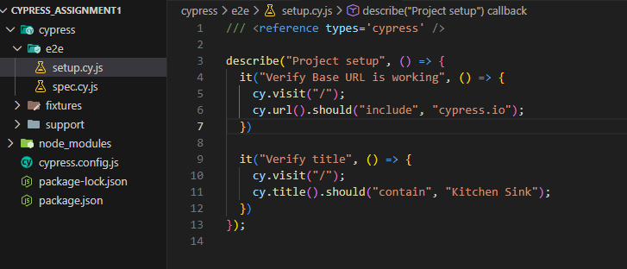
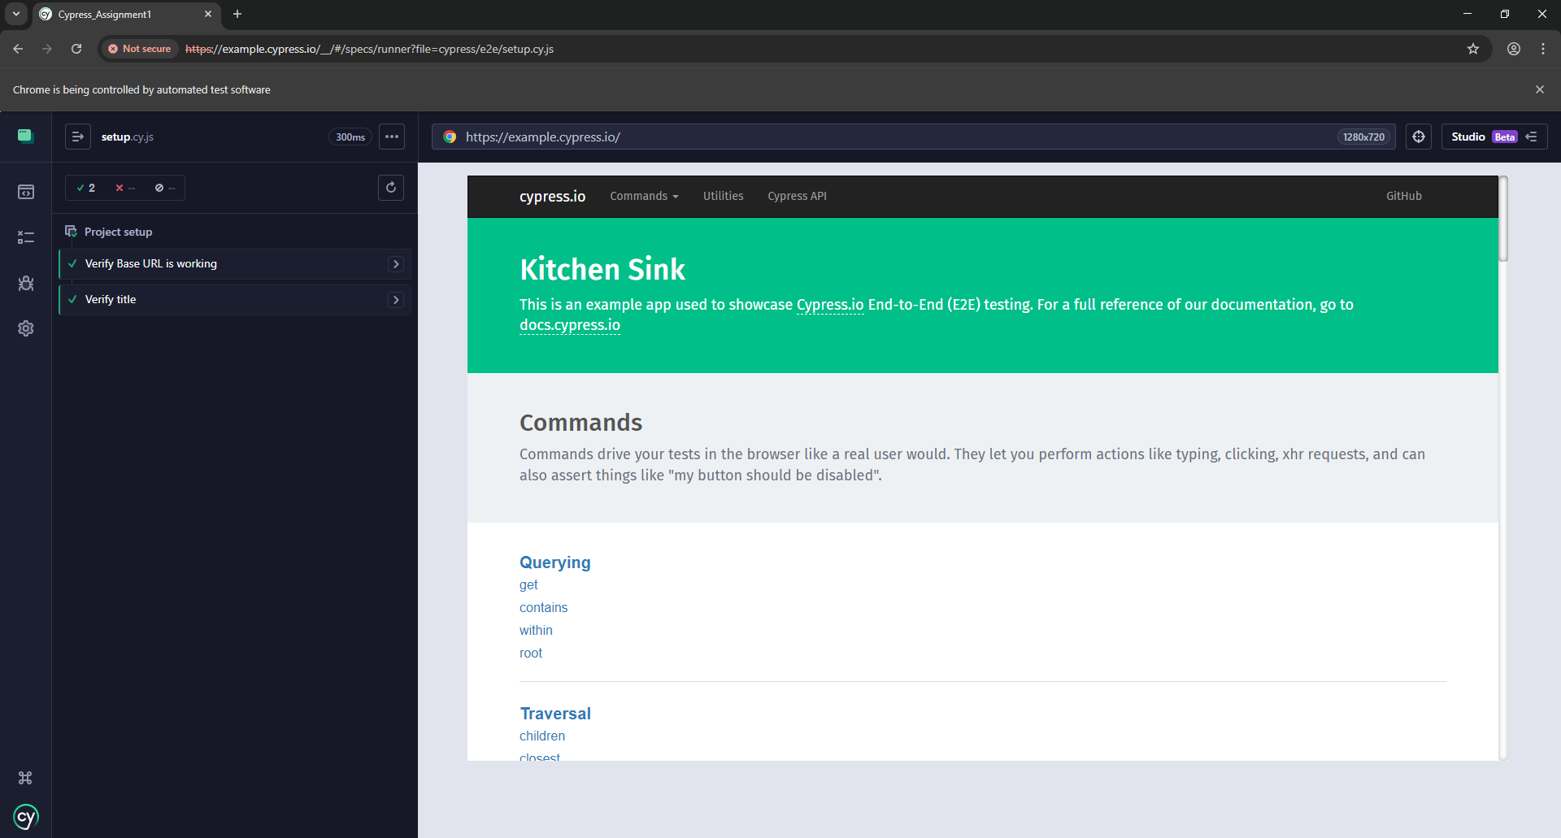
2.6 Executing Tests Using CLI:
The test cases were executed in headless mode using the command:
npx cypress run
This runs Cypress without opening the GUI and executes the test cases directly in the terminal.
Both test cases executed successfully and passed.
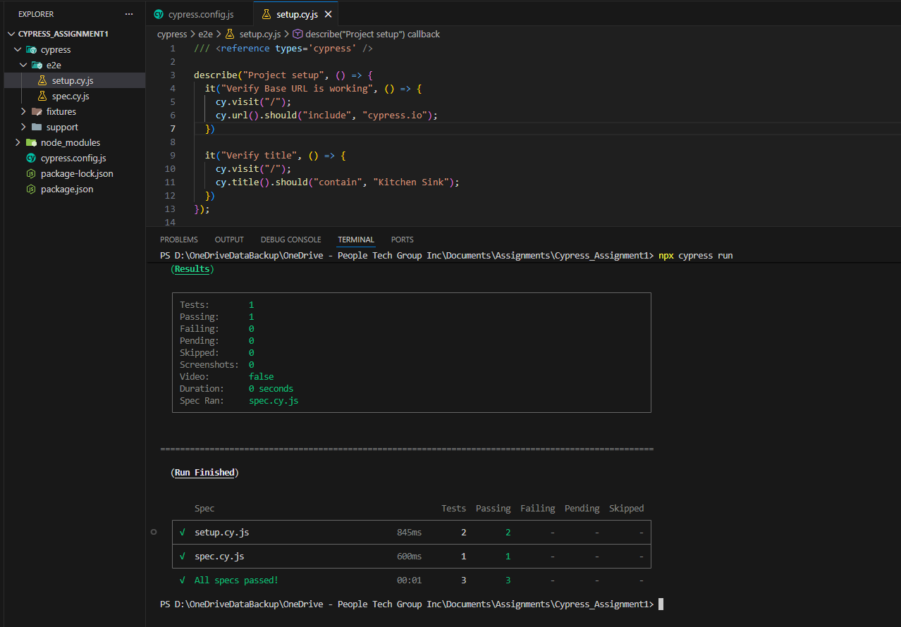
2.7 Verifying Retry Mechanism:
To validate the retry configuration, the page title assertion was intentionally modified to an incorrect value as “Wrong Title”.
The test was executed using:
npx cypress run
The test failed and Cypress retried it automatically based on the configured retries value (2).
The error message showed:
"Timed out retrying after 8000ms"
This confirms that:
- The defaultCommandTimeout setting is active (8000 ms)
- The retries configuration is functioning correctly
After verification, the assertion was restored to the correct expected value.
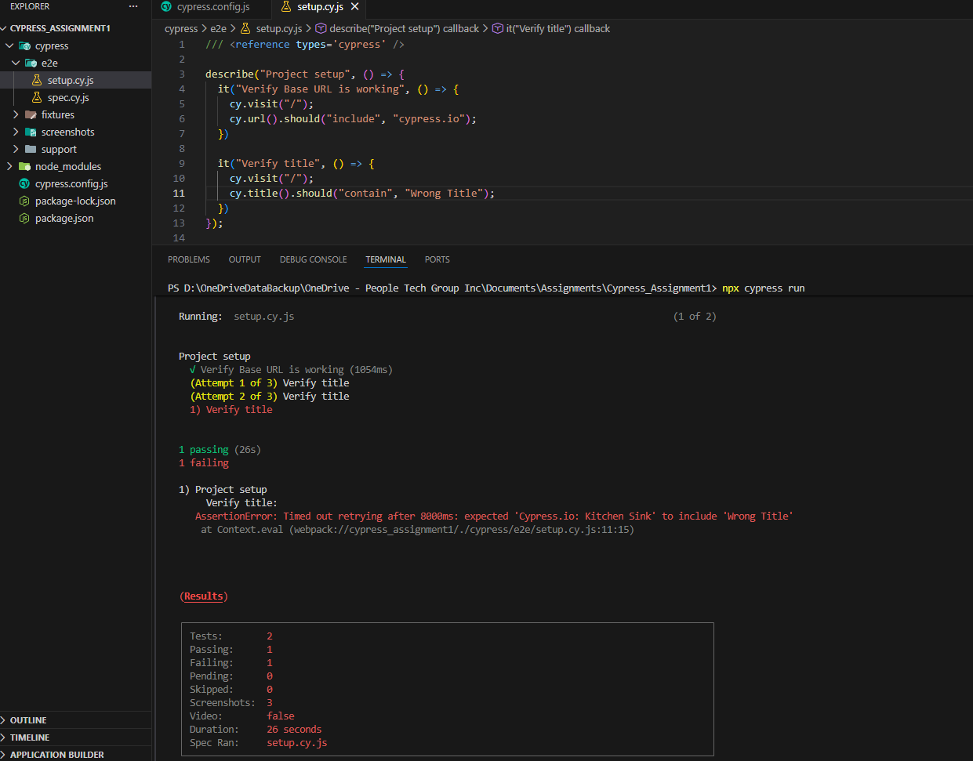
- Core Commands & DOM Validation:

3.1 Creating Test File & Test Initialization
A new test file named coreCommands.cy.js was created inside the cypress/e2e directory to implement assertions and DOM validation scenarios.
The describe() block was created to group all core command test cases.
A beforeEach() hook was implemented to visit the page:
/commands/actions
This ensures that each test starts with a fresh browser state and maintains test independence.

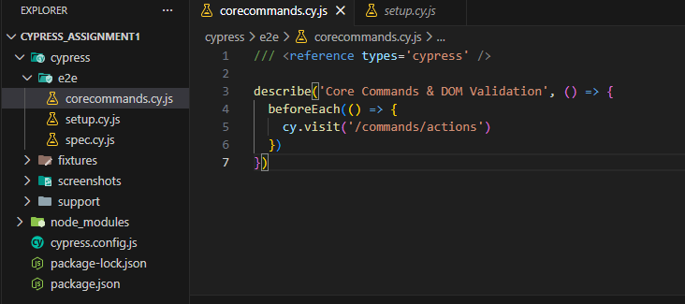
3.2 Verifying Element Visibility
A test case was implemented to verify that the email input field is visible on the page.
The element was located using its unique ID selector:
cy.get('#email1')
The assertion .should('be.visible') ensures that the element is displayed and accessible to the user.
The test executed successfully and passed. 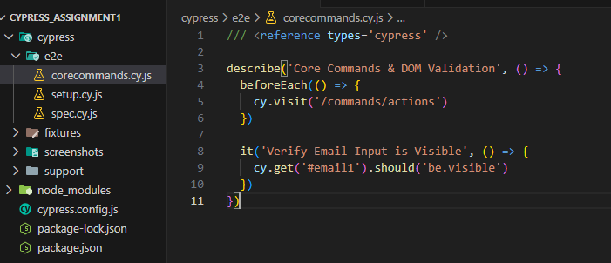
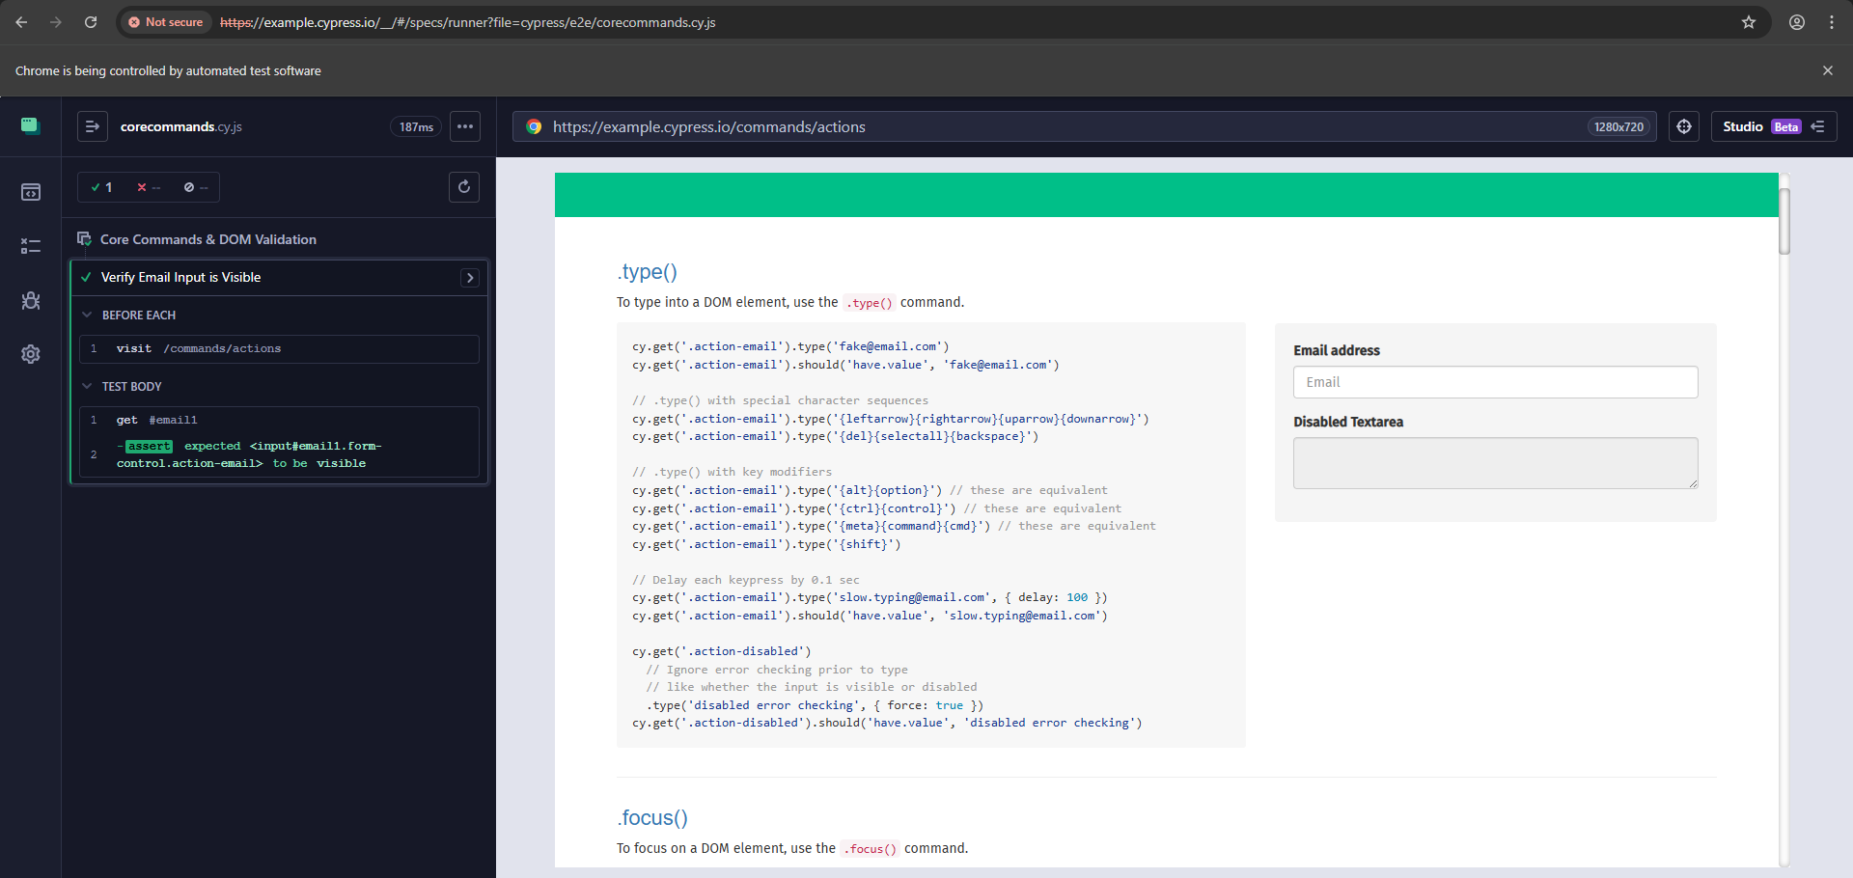
3.4 Validating Element Count
The number of primary buttons on the page was verified.
The element selector .btn-primary was identified through DOM inspection.
Using:
cy.get('.btn-primary').should('have.length', 2)
The test confirms that exactly two primary buttons are present on the page.
The test executed successfully and passed. 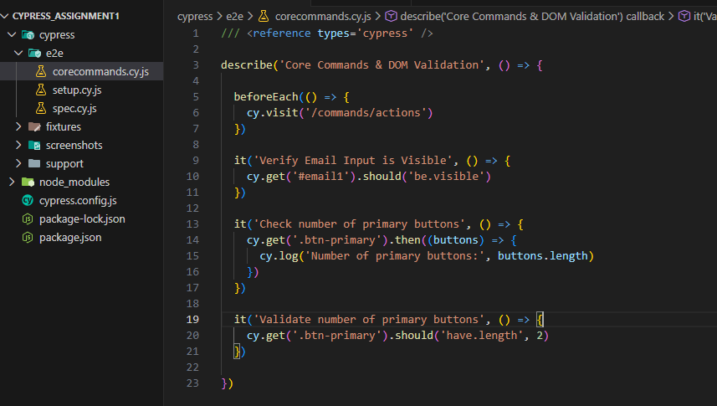
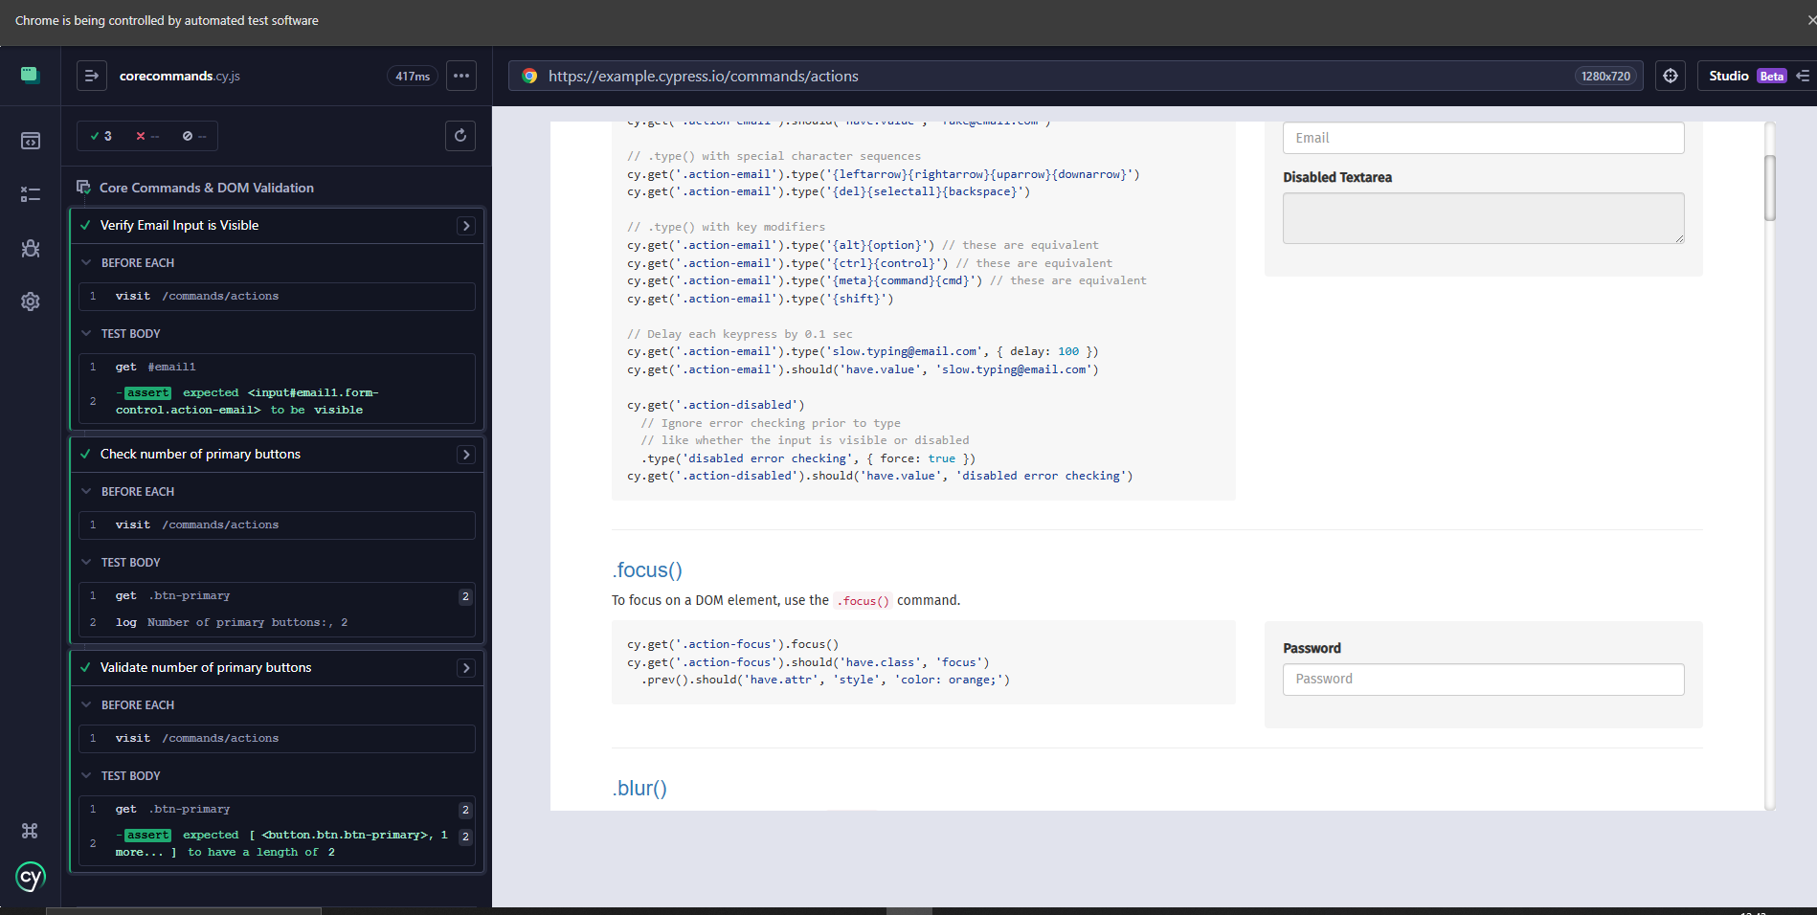
3.5 Validating Multiple Properties Using Chained Assertions
A test case was implemented to validate multiple properties of the email input field using chained assertions.
Explanation:
- cy.get('#email1')
This command selects the email input field using its unique ID selector.
- should('be.visible')
Verifies that the element is visible on the page and accessible to the user.
- should('have.attr','placeholder','Email')
Confirms that the element contains a placeholder attribute and that its value is exactly "Email".
- should('not.be.disabled')
Ensures that the input field is enabled and available for user interaction
The test executed successfully and passed.
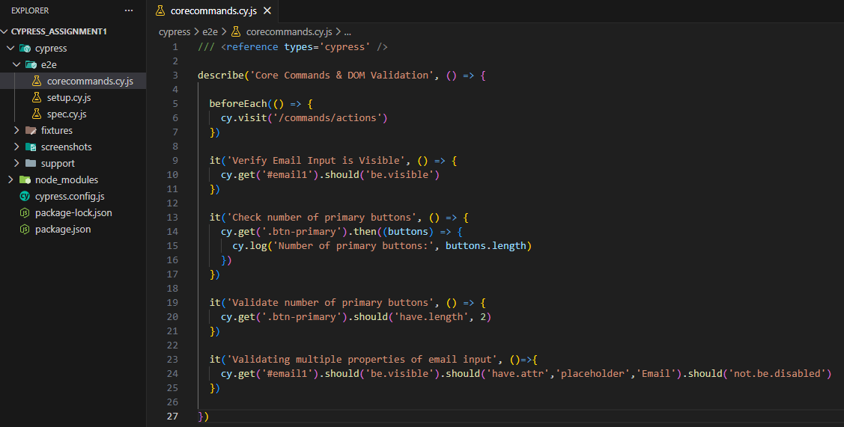
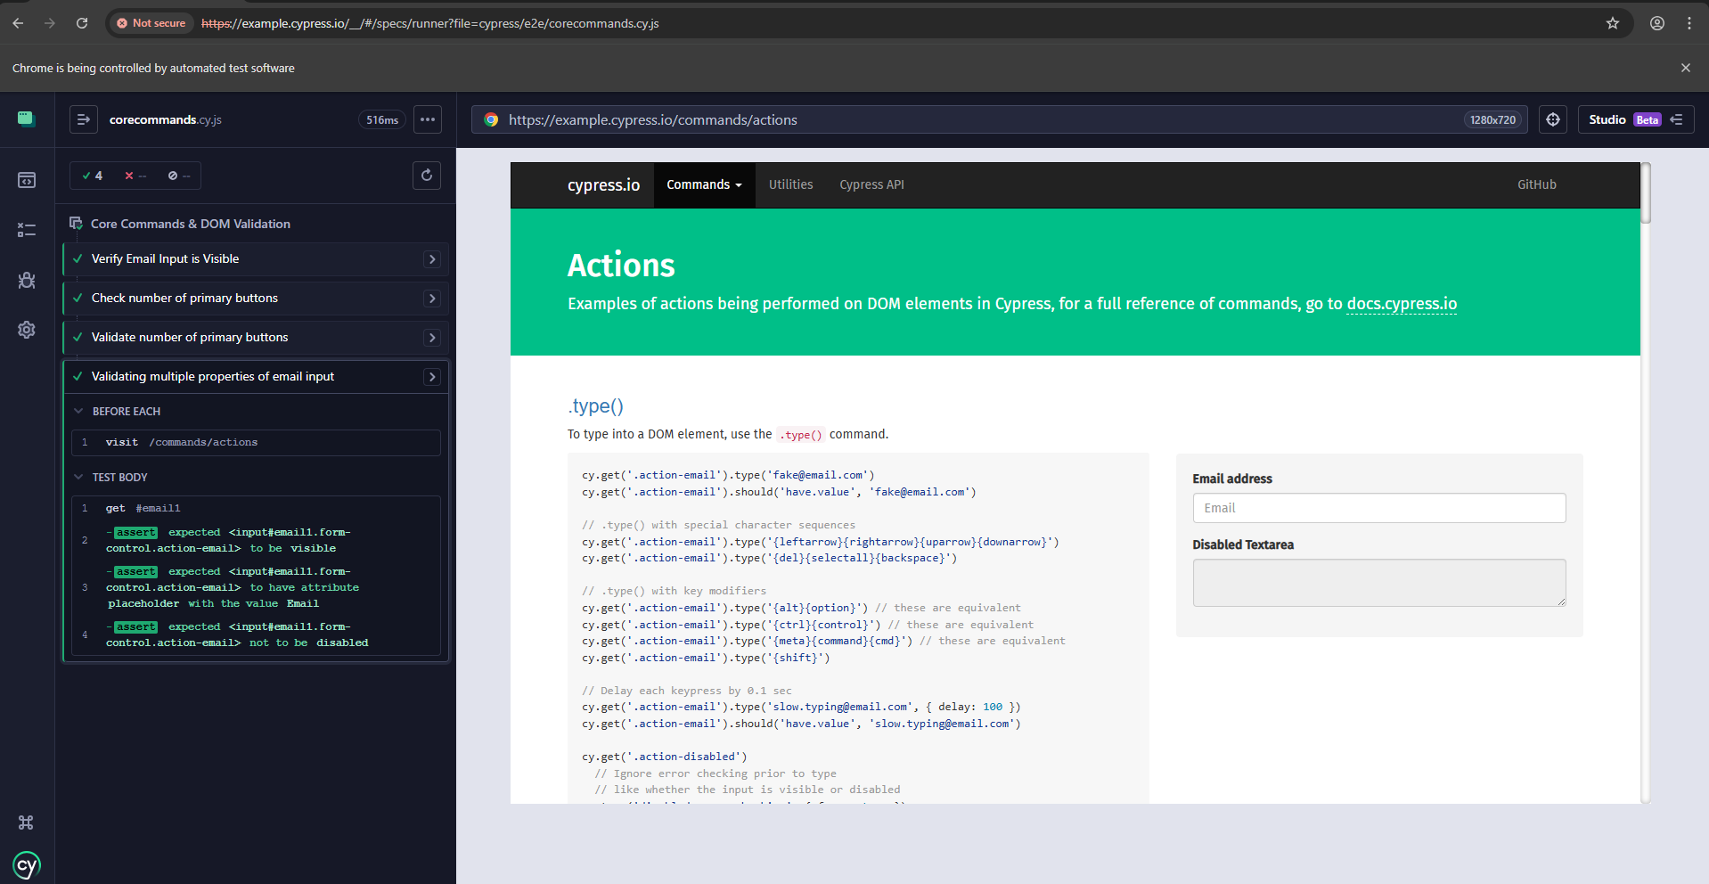
3.6 Using invoke() to Access Element Attributes
A test case was implemented to extract the placeholder attribute value using the invoke() command.
The invoke() function calls a method on the selected DOM element.
In this case, it retrieves the value of the placeholder attribute.
The returned value is then validated using .should('equal', 'Email').
This demonstrates how Cypress can access and validate specific element properties.
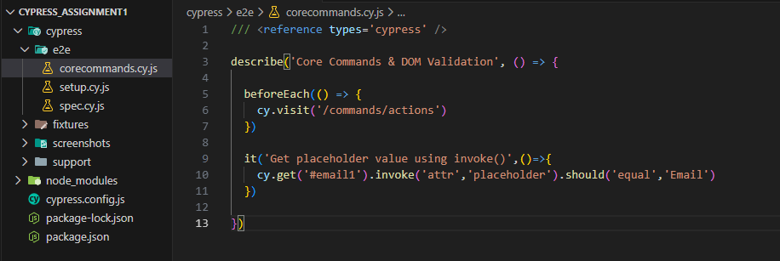
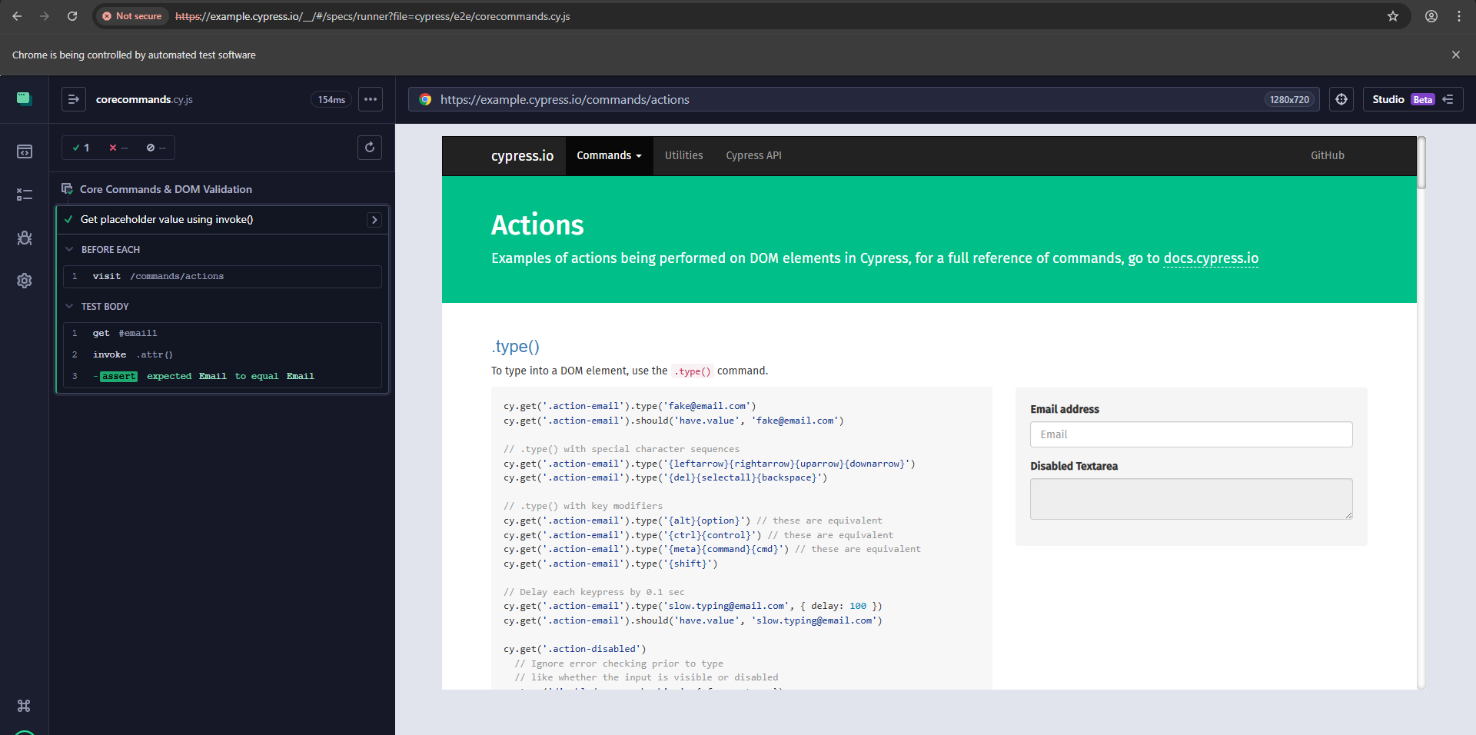
3.6 Using clear() Command
A test case was implemented to validate the clear() command on the email input field.
The following steps were performed:
- Entered text into the input field using .type()
- Verified the entered value using .should('have.value')
- Cleared the input using .clear()
- Confirmed that the input field value is empty.
The test executed successfully and validated that the clear command works as expected. 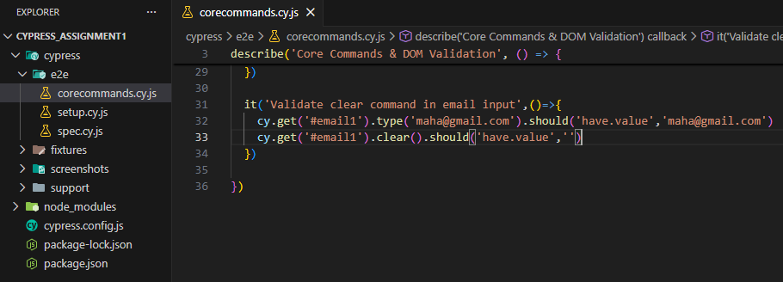
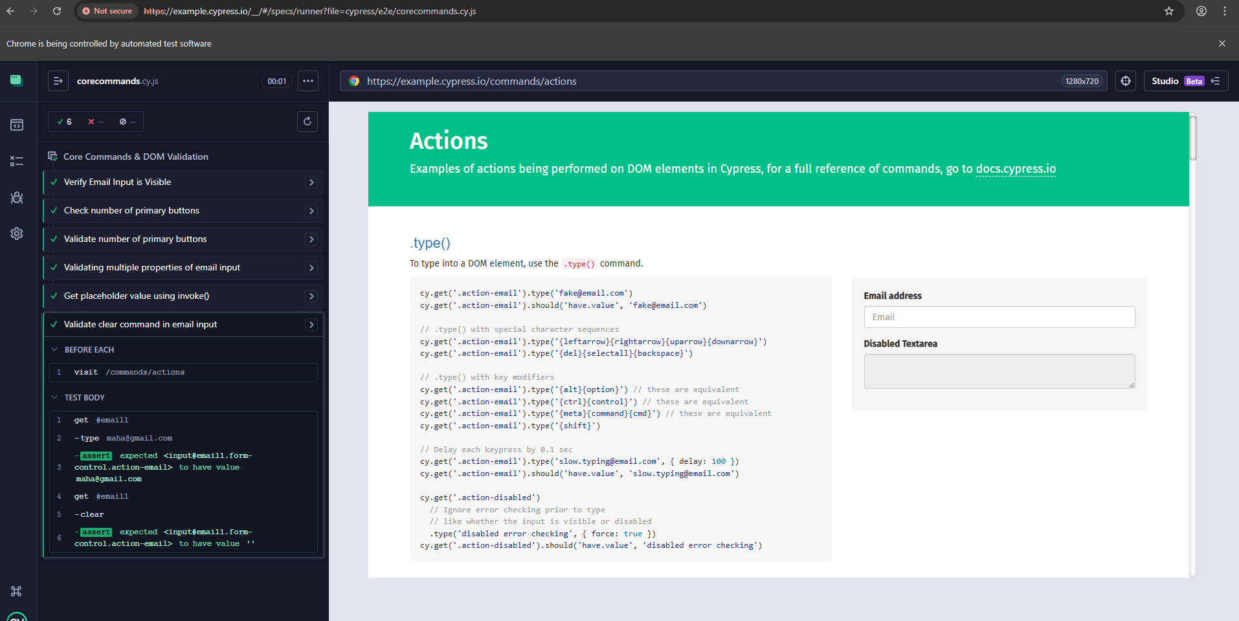
3.7 Using contains() for Text-Based Validation
A test case was implemented to validate the presence of a button using visible text.
The cy.contains('Submit') command searches the DOM for an element containing the specified text.
The assertion .should('be.visible') confirms that the element is displayed on the page.
This approach improves readability and mimics real user interaction.
The test executed successfully and passed. 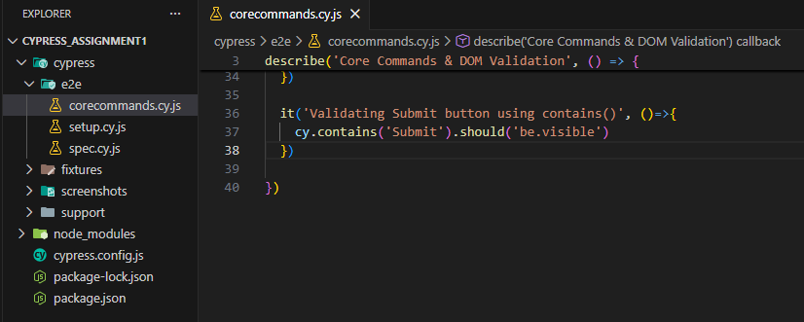
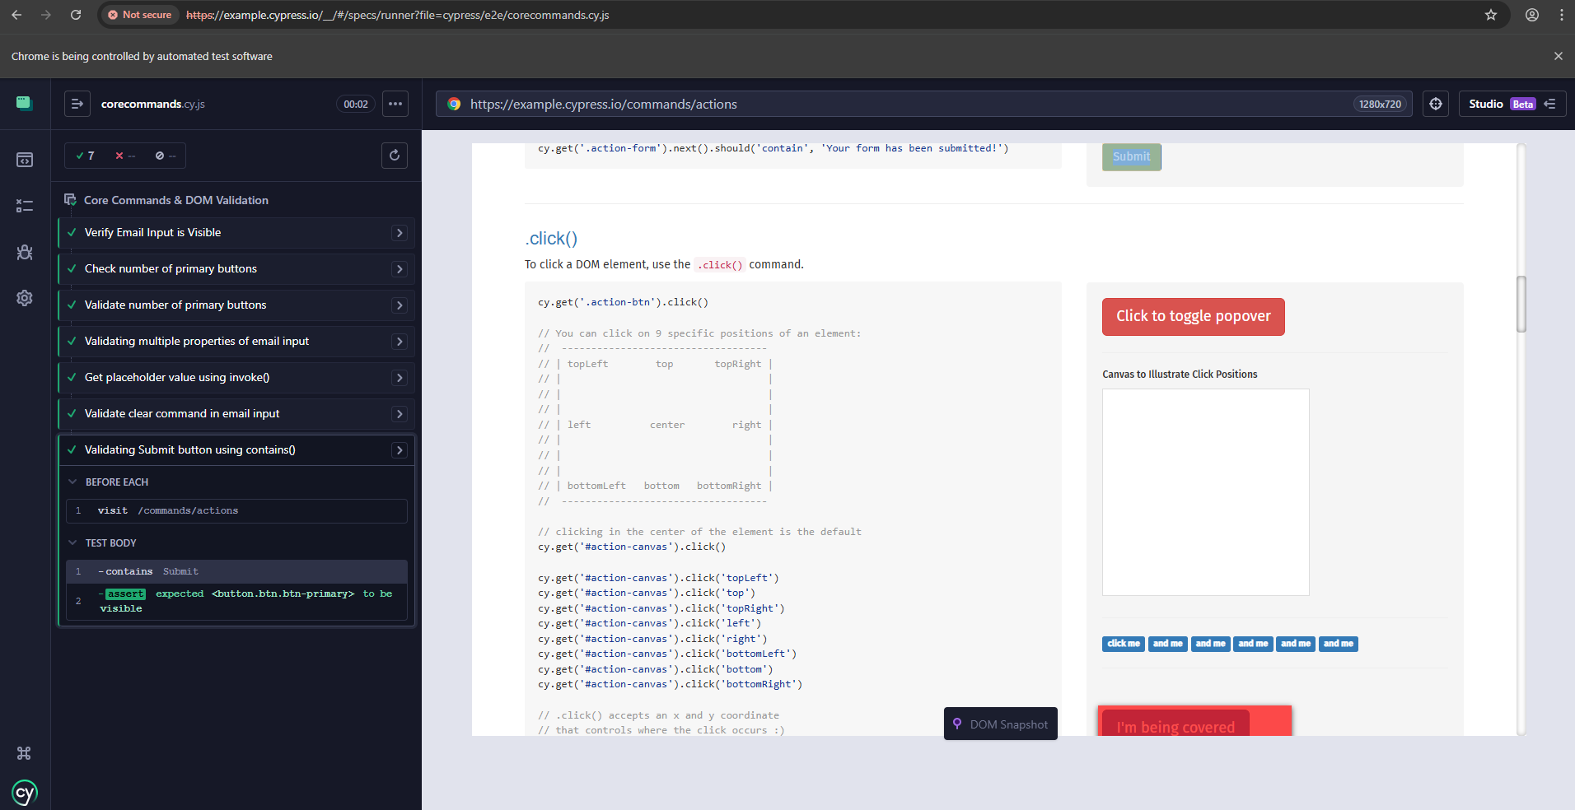
4. Forms & Data Handling
4.1 Creating Forms Test File & Creating Fixture File
A fixture file named userData.json was created inside the cypress/fixtures directory.
The file contains test data in JSON format:

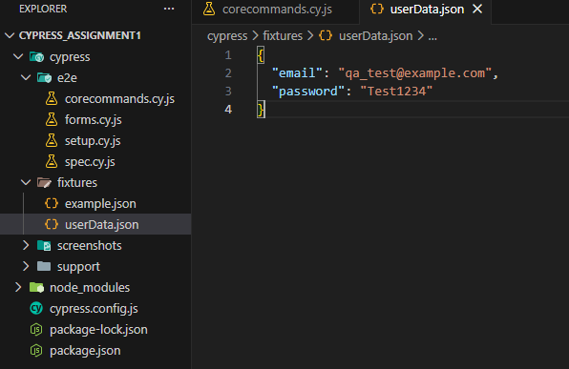
4.2 Using Fixture Data in Test
A test case was implemented to fill the email input field using external fixture data.
The cy.fixture('userData') command loads data from the userData.json file.
The email value was accessed using data.email and entered into the input field using .type()
The entered value was validated using .should('have.value', data.email)
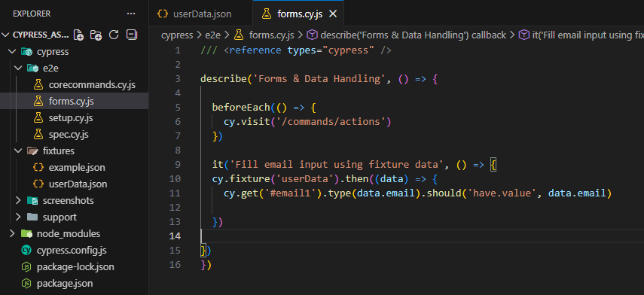
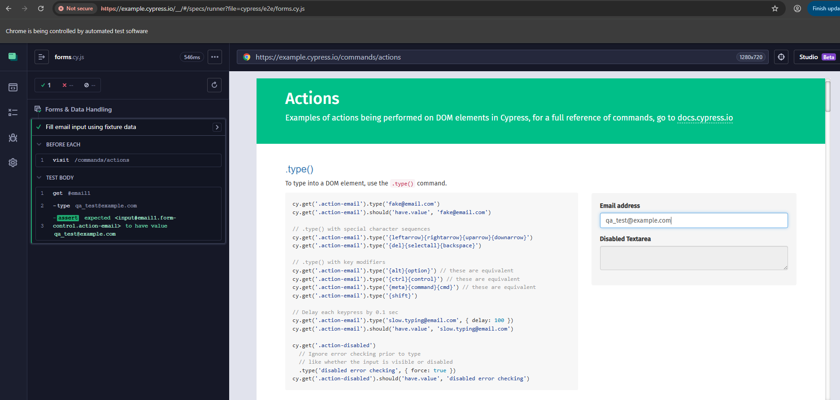
4.3 Handling Checkboxes
A test case was implemented to validate checkbox selection and deselection.
The check() command was used to select the checkbox, and .should('be.checked') verified the selection.
The uncheck() command was used to deselect the checkbox, and .should('not.be.checked') confirmed it was unchecked.
The test executed successfully and validated checkbox functionality.
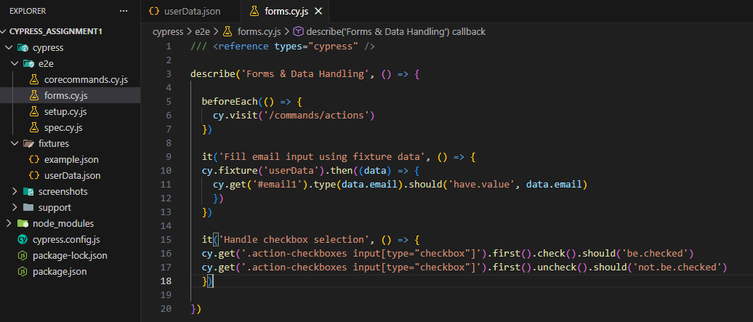
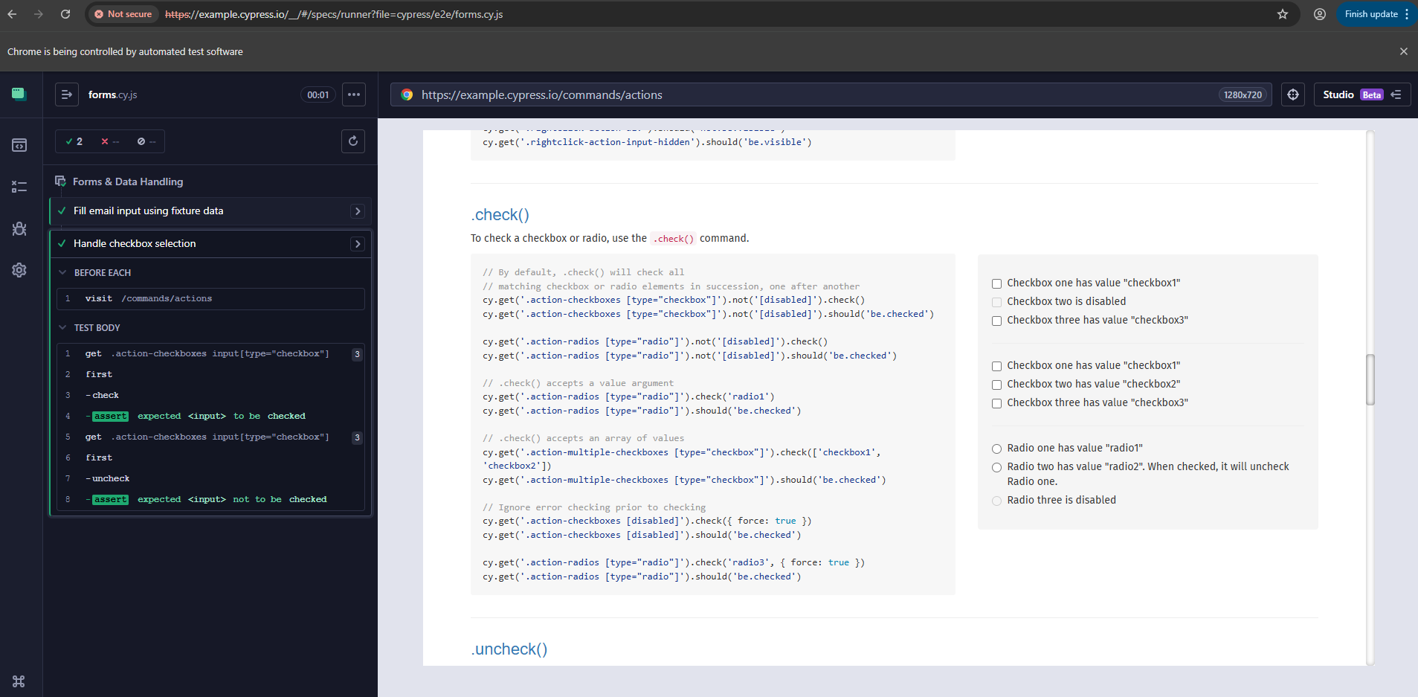
4.5 Handling Radio Buttons
A test case was implemented to validate radio button behavior.
The test selected radio1 and verified it was checked.
Then radio2 was selected, and the test confirmed that radio1 was automatically unchecked.
Additionally, the disabled radio button was validated using .should('be.disabled')
The tests executed successfully and confirmed correct radio functionality. 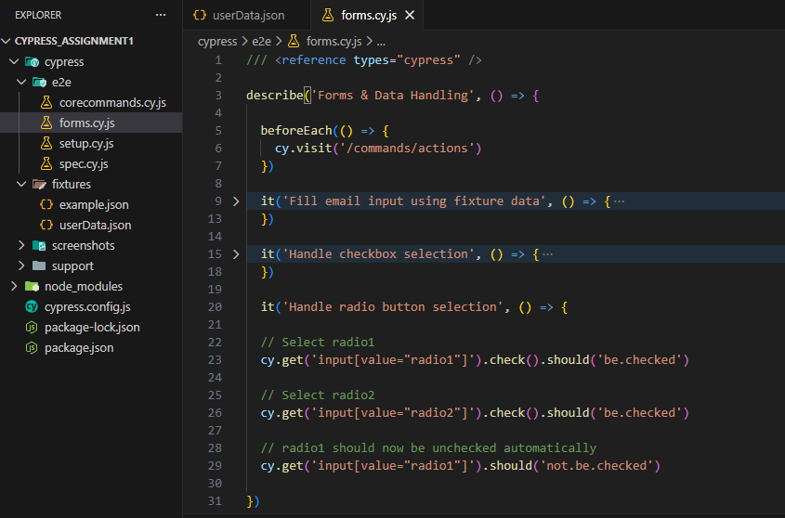
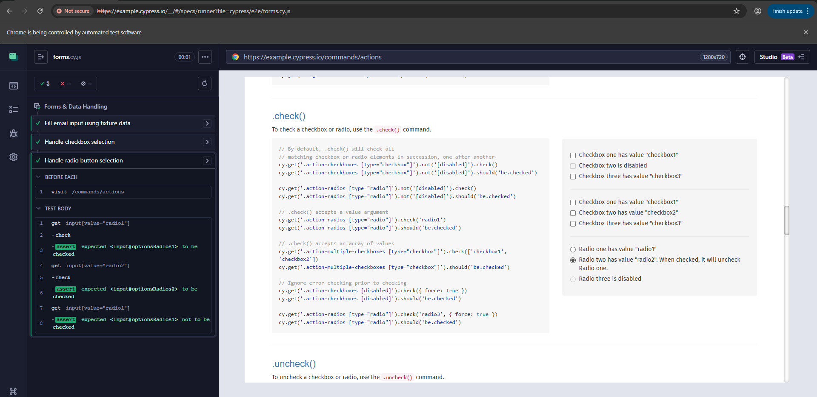
4.6 Handling Dropdown Selection
Dropdown selection was validated using the .select() command.
Two test cases were implemented:
- Selecting option by value.
- Selecting option by visible text.
The selected value was verified using .should('have.value')
The tests executed successfully and confirmed correct dropdown behavior.
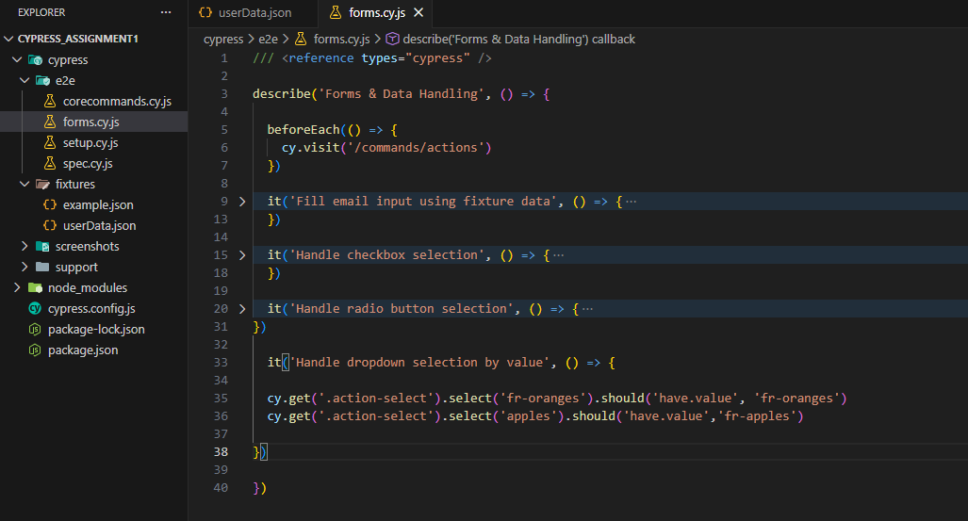
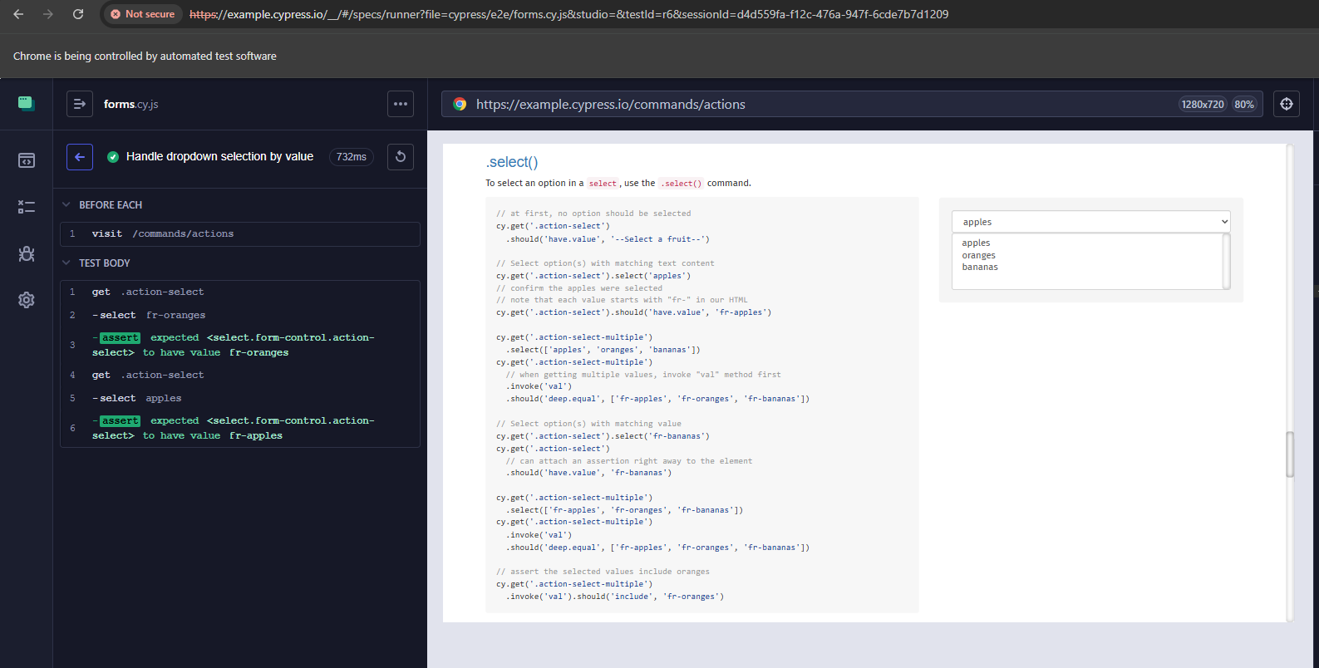
4.7 Button Interaction
A test case was implemented to validate button interaction using cy.contains('Submit').click()
This verifies basic button functionality within the form. 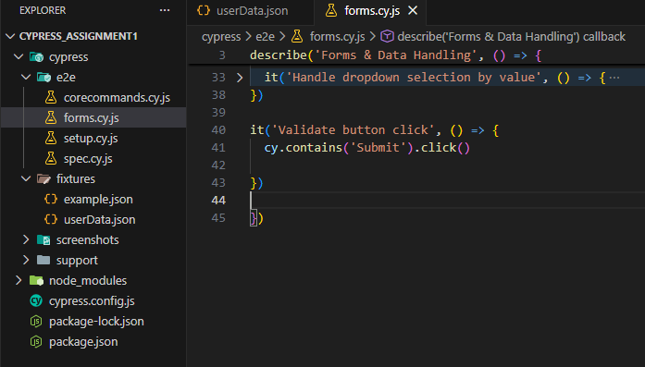
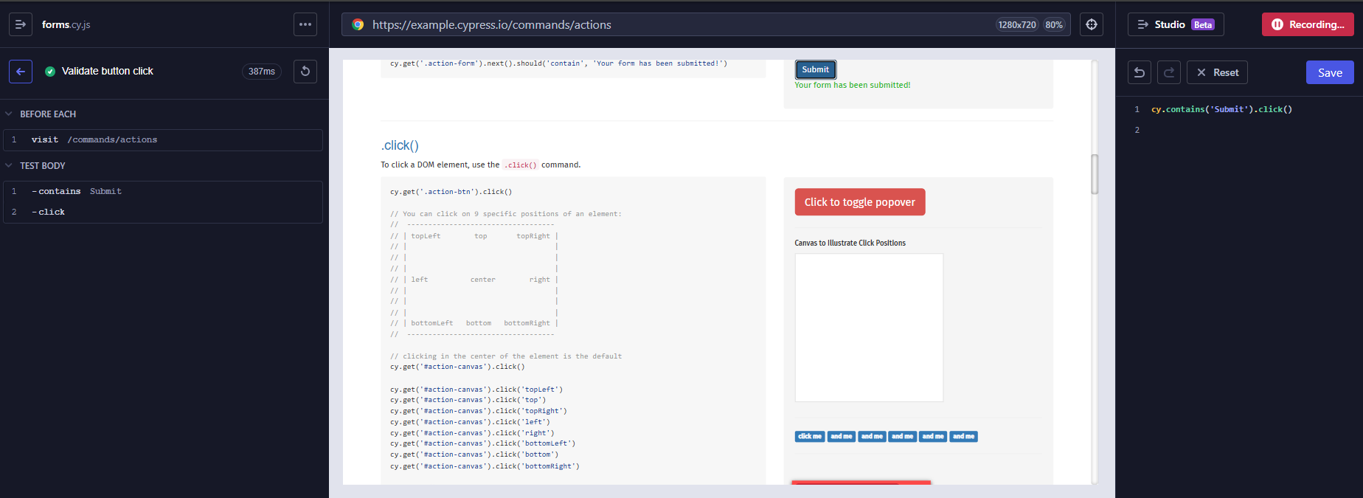
4.7 File Upload
File upload functionality was validated using Cypress built-in selectFile() command.
The file userData.json from the fixtures folder was uploaded and the success message "File Uploaded!" was verified. The test executed successfully. 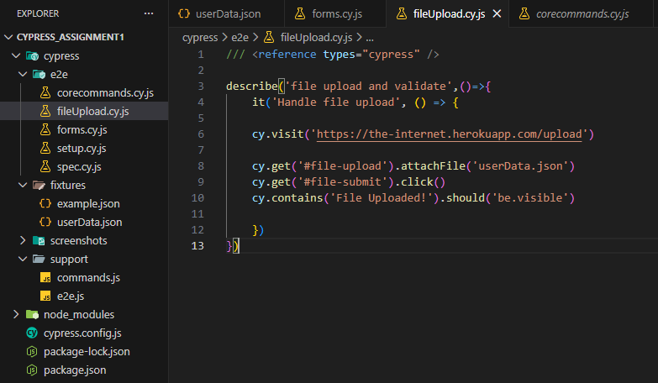
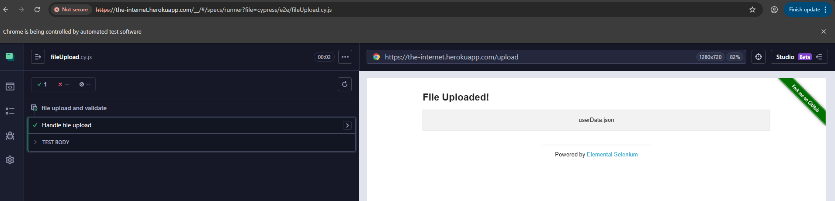
4.8 Read and Write File Handling
File handling functionality was validated using cy.writeFile() and cy.readFile().
The writeFile() command created a text file and stored sample data.
The readFile() command read the file content and validated it using .should('equal').
The test executed successfully and confirmed file read/write functionality. 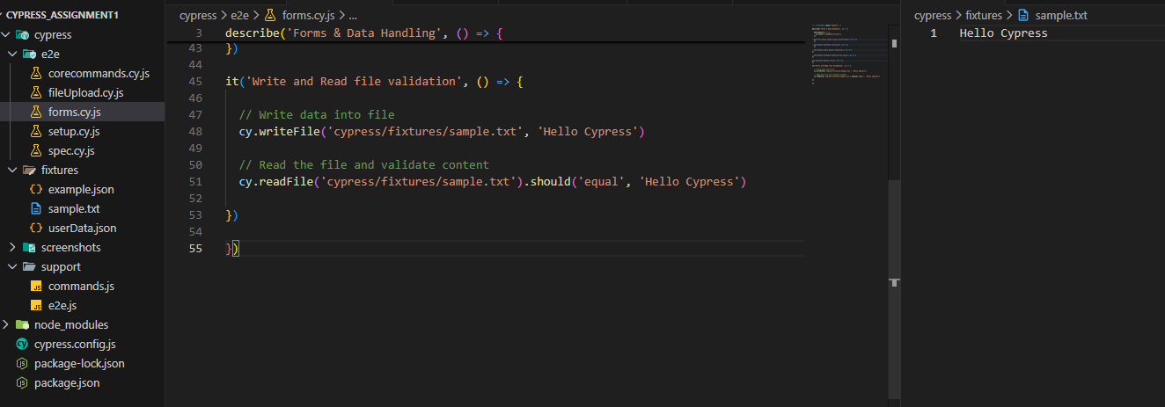
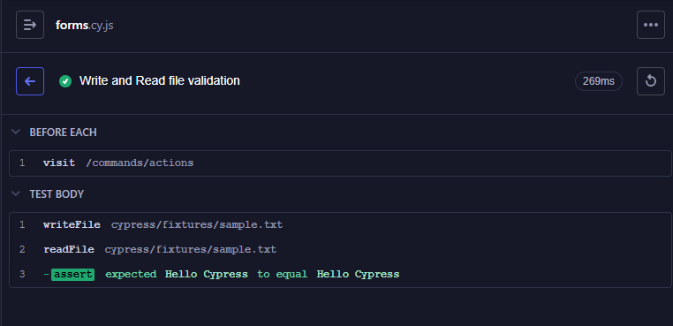
5. UI Interaction
5.1 Handling JavaScript Alert
A test case was implemented to validate JavaScript alert handling.
The alert was triggered using: cy.contains('Click for JS Alert').click()
The alert message was captured using:
cy.on('window:alert', (text) => {
expect(text).to.equal('I am a JS Alert')
})
The alert message was successfully validated and the test passed. 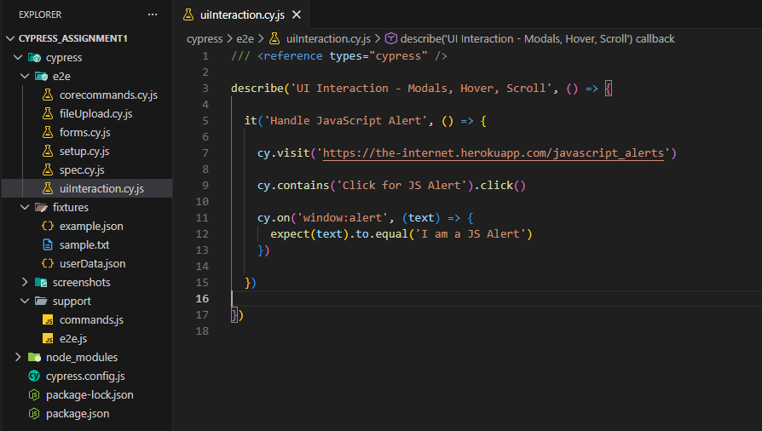
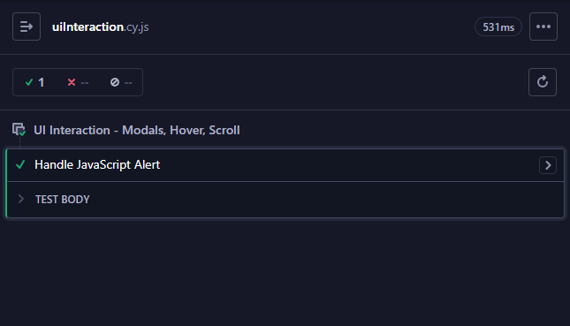
5.3 Handling Modal Popup:
The test navigates to the modal page and verifies that it loads correctly.
The modal is opened by clicking the #simpleModal button.
The modal title and body text are validated to ensure correct content is displayed.
Finally, the modal is closed using the visible close button.
The test passed successfully, confirming that the modal opens, displays correct content, and closes as expected. 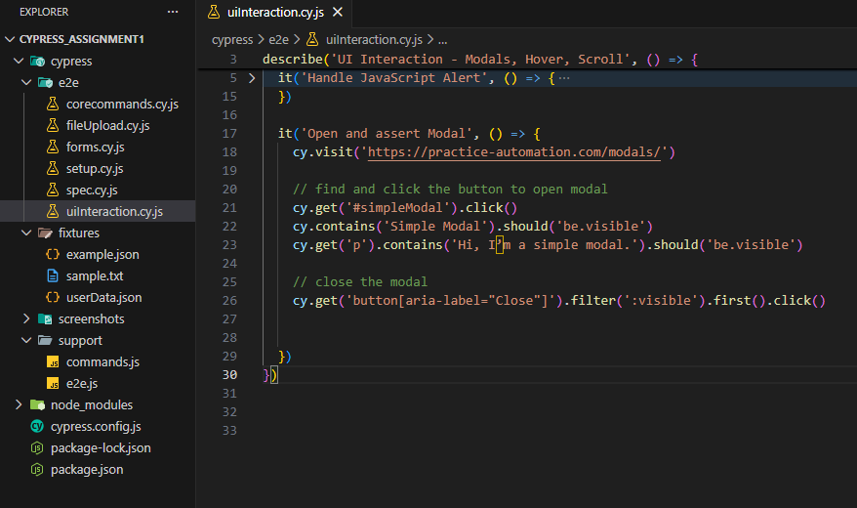
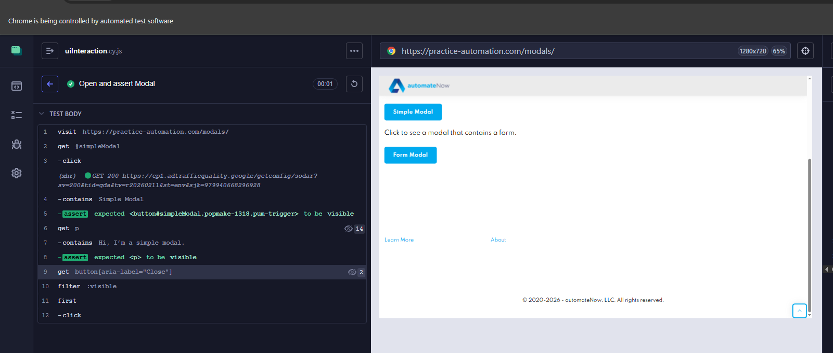
5.4 Hover Interaction
A hover action was simulated using the .trigger('mouseover') command.
Since Cypress does not support real mouse hover natively, the hover event was triggered programmatically to validate hover-based UI behavior.
The test executed successfully and confirmed hover functionality. 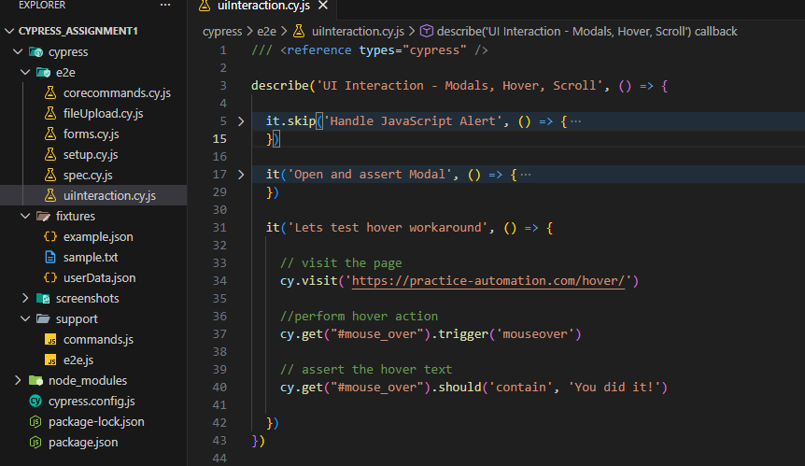
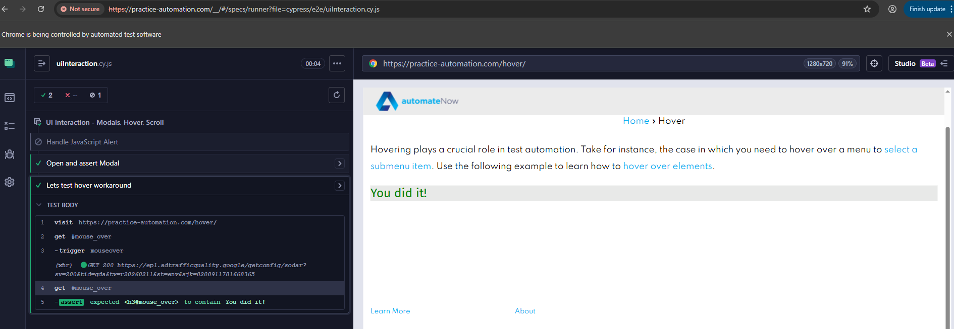
📄 5.5 Device Emulation (Viewport)
Device emulation was performed using the cy.viewport() command.
The viewport was changed to simulate a mobile device screen (e.g., iPhone-6) to validate responsive behavior. The test confirmed that the application adjusts correctly for different screen sizes.
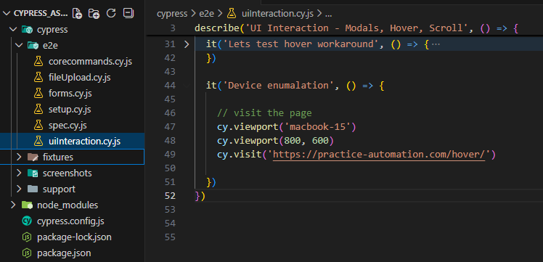
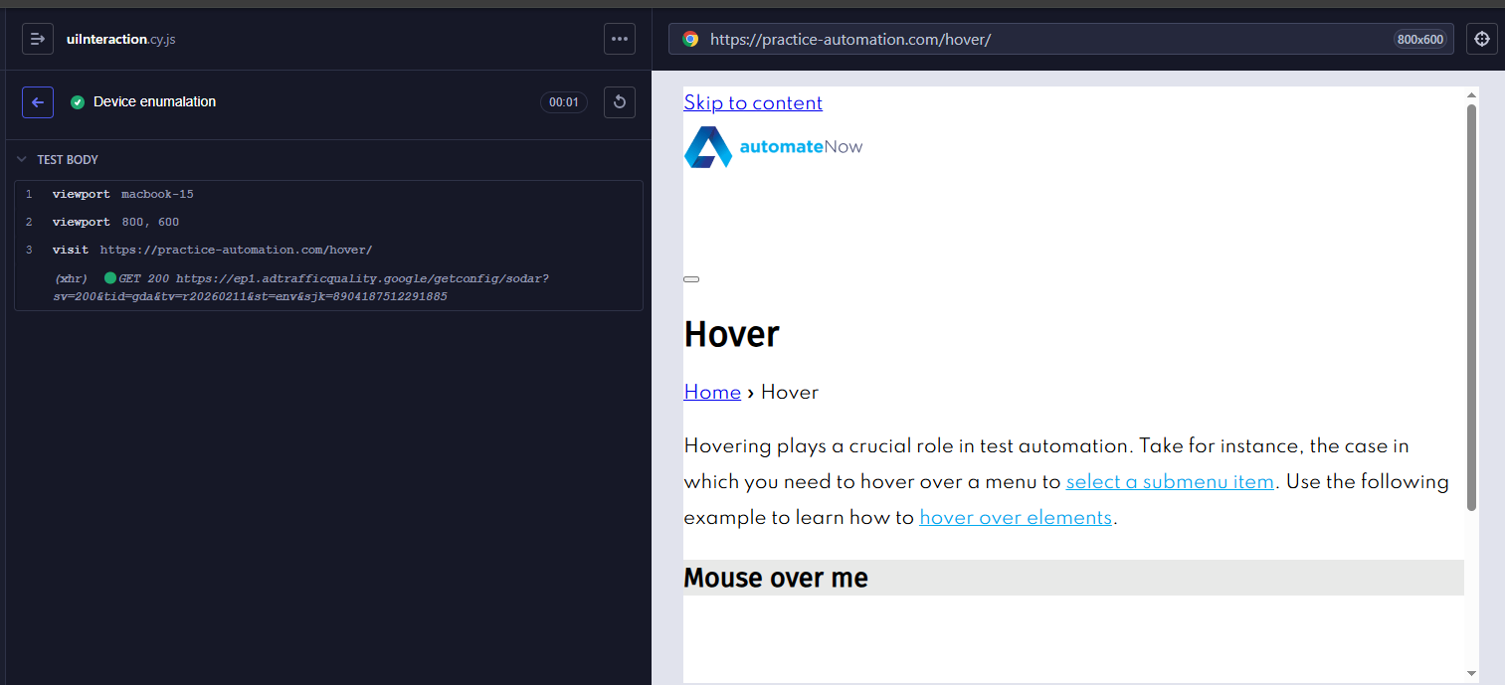
📄 5.6 Screenshots
The cy.screenshot() command was used to capture a screenshot of the application during test execution.
Screenshots help in debugging and provide visual confirmation of the application state.
The screenshot was successfully generated.
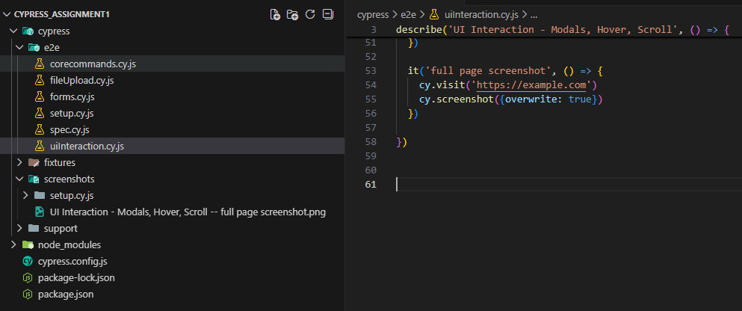
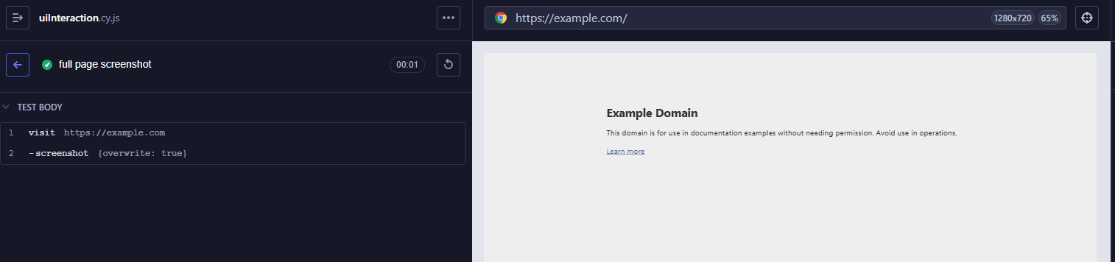
5.7 Reload & Logs
The cy.reload() command was used to refresh the browser and validate page stability.
The cy.log() command was used to display custom messages in the Cypress command log for better test readability and debugging.
Both commands executed successfully.
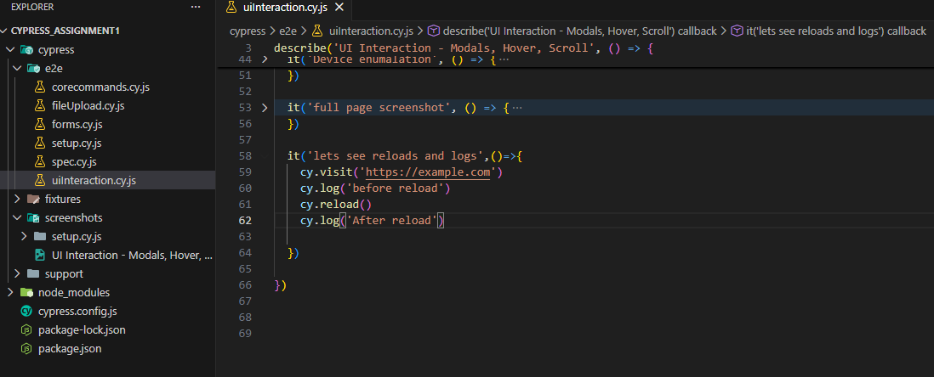
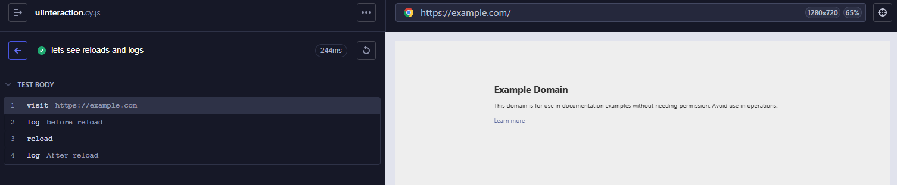
6 Test structure:
6.1: Hooks & Tags:
Test hooks such as before(), beforeEach(), after(), and afterEach() were used to control test execution flow.
- beforeEach() runs before every test case.
- It ensures a fresh test state and avoids dependency between tests.
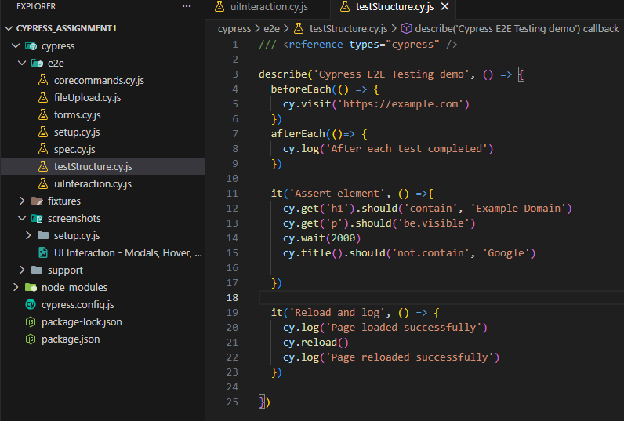
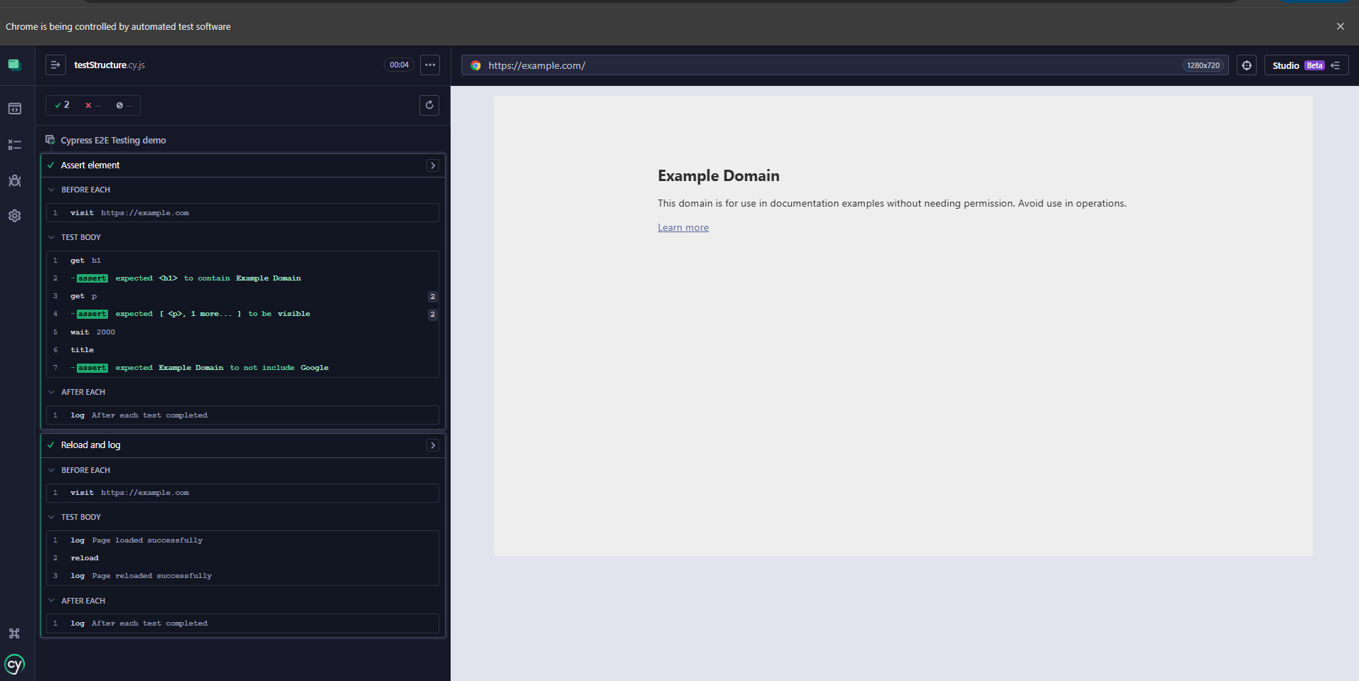
6.2: Custom Commands
A reusable login command was created inside cypress/support/commands.js using:
