# ANNAMACHARYA INSTITUTE OF TECHNOLOGY AND SCIENCES, KADAPA



## Project Report on

**SALESFORCE - Garage Management system BY – BOYA MAHALAKSHMI (23HM5A0403)**

[mahalakshmiboya41@gmail.com](mailto:mahalakshmiboya41@gmail.com)

### S. No.

1. **Project Overview**
   1. Overview

## Table of Contents

### Title

* 1. Key Features & Business Needs

1. **Objectives**
2. **Requirement Analysis & Planning**
   1. Understanding Business Requirements
   2. Defining Project Scope & Objectives
3. **Salesforce Development**
   1. Setup Environment
4. **Customizations & Automation**
   1. Core System Customizations
5. **Automation Components**
   1. Flows
   2. Apex Development
6. **Key Features and Functionalities**
   1. Work Order Management(Appointment & Service Records)
   2. Customer Management
   3. Billing & Feedback
   4. Dynamic Service Pricing(Apex)
   5. Automated Email Notifications (Flow)
7. **UI/UX Development& Customization**
   1. Lightning App Setup
   2. Reports& Dashboards
8. **Conclusion**
9. **PROJECTOVERVIEW**

#### OVERVIEW

The Garage Management System (GMS) is a robust, cloud-based application developed using Salesforce CRM to automate and optimize day-to-day garage operations. Traditional garages face delays due to manual appointment bookings, service tracking, and paper-based billing. GMS overcomes these limitations through automation, digitization, and intelligent workflows. The platform is tailored for vehicle servicing businesses, offering seamless management of customer profiles, service appointments, billing, and technician coordination—all within Salesforce’s secure cloud infrastructure.

**Additional Highlights:**

* Fully customizable to suit different garage sizes and workflows.
* Integration-ready for third-party apps like WhatsApp, Google Maps, and SMS gateways.
* Mobile responsive via Salesforce Mobile App.

Built on **Salesforce Lightning**, GMS combines **user-friendly interfaces** with **robust automation** to enhance productivity, reduce errors, and improve customer satisfaction.

#### Key Features & Business Needs

* + 1. **Key Features**

|  |  |
| --- | --- |
| **Feature** | **Description** |
| **Customer & Vehicle Management** | Stores customer profiles, vehicle history, VIN validation, and service logs. |
| **Automated Service Appointment Booking** | Web interface and internal booking support with automated technician assignment. |
| **Billing& Feedback** | Real-time billing updates, automated payment tracking, and customer feedback collection. |
| **Reporting & Dashboards** | Performance KPIs, technician productivity, revenue reports, and feedback trends. |

* + 1. **Business Benefits**

|  |  |
| --- | --- |
| **Pain Point** | **GMS Solution** |
| **Improved Operational Visibility** | Management gains access to real-time dashboards. |
| **Reduced Manual Errors** | Automation reduces duplicate entries and missed updates. |
| **Customer Loyalty** | Personalized service via history tracking improves satisfaction. |

# OBJECTIVES

#### Objectives

1. **Enhance Customer Experience**
   * Reduce service booking time through automated appointments bookings.
2. **Streamline Operations**
   * Automate **maximum of repetitive tasks**.
   * Cut paper work by digitizing service records by using reports.
3. **Automation& Integration**
   * Implement Flows for:
     + Auto-updates reports based on billing updates.
4. **Data-Driven Decision Making**
   * Build dashboards:
     + Average service completion time.
     + Revenueper customer/vehicle.

## Requirement Analysis & Planning

#### Understanding Business Requirements

**Current System Gaps**

1. **Data Duplication**
   * No standardized duplicate rules for critical objects (e.g., customers, vehicles).
   * Manual checks required (matches your "Duplicate Rule" screenshot).
2. **Access Control Issues**
   * Roles/Profiles(shown in your UI)lack granular permissions for:
     + Technicians (needed it access to Work_Order_c but not In voice).
     + Public Groups not optimally used for sharing records.
3. **Process In efficiencies**
   * Flows/Triggers(referenced in your screenshots)not fully automating:
     + Appointment reminders.
     + Inventory reorder alerts.

**Stakeholder Needs**

|  |  |  |
| --- | --- | --- |
| **Component** | **Business Requirement** | **Impact** |
| **Validation Rules** | Mandatory input formatting | Ensures data accuracy |
| **Approval Process** | Discount validation | Prevents financial loss |
| **Email Alerts** | Payment reminders and thank-you messages | Enhances communication |
| **Lookup Relationships** | Data linking between objects | Improves traceability |

#### Defining Project Scope & Objectives

##### Project Scope

**Included Components**

The Garage Management System (GMS)will implement the following Salesforce components:

* **Custom Objects:** Vehicle_c, Service _Booking_c, and Inventory_c with defined relationships to centralize customer, service, and parts data.
* **Duplicate Rules:** Prevent duplicate customer entries (matching on email/phone) and vehicle records (matching on VIN) to eliminate manual cleanup efforts.
* **Role Hierarchy:** A three-tier structure (Admin > Service Manager > Technician) to enforce approval workflows, such as discounts exceeding 15%.
* **Automation:** Flows for auto-assigning technicians and sending SMS/email appointment reminders to reduce no-shows.
* **Validation Rules:** Enforce mandatory fields like Mileagec during service bookings to ensure data accuracy.
* **Reports & Dashboards:** Real-time tracking of daily appointments, revenue, and inventory levels for data-driven decisions.

**Objectives**

1. **Operational Efficiency:** Reduce appointment scheduling time by 50% (from 10 minutes to 5 minutes) through self-service portals and automated workflows. Track progress via time-tracking reports.
2. **Customer Experience:** Cut no-show rates by 25% using automated reminders (SMS/email) triggered 24 hours before appointments. Measure success through attendance analytics.
3. **Inventory Optimization:** Decrease stock outs by 40% by implementing real-time inventory alerts and reorder triggers. Monitor results via inventory turnover reports.
4. **Compliance:**Ensure100%audittrailsforfinancialtransactions(SOXcompliance)

Using Salesforce’s built-in audit logging.

# SALESFORCE DEVELOPMENT

#### Setup Environment

We established a robust Salesforce development environment using:

* **Developer Org Strategy:** Created Developer Org sandboxes for development and testing.

Link for creating the developer org https://orgfarm-706559aa50-dev-ed.develop.my.salesforce.com/

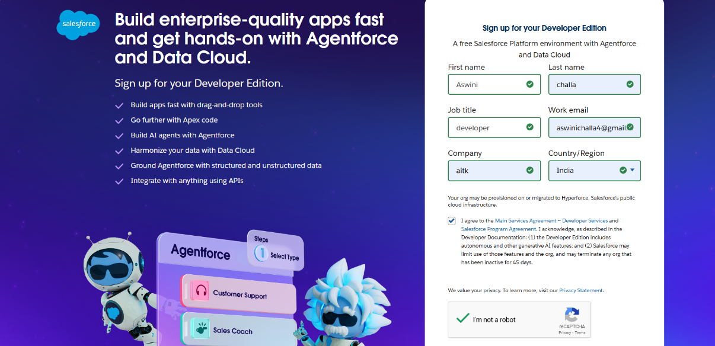

**Fig: Signing up for a developer Org**

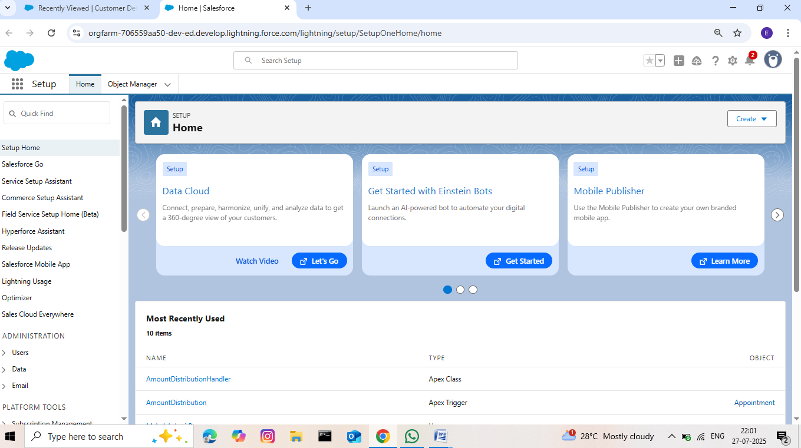

**Fig: Developer Org Login**

# CUSTOMIZATIONS&AUTOMATION

#### Core System Customizations

* **Custom Objects & Fields:**
  + Created Customer_ Details _c and Appointment _c objects for creating customers and their appointments with the fields included:
    - Vehicle_ number_ plate _c for accessing vehicle number with a validation rule as “NOT(REGEX( Vehicle_ number_ plate _c , "[A-Z]{2}[0-9]{2}[A- Z]{2}[0-9]{4}"))”.
    - Appointment _ Date _c to select a particular date
  + Created Service_ Records _c object for updating the service status records:
    - Look up to Appointment _c to get details of appointment.
  + Created Billing_ details_ and_ feedback _c object to update the bill status and feedback rating from the customer.
  + Added critical fields:
    - Service_ Type _c(Checkbox)
    - Appointment_ Date _c(Date)
    - Service_ Date _c (Formula)
* **Validation Rules:**

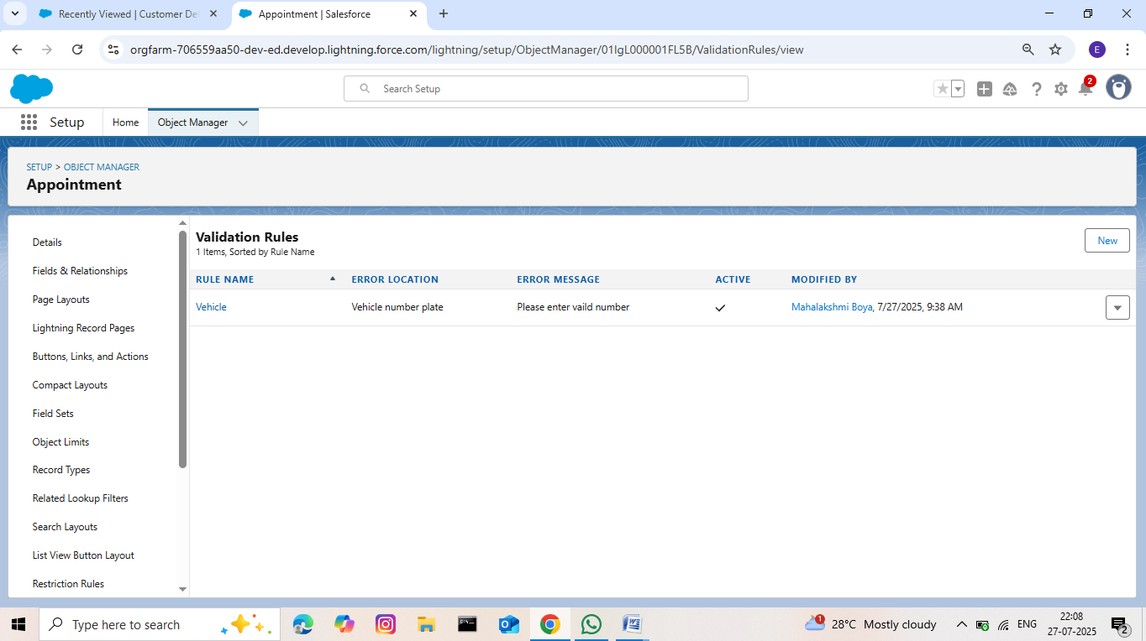

**Fig: Validation Rule for Vehicle_ Number _c field**

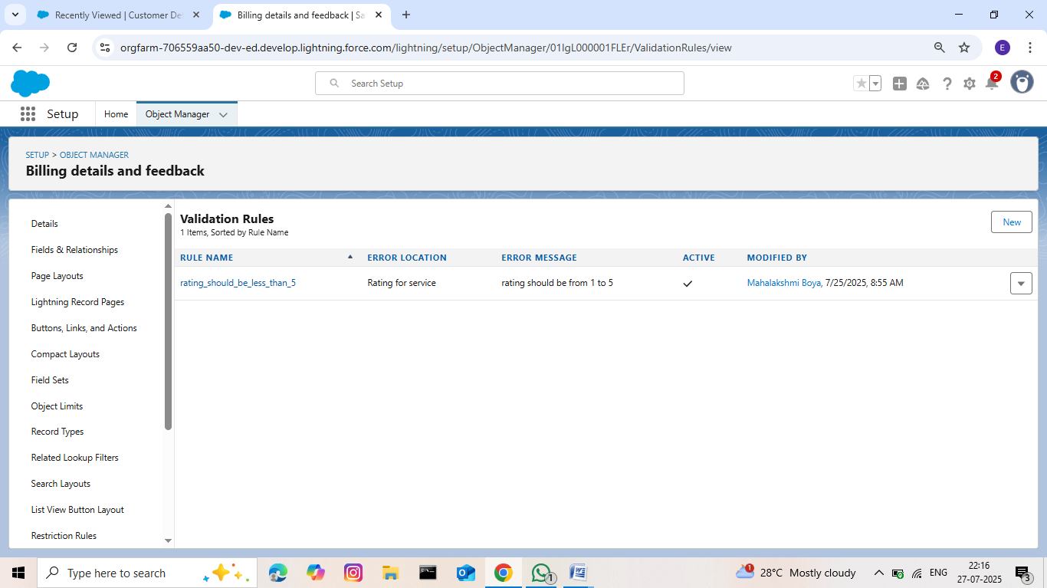

**Fig: Validation Rule for Billing details & feedback _c field**

* **Duplicate Rules & Matching Rules:**

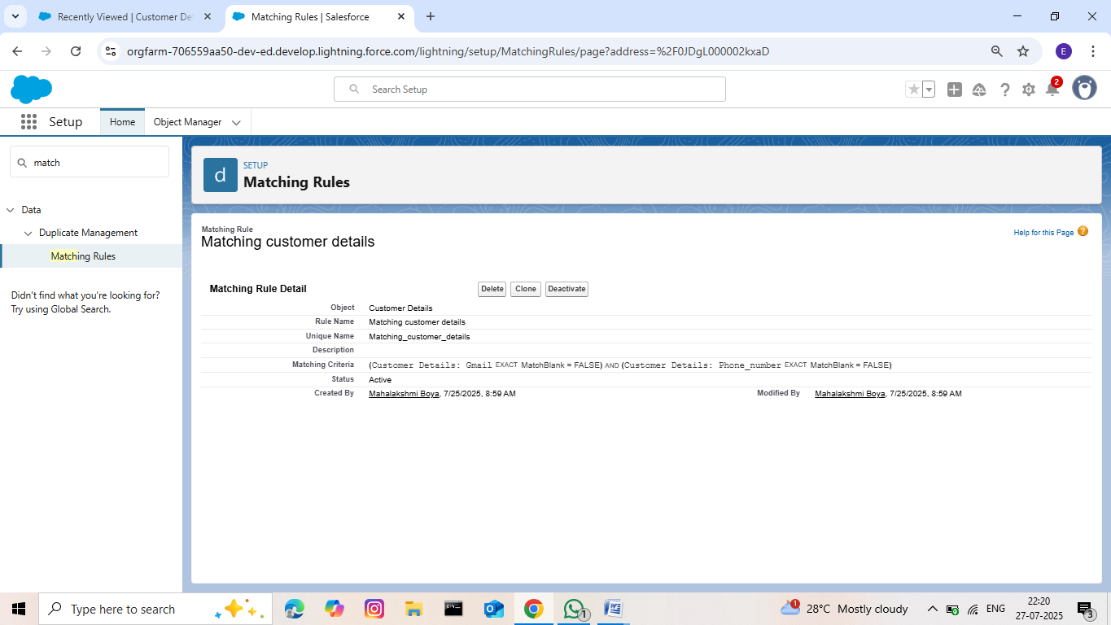

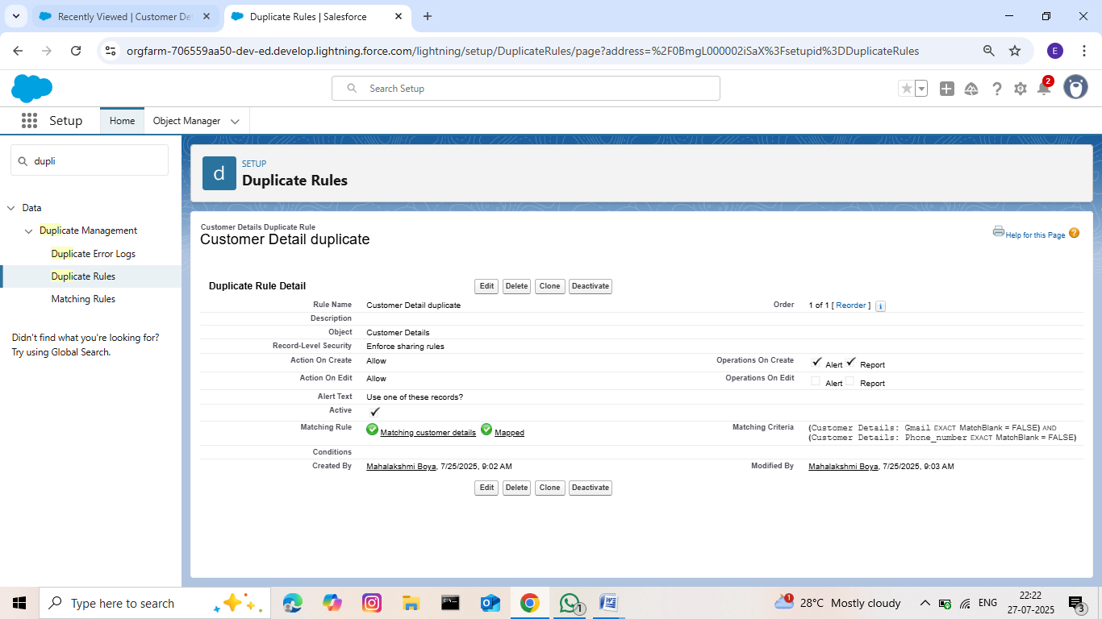

**Fig: Duplicate and Matching Rules for Customer_ Details _c object**

# AUTOMATIONCOMPONENTS

#### Flows:

* Billing amount flow is created to send an email alert. Whenever the payment status in Billing details and feedback record is updated as completed for a particular service records the flow automatically sends an email alert as Thank You for Your Payment

-Garage Management.

* The Update service status flow is designed for a purpose of updating the service status as completed when the quality service check box is selected when editing the service records.

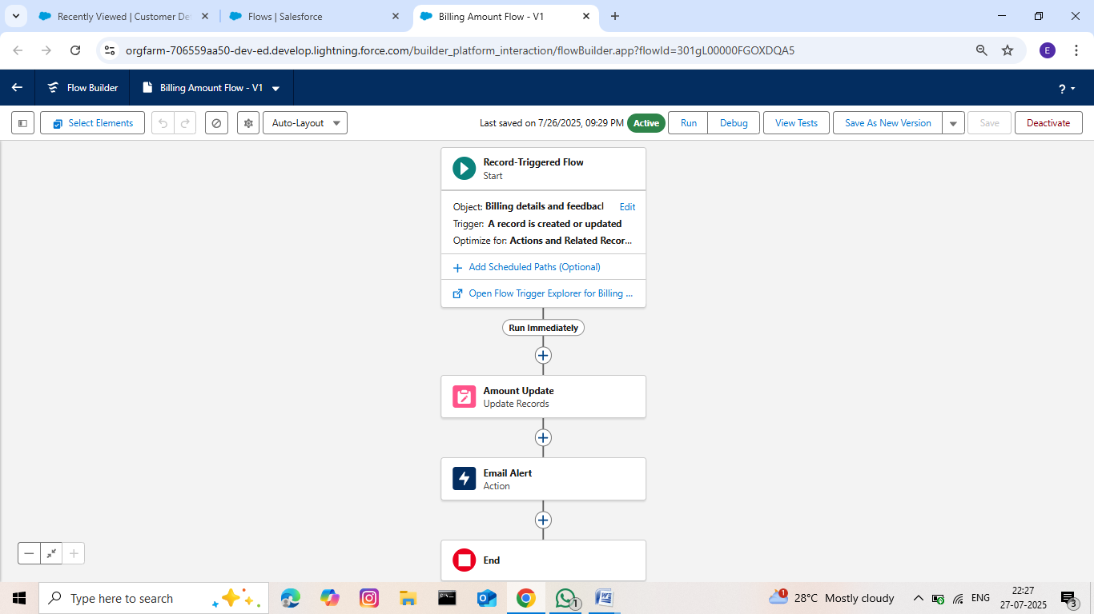

**Fig: Billing Amount Flow**

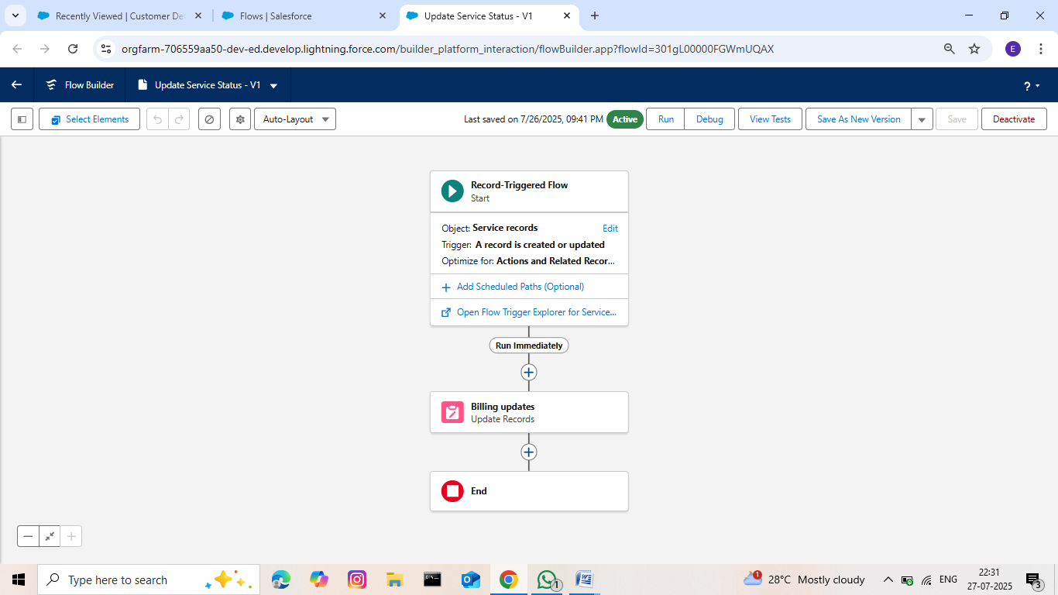

**Fig: Update Service Status Flow**

#### Apex Development:

* Apex Distribution Handler apex code to automatically update the Amount records without entering by manually as per the user selection for the services.

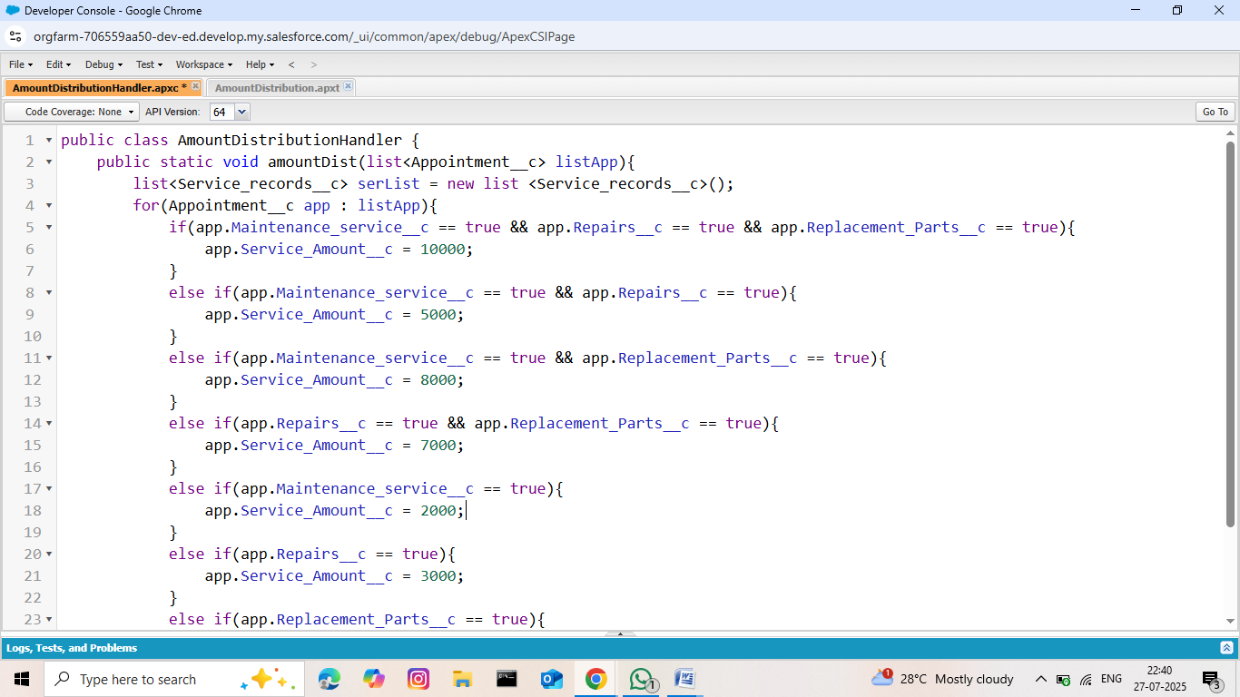

**Fig: Apex Distrubition Handler code**

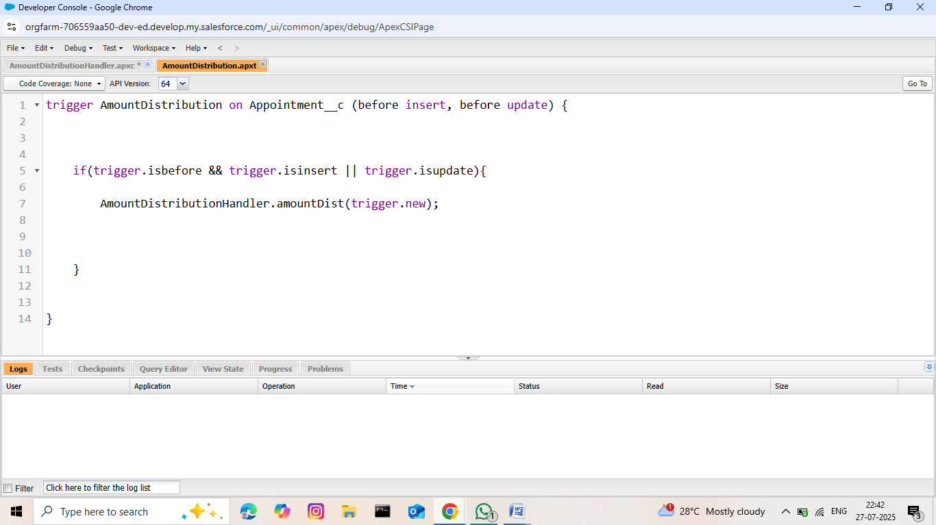

**Fig: Apex Distribution Trigger**

# KEY FEATURES AND FUNCTIONALITIES

The Garage Management System's core functionality suite delivers a comprehensive set of tools designed to revolutionize garage operations management, leveraging Salesforce's robust automation capabilities.

#### Work Order Management (Appointment & Service Records)

The system meticulously manages the life cycle of a service request:

* Appointment Scheduling: Allows customers to book appointments, capturing essential details like customer information, desired service types (Maintenance, Repairs, Replacement Parts), and vehicle number plates. The Appointment Date is a crucial field, ensuring all necessary information is collected upfront.
* Dynamic Service Amount Calculation: Based on the services selected during appointment creation (Maintenance, Repairs, Replacement Parts), an Apex Trigger dynamically calculates and populates the Service Amount field. This ensures accurate upfront estimates.
* Service Execution Tracking: Once an appointment is confirmed, a Service record is created, automatically assigned a unique ser-{000} ID. The Service Status defaults to 'Started'.
* Quality Control Checkpoints: The Quality Check Status checkbox on the Service records object allows technicians to confirm critical quality checks have been performed.
* Automated Status Update: Upon marking Quality Check Status as true, the Service Status automatically updates to 'Completed', providing real-me visibility into service progression.
* Lookup Filter for Service Records: A validation on the Appointment lookup ensures thattheAppointmentDateforaservicerecordislogicallylessthantheServicerecords Created Date, maintaining data integrity.

#### Customer Management

* Centralized Customer Profiles: The Customer Details object acts as a single source of truth for all customer information, including contact details (Phone number, Gmail)and a unique Customer Name.
* Relationship Tracking: All appointments, service records, and billing details are linked back to the Customer Details, providing a comprehensive view of a customer's history with the garage. This enables personalized service delivery and proactive communication.

#### Billing & Feedback

* Automated Billing Integraon: The Billing details and feedback object captures payment information. The Payment Paid field is designed to be populated automatically via a Flow when the Payment Status is 'Completed', drawing the amount from the related Service Amount on the Appointment.
* Payment Status Tracking: A pick list field (Payment Status) allows for clear tracking of billing states ('Pending', 'Completed').
* Customer Feedback Collection: The Rang for service (1-5) field on the Billing details and feedback object provides a direct mechanism for customers to rate their experience, enabling continuous service improvement.

#### Dynamic Service Pricing (Apex)

The Amount Distribution Handler Apex class, triggered before insert and before update on the Appointment _c object, implements the business logic for calculating the Service_ Amount _c based on the selected services:

* Logic:
  + Maintenance, Repairs, and Replacement Parts:$10,000
  + Maintenance and Repairs: $5,000
  + Maintenance and Replacement Parts:$8,000
  + Repairs and Replacement Parts: $7,000
  + Maintenance Service only:$2,000
  + Repairs only: $3,000
  + Replacement Parts only: $5,000

This ensures that the service amount is dynamically calculated and displayed to the customer based on their selections.

#### Automated Email Notifications(Flow)

ARecord-triggeredFlowontheBillingdetailsandfeedbackobjectautomatescustomer communication:

* Trigger: When a Billing details and feedback record is Created or Updated.
* Condition: Executes only when Payment_ Status _c is 'Completed'.
* Action:
  1. Update Records: Sets the Payment _Paid _c field on the Billing details and feedback record to the value of Service_ Amount _c from there lated Appointment _c record.
  2. Email Alert: Sends a personalized "Thank You for Your Payment" email to the customer using their Gmail _c from the Customer Details record. The email includes the customer's name and the Amount paid. This enhances customer experience and provides automated confirmation.

### 9.Fields

* + - * Created "Garage Management Application" Lightning App for accessing all objects, reports and dashboards as follows:

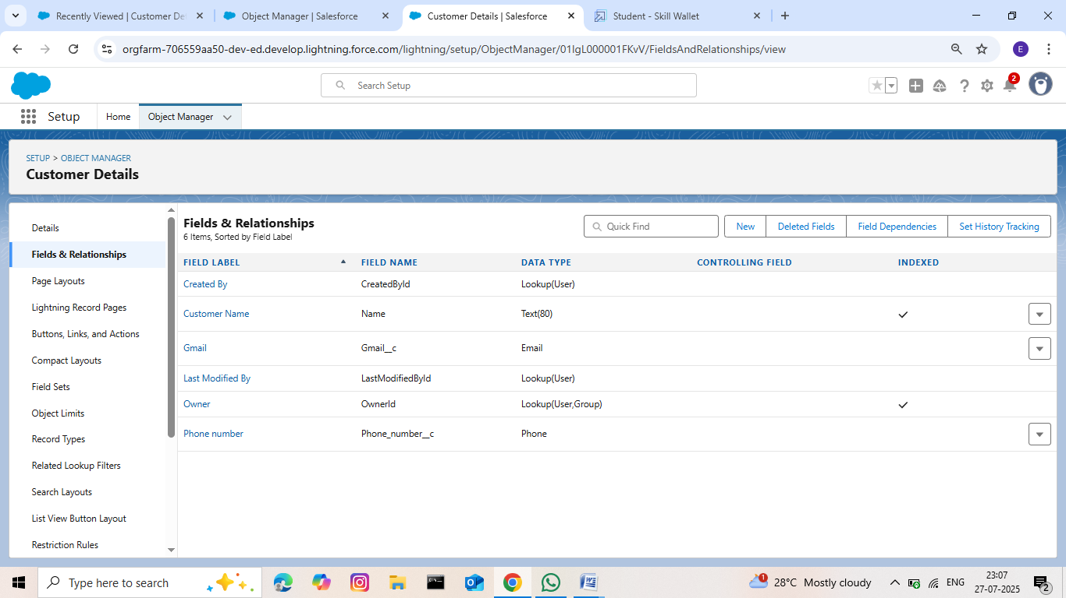

### Fig: Creation of fields for the Customer Details object

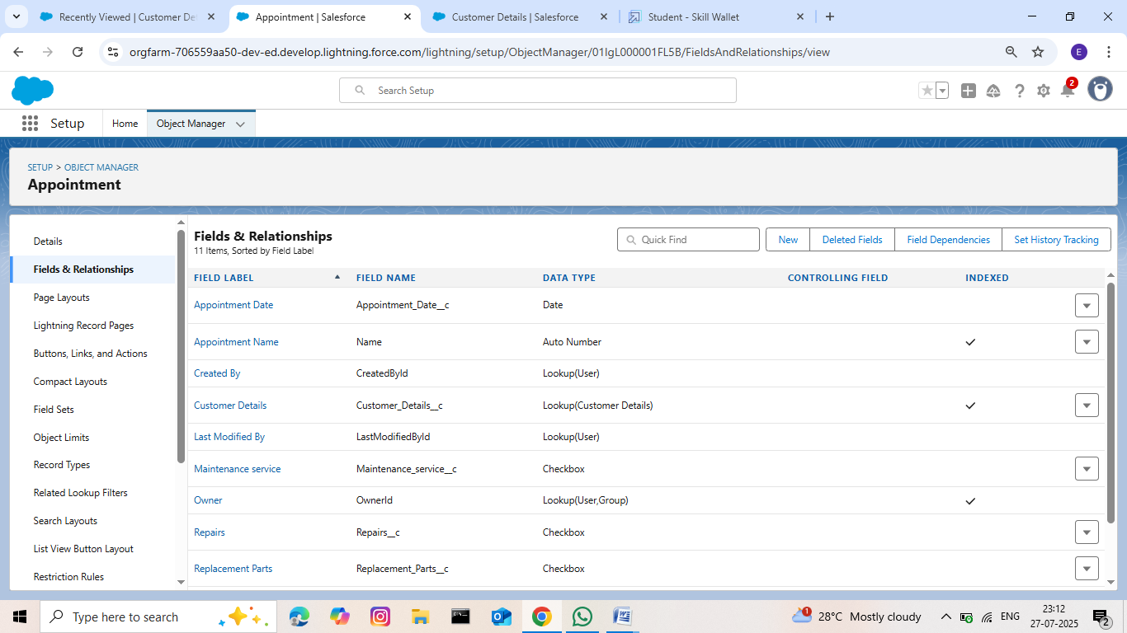

### Fig: Creation of Lookup Fields

#### 9.Reports & Dashboards

##### Reports

The “New service information Report” is created to display the services payments detailssummaryandachartrepresentingtheratiobetweentheratinggivenbycustomerswhile payment and number of payments rated same.

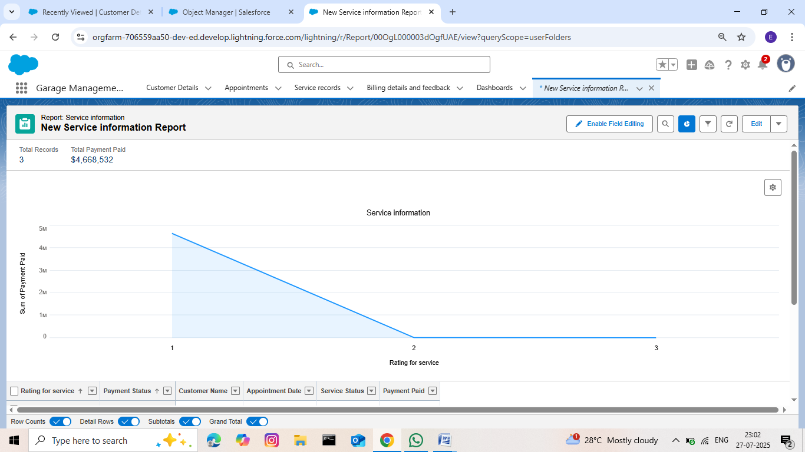

##### Dashboards

The “Customer Review” dashboard is as similar as report without the other data rather than line chart. The line chart of “New service information report” is displayed as a widget in the dashboard.

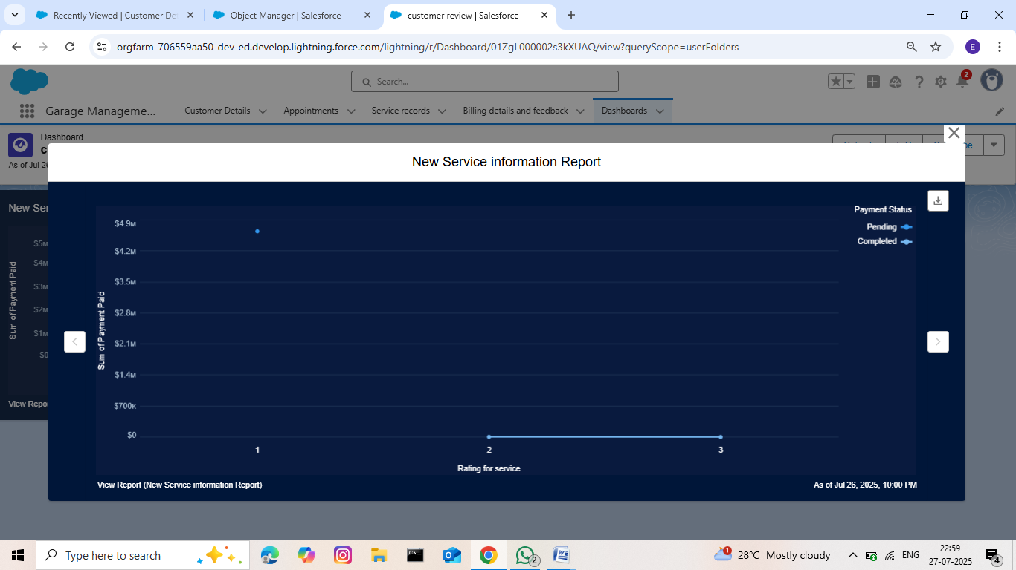

**Fig: Customer Review Dashboard**

# 10.CONCLUSION

The implementation of Garage Management System built on Salesforce provides a powerful, scalable, and efficient platform to streamline all aspects of garage operations — from customer appointment scheduling to vehicle service tracking, inventory control, billing, and customer communication. Leveraging Salesforce’s CRM capabilities, automation tools, and cloud infrastructure, the system enhances operational efficiency, reduces manual errors, and improves customer satisfaction.

With real-time dashboards, integrated workflows, and mobile accessibility, this system empowers garage owners and staff to manage day-to-day tasks more effectively. Furthermore, the flexibility of Salesforce allows for future scalability and integration with third-party services, positioning the garage for digital growth and long-term success in a competitive market.