SIMATS ENGINEERING (SAVEETHA SCHOOL OF ENGINEERING)
Department of Computer Science and Engineering
ASSESSMENT TOOL 1 – EXPERIMENTS
Course Code: | CSA06 | Course Title: | Design and Analysis of Algorithms
CO Assessed: | CO3: Experiments  (BL4, BL5) | Assessment: | Assessment Tool 1 – Experiments
Weightage: | 40% of CIA | Total Marks: | 100 (2 Questions × 50 Marks)
CO3 Statement: | Design Divide and Conquer algorithms for Merge Sort, Quick Sort, Binary Search and Matrix Multiplication
Student Name: | S,MAHALAKSHMI | Reg. No.: | 192524372
Section / Batch: | BTECH AI DS | Date: | 12.08.26
Instructions to Students
- Write algorithm and execute code both experiments.
- Each questions 50 Marks. Total: 100 Marks.
- Follow a well-structured, systematic approach to design and implement an optimal solution.
- Provide insightful analysis with accurate validation, supported by clear documentation including diagrams, code, and results.
Question Type | Description | Questions | Total Marks
Experiments | Design and Code for Divide and Conquer Algorithms: Merge Sort, Quick Sort, Binary Search, and Matrix Multiplication | Q1 – Q2 | 100
SECTION A – Experiments

QUESTION 1:

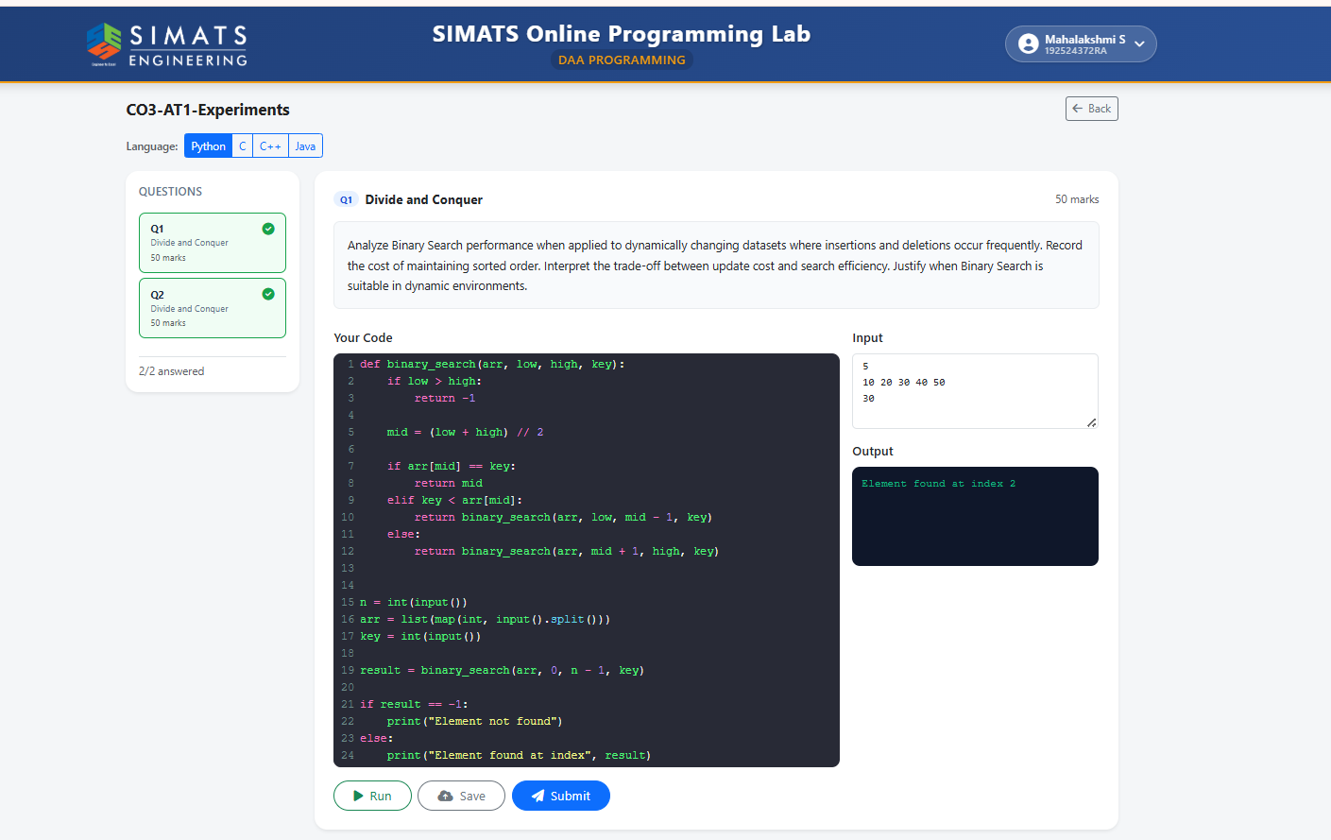

QUESTION 2:

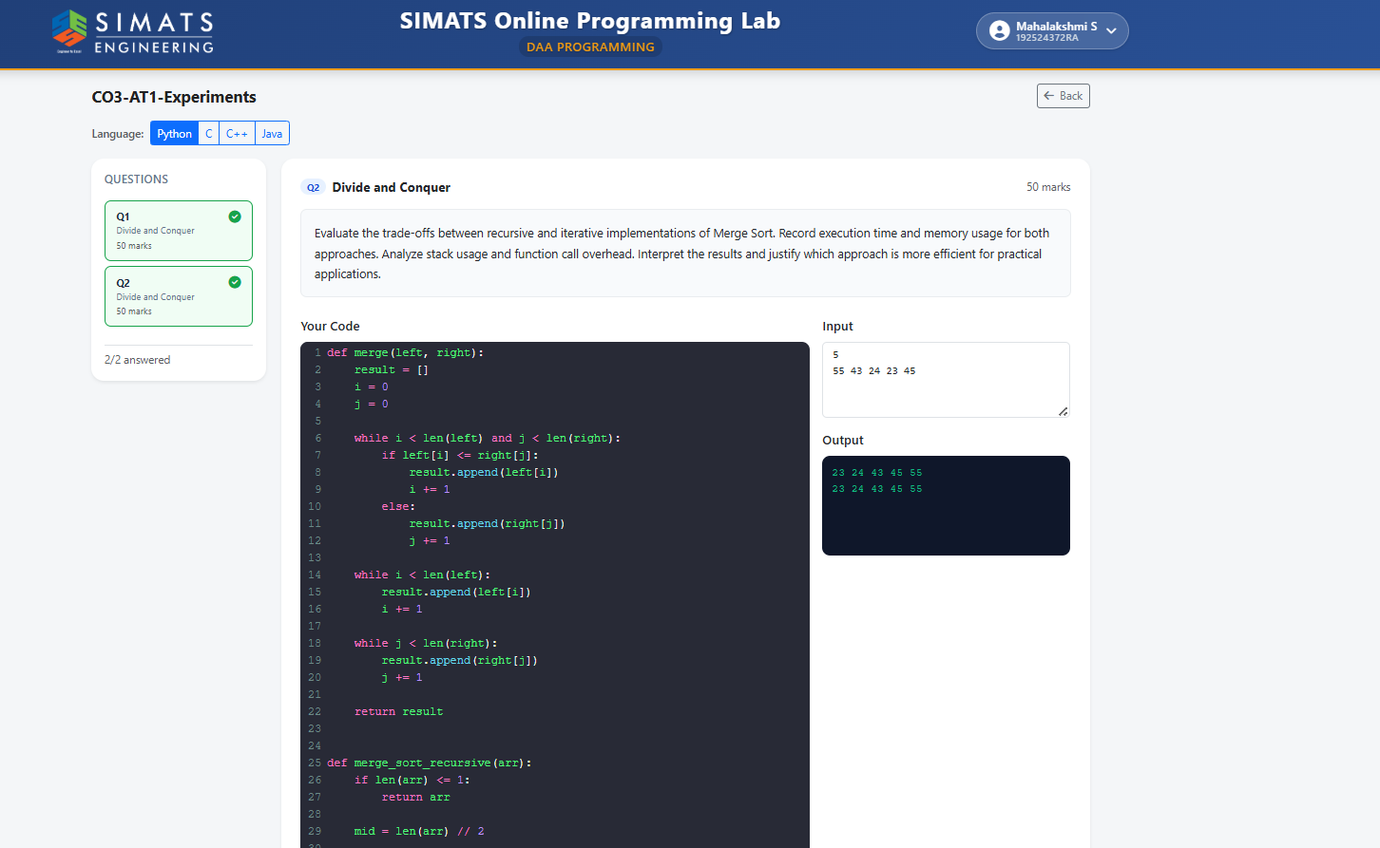

Code of Conduct
I S,MAHALAKSHMI(192524372)________________________ (Name / Reg No) certify that this submission is my original work and that I have adhered to the guidelines specified for this assessment. I understand that any violation of academic integrity rules will result in disciplinary action.
Signature of the Student: S.MAHALAKSHMI_________________________

RUBRICS FOR CALCULATION
Experiments
Criteria | Weightage | Level 4 – Exemplary | Level 3 – Proficient | Level 2 – Developing | Level 1 – Beginning
Understanding of Concepts | 25 | Demonstrates thorough understanding and effectively integrates multiple concepts/technologies | Good understanding with proper integration of most concepts | Basic understanding; limited or partial integration | Poor understanding; unable to integrate concepts
Experimental Design | 30 | Well-planned, systematic implementation with optimal solution | Correct implementation with minor issues | Basic implementation with errors or inefficiencies | Incorrect or incomplete implementation
Use of Tools | 20 | Effective and advanced use of tools/technologies with proper configuration | Appropriate use of tools with correct execution | Limited or inconsistent use of tools | Incorrect or minimal use of tools
Analysis of Results | 15 | Insightful analysis with accurate interpretation and validation of results | Good analysis with reasonable interpretation | Basic analysis with limited insights | Poor or incorrect analysis of results
Documentation | 10 | Clear, well-structured documentation with diagrams, code, and results | Organized documentation with necessary details | Basic documentation with missing details | Poor or incomplete documentation
Marks Evaluation:
Experiments | Understanding of Concepts  (25) | Experimental Design  (30) | Use of Tools  (20) | Analysis of Results  (15) | Documentation  (10) | Total Marks  (Each - 50)
Ex. 1
Ex. 2
Overall Total (100) |  |  |  |  |  | 100 %

Faculty In-charge | Course Coordinator | Head of Department
Name: __________________  Signature: _______________ | Signature: _______________ | Signature: _______________
Date: ___________________ | Date: ___________________ | Date: ___________________

