**EXP NO:** **4**

**Web Form with Servlet to Capture and Display User's Name and Age**

**AIM:**

Create a web form that accepts a user's name and age. Write a Servlet to process the form data and display it back on the browser.

**CODE:**

**Userdetails.html**

<!DOCTYPE html>

<html>

<head>

<meta charset="ISO-8859-1">

<title>Insert title here</title>

</head>

<body>

<form action="./UserValidate">

    <label for="name">User Name</label>

    <input type="text" id="name" name="name" placeholder="Enter Your Name" required><br><br>

    <label for="age">Age</label>

    <input type="number" id="age" name="age" placeholder="Enter Your Age"><br><br>

    <button type="submit">Submit</button>

</form>

</body>

</html>

**UserValidate.Java**

package com.karthick.servlet;

import java.io.IOException;

import java.io.PrintWriter;

import javax.servlet.ServletException;

import javax.servlet.annotation.WebServlet;

import javax.servlet.http.HttpServlet;

import javax.servlet.http.HttpServletRequest;

import javax.servlet.http.HttpServletResponse;

/**

 * Servlet implementation class UserValidate

 */

@WebServlet("/UserValidate")

public class UserValidate extends HttpServlet {

    private static final long serialVersionUID = 1L;

    /**

     * @see HttpServlet#HttpServlet()

     */

    public UserValidate() {

        super();

        // TODO Auto-generated constructor stub

    }

    /**

     * @see HttpServlet#doGet(HttpServletRequest request, HttpServletResponse response)

     */

    protected void doGet(HttpServletRequest request, HttpServletResponse response) throws ServletException, IOException {

        String user=request.getParameter("name");

        int age=Integer.parseInt(request.getParameter("age"));

        PrintWriter pw=response.getWriter();

        pw.println("User Name: "+ user);

        pw.println("Age: "+ age);

    }

}

**OUTPUT**:

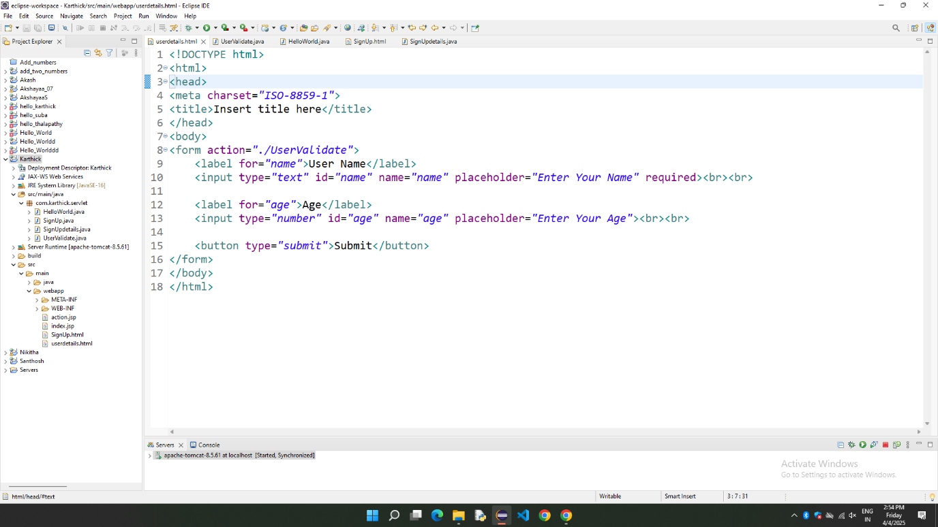

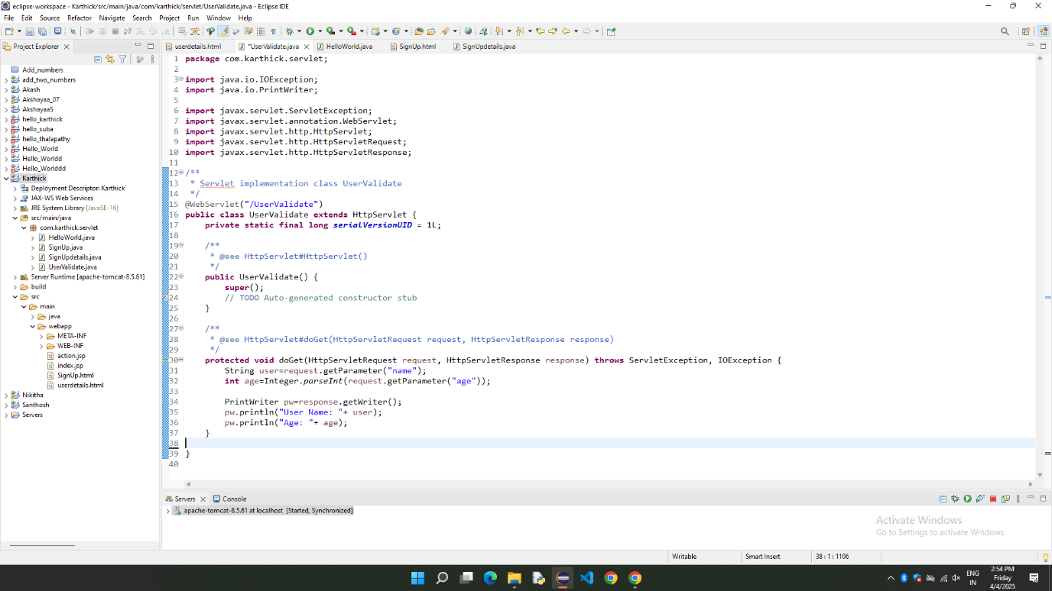

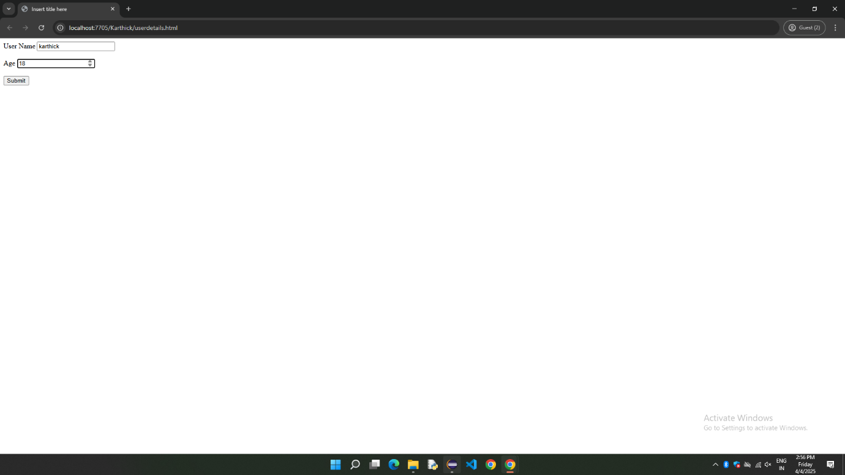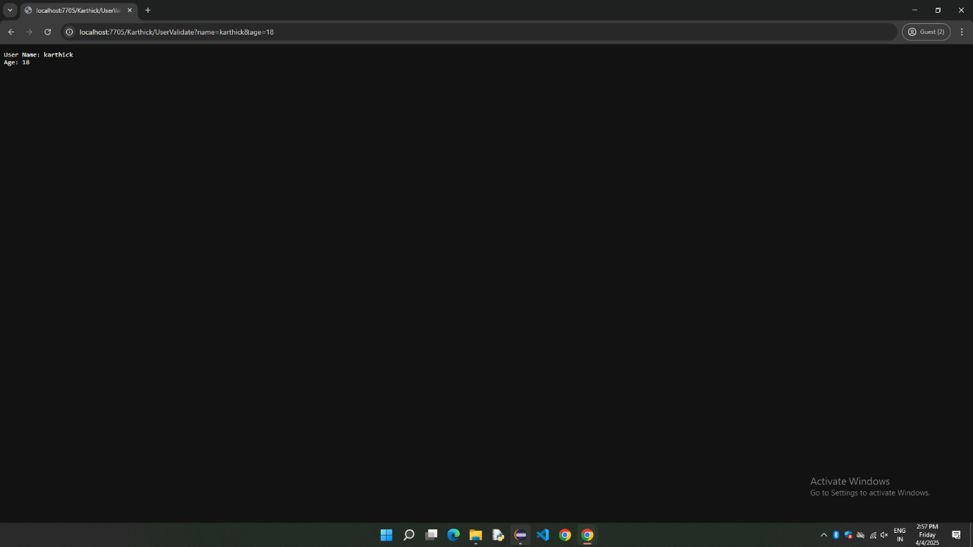

**RESULT:**

Thus, the web form is Implemented Successfully using html and Servlet.