**Learning and Assignment of IP address manually to computers**

EXP NO: 2

DATE: 15/7/25

**AIM:**

To understand what an ip addresss is and learn how to manually assign a static IP address to a computer

**PROCEDURE:**

Step 1: Open Network Settings

Right-click on Network icon in taskbar → Click Open Network Internet Settings;

Step 2: Open Adapter Settings

Click on Change adapter options;

Right-click on Ethernet (or Wi-Fi) → Click Properties

Step 3: Choose Internet Protocol

Select Internet Protocol Version 4 (TCP/IPv4)

Click on Properties;

Step 4: Assign IP Address

Select Use the following IP address

Enter the following:

IP Address: 192.168.1.10 (example)

Subnet Mask: 255.255.255.0

Default Gateway: 192.168.1.1 (optional for internet)

Click OK

Step 5: Test the Connection

Open Command Prompt → Type:

ipconfig

→ To check your IP address.

Then try:

ping 192.168.1.11

→ To check connection between two manually assigned computers.

**OUTPUT:**

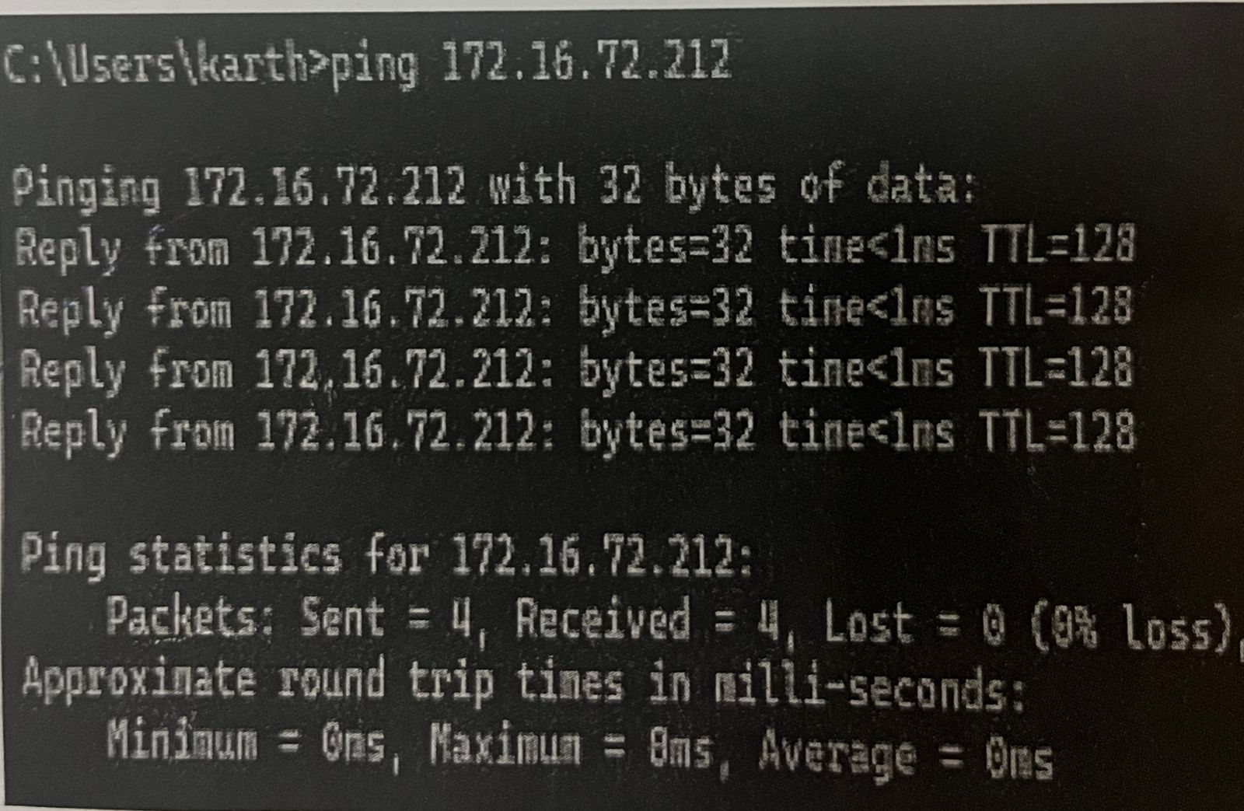

**RESULT:**

Hence Learned and assigned a static IP address to a computer in a local network successfully.