**Study of different types of network cables and crimping with RJ45 connector**

EXP NO: 3

DATE: 15/7/25

**AIM:**

To study different types of network cables using an RJ45 connector.

**APPARATUS REQUIRED:**

RJ45 connectors (male plug)

Twisted Pair cable (Cat5e or Cat6)

Crimping tool

LAN tester (optional for testing)

Scissors

**PROCEDURE:**

Step 1: Strip the Cable

Use the cable stripper to remove about 1 inch (2.5 cm) of the outer jacket of the

cable.

You will see 4 pairs of twisted wires (8 wires total).

Step 2: Untwist and Arrange

Untwist the wire pairs.

Arrange them in the correct order (T568B or T568A).

Step 3: Trim the Wires

Once arranged in order, trim the wires to make them even using scissors (about 1.5

cm in length).

Step 4: Insert into RJ45

Carefully push the wires into the RJ45 connector, making sure each wire goes into

the correct pin slot.

The copper tips must touch the metal pins inside the connector.

Step 5: Crimp

Insert the RJ45 into the crimping tool and press tightly to fix the wires inside the

connector.

Step 6: Test (Optional)

Use a LAN cable tester to check if the connection is correct.

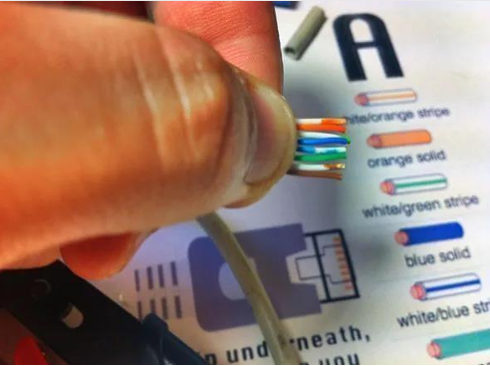**OUTPUT:**

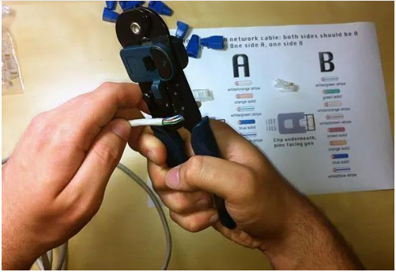 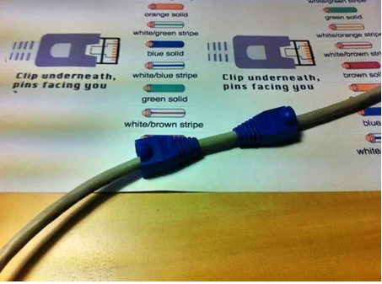

**RESULT:**

Successfully studied various types of network cables and created a network cable using RJ45

connector through proper crimping.