**Implement packet sniffing using raw sockets in python**

EXP NO: 4

DATE: 25/7/25

**AIM:**

To implement packet sniffing using raw sockets in python.

**PROCEDURE:**

Step 1: Install Scapy

Open your terminal or VSCode and run:

> pip install scapy

Scapy is a powerful Python library used for packet sniffing and analysis.

Step 2: Install Npcap (Packet Capture Driver)

1. Visit the official download page:

https://npcap.com/#download

2. Download and run the Npcap Windows installer.

3. During installation, make sure to check the following options:

- "Install Npcap in WinPcap API-compatible Mode" (Required for Scapy support)

- (Optional) "Support raw 802.11 traffic (and monitor mode)"

These options are critical to allow packet sniffing at the Ethernet (Layer 2) level on Windows.

4. After installation, restart your computer to ensure Npcap is properly loaded.

Step 3: Run the Python Code

**CODE:**

Save the following code to a file like sniffer.py and run it using VSCode (as Administrator):

from scapy.all import sniff, Ether

def packet_callback(packet):

if Ether in packet:

ether = packet[Ether]

print(f"Source MAC: {ether.src}")

print(f"Destination MAC: {ether.dst}")

print(f"Payload (first 100 hex chars): {bytes(packet.payload).hex()[:100]}")

print("-" * 60)

print("Listening for a packet... (Press Ctrl+C to stop)")

sniff(prn=packet_callback, count=1)

**OUTPUT:**

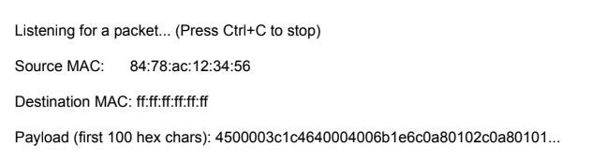

**RESULT:**

Thus the packet sniffing using raw sockets in python has been implemented successfully.