**Develop a customized ping command to test the server connectivity**

EXP NO: 5

DATE: 1/8/25

**AIM:**

To develop a customized ping command to test the server connectivity.

**PROCEDURE:**

**Step 1:** Install the required package using  
pip install ping3

**Step 2:** Import the library  
from ping3 import ping

**Step 3:** Take hostname input from the user  
host = input("Enter hostname (e.g., google.com): ")

**Step 4:** Send multiple ping requests using a loop and check for replies

* If response time is received → print success message
* If no response → print “Request timed out”

**Step 5:** Display final connection status showing number of successful replies

**CODE:**

Step1: use   
pip install ping3 and download the package   
Step2: Write the Code  
from ping3 import ping  
  
host = input("Enter hostname (e.g., google.com): ")  
count = 4  
success_count = 0  
  
print(f"\nPinging {host} {count} times...\n")  
  
for i in range(count):  
    delay = ping(host, timeout=2)  
    if delay is None:  
        print(f"Ping {i+1}: Request timed out.")  
    else:  
        print(f"Ping {i+1}: Reply from {host} - time={delay*1000:.2f} ms")  
        success_count += 1  
  
if success_count > 0:  
    print(f"\n✅ Connection Established with {host}. {success_count}/{count} replies received.")  
else:  
    print(f"\n❌ Connection Failed. No reply from {host}.")

**OUTPUT:**

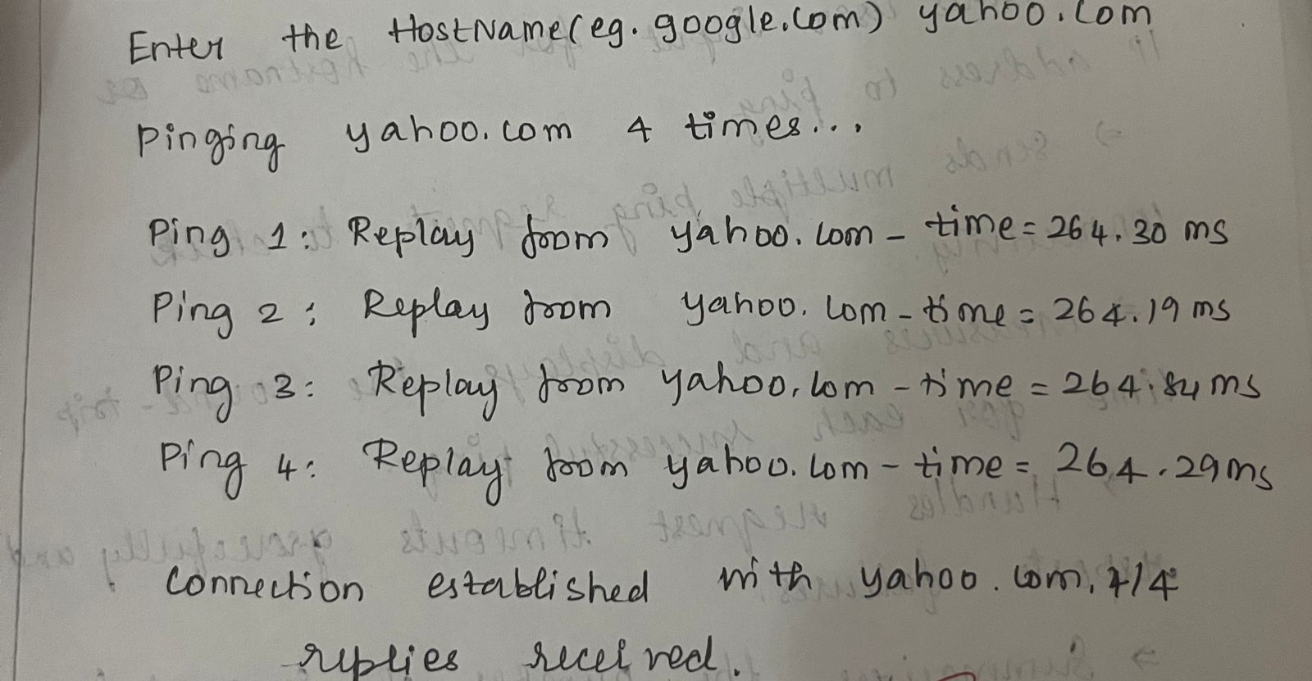

**RESULT:**

The customized ping command to test the server connectivity is developed successfully.