**Design a simple topology and configure with one router,two switches and Pcs using CISCO Packet Tracer**

EXP NO: 6

DATE: 8/8/25

**AIM:**

To design a simple topology using Cisco packet Tracer.

**PROCEDURE:**

**Step 1:** Open **Cisco Packet Tracer** and drag one **Router**, two **Switches**, and multiple **PCs** onto the workspace.

**Step 2:** Connect devices using appropriate cables —

* PCs to Switches (Straight-through cable)
* Switches to Router (Cross-over cable).

**Step 3:** Assign **IP addresses** to all PCs in the same network and configure **interfaces** on the Router using the **CLI** (Command Line Interface).

**Step 4:** Enable interfaces using commands:

Router> enable

Router# configure terminal

Router(config)# interface fastethernet 0/0

Router(config-if)# ip address <IP> <SubnetMask>

Router(config-if)# no shutdown

**Step 5:** Test connectivity between PCs using the **ping command** to verify successful communication.

**OUTPUT:**

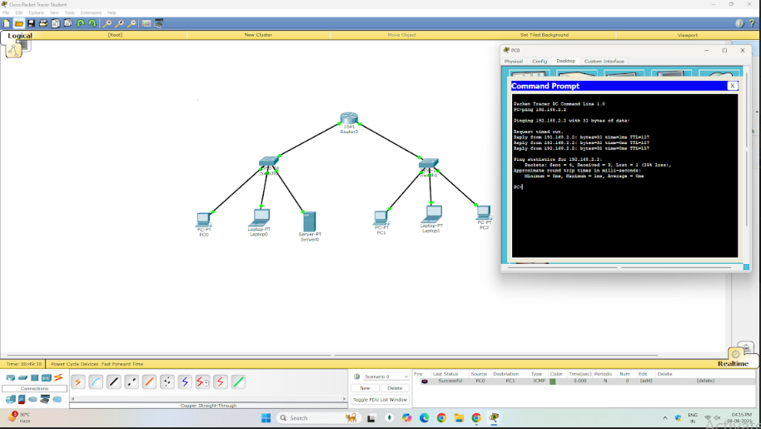

**RESULT:**

All PCs can communicate through the router, confirming the network topology is working.