**Develop a Simple Calculator Using XMLRPC**

EXP NO: 7

DATE: 19/9/25

**AIM:**

To develop a simple calculator using XMLRPC

**PROCEDURE:**

**Step 1:** Install the library (if needed)

pip install xmlrpc

**Step 2:** Create a **server program** that defines calculator functions (add, subtract, multiply, divide).

**Step 3:** Start the XML-RPC server and register these functions.

**Step 4:** Create a **client program** that connects to the server and calls these remote functions.

**Step 5:** Run the server first, then the client, and view the calculation results.

**CODE:**

Server code:  
from xmlrpc.server import SimpleXMLRPCServer

# Step 1: Create server

server = SimpleXMLRPCServer(("localhost", 8000))

print("XML-RPC Server is running on port 8000...")

# Step 2: Define calculator functions

def add(x, y): return x + y

def sub(x, y): return x - y

def mul(x, y): return x * y

def div(x, y):

if y == 0:

return "Division by zero error"

return x / y

# Step 3: Register functions

server.register_function(add, "add")

server.register_function(sub, "sub")

server.register_function(mul, "mul")

server.register_function(div, "div")

# Step 4: Run the server forever

server.serve_forever()

Client code:

import xmlrpc.client

# Step 1: Connect to server

proxy = xmlrpc.client.ServerProxy("http://localhost:8000/")

# Step 2: Call remote functions

a, b = 10, 5

print("Addition:", proxy.add(a, b))

print("Subtraction:", proxy.sub(a, b))

print("Multiplication:", proxy.mul(a, b))

print("Division:", proxy.div(a, b))

**OUTPUT:**

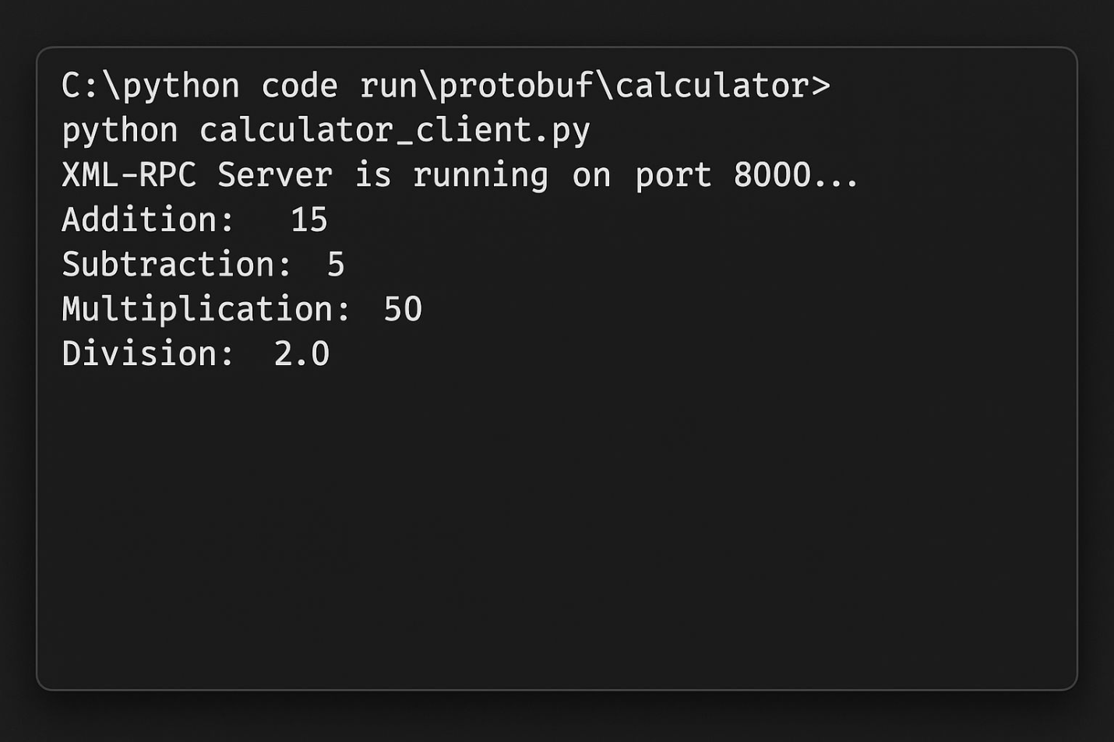

**RESULT:**

Thus to implement a simple calculator using XMLRPC in python has been executed and verified successfully.