EXPENSE TRACKER
A MINI-PROJECT REPORT
Submitted by
MAHALAXMI VPK 241901052
NAKSHATRA PA 241901062
in partial fulfillment of the award of the degree
of
BACHELOR OF ENGINEERING
IN
COMPUTER SCIENCE AND ENGINEERING
(CYBER SECURITY)

RAJALAKSHMI ENGINEERING COLLEGE, CHENNAI
AN AUTONOMOUS INSTITUTE
November 2025
BONAFIDE CERTIFICATE

Certified that this project “EXPENSE TRACKER” is the bonafide work of “MAHALAXMI VPK (Reg.no 241901052) AND NAKSHATRA PA (Reg no 241901062)” who carried out the project work under my supervision.

SIGNATURE
Ms. R RUPMALA
ASSISTANT PROFESSOR
Department of Computer Science and Engineering, Cyber Security
Rajalakshmi Engineering College
Chennai

This mini project report is submitted for the viva voce examination to be held on __________

INTERNAL EXAMINER EXTERNAL EXAMINER

DECLARATION

We hereby declare that the mini project report Expense Tracker, submitted as part of the curriculum requirements for the Bachelor of Engineering (B.E) degree affiliated to Anna University, is a bonafide work carried out by us under the supervision of Ms. R. Rupmala, Assistant Professor, Department of Computer Science Engineering and Cyber Security, Rajalakshmi Engineering College, Chennai.
This submission represents our ideas in our own words, and where ideas or words of others have been included, we have adequately and accurately cited and referenced the original sources.
We also declare that we have adhered to the ethics of academic honesty and integrity and have not misrepresented or fabricated any data, idea, fact, or source in our submission. We understand that any violation of the above will be grounds for disciplinary action by the institute and/or the University and may also evoke penal action from the sources which have not been properly cited or from whom proper permission has not been obtained. This report has not previously formed the basis for the award of any degree, diploma, or similar title of any other University.

Rajalakshmi Engineering College, MAHALAXMI VPK
Chennai NAKSHATRA PA
November 2025

ABSTRACT

This project presents the development of a Gamified Expense Tracker application built with JavaFX for the user interface and MySQL as the backend database. The main objective of the system is to make managing personal finances more engaging and motivating by incorporating gamification elements. Instead of treating budgeting as a routine task, users interact with a goal-driven experience powered by a Consistent Hybrid Levelling System.
In this system, users can level up only when they meet two key conditions: regular usage (based on the number of transactions logged) and financial progress (measured through earned points). This dual-criteria approach encourages both consistent tracking and responsible spending habits.
On the technical side, the application features a well-structured relational database with strong integrity constraints to ensure accurate and reliable data handling. Java Database Connectivity (JDBC) is used to seamlessly manage user information and store detailed transaction histories.
Overall, this project demonstrates how core DBMS concepts can be combined with modern interface design and gamification techniques to create a practical and user-friendly desktop finance tool.
.
Keywords: JavaFX, MySQL, JDBC, Expense tracker, Consistent Hybrid Levelling System

i
ACKNOWLEDGEMENT
We express our sincere thanks to our beloved and honourable chairman MR. S. MEGANATHAN and the chairperson DR. M. THANGAM MEGANATHAN for their timely support and encouragement.
We are greatly indebted to our respected and honourable principal
Dr. S.N. MURUGESAN for his able support and guidance.
No words of gratitude will suffice for the unquestioning support extended to us by our Head of the Department Mr. BENEDICT J N and our Deputy Head of the Department
Dr. V. BALASUBRAMANIAN for being ever supporting force during our project work
We also extend our sincere and hearty thanks to our internal guide
Ms. R RUPMALA, for her valuable guidance and motivation during the completion of this project.
Our sincere thanks to our family members, friends and other staff members of computer science engineering.

1. MAHALAXMI VPK
2. NAKSHATRA PA

ii
TABLE OF CONTENTS
CHAPTER NO. | TITLE | PAGE NO
 | ABSTRACT | i
 | ACKNOWLEDGEMENT | ii
 | LIST OF FIGURES | iii
1 | INTRODUCTION | 1
1.1 | Project objectives | 1
1.2 | Scope | 1
2 | LITERATURE REVIEW | 2
2.1 | Three-Tier Architecture | 2
2.2 | Gamification in Financial Technology (Fin Tech) | 2
3 | SYSTEM DESIGN | 3
3.1 | ER Diagram | 3
3.2 | Database Schema Design | 3
4 | IMPLEMENTATION | 5
4.1 | Code | 6
4.2 | Results and Discussions | 11
5 | DEVELOPMENT CYCLE | 15
5.1 | Development Cycle | 15
5.2 | System and Technical Requirements | 17
6 | FUNCTIONAL OVERVIEW | 18
7 | CONCLUSION | 19
8 | REFERENCES | 20

LIST OF FIGURES

FIGURE NO | TITLE | PAGE NO
3.1 | ER Diagram | 3
3.2 | Users | 4
3.3 | Transactions | 4
4.1 | Login Page | 11
4.2 | Terms | 11
4.3 | Creating new account | 12
4.4 | Main Page | 12
4.5 | New Transactions | 13
4.6 | Level Up | 13
4.7 | All your transactions | 13
4.8 | Level 5 | 14
4.9 | Dark Mode | 14

iii
CHAPTER-1
INTRODUCTION

The management of personal finances often suffers from low user engagement due to its repetitive and non-rewarding nature. This mini-project addresses this challenge by applying gamification-the use of game elements in non-game contexts-to create a motivational and analytically useful tool.
1.1 Project Objectives
- Design and Implement a Functional RDBMS: Create a normalized MySQL database schema capable of reliably storing user accounts, financial balances, transaction history, and granular transaction details, specifically categorization.
- Establish Secure Persistence: Utilize Java Database Connectivity (JDBC) and Prepared Statement to ensure robust, type-safe communication between the Java client and the MySQL server for all data operations.
- Develop a Hybrid Gamification Model: Implement a unique levelling system that rewards both transaction consistency and financial value, ensuring a sustained incentive for the user.
- Enhance User Experience (UX) and Analysis (New): Provide visual feedback, theme options (Dark Mode), clear alerts, and integrate instant analytical reporting (Monthly Summary) for improved financial oversight.
1.2 Scope
The project scope is limited to a single-user desktop application focusing on core expense and income tracking. The initial feature set has been expanded to include Transaction Categorization and aggregate Monthly Summary Reporting. The primary emphasis of this report is on the System Design and Implementation of the DBMS component, which forms the persistent backbone of the application's gamification state and analytical capabilities.

CHAPTER-2
LITERATURE REVIEW
2.1 Three-Tier Architecture
This application follows a classic Three-Tier Architecture model, with roles slightly expanded to include new analytical responsibilities:
- Presentation Tier (Client): Implemented using JavaFX, responsible for the GUI, user interaction, and collecting detailed input (e.g., transaction category).
- Logic Tier (Application Server Logic): Handled within the Java application's methods (e.g., handleIncome, updateLevel, loadMonthlySummary). This tier manages business rules, such as points calculation, level requirements, debt management logic (Pending Balance), and executes analytical queries to generate the Monthly Summary.
- Data Tier (Database Server): Implemented using MySQL. This tier ensures data integrity, manages concurrency (though single-user in this scope), and provides persistent storage for all application state, including the granular category data.
The connection between the Logic Tier (Java) and the Data Tier (MySQL) is established via JDBC, highlighting the critical role of database drivers and Structured Query Language (SQL) in retrieving both transactional data and aggregate analytical reports.
2.2 Gamification in Financial Technology (FinTech)
Gamification in FinTech leverages principles like Feedback, Rewards, and Status to motivate behavioural change. The Consistent Hybrid Levelling Model is used here to encourage balanced behaviour by requiring both Frequency (incomeCount) and Value (points) for advancement, addressing a key weakness in single-metric gamification systems. The application of these principles is reinforced by the new analytical features, which provide clearer, categorized insight into the user's progress toward financial health.

CHAPTER-3
SYSTEM DESIGN
The Data Tier utilizes a relational model implemented in MySQL. The design is based on two tables: users and transactions, linked by a One-to-Many relationship where users (username) is the primary key and transactions(username) is the foreign key.
3.1 Final Entity-Relationship (E-R) Overview
The schema is in the Third Normal Form (3NF), minimizing redundancy by separating user metadata from repetitive transaction records.
Fig:3.1 ER Diagram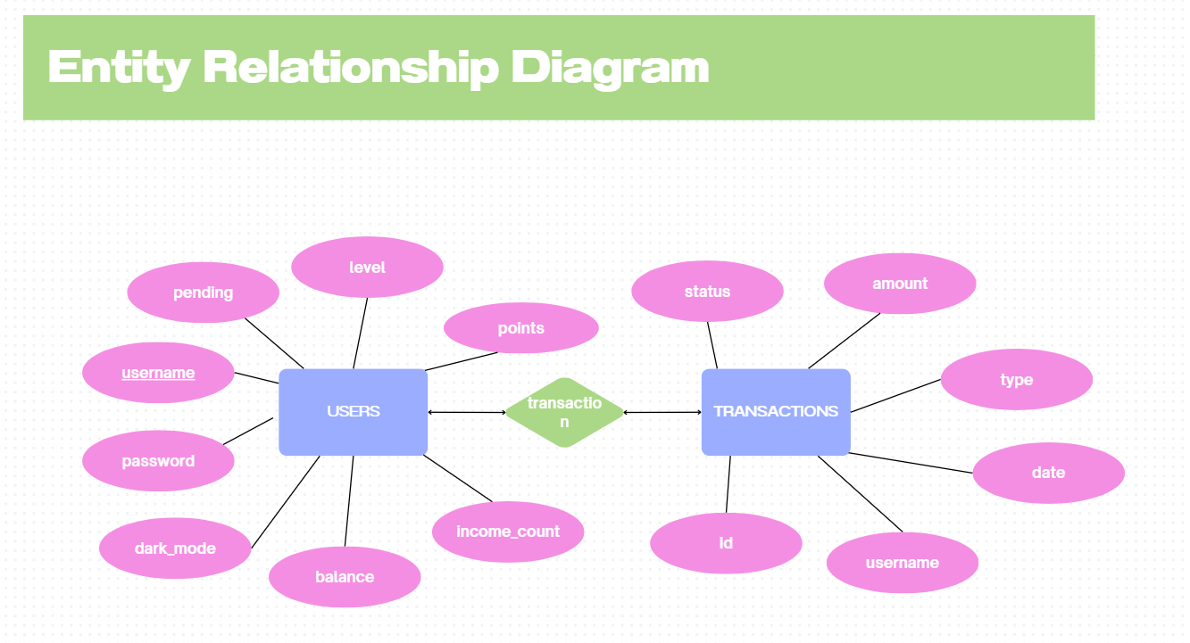
category
3.2 Database Schema Design
The schema is detailed below, including the critical additions of balance and points to support the application's core functionality.

Fig:3.2 USERS
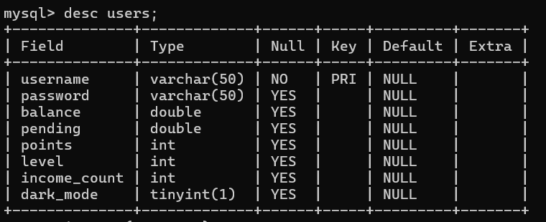

Fig:3.3 TRANSACTIONS
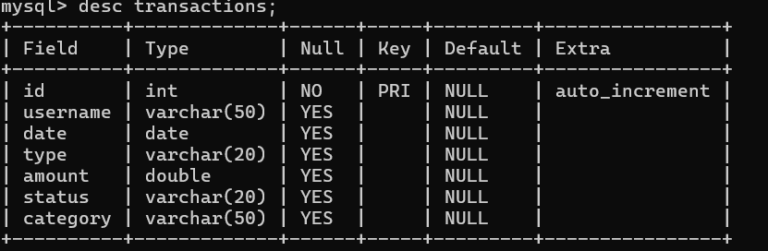

CHAPTER-4
IMPLEMENTATION
The implementation focuses on the critical application logic that governs user state and gamification feedback, primarily handled by the Java application layer interacting with MySQL via JDBC.
Key Java Implementation Logic
The application layer manages the flow of data between the GUI and the persistent MySQL database. When a transaction is submitted, an atomic SQL operation is performed to ensure data integrity. The core logic involves a sequence: reading the current state (balance, points, income count) from the users table, calculating the new state based on the transaction, and executing a single SQL UPDATE statement via the saveUser() method. This centralized saveUser() method is responsible for setting the new values for all key user state columns (balance, pending, points, level, income_count, dark_mode) in one robust action. Importantly, all database interactions rely on PreparedStatement objects, which is a mandatory DBMS security practice to prevent SQL injection and enhance query execution speed. On a new user's first login, a mandatory form prompts for the initial bank/cash balance, which seeds the balance column in the users table, establishing the financial starting point.
Gamification Engine Logic
The gamification engine's logic is designed around the Consistent Hybrid Leveling System and tiered rewards. The points system ensures that every income contributes to the Value Requirement. For instance, base income grants 20 points, while high-value deposits (e.g., ₹50,000) award 100 points, promoting high-value savings. Concurrently, the Frequency Requirement tracks progress via the income_count column, which is advanced by 1 to 4 points depending on the deposit value, encouraging transaction consistency. This integrated logic ensures that every action a user takes provides immediate, measurable feedback, which is crucial for forming consistent habits, especially when debt management is involved. When a user successfully clears their Pending Balance, a "BACK ON TRACK!" alert serves as powerful positive reinforcement, linking achievement directly to financial health.

4.1 Code:
void connectDB() {
try {
con = DriverManager.getConnection( "jdbc:mysql://localhost:3306/expensedb", "root",
"maha2029" );
} catch (Exception ex) {
ex.printStackTrace();}}
void registerUser(String username, String password, double initialBalance) {
try {
PreparedStatement ps = con.prepareStatement( "INSERT INTO users VALUES(?,?,?,?,?,?,?,?)" );
ps.setString(1, username);
ps.setString(2, password);
ps.setDouble(3, initialBalance);
ps.setDouble(4, 0);
ps.setInt(5, 0);
ps.setInt(6, 1);
ps.setInt(7, 0);
ps.setBoolean(8, false);
ps.executeUpdate();
System.out.println("User registered successfully!");
} catch (SQLException e) {
System.out.println("Username already exists or DB error.");
}
}
boolean loginUser(String username, String password) {
try {
PreparedStatement ps = con.prepareStatement(
"SELECT * FROM users WHERE username=? AND password=?"
);
ps.setString(1, username);
ps.setString(2, password);
ResultSet rs = ps.executeQuery();

if (rs.next()) {
currentUser = rs.getString("username");
currentBalance = rs.getDouble("balance");
pendingBalance = rs.getDouble("pending");
points = rs.getInt("points");
level = rs.getInt("level");
incomeCount = rs.getInt("income_count");
System.out.println("Login successful!");
return true;
} else {
System.out.println("Invalid login credentials.");
}
} catch (Exception e) {
e.printStackTrace();
}
return false;
}
void recordTransaction(String type, double amount, String status, String category) {
try {
PreparedStatement ps = con.prepareStatement(
"INSERT INTO transactions(username, date, type, amount, status, category) VALUES(?,?,?,?,?,?)"
);
ps.setString(1, currentUser);
ps.setDate(2, Date.valueOf(LocalDate.now()));
ps.setString(3, type);
ps.setDouble(4, amount);
ps.setString(5, status);
ps.setString(6, category);
ps.executeUpdate();
System.out.println("Transaction recorded successfully.");
} catch (Exception e) {
e.printStackTrace();
}
}
void saveUser() {
try {
PreparedStatement ps = con.prepareStatement(
"UPDATE users SET balance=?, pending=?, points=?, level=?, income_count=?, dark_mode=? WHERE username=?"
);
ps.setDouble(1, currentBalance);
ps.setDouble(2, pendingBalance);
ps.setInt(3, points);
ps.setInt(4, level);
ps.setInt(5, incomeCount);
ps.setBoolean(6, isDarkModeEnabled);
ps.setString(7, currentUser);
ps.executeUpdate();
System.out.println("User data updated.");
} catch (Exception e) {
e.printStackTrace();
}
}
void loadMonthlySummary() {
double totalIncome = 0, totalExpense = 0;
LocalDate today = LocalDate.now();
YearMonth currentMonth = YearMonth.from(today);
try {
PreparedStatement ps = con.prepareStatement(
"SELECT type, SUM(amount) FROM transactions WHERE username=? AND date BETWEEN ? AND ? GROUP BY type"
);
ps.setString(1, currentUser);
ps.setDate(2, Date.valueOf(currentMonth.atDay(1)));
ps.setDate(3, Date.valueOf(currentMonth.atEndOfMonth()));
ResultSet rs = ps.executeQuery();
while (rs.next()) {
String type = rs.getString(1);
double sum = rs.getDouble(2);
if ("Income".equals(type)) totalIncome = sum;
else if ("Expense".equals(type)) totalExpense = sum;
}
System.out.println("Monthly Income: ₹" + totalIncome);
System.out.println("Monthly Expense: ₹" + totalExpense);
} catch (Exception e) {
e.printStackTrace();}}
void loadTransactions() {
try {
PreparedStatement ps = con.prepareStatement(
"SELECT date, type, amount, status, category FROM transactions WHERE username=? ORDER BY id DESC");
ps.setString(1, currentUser);
ResultSet rs = ps.executeQuery();
while (rs.next()) {
System.out.println(rs.getDate(1) + " | " + rs.getString(2) + " | " + rs.getDouble(3) + " |" + rs.getString(4) + " | " +rs.getString(5))}}
catch (Exception e) {e.printStackTrace(); } }
4.2 Results and Discussions
Fig:4.1 Login Page:
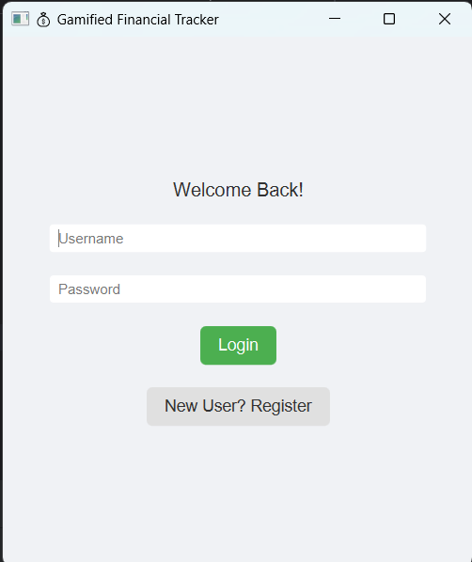Fig:4.2 Terms and Conditions:
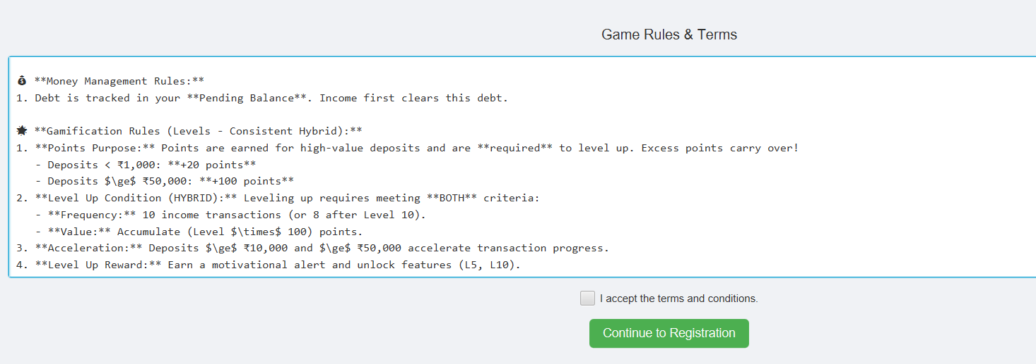
Fig:4.3 Creating new account: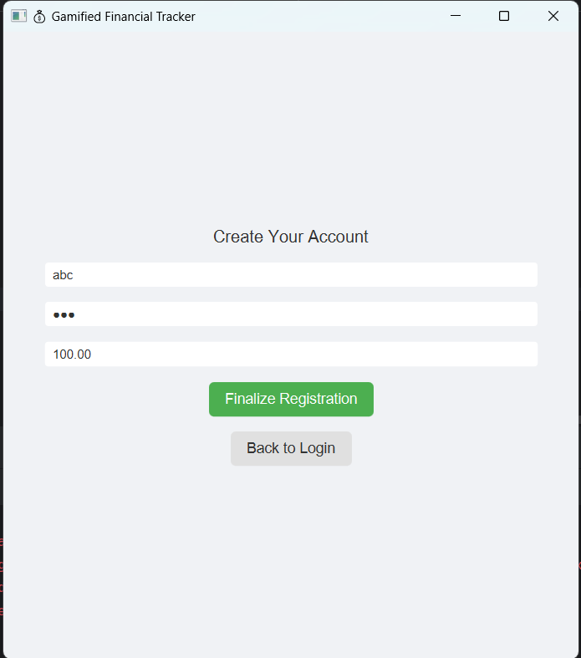
Fig:4.4 Main Page: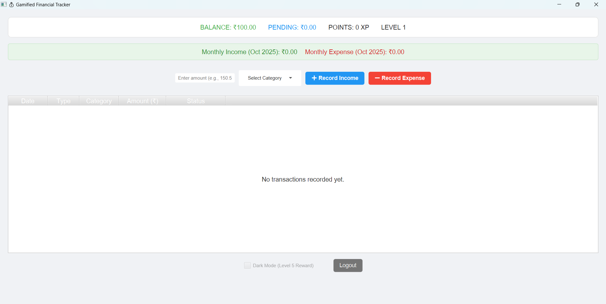

Fig:4.5 New Transaction (Income):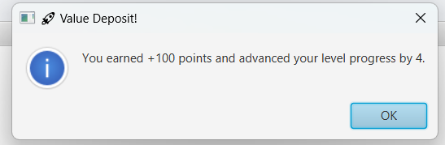

Fig:4.6 Level Up:
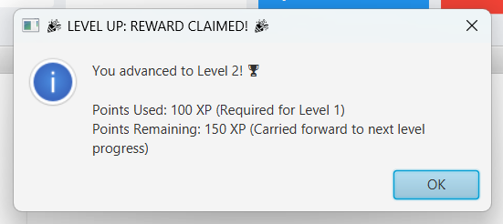

Fig: 4.7 All your transactions: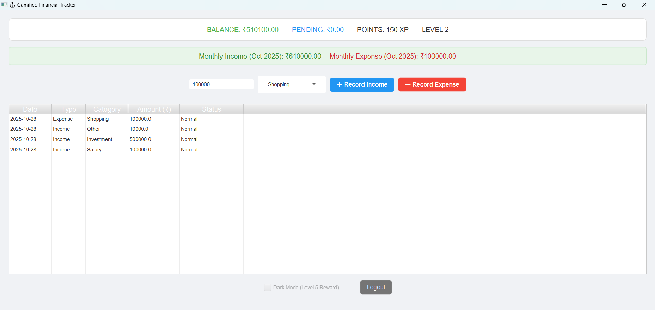

Fig:4.8 Level 5:
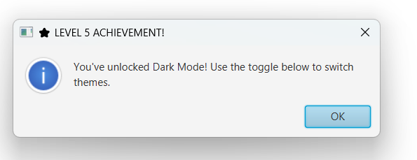
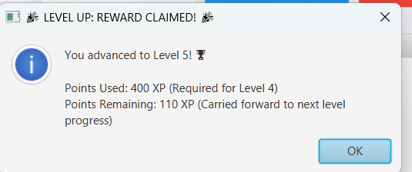
Fig:4.9 Dark Mode: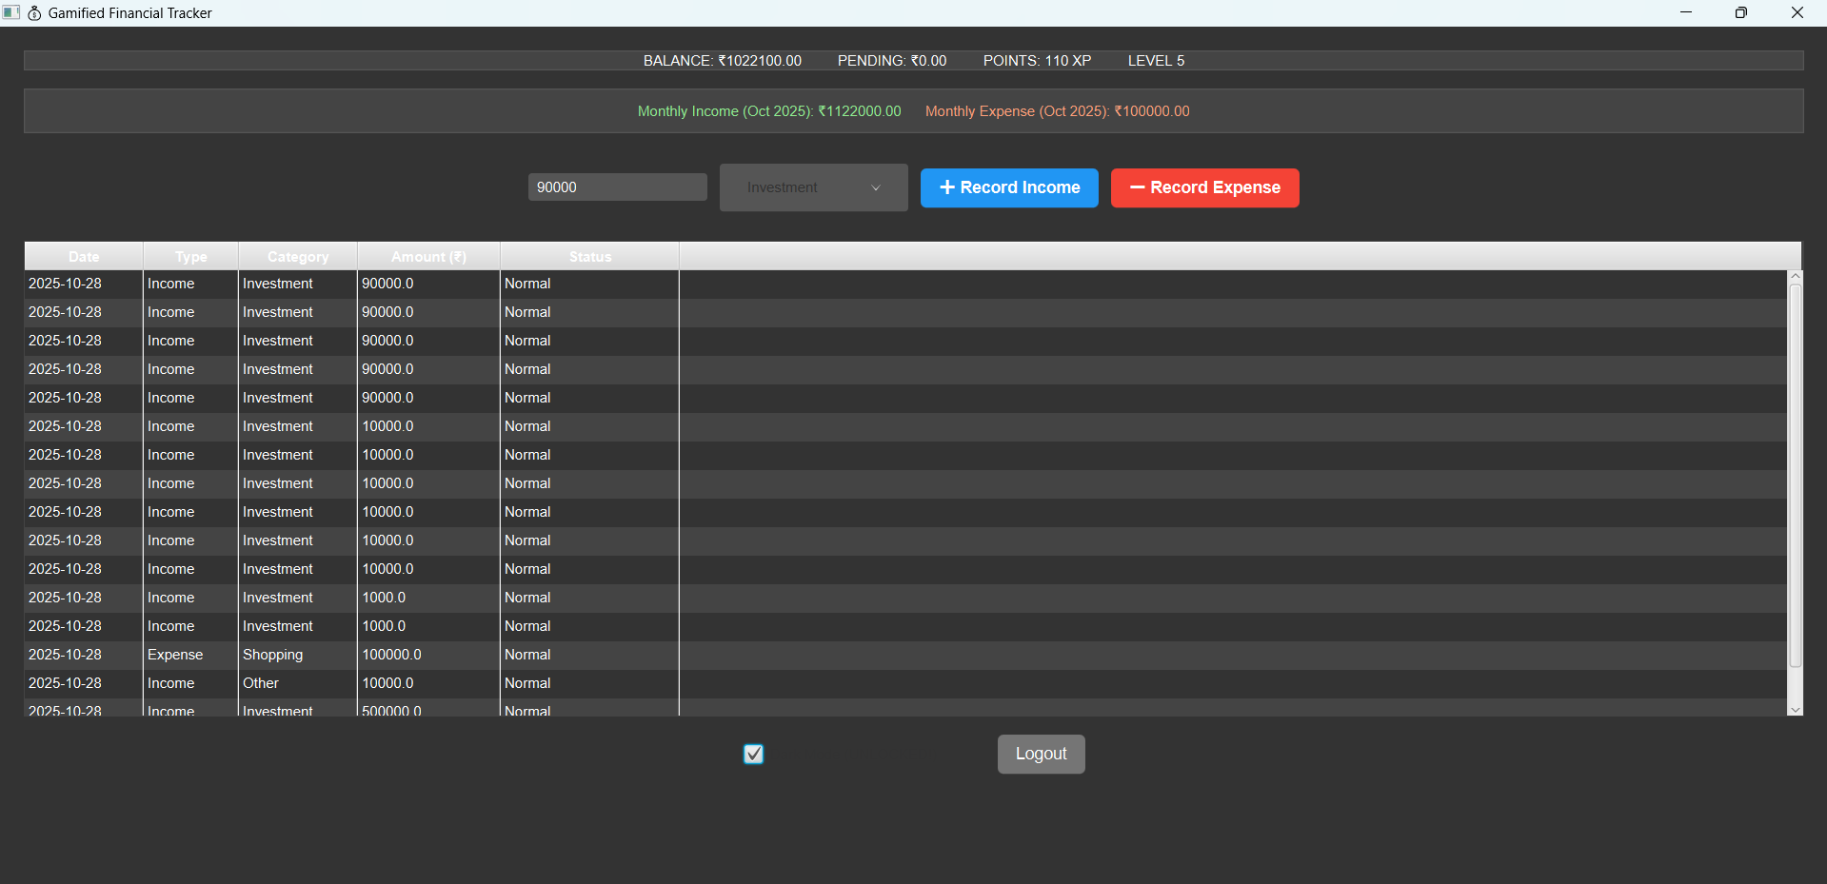
CHAPTER-5
DEVELOPMENT CYCLE

5.1 Development Cycle
The project followed a modified Agile/Iterative Development Model, prioritizing rapid prototyping of core features before refinement. The addition of the Category and Monthly Summary features extends the complexity and utility of the application, requiring a refinement of the existing phases.

Phase 1: Planning and Design
This initial phase focused on defining the project's foundation.
- Requirements Gathering: Defined core features (Login, Transaction, Dashboard) plus new requirements for transactional detail (Category) and financial analysis (Monthly Summary).
- Database Design: Finalized the users and transactions schema. Crucially, this phase finalized the inclusion of the category column in the transactions table to support detailed filtering.
- Wireframing: Completed the primary user interface screens, including a design revision to incorporate the Category Combo Box in the action panel and the new Monthly Summary display box near the top of the main dashboard.
Phase 2: Core Implementation
This phase established the application's stability and persistence.
- MySQL & JDBC Setup: Established database and JDBC connection.
- Authentication Module: Developed secure user registration and login.
- Base Transaction Logic: Implemented the foundational CRUD operations. The recordTransaction() and loadTransactions() methods were updated to specifically handle the new category field.
- Balance Management: Implemented the logic for initial balance setup and real-time updates to the users table.
Phase 3: Gamification, Feedback, and Reporting
This key phase integrated the unique elements of the project and enhanced reporting capabilities.
- Hybrid Levelling System: Coded the dual check for incomeCount(Frequency) and points(Value) thresholds. This core logic remains stable and was unaffected by the new features.
- Feature Rewards: Implemented Dark Mode and Speed Boost rewards.
- Monthly Reporting Module (New): A dedicated sub-phase to develop the Monthly Summary feature. This involved coding the loadMonthlySummary() method, which uses SQL aggregation (SUM and GROUP BY) to calculate and display month-to-date Income and Expense totals.
- UI Integration and Styling: Implemented the new Monthly Summary box and dedicated styles (e.g., summary-income-label, summary-expense-label) to ensure clear visualization of monthly progress.

Phase 4: Testing and Documentation
The final phase focused on quality assurance and formal reporting.
- Unit Testing: Verified correctness of individual functions, including new tests for category persistence (checking if the correct category is saved) and monthly summary calculation (verifying aggregate totals for a fixed month).
- Integration Testing: Verified seamless data flow and integrity, specifically testing if transactions are correctly grouped and summed by the loadMonthlySummary() query.
- Regression Testing: Ensured that the newly added features did not break existing critical gamification logic (e.g., point assignment, level-up checks).
- Documentation: Compiled the final project report, detailing the architecture, DBMS implementation, and the design choice for the new Category and Monthly Summary features.
5.2 System and Technical Requirements
Requirement Type | Specification | Description
Frontend | Java Development Kit (JDK) 8+ | Required for compilation and execution of Java code.
UI Framework | Java Swing or JavaFX | Used for developing the desktop application GUI.
Backend/Database | MySQL Server 5.7+ | Used for persistent storage of user and transaction data.
Connectivity | JDBC Driver | Required for connecting the Java application to the MySQL database.
Development | Integrated Development Environment (IDE) | IntelliJ
OS | Windows, macOS, or Linux | Desktop application is designed to be platform-independent.

CHAPTER-6
FUNCTIONAL OVERVIEW
The application is structured into four main functional modules, all centred around promoting user engagement through gamification. The Authentication Module handles secure user registration, ensuring the mandatory initial balance is recorded and setting default values for the 8 persistent state columns in the users table upon creation. The Transaction Module provides quick entry for income and expense records. Upon submission, this module immediately triggers the real-time update of the user's current balance and awards the corresponding points based on the deposit value tier, simultaneously updating the income_count column. The Financial Dashboard serves as the user's main hub, dynamically displaying the four critical real-time metrics: Current Balance, Pending Debt, Point Total, and Current Level, all sourced instantly from the users table. Finally, the Gamification and Feedback Engine module is the heart of the system, running the complex Hybrid Levelling logic. It ensures that the Level Up event only occurs when both the required incomeCount (frequency) and the required points (value) are achieved, awarding rewards like the permanent Dark Mode unlock at Level 5 and the transaction speed boost at Level 10.

CHAPTER-7
CONCLUSION
Summary
The Gamified Expense Tracker successfully developed a functional desktop application that moves beyond simple logging. By integrating a dynamic balance system, a motivational points system, and a persistent state managed by MySQL and JDBC, the project achieved its goal of making personal finance tracking engaging. The implementation of real-time balance updates and the tiered reward mechanism demonstrate a viable solution for overcoming the "data entry barrier" common in traditional finance applications, with all core logic dependent on robust DBMS operations.
Advantages and Disadvantages
Advantages include High Engagement, driven by the gamified points system and the clear, incremental goals of the Hybrid Levelling model. The system offers Immediate Feedback with real-time balance and point updates, and it demonstrates strong Stability by utilizing established technologies (Java and MySQL).
Disadvantages include a reliance on Manual Dependency for transaction logging and the application's current Scope as a desktop solution, lacking the portability of a mobile application. The most significant architectural constraint is the system's limitation to a Single-User Environment, which avoids the complexities of concurrency control required for a larger-scale DBMS application.
Future Scope
The project offers several avenues for expansion to enhance both the gamified experience and the DBMS capabilities. These include implementing Advanced Reporting using complex SQL queries with GROUP BY and aggregate functions to provide meaningful financial reports. It could also benefit from Categorization, which would require adding a new foreign key constraint to the transactions table. For a robust DBMS focus, future work should consider Stored Procedures to encapsulate and centralize core business logic (like updateLevel) directly within the MySQL server, reducing network latency and simplifying the Java application code.

REFERENCES
- Silberschatz, A., Korth, H. F., & Sudarshan, S. (2020). Database System Concepts (7th ed.). McGraw-Hill Education.
- Elmasri, R., & Navathe, S. B. (2016). Fundamentals of Database Systems (7th ed.). Pearson Education.
- GeeksforGeeks. (n.d.). DBMS Projects Ideas and Examples. Retrieved from https://www.geeksforgeeks.org
- W3Schools. (n.d.). MySQL Tutorial. Retrieved from https://www.w3schools.com/mysql/
- TutorialsPoint. (n.d.). Database Management System Overview. Retrieved from https://www.tutorialspoint.com/dbms
- Oracle MySQL Documentation. (n.d.). MySQL 8.0 Reference Manual. Retrieved from https://dev.mysql.com/doc/
- JavaTpoint. (n.d.). JDBC Tutorial. Retrieved from https://www.javatpoint.com/jdbc-tutorial
- Stack Overflow. (n.d.). Discussion threads on Expense Tracker implementation. Retrieved from https://stackoverflow.com/
- GitHub. (n.d.). Open-source Expense Tracker Projects. Retrieved from https://github.com

