# Phase 3: Data Modeling & Relationships (Fuel Station Project)

This phase defines the data model, objects, and relationships required for the Fuel Station project in Salesforce.

## 1. Standard & Custom Objects

- Standard Objects: Account (Fuel Station), Contact (Station Manager / Employee), Opportunity (Fuel Sales Deals), Product (Fuel Types)  
- Custom Objects:   
 • Pump (individual fuel dispensing units)  
 • Fuel Transaction (each sale at pump)  
 • Maintenance Record (service logs of pumps & stations)  
 • Fuel Inventory (track stock levels of petrol, diesel, CNG)

## 2. Fields

- Pump Object: Pump ID, Pump Type, Status (Active/Inactive), Last Service Date  
- Fuel Transaction: Transaction ID, Fuel Type, Quantity, Amount, Date & Time  
- Fuel Inventory: Fuel Type, Opening Balance, Current Stock, Last Refill Date  
- Maintenance Record: Pump ID, Service Date, Issue Reported, Technician Name

## 3. Record Types, Page Layouts & Compact Layouts

- Record Types for Fuel Transaction: Retail Sale, Bulk Sale  
- Record Types for Maintenance: Preventive Maintenance, Breakdown Repair  
- Page Layouts customized for each object to capture relevant data  
- Compact Layouts to display Pump ID, Pump Type, and Status at glance

## 4. Schema Builder & Relationships

- Account ↔ Pump: One-to-Many (One station has many pumps)  
- Pump ↔ Fuel Transaction: One-to-Many (One pump can have multiple transactions)  
- Pump ↔ Maintenance Record: One-to-Many (Each pump can have multiple service logs)  
- Account ↔ Fuel Inventory: One-to-One (Each station has a single inventory record)

## 5. Relationship Types

- Lookup Relationship: Pump to Account  
- Master-Detail Relationship: Fuel Transaction to Pump, Maintenance Record to Pump  
- Junction Object (if needed): Fuel Supply Contracts (between Fuel Supplier and Station)  
- External Objects: Fuel Supplier Data (via integration)

# Phase 3 Screenshots

Screenshot 1

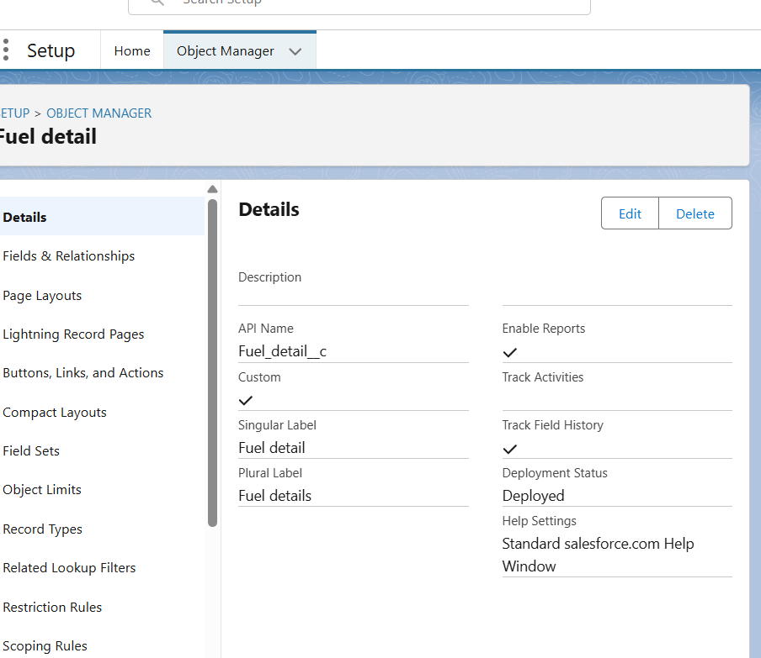

Screenshot 2

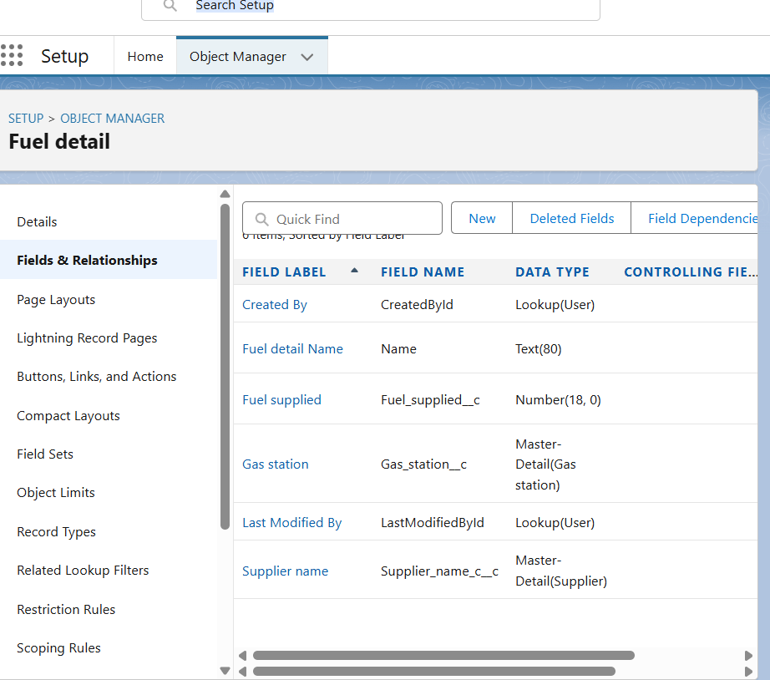

Screenshot 3

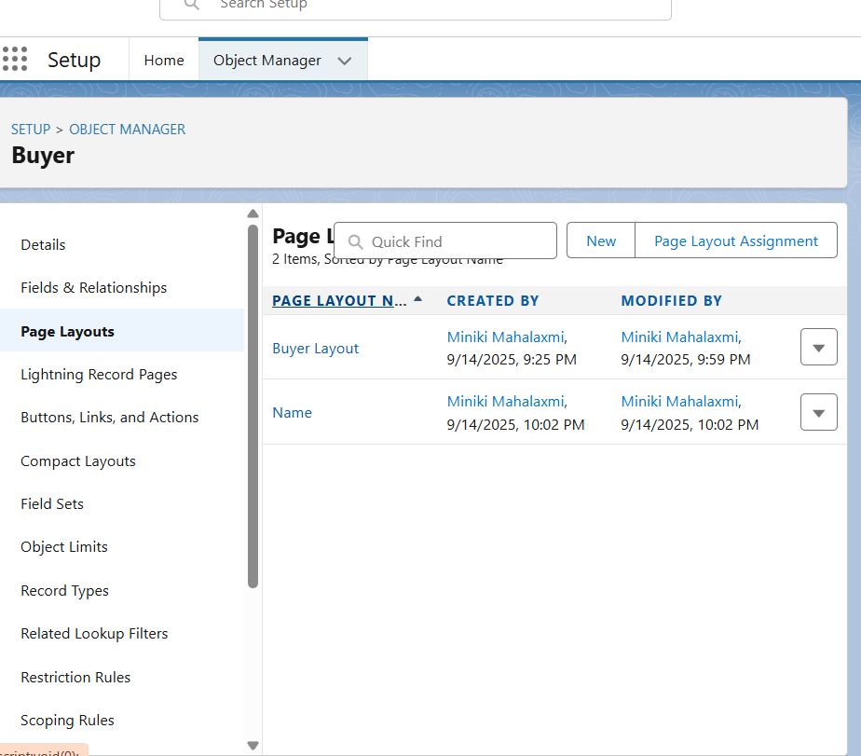

Screenshot 4

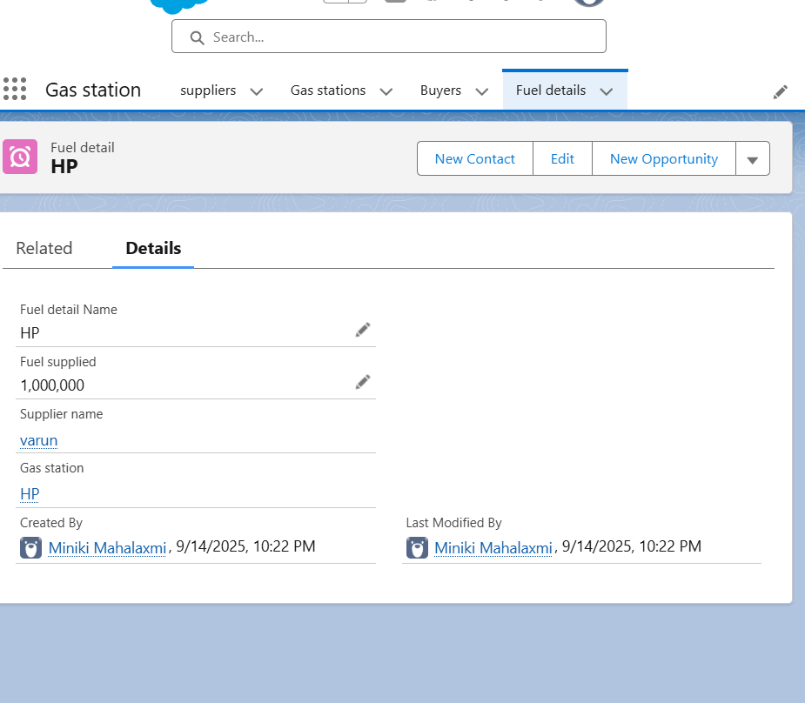

Screenshot 5

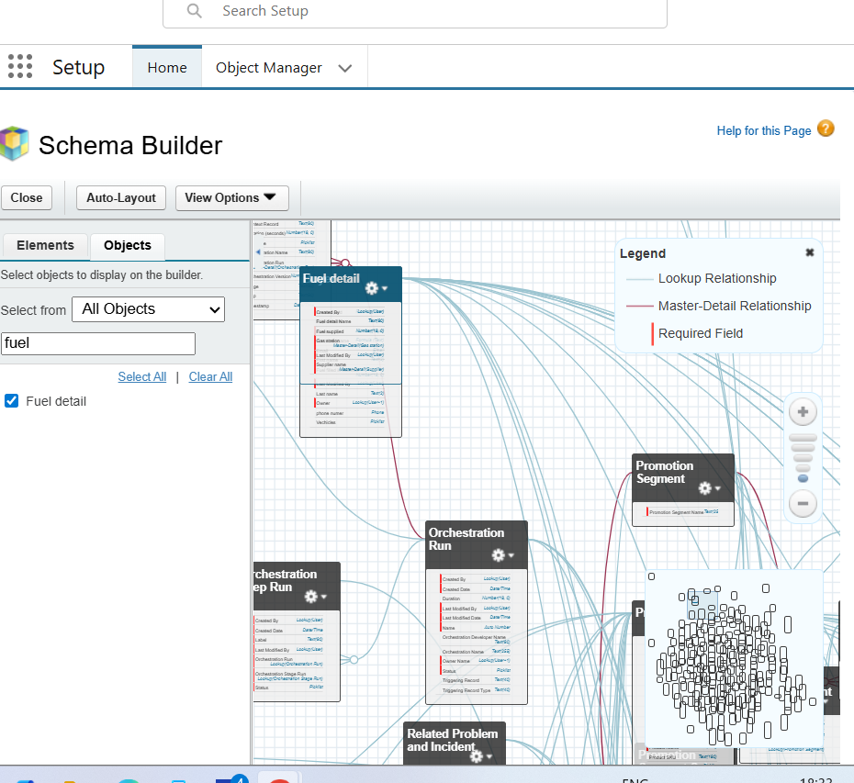

Screenshot 6

