Kmeans

In [1]: import pandas as pd

import numpy as np

import matplotlib.pyplot as plt

%matplotlib inline

df = pd.DataFrame({

'x': [12, 20, 28, 18, 29, 33, 24, 45, 45, 52, 51, 52, 55, 53, 55, 61, 64, 69, 72],

'y': [39, 36, 30, 52, 54, 46, 55, 59, 63, 70, 66, 63, 58, 23, 14, 8, 19, 7, 24]

})

np.random.seed(200)

k = 3

centroids = { i+1: [np.random.randint(0, 80), np.random.randint(0, 80)] for i in range(k) }

In [4]: fig = plt.figure(figsize=(5, 5))

plt.scatter(df['x'], df['y'], color='k')

Out[4]: <matplotlib.collections.PathCollection at 0x9521860>

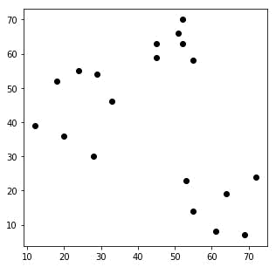

In [5]: fig = plt.figure(figsize=(5, 5))
plt.scatter(df['x'], df['y'], color='k')
colmap = {1: 'r', 2: 'g', 3: 'b'}
for i in centroids.keys():
plt.scatter(*centroids[i], color=colmap[i])
plt.xlim(0, 80)
plt.ylim(0, 80)
plt.show()

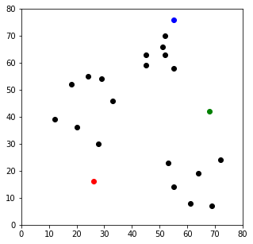

In [6]: def assignment(df, centroids):

for i in centroids.keys():

# sqrt((x1 - x2)^2 - (y1 - y2)^2)

df['distance_from_{}'.format(i)] = (

np.sqrt(

(df['x'] - centroids[i][0]) ** 2

+ (df['y'] - centroids[i][1]) ** 2

)

)

centroid_distance_cols = ['distance_from_{}'.format(i) for i in centroids.keys()]

df['closest'] = df.loc[:, centroid_distance_cols].idxmin(axis=1)

df['closest'] = df['closest'].map(lambda x: int(x.lstrip('distance_from_')))

df['color'] = df['closest'].map(lambda x: colmap[x])

return df

df = assignment(df, centroids)

print(df.head())

fig = plt.figure(figsize=(5, 5))

plt.scatter(df['x'], df['y'], color=df['color'], alpha=0.5, edgecolor='k')

for i in centroids.keys():
plt.scatter(*centroids[i], color=colmap[i])

plt.xlim(0, 80)

plt.ylim(0, 80)

plt.show()

 | x | y | distance_from_1 | distance_from_2 distance_from_3 |  | closest color
0 | 12 | 39 | 13.601471 | 69.354164 | 70.682388 | 1 | r
1 | 20 | 36 | 11.401754 | 64.070274 | 65.000000 | 1 | r
2 | 28 | 30 | 17.720045 | 61.554854 | 61.846584 | 1 | r
3 | 18 | 52 | 7.071068 | 58.523500 | 60.440053 | 1 | r
4 | 29 | 54 | 9.219544 | 47.539457 | 49.335586 | 1 | r

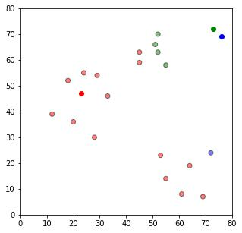

# Stage 3
## Update Stage

import copy

old_centroids = copy.deepcopy(centroids)

def update(k):
for i in centroids.keys():
centroids[i][0] = np.mean(df[df['closest'] == i]['x'])
centroids[i][1] = np.mean(df[df['closest'] == i]['y'])
return k

centroids = update(centroids)

fig = plt.figure(figsize=(5, 5))
ax = plt.axes()
plt.scatter(df['x'], df['y'], color=df['color'], alpha=0.5, edgecolor='k')
for i in centroids.keys():
plt.scatter(*centroids[i], color=colmap[i])
plt.xlim(0, 80)
plt.ylim(0, 80)
for i in old_centroids.keys():
old_x = old_centroids[i][0]
old_y = old_centroids[i][1]
dx = (centroids[i][0] - old_centroids[i][0]) * 0.75
dy = (centroids[i][1] - old_centroids[i][1]) * 0.75
ax.arrow(old_x, old_y, dx, dy, head_width=2, head_length=3, fc=colmap[i], ec=colmap[i])
plt.show()

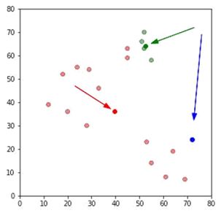

# Stage 4
## Repeat Assigment Stage

df = assignment(df, centroids)

# Plot results
fig = plt.figure(figsize=(5, 5))
plt.scatter(df['x'], df['y'], color=df['color'], alpha=0.5, edgecolor='k')
for i in centroids.keys():
plt.scatter(*centroids[i], color=colmap[i])
plt.xlim(0, 80)
plt.ylim(0, 80)
plt.show()

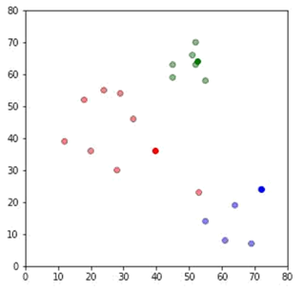

# Stage 5

# Continue until all assigned categories don't change any more
while True:
closest_centroids = df['closest'].copy(deep=True)
centroids = update(centroids)
df = assignment(df, centroids)
if closest_centroids.equals(df['closest']):
break

fig = plt.figure(figsize=(5, 5))
plt.scatter(df['x'], df['y'], color=df['color'], alpha=0.5, edgecolor='k')
for i in centroids.keys():
plt.scatter(*centroids[i], color=colmap[i])
plt.xlim(0, 80)
plt.ylim(0, 80)
plt.show()

