CS-499 Module Three

Milestone Two

Enhancement One: Software Design and Engineering

Alex Mehr

3/22/2025

The artifact I selected for software design and engineering is the **Weight loss** mobile

application. The goal of this app to allow users log in to their account and track their

wight and weigh loss plan which is developed for Android devices. This software is

developed in Java programming language and SQLite relational database. The

Development tool I utilized for this development is Android Studios IDE and it was

part of CS-360 Mobile Architecture and Programming course.

This artifact shows the achievement of application development, and it showcases my

ability to write proper code writing and application development skills. I did the most of

improvements when I was working on my final project, so I have not been able to make

any enhancements yet.

This artifact involves an entire software design and engineering process and it consist

of UX (design consideration), UI(User Interface) with multiple screens and necessary

actions required for the application such as login process, register new user, provide

weight loss goals and plans, … Also using CRUD (Create, Read, Update, Delete) method

within the relational database.

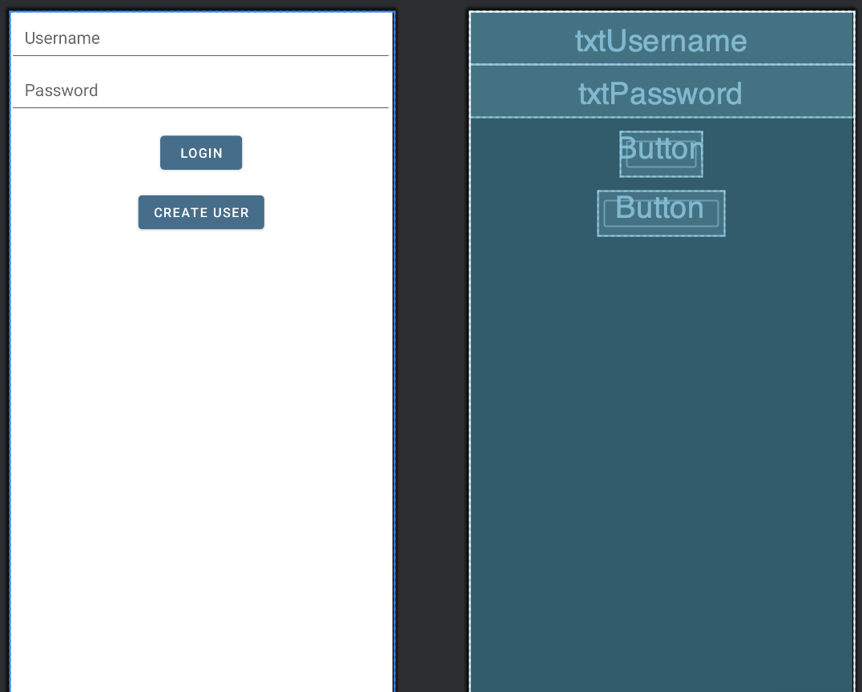

By design and development of the mobile application, we showcase out abilities and skills in

software development and engineering, by considering the user needs and translating them

into a user-friendly feature. This artifact enhancement made the application functional and

using CRUD functionality and structure. I followed the best practices and application

development principles with simplifying user interaction in mind. User interaction focused

application will demonstrate my ability to design an application using innovative methods and

techniques and showcase my skill in implementing solutions to deliver value to achieve the

best result and to eliminate any issues and vulnerabilities of the application.

The application main screen is for the user to enter their credentials and get authenticated and if

the credentials do not exist in the database, the user will be notified and routed to create user to

create a new account. The authentication process is to ensure the security of the application and

safe keeping user information.

I utilize industry standard best practices in JAVA, including in-line comments, proper

indentation, naming convention and formatting to make the code easy to read and followed by

any other developer who has not worked on the application. Variables and functions are utilized

according to the Java best practices and techniques, including capital words and camelCase

naming to define the proper scope for each function and code block.

As an application designer and developer, I plan my idea and work through that to define the

purpose of the application and who is the audience and end user of my application. I then take

the user requests and needs and implement the features according to that and that will prioritize

the tasks and what needs to be displayed on my application. This is the first enhancement of this

application and more enhancement will be performed to deliver an app that meets the user needs.

There are many approaches to application design and understanding that the process is critical to

delivering a high-quality app that is accepted by the end users and to deliver such an application

it is required to continuously work on enhancing the application to provide that experience and

that is unattainable by only one designer/ developer and will introduce challenges which will

need team collaboration and continuous research and development to achieve that goal and to

overcome challenges.

import androidx.appcompat.app.AppCompatActivity;  
import androidx.room.*;  
import android.os.Bundle;  
import android.view.View;  
import android.widget.EditText;  
import android.widget.TextView;  
  
import java.util.List;  
  
public class MainActivity extends AppCompatActivity {  
  
 AppDatabase db;  
  
 @Override  
 protected void onCreate(Bundle savedInstanceState) {  
 super.onCreate(savedInstanceState);  
 setContentView(R.layout.*activity_main*);  
  
 db = Room.*databaseBuilder*(getApplicationContext(),  
 AppDatabase.class, "users").build();  
 }  
  
 public void RegisterClick(View v){  
 EditText usernameText = (EditText) findViewById(R.id.*editTextUsername*);  
 EditText passwordText = (EditText) findViewById(R.id.*editTextTextPassword*);  
 String nameTextValue = usernameText.getText().toString();  
 String passwordTextValue = passwordText.getText().toString();  
 if(!checkLogin(nameTextValue, passwordTextValue)){  
 createUser(nameTextValue, passwordTextValue);  
 }  
 }  
  
 public void LoginClick(View v){  
 EditText usernameText = (EditText) findViewById(R.id.*editTextUsername*);  
 EditText passwordText = (EditText) findViewById(R.id.*editTextTextPassword*);  
 String nameTextValue = usernameText.getText().toString();  
 String passwordTextValue = passwordText.getText().toString();  
 if(checkLogin(nameTextValue, passwordTextValue)){  
 setContentView(R.layout.*main_display*);  
 }  
 }  
  
 private boolean checkLogin(String username, String password){  
 UserDao userDao = db.userDao();  
 User user = userDao.findByName(username, password);  
 return user != null;  
 }  
  
 private void createUser(String username, String password){  
 UserDao userDao = db.userDao();  
 User user = new User();  
 user.userName = username;  
 user.password = password;  
 userDao.insertAll(user);  
 }  
}