* Created an account on GitHub

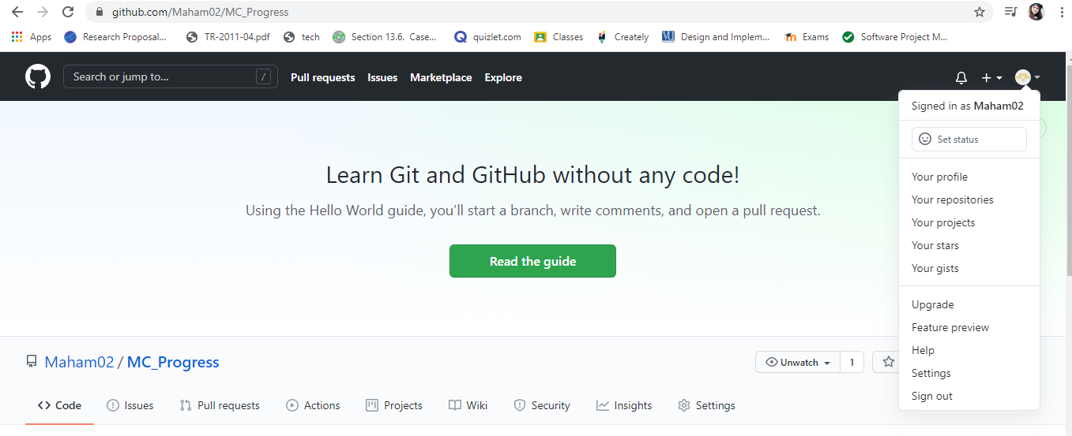

* Creating a repository

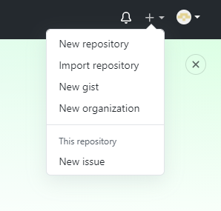

Naming the repository

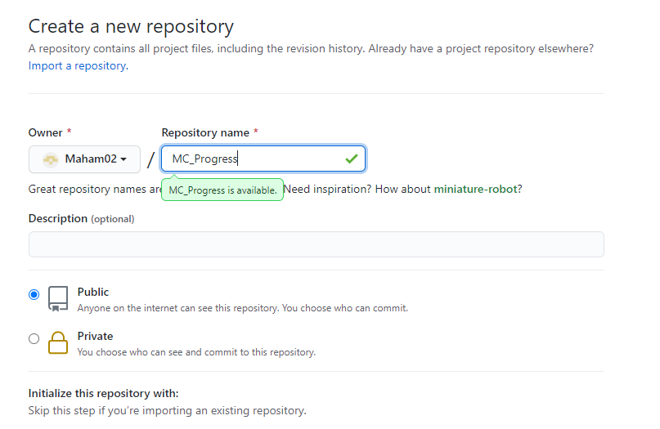

Repository Created

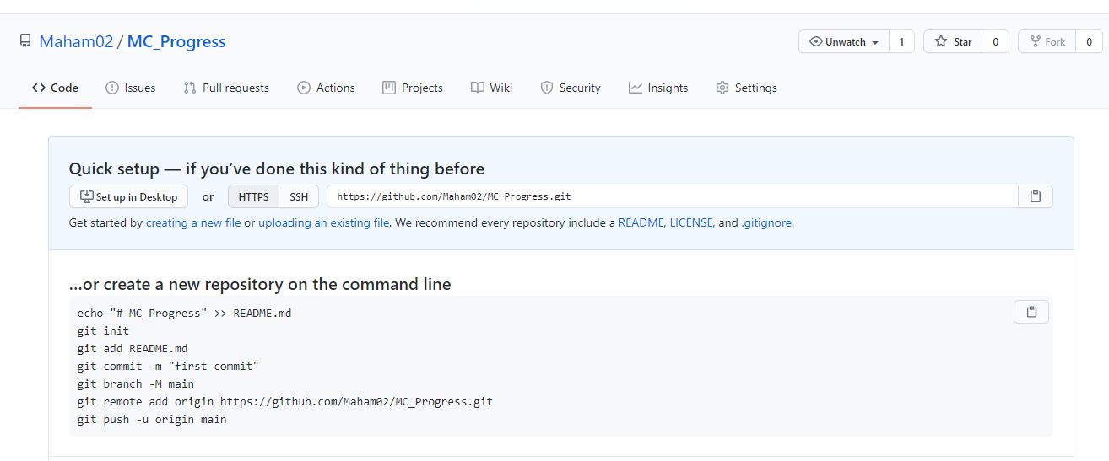

* **Running ls command to see all list of files**

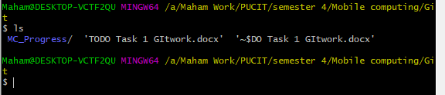

* **Creating a connection of local repository to central repository using clone command**

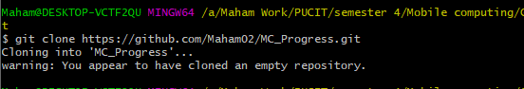

* **Adding a file using git add command**

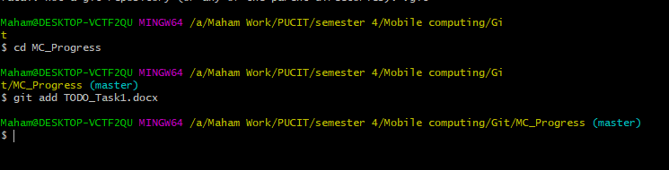

* **Changes made with message to track changes**
* **Commit command**

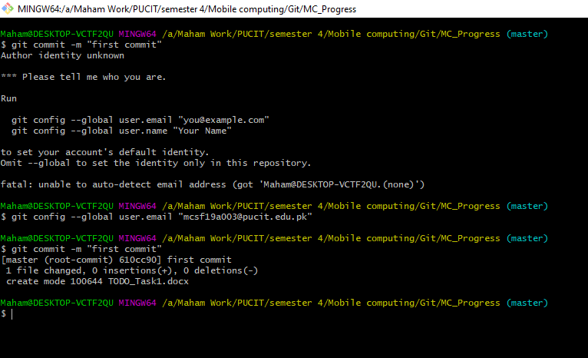

* **Command for checking current status**

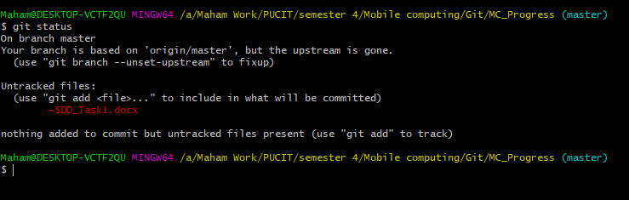

* **Command for push files on server**

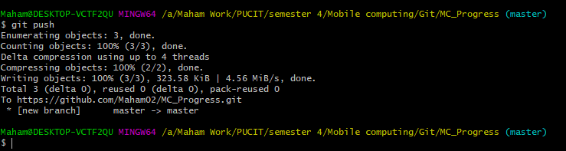

* **File pushed on Server**

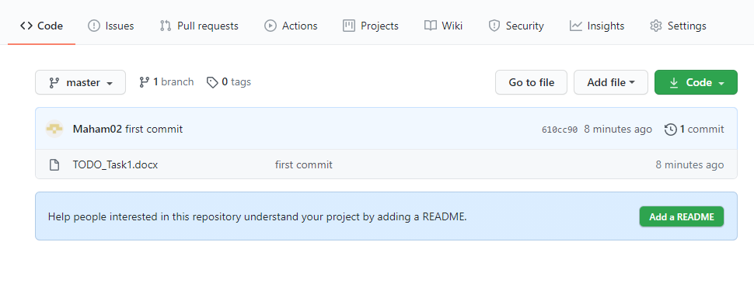

* **Now some more content added in file. Now I’m add, commit and push it again.**

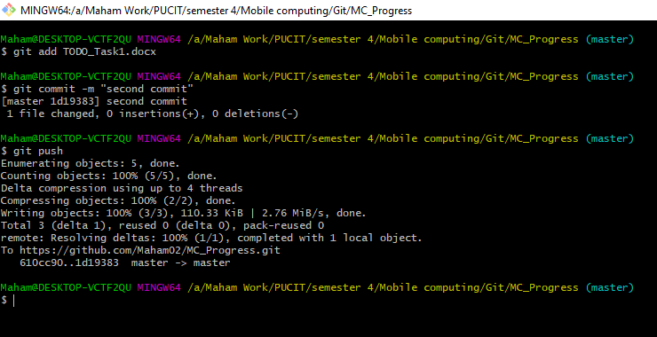

* **Changes done**

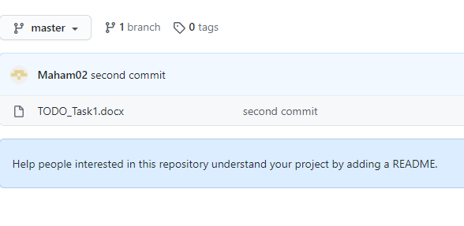

* **Editing file in repository**

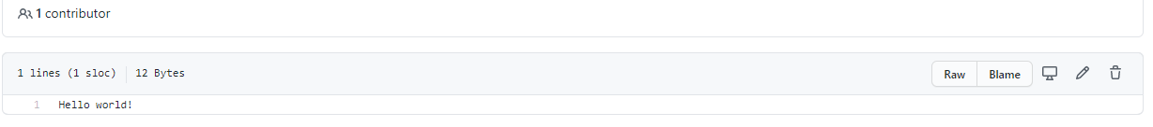

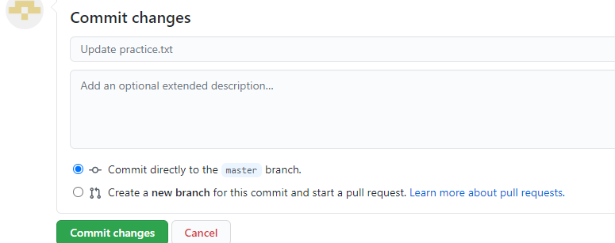

* **New line added**



* **Git pull command to change in the local repository**

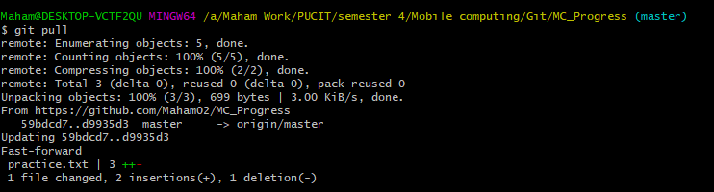

* **Merge conflicts**

**Editing in online**

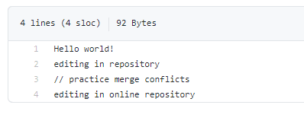

**Editing in local repository**

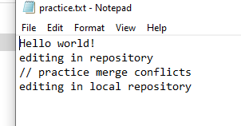

**Error**

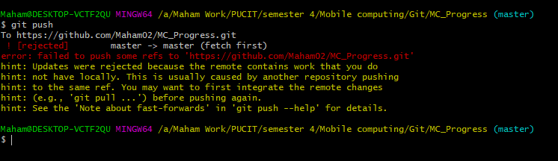

* **Merge Conflict resolved**

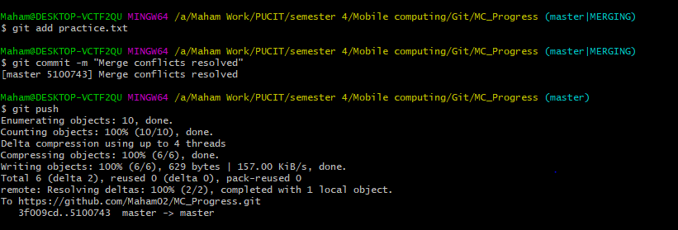

* **Git log command to check details**

