**MCSF19A003 Maham Hameed**

**TODO Task 2**

**Working on android studio**

* **Creating a project on Android Studio**

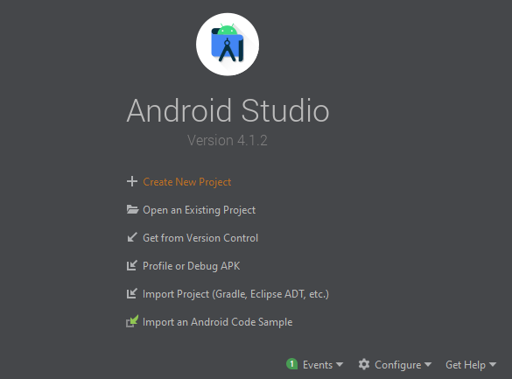

* **Selecting Project Template**

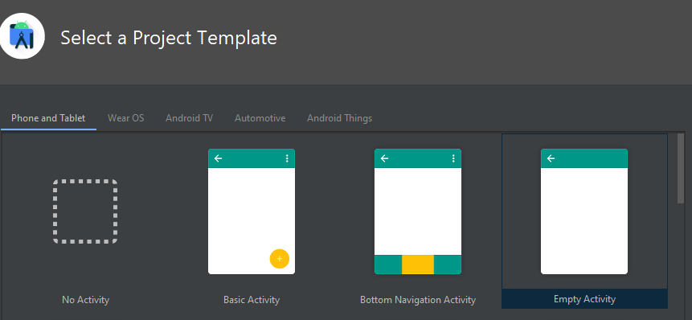

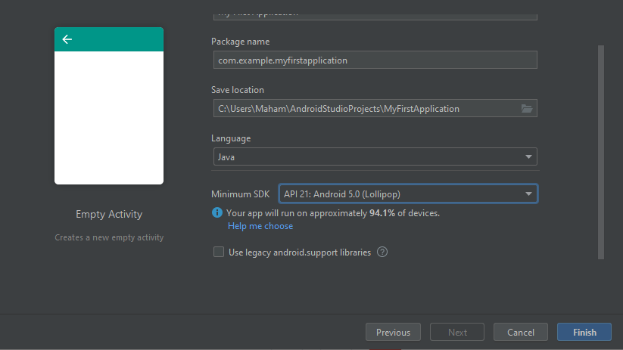

* **Different files in android studio**

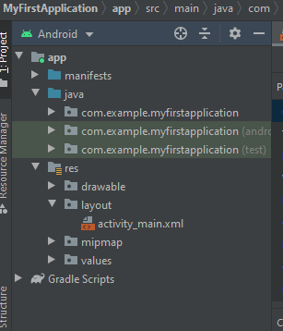

* **Coding file**

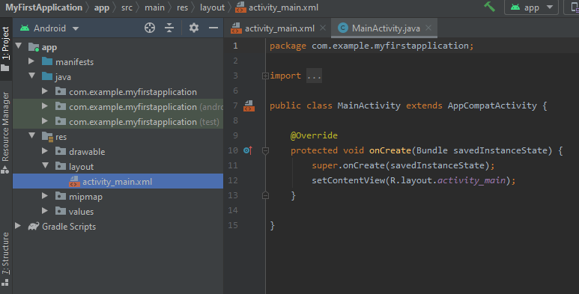

**All coding is done in MainActivitity.java file**

* **Graphical user interface file**

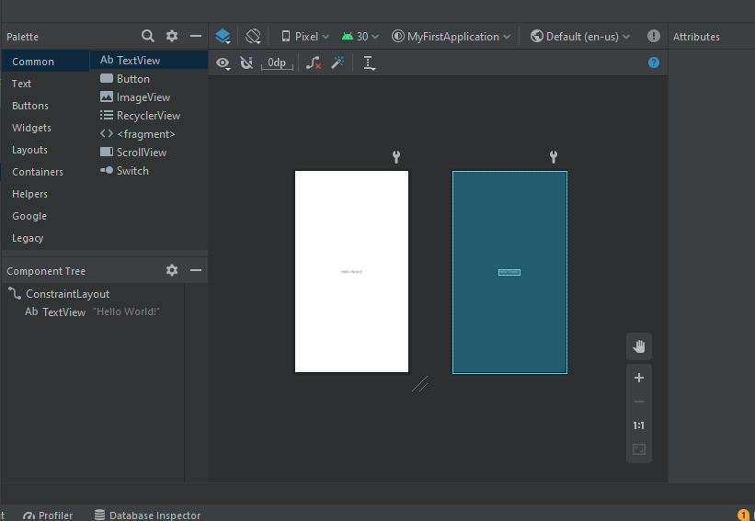

* **Project Resources**

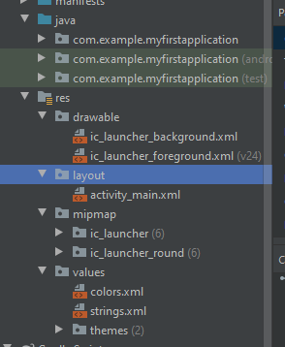

* **Maintaining TODO**

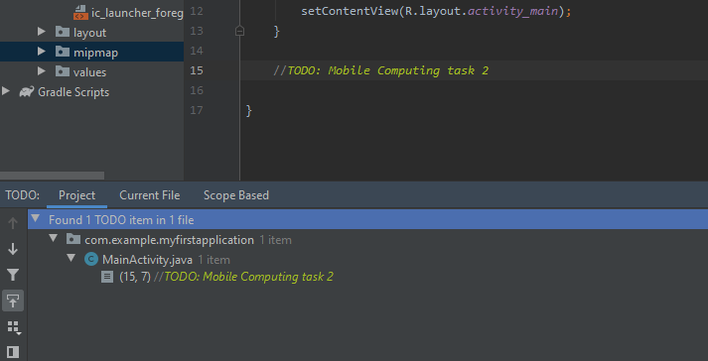

* **Globally define things**

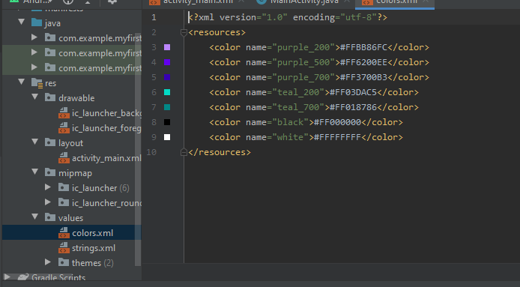

* **Wrap content maintain text according to width**

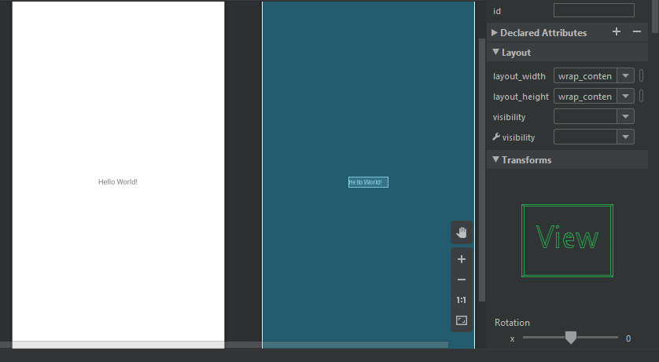

* **Changing text, color and text size**

