Part 5 – Cleaning Pipeline & Reproducibility
NLP Assignment 1, Phase 1 · Team 5 Siphahi · Sameer Javed Khan (L1F23BSCS0355)

5.1 Purpose
The earlier parts each produce a piece of the cleaning: remove_noise() in Part 3, and normalize_unicode() and normalize_text() (spaCy tokenization, stop words and lemmatization) in Part 4. Part 5 joins them into one reusable function, clean_text() in src/cleaning_pipeline.py, so every tweet is cleaned the same way on every run and on every teammate’s machine. The script saves the result as data/processed/cleaned_dataset.csv, which Phase 2 loads directly.

5.2 Pipeline order and justification
Every tweet passes through the same six steps in this order:
# | Step | Code | Why it sits here
1 | Decode HTML entities | decode_entities (Part 5) | 720 tweets store &amp;, &lt; and &gt;. If they are not decoded first, amp and lt become words, and &lt;3 cannot be read as a heart.
2 | Unicode NFC, then curly quotes → straight | normalize_unicode (Part 4) + standard_quotes (Part 5) | Must run before any regex or tokenizer so identical-looking text is the same bytes. Straight quotes matter because spaCy only turns n't into not with a straight apostrophe: without this step, didn’t like it became like, flipping the sentiment.
3 | Case folding | case_fold (Part 5) | Capitalisation in tweets is inconsistent (DELAYED, Delayed), which splits one word into several types. Uses casefold(), as Part 4 does.
4 | Noise removal | remove_noise (Part 3) | Removes URLs, @mentions and numbers, keeps the hashtag word without #, and squeezes whitespace.
5 | Keep sentiment cues | keep_sentiment_cues (Part 5) | Emojis become their names (thumbs-up emoji → thumbs up), :) / :( become happyface / sadface, dont / cant become do not / can not, and sooooo → soo. spaCy would otherwise drop emojis and emoticons, which are strong sentiment signals.
6 | Tokenization, stop-word removal, lemmatization | normalize_text (Part 4) | spaCy en_core_web_sm splits the text into tokens, drops stop words and punctuation but keeps negations (not, no, never) and intensifiers (very, really, but), and lemmatizes (flights → flight, delayed → delay).
The order matters. Decoding and Unicode normalization come before anything that matches text, so every regex sees one consistent form. Noise removal comes before step 5, so URLs are gone before the emoticon regex runs; otherwise http:// would be read as the emoticon :/. spaCy runs last because it needs clean, plain words to tag and lemmatize correctly.
The pipeline imports remove_noise from src/noise_removal.py and normalize_unicode and normalize_text from src/normalization.py, and each run prints which file every step comes from.

5.3 Output
data/processed/cleaned_dataset.csv has one row per raw tweet, in the same order as Tweets.csv:
Column | Contents
tweet_id | Original tweet id
airline | Airline the tweet is addressed to
airline_sentiment | The label, copied unchanged
airline_sentiment_confidence | Annotator agreement (rounded to 4 decimals, as in the source)
negativereason | Reason for negative tweets, otherwise empty
text | Raw tweet, untouched
clean_text | Pipeline output, tokens separated by spaces
n_tokens | Number of tokens after cleaning
No rows are dropped. The 36 exact duplicate rows found in Part 1 and the 57 tweets that are empty after cleaning (for example, a tweet that was only a mention and a link) stay in, so the file lines up one-to-one with the raw data. Phase 2 will decide how to de-duplicate and split.
Examples from report/pipeline_examples.txt:
Label | Before | After
positive | @JetBlue thanks to the gent on the phone who fixed my BOS-MCO flight and the fee waiver! A320 now :) #flyfi ! I forget her name :( | thank gent phone fix bos mco flight fee waiver happyface flyfi forget sadface
negative | @united great job losing one of my six bags on a direct flight. Don’t know how you manage to do it. | great job lose bag direct flight not know manage
positive | @united wins top marks for customer service via Twitter. They turned a poor experience into a positive. Many thanks for the effort! (thumbs-up emoji) | win mark customer service twitter turn poor experience positive thank effort thumb
neutral | @SouthwestAir do you have any info about when #DestinationDragons winners will be announced? me & my best friend are hoping to win. thanks! | info destinationdragon winner announce good friend hop win thank
The fourth example shows two known weaknesses of spaCy’s lemmatizer: hoping becomes hop, and best becomes good. We accepted these because they are rare and keep the step consistent across the whole dataset. The third shows an emoji kept as a word (thumbs-up emoji → thumb; up is removed as a stop word).

5.4 Results
 | Before cleaning | After cleaning
Tweets | 14,640 | 14,640
Tokens | 268,713 | 119,888
Vocabulary (types) | 15,089 | 8,961 (−40.6%)
negative / neutral / positive | 9,178 / 3,099 / 2,363 | 9,178 / 3,099 / 2,363
Average length per tweet | 17.65 words | 8.19 tokens
Empty after cleaning | 0 | 57
The “before” counts use simple_tokenize() from Part 1, so both columns are measured the same way. The label counts are identical before and after, which confirms that cleaning changed no labels.

5.5 Testing and reproducibility
We checked the pipeline in three ways.
- Unit tests. tests/test_cleaning_pipeline.py has 10 tests. They check that URLs and mentions are removed, HTML entities are decoded, negations survive (don't, didn’t with a curly apostrophe, didnt, never), hashtags, emojis and emoticons become words, stretched words are shortened, composed and decomposed Unicode give the same output, cleaning an already-cleaned tweet changes nothing, and labels and row order are preserved. All 10 pass (Figure 5.2).
- Fresh-clone check. src/verify_reproducibility.py re-runs the whole pipeline from the raw CSV and compares the result with the committed file. It checks row count, labels against the raw data, labels against the committed file, tweet-id order, missing labels and a byte-for-byte SHA-256 match. It prints REPRODUCIBLE only if every check passes.
- Different machines. The output was produced on Linux and reproduced byte-for-byte on a fresh clone in a new virtual environment (pandas 3.1.1, spaCy 3.8.18, en_core_web_sm 3.8.0) and on a MacBook (Figure 5.3). An earlier fresh-clone run found a real problem: pandas 3.1 read a few confidence scores with float noise (0.352 became 0.35200000000000004). Rounding that column to its original 4 decimals fixed it.
SHA-256 of the committed cleaned_dataset.csv: af10013ff447a66431f309c825db528e0db6b9689f68369bd935a50998e15335
How to reproduce from a fresh clone:
git clone https://github.com/Maham411/NLP-Project.git
cd NLP-Project
python3 -m venv venv
source venv/bin/activate
pip install -r requirements.txt
python3 -m spacy download en_core_web_sm
python3 src/load_data.py
python3 src/cleaning_pipeline.py
python3 tests/test_cleaning_pipeline.py
python3 src/verify_reproducibility.py
Repository: https://github.com/Maham411/NLP-Project (pull requests #1 and #4). Full details: docs/REPRODUCIBILITY.md in the repository.

5.6 Screenshots
All three were taken on a MacBook (macOS, Python 3.13, pandas 3.1.1, spaCy 3.8.18) from a fresh clone of the repository.
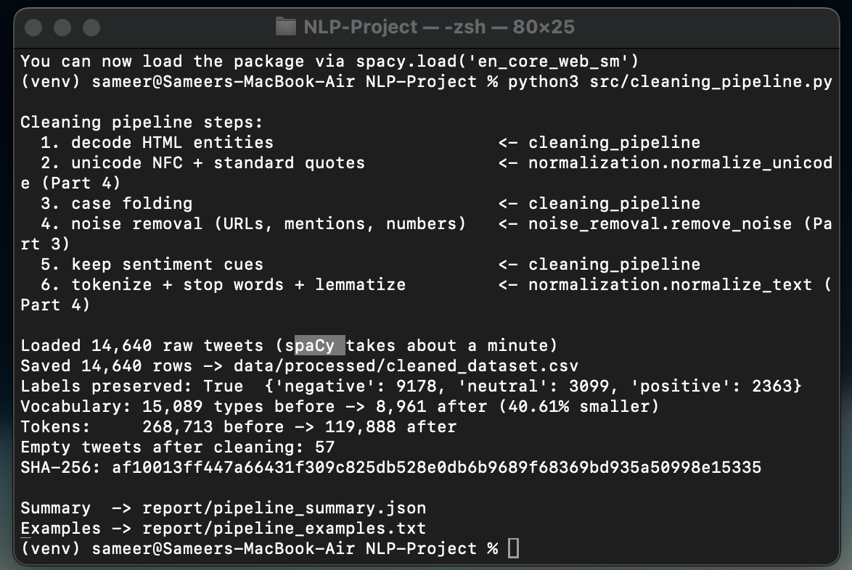
Figure 5.1 – python3 src/cleaning_pipeline.py: the six steps and which member’s code runs each one, labels preserved, and vocabulary 15,089 → 8,961.
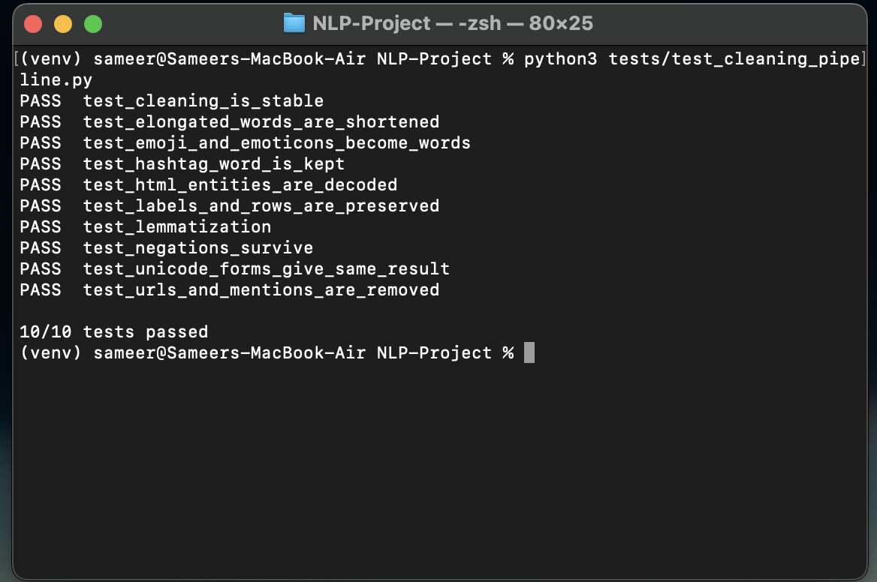
Figure 5.2 – python3 tests/test_cleaning_pipeline.py: all 10 tests pass.
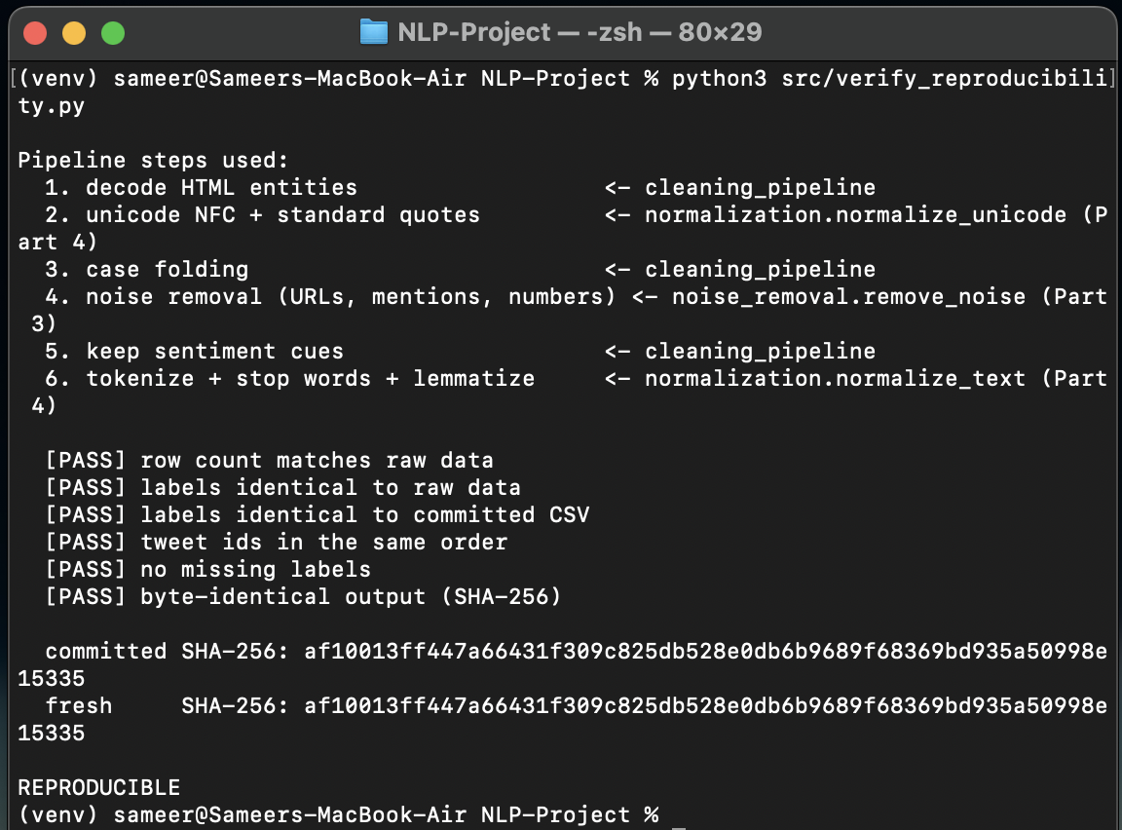
Figure 5.3 – python3 src/verify_reproducibility.py: all six checks pass and the fresh SHA-256 matches the committed file.

