NLP SEMESTER PROJECT – PHASE 1
Regular Expressions and Noise Removal
Sentiment Analysis of US Airline Customer Tweets Using Natural Language Processing
Member Name | Tamazar Fatima
Roll Number | L1F23BSCS1221
Assigned Role | Regular Expressions and Noise Removal
Dataset | Twitter US Airline Sentiment (Kaggle)

1. Introduction
Tweets contain useful customer opinions, but they can also include URLs, user mentions, hashtag symbols, HTML entities, and extra whitespace. Noise removal prepares text for later Natural Language Processing (NLP) tasks. This component uses Python regular expressions and text-processing functions to identify and remove selected noise while keeping words and expressions that may carry sentiment.

2. Objectives
- Create regular expression patterns for common elements in airline tweets.
- Detect URLs, mentions, hashtags, numbers, HTML entities, whitespace, and repeated punctuation.
- Remove selected unnecessary text while preserving useful sentiment clues.
- Show before-and-after examples.
- Apply noise removal to the complete dataset and save the processed tweets.

3. Regular Expression Patterns
Pattern | Regular expression | Purpose
URL_PATTERN | https?://\S+|www\.\S+ | Detects web links.
MENTION_PATTERN | @\w+ | Detects Twitter mentions such as @VirginAmerica.
HASHTAG_PATTERN | #(\w+) | Captures hashtag words without the # symbol.
NUMBER_PATTERN | \b\d+(?:[.:/-]\d+)*\b | Detects numbers and simple number formats.
HTML_ENTITY_PATTERN | &(?:amp|lt|gt|quot|#39); | Detects common HTML entities such as &amp;.
WHITESPACE_PATTERN | \s+ | Detects one or more whitespace characters.
REPEATED_PUNCTUATION_PATTERN | ([!?.,])\1{1,} | Detects repeated marks such as !!! or ???.
The patterns are used for detection and testing. The cleaning function removes URLs and mentions, removes the # symbol while retaining the hashtag word, decodes HTML entities, and standardizes whitespace. Numbers and repeated punctuation are detected but intentionally retained.

4. Noise Removal Method
The remove_noise() function performs the following steps to clean tweet text:
- Non-string inputs: Non-string values are returned as an empty string.
- HTML entities: HTML entities are decoded; for example, &amp; becomes &.
- URL removal: URLs are removed using URL_PATTERN.
- Mention removal: Twitter mentions (such as @username) are removed using MENTION_PATTERN.
- Number removal: Numbers, including flight numbers and other numeric values, are removed using NUMBER_PATTERN.
- Hashtag handling: The # symbol is removed from hashtags, while the hashtag word is preserved. For example, #WorstAirline becomes WorstAirline.
- Whitespace handling: Tabs and line breaks are replaced with spaces, and multiple whitespace characters are reduced to a single space.
- Punctuation spacing: Extra spaces before punctuation marks are removed.
- Final trimming: Leading and trailing spaces are removed using strip().
The function preserves important sentiment information, including negations and emojis, because these can help determine whether a tweet expresses positive, negative, or neutral sentiment.

5. Sentiment-Preserving Decisions
The implementation keeps negation words such as “not” and “didn't”, emotional words such as “unhappy” and “bad”, hashtag words such as “WorstAirline”, numbers, and repeated punctuation such as “!!!”. Repeated punctuation and elongated words such as “sooo” can express emphasis. The hashtag marker is removed, but its text is retained.

6. Before-and-After Examples
Original tweet | After noise removal
@VirginAmerica What @dhepburn said. | What said.
Visit https://example.com for updates!!! | Visit for updates!!!
My flight is delayed &amp; I am unhappy! | My flight is delayed & I am unhappy!
#WorstAirline has delayed my flight!!! | WorstAirline has delayed my flight!!!
Flight 123 is delayed by 2 hours. | Flight 123 is delayed by 2 hours.
This is sooo bad!!! | This is sooo bad!!!

7. Dataset Processing and Results
The script src/noise_removal_analysis.py loaded Tweets.csv, selected the text and airline_sentiment columns, applied the noise removal function, and saved the processed data.
Measure | Result
Total tweets processed | 14,640
Negative tweets | 9,178
Neutral tweets | 3,099
Positive tweets | 2,363
Output file | data/processed/noise_removed_tweets.csv
The output CSV contains two columns: noise_removed_text and airline_sentiment. The sentiment labels were retained for later project stages.

8. Implementation Files
- src/regex_patterns.py – stores the regular expression patterns.
- src/noise_removal.py – contains the remove_noise() function.
- src/noise_removal_examples.py – tests patterns and displays before-and-after examples.
- src/noise_removal_analysis.py – processes the dataset and saves the output CSV.
- data/raw/Tweets.csv – original dataset copy used for this task.
- data/processed/noise_removed_tweets.csv – processed dataset.

9. Conclusion
The regular expression and noise removal component was implemented and tested successfully. The patterns detected the selected tweet elements. The cleaning function removed URLs and mentions, decoded HTML entities, retained hashtag words, and standardized whitespace. The complete dataset of 14,640 tweets was processed and the cleaned CSV was generated. Sentiment-related content such as negation, emotional words, numbers, and repeated punctuation was retained where appropriate.

10. Practical Evidence and Screenshots
The following screenshots provide evidence of the code, regex testing, full dataset processing, and saved output.
Figure 1. Regular expression patterns.
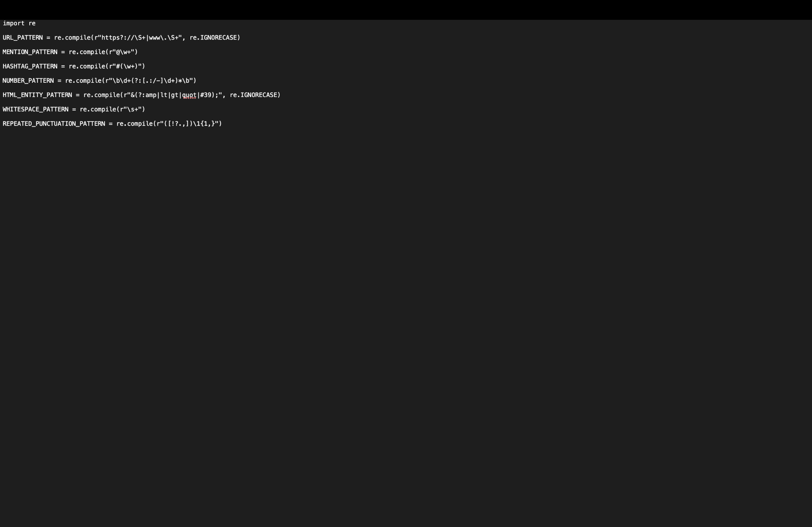
Figure 2. Noise removal function.
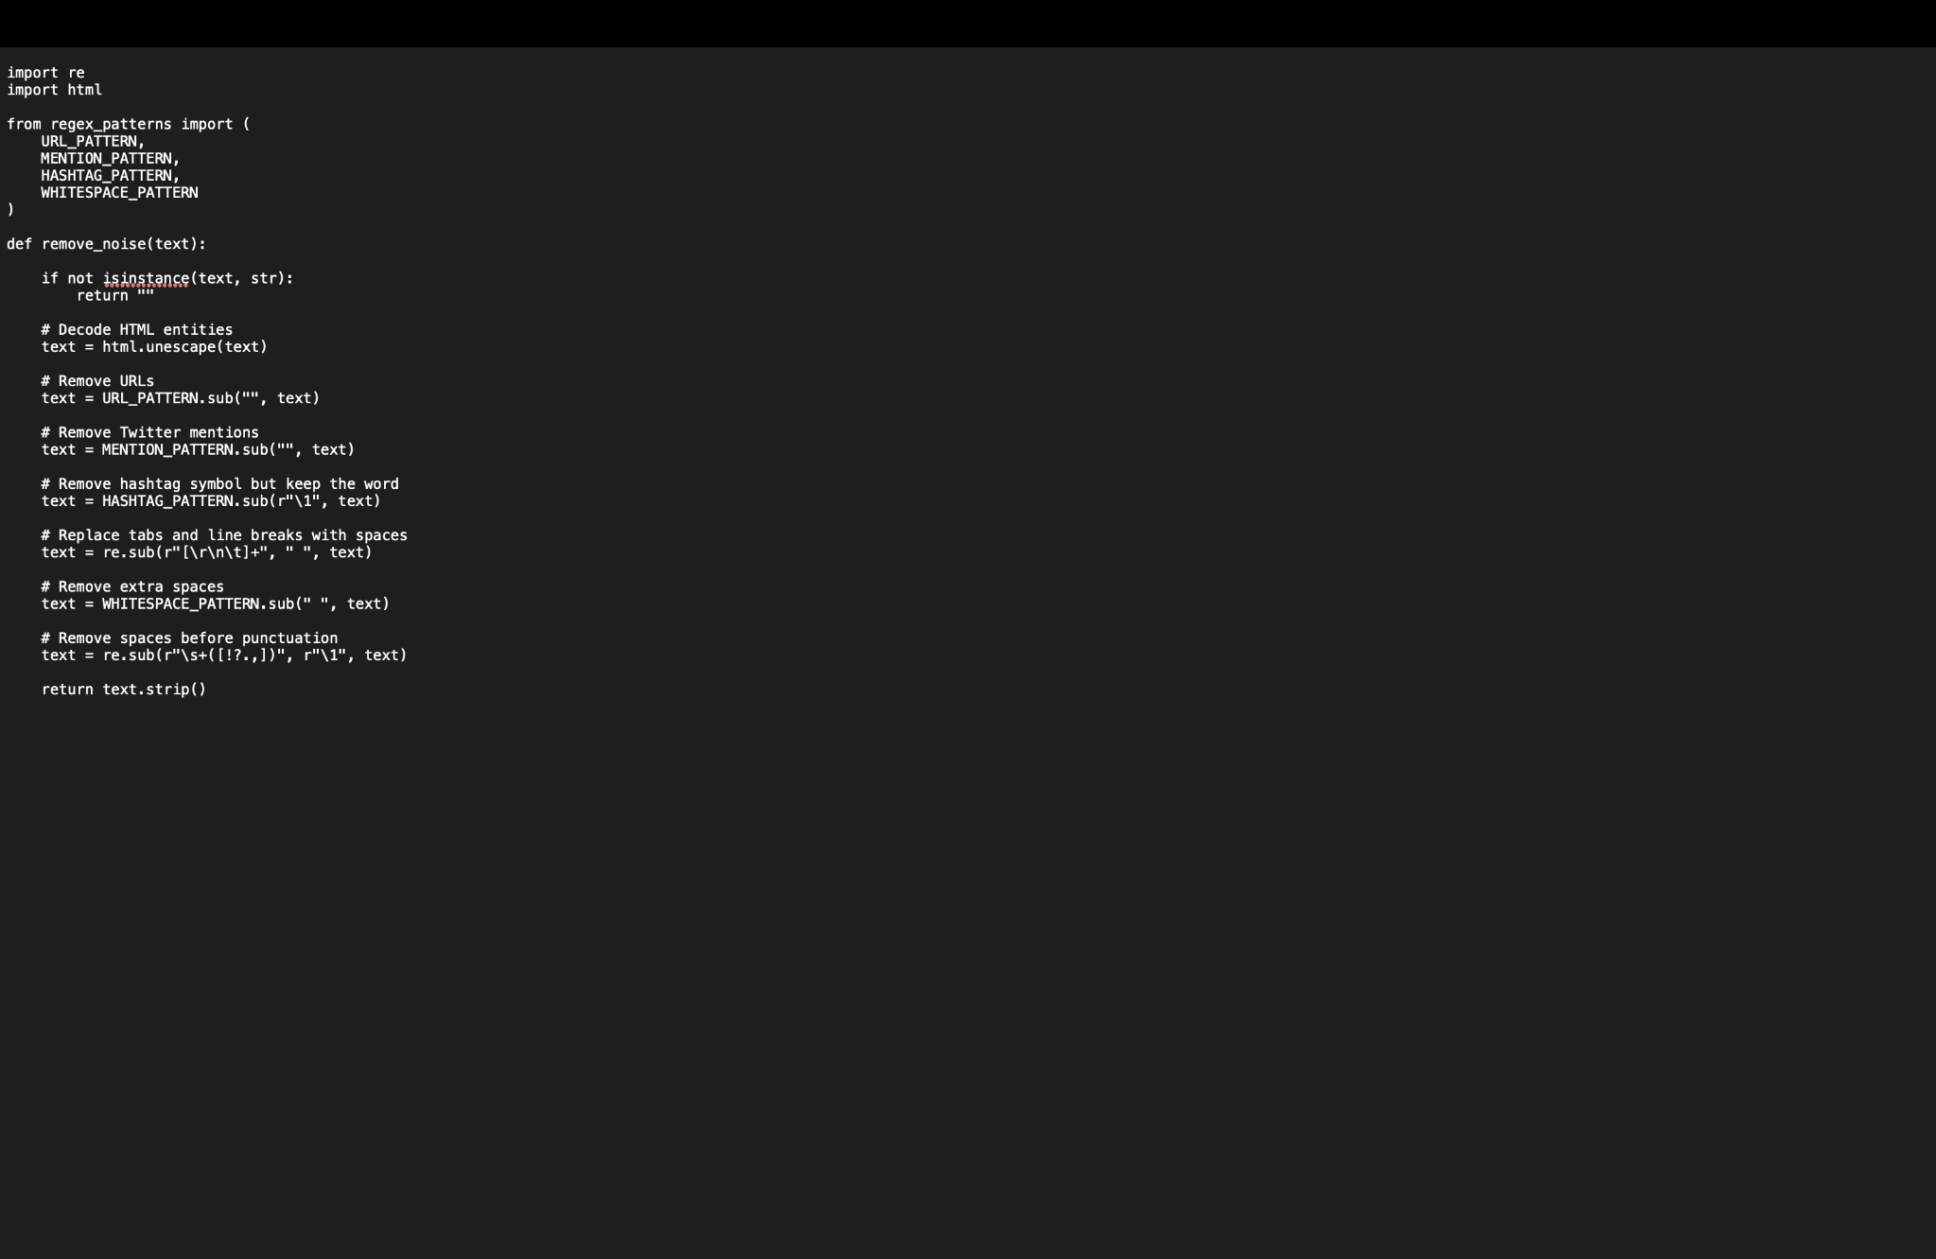
Figure 3. Regex detection and before-and-after testing output.
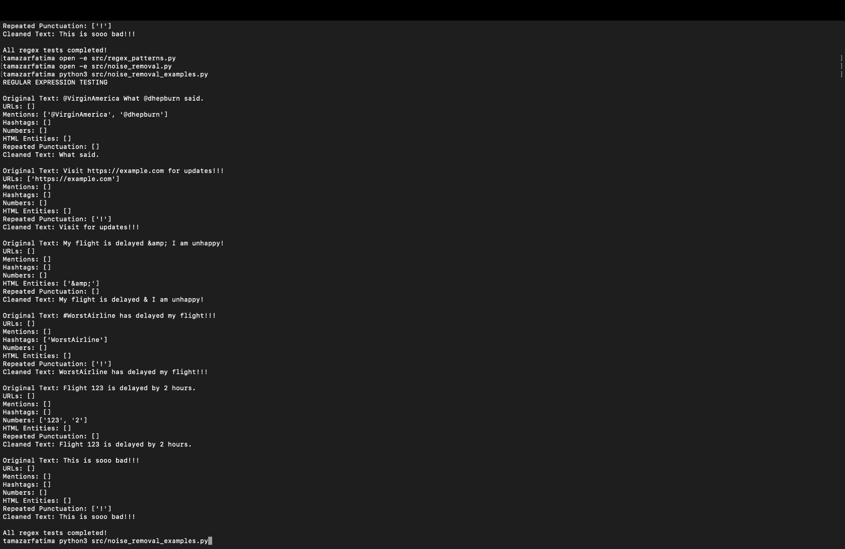
Figure 4. Full dataset processing output and sentiment distribution.
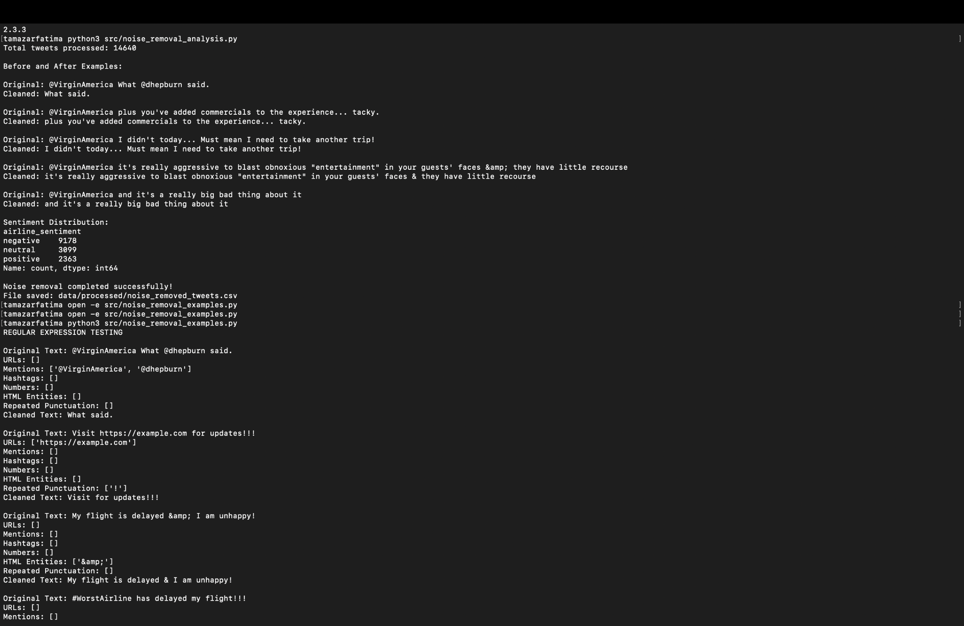
Figure 5. Processed CSV opened in a spreadsheet.
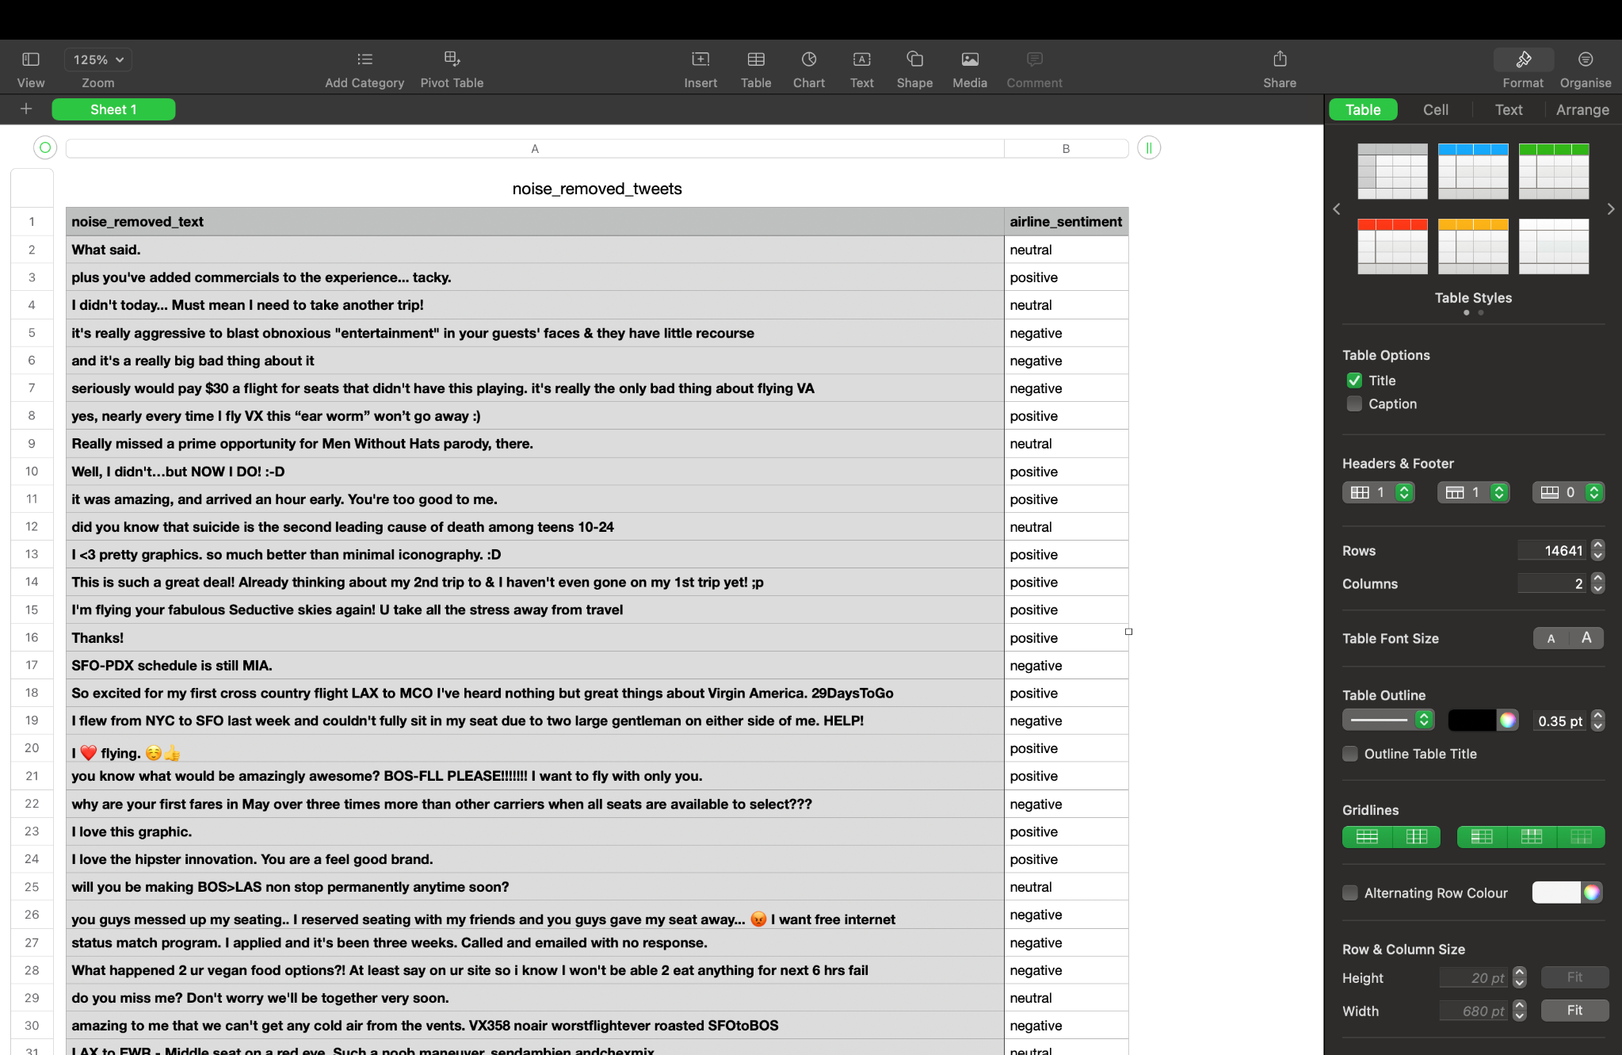
Figure 6. Additional terminal evidence of successful tests and processing.


