

**NAME: MAHAM AZAM**

**ROLLNO: 005**

**SECTION: BSAI-4A**

**LAB –task10**

**Create the following Chatbot (GUI using flask), develop its flask -> html: based front end**

**-> University admission**

This is a university admission Chabot made using Python and Flask a web frame work, it helps users by answering basic questions about university admissions like, what is the eligibility for admission? Or what documents are required? The Chabot reads the message, checks what it's about, and replies with the correct information**.** Once a user types a message and clicks the submit button, the app reads the message using the POST method. Then it sends the message to a function called get response, which checks what the message is about by looking for specific words like "admission", "fee", "documents", "eligibility", or "contact". If it doesn't understand your question, it says Sorry, I didn't understand. The Chatbot runs locally on the localhost: 5000 making it ideal for light weight applications or demonstrations.

**Output:**

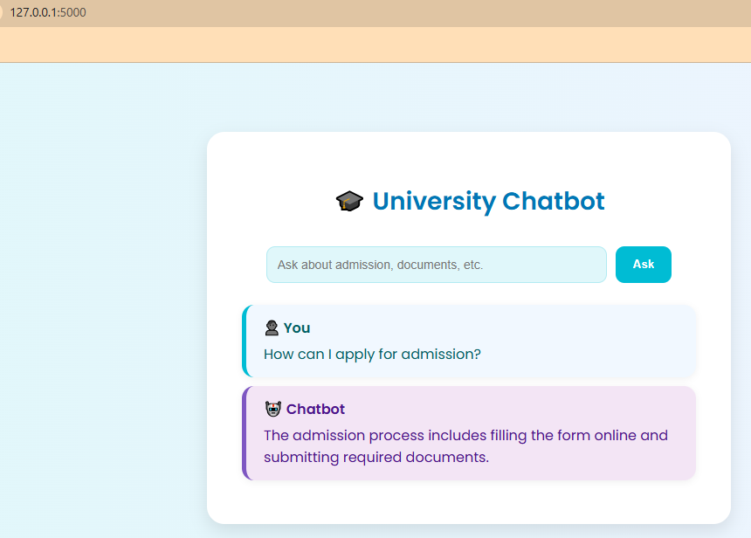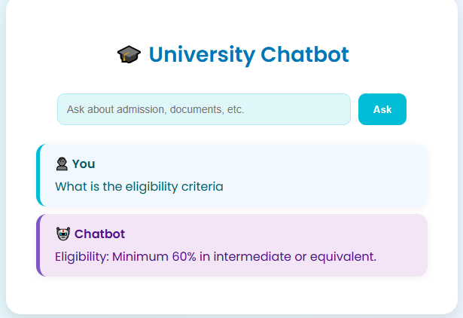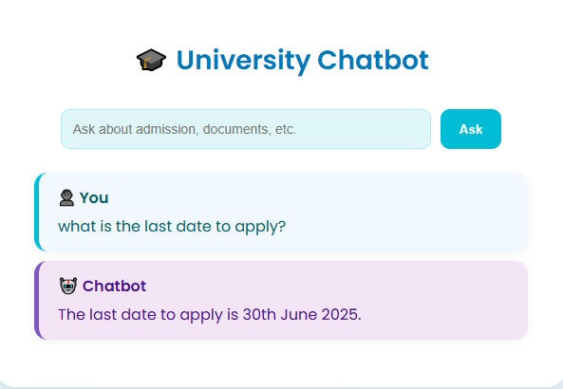

So like this we can ask different questions about university admission.

**App.py**

from flask import Flask, render_template, request

app = Flask(__name__)

def get_response(user_input):

user_input = user_input.lower()

if "admission" in user_input:

return "The admission process includes filling the form online and submitting required documents."

elif "eligibility" in user_input:

return "Eligibility: Minimum 60% in intermediate or equivalent."

elif "documents" in user_input:

return "You need to submit CNIC, academic transcripts, and passport-sized photos."

elif "fee" in user_input:

return "The fee structure varies by department. On average, it's around PKR 100,000 per semester."

elif "contact" in user_input:

return "You can contact the admission office at admissions@university.edu.pk"

elif "deadline" in user_input or "last date" in user_input:

return "The last date to apply is 30th June 2025."

else:

return "Sorry, I didn't understand. Please ask about admissions, documents, eligibility, etc."

@app.route("/", methods=["GET", "POST"])

def index():

user_msg = ""

bot_msg = ""

if request.method == "POST":

user_msg = request.form["msg"]

bot_msg = get_response(user_msg)

return render_template("index.html", user_msg=user_msg, bot_msg=bot_msg)

if __name__ == "__main__":

app.run(debug=True)

**index.html**

<!DOCTYPE html>

<html lang="en">

<head>

<meta charset="UTF-8">

<title>University Chatbot</title>

<link rel="stylesheet" href="{{ url_for('static', filename='style.css') }}">

</head>

<body>

<div class="chat-container">

<h1>🎓 <span>University Chatbot</span></h1>

<form method="POST">

<input type="text" name="msg" placeholder="Ask about admission, documents, etc." required>

<input type="submit" value="Ask">

</form>

{% if user_msg %}

<div class="messages">

<div class="user-msg">

<span>👤 You</span>

{{ user_msg }}

</div>

<div class="bot-msg">

<span>🤖 Chatbot</span>

{{ bot_msg }}

</div>

</div>

{% endif %}

</div>

</body>

</html>

**Style**

@importurl('https://fonts.googleapis.com/css2?family=Poppins:wght@400;600&display=swap');

body {

font-family: 'Poppins', sans-serif;

background: linear-gradient(to right, #e0f7fa, #f0f4ff);

margin: 0;

padding: 0;

display: flex;

height: 100vh;

align-items: center;

justify-content: center;

}

.chat-container {

background: white;

padding: 40px;

border-radius: 20px;

width: 100%;

max-width: 520px;

box-shadow: 0 8px 20px rgba(0, 0, 0, 0.1);

text-align: center;

}

h1 {

font-size: 28px;

margin-bottom: 30px;

color: #0077b6;

}

form {

display: flex;

gap: 10px;

justify-content: center;

margin-bottom: 25px;

flex-wrap: wrap;

}

input[type="text"] {

padding: 12px;

border: 1px solid #b2ebf2;

border-radius: 10px;

width: 70%;

font-size: 14px;

background: #e0f7fa;

color: #004d40;

transition: all 0.3s ease;

}

input[type="text"]:focus {

outline: none;

border-color: #00bcd4;

background: #ffffff;

}

input[type="submit"] {

padding: 12px 20px;

background-color: #00bcd4;

color: #fff;

border: none;

border-radius: 10px;

font-weight: 600;

cursor: pointer;

transition: background 0.3s ease;

}

input[type="submit"]:hover {

background-color: #0097a7;

}

.messages {

margin-top: 20px;

text-align: left;

}

.user-msg,

.bot-msg {

background: #f1f8ff;

padding: 14px 20px;

border-radius: 14px;

margin: 10px 0;

box-shadow: 0 2px 8px rgba(0, 0, 0, 0.06);

animation: fadeIn 0.3s ease-in;

position: relative;

}

.user-msg {

border-left: 5px solid #00bcd4;

color: #006064;

}

.bot-msg {

border-left: 5px solid #7e57c2;

background: #f3e5f5;

color: #4a148c;

}

.user-msg span,

.bot-msg span {

font-weight: 600;

display: block;

margin-bottom: 5px;

}

@keyframes fadeIn {

from { opacity: 0; transform: translateY(10px); }

to { opacity: 1; transform: translateY(0); }

}