

**NAME**: MAHAM AZAM

**ROLLNO**: BSAIM-F23-005

**SECTION**: 4A

**NEWS APP**

This project is the news website that show the latest news from different countries using flask and news API. When a user open the site the app fetch the news from the API that we have given to it. The news article include title, description, image and link to read more about it also format the date of each article nicely. The processed news is displayed using the index.html template.

Index.html is the main web page that shows the news, has a dropdown menu to select category and country, new articles displayed in the grid format with images, title, description, sources and link. Page is style with CSS to look clean and modern, layout.html helps structure the webpage.

So the main features are flask for creating the web page, request library to get news from news API, html to display news dynamically and CSS for styling the website.

**Output:**



By clicking on this URL we go to page

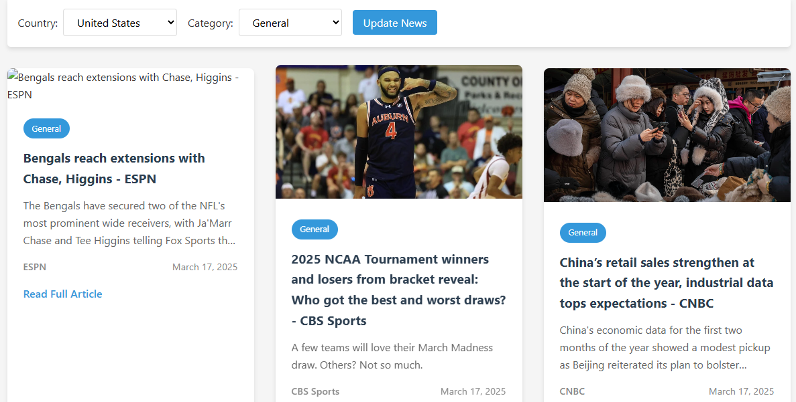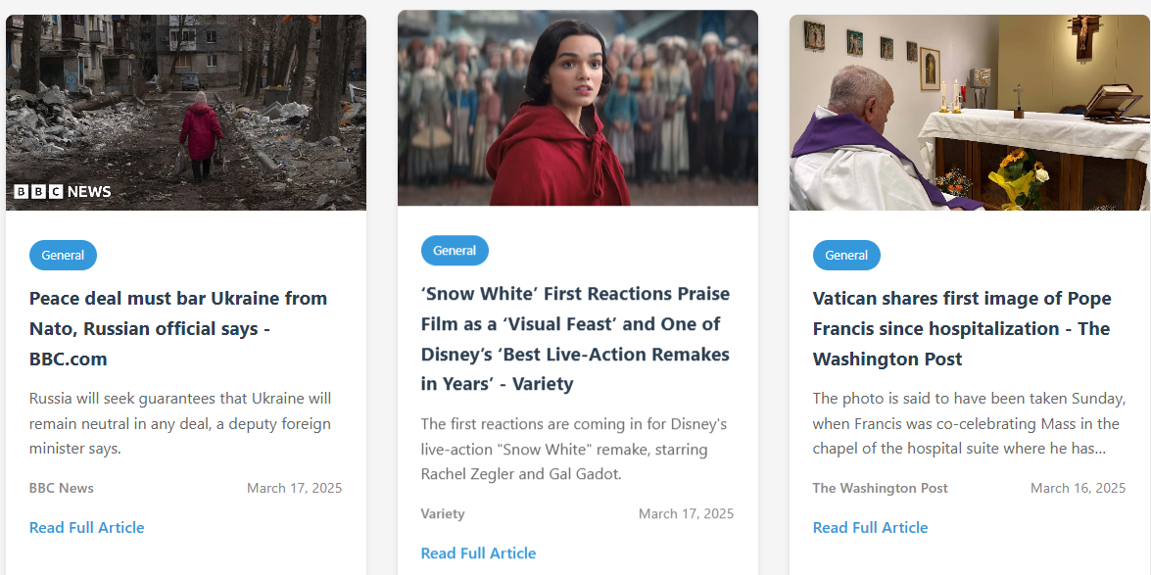

So we can read the full article by clicking on the Read Full Article.

