Week 3: Connecting to the Database
SQLite Migration - Test Report
Assignment BE-02 · Backend AI Engineering Track
This report documents end-to-end testing of the task-crud-api after replacing the in-memory task array with a SQLite database (better-sqlite3). Every request below was actually executed against the running server, and every result shown is a real screenshot of the output — not a simulated example.

Summary of Results
Request | Expected | Actual Result
GET (first run) /tasks | 3 seed tasks | Pass — 3 tasks returned
GET (before creating) /tasks | 3 tasks, no duplicates | Pass — still 3 tasks
POST /tasks | 201 Created, new row | Pass — id 4 created
GET (after POST) /tasks | 4 tasks incl. id 4 | Pass
PUT /tasks/4 | 200 OK, done: true | Pass
GET (after PUT) /tasks | id 4 shows done: true | Pass
DELETE /tasks/4 | 204 No Content | Pass
GET (after DELETE) /tasks | id 4 removed, 3 tasks | Pass
GET (persistence recheck) /tasks | Still 3 tasks, stable | Pass
DB Browser — Browse Data tasks.db | 3 rows visible in table | Pass
SELECT * FROM tasks WHERE done = 1 SQL | 1 row returned | Pass
SELECT * FROM tasks WHERE done = 0 SQL | 2 rows returned | Pass

Stage 0 — First Run & Seed Check
The server was started for the very first time. GET /tasks returned exactly the three seed tasks defined in db.js (Buy milk, Complete Internship task, Complete assignment) — confirming the database and table were created automatically, and seeding worked.
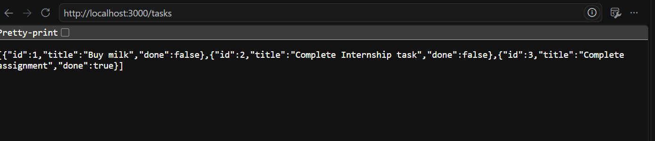
Figure 1 — GET /tasks on first run: 3 seed tasks.
The server was checked again before any writes were made, confirming seeding does not repeat on every load — only when the table is empty.
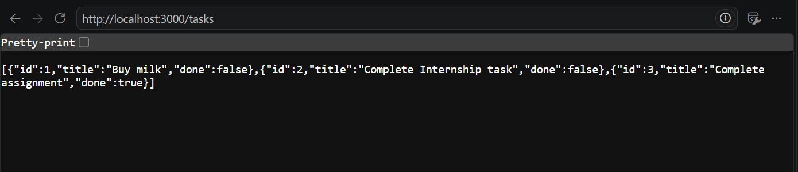
Figure 2 — GET /tasks re-checked: still exactly 3 tasks, no duplicates.

Stage 2 — Create (POST)
A POST request was sent via Thunder Client with body { "title": "Test task" }. The API returned 201 Created with the new row, assigned id 4 and done defaulting to false.
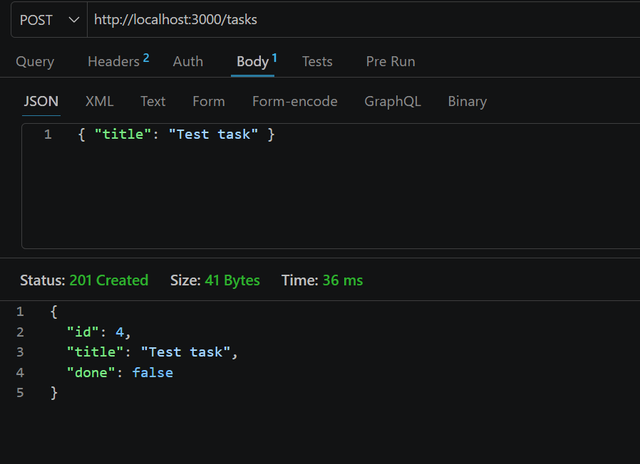
Figure 3 — POST /tasks → 201 Created, id 4 assigned.
GET /tasks was called again in the browser to confirm the new row is visible through the read endpoint too, not just in the POST response.
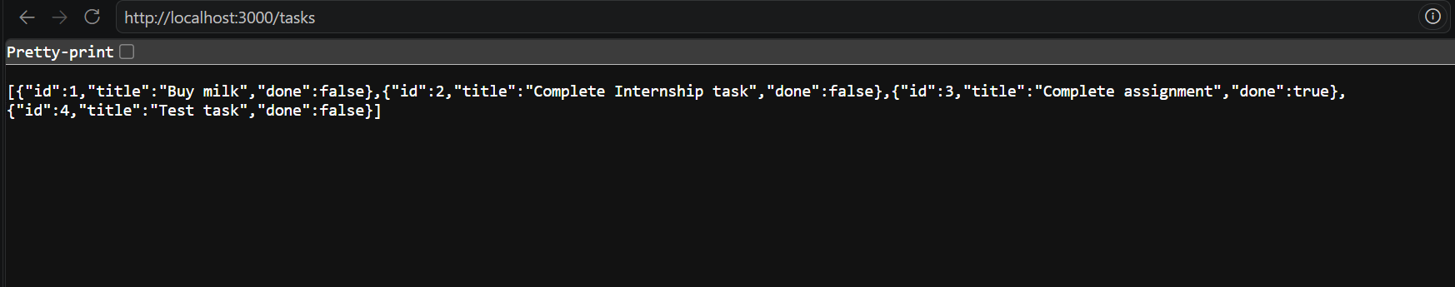
Figure 4 — GET /tasks after POST: 4 tasks, id 4 present with done:false.

Stage 3 — Update (PUT) & Delete
A PUT request was sent to /tasks/4 with body { "done": "true" }. The API returned 200 OK with the updated row, done now true.
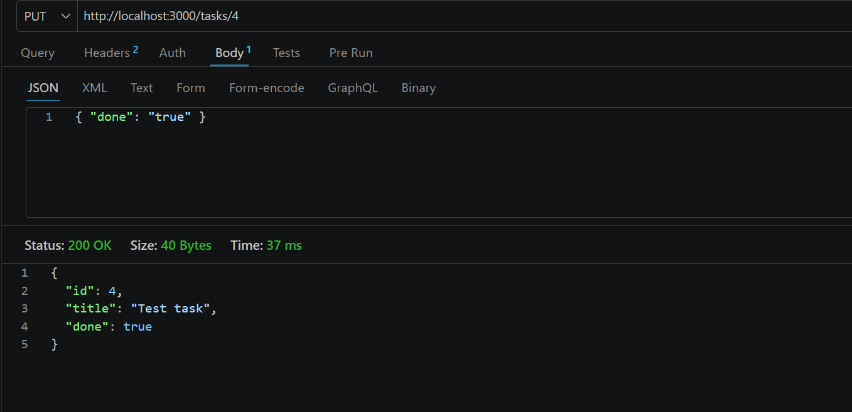
Figure 5 — PUT /tasks/4 → 200 OK, done updated to true.
GET /tasks was called again to confirm the update is reflected through the read endpoint.
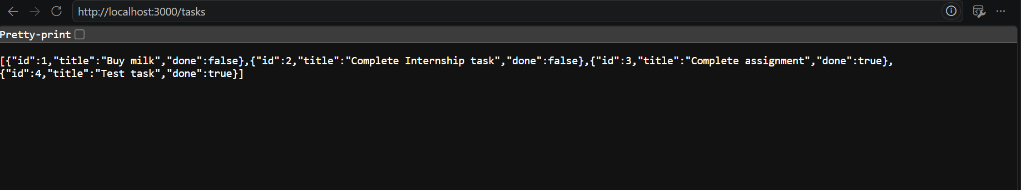
Figure 6 — GET /tasks after PUT: id 4 now shows done:true.
A DELETE request was sent to /tasks/4. The API returned 204 No Content, the correct response for a successful delete with no body.
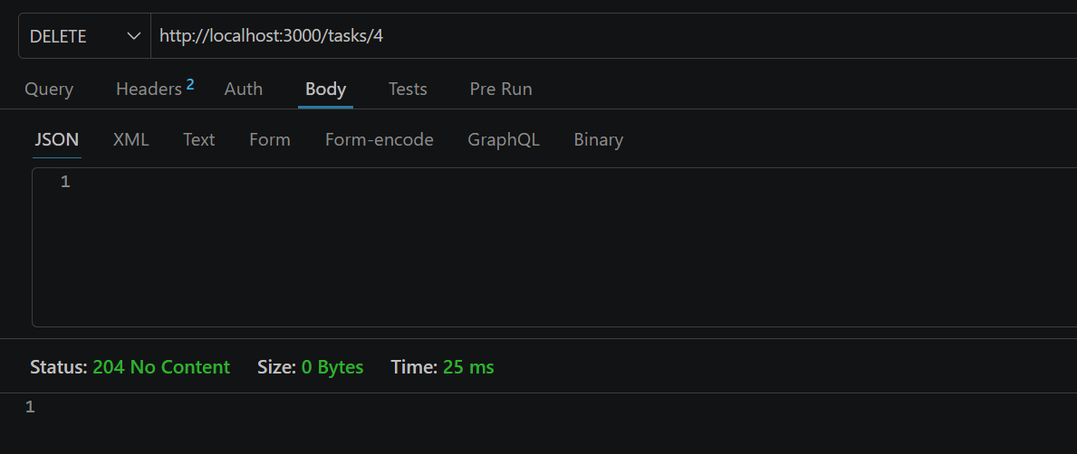
Figure 7 — DELETE /tasks/4 → 204 No Content.
GET /tasks was checked once more to confirm id 4 was actually removed from the database, not just from the response.
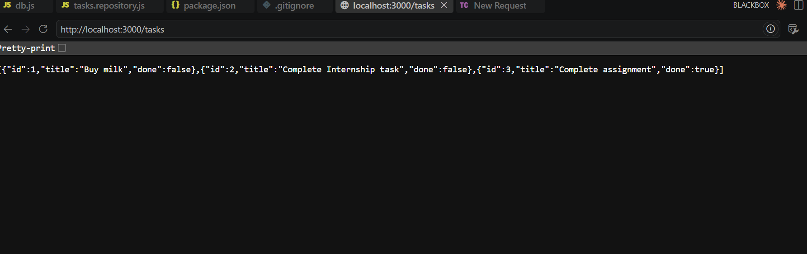
Figure 8 — GET /tasks after DELETE: back to 3 tasks, id 4 gone.

Persistence Recheck
GET /tasks was checked again after the CRUD cycle above to confirm the database state remained stable and consistent — the same 3 tasks (Buy milk, Complete Internship task, Complete assignment) that existed before the test cycle, with no leftover or duplicate rows.
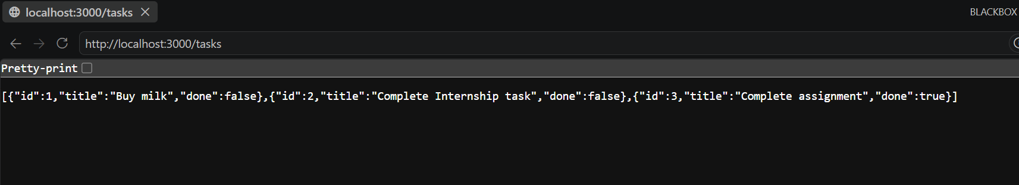
Figure 9 — GET /tasks: state is stable and consistent after the full CRUD cycle.

Stage 4 — Manual SQL Exploration (DB Browser for SQLite)
tasks.db was opened directly in DB Browser for SQLite. The Browse Data tab shows the tasks table with its 3 rows, matching exactly what the API returns — confirming the API and the database file are the same source of truth.
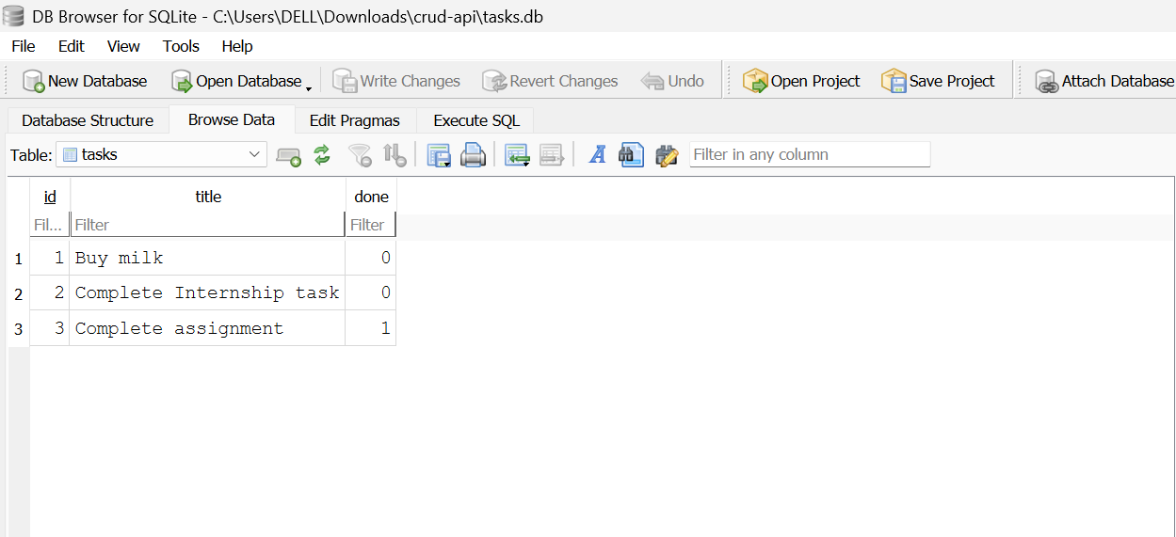
Figure 10 — DB Browser, Browse Data tab: tasks table contents.
The query SELECT * FROM tasks WHERE done = 1; was run manually in the Execute SQL tab. It correctly returned only the one completed task.
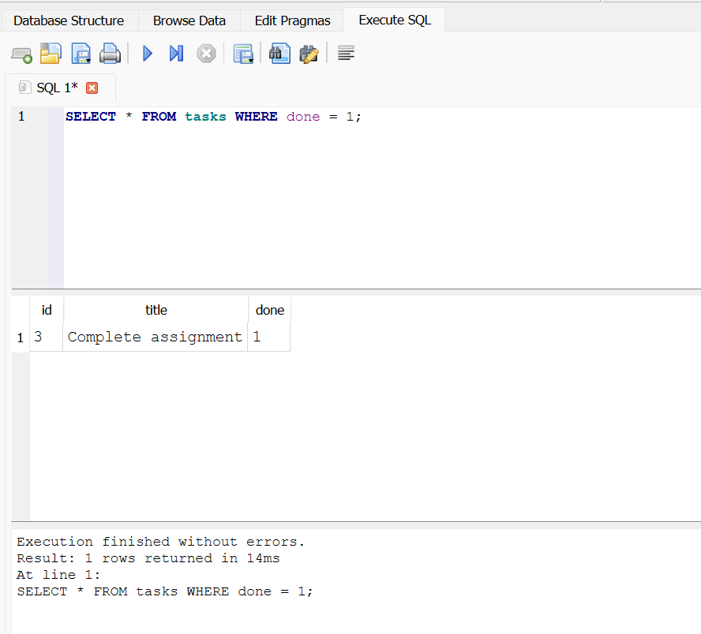
Figure 11 — Execute SQL: SELECT * FROM tasks WHERE done = 1; → 1 row returned.
The query SELECT * FROM tasks WHERE done = 0; was also run manually, correctly returning the two incomplete tasks.
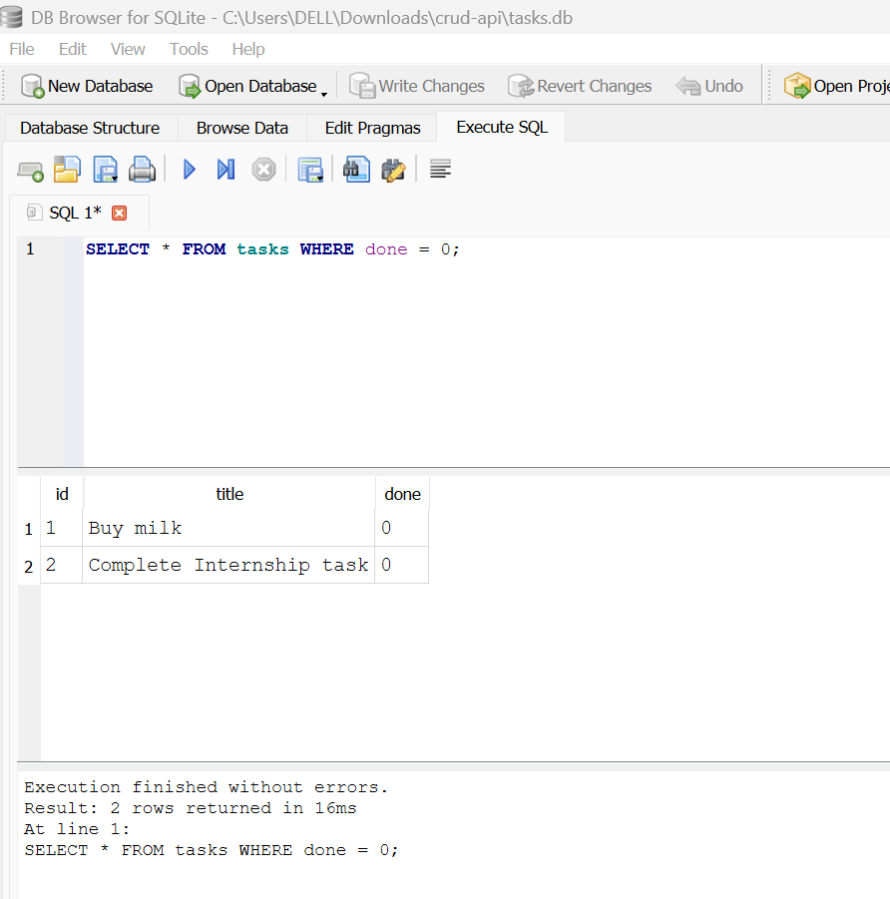
Figure 12 — Execute SQL: SELECT * FROM tasks WHERE done = 0; → 2 rows returned.

Conclusion
All required behaviours for Assignment BE-02 were verified against the running application: automatic database/table creation, one-time seeding, full CRUD (GET, POST, PUT, DELETE) operating through SQL against tasks.db, correct HTTP status codes, and manual inspection of the database confirming the API and the database file share the same data. The migration from the in-memory array to SQLite is complete and behaves identically from the client's perspective, as required.

