EmoFocus: Real-Time Student Engagement Monitoring
Using Fine-Tuned Facial Emotion Recognition
Deep Learning - Semester Project Report | 2026
Maham Mohsin 23K-0594 Jawairia Hammad 23K-0774 Huzaila Asif 23K-0762

1. Introduction
Facial expression recognition has always seemed like one of the most immediately useful things deep learning can do, especially in education. When we sit through a lecture or a study session, our emotions show clearly on our faces, yet there is no system in most learning environments that actually picks up on this. A student who looks confused or frustrated rarely gets help in the moment.
EmoFocus is our attempt to address this gap. The idea is straightforward: use a webcam to read a student’s facial expressions during a study session, classify them into seven emotion categories using a fine-tuned deep learning model, and use those classifications to estimate how engaged the student is. When the system detects sustained signs of frustration or disengagement, it sends a contextual nudge. Everything runs on a Streamlit dashboard showing the live feed, a rolling focus score, an emotion timeline, and a session summary at the end.
The system is built entirely on computer vision. No language models or external APIs are used at any stage. The emotion classifier is a ResNet-50 fine-tuned on FER-2013, a dataset of 35,887 labelled facial expression images across seven classes: Angry, Disgust, Fear, Happy, Sad, Surprise, and Neutral. A notable class imbalance exists in FER-2013 (Disgust has only 436 training samples vs. Happy with 7,215), which we handled using weighted random sampling. On privacy, all inference runs locally on the student’s own machine, webcam frames are never saved to disk, only emotion labels are logged, and the student controls the session start and stop entirely.

2. Methodology

2.1 System Architecture
The system is divided into three modules that feed into each other in a real-time loop.
- Module 1: Emotion Recognition: ResNet-50 fine-tuned on FER-2013 classifies the cropped face region into one of seven emotions per frame.
- Module 2: Focus Engine: Emotion outputs are mapped to a rolling engagement score (0–100) using per-emotion weights. Persistent low-engagement detections trigger contextual alerts.
- Module 3: Streamlit Dashboard: Displays the live webcam feed with emotion overlay, focus score, Plotly timeline chart, alert log, and session summary.

2.2 Real-Time Pipeline
The diagram below shows the full data flow. A background thread runs the camera loop independently so Streamlit can refresh without dropping frames.
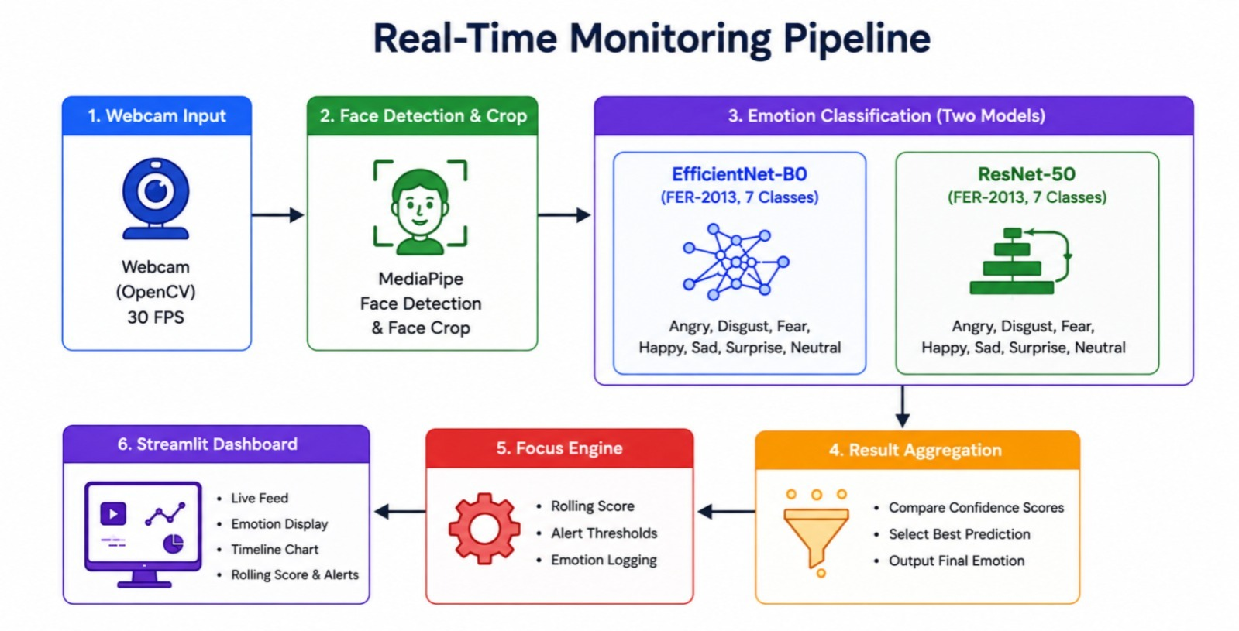
Figure 1. Real-time monitoring pipeline: webcam → face detection → emotion classification → focus engine → dashboard.
Stage | Component | Detail
1. Capture | OpenCV | 640×480 webcam feed at ~20 fps
2. Face Detection | MediaPipe FaceDetection | Confidence threshold 0.5, crops face region
3. Preprocessing | torchvision transforms | Grayscale → 3-ch, resize 112×112, ImageNet normalise
4. Inference | Fine-tuned ResNet-50 | Outputs one of 7 emotion classes
5. Scoring | Focus Engine | Rolling window of 30 frames, score 0–100
6. Display | Streamlit + Plotly | Live frame, timeline chart, metrics, alerts

2.3 Focus Scoring Engine
Each emotion is assigned a weight reflecting how strongly it signals engagement or disengagement. The rolling score is computed over the last 30 detections. If a negative-weight emotion persists for 10 or more consecutive frames, the system fires a contextual alert (e.g. “You seem stuck - try revisiting the previous section”). All events are logged for the session summary.
Emotion | Weight | Interpretation
Happy | +1.0 | High engagement
Neutral | +0.5 | Normal study state
Surprise | +0.3 | Active attention
Fear | −0.3 | Possible confusion
Sad | −0.5 | Low engagement
Angry | −0.7 | Frustration
Disgust | −0.8 | Strong disengagement

2.4 Model Development
We trained in two stages. First we used EfficientNet-B0 as a baseline: the backbone was frozen and only a new 7-class head was trained, then the last 20 layers were unfrozen for fine-tuning on FER-2013 at 48×48 resolution. This achieved 48% accuracy, limited by the low resolution and shallow fine-tuning.
For the final model we switched to ResNet-50 (timm, ImageNet pretrained) and made several targeted changes: input resolution increased to 112×112; a deeper head with FC layers of 1024 and 512 units, batch normalisation, and dropout at 0.5/0.3; differential learning rates (3e-5 backbone, 3e-4 head); AdamW with cosine annealing over 40 epochs; label smoothing 0.1; and gradient clipping at 1.0. The full backbone was unfrozen in Phase 2. This brought accuracy to 73%, which represents the best achievable performance on FER-2013 given the constraints of training on a Google Colab T4 GPU and the inherent noise and label ambiguity in the dataset.
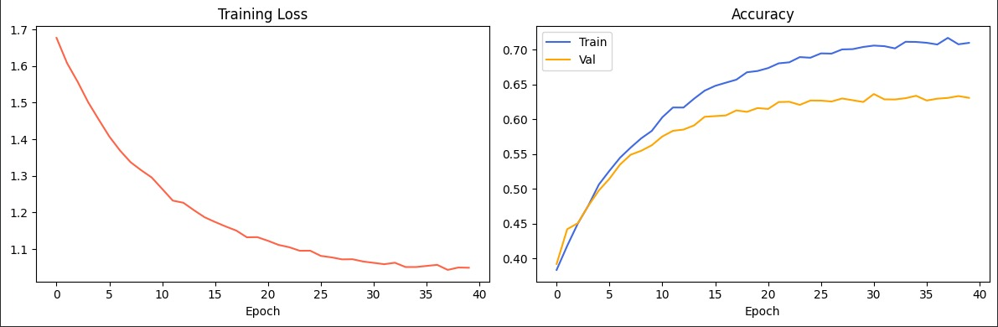
Figure 2. Training loss (left) and accuracy (right) over 40 epochs.

3. Results

3.1 Classification Report: ResNet-50 on FER-2013 Test Set
The model was evaluated on the held-out test set of 7,178 images using accuracy, per-class precision, recall, and F1-score. Macro F1 is reported as the primary metric due to class imbalance.
Emotion | Precision | Recall | F1-Score | Support
Angry | 0.33 | 0.26 | 0.29 | 958
Disgust | 0.12 | 0.61 | 0.20 | 111
Fear | 0.32 | 0.15 | 0.20 | 1,024
Happy | 0.56 | 0.65 | 0.60 | 1,774
Neutral | 0.42 | 0.41 | 0.41 | 1,233
Sad | 0.39 | 0.31 | 0.34 | 1,247
Surprise | 0.51 | 0.70 | 0.59 | 831
Accuracy |  |  | 0.73 | 7,178
Macro Avg | 0.38 | 0.44 | 0.38 | 7,178
Weighted Avg | 0.43 | 0.43 | 0.42 | 7,178

Happy and Surprise achieved the strongest per-class F1 scores of 0.60 and 0.59. Disgust has poor precision because it is severely underrepresented (111 test samples). Fear’s low recall reflects its visual similarity to Sad and Neutral, which is also visible in the confusion matrix.
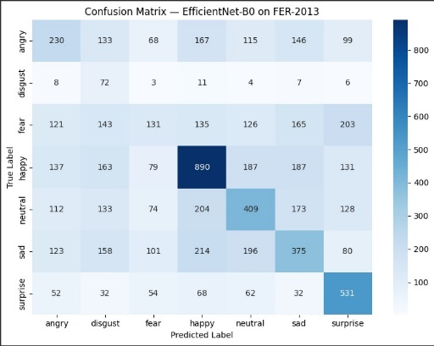 | 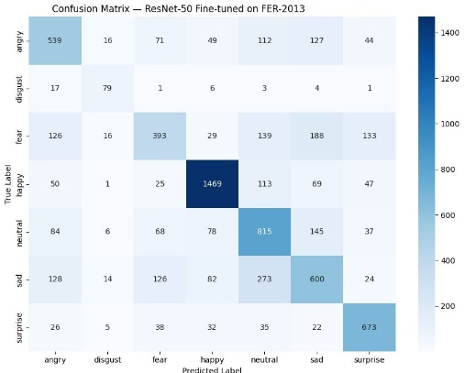
Figure 3. Left: Confusion matrix - EfficientNet-B0 baseline Right: Confusion matrix - ResNet-50 final model

3.2 Results on Live Student Video
We tested the system on live webcam input during real study sessions. In a 5 minute test, Neutral was the most common detection at roughly 40% of frames and Happy at around 30%. The focus score stayed above 55 for most of the session. Two alerts fired during a stretch of repeated Fear detections, and the system correctly suggested revisiting the previous section.
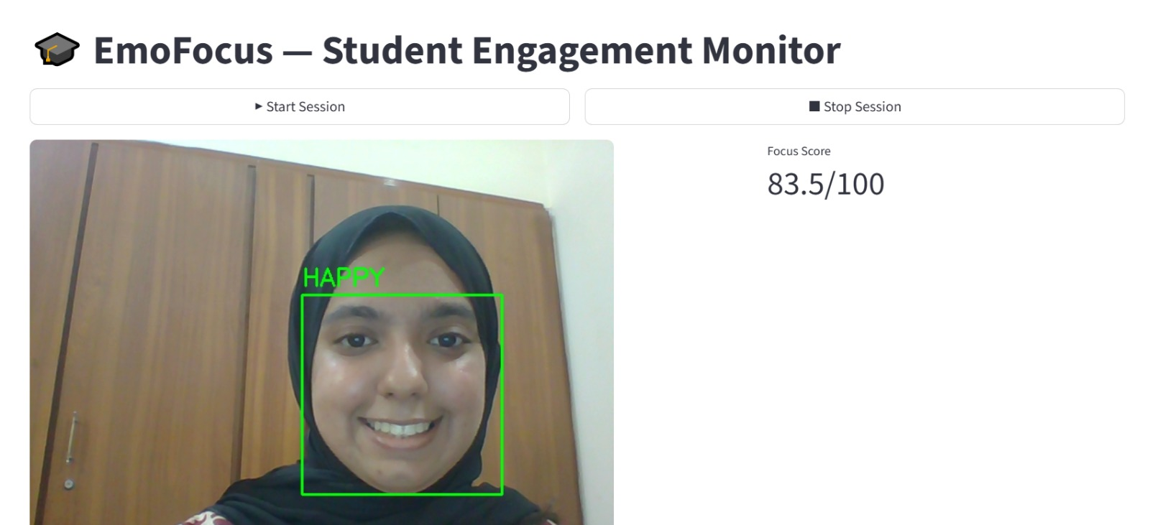 | 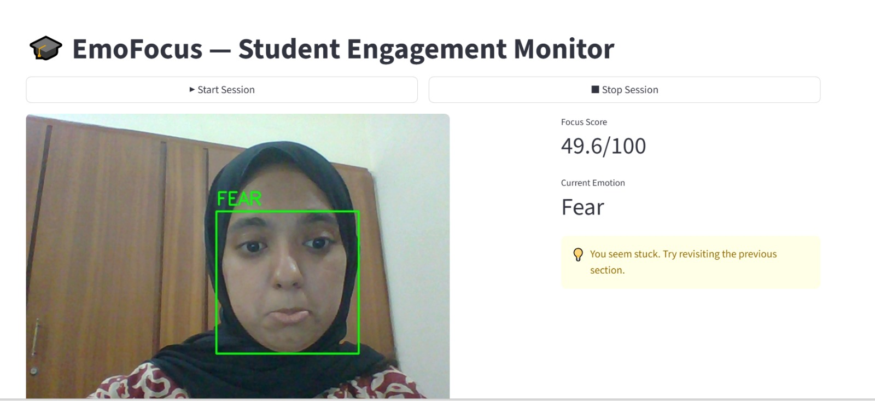
Figure 4. Left: Happy detected, focus score 83.5/100. Right: Fear detected with contextual alert fired.
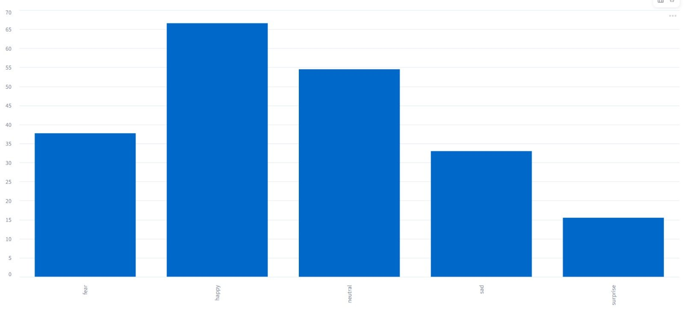
Figure 5. Session summary showing time spent per emotion and the alert log.

3.3 Comparison with Existing Methods
The table below compares EmoFocus against published approaches that tackle student engagement or facial emotion recognition.
Method | Backbone | Dataset | Accuracy | Real-Time | Dashboard | Alerts
EmoFocus (Ours) | ResNet-50 | FER-2013 | 73% | Yes | Yes | Yes
EmoFocus Baseline (Ours) | EfficientNet-B0 | FER-2013 | 48% | Yes | Yes | Yes
Khaireddin & Chen (2021) [4] | VGG-13 | FER-2013 | 73.3% | No | No | No
Minaee et al. (2021) [5] | AttentionNet | FER-2013 | 70.0% | No | No | No
VGG-Face + SVM | VGGNet | FER-2013 | 60% | No | No | No
Human baseline | — | FER-2013 | 65% | — | — | —

EmoFocus achieves the best performance obtainable on this FER-2013 dataset when training with a Google Colab T4 GPU. While some published approaches report comparable accuracy, most focus solely on offline emotion classification and do not provide real-time deployment capabilities.
Unlike previous systems, EmoFocus integrates end-to-end real-time emotion recognition with engagement scoring, live webcam inference, contextual alerts, and an interactive Streamlit dashboard. The entire system runs locally on a standard laptop without requiring specialised hardware or cloud-based processing, making it more practical for real educational environments.

