**SMART PUBLIC RESTROOMS**

Platform or Base: -

It is a wooden base consisting of two wooden plates connected with 12 springs in 3*4 arrays. It is provided with 4 bolts and 8 nuts that constraints the platform to move only in vertical direction.

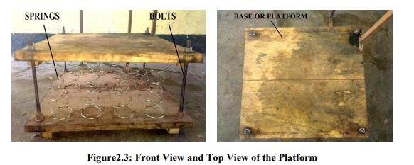

**Supporting Stand: -** Two square pipes that help the cistern (water reservoir) to hold 770 mm above the ground providing a potential head .This head is then converted to velocity of flow of water which is responsible for cleaning of the toilet bow

l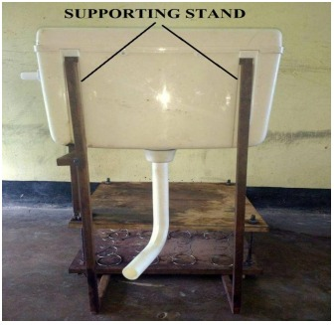

**Coil Compression Sofa Spring: -**

The spring which is used are locally termed as sofa spring. They are selected for their physical property. They are robust in nature and have long service life. It is highly tempered steel. The following images below show the spring used and their arrangement.

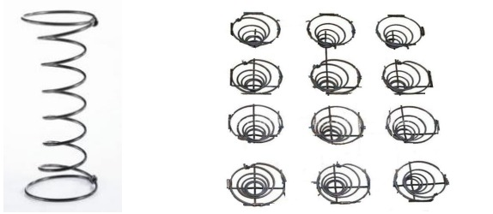

**Compression Coil Spring and its Arrangement in the System**

**Bolt and nut :-**

A bolt is a form of threaded fastener with an external male thread while a nut is a type of fastener with a threaded hole.There are 4 bolts used in the 4 corners of the platform to constrain the motion in one direction and nut is provided to limit the motion in upward direction.

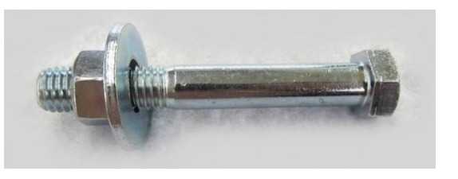

**View of nut, bolt and washer in assembly**

**MATERIAL USED AND THERE DIMENSIONS**

Table shows the six major components that make the system run. The material and dimensions of the components are shown below:

**MATERIALS USED:-**

**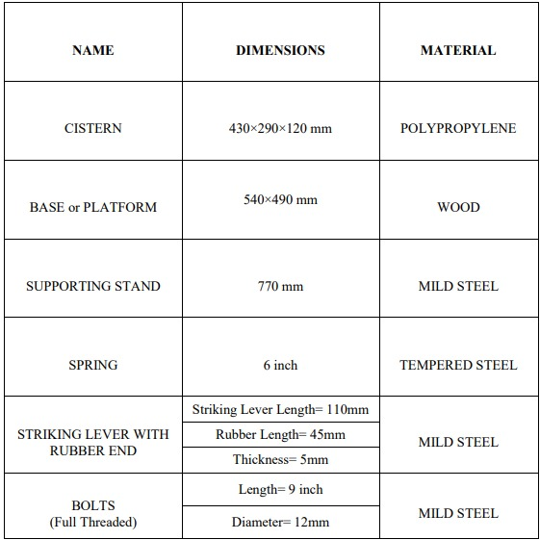  
COST ANALYSIS**

The total cost incurred in the model is illustrated in the table below:

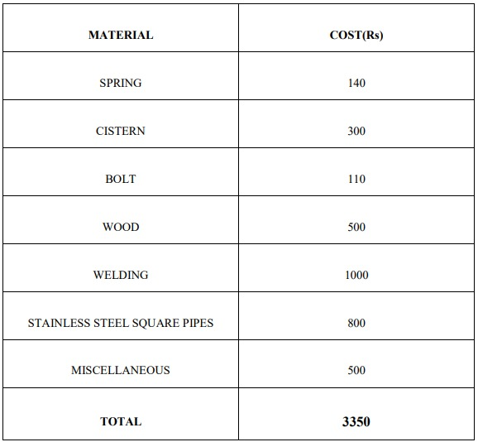

**CONSTRUCTION**

Construction of the system is simple and efficient. It does not have any complicated arrangement. The operation of the arrangement is fully mechanical. Steps involved in fabricating are:

**MAIN PARTS USED IN THE CONSTRUCTION**

• Platform Making

• Cistern Fitting

• Motion Transmitting Lever

Platform Making Platform is made of wood. It is a replica of originally used Indian toilet. In our design of platform we have used 12 numbers of springs, rectangular wood (54 x 49) cm in the figure given below. This platform is arranged by attaching 4 bolts of 9 inch length and 12 mm diameter each, these are attached at four corner of wood. In the middle of the two wood pattern springs are arranged in parallel arrangement in three rows.

Cistern Fitting Cistern is fitted by attaching metal plate with lower part of the platform. It is given a minimum height of 760 mm. To the cistern a continuous water supply line is connected. Cistern contains a floating ball and manually pressed handle .When water in the container crosses maximum limit floating ball prevents further flowing of water in the inlet. When handle is pressed discharge of water occurs.

Motion Transmitting Lever It is a square hollow pipe which is attached on the upper part of the platform by making a bracket and thereby screwing it up. This motion transmitting lever is connected to another small thin lever by arc welding. This thin lever is drilled and attached to the cistern frame with the help of a screw. At the end portion of the lever a synthetic rubber band is used having thickness 5 mm .The end portion of the thin lever having synthetic rubber at the end touches the handle and pressed it whenever people gets off from the platform