**SMART PUBLIC RESTROOM**

WORKING OF SMART TOILET FOR AUTOMATIC FLUSHING **WORKING PRINCIPLE**

The working principle of the mechanism is very simple which uses only mechanical means (such as springs, levers etc.) for its functioning. The wooden platform is consisting of two halves, one movable and the other fixed, both having springs between them. It mainly works on the principle of spring compression and expansion. When force is applied on spring, it gets compressed and after removal of the force, because of spring stiffness it provides a reaction force in opposite direction. The vertical steel pipe attached to the upper half of the base also moves up and down along with it. As a result due to lever mechanism the flexible element attached to the tip of the lever moves up crossing the cistern handle. All the arrangements work together and provide us automatic flushing from cistern

**WORKING OF EVERY ITEM USED IN OUR SYSTE**

• Platform working

• Cistern working

• Lever working

**Platform Working** Platform is nothing but spring mass system arrangement. It is the main part of our developed project where people will sit for toilet and thus compressing the spring attached in it. So when the person lifts off from the platform because of spring stiffness platform will try to comeback to original position and thus allowing an upward automatic movement of the platform.

**Cistern Working** The cistern contains a handle, an inlet valve and a float rod with float ball at the end. The inlet is mainly controlled by float ball whereas outlet is controlled by handle 12 attached on the cistern. When handle is pressed in downward direction outlet valve opens and discharge takes place.

**Lever Working** There are total two levers attached on our system which do the function on the following manner:

- • Motion transmitting lever: Motion transmitting lever is directly attached on the upper part of platform. Upward motion of platform is first transmitted to motion transmitting lever which pushes the 2nd lever attached on it in upward direction and net effect is converted into downward direction.

• Lever with synthetic rubber at the end: The lever having synthetic rubber at the end is connected by bolt joint to the motion transmitting lever. The end this lever is grooved and synthetic rubber is attached which touches the handle of the cistern. Thus handle of the cistern is pushed in downward direction by rubber and providing an automatic flush from the cistern.

CALCULATIONS AND RESULTS

**DIFFERENT PARAMETERS INVOLVED**

While developing the mechanism some experiments were performed to calculate the spring stiffness (which are used in the platform), minimum deflection for varying load, discharge capacity, flow velocity etc. which were required for constructing the mechanism. The calculations and the results are presented in the following tables.

**Experiment for Determination of Spring Stiffness** The experiment was performed by placing different loads on the upper half of the platform and then measuring the corresponding deflection .The spring stiffness is obtained by the formula:

**EQUIVALENT SPRING CONSTANT:**

In the platform the springs are arranged in 3*4 arrays. All the springs are connected in parallel so the equivalent spring constant of the arrangement can be obtained as follows: Let the spring constant of each spring be K and the equivalent spring constant is K1.

Therefore,

K1 = 12×K ,

Hence , K = K1/12

**Spring Stiffness Calculation**

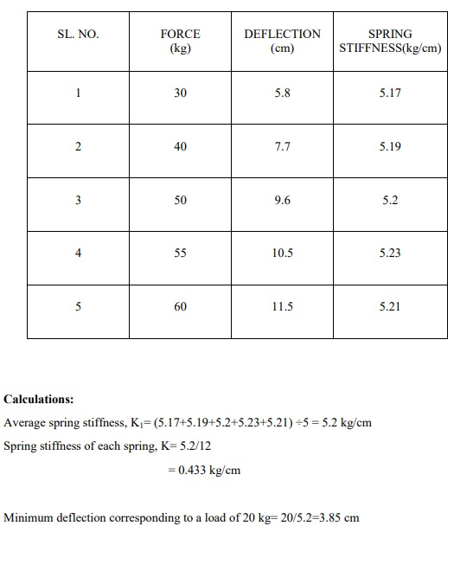

**Flow Velocity Calculation**

**Average Discharge Calculation**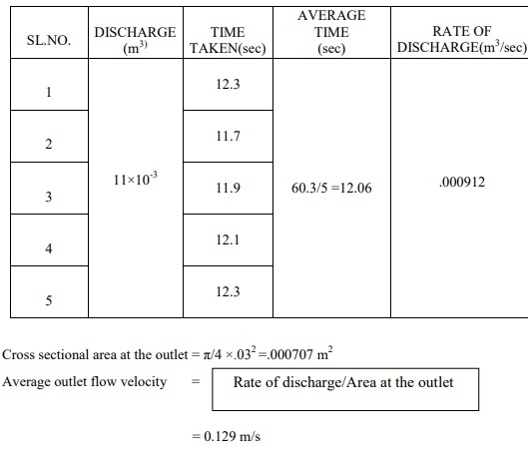

**FUTURE SCOPE**

The present work is successful in the view that the proposed mechanism has been successfully designed and demonstrated; but there is still a lot of room for further improvement which may include the following:

• In the project, the platform is unstable, i.e. it does not hold still when a person mounts or dismounts it. Therefore it could be made more stable by providing bushing instead of bolts to constraint the motion.

• The currently constructed platform is a wooden one and can be replaced with a steel platform so that welding the lever would be easier rather than to screwing it up.

• The levers can be arranged in other suitable positions to make the working more efficient

. • The metal attachment that is used to work the flush switch can be replaced by more efficient methods like by another lever arrangement with fulcrum or a cam.

• With more testing and calculation, the design of the developed mechanism can be improved further and implemented in the concerned areas