**Sentiment Analysis for Marketing**

**Sentiment Analysis:**

* Sentiment Analysis is also known as opinion mining. It’s an automated text analysis technique used to extract aggregated emotional information from the given text. In other words, it’s used to analyse the emotions of the comments, opinions, user feedback, or any other data set.
* Sentiment analysis is a valuable tool in marketing that involves using natural language processing (NLP) and machine learning techniques to determine the sentiment or emotional tone behind text data, such as customer reviews, social media posts, and comments.
* Sentiment analysis is a marketing tool that helps you examine the way people interact with a brand online. This method is more comprehensive than traditional online marketing tracking, which measures the number of online interactions that customers have with a brand, like comments and shares.

**Types of sentiment analysis:**

To perform sentiment analysis, a marketing team might use a software platform that creates an algorithm to monitor customer engagement online. There are three fundamental ways to develop an algorithm for distinguishing social sentiment:

* **Manual analysis:** This type uses manually created rules based on neurolinguistic principles, such as stemming and tokenization. It takes a long time to set up, but it's easy to change and customize.
* **Automatic analysis:** This type uses machine learning techniques that use neural networks and statistical models to classify language. It can be challenging to change, but it's easy to set up and manage.
* **Hybrid analysis:** This type uses both rules-based and machine-learning analyses. It's a balanced approach that most social listening applications employ.

**Example for sentiment analysis:**

It is done using VADER (Valence Aware Dictionary and sentiment Reasoned) library, which is a lexicon-based sentiment analysis tool.

**Command to install vaderSentiment:**

*pip install vaderSentiment*

**VADER Sentiment Analysis:**

* ADER (Valence Aware Dictionary and sentiment reasoned) is a lexicon and rule-based sentiment analysis tool that is specifically attuned to sentiments expressed in social media.
* VADER uses a combination of A sentiment lexicon is a list of lexical features (e.g., words) which are generally labelled according to their semantic orientation as either positive or negative.
* VADER not only tells about the Positivity and Negativity score but also tells us about how positive or negative a sentiment is.

**CODE:**

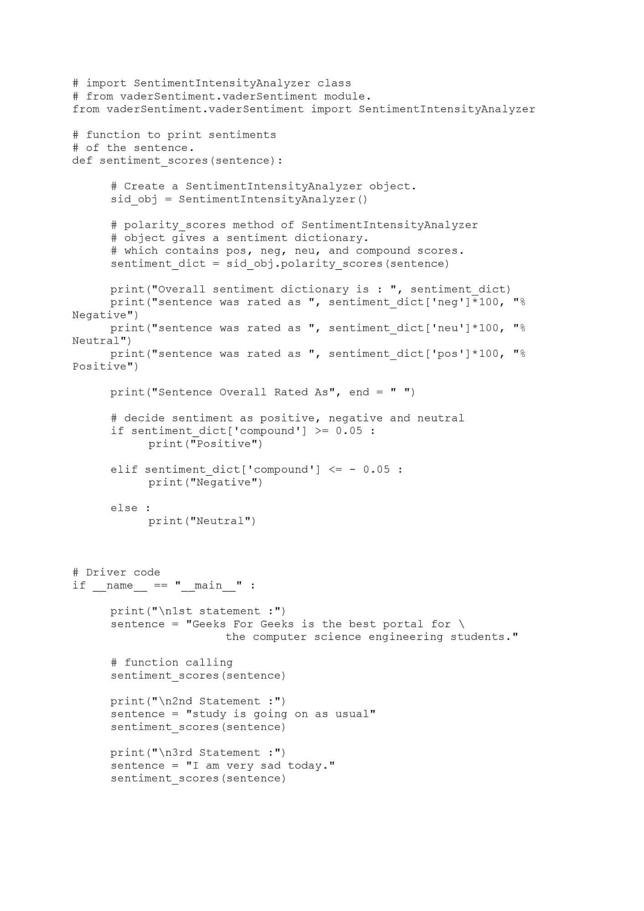

**Output:**

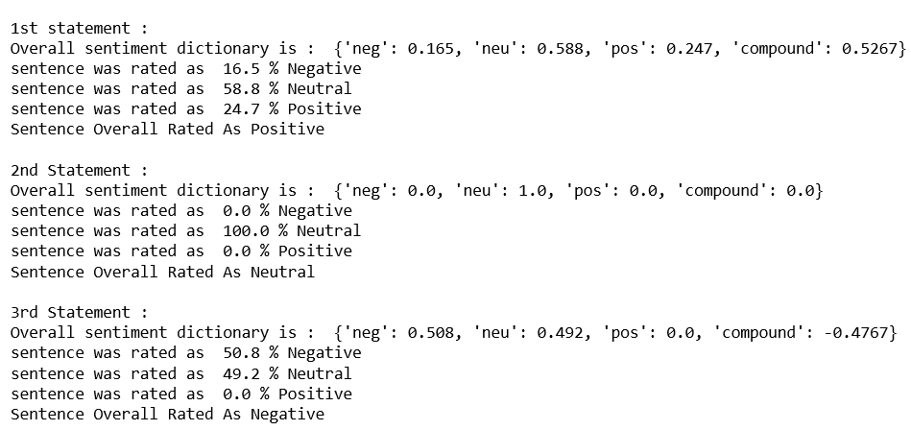

* It defines a function sentiment scores(sentence) that takes a sentence as input and analyzes its sentiment, providing a sentiment dictionary with positive, negative, neutral, and compound scores.
* It also prints the sentiment of the sentence as either "Positive," "Negative," or "Neutral" based on the compound score.
* The code then provides three example statements and uses the sentiment scores function to analyze their sentiments. It prints out the sentiment analysis results for each statement.
* This code showcases how to perform sentiment analysis on text data using the VADER sentiment analysis tool and print out the sentiment scores and overall sentiment for given sentences.

**Advantages and Disadvantages of the code for sentiment analysis using VADER:**

Advantages:

* Simple and Easy to Understand: The code is relatively simple and easy to understand, making it accessible for beginners to learn about sentiment analysis.
* Quick Implementation: It provides a quick way to implement sentiment analysis without the need for complex machine learning models or extensive training data.
* No Training Required: VADER is a lexicon-based sentiment analysis tool, so it doesn't require training on large datasets. This can be an advantage if you have limited training data or time.
* Real-time Analysis: It can be used for real-time sentiment analysis of short text snippets, which is useful for monitoring social media or customer feedback.
* Interpretability: The code includes comments that explain each step of the sentiment analysis process, making it easy to follow and modify as needed.

Disadvantages:

* Limited to English: VADER is primarily designed for English text. It may not perform well on text in other languages.
* Limited Context Understanding: VADER relies on sentiment lexicons and does not deeply understand the context of sentences. It may misinterpret sarcasm or nuanced expressions.
* Subjectivity: Sentiment analysis, in general, is subjective and can vary depending on the lexicon used. VADER's performance may not always align with human judgment.
* Not Suitable for Long Texts: VADER is best suited for short text snippets like social media posts or headlines. It may not be as accurate for longer, more complex texts.
* Lack of Customization: The code uses predefined sentiment thresholds (compound >= 0.05 for positive, <= -0.05 for negative). These thresholds may not be optimal for all applications and might require customization.
* No Consideration for Aspect-Based Sentiment: The code does not consider aspect-based sentiment analysis, where different aspects of a product or service are analyzed separately.
* No Handling of Negations: It doesn't handle negations well. For example, "not good" might be classified as positive.
* No Error Handling: The code lacks error handling, which could lead to crashes if unexpected input is provided.

**Conclusion**:

In conclusion, sentiment analysis is a powerful tool in marketing and various other domains that allows businesses to gain insights into customer emotions and opinions. By collecting and analyzing text data, businesses can make data-driven decisions, optimize marketing strategies, and improve products and services. Sentiment analysis helps in understanding how customers perceive a brand or product, enabling companies to engage with their audience effectively and respond to their needs. It is an essential component of modern marketing and can provide a competitive edge by staying attuned to customer sentiment and feedback.